
MOVIE NITE
on
Sunday, 15th May 2022 @ 7.00 pm

K.G.F:Chapter 2
(with English Sub Titles)

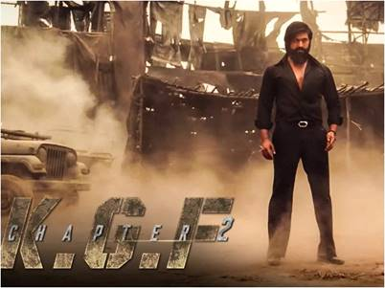

Dear Member,

The Tamil Movie “K.G.F:Chapter 2” will be screened @ The New Sports complex open terrace (2nd floor) on Sunday, 15th May 2022 at 7.00 pm.

K.G.F: Chapter 2 is a 2022 action film written and directed by Prashanth Neel, and produced by Vijay Kiragandur under the banner Hombale Films

- The number of Members will be restricted to 120.

- Members are requested to warn in for the movie by calling Front office @ 97109-33390.

- Guests are NOT permitted for the Movie.

Looking forward to you and your family enjoying the Movie Nites @ MCC.

AKBAR EBRAHIM R.KARTHIK
MIC Entertainment Honorary Secretary

