Credit Card
Default Prediction
Last date of revision: 02/09/2022

Lokendar Tirunahari

- Introduction
- Exploratory Data Analysis
2.1Data Information
  - Feature Information
  - Exploratory Analysis
3 Methodology
  - Data Preprocessing Technique
  - Logistic Regression
3.3Random Forest
  - XG-Boosting
  - AdaBoosting
  - Neural Networks
- Model Analysis

  - Logistic Regression
  - Random Forest
  - XG-Boosting
  - AdaBoosting
  - Neural Network
- Conclusion

Abstract
Credit cards are big source of income when deftly managed. But errors in risk assessment can leads to stains on the balance sheet. The climbing delinquencies will result in significant amount of money loss from the lending institutions, such as those commercial banks. Therefore, it is very crucial for banks to have a risk prediction model and be able to classify the most relative characteristics that are indicative of people who have higher probability to default on credit card loans. A robust model is not only a useful tool for the lending institutions to make decision on credit card applications, but it can also help the clients to be aware of the behaviors that may damage their credit scores.
This model will help financial institutions, commercial banks and other loan institutes to predict a defaulter earlier.

1 Introduction
- Why this High-Level Design Document?
The purpose of this High-Level Design (HLD) Document is to add the necessary detail to the current project description to represent a suitable model for coding. This document is also intended to help detect contradictions prior to coding, and can be used as a reference manual for how the modules interact at a high level.
- Scope
The HLD documentation presents the structure of the system, such as the database architecture, application architecture (layers), application flow (Navigation), and technology architecture. The HLD uses non-technical to mildly-technical terms which should be understandable to the administrators of the system.(PaaS) that enables developers to build, run,and operate applications entirely in the cloud

2.1 Product Perspective
Building a robust model for financial institutions to make decisions on credit card defaulters.

2.2 Problem statement
Financial threats are displaying a trend about the credit risk of commercial banks as the incredible improvement in the financial industry has arisen. In this way, one of the biggest threats faces by commercial banks is the risk prediction of credit clients.
The goal is to predict the probability of credit default based on credit card owner's payment history,credit limit,age etc

2.3 Data set Information
The data set for training and testing contains the information of customers default payment. There are 30,000 different instances and 25 attributes total; each instance represents one customer, and attributes consist demographic information about the customers and their past payment history from April to September.

2.4 Attribute information
•  •  •  • | ID : unique identification number assigned to each customer  LIMIT BAL : amount of given credit access line  SEX : gender (1 = male; 2 = female)  EDUCATION : highest degree obtained (1 = graduate school; 2 = university; 3
•  •  •  •  • | -  MARRIAGE  AGE  PAY 1  PAY 2  PAY 3 | high school; 4 = others; 5 = unknown; 6 = unknown)  : marital status (1 = married; 2 = single; 3 = others)  : age in year  : monthly payment record in September  : monthly payment record in August  : monthly payment record in July
•  •  •  •  •  •  •  •  •  •  •  •  • | PAY 4  PAY 5  PAY 6  BILL AMT1  BILL AMT2  BILL AMT3  BILL AMT4  BILL AMT5  BILL AMT6  PAY AMT1  PAY AMT2  PAY AMT3 PAY AMT4 PAY AMT5  PAY AMT6 | : monthly payment record in June : monthly payment record in May  : monthly payment record in April  : total amount owed in September  : total amount owed in August  : total amount owed in July  : total amount owed in June  : total amount owed in May  : total amount owed in April  : amount of previous payment in September  : amount of previous payment in August  : amount of previous payment in July  : amount of previous payment in June : amount of previous payment in May  : amount of previous payment in April

2.5 Tools used
Python programming language and frameworks such as NumPy, Pandas, Scikit-learn, TensorFlow, Keras are used to build the whole model.



- PyCharm is used as IDE.
- For visualization of the plots, Matplotlib, Seaborn and are used.
- Heroku is used for deployment of the model. ▪ Front end development is done using HTML/CSS ▪ GitHub is used as version control system.
Exploratory Analysis :
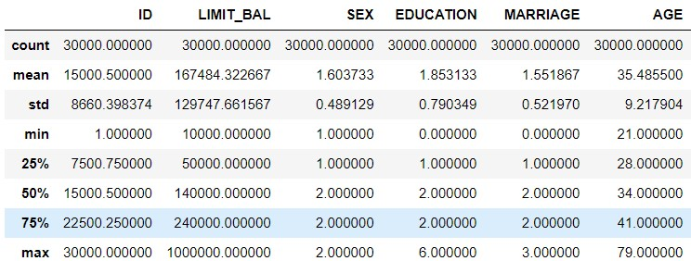
- From Table we can see that the average amount of given credit access line is 167,484 with an extremely high standard derivation close to 129,747, which can be explained by the large number of maximum credit card limit of 1 million.
- The average education level is 1.853, which indicates that most customers obtained bachelor or master degrees.
- More customers are either married or singled, compared to the number of unknown. The median age is 35.4 with 9.2 standard deviation. The youngest customer is 21 years old, while the oldest is 79 years old.
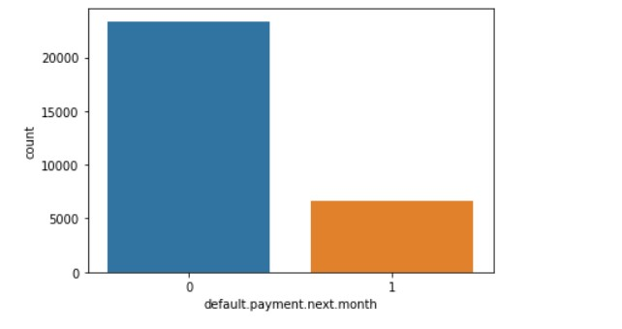
6,636 customers (approximate 22% of the entire data set) will default in the next months payment, while 23,364 will not default.
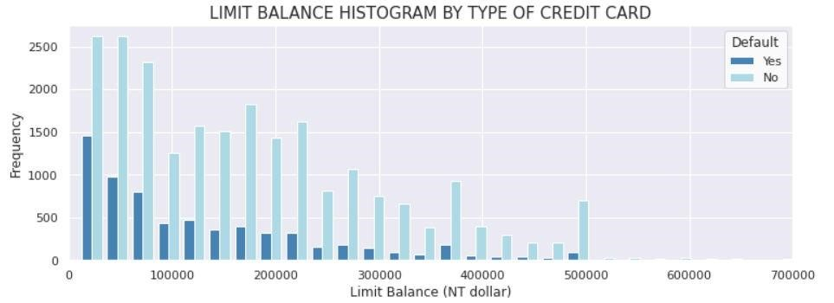
As the credit limit goes beyond the average, the number of non-defaulters gradually increases within each group and most of them are larger than the number of defaulters. The amounts of 50,000 credit limit has the largest defaults number ,as well as 20,000 and 30,000 credit limits.
Methodology:
Like any other classification problem , data is also highly imbalanced.To deal with this situation I used 3 sampling methods.
•SYNTHETIC MINORITY OVERSAMPLING TECHNIQUE
•RANDOM OVERSAMPLING •ADASYN
Model selection:

Logistic Regression with Random oversampling
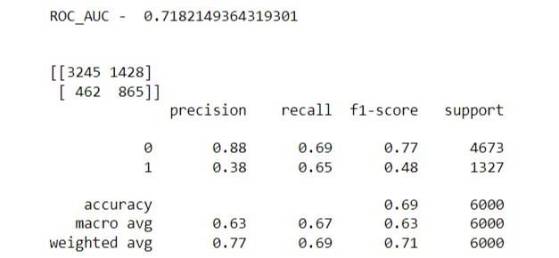

Logistic Regression with SMOTE
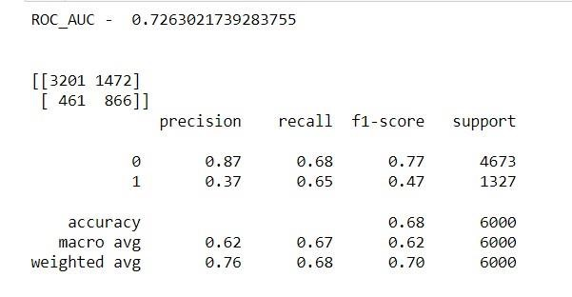

Logistic Regression with ADASYN
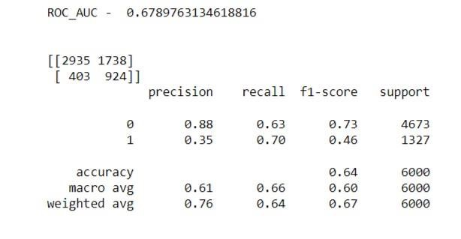

Tuned Logistic Regression with Random oversampling
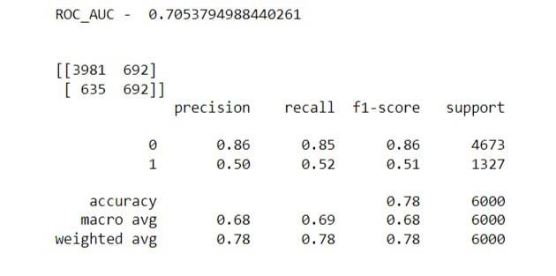

Tuned Logistic Regression with SMOTE
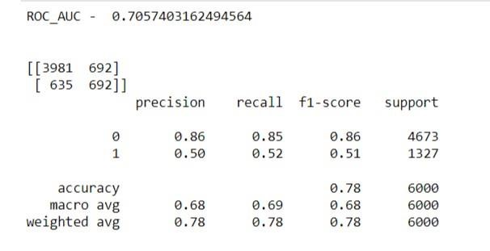

Tuned Logistic Regression with ADASYN
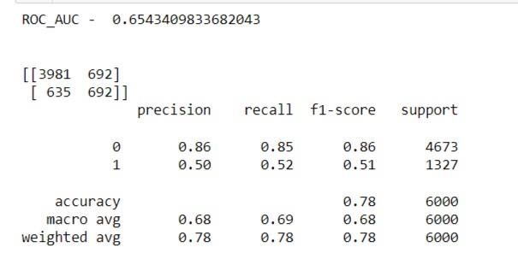

Random Forest with Random oversampling
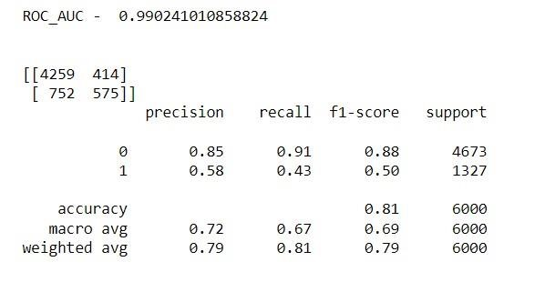

Random Forest with SMOTE
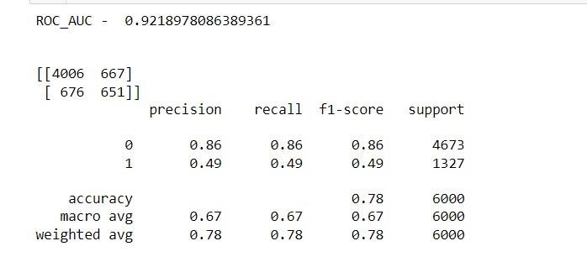

Random Forest with ADASYN
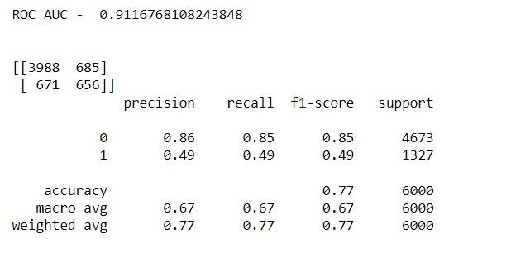

Tuned Random Forest with SMOTE
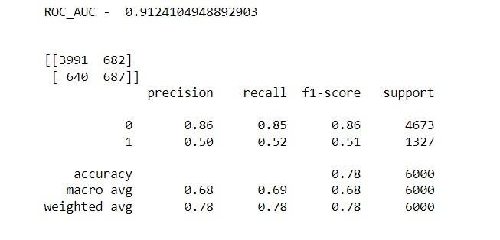

Tuned Random Forest with Random oversampling
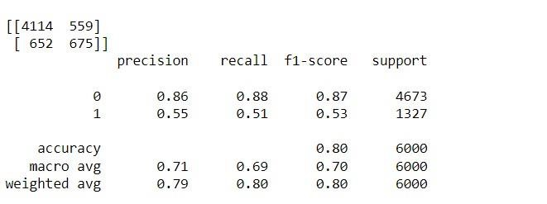

Xgboost with SMOTE
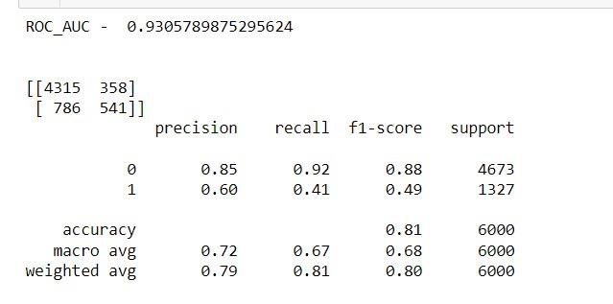

Xgboost with Random OS
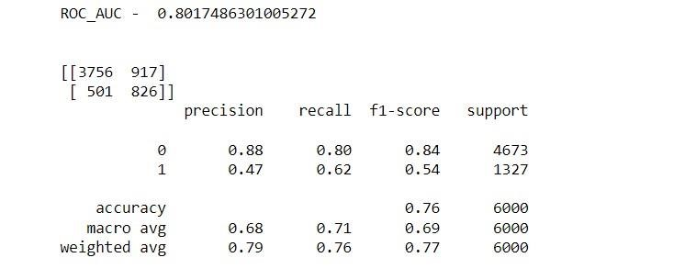

Xgboost with ADASYN
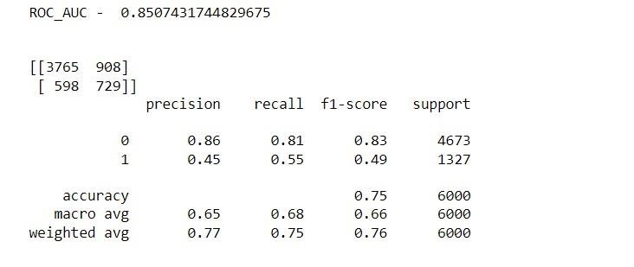

Tuned Xgboost with Random OS
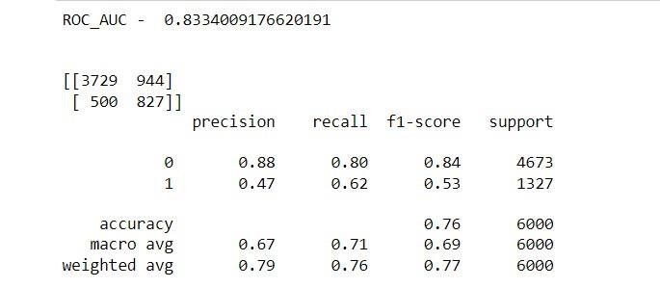

Tuned Xgboost with SMOTE
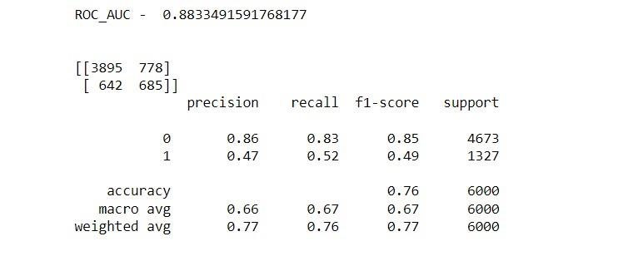

Tuned Xgboost with ADASYN
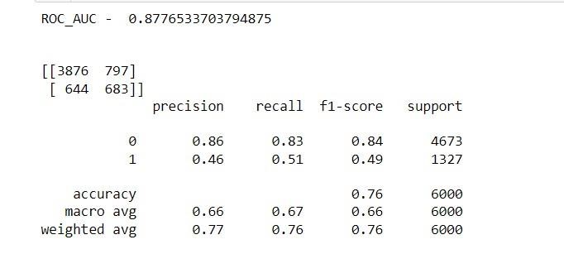

Tuned Xgboot with SMOTE
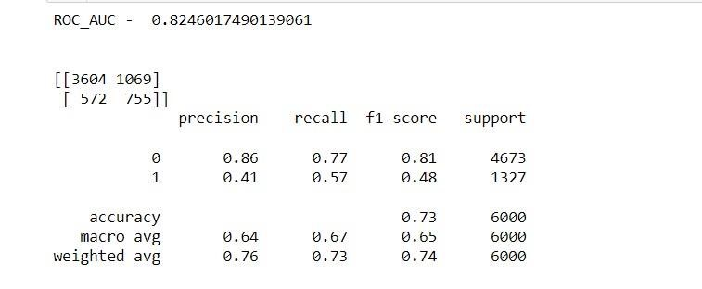

Adaboost with SMOTE
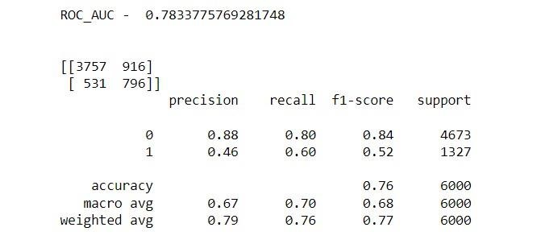

Adaboost with Random over sampling
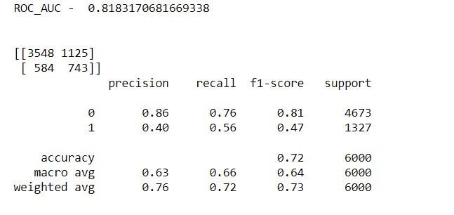

Tuned Adaboost with Random os
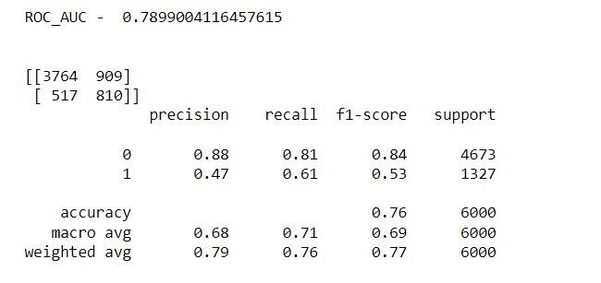

Tuned Adaboost with ADASYN
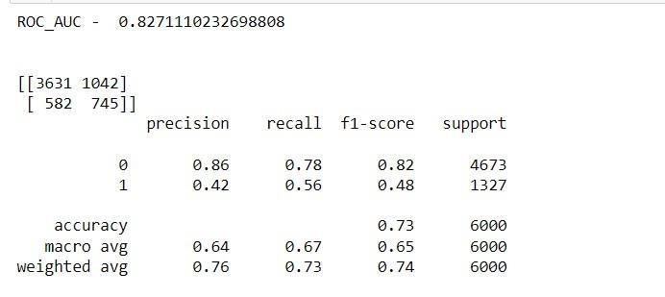

Tuned Adaboost with SMOTE
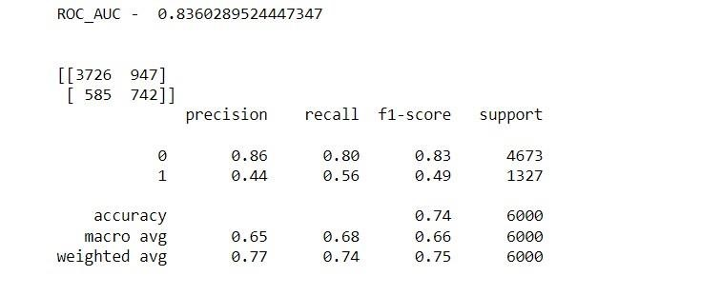

Neural Networks
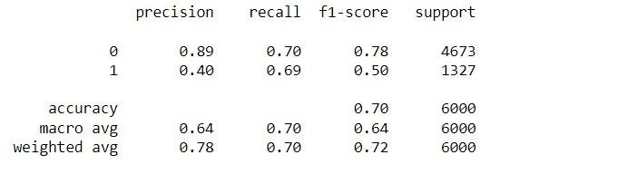

Conclusion:
The objective is to train multiple machine learning algorithms to predict customers behavior on paying of credit card balance. First observed the data by using the EDA
techniques including cleaning missing or invalid values and exploring the relationship between different features.
Various ML algorithms were used to predict the defaulter,these include:
- Logistic regression
- Random Forest
- AdaBoost
- XgBoost
- Neural Networks
Like any other classification problem statement this data also has high imbalance,to deal with this various sampling techniques were used,these include:
- Random oversampling
- SMOTE
- ADASYN
Metrics used for evaluating models performance are Prescision, Recall, ROC curve and confusion matrix.
Though main objective is to find out the defaulter which basically means we need high recall for our model it is desirable to have a high precision since the bank wouldn’t want to lose customers who were denied a loan based on the model’s prediction that they would be defaulter.
Keeping all the above things in mind random forest is suggested.
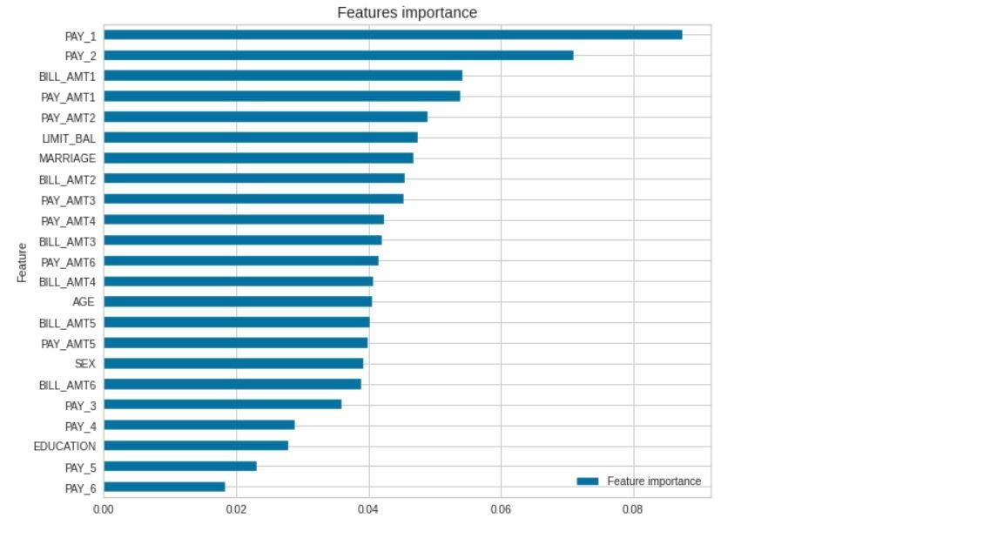
According to the bar chart of feature importance score, the feature PAY 1" is the most signifcant feature.
This feature not only indicates that the customers payment behavior in September, it also indicates the overall behavior from March to September.

