[**Software Requirements Specification**](http://en.wikipedia.org/wiki/Software_requirements_specification) (SRS)

AWARENESS OF POLICE SYSTEM

**1.** **Introduction** 3

Purpose 3

Scope 3

Definitions, Acronyms, and Abbreviations 3

References and Software Used 3

Overview 3

**2.** **Overall Description** 4

Model Used 4

Risk 4

Product Perspective 5

Product Functions 5

User Characteristics 5

Constraints 6

**3.** **Specific Requirements** 6

External Interface Requirement 6

Functional Requirements 6

Overview of Data Requirements 9

Performance Requirements 9

Software System Attributes 9

User View of Product Use 10

1. **Introduction**

* **Purpose**

The purpose of this document is to present a detailed description of our project named “Awareness of Police System” based on online task manager. It will explain the purpose and features of the system, the interface of the system, the constraints under which it must operate and how the system will react to external stimuli. This document is intended for both stakeholders and developers of the system. The main agenda of our project is to keep user in touch with IPC , Police record of our database.

**🡪Scope**

The scope of our project includes Search IPC with other specified options like Minority Act, Code Of Criminal Procedure , Evidence Act, Post and Branches Of Police, and Database of Police and Criminal. User can search by with their cases and thus can be classified according to it. Police Person can edit and modify their personal and academic details. Police Person and User can search Police Person. Police Person can add the another person and also he can modify the data of any criminal and also he can edit the data of any criminal .Police can search criminals profile.

* **Definitions, Acronyms, and Abbreviations**

HTML – Creating pages.

CSS-To change the style of web pages

J Query-It is use to make Our website more user Friendly.

JSP- A server scripting language.

My SQL - The database that will be used for this project

Apache - A web service

.

**🡪References and softwares used.**

Xampp, Netbeans, [www.google.com](http://www.google.com), www.w3schools.com .

* **Overview**

The Overall Description section, of this document gives an overview of the functionality of the product. It describes the informal requirements and is used to establish a context for the technical requirements specification in the next chapter.

The Requirements Specification section, of this document is written primarily for the developers and describes in technical terms the details of the functionality of the product.

Both sections of the document describe the same software product in its entirety, but are intended for different audiences and thus use different language.

1. **Overall Description**

* **Model Used**

AWARENESS OF POLICE SYSTEM is based on incremental model. Software requirements are reasonably well defined but the overall scope is not clear. We have used this model basically to manage technical risks and because to make easy to include different fields at the later stages of project.

Login Page with task entry option

Addition of Database of police and criminal.

Increment #1 Increment #2

Increment #3

Police Portal shall include Chat to Other Police Person

Add Search Engine to Search by IPC name

Add Static Pages Of IPC , States , Minor act , Evidence Act.

Increment #5Increment #4

* **Risk**

If we are unable to host the website, then email notification will not be included because in local host, we cannot send email notifications. Same is with mobile notifications.

|  |  |  |  |  |
| --- | --- | --- | --- | --- |
| Risk Summary | Risk Category | Probability | Impact (1-4) | RMMM |
| Database Crash | Performance risk | 80% | 4 |  |
| Staff inexperienced | **Staff size and experience** | 50% | 2 |  |
| Scalability | Performance risk | 50% | 4 |  |
|  |  |  |  |  |

* **Product Perspective**

This product is designed to run an any system. This covers a wide variety of machines, including operating systems Mac OS X, Windows XP,7,8 and Linux. The sole requirement for the user is a web browser (Safari,Google Chrome, Firefox or Internet Explorer) with an active internet connection

* **Product Functions**

User

Login Page

* **User Characteristics**

The user expected to be Internet literate Once he/she can log in the system and navigate between WebPages he/she can use basic functionality of the system.

**🡪Constraints**

The system must run in windows operating system environment.

1. **Specific Requirements**

* **External Interface Requirement**

**User Interfaces**

It must interface icons or wizard.

**Hardware Interfaces**

There must be PC to link to task manager with an internet connection.

* **Functional Requirements**

Must be capable of storing data that can be done by several people at the same time.

Must contain an easy interface with little to no learning curve.

**Creating database**

Integration with database system: The system shall periodically upload the upcoming data of the User.

**Search**

It is the special feature added to the software. User can set the search the data by which he can meet his requirement. This is one of the essential feature of the project as one can clearly search the data that he/she want.

**Task Completion**

User must get up to date information about the data.

Home Page and search that user want

&

VERIFYED INFORMATION

CHECK Database

Searching

VERIFYING INFORMATION

USERNAME AND PASSWORD

User Screen

SEND TO

Home page

**Create Accounts**

The user must first fill the **sign up** page to access the website which will include username and password.

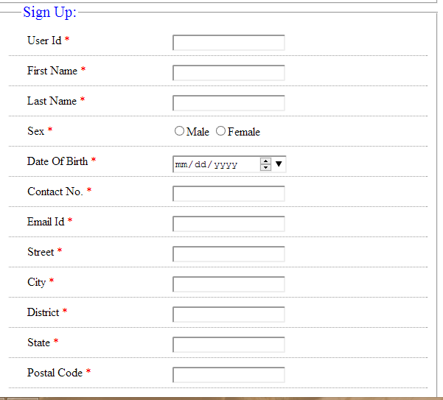

* **Overview of Data Requirements**

All the data will be stored and retrieved within Mysql. This program will work with virtually any system that can connect to the internet and browse web pages.

* **Performance Requirements**

**Response Time**

Average response time shall be less than 2 second.

**Recovery Time**

In case of a system failure, redundant system shall resume operations within 30 seconds.

Average repair time shall be less than 2 hour.

**Start-up/Shutdown Time**

The system shall be operational within 1 minute of starting-up.

**Capacity**

The system accommodate 500 concurrent users.

**Utilization of Resources**

The system shall store in the database no more than one thousand entries.

If the database grows over this limit, old transaction shall be backed up and deleted.

* **Software System Attributes**

**Security**

*Firewall Protection*: The software system shall run inside a firewall.

**Reliability**

The system shall not be down frequently.

**Scalability**

Scaling the system to large number of users:

The system shall be able to handle the load when many users can be expected to access the Awareness Of Police System.

* ***User View of Product Use***

The user comes to the website:

**Registration:**

• After entering in a user name, email address and password, the

user can register with our site.

**Main Menu:**

• The user can view all tasks in the middle of the screen.

• The user can accept and reject tasks within this menu.

* The user/admin can modify personal information here as well.

• The admin can create new tasks

**Objectives:**

• The purpose of this website will be to allow Users to remind about their tasks.