**Static and Dynamic Routing on Mininet**

-Lokendra Birla (15IT60R07)

Department of Computer Science& Engineering

IIT Kharagpur

**INTRODUCTION**

All routers need a routing logic for forwarding the packets. These routing protocols need to be configured at the routers. Here we using dynamic routing algorithm (**PWOSPF**). The goal is to generate dynamic routing table automatically based on routes advertised by other router on the network. In SDN based routers, the network administrators can load the routing logic at the controller. Based on the logic, the controller creates and dumbs the configurations at individual switches. Here the switches work as router and controller is the brain of the network. The topology that was constructed is as shown below:-

**TOPOLOGY**

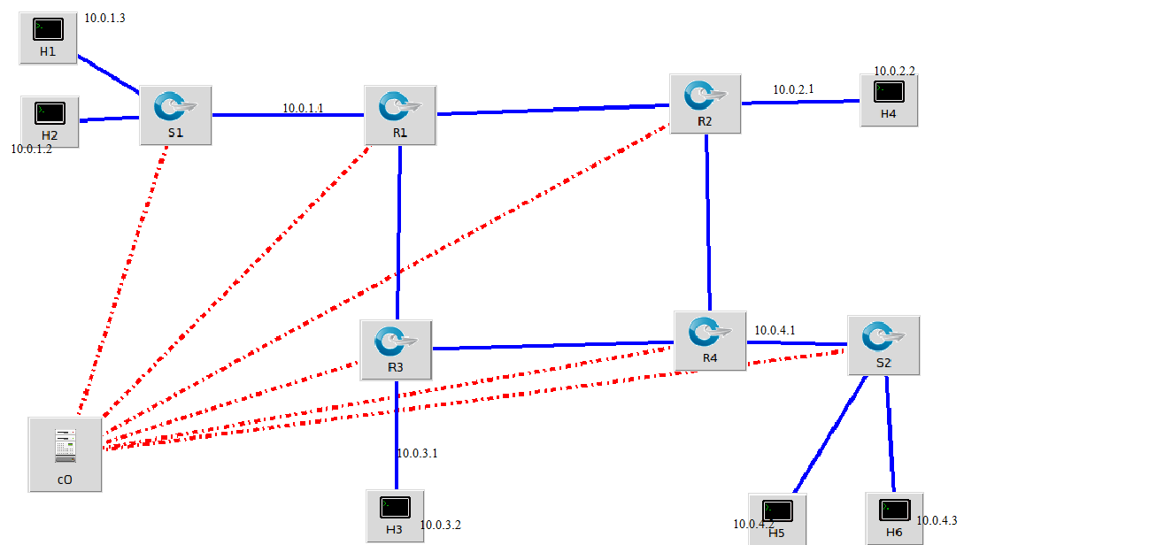

**TOPOLOGY DETAILS**

-R1 (Subnet: 10.0.1.0/24)

-R2 (Subnet: 10.0.2.0/24)

-R3 (Subnet: 10.0.3.0/24)

-R4 (Subnet: 10.0.4.0/24)

each L3 switches are have 3 interface and all these interfaces assigned IP address.

• Two L2 switches S1 and S2 – which works only at Layer 2.

• Six Hosts – IP's are assigned to the hosts as shown in above topology

• One Controller

**CONFIGURATION OF GATEWAY INTERFACES ALONG WITH THEIR DUMMY MAC ID**

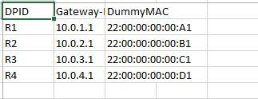

DPID represents the ID assigned to each of the Routers. Dummy MAC indicates that the MAC id assigned to the gateway interface.

**SUBNET BASED ROUTING TABLE**

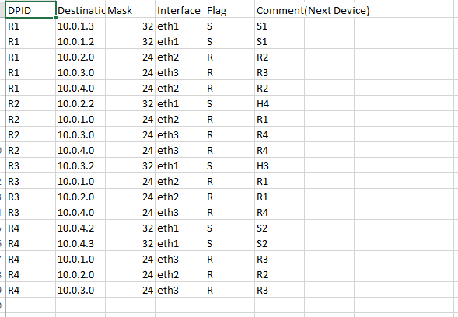

R- indicates a Router

S- indicates a Switch

**TEST REPORTS**

**PING RESULTS FROM H1 TO ALL OTHER HOSTS**

**H1 TO H2**

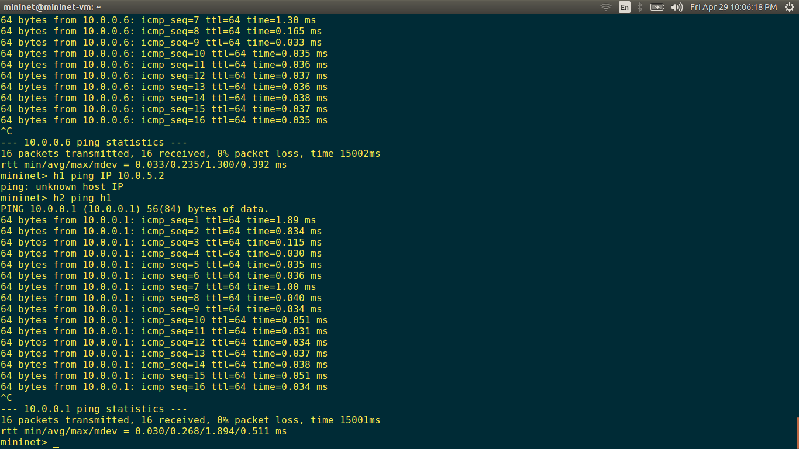

**H1 TO H3**

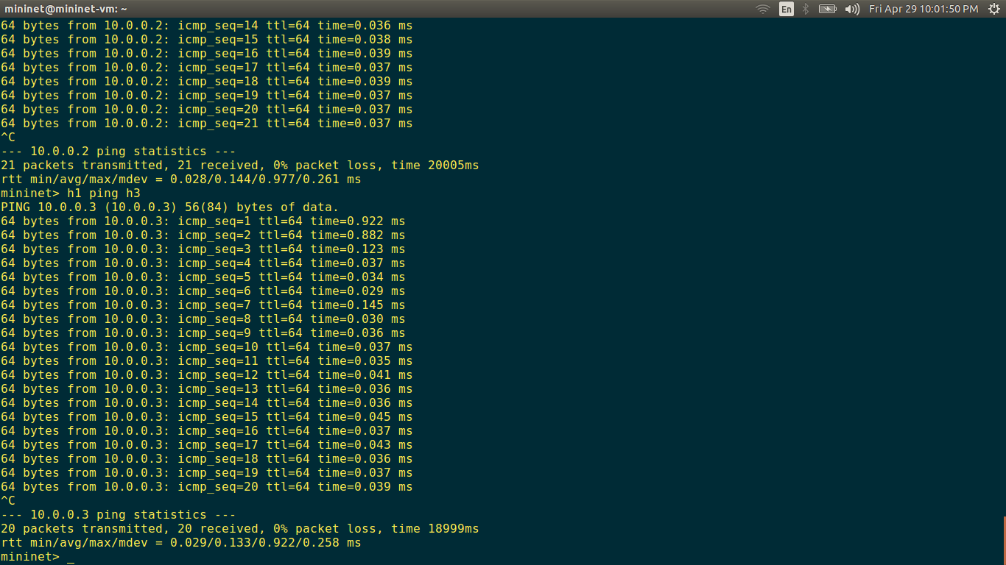

**H1 TO H4**

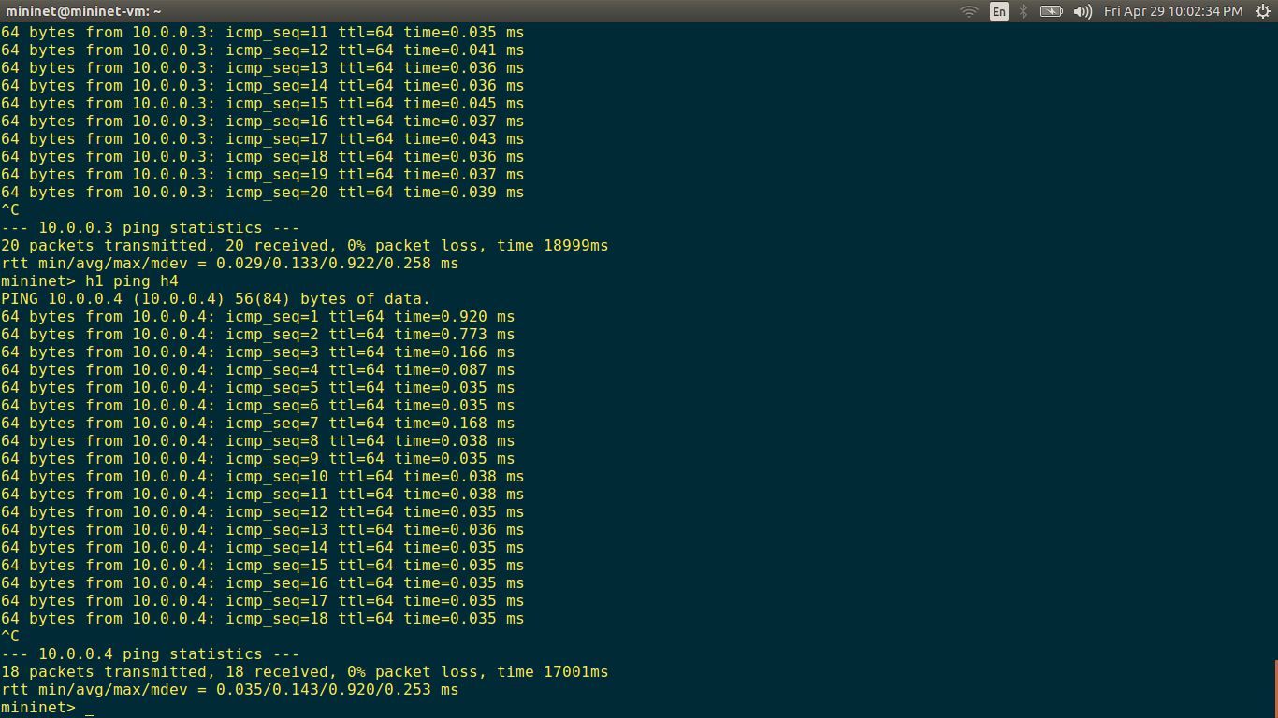

**H1 TO H5**

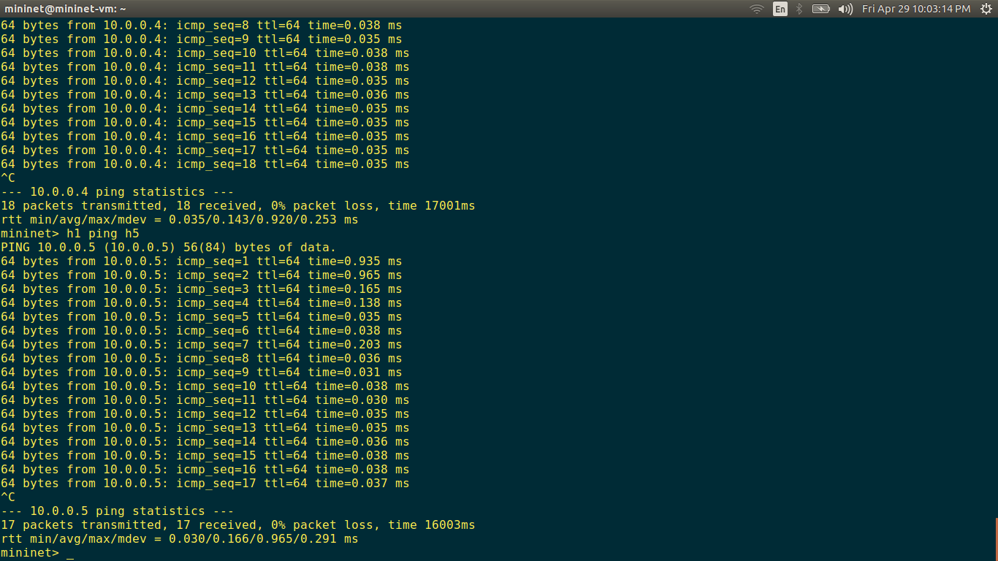

**H1 TO H6**

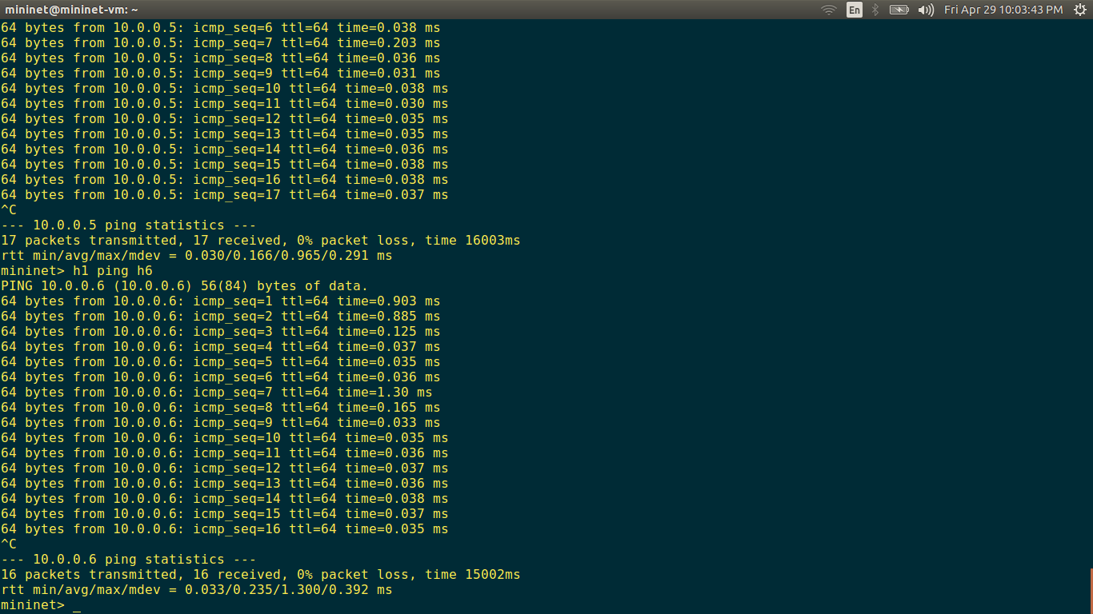

**PING RESULTS FROM H1 TO 10.0.5.2**

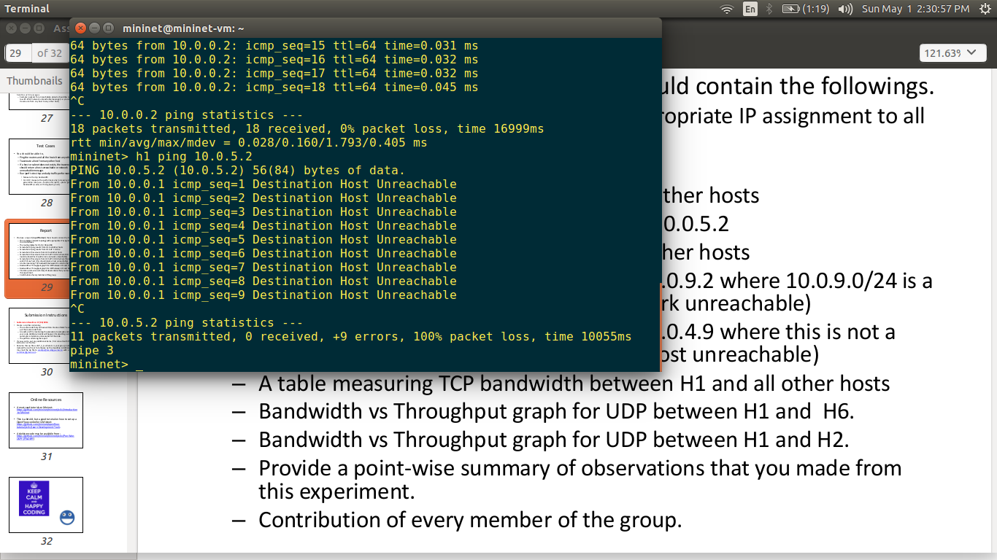

**Throughtput netween h1 to h2 and h1 to h6 respectivery**

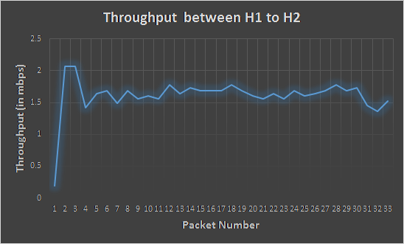

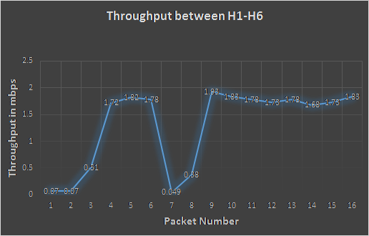

**SUMMARY OF OBSERVATIONS**

1.Initially one packet miss may occur if the router does not have MAC address of host connected within its subnet.  
2. trace route problem.  
3. Flooding occurs if MAC->PORT table is not populated for particular destination MAC, in such a case flooding on all ports except incoming ports. Direct forwarding to port if MAC entry is a available.  
4. Same auto configurable switch for L2 switching (without/hardcoding). Compact routing logic for all routers based on configuration file.  
5. Lack of mininet support for UDP traffic check in iperf command.