SUPERSTORE SALES PERFORMANCE DASHBOARD
Project Report
Prepared by: Lokendra Chawla
Course: B.Sc. Bioinformatics
Project: Data Analytics Portfolio Project
Tools Used: Microsoft Excel, Power BI
Dataset Source: Kaggle – Sample Superstore Dataset

1. Project Objective
This project analyzes the sales performance of an e-commerce business using Power BI. By converting raw transactional data into meaningful business insights, the dashboard addresses key questions, including:
- Performance Drivers: Which product categories generate the highest sales?
- Regional Analysis: Which cities, states, and regions contribute the most revenue?
- Customer Segmentation: Which segments are the most valuable?
- Trends: How do sales evolve over time?
- Logistics: Which shipping methods are the most efficient?
The resulting dashboard serves as a decision-support tool, leveraging interactive visualizations to drive data-informed strategies.

2. Dataset Information
- Source: Kaggle – Sample Superstore Dataset
- Time Period: 2015–2018
- Key Data Points: Order ID, Order/Ship Date, Ship Mode, Customer/Product Details, Sales, Region, and Category.

3. Data Cleaning & Preparation
Before dashboard development, the dataset was refined in Microsoft Excel to ensure accuracy and analytical capability.

Cleaning Steps
- Validation: Checked for missing values, removed duplicates, and ensured data consistency.
- Formatting: Standardized column formats, specifically ensuring Order and Ship dates were recognized as date fields.
- Refinement: Removed unnecessary formatting to streamline the data model.

Feature Engineering
To enable deeper analysis, I created the following calculated columns:
- Temporal Fields: Year, Month Name, Month Number, and Quarter.
- Operational Metric: "Order to Ship Delay" (Ship Date − Order Date).
These columns made it possible to perform yearly filtering, monthly trend analysis, quarterly reporting, and shipping performance analysis.

4. Dashboard Overview
The Power BI dashboard consists of four interactive pages.

Page 1: Sales Overview
Provides an executive summary using KPIs (Total Sales, Orders, Customers, Avg. Ship Delay) and visualizations like Sales by Category and Monthly Sales Trends.
Figure 1: Sales Overview Dashboard
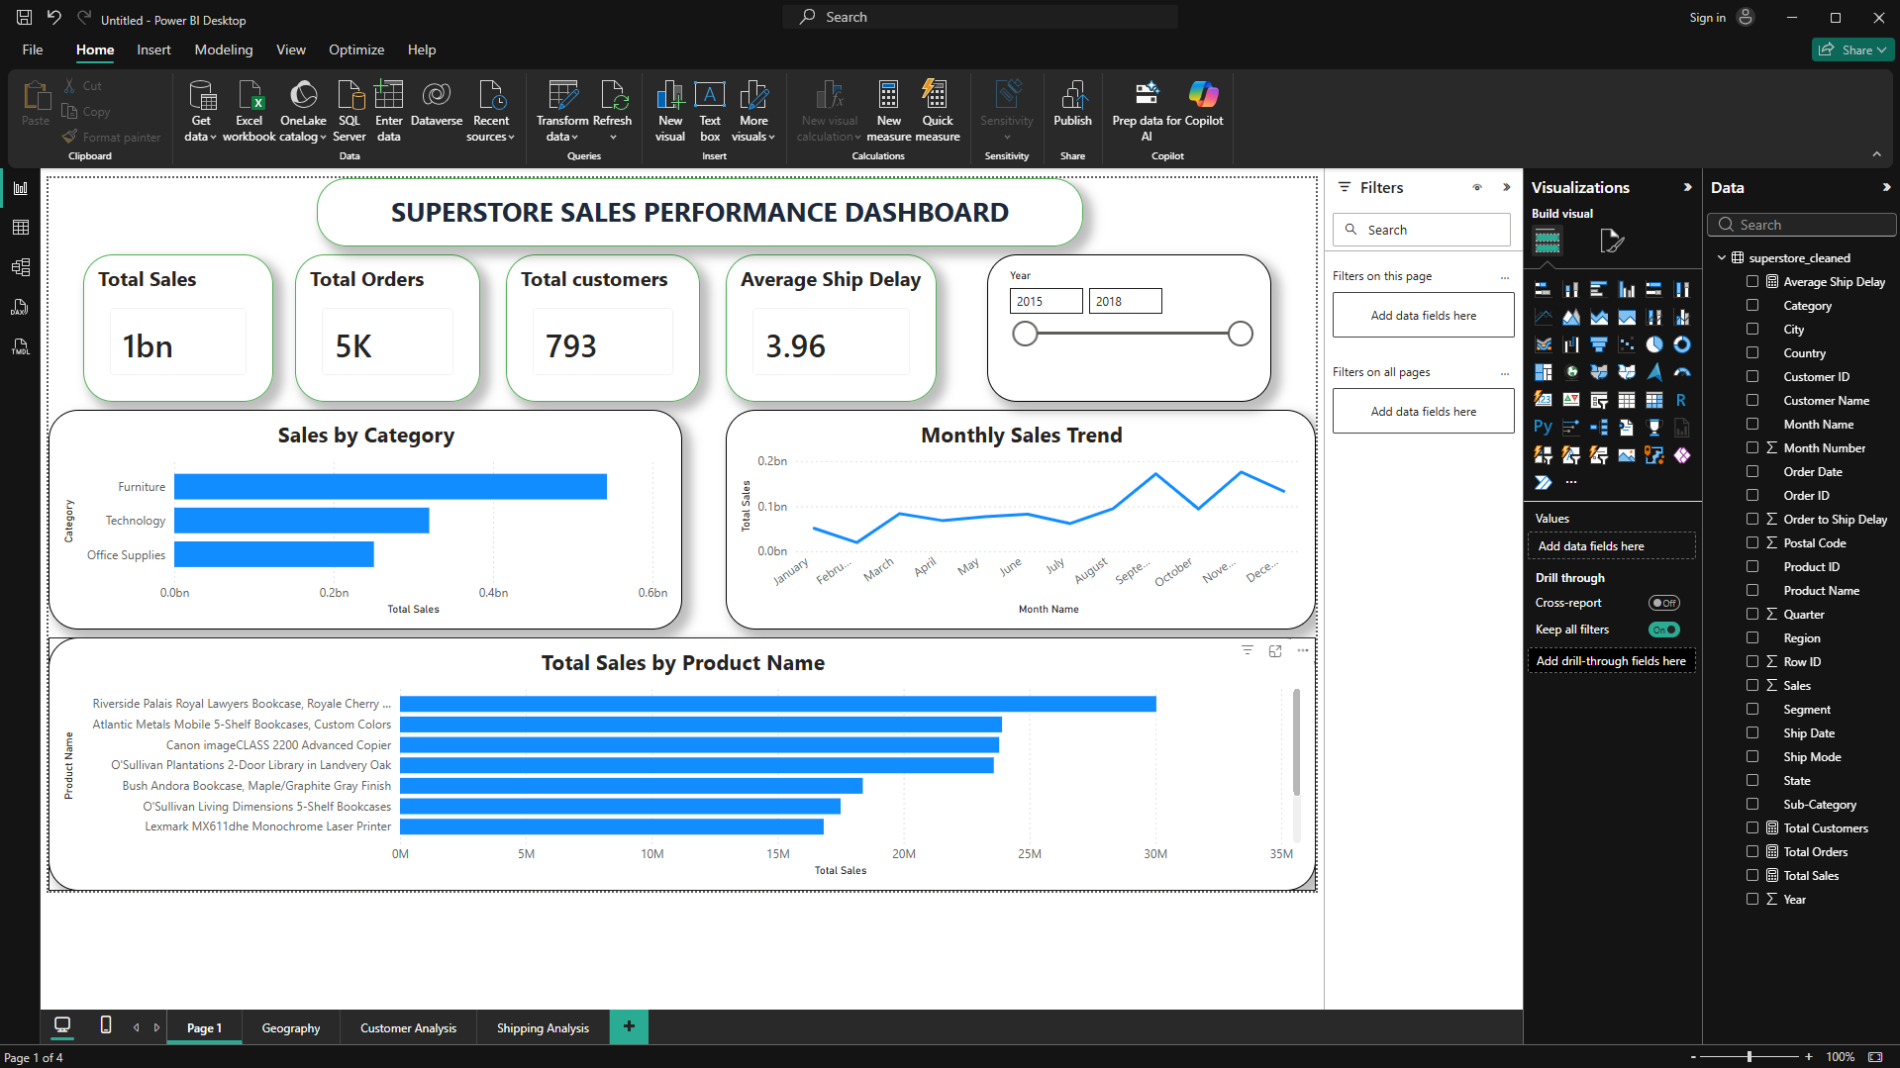

Page 2: Geographic Analysis

Focuses on regional and city performance using interactive maps and donut charts.
Figure 2: Geographic Sales Analysis Dashboard
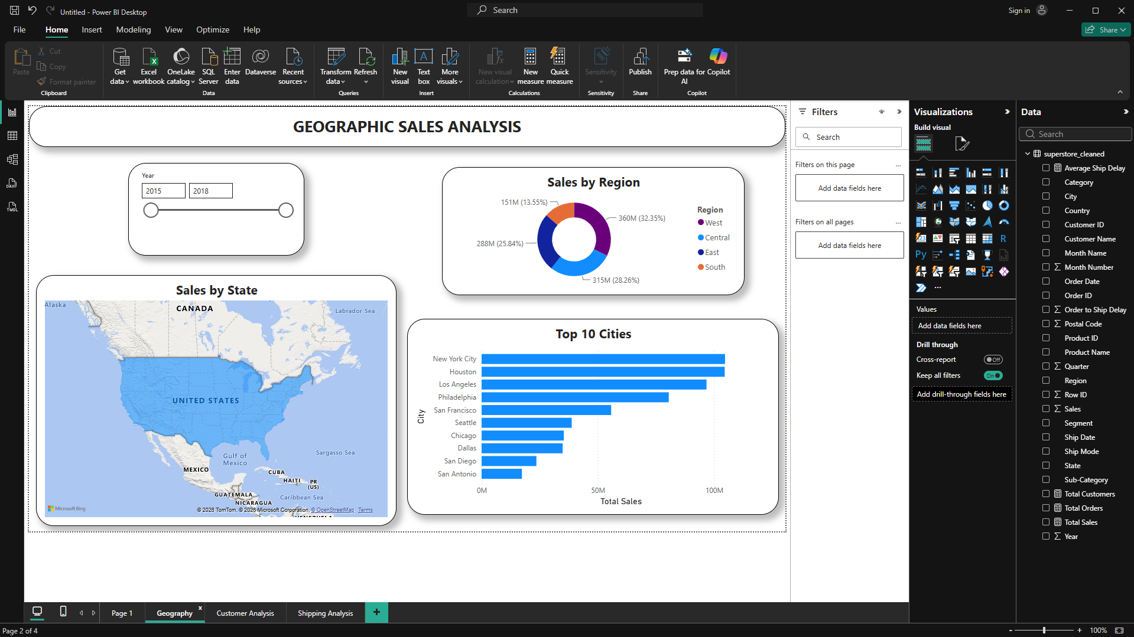

Page 3: Customer & Segment Analysis
Profiles user segments and identifies top customers by sales volume.
Figure 3: Customer and Segment Analysis Dashboard
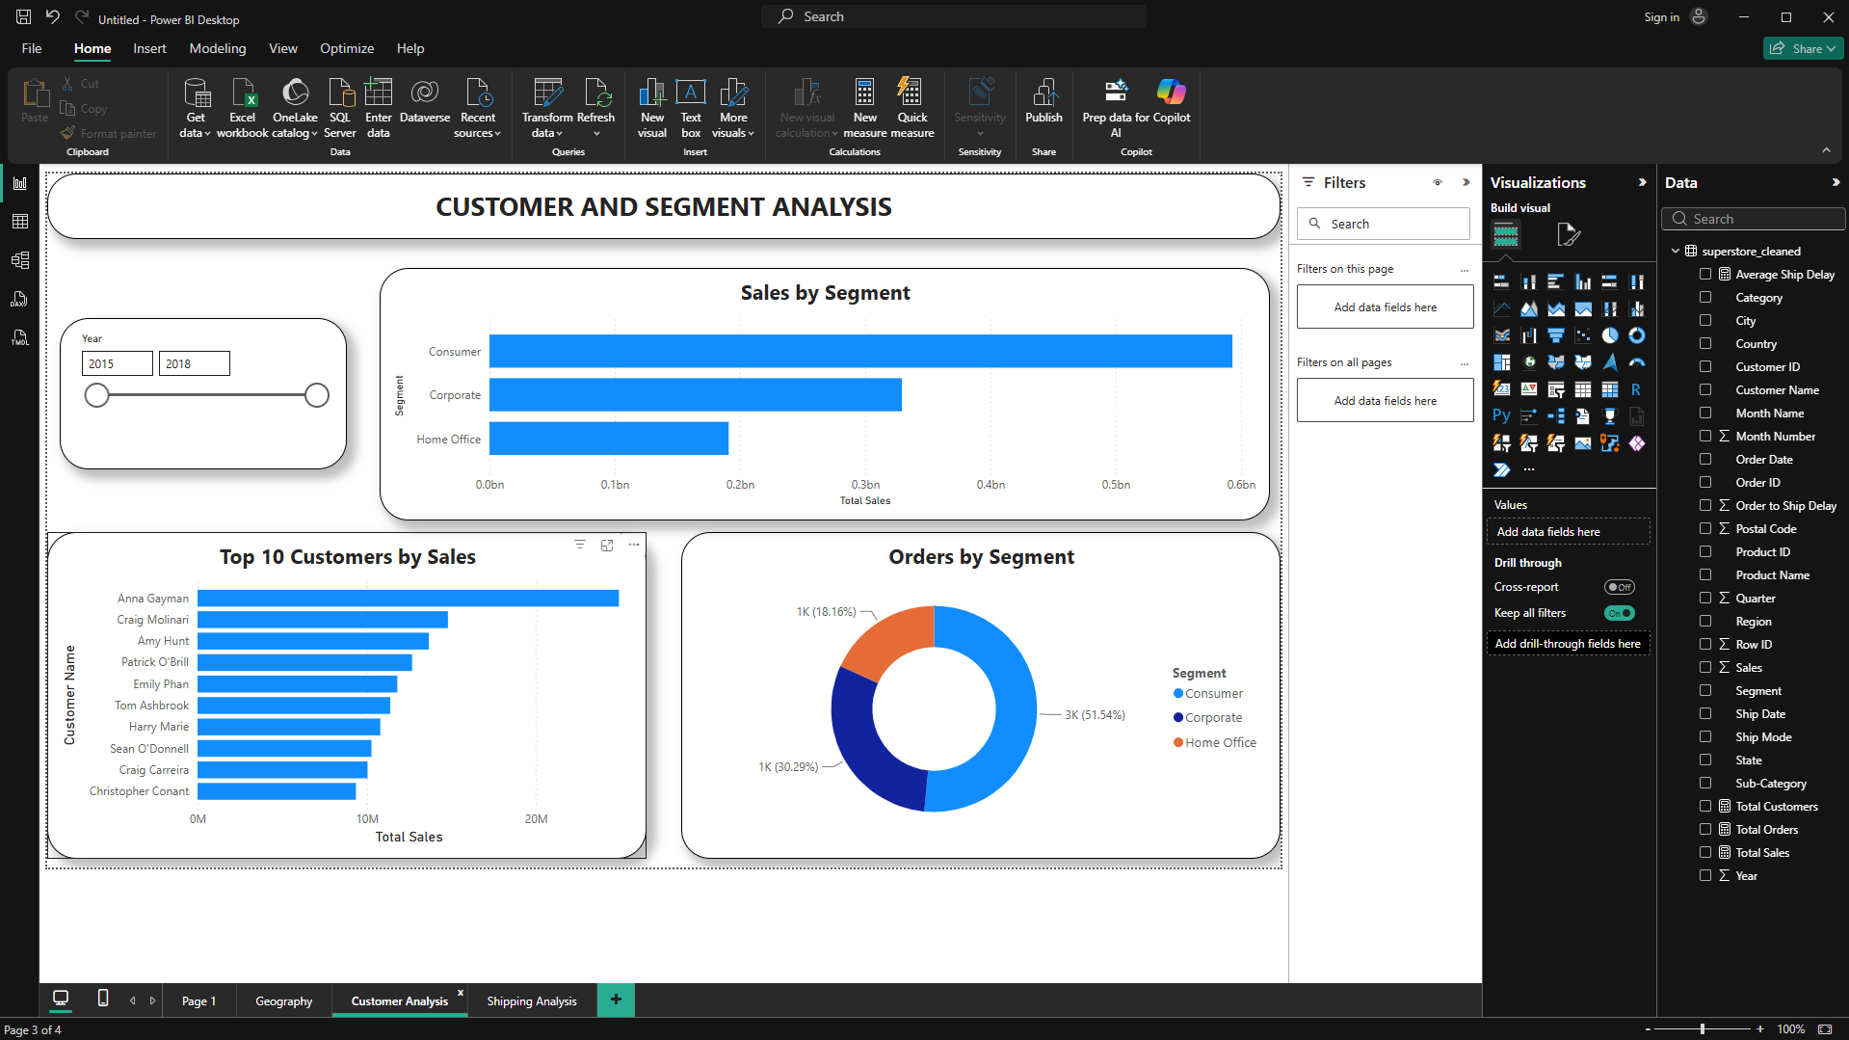

Page 4: Operations & Shipping
Evaluates logistics, specifically tracking shipping delays and performance by Ship Mode.
Figure 4: Operations and Shipping Analysis Dashboard
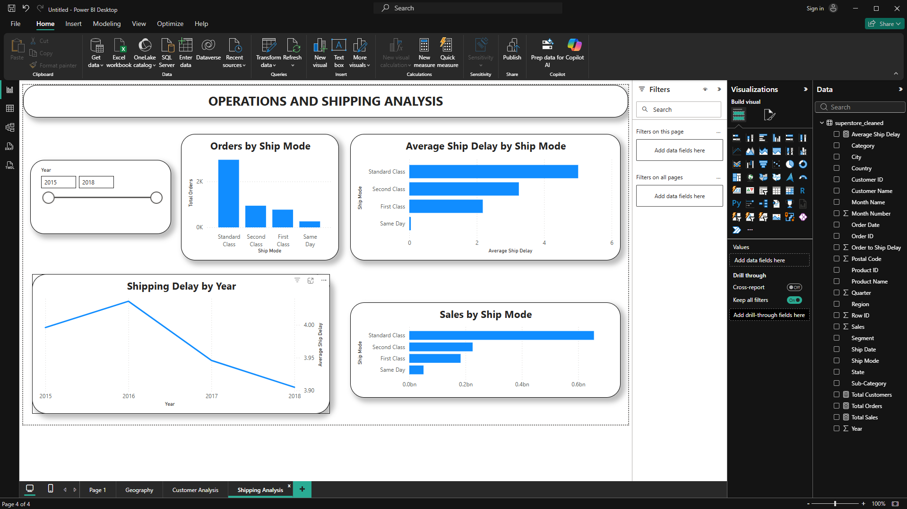

5. Key Business Insights

1. Product Leadership: Furniture generates the highest sales
Among all product categories, Furniture contributes the highest sales, confirming its role as a core revenue driver.

2. Regional Strength: The West region is the strongest performing market
Regional analysis shows that the West region is the strongest performing market for the company.

3. Key Markets: New York City leads in sales
The city analysis identifies New York City as the leading contributor to sales, followed by Houston and Los Angeles.

4. Primary Segment: Consumer is the largest customer segment
The Consumer segment accounts for the highest volume of sales and orders, making it the primary customer base.

5. Logistics Bottlenecks: Standard Class handles most orders
While "Standard Class" is the most popular shipping method, it exhibits the longest shipping delays.

6. Seasonality: Sales increase during the later months
Sales consistently peak in the second half of the year, suggesting seasonal buying behavior.

7. Revenue Concentration: Revenue is driven by a limited number of products
A significant portion of revenue is driven by a limited subset of top-performing products, highlighting opportunities for focused strategies.

6. Business Recommendations

Inventory Optimization
Increase stock levels and marketing focus for top-performing product categories to maximize revenue opportunities.

Strategic Expansion
Capitalize on the West region's success while developing targeted growth strategies for comparatively lower-performing regions.

Shipping Efficiency
Streamline "Standard Class" logistics through better planning to reduce delivery delays and improve overall customer satisfaction.

7. Conclusion
This project provides an end-to-end business intelligence solution—from data preparation to interactive visualization.
It highlights practical expertise in data cleaning, Power BI development, and actionable insight generation, resulting in a comprehensive tool suitable for a professional data analytics portfolio.

