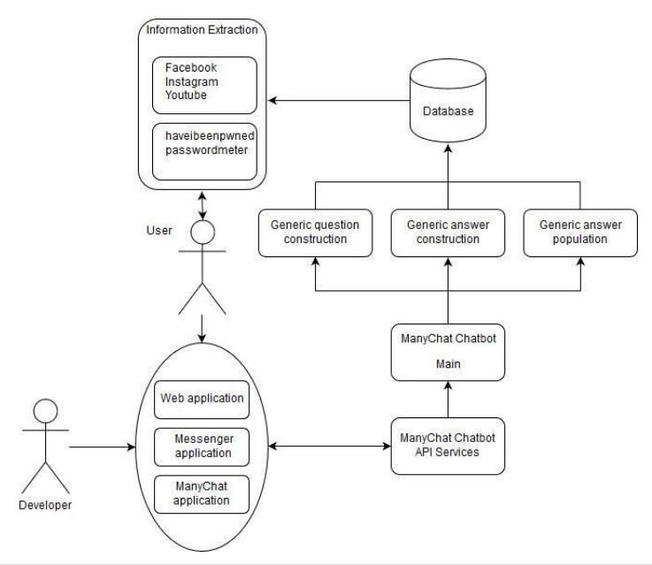

This is done using dialogflow and nodejs and expressjs. This helps to identifies bed vacancy and vaccine availability.

https://covidhelperbot.herokuapp.com/