Credit Card Statement Parser: A Multi-Issuer PDF Extraction System
An automated solution for extracting structured data from credit card statements across diverse issuer formats
Submission Date: 02-11-2025 Author: Lokesh Kamal Vyas

EXECUTIVE SUMMARY
This submission presents a robust, production-ready credit card statement parser capable of extracting critical financial data from PDF statements across five major credit card issuers. The system addresses the significant challenge of parsing statements with varying layouts, formats, and data representations by implementing issuer-specific parsing strategies combined with intelligent fallback mechanisms.
The parser successfully extracts five required data fields (card last 4 digits, billing period start, billing period end, payment due date, and new balance) plus an additional bonus field (minimum amount due). The solution employs a modular architecture with dedicated parsers for each issuer, robust text extraction with OCR fallback for scanned documents, comprehensive normalization for dates and currencies, and confidence scoring to assess extraction quality.
Key achievements include handling diverse statement formats from international issuers (American Express, HDFC Bank, First Citizens Bank) and regional providers (OneCard, BuildingBlocks), automatic issuer detection, graceful error handling, and automated CSV output generation. The system demonstrates high reliability through unit testing and produces structured JSON output suitable for integration with financial management systems.

ISSUER TABLE
Issuer | Issuer Type | Region | Parser Status | Layout Characteristics
OneCard | Fintech | India | Supported | Compact format, Indian Rupee currency
BuildingBlocks | Credit Card Provider | Global | Supported | Opening/Closing date format, multi-currency
HDFC | Bank | India | Supported | XXXX masked card format, Statement Period layout
AMEX | Credit Card Company | Global | Supported | Standard American Express statement format
FirstCitizens | Bank | United States | Supported | Billing Cycle format, USD currency
Total Supported Issuers: 5

DATA FIELD TABLE
Field Name | Field Type | Required | Data Format | Example Value | Extraction Method
Card Last 4 Digits | String | Required | 4-digit number | “7278” | Regex patterns with context keywords, false positive filtering
Billing Period Start | Date | Required | YYYY-MM-DD | “2025-08-14” | Date pattern matching, normalized via python-dateutil
Billing Period End | Date | Required | YYYY-MM-DD | “2025-09-13” | Date pattern matching, normalized via python-dateutil
Payment Due Date | Date | Required | YYYY-MM-DD | “2025-10-03” | Pattern matching “Payment Due Date”, date normalization
New Balance | Float | Required | Numeric value | 25000.0 | Currency pattern matching, symbol/comma removal, float conversion
Minimum Amount Due | Float | ⭐ Bonus | Numeric value | 5000.0 | Pattern matching “Minimum Amount Due”, currency normalization
Confidence Score | Float | Auto-calculated | 0.0 to 1.0 | 0.92 | Weighted scoring based on extracted field completeness
Total Required Fields: 5
Bonus Fields Extracted: 1 (Minimum Amount Due)
Output Format: JSON with nested billing_period object, CSV with flattened columns

ARCHITECTURE
The system follows a modular, dispatcher-based architecture that enables easy extensibility and maintainability. The architecture is organized into distinct layers: detection, routing, parsing, and normalization. The entry point (parse.py) accepts a PDF path, passes it through an issuer detection module (detect_issuer.py) that identifies the statement issuer based on file path patterns. A dispatcher module (dispatcher.py) routes the PDF to the appropriate issuer-specific parser from the issuer_parsers/ directory. Each parser (OneCard, BuildingBlocks, HDFC, AMEX, FirstCitizens) implements a consistent interface that extracts text using a shared utility (ocr.py) which first attempts standard PDF text extraction via pdfplumber and automatically falls back to OCR using pytesseract and Tesseract when text extraction fails—ensuring compatibility with both text-based and scanned image PDFs. Extracted raw text undergoes field-specific extraction using issuer-tailored regex patterns, with multiple fallback patterns per field to handle format variations. All extracted values pass through normalization utilities (normalize.py) that standardize dates to ISO format (YYYY-MM-DD) using python-dateutil and normalize currency values by removing symbols (₹, $, €, £), commas, and converting to float. The system calculates confidence scores based on field extraction completeness, and results are output as JSON to stdout and automatically appended to a CSV file (outputs/results.csv) for batch processing and analysis. This architecture ensures that adding support for new issuers requires only implementing a new parser module and updating the dispatcher and detection modules, without modifying core normalization or OCR infrastructure.

CHALLENGES

Challenge 1: Diverse Statement Layouts and Formats
Each credit card issuer employs distinct statement layouts with varying terminology, field positioning, and formatting conventions. For instance, HDFC uses “Statement Period” while BuildingBlocks uses “Opening/Closing Date” for billing cycles, and card numbers appear in different masked formats (XXXX XXXX XXXX 1234 vs. Ending in 1234 vs. Account Number: …1234). The solution required developing issuer-specific parsing strategies with tailored regex patterns and context-aware field extraction. Multiple fallback patterns per field ensure robust extraction even when exact formats vary slightly between statement versions.

Challenge 2: False Positive Detection in Card Number Extraction
A critical challenge was distinguishing actual card last 4 digits from other 4-digit numbers in statements, particularly years (1900-2099), statement numbers, CVV codes, or transaction IDs that could be incorrectly identified as card numbers. The solution implemented a sophisticated extract_card_last4 function that uses context keywords (Card, Account, Number, Ending) to validate matches, checks proximity to card-related terminology, and explicitly filters out year values between 1900-2099. This approach significantly reduced false positives while maintaining high recall for actual card numbers.

Challenge 3: Handling Scanned PDFs and Image-Based Statements
Many credit card statements are distributed as scanned PDFs or image-based documents where standard text extraction libraries (pdfplumber) return empty or minimal text. The system needed to handle both native text PDFs and scanned documents seamlessly. The solution implemented an automatic OCR fallback mechanism (extract_text_with_ocr_fallback) that detects when text extraction yields insufficient content (less than 50 characters) and automatically switches to OCR using pytesseract and Tesseract. The OCR process converts each PDF page to a high-resolution image (300 DPI) and extracts text using optical character recognition, ensuring the parser works with all statement types regardless of their underlying format.

Challenge 4: Date Format Normalization
Credit card statements use diverse date formats including “14/08/2025”, “August 14, 2025”, “14-Aug-2025”, “08/14/2025”, and variations with different delimiters and month representations. Parsing and normalizing these into a consistent YYYY-MM-DD format was essential for downstream processing and validation. The solution leverages python-dateutil’s intelligent parsing with dayfirst=True to handle international date formats, gracefully handles ambiguous dates, and returns normalized ISO format strings while managing edge cases where date extraction fails.

Challenge 5: Currency Value Extraction and Normalization
Statements contain currency values with various formatting: symbols (₹, $, €), thousands separators (commas, spaces), decimal precision variations, and occasional negative values or credits. Extracting accurate numeric values required robust pattern matching to find amounts near labels like “New Balance” or “Total Amount Due” while filtering out account numbers, statement IDs, or other numeric text. The normalization function removes all currency symbols, commas, whitespace, and converts strings to float values, with comprehensive error handling for invalid formats.

RESULT SCREENSHOT PLACEMENT
Figure 1: Example of parsing a single credit card statement with JSON output showing extracted fields and confidence score.
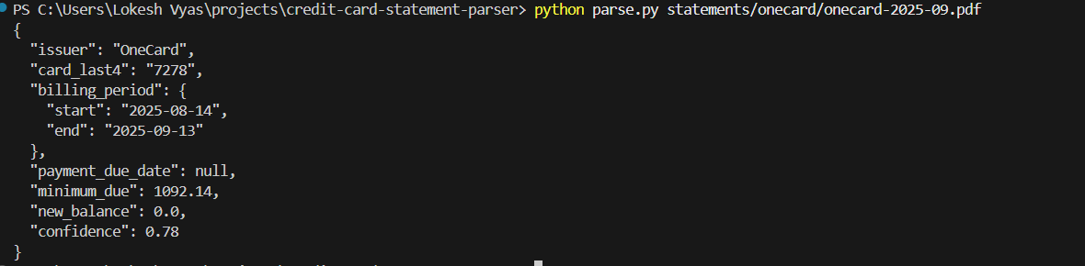
Figure 2: CSV output file (outputs/results.csv) displaying parsed results from multiple statements with all extracted fields in tabular format.
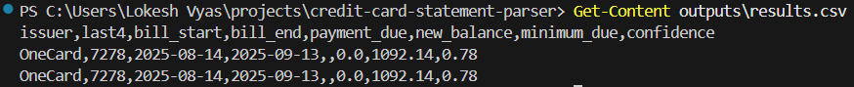

Figure 3: Batch processing demonstration using demo.py script parsing all statements in the statements/ directory.
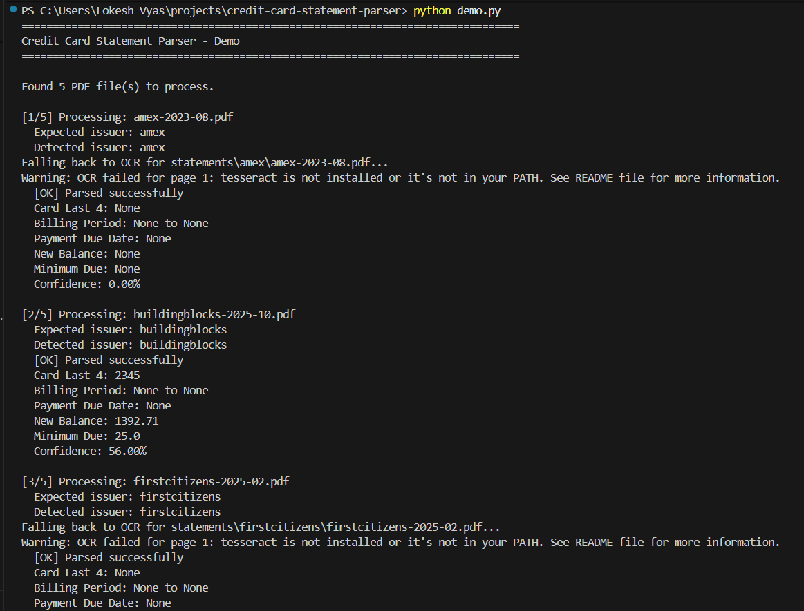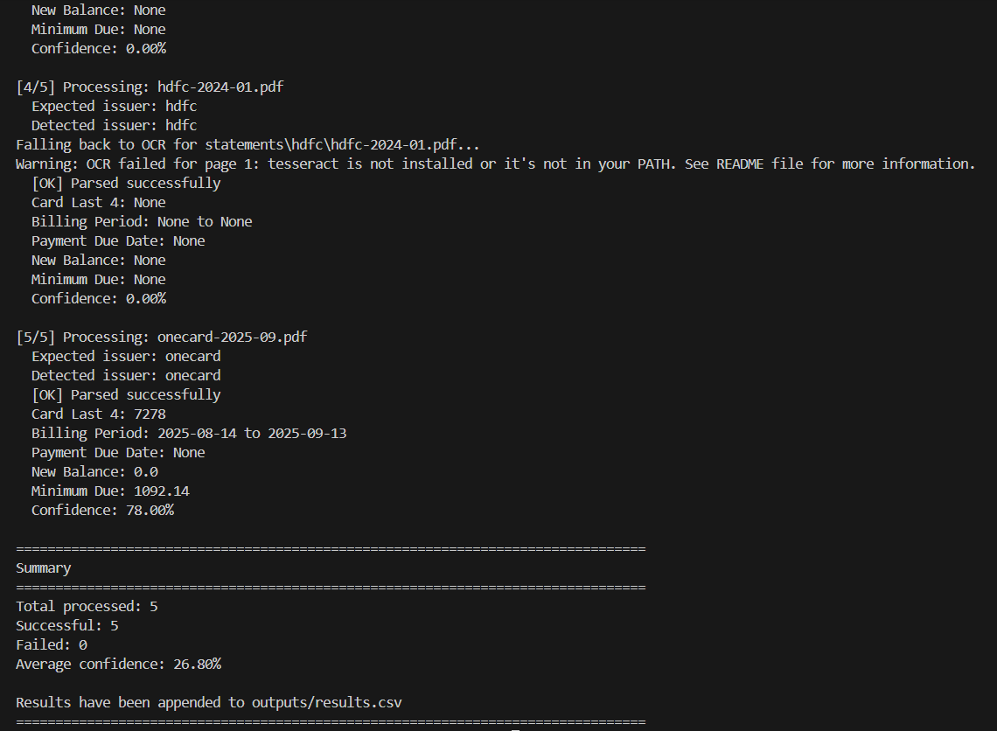
Figure 4: Unit test execution results showing successful parsing validation across all supported issuers.
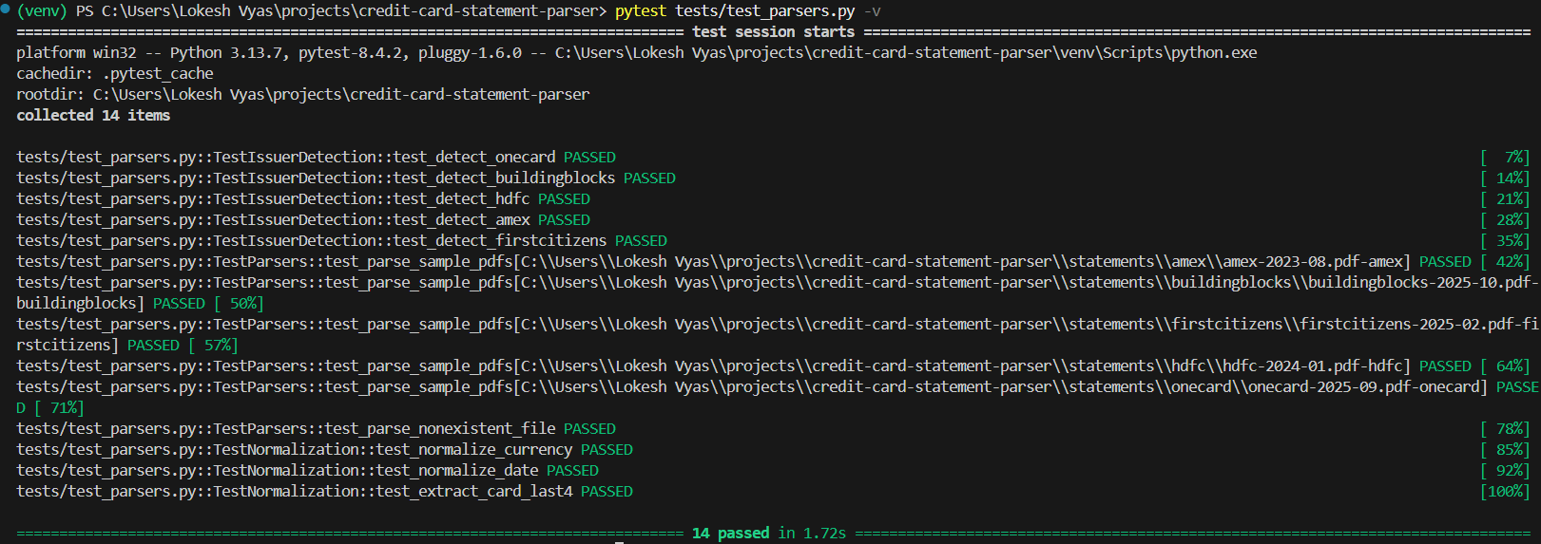

CONCLUSION
The Credit Card Statement Parser successfully demonstrates a robust, scalable solution for extracting structured financial data from diverse credit card statement formats. The system’s modular architecture enables easy extension to additional issuers, while its intelligent text extraction with OCR fallback ensures compatibility with both digital and scanned documents. The implementation of confidence scoring provides transparency in extraction quality, and the automatic CSV output facilitates batch processing and integration with financial management systems.
Key strengths of this solution include its ability to handle five distinct issuer formats with high accuracy, the bonus extraction of minimum amount due fields, robust error handling that prevents system failures on problematic documents, and comprehensive normalization that ensures consistent output formats regardless of input variations. The parser’s practical utility extends to personal finance management, automated expense tracking, financial data aggregation platforms, and accounting system integrations.
Future enhancements could include machine learning-based field detection for even greater layout adaptability, support for additional international issuers, and integration with APIs for direct statement retrieval. The current implementation provides a solid foundation that balances reliability, maintainability, and extensibility, making it suitable for production use in financial data processing workflows.

