EECE 4712/6712 Embedded Systems

Weekly Assignment 7: Introduction to Embedded Systems

Name: Lokesh Chandra Das UUID: U00740183, Date: 14th April 2021

Problem:

1. The state flow diagram for detecting the binary sequence “11010”



1. Code design using VHDL for detecting binary sequence

binarySequence.vhd

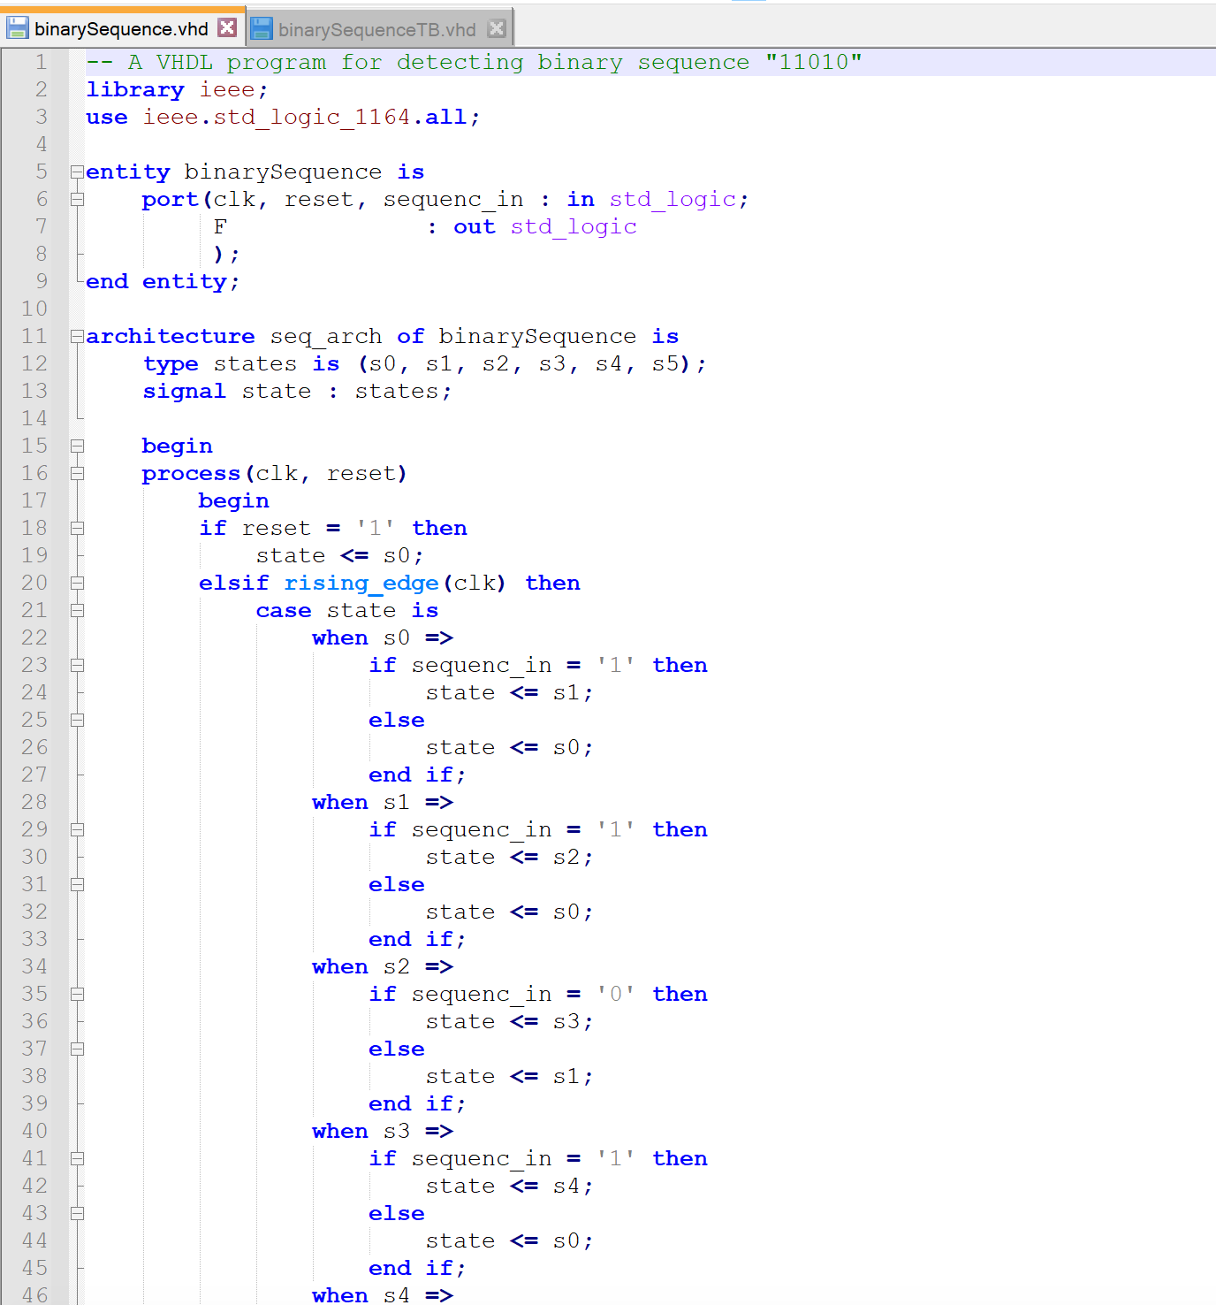

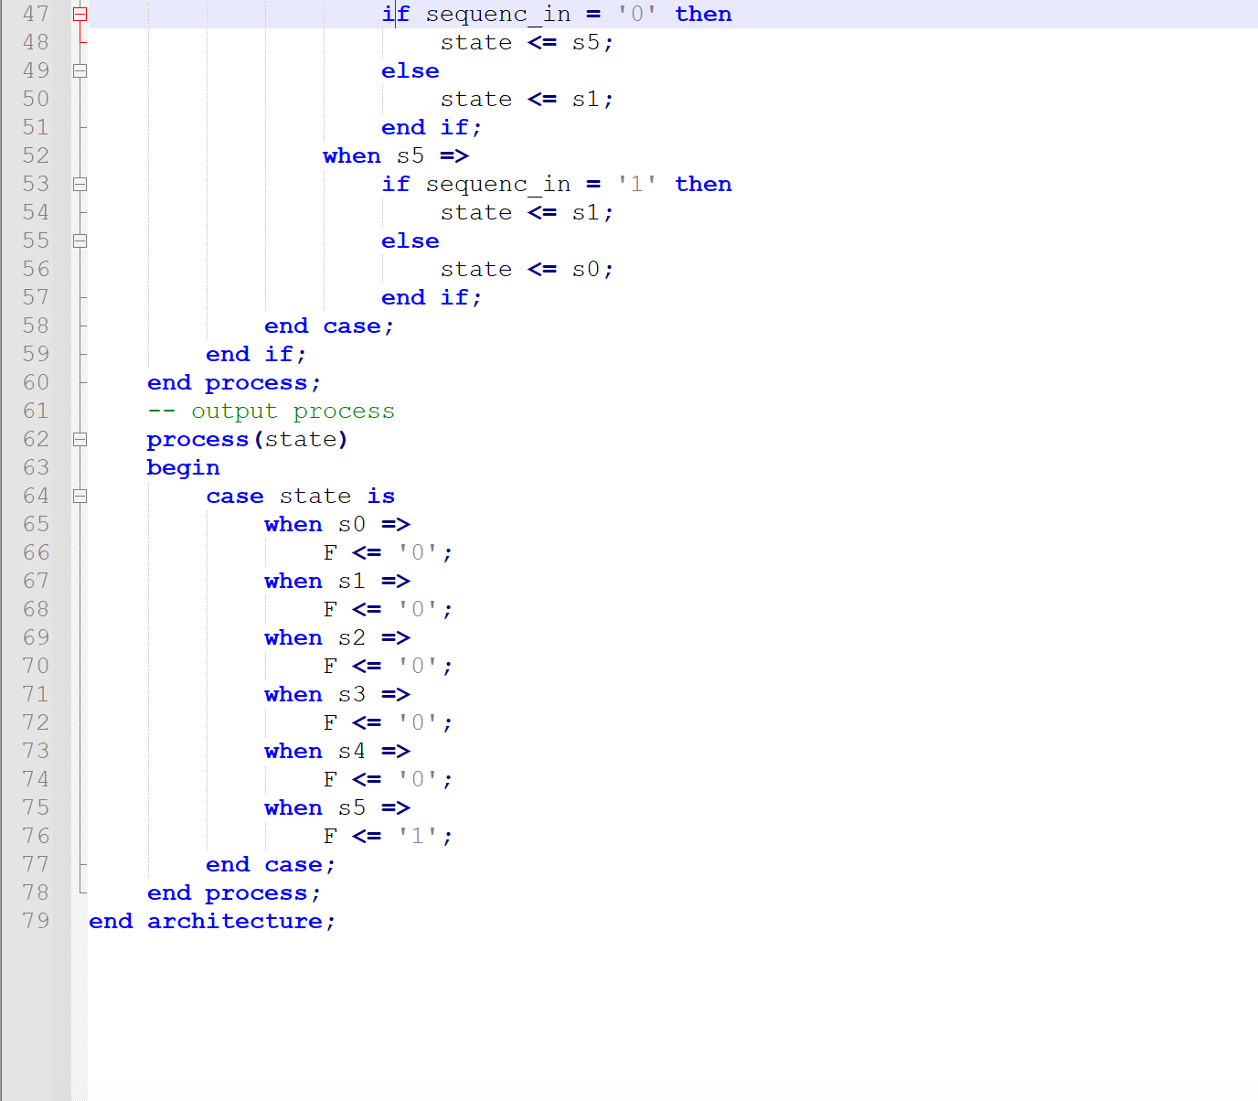

binarySequenceTB.vhdl

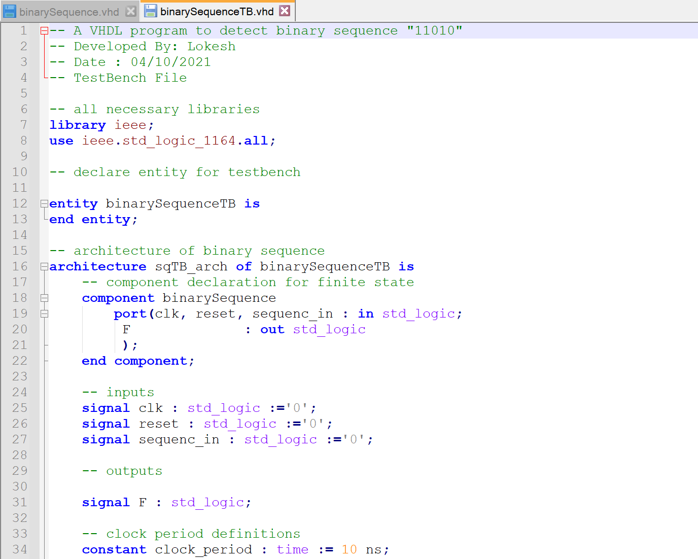

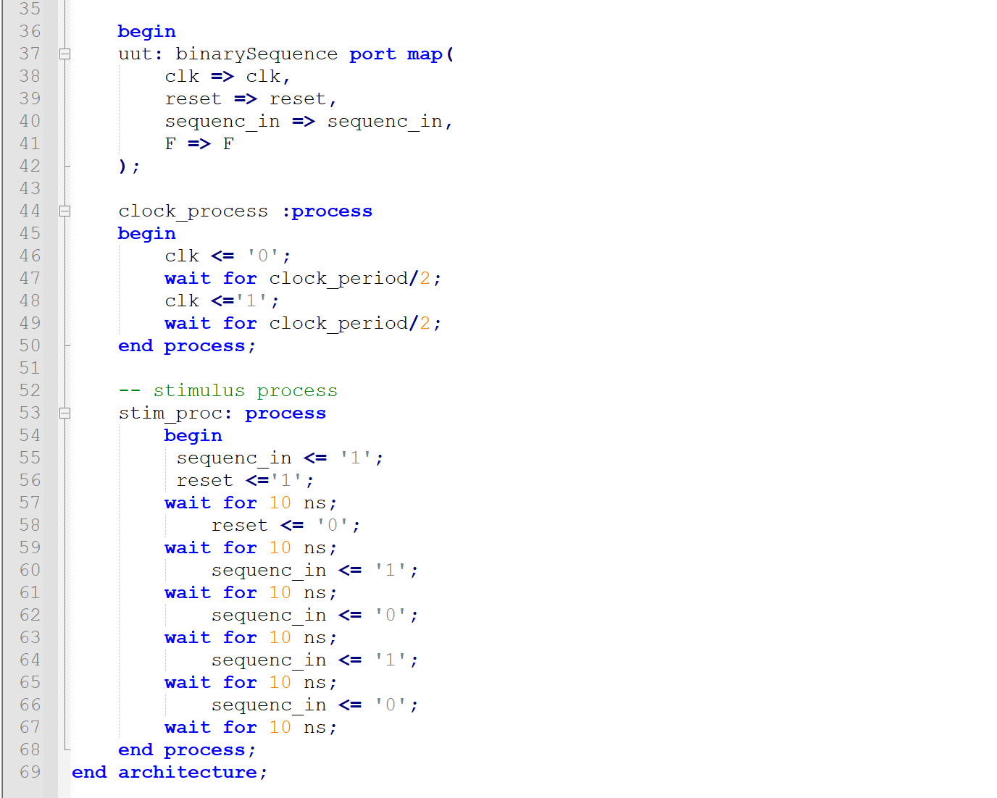

1. Snapshot of successful code compilation and simulation

