Lokesh Singla

2201AI22

**LAB-3(Ping)**

1. The ‘ping’ utility is a network administration tool used to test the reachability of a host (such as a website or a local computer) on an IP network. It measures the round-trip time for messages sent from the originating host to a destination host. The ping command is commonly used to diagnose network connectivity issues by sending Internet Control Message Protocol (ICMP) Echo Request messages to the target host and waiting for an ICMP Echo Reply.

### **Basic Syntax**

The basic syntax for the ping command is: ping [options] destination

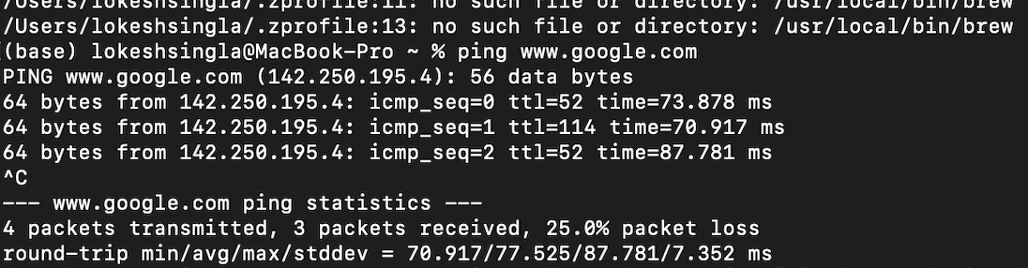

**Ping Command Output:**

* PING google.com (142.250.183.174): 56 data bytes: This indicates that you are sending packets to Google’s server with an IP address of 142.250.183.174. Each packet is 56 bytes of data.
* 64 bytes from 142.250.183.174: Each response packet from the server is 64 bytes. The rest of the line provides details about the packet.
* icmp_seq=X: This is the sequence number of the packet. X represents the packet’s sequence number (0, 1, 2, etc.).
* ttl=54: TTL stands for "Time To Live," which is a field in the packet that gets decremented by each router it passes through. It’s a measure of how many hops the packet has made.
* time=XXX ms: This is the round-trip time it took for the packet to go from your computer to the server and back. The time is measured in milliseconds (ms).

**Ping Statistics:**

* 6 packets transmitted, 6 packets received, 0.0% packet loss: All 6 packets sent were received back, indicating there was no packet loss during the test.
* round-trip min/avg/max/stddev = 120.146/150.213/215.035/31.678 ms: This summary provides:
  + min: The minimum round-trip time (120.146 ms).
  + avg: The average round-trip time (150.213 ms).
  + max: The maximum round-trip time (215.035 ms).
  + stddev: The standard deviation of the round-trip times, which measures how much the times vary from the average (31.678 ms).

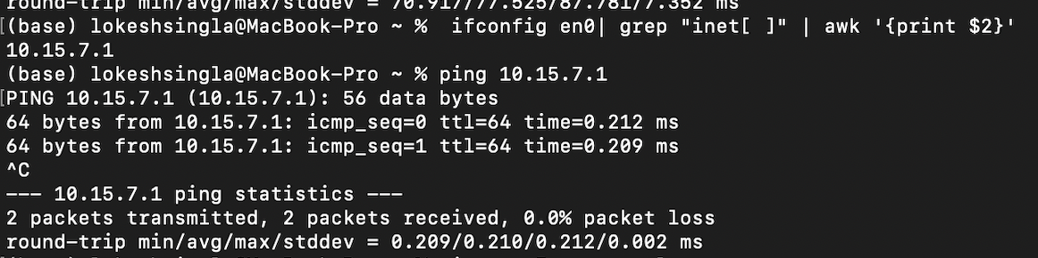

PING localhost (127.0.0.1): 56 data bytes: This indicates that you are pinging the local loopback address (127.0.0.1), which refers to your own computer. Each packet sent is 56 bytes of data.

1. **Ping Responses:**
   * 64 bytes from 127.0.0.1: Each response packet received from the loopback address is 64 bytes.
   * icmp_seq=X: The sequence number of the packet, which increments with each sent packet (0, 1, 2, etc.).
   * ttl=64: TTL stands for "Time To Live." For local loopback traffic, TTL is typically set to 64 and is not decremented because the packet stays within the local machine.
   * time=XXX ms: The time taken for the packet to travel from your computer to the loopback address and back. The time is measured in milliseconds (ms).

### Ping Statistics:

* 6 packets transmitted, 6 packets received, 0.0% packet loss: All 6 packets sent were successfully received back, indicating a perfectly reliable local network interface with no packet loss.
* round-trip min/avg/max/stddev = 0.073/0.134/0.169/0.031 ms:
  + min: The minimum round-trip time for the packets (0.073 ms).
  + avg: The average round-trip time for the packets (0.134 ms).
  + max: The maximum round-trip time for the packets (0.169 ms).

stddev: The standard deviation of the round-trip times, indicating how much the times vary from the average (0.031 ms).

**Task-3**

### 1. -c (count)

**Explanation:** The -c option specifies the number of packets to send before stopping the ping test.

ping -c 4 google.com

In this example, ping will send 4 packets to google.com and then stop.

### 2. -s (size)

**Explanation:** The -s option specifies the size of the ping packets in bytes. By default, ping sends packets of 56 bytes, but you can change this with the -s option.

ping -s 128 google.com

Here, ping will send packets of 128 bytes to google.com.

### 3. -t (ttl)

**Explanation:** The -t option sets the Time To Live (TTL) value for the packets. TTL is a field in the IP header that determines the maximum number of hops (routers) the packet can traverse before being discarded. This can be useful for network troubleshooting and diagnostics.

ping -t 64 google.com

This will send packets with a TTL of 64. Note that the -t option might be used differently on various operating systems. For instance, on Linux, the -t option is used for setting TTL, while on Windows, it is -i.

### 4. -W (deadline)

**Explanation:** The -W option sets a timeout (in seconds) for the ping command to wait for each response before considering it lost. This option specifies the maximum time to wait for a reply.

ping -W 2 google.com

Here, ping will wait up to 2 seconds for each packet to receive a response before timing out.

**Task-4**

### Example Troubleshooting Workflow

1. **Check Basic Connectivity:** Run ping google.com to ensure you can reach the server.
2. **Analyze Packet Loss:** Run ping -c 10 google.com to check for packet loss. If packet loss is present, the issue might be with your network connection or intermediate routers.
3. **Assess Latency:** Run ping -c 10 google.com again to check latency. Consistently high latency can indicate network congestion or routing issues.
4. **Test with Larger Packets:** Run ping -s 1400 google.com to see if larger packets are causing issues. If packet loss or high latency occurs with larger packets, it may be due to MTU or fragmentation issues.
5. **Set TTL to Trace Route:** Run ping -t 64 google.com to trace the path and identify where delays might be occurring.
6. **Adjust Timeout Settings:** Run ping -W 2 -c 10 google.com to ensure you’re not waiting too long for responses and to identify if delays are affecting connectivity.

**Task-5**

Code Link-> <https://pastebin.com/gzf46ewG>

