Name: Lokesh Challagulla

NUID: 002921968

Overview:

I have created a Java Swing application with GUI which acts as a platform for people to find medical resources in a specific city and community.

Workflow: System admin has all privileges. Initially, the system admin adds a hospital to the application in every city and community in his control. Followed by that, a doctor and a hospital admin are added. The doctor and hospital admin are assigned to a hospital created earlier. Lastly, a community admin and a person belonging to the community are added. A patient can view hospitals/doctors and contact them to schedule an appointment.

Application: Upon login, every user is shown a different page, menu and options, depending on the user permissions. Using the application, System admin can perform all the functions. He can add a hospital, a doctor, a patient, a community admin, a hospital admin and also perform management functions such as removing, updating and viewing their information.

A patient can login and search for a specific hospital/doctor in a specific area. The patient can also view the hospital contact information.

A doctor can add a person in the community as a patient. He can then create an encounter to record the patient's vitals such as BP, weight etc. Moreover, the doctor can also view the patient's vital signs history for diagnosis.

A community admin can login and view all patients in a community. He can also add a new person in the community apart from the system admin, along with performing other tasks with respect to the person such as modify, view and delete.

Similarly, a hospital administrator can add a new doctor in a hospital. He can also perform other functions with respect to the doctors such as viewing a new doctor information, deleting a doctor and updating doctor information.

CRUD operations are implemented based on the user who has logged in. For example, a patient cannot perform CRUD functions. A hospital admin has limited CRUD permissions in the sense that he can only add/view/delete/edit a person in the community. While a system admin has all the CRUD operations.

Class diagram:

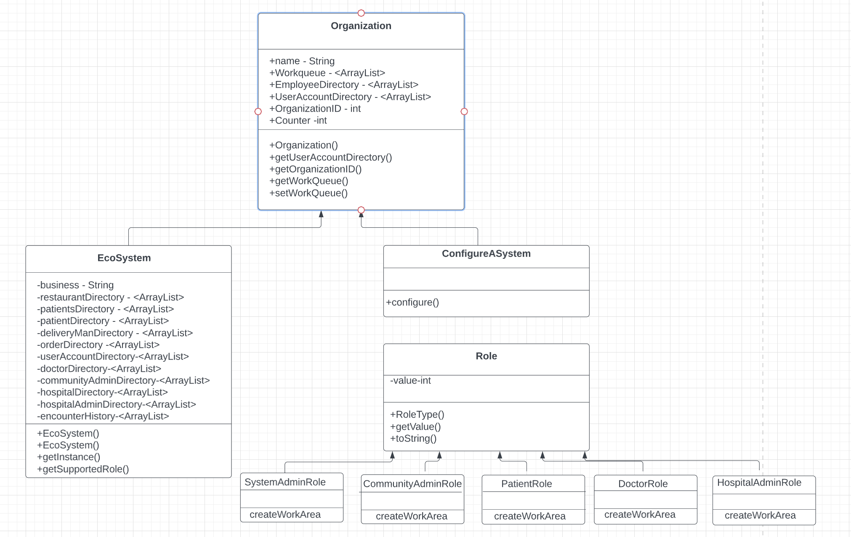

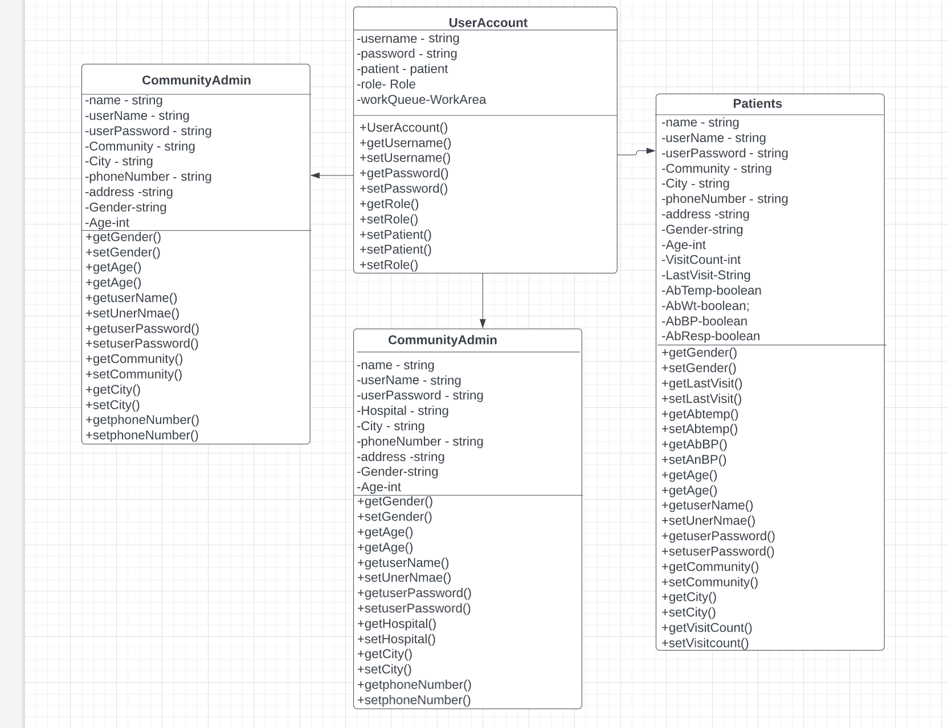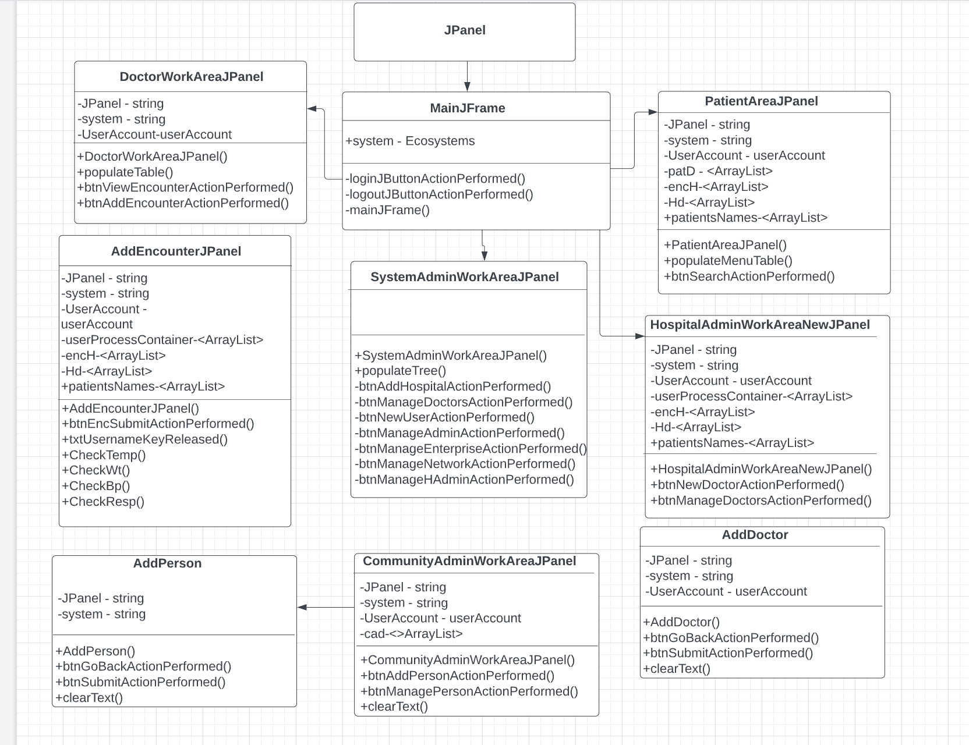

Sequence diagram:

System admin:

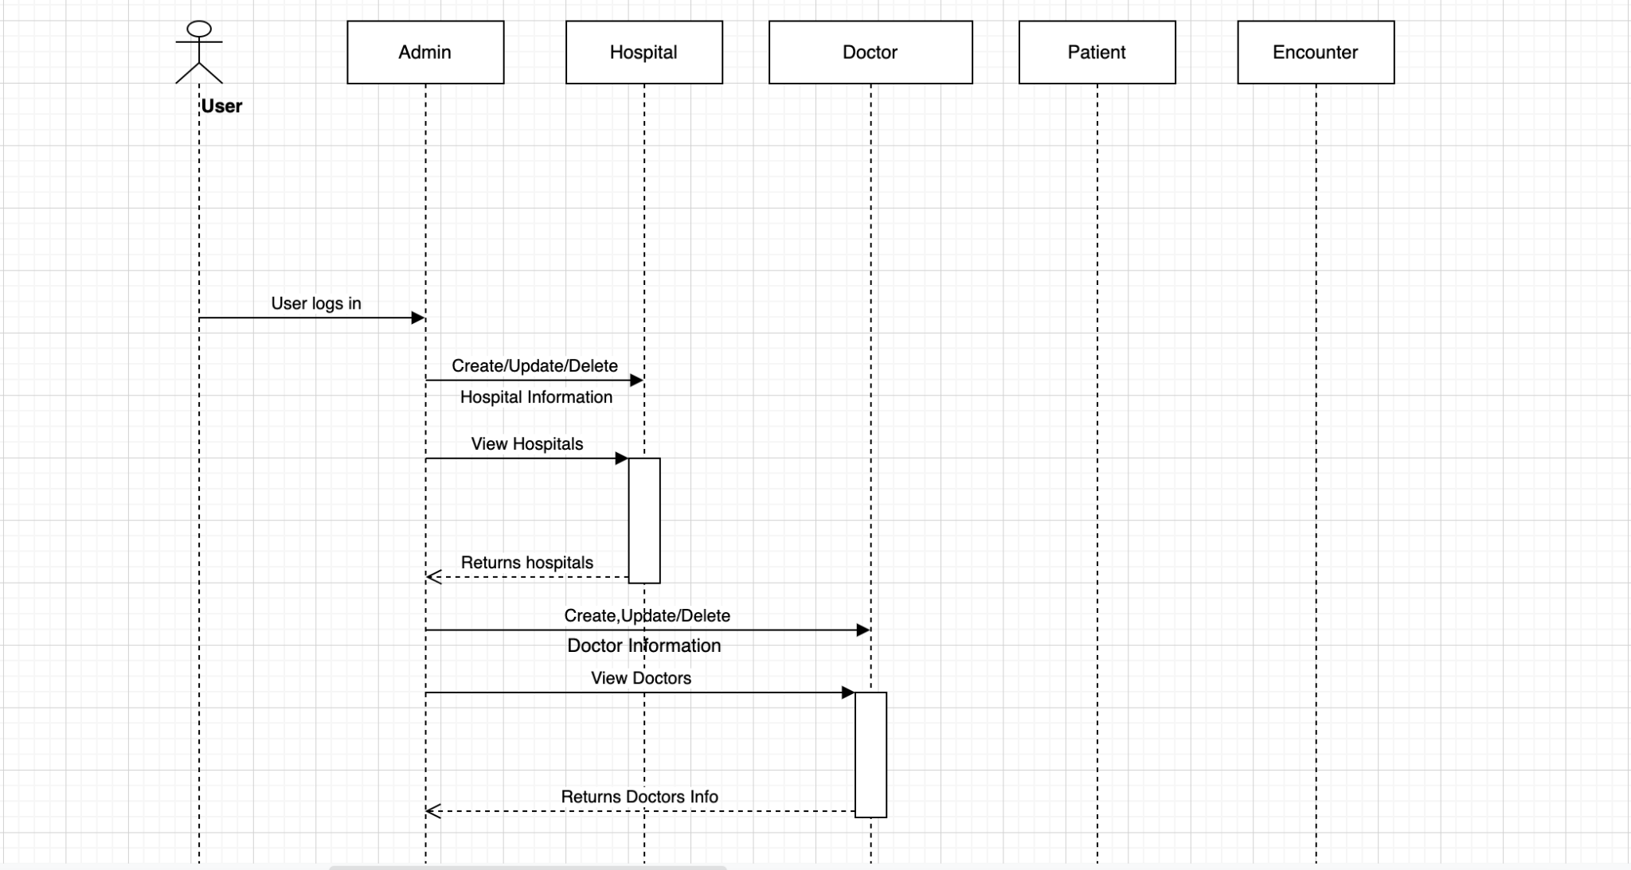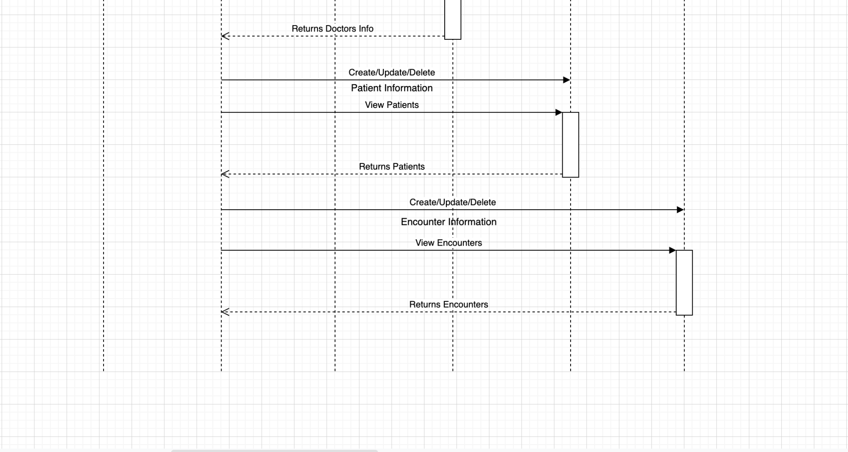

Patient:

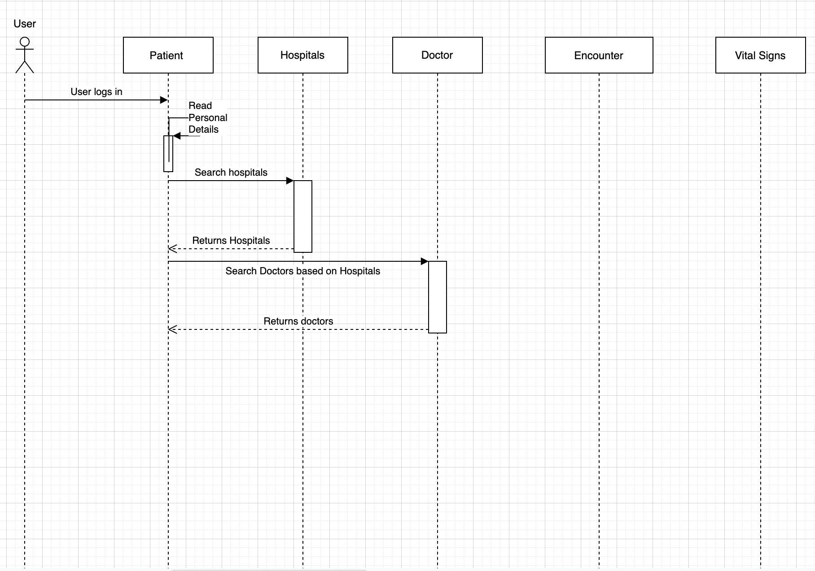

Doctor:

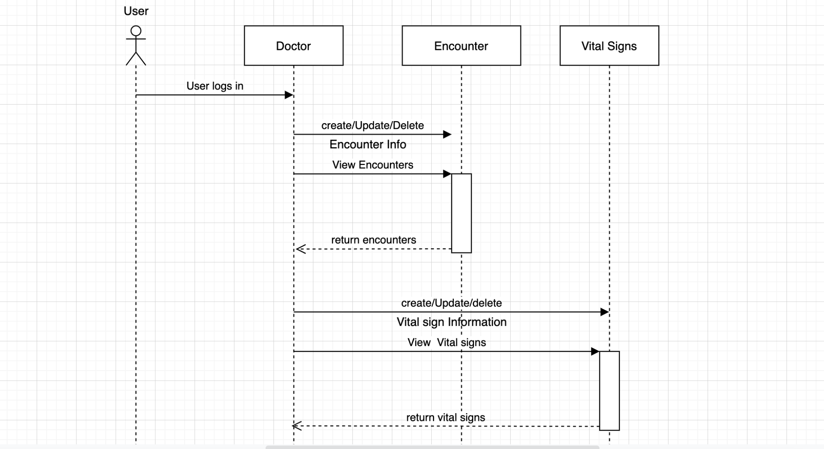

Hospital Admin:

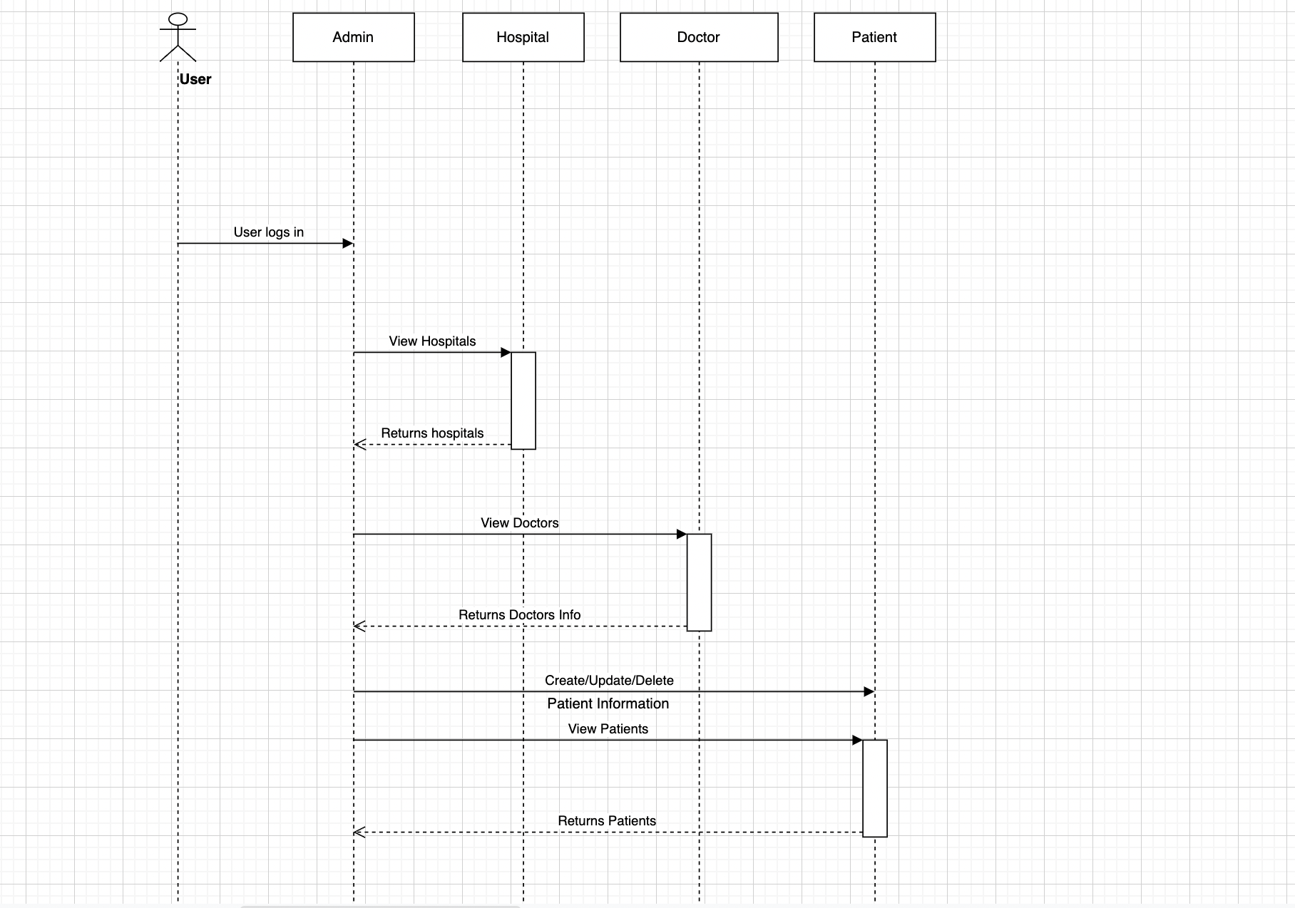

Community admin:

