App.jsx
import { useState } from 'react'
import reactLogo from './assets/react.svg'
import viteLogo from './assets/vite.svg'
import heroImg from './assets/hero.png'
import './App.css'

function App() {
const [count, setCount] = useState(0)

return (
<>
<div className="hello">
<h1>Hello World</h1>
</div>
</>
)
}

export default App
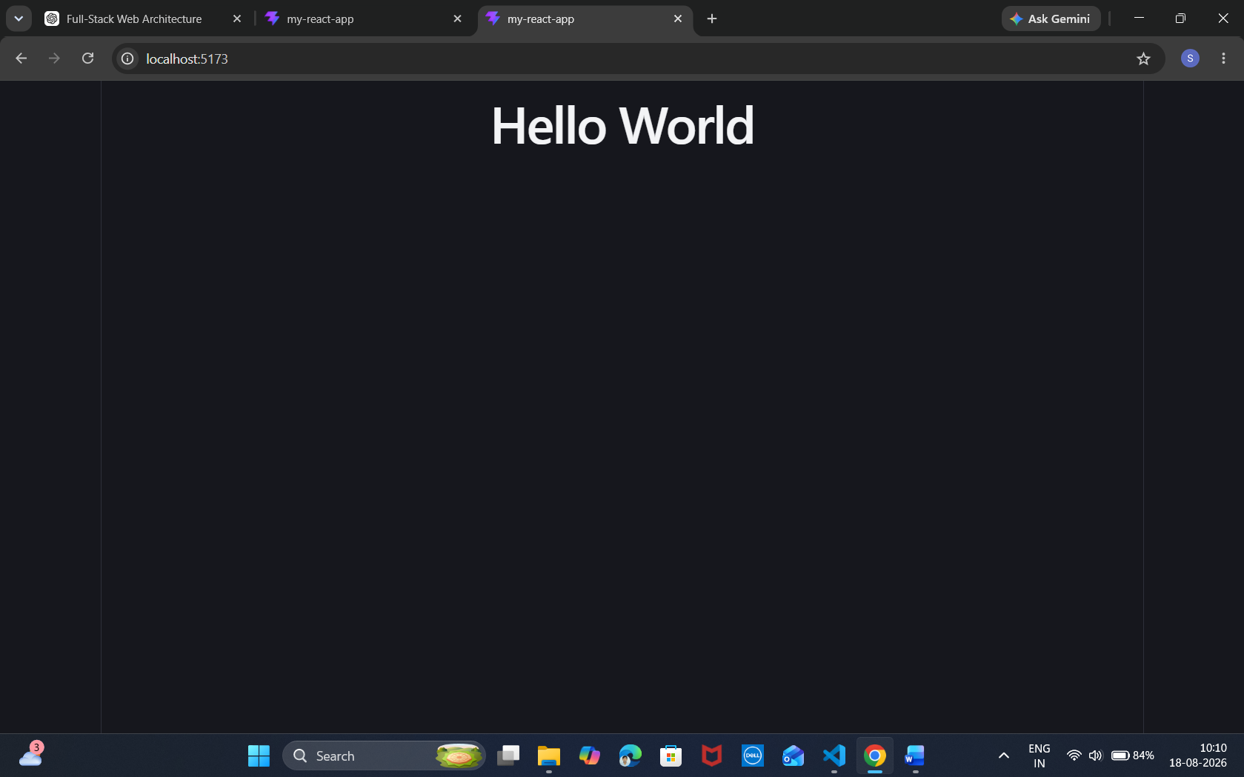

App.jsx
import { useState } from 'react'
import reactLogo from './assets/react.svg'
import viteLogo from './assets/vite.svg'
import heroImg from './assets/hero.png'
import './App.css'

function App() {
const [count, setCount] = useState(0)

return (
<>
<div className="hello">
<h1 style={{ color: 'green', fontSize: '2rem', fontWeight: 'bold' }}>Hello World</h1>
</div>
</>
)
}

export default App

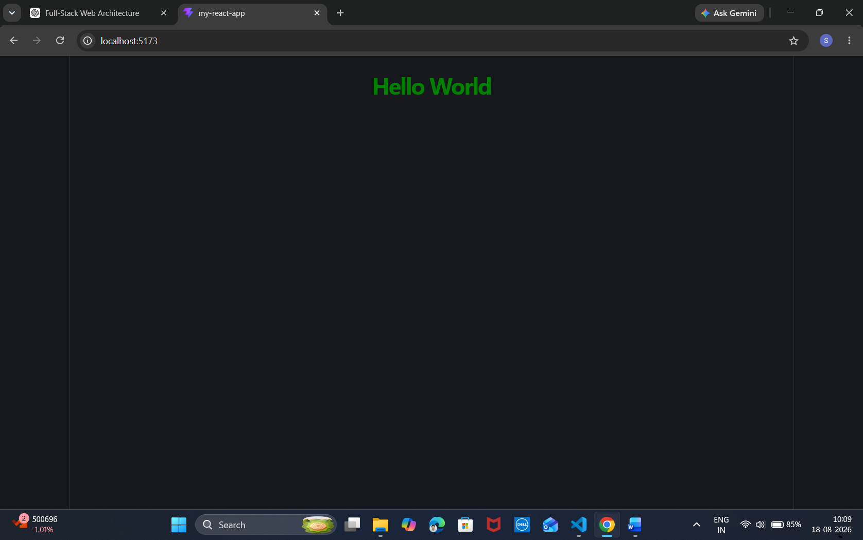
App.jsx
import { useState } from 'react'
import reactLogo from './assets/react.svg'
import viteLogo from './assets/vite.svg'
import heroImg from './assets/hero.png'
import './App.css'

function App() {
const [count, setCount] = useState(0)

return (
<>
{/* <div className="hello">
<h1>Hello World</h1>
{/* </div> */}

{/* <div className="hello">
<h1 style={{ color: 'green', fontSize: '2rem', fontWeight: 'bold' }}>Hello World</h1>
{/* </div> */}
<div className="container">
<h1 className="title">3D Image Gallery</h1>
<div className="image-grid">
<div className="card">
<img src="https://static.vecteezy.com/system/resources/thumbnails/070/036/701/small/majestic-lion-in-a-grassy-plain-under-cloudy-sky-photo.jpg" alt="Lion" />
<div className="layer">Lion</div>
</div>
</div>
</div>
</>
)
}

export default App
App.css
/* .counter {
font-size: 16px;
padding: 5px 10px;
border-radius: 5px;
color: var(--accent);
background: var(--accent-bg);
border: 2px solid transparent;
transition: border-color 0.3s;
margin-bottom: 24px;

&:hover {
border-color: var(--accent-border);
}
&:focus-visible {
outline: 2px solid var(--accent);
outline-offset: 2px;
}
}

.hero {
position: relative;

.base,
.framework,
.vite {
inset-inline: 0;
margin: 0 auto;
}

.base {
width: 170px;
position: relative;
z-index: 0;
}

.framework,
.vite {
position: absolute;
}

.framework {
z-index: 1;
top: 34px;
height: 28px;
transform: perspective(2000px) rotateZ(300deg) rotateX(44deg) rotateY(39deg)
scale(1.4);
}

.vite {
z-index: 0;
top: 107px;
height: 26px;
width: auto;
transform: perspective(2000px) rotateZ(300deg) rotateX(40deg) rotateY(39deg)
scale(0.8);
}
}

#center {
display: flex;
flex-direction: column;
gap: 25px;
place-content: center;
place-items: center;
flex-grow: 1;

@media (max-width: 1024px) {
padding: 32px 20px 24px;
gap: 18px;
}
}

#next-steps {
display: flex;
border-top: 1px solid var(--border);
text-align: left;

& > div {
flex: 1 1 0;
padding: 32px;
@media (max-width: 1024px) {
padding: 24px 20px;
}
}

.icon {
margin-bottom: 16px;
width: 22px;
height: 22px;
}

@media (max-width: 1024px) {
flex-direction: column;
text-align: center;
}
}

#docs {
border-right: 1px solid var(--border);

@media (max-width: 1024px) {
border-right: none;
border-bottom: 1px solid var(--border);
}
}

#next-steps ul {
list-style: none;
padding: 0;
display: flex;
gap: 8px;
margin: 32px 0 0;

.logo {
height: 18px;
}

a {
color: var(--text-h);
font-size: 16px;
border-radius: 6px;
background: var(--social-bg);
display: flex;
padding: 6px 12px;
align-items: center;
gap: 8px;
text-decoration: none;
transition: box-shadow 0.3s;

&:hover {
box-shadow: var(--shadow);
}
.button-icon {
height: 18px;
width: 18px;
}
}

@media (max-width: 1024px) {
margin-top: 20px;
flex-wrap: wrap;
justify-content: center;

li {
flex: 1 1 calc(50% - 8px);
}

a {
width: 100%;
justify-content: center;
box-sizing: border-box;
}
}
}

#spacer {
height: 88px;
border-top: 1px solid var(--border);
@media (max-width: 1024px) {
height: 48px;
}
}

.ticks {
position: relative;
width: 100%;

&::before,
&::after {
content: '';
position: absolute;
top: -4.5px;
border: 5px solid transparent;
}

&::before {
left: 0;
border-left-color: var(--border);
}
&::after {
right: 0;
border-right-color: var(--border);
}
/* } */
/* Center everything on the screen */
.container {
display: flex;
flex-direction: column;
align-items: center;
justify-content: center;
min-height: 100vh;
background-color: #1a1a1a;
color: white;
font-family: sans-serif;
}

.title {
margin-bottom: 2rem;
font-size: 2.5rem;
}

/* Flexbox grid for images */
.image-grid {
display: flex;
gap: 40px;
justify-content: center;
flex-wrap: wrap;
/* Crucial for 3D depth perception */
perspective: 1000px;
}

/* The 3D Card Container */
.card {
position: relative;
width: 300px;
height: 400px;
border-radius: 15px;
overflow: hidden;
box-shadow: 0 15px 35px rgba(0, 0, 0, 0.5);
transition: transform 0.5s ease, box-shadow 0.5s ease;
transform-style: preserve-3d;
cursor: pointer;
}

/* Image styles */
.card img {
width: 100%;
height: 100%;
object-fit: cover;
transition: transform 0.5s ease;
}

/* 3D Hover effect */
.card:hover {
/* Tilts the card slightly upward and rotates it */
transform: translateY(-10px) rotateX(15px) rotateY(-15px);
box-shadow: -15px 25px 50px rgba(0, 0, 0, 0.7);
}

/* Zoom effect on the image inside the card */
.card:hover img {
transform: scale(1.1);
}

/* 3D Text Overlay */
.layer {
position: absolute;
bottom: 20px;
left: 20px;
color: white;
font-size: 1.8rem;
font-weight: bold;
text-shadow: 0 2px 5px rgba(199, 209, 97, 0.5);
transition: transform 0.5s ease;
/* Pushes text forward in 3D space */
transform: translateZ(50px);
}

.card:hover .layer {
transform: translateZ(80px) translateY(-10px);
}
