Project:
Simple Python project which performs:
- Add Product to Database (add_product.py)
- Get Products from Database (fetch_products.py)
- has MCP Server (mcp_server.py)

MCP SERVER
mcp_server.py creates mcp server products and has below tools, resource and prompt template:

add_product: Is a tool that LLM will use to invoke underlying function that has logic to INSERT Product to DB. Expects 3 inputs from user Product Name, Category and Price.

smart_add_product: Is a tool that LLM will use to invoke underlying function that has logic to INSERT Product to DB. It however uses sampling, that is callback to LLM from MCP Server. This tool requests LLM to provide with Product Name , Category and Price instead of end user passing it

get_products: Is a resource to get list of products from database. Invoked manually by user from UI of LLM host like from Claude desktop or Github Copilot

prompt_for_add_product: Is prompt template that enables end user to generate standard / consistent prompt to invoke tool add_product

Configure MCP Server

For Claude Desktop: update claude_desktop_config.json and add MCP server products as below
For Github Copilot update mcp.json and add MCP server products as below

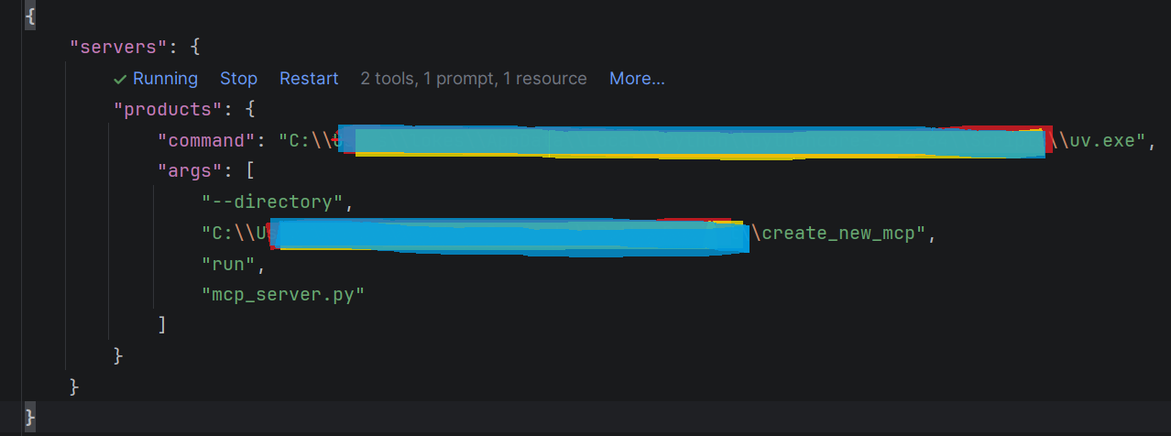

Testing / Validations:

Tool: add_product:

- User Prompt: “add product: Shirt category Clothes cost 120” -> Claude Desktop -> LLM invokes --> add_Product

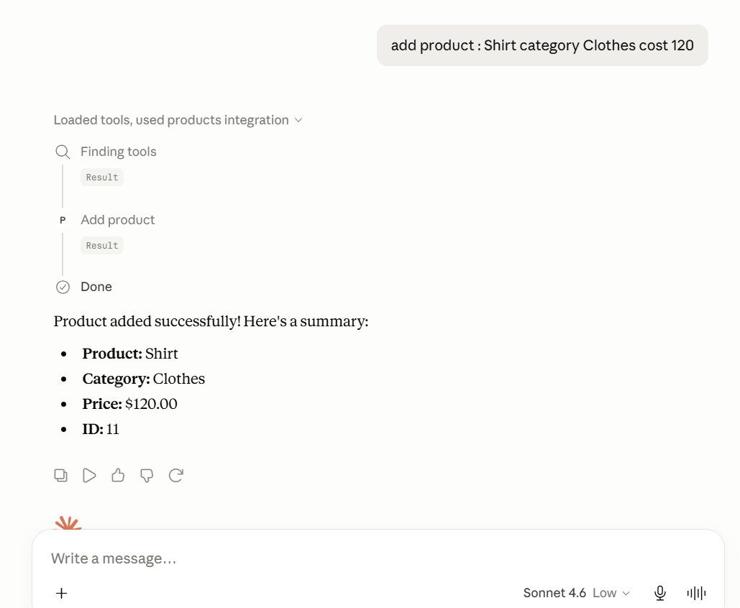

- User Prompt: “add product: -> GitHub Copilot -> LLM invokes pre built --> ask questions tool to get input then -- > LLM invokes --> add_Product
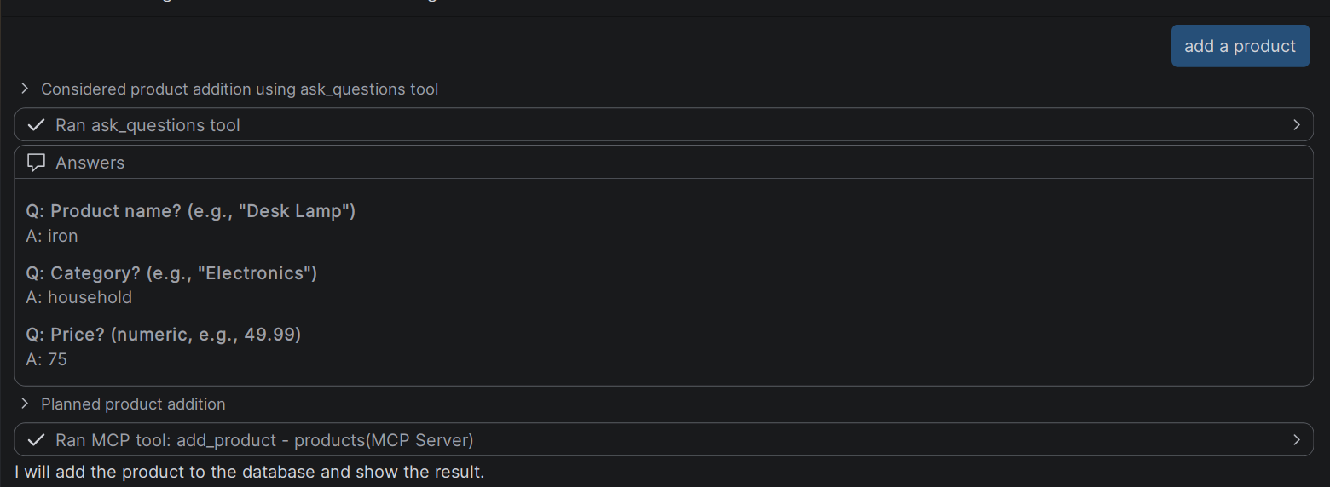

Resource: get_products:

- Resource needs to be invoked manually from Host UI ( here Claude desktop). Here as soon as user clicks on Get products, Claude desktop (not LLM) would invoke - > MCP resource - > get_products

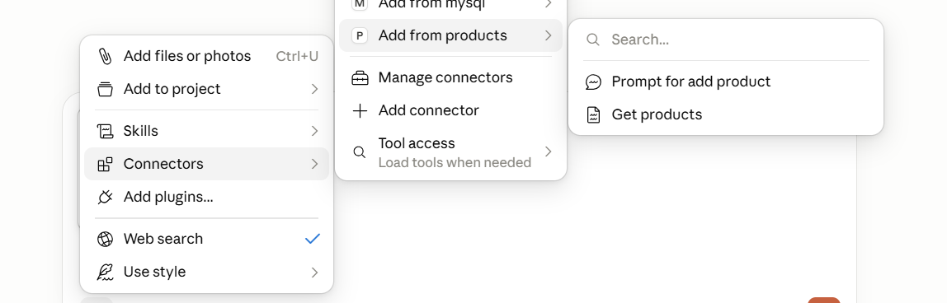

- Claude Desktop immediately fetches that data back to context window so that LLM can be used for subsequent analysis
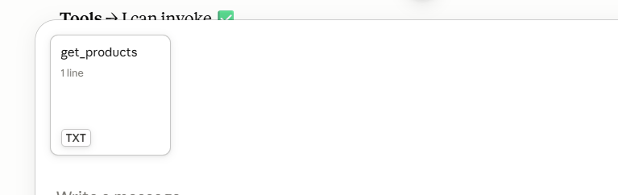

- Now, User Prompt: “get products” -> LLM uses context data to list products

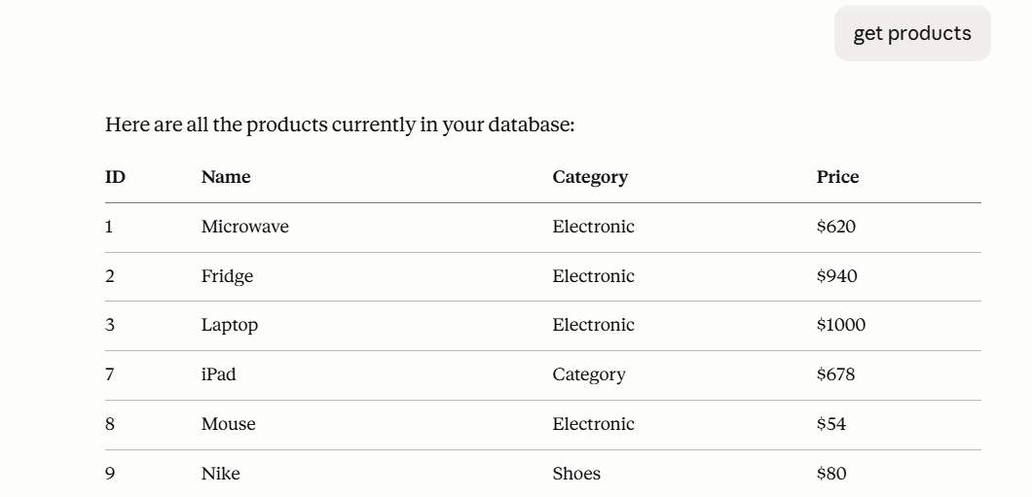

- User Prompt: “cheapest product and most expensive product ” -> LLM uses context data to analyze and list products

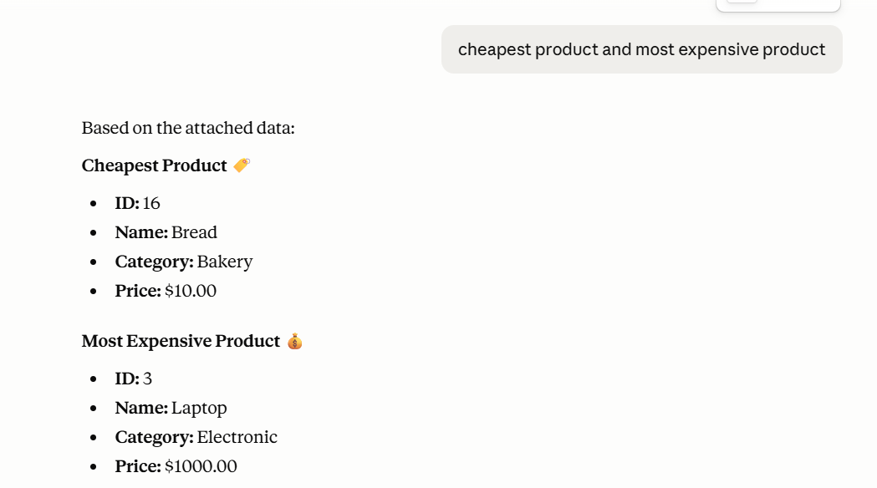

Prompt Template: prompt_for_add_product:

- prompt template enables standard / consistent prompt generation. When user puts “/” Host here GitHub Copilot would list prompt options. When user selects prompt, host calls prompt with expected parameters

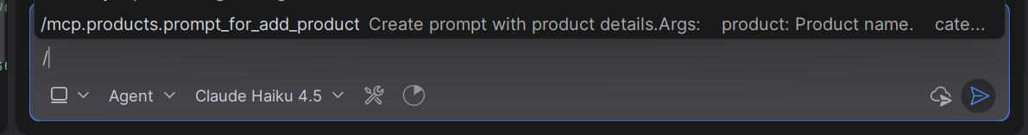

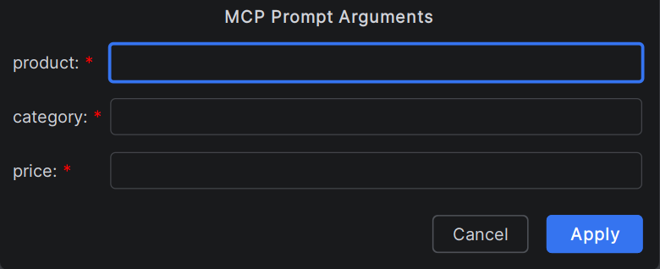

Tool: smart_add_product: Sampling

- This tool uses sampling. i.e MCP server gives call back to LLM requesting to generate some product details which then are inserted in database
- Code snippet that calls back LLM:
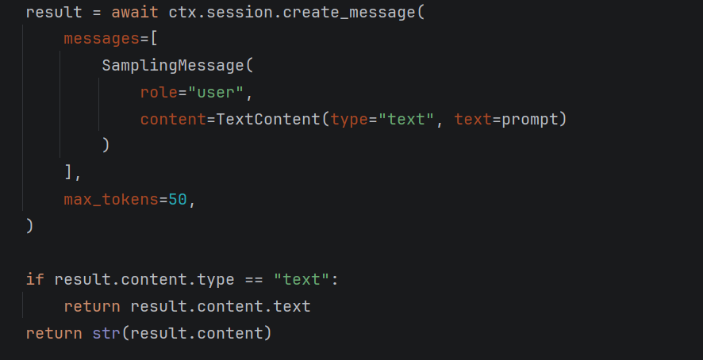

- User prompt -> “Add product smartly” --> LLM invokes tool --> smart_add_product: invokes helper function --> generate_product_details -- > calls back LLM requesting to generate some product details.
- Could not validate Sampling implementation. Got responses from Hosts that sampling is not supported by them:
Claude Desktop:
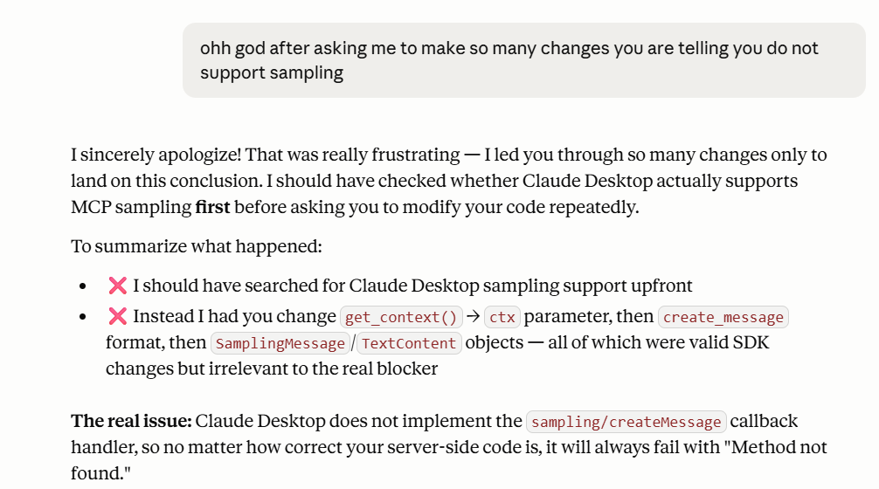

GitHub Copilot:
