# HACKATHON PROJECT DOCUMENT

## Project Title:

Weather Info App

## Student Name(s) and Roll Number(s):

B. Lokesh (25B21A4678)  
B. S. S. Sai Teja (25B21A4619)  
V. Durga Prasanth (25B21A4620)  
S. Tejas (25B21A4623)  
L. T. V. Satyanarayana Swamy (25B21A4622)

## Department, Institution, Academic Year:

CSC-DS, Kakinada Institute of Engineering and Technology, 2025

import tkinter as tk

import requests

def get_weather():

city = city_entry.get()

url = f"https://wttr.in/{city}?format=3"

try:

weather = requests.get(url).text

result_label.config(text=weather)

except:

result_label.config(text="Error getting weather info")

root = tk.Tk()

root.title("Weather Info App")

root.geometry("300x200")

tk.Label(root, text="Enter city name:").pack(pady=5)

city_entry = tk.Entry(root)

city_entry.pack(pady=5)

tk.Button(root, text="Get Weather", command=get_weather).pack(pady=5)

result_label = tk.Label(root, text="")

result_label.pack(pady=10)

root.mainloop()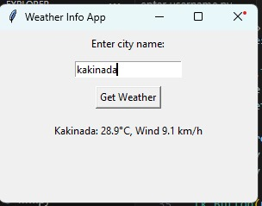

# Problem Statement

It describes about mini weather info in various cities.

# How You Did It

We used Python language with Tkinter to create a simple weather information app that displays weather details for different cities.

# Conclusion

This project demonstrates how Python and Tkinter can be used to create a real-time weather information app, providing users with instant weather details in a simple graphical interface.