Exercise 1:Control Structures
Question: Write a PL/SQL block that loops through all customers, checks their age, and if they are above 60, apply a 1% discount to their current loan interest rates.
Query:
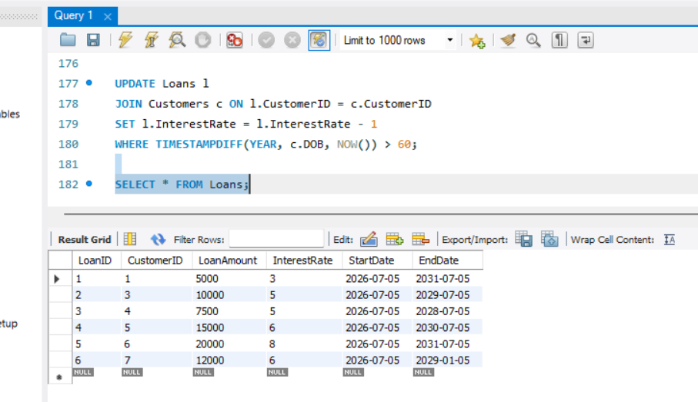

Question: Write a PL/SQL block that iterates through all customers and sets a flag IsVIP to TRUE for those with a balance over $10,000.
Query:
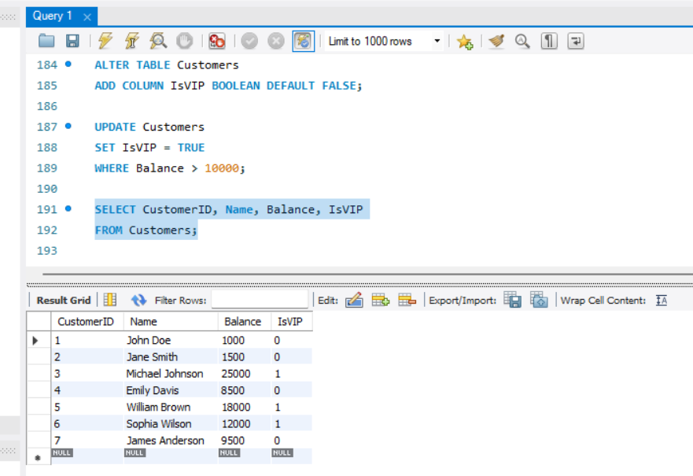

Question: Write a PL/SQL block that fetches all loans due in the next 30 days and prints a reminder message for each customer.
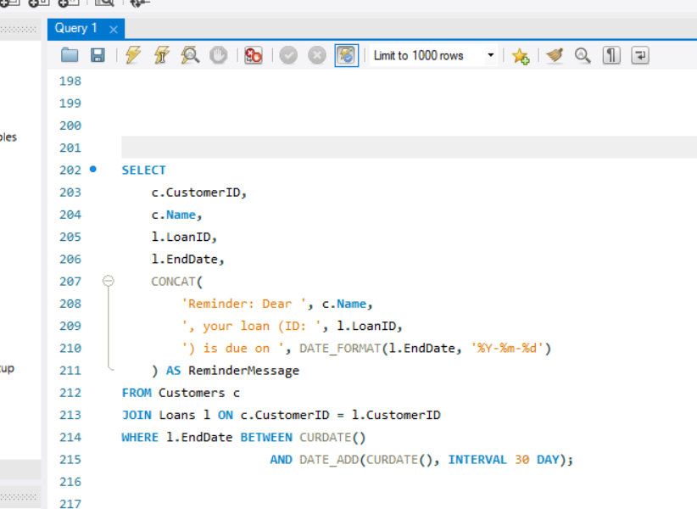
Output:
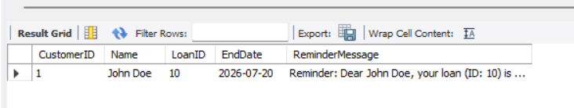

Exercise 2:Stored Procedures
1.Write a stored procedure ProcessMonthlyInterest that calculates and updates the balance of all savings accounts by applying an interest rate of 1% to the current balance.
Query:
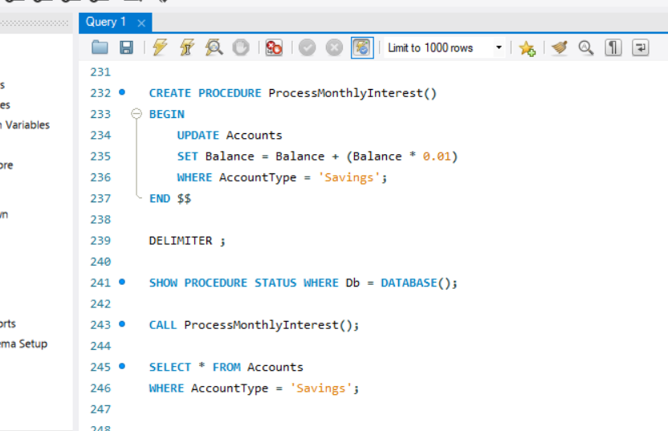

Question 2: Write a stored procedure UpdateEmployeeBonus that updates the salary of employees in a given department by adding a bonus percentage passed as a parameter.
Query:
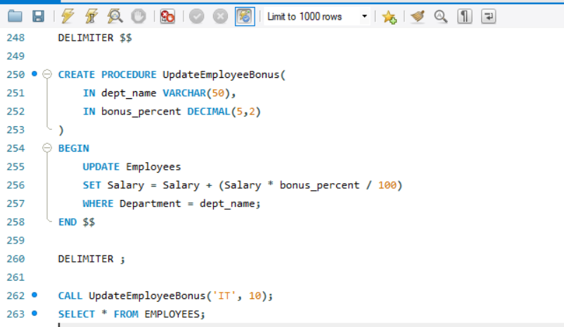
Output:
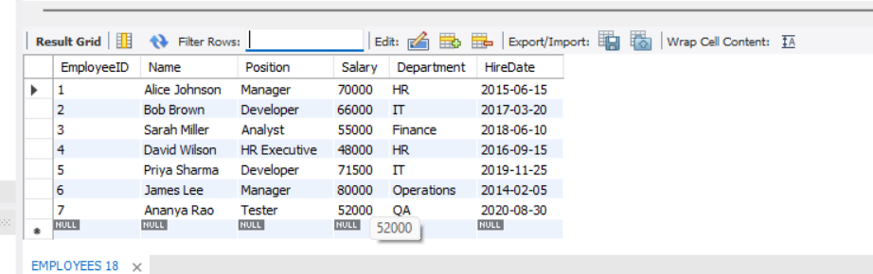

Question 3: Write a stored procedure TransferFunds that transfers a specified amount from one account to another, checking that the source account has sufficient balance before making the transfer.Query: