Customer Conversion Analysis for Online Shopping Using Clickstream Data

1. Introduction
This project focuses on analyzing customer behavior in online shopping using clickstream data. The goal is to build regression, classification, and clustering models to gain insights into customer conversion and purchasing patterns.

2. Dataset Description
The dataset is sourced from the UCI Machine Learning Repository. It includes variables such as session information, product categories, price, and customer behavior metrics.
• Source: UCI Machine Learning Repository - Clickstream Data
• Train Dataset: train.csv for training machine learning models.
• Test Dataset: test.csv for evaluating model performance.

3. Methodology
The project follows a structured pipeline approach:
1. Data Preprocessing: Cleaning, handling missing values, encoding categorical variables, and scaling features.
2. Exploratory Data Analysis (EDA): Understanding data distributions, correlations, and customer interaction patterns.
3. Feature Engineering: Adding session-level features, encoding categorical columns, and scaling numeric values.
4. Modeling:
- Regression: Linear Regression, Random Forest Regressor, Gradient Boosting.
- Classification: Logistic Regression, Decision Tree, Random Forest, XGBoost, Neural Networks.
- Clustering: K-Means, DBSCAN, Agglomerative.
5. Model Evaluation: Metrics such as RMSE, R², Accuracy, Precision, Recall, F1-score, and Silhouette score.
6. Deployment: Streamlit app for interactive predictions and insights.

4. Results
The models were trained and evaluated on the dataset. Key results are summarized below:
Regression:
✅ Best Regression Model: Random Forest Regressor (R² = 0.99, RMSE = 1.09)
Classification:
✅ Best Classification Model: XGBoost (Accuracy = 1.00, F1 = 1.00)
Clustering:
✅ Best Clustering Model: KMeans (k=4, Silhouette = 0.775, DB Index = 0.348)

5. Streamlit Application
An interactive Streamlit web application was developed to:
- Allow users to upload and analyze clickstream data.
- Run regression and classification predictions.
- Visualize clustering results.
- Provide insights into customer conversion probabilities.
Screenshots of Streamlit app:
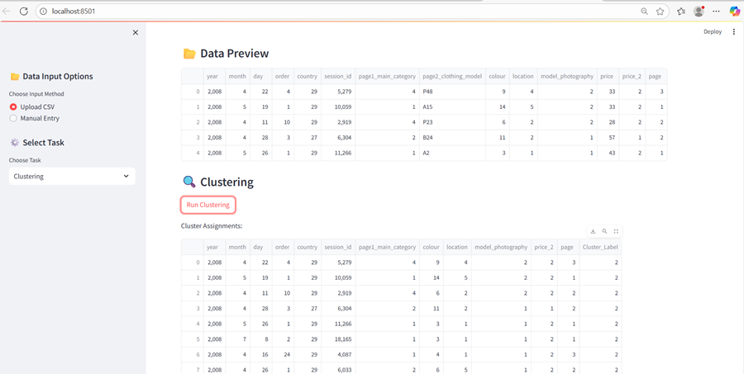
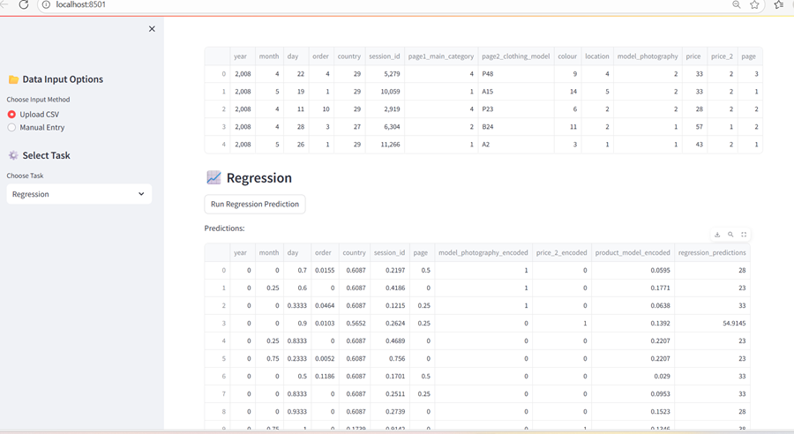
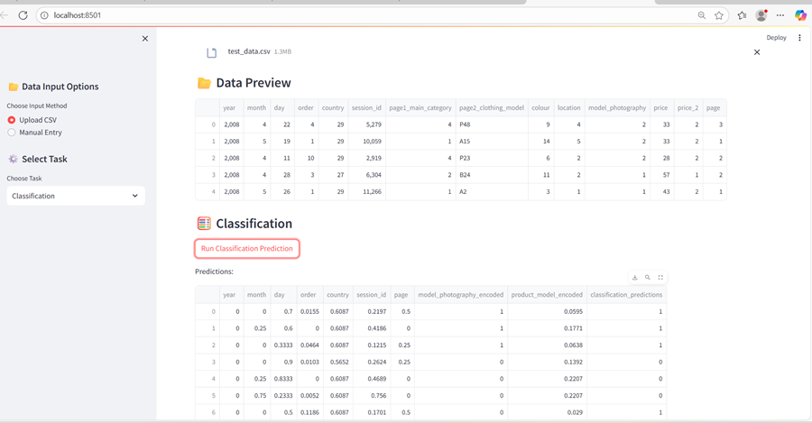

6. Conclusion
This project demonstrates the successful application of machine learning techniques on online shopping clickstream data to analyze and predict customer conversion behavior.
1. Regression analysis identified Random Forest Regressor as the best model (R² = 0.99, RMSE = 1.09).
2. Classification analysis showed that XGBoost achieved near-perfect performance (Accuracy & F1 = 1.00).
3. Clustering analysis (KMeans, k=4) revealed clear customer segments based on price sensitivity and browsing patterns.
✅ Overall, this project concludes that machine learning models, particularly Random Forest and XGBoost, combined with clustering insights, provide a powerful framework for customer behavior prediction, segmentation, and strategic decision-making in e-commerce.

7. Future Work
- Hyperparameter tuning for all models.
- Expanding dataset with more diverse features.
- Deploying the application with a cloud-based backend.
- Real-time data integration.

