1)

A customer has a unique customer identifier, a name, a billing address (street, city, state, and zip), and a collection of submitted work orders.

A work order has a unique work order number, a creation date, a date required, a completion date, a customer, an optional supervising employee, a work address (street, city, state, zip), and a set of tasks.

Each task has a unique task identifier, a task name, an hourly rate, and estimated hours. Tasks are standardized across work orders so that the same task can be performed on many work orders.

Each task on a work order has a status (not started, in progress, or completed), actual hours, and a completion date. The completion date is not entered until the status changes to complete.



The Customer, WorkOrder and Task entity types follow directly from the narrative. The narrative statement clearly indicates attributes and a primary key for each entity type. The M side of the 1-M relationship, Submitted, follows from the narrative with Customer Submitting multiple Work orders. The minimum cardinalities are not specified in the narrative so additional requirements collection is necessary.

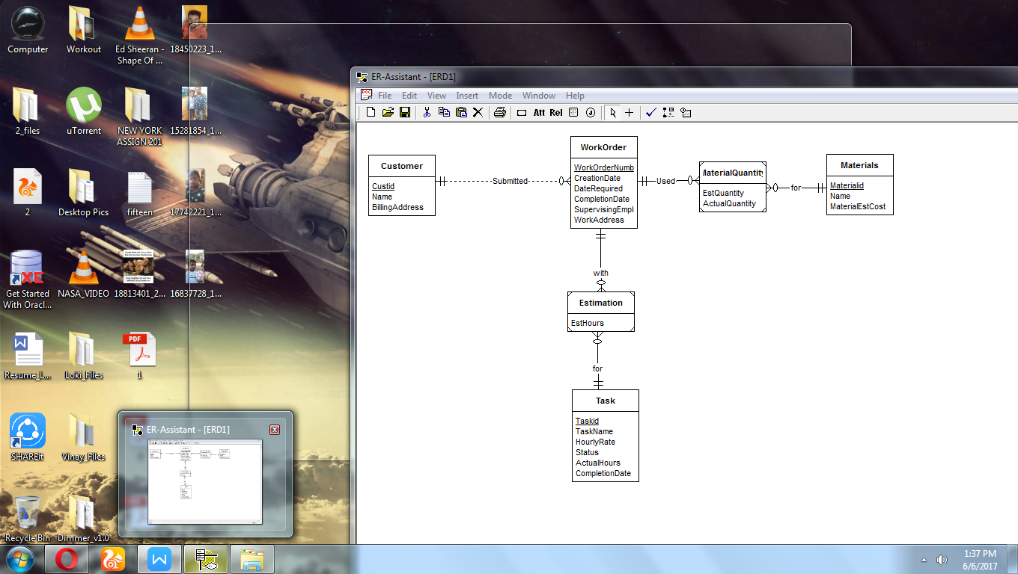

The company wants to maintain a list of materials. The data about materials include a unique material identifier, a name, and an estimated cost. A material can appear on multiple work orders.

Each work order uses a collection of materials. A material used on a work order includes the estimated quantity of the material and the actual quantity of the material used.

The estimated number of hours for a task depends on the work order and task, not on the task alone. Each task of a work order includes an estimated number of hours.