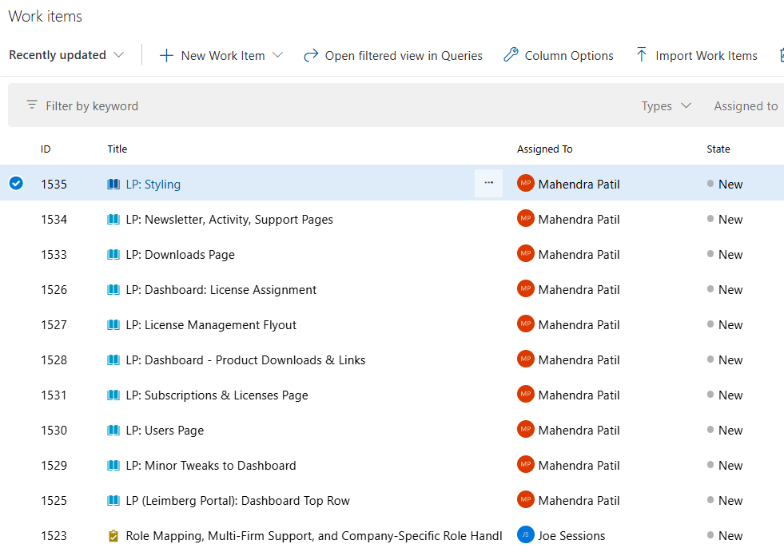

User Story ID #1530:

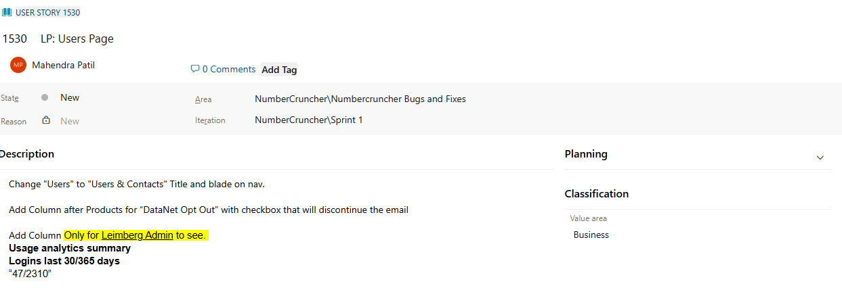

#1529:
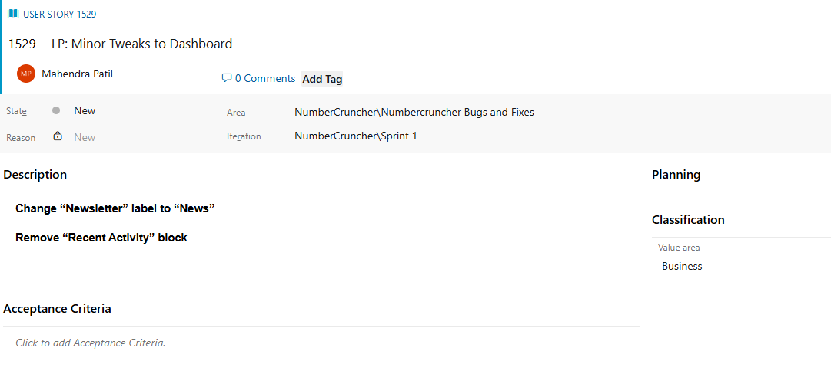

#1528:
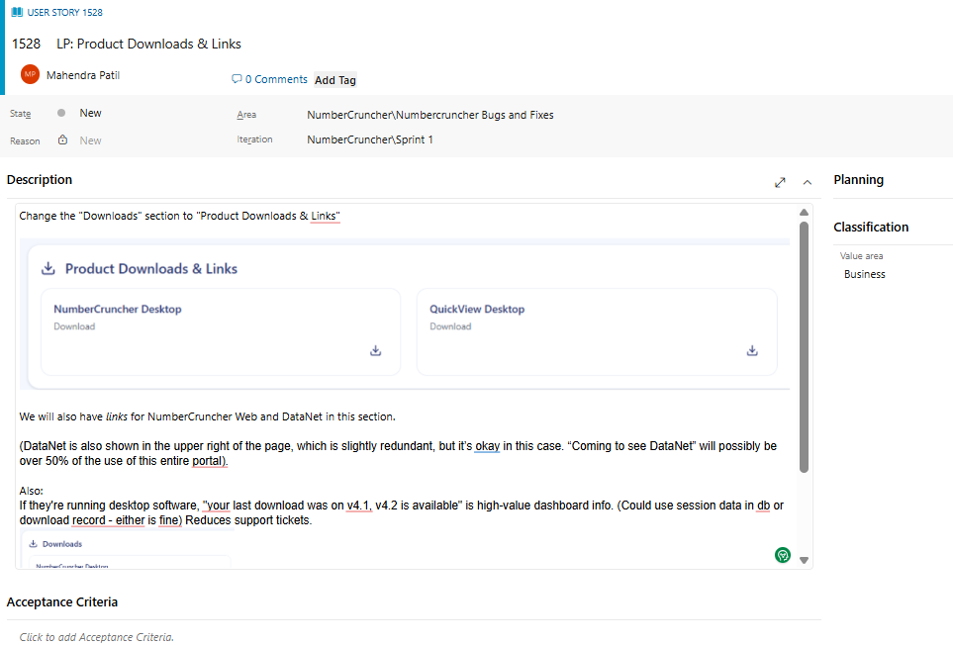

Change the "Downloads" section to "Product Downloads & Links"

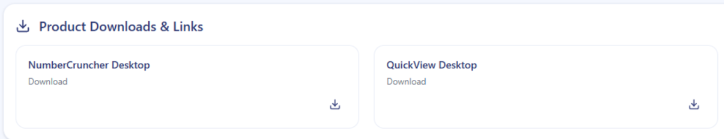

We will also have links for NumberCruncher Web and DataNet in this section.

(DataNet is also shown in the upper right of the page, which is slightly redundant, but it’s okay in this case. “Coming to see DataNet” will possibly be over 50% of the use of this entire portal).

Also:
If they're running desktop software, "your last download was on v4.1, v4.2 is available" is high-value dashboard info. (Could use session data in db or download record - either is fine) Reduces support tickets.
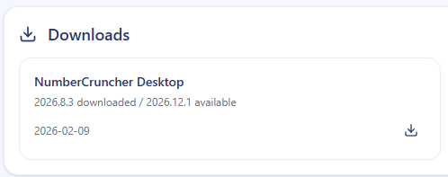

#1527:
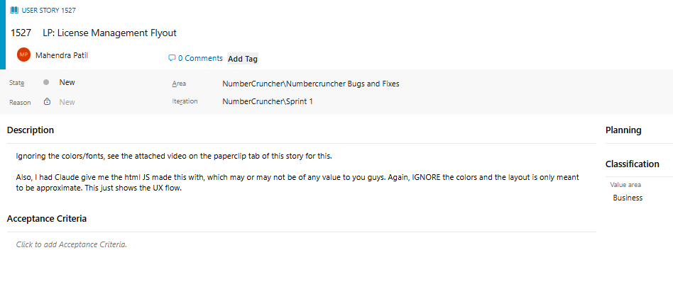
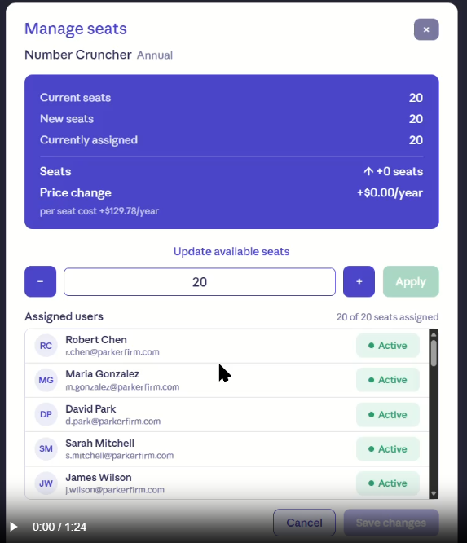
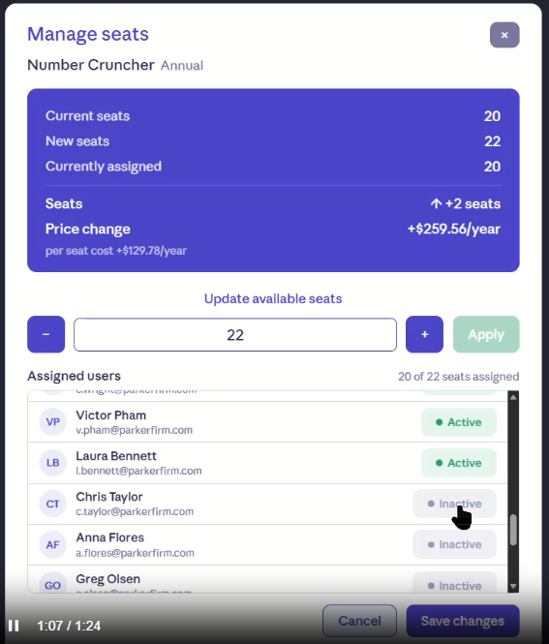
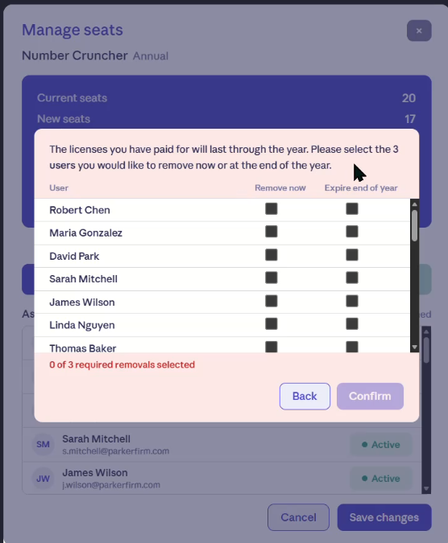
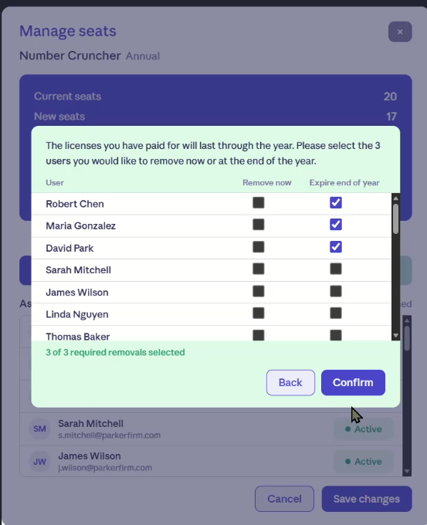
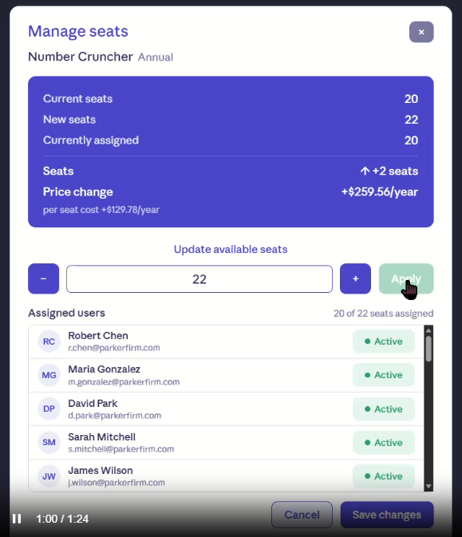

https://docs.google.com/document/d/1kLAaomb20MMQdUJjCIZOdR1hc2JwkNCisRnYg6Ja1TA/edit?tab=t.0

#1626:

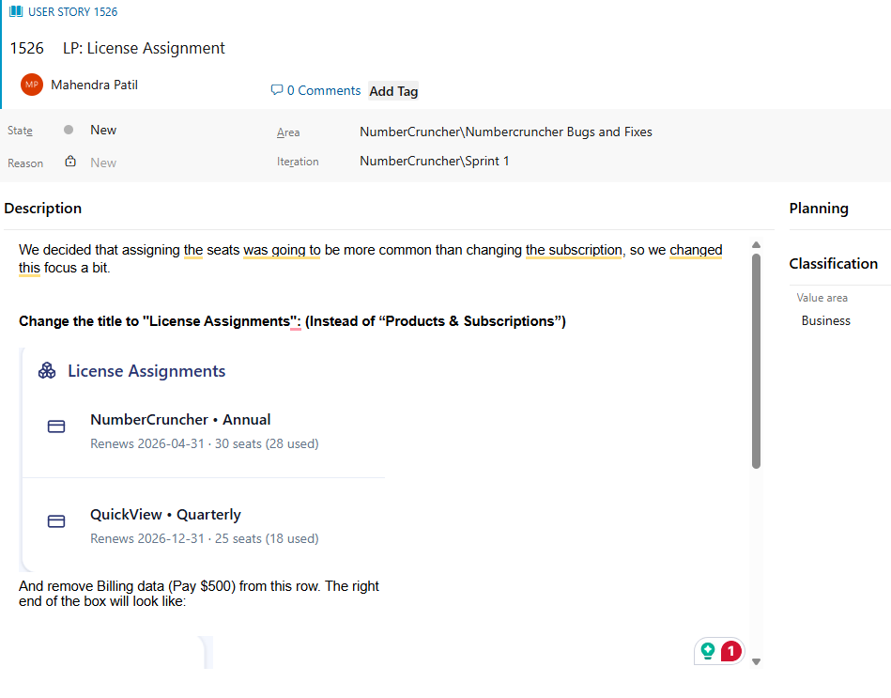
We decided that assigning the seats was going to be more common than changing the subscription, so we changed this focus a bit.

Change the title to "License Assignments": (Instead of “Products & Subscriptions”)

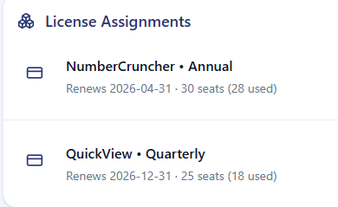
emove Billing data (Pay $500) from this row. The right end of the box will look like:

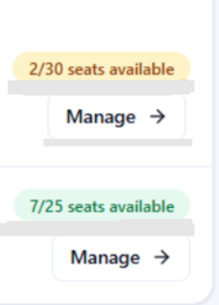

Note change: "2 available" to "2/30 seats available"

The "manage" button should go to a new flyout, which I'll create in the next story.

#1525:

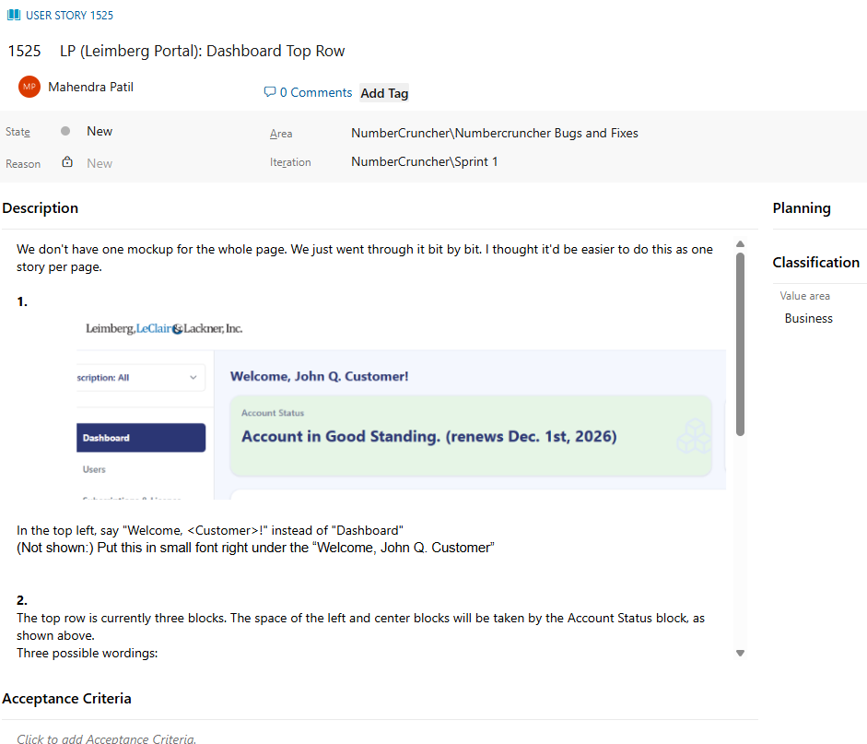
We don't have one mockup for the whole page. We just went through it bit by bit. I thought it'd be easier to do this as one story per page.

1.
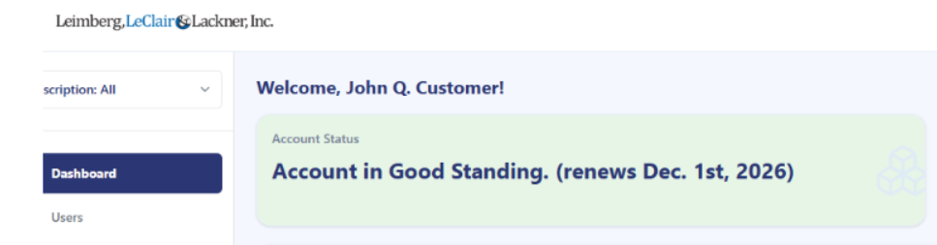

In the top left, say "Welcome, <Customer>!" instead of "Dashboard"
(Not shown:) Put this in small font right under the “Welcome, John Q. Customer”

2.
The top row is currently three blocks. The space of the left and center blocks will be taken by the Account Status block, as shown above.
Three possible wordings:
- Account is Current (Note the change from “good standing") (renews Dec. 1st, 2026) (#e6f5e6 - VERY light green for good feeling.)
- Additional License Invoice Due (this when someone has requested invoices for more users than they currently have, but hasn’t paid for them yet.) (light yellow background - not shown)
- Annual Fee Due
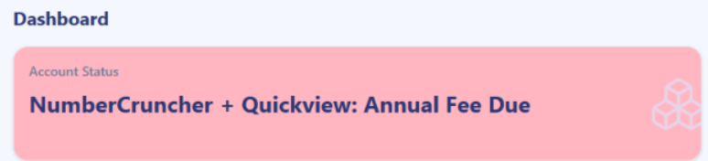

3.
The third column will just have this simple route to the latest DataNet, with a convenient way to opt out in the lower right:
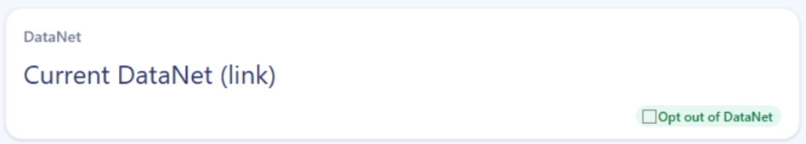
The “Opt Out” checkbox is for the current, logged individual user to opt out of the DataNet emails. (For multi-user, there will also be an option on the “User” tab.)

#1531:
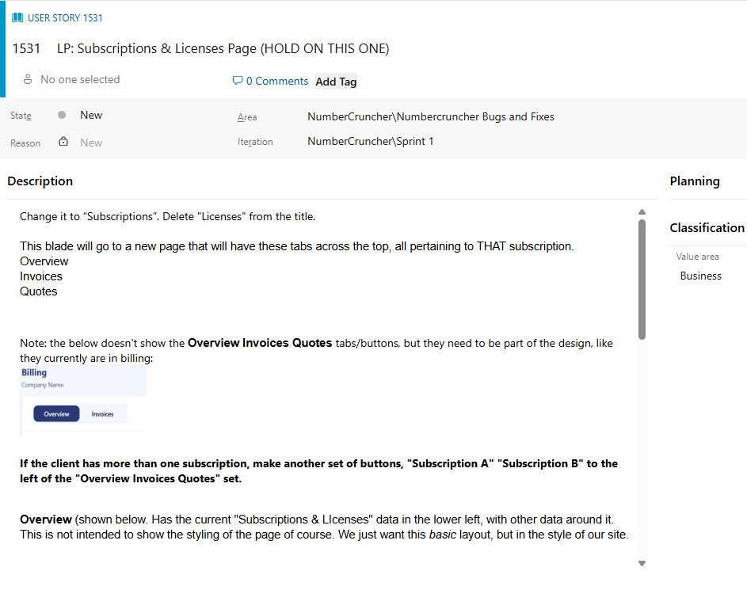

Change it to “Subscriptions”. Delete "Licenses" from the title.

This blade will go to a new page that will have these tabs across the top, all pertaining to THAT subscription.
Overview
Invoices
Quotes

Note: the below doesn't show the Overview Invoices Quotes tabs/buttons, but they need to be part of the design, like they currently are in billing:

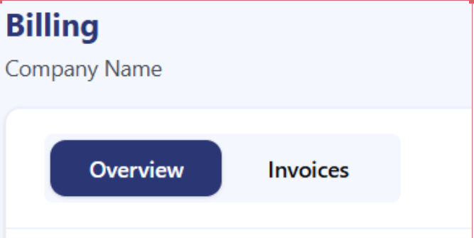

If the client has more than one subscription, make another set of buttons, "Subscription A" "Subscription B" to the left of the "Overview Invoices Quotes" set.

Overview (shown below. Has the current "Subscriptions & LIcenses" data in the lower left, with other data around it. This is not intended to show the styling of the page of course. We just want this basic layout, but in the style of our site.

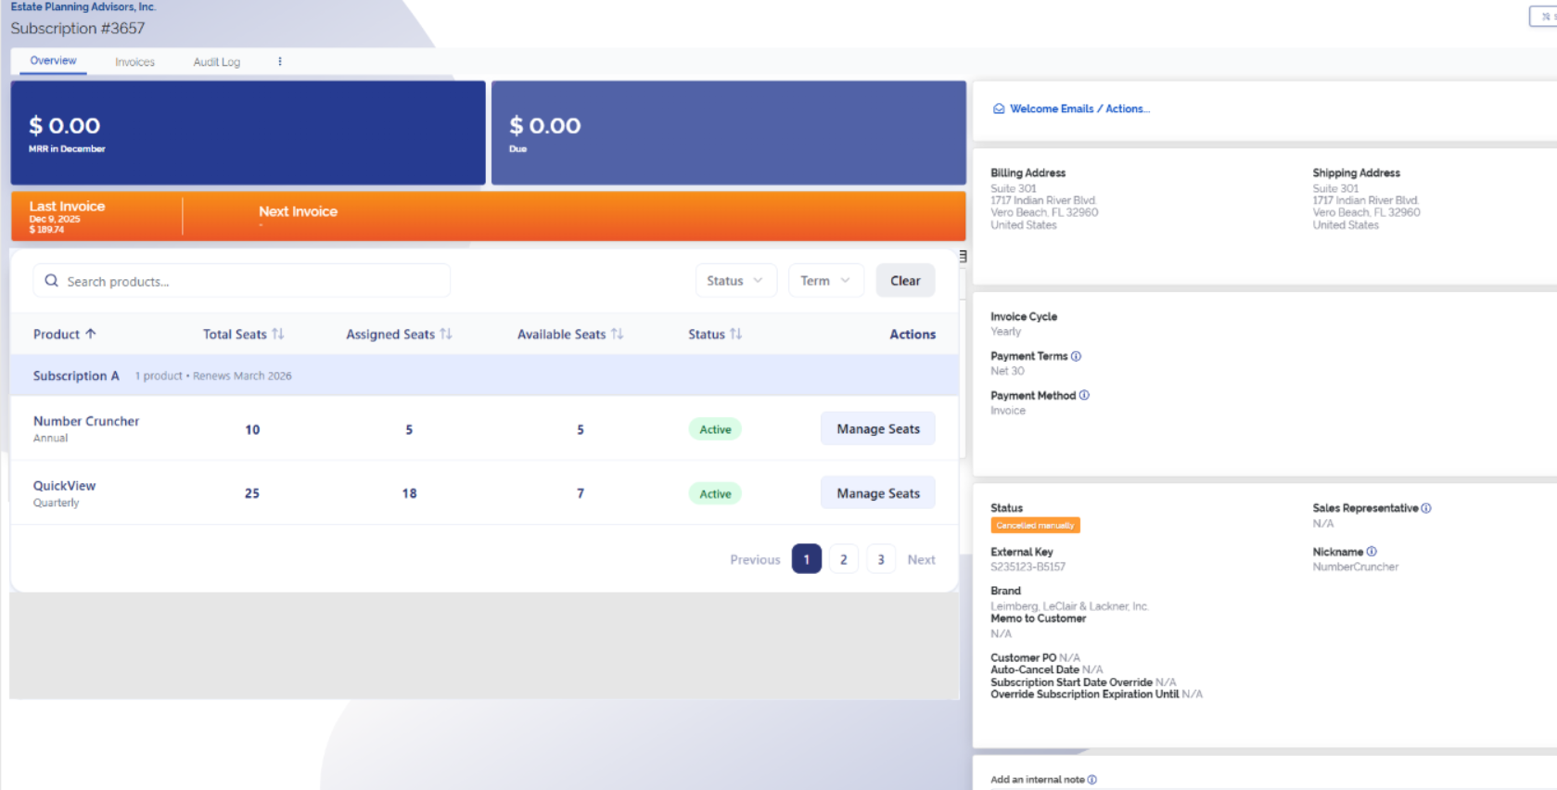

(info) You last paid by <credit card or whatever>.

Renewal options:
Direct ACH
Credit Card
ACH e-Check
Paper Check
Invoice Only (Net 30)

Billing Details: (new section under the above. Edit pencil on hover. Edit on a small popup)
Company Name:
Address:
Company Contact(s):
Their email addresses:

The next two tabs, Invoices (fine as it is) and Quotes (only one edit: remove the “plan” column) are already built.

#1533:
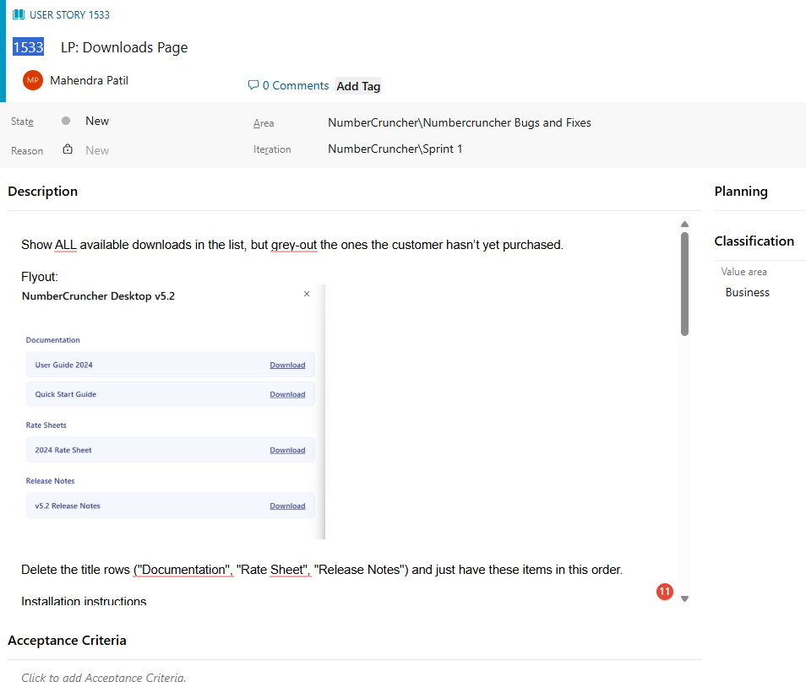
Show ALL available downloads in the list, but grey-out the ones the customer hasn’t yet purchased.

Flyout:
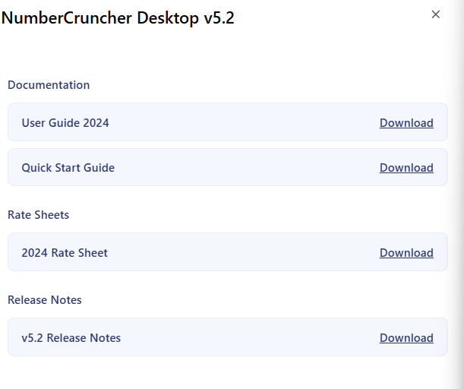
Delete the title rows ("Documentation", "Rate Sheet", "Release Notes") and just have these items in this order.
Installation instructions
Quickstart Guide
Release Notes
Documentation
Product Info

Change the buttons from “Documents” to “Resources”.(see below) When hovering over “Download” have a tooltip on resources appear on Resources that says “Helpful links including installation instructions and quick start guides are here.”

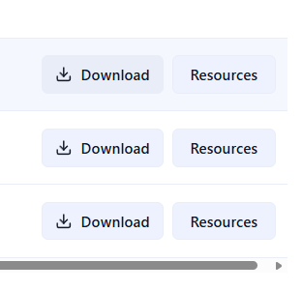
The Download button should have a main area with the word to the left, and then a dropdown arrow for other file type options.
Basically, this theme:
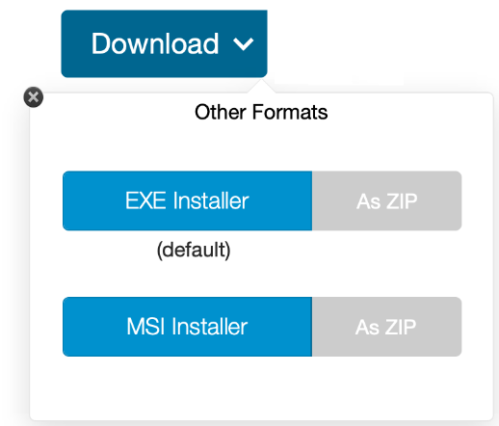
(change above label to “All Formats” instead of “Other Formats”)
#1534:

