Week- 1 Mandatory Hands-On Superset Id: 6361403 Name: Lokesh ojha

# Design Patterns and principles Exercise 1: Implementing the Singleton Pattern

Main.java

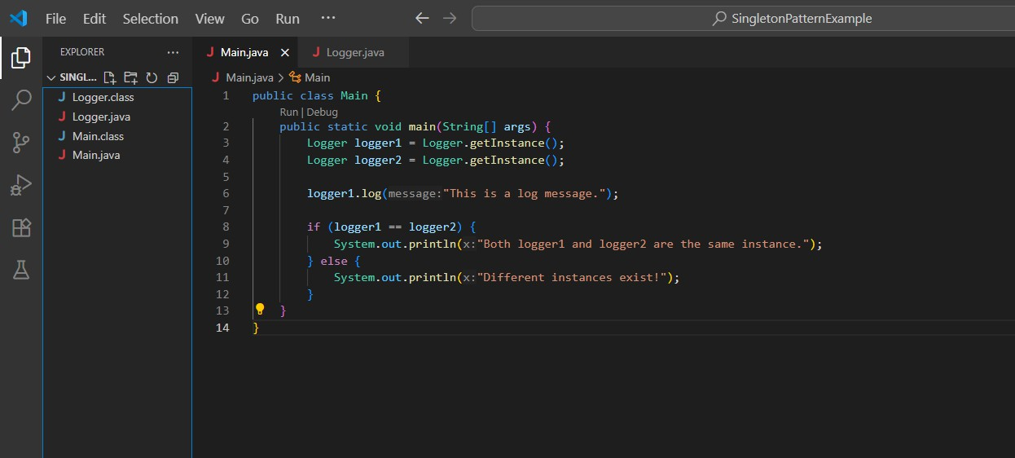

Logger.java

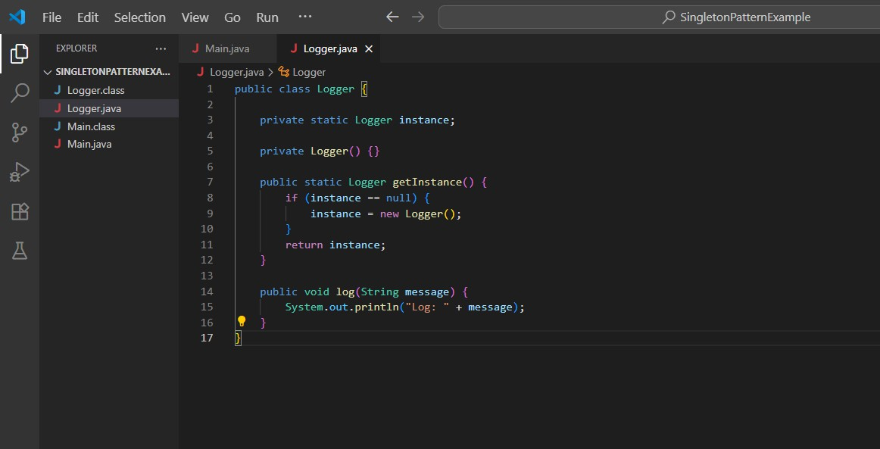

Output:

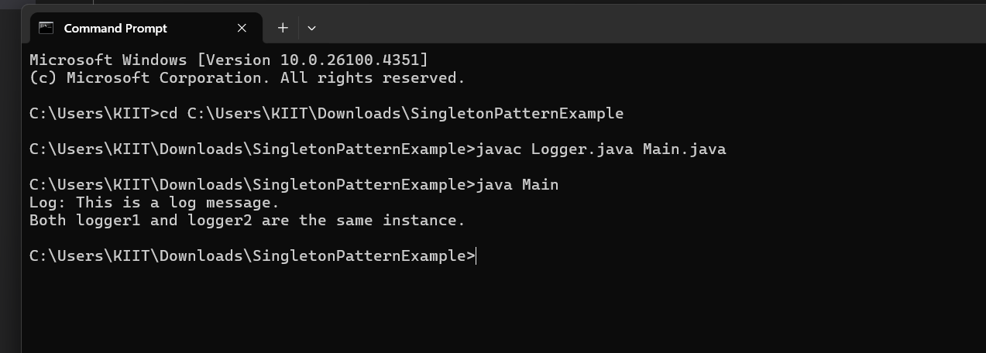

# Exercise 2: Implementing the Factory Method Pattern

Document.java

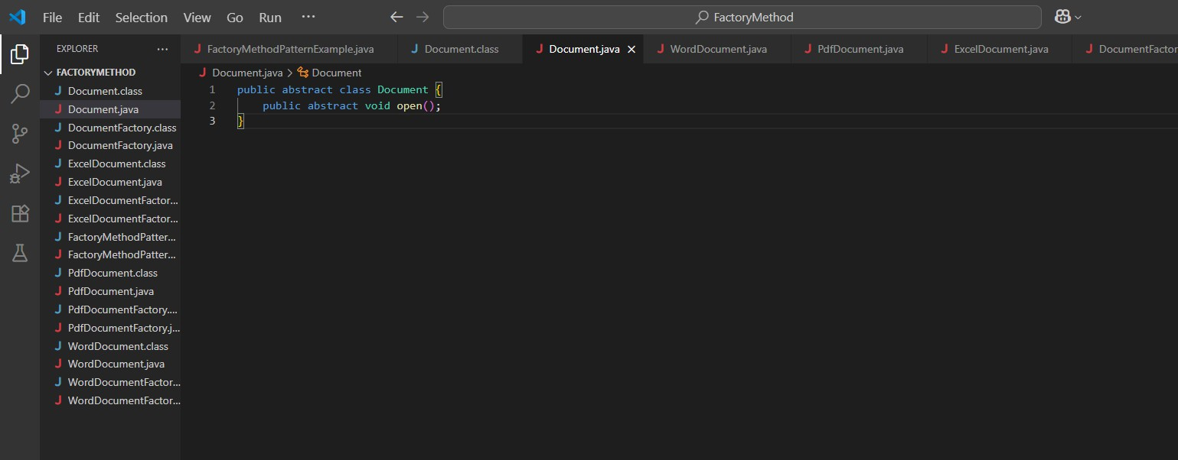

DocumentFactory.java

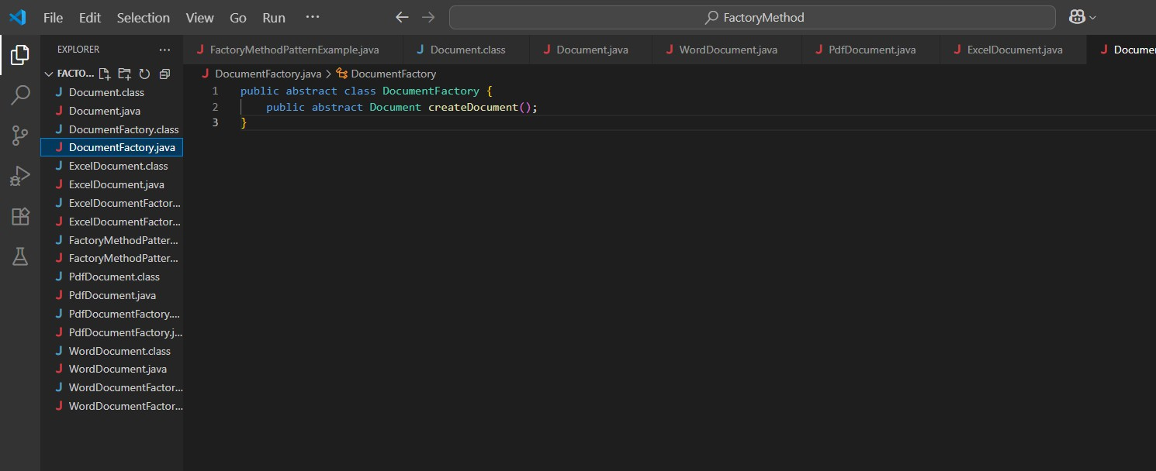

ExcelDocument.java

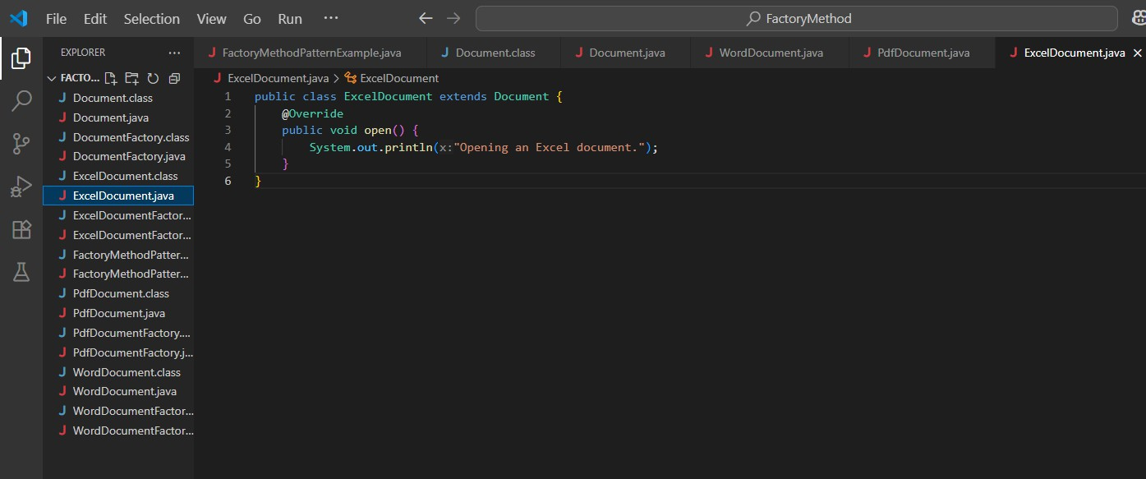

ExcelDocumentFactory.java

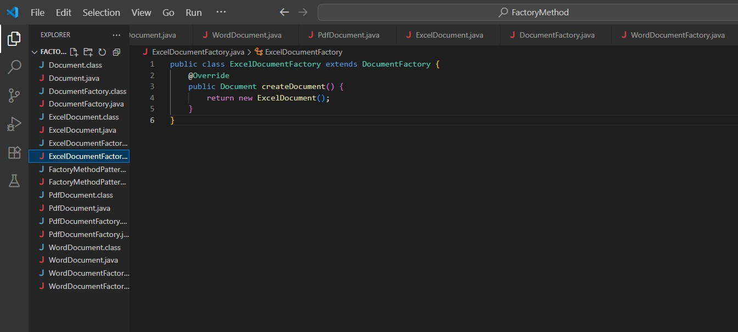

PdfDocument.java

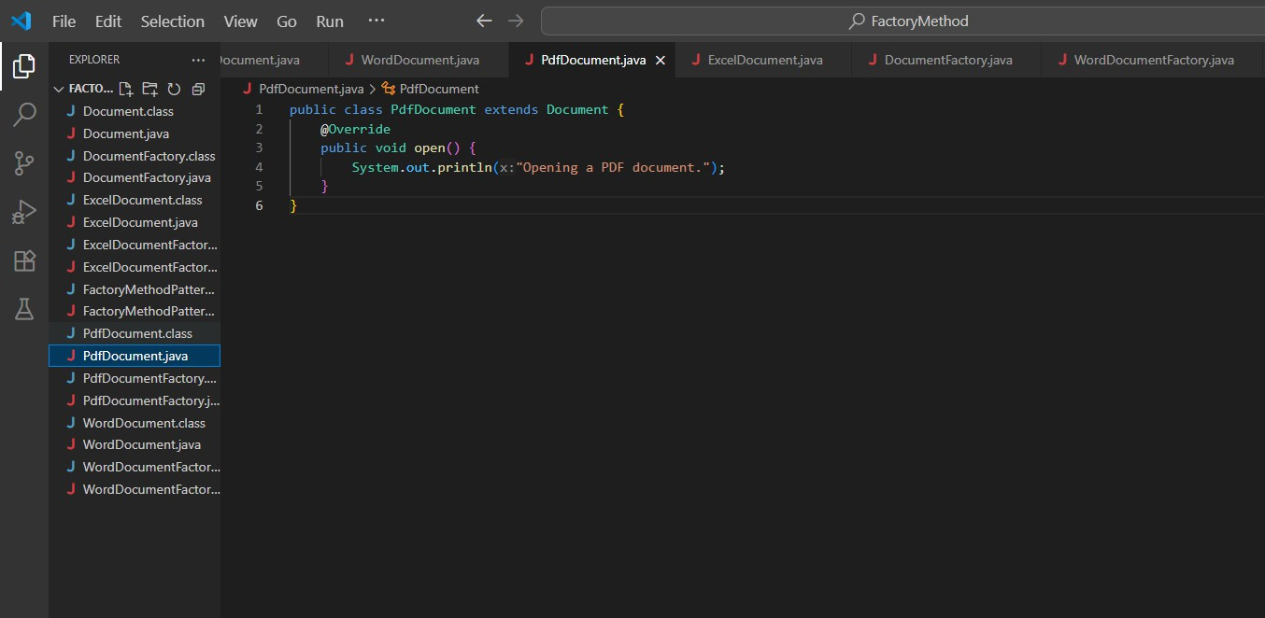

PdfDocumentFactory.java

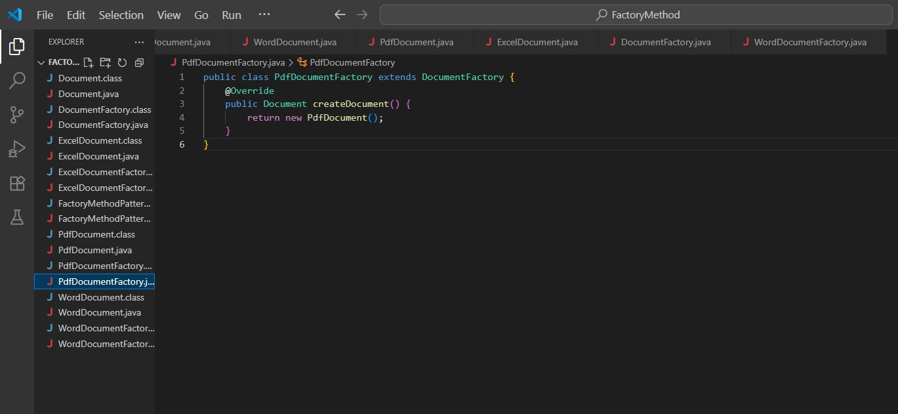

WordDocument.java

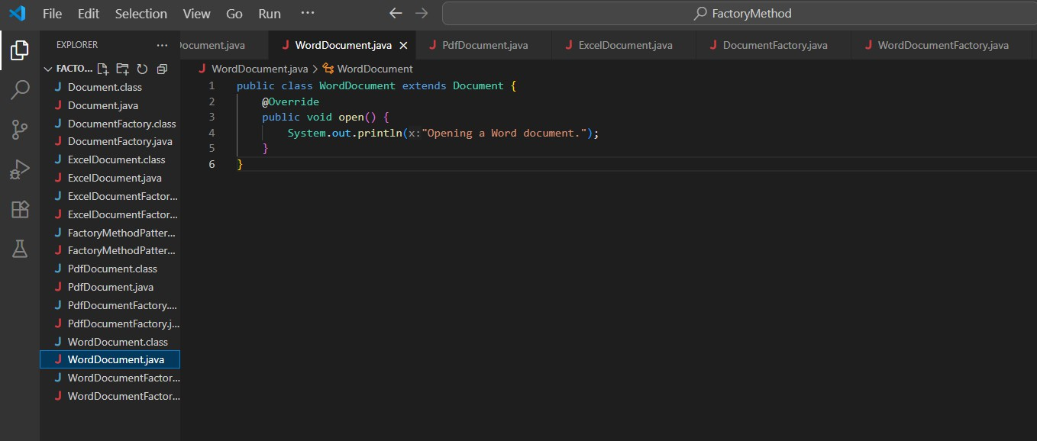

WordDocumentFactory.java

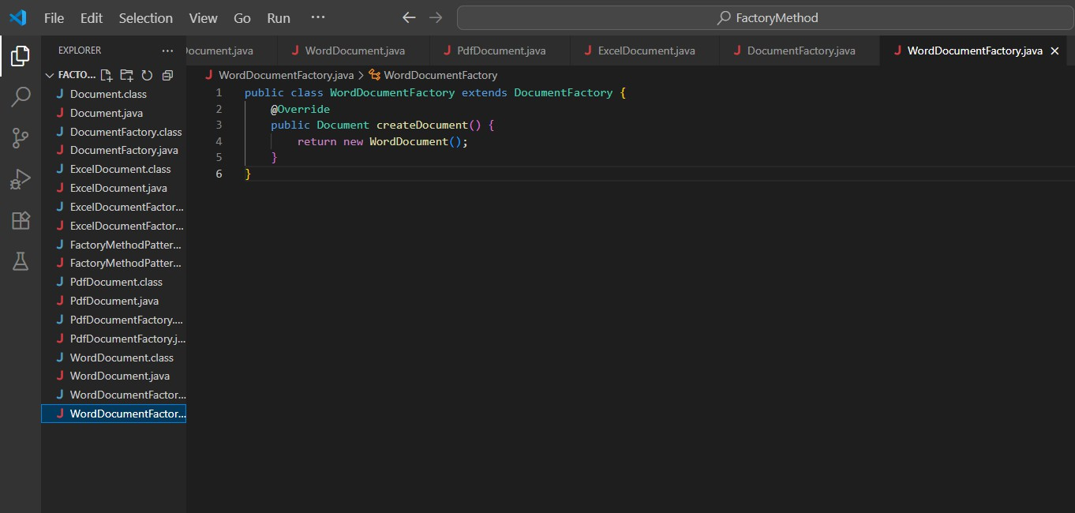

Main.java

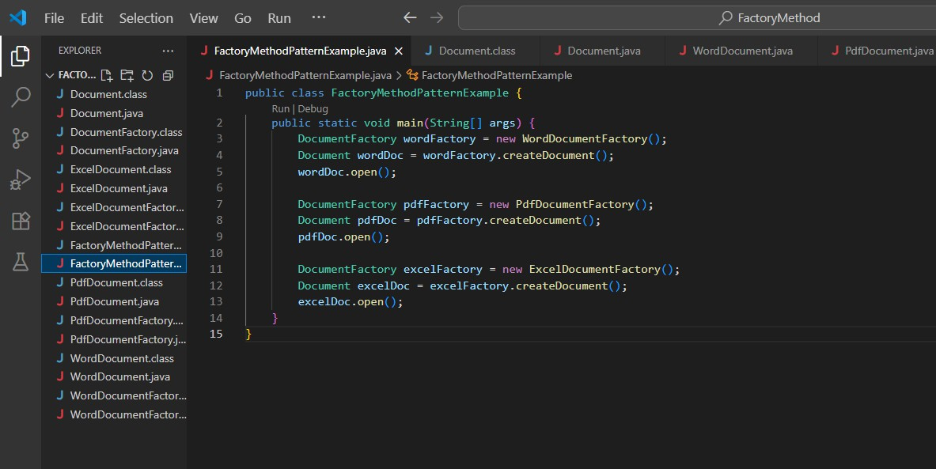

Output

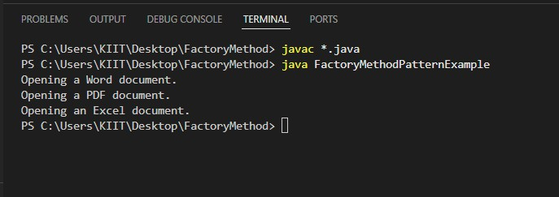

Week 1 Mandatory Hands-On

# Data structures and algorithms Exercise 2: E-commerce Platform Search Function Explanations

**Big O Notation**: Big O notation describes the upper bound of an algorithm’s running time as the input size grows. It helps us analyze and compare the efficiency of algorithms, especially for large datasets.

# Best, Average, and Worst-Case Scenarios

* Best Case: The minimum time an algorithm takes (e.g finding the item at the first position).
* Average Case: The expected time for a random input.
* Worst Case: The maximum time an algorithm takes (e.g item not found or at the last position).

Main.java

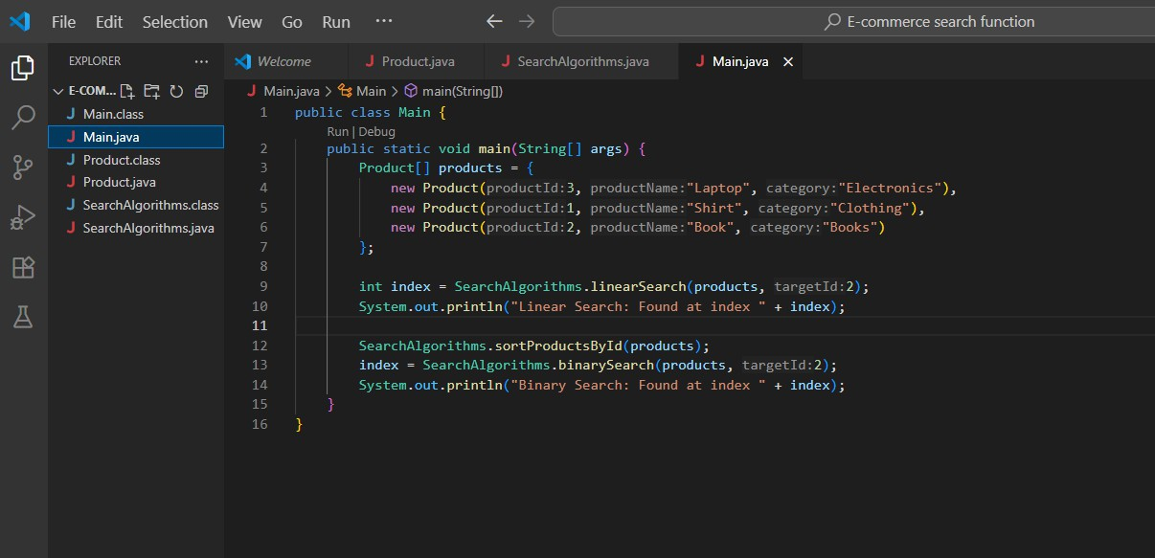

Product.java

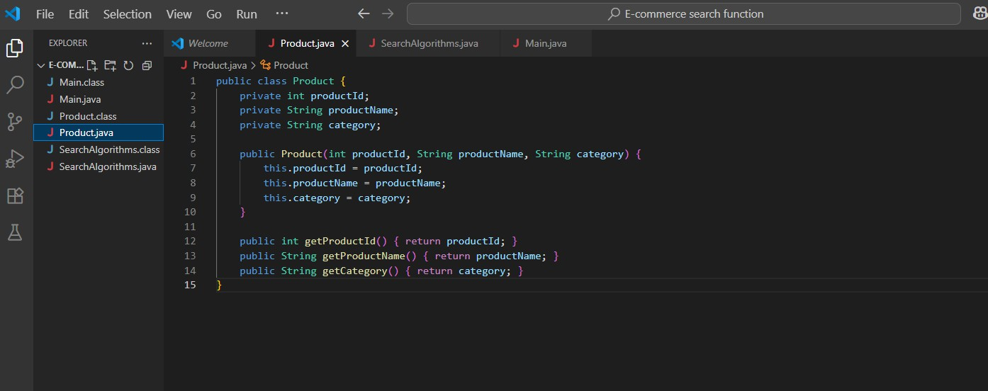

SearchAlgorithms.java

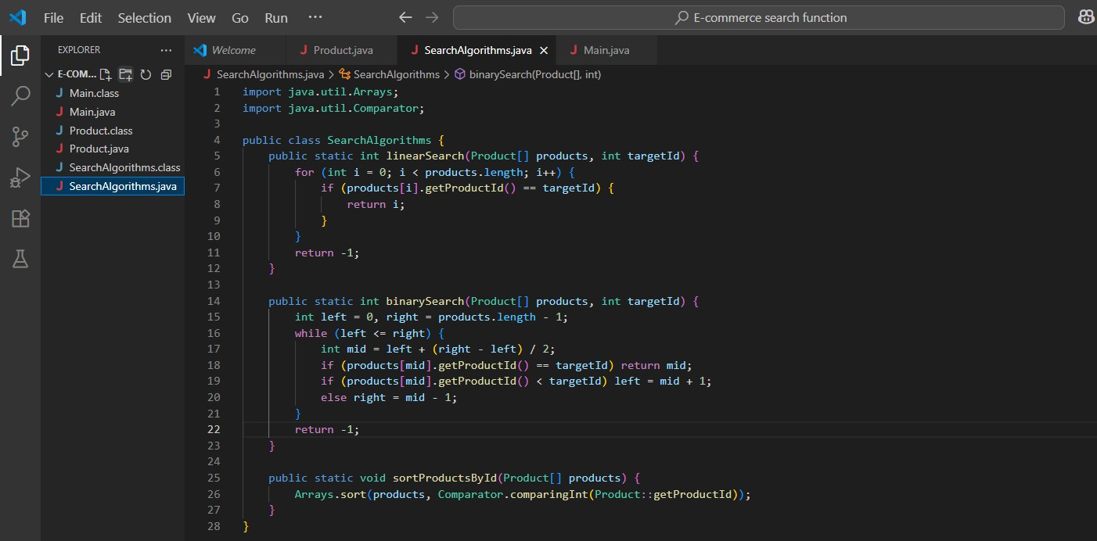

Output

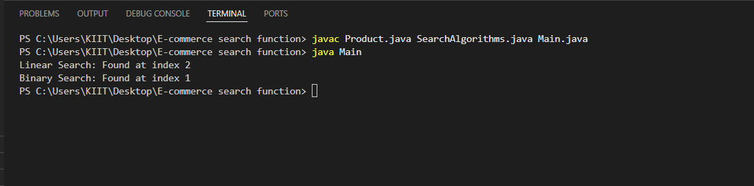

# Exercise 7: Financial Forecasting

**Recursive Algorithms**: Recursion is when a function calls itself to solve smaller instances of a problem. It simplifies problems that can be broken into similar subproblems like calculating future values over time.

FinancialForecast.java

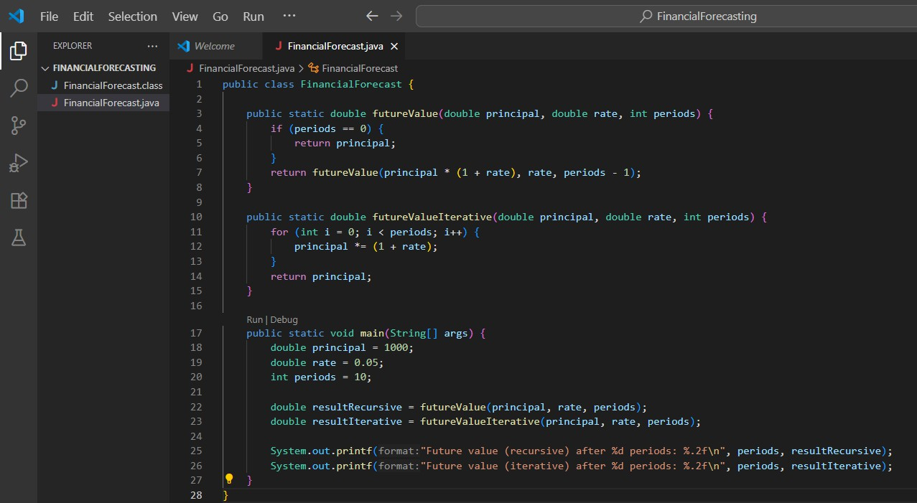

Output

