EXPERIMENT NO. 3:

STEP RESPONSE OF RLC CIRCUITS

**Objective:**

Study of digital to analog converter using R–2R ladder circuit.

**Equipment:**

1. Bread board.
2. OpAmp 741
3. Resistors
4. Wires

**Theory**

Real world signals are analog. Digital systems that interface with the real world do so using analog-to-digital converters (ADC). Conversion back to analog is accomplished using digital-to- analog converters (DAC). The R-2R ladder network is commonly used for Digital to Analog conversions.

In basic N-bit R-2R resistor ladder network the digital inputs or bits range from the most significant bit (MSB) to the least significant bit (LSB). The bits are switched between either 0V or VR and depending on the state and location of the bits Vo will vary between 0V and VR. The MSB causes the greatest change in output voltage and the LSB causes the smallest.

The R-2R ladder is inexpensive and relatively easy to manufacture since only two resistor values are required. It is fast and has fixed output impedance R.

In R-2R ladder type D to A converter, only two values of resistor are used (i.e. R and 2R). Hence it is suitable for integrated circuit fabrication. The typical values of R are from 2.5KΩ to 10KΩ. In this output voltage is a weighted sum of digital inputs. Since the resistive ladder is a linear network, the principle of super position can be used to find the total analog output voltage for a particular digital input by adding the output voltages caused by the individual digital inputs. The output voltage is linearly proportional to the digital input and the range can be adjusted by changing the reference voltage VR.

**Circuit Diagram**

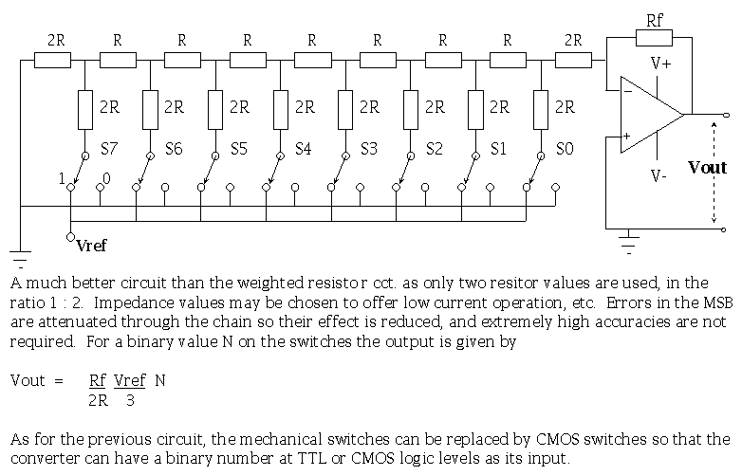

**Conclusion**

This improves the precision due to the relative ease of producing equal valued-matched resistors (or current sources).

**Applications of Digital to Analog Converter**

DACs are used in many digital signal processing applications and many more applications. Some of the important applications are discussed below.

Audio Amplifier

DACs are used to produce DC voltage gain with Microcontroller commands. Often, the DAC will be incorporated into an entire audio codec which includes signal processing features.

Video Encoder

The video encoder system will process a video signal and send digital signals to a variety of DACs to produce analog video signals of various formats, along with optimizing of output levels. As with audio codecs, these ICs may have integrated DACs.

Display Electronics

The graphic controller will typically use a lookup table to generate data signals sent to a video DAC for analog outputs such as Red, Green, Blue (RGB) signals to drive a display.

Data Acquisition Systems

Data to be measured is digitized by an Analog-to-Digital Converter (ADC) and then sent to a processor. The data acquisition will also include a process control end, in which the processor sends feedback data to a DAC for converting to analog signals.

Calibration

The DAC provides dynamic calibration for gain and voltage offset for accuracy in test and measurement systems.

Motor Control

Many motor controls require voltage control signals, and a DAC is ideal for this application which may be driven by a processor or controller.

Data Distribution System

Many industrial and factory lines require multiple programmable voltage sources, and this can be generated by a bank of DACs that are multiplexed. The use of a DAC allows the dynamic change of voltages during operation of a system.

Digital Potentiometer

Almost all [digital potentiometers](https://www.elprocus.com/types-of-variable-resistors-its-working-and-applications/) are based on the string DAC architecture. With some reorganization of the resistor/switch array, and the addition of [an I2C compatible interface](https://www.elprocus.com/i2c-bus-protocol-tutorial-interface-applications/), a fully digital potentiometer can be implemented.

Software Radio

A DAC is used with a Digital Signal Processor (DSP) to convert a signal into analog for transmission in the mixer circuit, and then to the radio’s [power amplifier](https://www.elprocus.com/classification-of-amplifiers-classes-its-applications/) and transmitter.