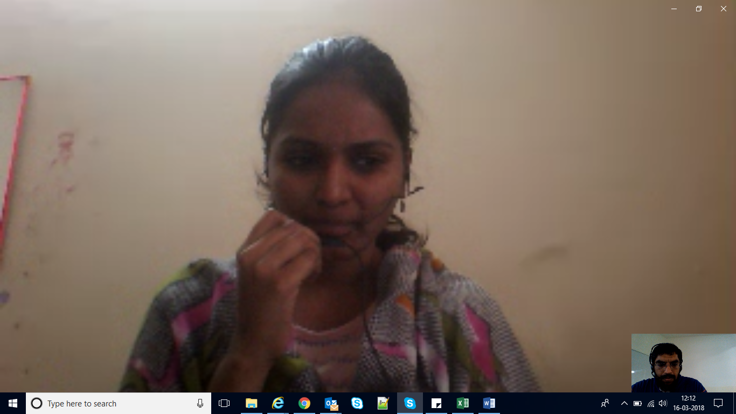

**Pkg : 5 – 6.5**

**3 months training in Tech Mahendra ODI**

**Lavanya Raghava Email:rlavanyabi@gmail.com**

**Mobile: 8096673876**

**Professional Summary:**

* Having 4.3 years of experience in Development and implementation of Data warehousing and ODI 11g/12c.
* Good understanding in ELT Design development Oracle Data integrator 11G & 12C
* Ability to setting up the connection parameters in the Topology Manager.
* Sound Knowledge on developed ODI Interfaces, packages, Models and Data stores in different Technologies.
* Sound Knowledge on Knowledge modules like RKM, LKM, CKM, IKM, and JKM.
* Good Understanding on ODI Components like Designer, Topology, Operator, Security Navigator.
* Understanding of the architecture of ODI in environment like Windows.
* Ability with loading metadata and data from Different Source Systems and into target Systems (Oracle, File, XML, SQL Server, Excel, Access).
* Ability with Exporting a Flat file source system to different target systems.
* Strong Knowledge on ODI Administration tasks and experience in creating master and work repository in the initial set up of the environment.
* Sound Knowledge about Master and Work Repositories.
* Knowledge on creating ODI procedures and to create and populate in target systems.
* Sound understanding of creating and scheduling ODI scenarios.
* Sound Knowledge on packages by using ODI tools.
* Knowledge in Debugging ODI interfaces, procedures, variables scenarios, packages.
* Extensive Experience in implementing SCD Type1 and Type2 and Change Data Capture.
* Sound knowledge at Router transformations, multi table insert.
* Fair knowledge about Standalone Agent, JavaEE Agent creation and configuration.
* Good knowledge on STAR Schema, Snowflake Schema, STARFLAKE Schema.
* Ability to do complex mappings by using ODI Interfaces.

**Education:**

* B.Tech (ECE) from Jawaharlal Nehru Technological University in 2013

**Work Experience:**

* Working as an ODI Developer in Tech Mahindra, Hyderabad from Sep 2013 to Mar 2018.

**Technical Skills**

* ETL Tool : ODI (Oracle Data Integrator 11g & 12c).
* Reporting Tool : BI Publisher
* RDBMS : Oracle 11g, 10g, 9i.
* Operating Systems : Windows, UNIX.

**Project # 1**

**Project : PPG**

**Client : PPG Industries.**

**Description: -** Paint line leverages PPG's expertise in coatings for airplanes, cars, ships and more. PPG recently announced the launch of PPG TIMELESS paint and primer in one. This premium paint for interior and exterior use incorporates PPG's industry-leading coatings innovation and expertise so do-it-yourselfers.

**Responsibilities:**

* Designed and developed different components to achieve customer requirement.
* Created Variable and using into Interfaces and Packages.
* Created Models and data stores for getting files and database object.
* Extensively worked on Defining Flat File, Relational Source & Targets, Designing Transformations Logic, Created different Mappings for different sources using LKM’s and IKM's.
* Created ODI procedures with PL/SQL Procedures to build business rules to load data.
* Performed Mapping Optimizations to ensure maximum Efficiency.
* Performed Data validation, Testing, Debugged the mapping for failed session.
* Prepared Unit Test scripts and tested data through development phase runs.
* Imported and executed master jobs, scenarios in Execution repository.
* Created jobs parallel and serial using Load plans with condition based using CASE.

**Project # 2**

**Project : American Red Cross DRMS.**

**Client : American Red Cross.**

**Description: -** The American Red Cross (ARC), also known as the American National Red Cross, is a humanitarian organization that provides emergency assistance, disaster relief and education in the United States. It is the designated US affiliate of the International Federation of Red Cross and Red Crescent Societies and United States movement to the international Red Cross and Red Crescent Movement.

**Responsibilities:**

* Developed Interfaces as per Customer requirement.
* Developed different procedures, Packages and Scenarios in ODI.
* Creating several reverse engineering Models as per the requirements.
* Performed Debugging and Tuning of Interfaces.
* Loading metadata from flat file(CSV) source system into RDBMS target system.
* Mapped Logical resources to Physical resources in contexts.
* Scheduling the scenarios by using ODI Scheduler.
* Performed unit testing at various levels of ELT flows.
* Performed UAT and data migrations from Dev to Test.
* Worked with Admin to resolve ODI Agent Load balancing issues.
* ODI Environment setup for Production and Testing.
* Knowledge transition to other team members.
* Implemented SCD Type 2 and Used CDC features for Incremental data loads.

**Project # 3:**

**Project : Wilsonart ODI and Data Cap.**

**Client : Wilsonart LLC**

**Description:-** Wilsonart is a global manufacturer and distributor of High Pressure Laminates and other engineered composite materials, used in furniture, office and retail space, countertops, worktops and other applications. Headquartered in Temple , Taxes Wilsonart was founded by Ralph Wilson Sr. in 1956. The company sells decorative laminates and other engineered surfaces under the Wilsonart brand and international brands Arborite, Polyrey, and Resopal.

**Responsibilities:**

* Designed and developed Joins, Lookup transformations to achieve customer requirement.
* Taking care of Sales, Orders, Finance and Operational data loads.
* Created Variable and using into Interfaces and Packages.
* Created Models and data stores for getting files and database object.
* Extensively worked on Defining Flat File, Relational Source & Targets, Designing Transformations Logic, Created different Interfaces for different sources using LKM’s and IKM's.
* Created ODI procedures with PL/SQL Procedures to build business rules to load data.
* Performed Mapping Optimizations to ensure maximum Efficiency.
* Performed Data validation, Testing, Debugged the mapping for failed session.
* Prepared Unit Test scripts and tested data through development phase runs.
* Imported and executed master jobs, scenarios in Execution repository.
* Performed UAT and code migrations from Dev to Test.