{QUESTION BEGINS}
{QUESTION NUMBER} 1
{SUBJECT} Numerical Ability
{TOPIC} Number System
{TAGS} tcs nqt, numerical ability, full syllabus mix, hard
{QUESTION TYPE} SINGLECORRECT
{QUESTION TEXT} How many positive integers not exceeding 200 are coprime to 200?
{OPTION 1} 100
{OPTION 2} 80
{OPTION 3} 60
{OPTION 4} 40
{OPTION 5}
{OPTION 6}
{OPTION 7}
{OPTION 8}
{OPTION 9}
{OPTION 10}
{RIGHT ANSWER} 2
{EXPLANATION} 200 = 2³ × 5². The count = 200 × (1 − 1/2)(1 − 1/5) = 200 × 1/2 × 4/5 = 80.
{CORRECT MARKS} 1
{NEGATIVE MARKS} 0
{DIFFICULTY} Hard
{QUESTION ENDS}

{QUESTION BEGINS}
{QUESTION NUMBER} 2
{SUBJECT} Numerical Ability
{TOPIC} Profit and Loss
{TAGS} tcs nqt, numerical ability, full syllabus mix, hard
{QUESTION TYPE} SINGLECORRECT
{QUESTION TEXT} A shopkeeper marks his goods 40% above the cost price and then allows two successive discounts of 10% and 20%. What is his net profit percentage?
{OPTION 1} 1.2%
{OPTION 2} 0.8%
{OPTION 3} 8%
{OPTION 4} 4%
{OPTION 5}
{OPTION 6}
{OPTION 7}
{OPTION 8}
{OPTION 9}
{OPTION 10}
{RIGHT ANSWER} 2
{EXPLANATION} Take CP = 100. MP = 140. SP = 140 × 0.9 × 0.8 = 100.8. Profit = 0.8%.
{CORRECT MARKS} 1
{NEGATIVE MARKS} 0
{DIFFICULTY} Hard
{QUESTION ENDS}

{QUESTION BEGINS}
{QUESTION NUMBER} 3
{SUBJECT} Numerical Ability
{TOPIC} Permutation and Combination
{TAGS} tcs nqt, numerical ability, full syllabus mix, hard
{QUESTION TYPE} SINGLECORRECT
{QUESTION TEXT} How many four-digit numbers greater than 5000 can be formed using the digits 1 to 7, with no digit repeated?
{OPTION 1} 360
{OPTION 2} 300
{OPTION 3} 420
{OPTION 4} 240
{OPTION 5}
{OPTION 6}
{OPTION 7}
{OPTION 8}
{OPTION 9}
{OPTION 10}
{RIGHT ANSWER} 1
{EXPLANATION} The first digit can be 5, 6 or 7 (3 choices). The other three places can be filled in 6 × 5 × 4 = 120 ways. Total = 3 × 120 = 360.
{CORRECT MARKS} 1
{NEGATIVE MARKS} 0
{DIFFICULTY} Hard
{QUESTION ENDS}

{QUESTION BEGINS}
{QUESTION NUMBER} 4
{SUBJECT} Numerical Ability
{TOPIC} Mixtures
{TAGS} tcs nqt, numerical ability, full syllabus mix, hard
{QUESTION TYPE} SINGLECORRECT
{QUESTION TEXT} A 50-litre mixture contains milk and water in the ratio 7 : 3. 10 litres of the mixture is removed and replaced with water. What is the new ratio of milk to water?
{OPTION 1} 14 : 11
{OPTION 2} 7 : 3
{OPTION 3} 7 : 5
{OPTION 4} 35 : 33
{OPTION 5}
{OPTION 6}
{OPTION 7}
{OPTION 8}
{OPTION 9}
{OPTION 10}
{RIGHT ANSWER} 1
{EXPLANATION} Milk = 35 L and water = 15 L. The 10 L removed contains 7 L milk and 3 L water. Milk left = 28 L. Water = 15 − 3 + 10 = 22 L. Ratio = 28 : 22 = 14 : 11.
{CORRECT MARKS} 1
{NEGATIVE MARKS} 0
{DIFFICULTY} Hard
{QUESTION ENDS}

{QUESTION BEGINS}
{QUESTION NUMBER} 5
{SUBJECT} Numerical Ability
{TOPIC} Averages
{TAGS} tcs nqt, numerical ability, full syllabus mix, hard
{QUESTION TYPE} SINGLECORRECT
{QUESTION TEXT} The average of 11 numbers is 50. The average of the first six is 49 and the average of the last six is 52. What is the sixth number?
{OPTION 1} 54
{OPTION 2} 60
{OPTION 3} 56
{OPTION 4} 52
{OPTION 5}
{OPTION 6}
{OPTION 7}
{OPTION 8}
{OPTION 9}
{OPTION 10}
{RIGHT ANSWER} 3
{EXPLANATION} The sum of the first six = 294 and of the last six = 312. These counts include the sixth number twice, so 294 + 312 = 550 + (sixth number). Sixth number = 606 − 550 = 56.
{CORRECT MARKS} 1
{NEGATIVE MARKS} 0
{DIFFICULTY} Hard
{QUESTION ENDS}

{QUESTION BEGINS}
{QUESTION NUMBER} 6
{SUBJECT} Numerical Ability
{TOPIC} Ages
{TAGS} tcs nqt, numerical ability, full syllabus mix, hard
{QUESTION TYPE} SINGLECORRECT
{QUESTION TEXT} A father is four times as old as his son. Six years from now he will be three times as old as his son. What is the father's present age?
{OPTION 1} 40 years
{OPTION 2} 52 years
{OPTION 3} 48 years
{OPTION 4} 44 years
{OPTION 5}
{OPTION 6}
{OPTION 7}
{OPTION 8}
{OPTION 9}
{OPTION 10}
{RIGHT ANSWER} 3
{EXPLANATION} F = 4S and F + 6 = 3(S + 6). So 4S + 6 = 3S + 18, giving S = 12 and F = 48 years.
{CORRECT MARKS} 1
{NEGATIVE MARKS} 0
{DIFFICULTY} Hard
{QUESTION ENDS}

{QUESTION BEGINS}
{QUESTION NUMBER} 7
{SUBJECT} Numerical Ability
{TOPIC} Time and Work
{TAGS} tcs nqt, numerical ability, full syllabus mix, hard
{QUESTION TYPE} SINGLECORRECT
{QUESTION TEXT} A is twice as efficient as B. Together they finish a work in 18 days. In how many days can A alone finish it?
{OPTION 1} 24 days
{OPTION 2} 27 days
{OPTION 3} 54 days
{OPTION 4} 36 days
{OPTION 5}
{OPTION 6}
{OPTION 7}
{OPTION 8}
{OPTION 9}
{OPTION 10}
{RIGHT ANSWER} 2
{EXPLANATION} Efficiencies are 2 : 1, so the total work = (2 + 1) × 18 = 54 units. A does 2 units a day, so A alone takes 54/2 = 27 days.
{CORRECT MARKS} 1
{NEGATIVE MARKS} 0
{DIFFICULTY} Hard
{QUESTION ENDS}

{QUESTION BEGINS}
{QUESTION NUMBER} 8
{SUBJECT} Numerical Ability
{TOPIC} Surds
{TAGS} tcs nqt, numerical ability, full syllabus mix, hard
{QUESTION TYPE} SINGLECORRECT
{QUESTION TEXT} 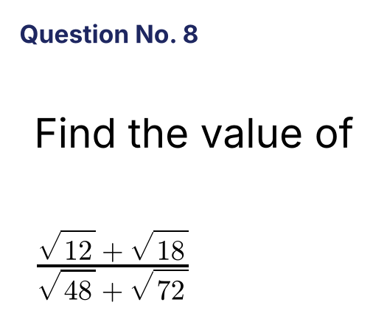
{OPTION 1} 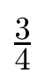
{OPTION 2} 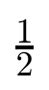
{OPTION 3} 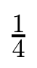
{OPTION 4} 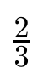
{OPTION 5}
{OPTION 6}
{OPTION 7}
{OPTION 8}
{OPTION 9}
{OPTION 10}
{RIGHT ANSWER} 2
{EXPLANATION} √12 + √18 = 2√3 + 3√2 and √48 + √72 = 4√3 + 6√2 = 2(2√3 + 3√2). The ratio = 1/2.
{CORRECT MARKS} 1
{NEGATIVE MARKS} 0
{DIFFICULTY} Hard
{QUESTION ENDS}

{QUESTION BEGINS}
{QUESTION NUMBER} 9
{SUBJECT} Numerical Ability
{TOPIC} Compound Interest
{TAGS} tcs nqt, numerical ability, full syllabus mix, hard
{QUESTION TYPE} SINGLECORRECT
{QUESTION TEXT} The difference between the compound interest and the simple interest on a sum for 3 years at 5% per annum is ₹122. What is the sum?
{OPTION 1} ₹12,000
{OPTION 2} ₹18,000
{OPTION 3} ₹16,000
{OPTION 4} ₹15,000
{OPTION 5}
{OPTION 6}
{OPTION 7}
{OPTION 8}
{OPTION 9}
{OPTION 10}
{RIGHT ANSWER} 3
{EXPLANATION} CI − SI for 3 years = P(r/100)²(3 + r/100)... = P × 0.0025 × 3.05 = 0.007625P = 122, so P = ₹16,000.
{CORRECT MARKS} 1
{NEGATIVE MARKS} 0
{DIFFICULTY} Hard
{QUESTION ENDS}

{QUESTION BEGINS}
{QUESTION NUMBER} 10
{SUBJECT} Numerical Ability
{TOPIC} Percentages
{TAGS} tcs nqt, numerical ability, full syllabus mix, hard
{QUESTION TYPE} SINGLECORRECT
{QUESTION TEXT} A machine loses 10% of its value in the first year and 15% of the remaining value in the second year. After two years it is worth ₹61,200. What was its original value?
{OPTION 1} ₹85,000
{OPTION 2} ₹80,000
{OPTION 3} ₹78,500
{OPTION 4} ₹75,000
{OPTION 5}
{OPTION 6}
{OPTION 7}
{OPTION 8}
{OPTION 9}
{OPTION 10}
{RIGHT ANSWER} 2
{EXPLANATION} Value factor = 0.90 × 0.85 = 0.765. Original value = 61,200/0.765 = ₹80,000.
{CORRECT MARKS} 1
{NEGATIVE MARKS} 0
{DIFFICULTY} Hard
{QUESTION ENDS}

{QUESTION BEGINS}
{QUESTION NUMBER} 11
{SUBJECT} Numerical Ability
{TOPIC} Logarithms
{TAGS} tcs nqt, numerical ability, full syllabus mix, hard
{QUESTION TYPE} SINGLECORRECT
{QUESTION TEXT} 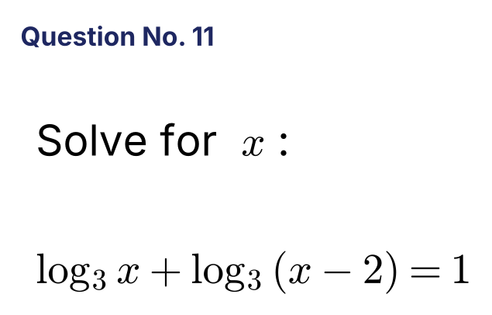
{OPTION 1} 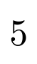
{OPTION 2} 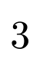
{OPTION 3} 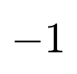
{OPTION 4} 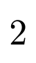
{OPTION 5}
{OPTION 6}
{OPTION 7}
{OPTION 8}
{OPTION 9}
{OPTION 10}
{RIGHT ANSWER} 2
{EXPLANATION} log₃[x(x − 2)] = 1, so x(x − 2) = 3, x² − 2x − 3 = 0 and x = 3 or −1. Since the logarithm needs x > 2, x = 3.
{CORRECT MARKS} 1
{NEGATIVE MARKS} 0
{DIFFICULTY} Hard
{QUESTION ENDS}

{QUESTION BEGINS}
{QUESTION NUMBER} 12
{SUBJECT} Numerical Ability
{TOPIC} Percentages
{TAGS} tcs nqt, numerical ability, full syllabus mix, hard
{QUESTION TYPE} SINGLECORRECT
{QUESTION TEXT} A is 40% more than B, and B is 25% less than C. By what percentage is A more than C?
{OPTION 1} 2.5%
{OPTION 2} 10%
{OPTION 3} 15%
{OPTION 4} 5%
{OPTION 5}
{OPTION 6}
{OPTION 7}
{OPTION 8}
{OPTION 9}
{OPTION 10}
{RIGHT ANSWER} 4
{EXPLANATION} Take C = 100. B = 75 and A = 75 × 1.4 = 105. So A is 5% more than C.
{CORRECT MARKS} 1
{NEGATIVE MARKS} 0
{DIFFICULTY} Hard
{QUESTION ENDS}

{QUESTION BEGINS}
{QUESTION NUMBER} 13
{SUBJECT} Numerical Ability
{TOPIC} Simplification
{TAGS} tcs nqt, numerical ability, full syllabus mix, hard
{QUESTION TYPE} SINGLECORRECT
{QUESTION TEXT} 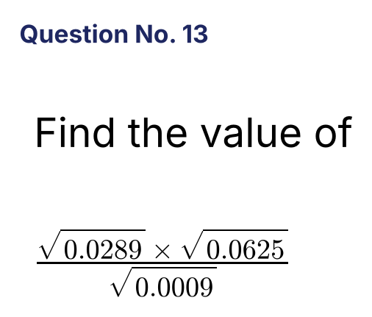
{OPTION 1} 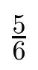
{OPTION 2} 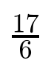
{OPTION 3} 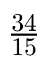
{OPTION 4} 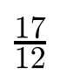
{OPTION 5}
{OPTION 6}
{OPTION 7}
{OPTION 8}
{OPTION 9}
{OPTION 10}
{RIGHT ANSWER} 4
{EXPLANATION} √0.0289 = 0.17, √0.0625 = 0.25 and √0.0009 = 0.03. The value = (0.17 × 0.25)/0.03 = 0.0425/0.03 = 17/12.
{CORRECT MARKS} 1
{NEGATIVE MARKS} 0
{DIFFICULTY} Hard
{QUESTION ENDS}

{QUESTION BEGINS}
{QUESTION NUMBER} 14
{SUBJECT} Numerical Ability
{TOPIC} LCM and HCF
{TAGS} tcs nqt, numerical ability, full syllabus mix, hard
{QUESTION TYPE} SINGLECORRECT
{QUESTION TEXT} The LCM of two numbers is 360 and their HCF is 6. If one number is 72, what is the other?
{OPTION 1} 30
{OPTION 2} 60
{OPTION 3} 36
{OPTION 4} 45
{OPTION 5}
{OPTION 6}
{OPTION 7}
{OPTION 8}
{OPTION 9}
{OPTION 10}
{RIGHT ANSWER} 1
{EXPLANATION} Product of the numbers = LCM × HCF = 360 × 6 = 2160. The other number = 2160/72 = 30.
{CORRECT MARKS} 1
{NEGATIVE MARKS} 0
{DIFFICULTY} Hard
{QUESTION ENDS}

{QUESTION BEGINS}
{QUESTION NUMBER} 15
{SUBJECT} Numerical Ability
{TOPIC} Surds
{TAGS} tcs nqt, numerical ability, full syllabus mix, hard
{QUESTION TYPE} SINGLECORRECT
{QUESTION TEXT} 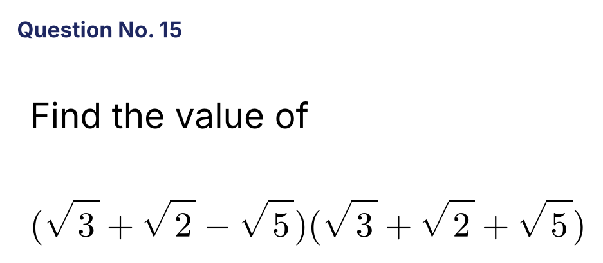
{OPTION 1} 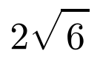
{OPTION 2} 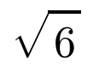
{OPTION 3} 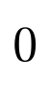
{OPTION 4} 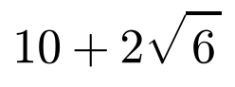
{OPTION 5}
{OPTION 6}
{OPTION 7}
{OPTION 8}
{OPTION 9}
{OPTION 10}
{RIGHT ANSWER} 1
{EXPLANATION} This is (√3 + √2)² − (√5)² = (5 + 2√6) − 5 = 2√6.
{CORRECT MARKS} 1
{NEGATIVE MARKS} 0
{DIFFICULTY} Hard
{QUESTION ENDS}

{QUESTION BEGINS}
{QUESTION NUMBER} 16
{SUBJECT} Numerical Ability
{TOPIC} Time and Work
{TAGS} tcs nqt, numerical ability, full syllabus mix, hard
{QUESTION TYPE} SINGLECORRECT
{QUESTION TEXT} Pipe A fills a tank in 20 minutes and pipe B in 30 minutes. A leak at the bottom can empty the full tank in 60 minutes. If all are open, in how many minutes is the empty tank filled?
{OPTION 1} 15
{OPTION 2} 18
{OPTION 3} 20
{OPTION 4} 12
{OPTION 5}
{OPTION 6}
{OPTION 7}
{OPTION 8}
{OPTION 9}
{OPTION 10}
{RIGHT ANSWER} 1
{EXPLANATION} Net rate = 1/20 + 1/30 − 1/60 = (3 + 2 − 1)/60 = 4/60 = 1/15. So the tank fills in 15 minutes.
{CORRECT MARKS} 1
{NEGATIVE MARKS} 0
{DIFFICULTY} Hard
{QUESTION ENDS}

{QUESTION BEGINS}
{QUESTION NUMBER} 17
{SUBJECT} Numerical Ability
{TOPIC} Profit and Loss
{TAGS} tcs nqt, numerical ability, full syllabus mix, hard
{QUESTION TYPE} SINGLECORRECT
{QUESTION TEXT} The cost prices of two articles are in the ratio 3 : 5. The first is sold at a 20% profit and the second at a 10% loss. What is the overall profit or loss percentage?
{OPTION 1} 5% profit
{OPTION 2} 2.5% profit
{OPTION 3} 1.25% loss
{OPTION 4} 1.25% profit
{OPTION 5}
{OPTION 6}
{OPTION 7}
{OPTION 8}
{OPTION 9}
{OPTION 10}
{RIGHT ANSWER} 4
{EXPLANATION} Take costs 300 and 500 (total 800). Profit on the first = 60. Loss on the second = 50. Net profit = 10 on 800 = 1.25%.
{CORRECT MARKS} 1
{NEGATIVE MARKS} 0
{DIFFICULTY} Hard
{QUESTION ENDS}

{QUESTION BEGINS}
{QUESTION NUMBER} 18
{SUBJECT} Numerical Ability
{TOPIC} Ratio and Proportion
{TAGS} tcs nqt, numerical ability, full syllabus mix, hard
{QUESTION TYPE} SINGLECORRECT
{QUESTION TEXT} 15 men working 8 hours a day build a 90 m wall in 12 days. In how many days will 20 men working 6 hours a day build a 120 m wall of the same kind?
{OPTION 1} 14
{OPTION 2} 16
{OPTION 3} 18
{OPTION 4} 20
{OPTION 5}
{OPTION 6}
{OPTION 7}
{OPTION 8}
{OPTION 9}
{OPTION 10}
{RIGHT ANSWER} 2
{EXPLANATION} Man-hours per metre = 15 × 8 × 12/90 = 16. For 120 m we need 1,920 man-hours. 20 men working 6 hours give 120 man-hours a day. Days = 1920/120 = 16.
{CORRECT MARKS} 1
{NEGATIVE MARKS} 0
{DIFFICULTY} Hard
{QUESTION ENDS}

{QUESTION BEGINS}
{QUESTION NUMBER} 19
{SUBJECT} Numerical Ability
{TOPIC} Profit and Loss
{TAGS} tcs nqt, numerical ability, full syllabus mix, hard
{QUESTION TYPE} SINGLECORRECT
{QUESTION TEXT} An article is sold at a 20% profit. If the cost price were 10% less and the selling price ₹30 less, the profit would be 25%. What is the cost price?
{OPTION 1} ₹400
{OPTION 2} ₹360
{OPTION 3} ₹300
{OPTION 4} ₹450
{OPTION 5}
{OPTION 6}
{OPTION 7}
{OPTION 8}
{OPTION 9}
{OPTION 10}
{RIGHT ANSWER} 1
{EXPLANATION} Selling price = 1.2c. New CP = 0.9c and new SP = 1.2c − 30 = 1.25 × 0.9c = 1.125c. So 0.075c = 30 and c = ₹400.
{CORRECT MARKS} 1
{NEGATIVE MARKS} 0
{DIFFICULTY} Hard
{QUESTION ENDS}

{QUESTION BEGINS}
{QUESTION NUMBER} 20
{SUBJECT} Numerical Ability
{TOPIC} Coordinate Geometry
{TAGS} tcs nqt, numerical ability, full syllabus mix, hard
{QUESTION TYPE} SINGLECORRECT
{QUESTION TEXT} What is the perpendicular distance of the origin from the line 3x + 4y = 10?
{OPTION 1} 2.5 units
{OPTION 2} 1.5 units
{OPTION 3} 10/3 units
{OPTION 4} 2 units
{OPTION 5}
{OPTION 6}
{OPTION 7}
{OPTION 8}
{OPTION 9}
{OPTION 10}
{RIGHT ANSWER} 4
{EXPLANATION} Distance = |3(0) + 4(0) − 10|/√(3² + 4²) = 10/5 = 2 units.
{CORRECT MARKS} 1
{NEGATIVE MARKS} 0
{DIFFICULTY} Hard
{QUESTION ENDS}

{QUESTION BEGINS}
{QUESTION NUMBER} 21
{SUBJECT} Numerical Ability
{TOPIC} Statistics
{TAGS} tcs nqt, numerical ability, full syllabus mix, hard
{QUESTION TYPE} SINGLECORRECT
{QUESTION TEXT} What is the variance of the numbers 5, 7, 9, 11 and 13?
{OPTION 1} 6
{OPTION 2} 10
{OPTION 3} 4
{OPTION 4} 8
{OPTION 5}
{OPTION 6}
{OPTION 7}
{OPTION 8}
{OPTION 9}
{OPTION 10}
{RIGHT ANSWER} 4
{EXPLANATION} Mean = 9. Squared deviations = 16, 4, 0, 4, 16, sum = 40. Variance = 40/5 = 8.
{CORRECT MARKS} 1
{NEGATIVE MARKS} 0
{DIFFICULTY} Hard
{QUESTION ENDS}

{QUESTION BEGINS}
{QUESTION NUMBER} 22
{SUBJECT} Numerical Ability
{TOPIC} Probability
{TAGS} tcs nqt, numerical ability, full syllabus mix, hard
{QUESTION TYPE} SINGLECORRECT
{QUESTION TEXT} Two letters are chosen at random, without replacement, from the letters of the word MATHEMATICS. What is the probability that both are vowels?
{OPTION 1} 4/55
{OPTION 2} 2/11
{OPTION 3} 6/55
{OPTION 4} 3/22
{OPTION 5}
{OPTION 6}
{OPTION 7}
{OPTION 8}
{OPTION 9}
{OPTION 10}
{RIGHT ANSWER} 3
{EXPLANATION} MATHEMATICS has 11 letters, of which the vowels are A, E, A, I = 4. Probability = C(4,2)/C(11,2) = 6/55.
{CORRECT MARKS} 1
{NEGATIVE MARKS} 0
{DIFFICULTY} Hard
{QUESTION ENDS}

{QUESTION BEGINS}
{QUESTION NUMBER} 23
{SUBJECT} Numerical Ability
{TOPIC} Surds
{TAGS} tcs nqt, numerical ability, full syllabus mix, hard
{QUESTION TYPE} SINGLECORRECT
{QUESTION TEXT} 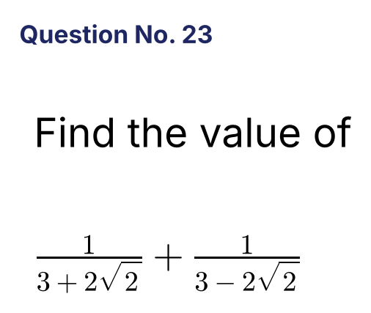
{OPTION 1} 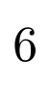
{OPTION 2} 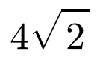
{OPTION 3} 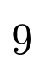
{OPTION 4}
{OPTION 5}
{OPTION 6}
{OPTION 7}
{OPTION 8}
{OPTION 9}
{OPTION 10}
{RIGHT ANSWER} 1
{EXPLANATION} The sum = [(3 − 2√2) + (3 + 2√2)]/[(3)² − (2√2)²] = 6/(9 − 8) = 6.
{CORRECT MARKS} 1
{NEGATIVE MARKS} 0
{DIFFICULTY} Hard
{QUESTION ENDS}

{QUESTION BEGINS}
{QUESTION NUMBER} 24
{SUBJECT} Numerical Ability
{TOPIC} Partnership
{TAGS} tcs nqt, numerical ability, full syllabus mix, hard
{QUESTION TYPE} SINGLECORRECT
{QUESTION TEXT} A invests ₹16,000 for the whole year. B joins after 5 months with ₹20,000. In what ratio should the profit at the end of the year be divided between A and B?
{OPTION 1} 12 : 7
{OPTION 2} 4 : 5
{OPTION 3} 16 : 25
{OPTION 4} 48 : 35
{OPTION 5}
{OPTION 6}
{OPTION 7}
{OPTION 8}
{OPTION 9}
{OPTION 10}
{RIGHT ANSWER} 4
{EXPLANATION} A's capital-months = 16000 × 12 = 192,000. B stays 7 months: 20000 × 7 = 140,000. Ratio = 192 : 140 = 48 : 35.
{CORRECT MARKS} 1
{NEGATIVE MARKS} 0
{DIFFICULTY} Hard
{QUESTION ENDS}

{QUESTION BEGINS}
{QUESTION NUMBER} 25
{SUBJECT} Numerical Ability
{TOPIC} Indices
{TAGS} tcs nqt, numerical ability, full syllabus mix, hard
{QUESTION TYPE} SINGLECORRECT
{QUESTION TEXT} 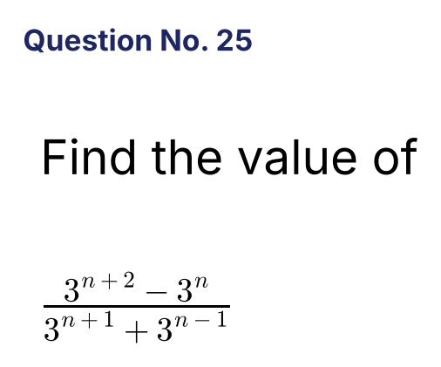
{OPTION 1} 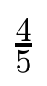
{OPTION 2} 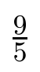
{OPTION 3} 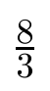
{OPTION 4} 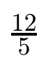
{OPTION 5}
{OPTION 6}
{OPTION 7}
{OPTION 8}
{OPTION 9}
{OPTION 10}
{RIGHT ANSWER} 4
{EXPLANATION} Numerator = 3ⁿ(9 − 1) = 8 · 3ⁿ. Denominator = 3^(n−1)(9 + 1) = 10 · 3^(n−1). Ratio = 8 × 3/10 = 12/5.
{CORRECT MARKS} 1
{NEGATIVE MARKS} 0
{DIFFICULTY} Hard
{QUESTION ENDS}

{QUESTION BEGINS}
{QUESTION NUMBER} 26
{SUBJECT} Numerical Ability
{TOPIC} Simple Interest
{TAGS} tcs nqt, numerical ability, full syllabus mix, hard
{QUESTION TYPE} SINGLECORRECT
{QUESTION TEXT} ₹15,000 is divided into two parts. One part is lent at 6% and the other at 8% simple interest per year. After 3 years the total interest is ₹3,060. What is the part lent at 6%?
{OPTION 1} ₹7,500
{OPTION 2} ₹10,000
{OPTION 3} ₹6,000
{OPTION 4} ₹9,000
{OPTION 5}
{OPTION 6}
{OPTION 7}
{OPTION 8}
{OPTION 9}
{OPTION 10}
{RIGHT ANSWER} 4
{EXPLANATION} Let the 6% part be x. Interest = 3[0.06x + 0.08(15000 − x)] = 3[1200 − 0.02x] = 3600 − 0.06x = 3060, so x = 540/0.06 = ₹9,000.
{CORRECT MARKS} 1
{NEGATIVE MARKS} 0
{DIFFICULTY} Hard
{QUESTION ENDS}

{QUESTION BEGINS}
{QUESTION NUMBER} 27
{SUBJECT} Numerical Ability
{TOPIC} Time, Speed and Distance
{TAGS} tcs nqt, numerical ability, full syllabus mix, hard
{QUESTION TYPE} SINGLECORRECT
{QUESTION TEXT} Two athletes start together from the same point of a circular track of 600 m and run in the same direction at 8 m/s and 5 m/s. After how many seconds will they meet again for the first time?
{OPTION 1} 200
{OPTION 2} 300
{OPTION 3} 120
{OPTION 4} 150
{OPTION 5}
{OPTION 6}
{OPTION 7}
{OPTION 8}
{OPTION 9}
{OPTION 10}
{RIGHT ANSWER} 1
{EXPLANATION} The faster runner gains 3 m/s. He must gain one full lap of 600 m, which takes 600/3 = 200 s.
{CORRECT MARKS} 1
{NEGATIVE MARKS} 0
{DIFFICULTY} Hard
{QUESTION ENDS}

{QUESTION BEGINS}
{QUESTION NUMBER} 28
{SUBJECT} Numerical Ability
{TOPIC} Quadratic Equations
{TAGS} tcs nqt, numerical ability, full syllabus mix, hard
{QUESTION TYPE} SINGLECORRECT
{QUESTION TEXT} One root of x² + px + 12 = 0 is 4. If x² + px + q = 0 has equal roots, what is q?
{OPTION 1} 9
{OPTION 2} 16
{OPTION 3} 12.25
{OPTION 4} 12
{OPTION 5}
{OPTION 6}
{OPTION 7}
{OPTION 8}
{OPTION 9}
{OPTION 10}
{RIGHT ANSWER} 3
{EXPLANATION} Putting x = 4: 16 + 4p + 12 = 0, so p = −7. Equal roots need p² = 4q, so q = 49/4 = 12.25.
{CORRECT MARKS} 1
{NEGATIVE MARKS} 0
{DIFFICULTY} Hard
{QUESTION ENDS}

{QUESTION BEGINS}
{QUESTION NUMBER} 29
{SUBJECT} Numerical Ability
{TOPIC} Probability
{TAGS} tcs nqt, numerical ability, full syllabus mix, hard
{QUESTION TYPE} SINGLECORRECT
{QUESTION TEXT} A three-digit number is chosen at random. What is the probability that it is divisible by 7?
{OPTION 1} 1/7
{OPTION 2} 1/9
{OPTION 3} 16/115
{OPTION 4} 32/225
{OPTION 5}
{OPTION 6}
{OPTION 7}
{OPTION 8}
{OPTION 9}
{OPTION 10}
{RIGHT ANSWER} 4
{EXPLANATION} There are 900 three-digit numbers. The multiples of 7 from 105 to 994 number (994 − 105)/7 + 1 = 128. Probability = 128/900 = 32/225.
{CORRECT MARKS} 1
{NEGATIVE MARKS} 0
{DIFFICULTY} Hard
{QUESTION ENDS}

{QUESTION BEGINS}
{QUESTION NUMBER} 30
{SUBJECT} Numerical Ability
{TOPIC} Permutation and Combination
{TAGS} tcs nqt, numerical ability, full syllabus mix, hard
{QUESTION TYPE} SINGLECORRECT
{QUESTION TEXT} In how many ways can 5 men and 4 women be seated in a row so that no two women sit together?
{OPTION 1} 14,400
{OPTION 2} 43,200
{OPTION 3} 86,400
{OPTION 4} 28,800
{OPTION 5}
{OPTION 6}
{OPTION 7}
{OPTION 8}
{OPTION 9}
{OPTION 10}
{RIGHT ANSWER} 2
{EXPLANATION} Seat the 5 men first: 5! = 120 ways. This creates 6 gaps; choose 4 of them for the women: C(6,4) = 15, and arrange the women in 4! = 24 ways. Total = 120 × 15 × 24 = 43,200.
{CORRECT MARKS} 1
{NEGATIVE MARKS} 0
{DIFFICULTY} Hard
{QUESTION ENDS}

{QUESTION BEGINS}
{QUESTION NUMBER} 31
{SUBJECT} Numerical Ability
{TOPIC} Mixtures
{TAGS} tcs nqt, numerical ability, full syllabus mix, hard
{QUESTION TYPE} SINGLECORRECT
{QUESTION TEXT} A container has 64 litres of pure spirit. 8 litres are drawn out and replaced by water. The process is repeated twice more (three times in all). How many litres of pure spirit are left?
{OPTION 1} 42
{OPTION 2} 43.5
{OPTION 3} 42.875
{OPTION 4} 45
{OPTION 5}
{OPTION 6}
{OPTION 7}
{OPTION 8}
{OPTION 9}
{OPTION 10}
{RIGHT ANSWER} 3
{EXPLANATION} Each replacement keeps 7/8 of the spirit. Spirit left = 64 × (7/8)³ = 64 × 343/512 = 42.875 litres.
{CORRECT MARKS} 1
{NEGATIVE MARKS} 0
{DIFFICULTY} Hard
{QUESTION ENDS}

{QUESTION BEGINS}
{QUESTION NUMBER} 32
{SUBJECT} Numerical Ability
{TOPIC} Simple Interest
{TAGS} tcs nqt, numerical ability, full syllabus mix, hard
{QUESTION TYPE} SINGLECORRECT
{QUESTION TEXT} A person borrows ₹12,000 at 5% simple interest per year and lends it at 8% simple interest per year. What is his total gain in 4 years?
{OPTION 1} ₹1,440
{OPTION 2} ₹1,920
{OPTION 3} ₹960
{OPTION 4} ₹1,200
{OPTION 5}
{OPTION 6}
{OPTION 7}
{OPTION 8}
{OPTION 9}
{OPTION 10}
{RIGHT ANSWER} 1
{EXPLANATION} Gain per year = 3% of 12,000 = ₹360. In 4 years = ₹1,440.
{CORRECT MARKS} 1
{NEGATIVE MARKS} 0
{DIFFICULTY} Hard
{QUESTION ENDS}

{QUESTION BEGINS}
{QUESTION NUMBER} 33
{SUBJECT} Numerical Ability
{TOPIC} Profit and Loss
{TAGS} tcs nqt, numerical ability, full syllabus mix, hard
{QUESTION TYPE} SINGLECORRECT
{QUESTION TEXT} An article is sold at a 12% loss. Had it been sold for ₹540 more, there would have been an 8% gain. What is the cost price?
{OPTION 1} ₹2,500
{OPTION 2} ₹2,700
{OPTION 3} ₹3,000
{OPTION 4} ₹2,160
{OPTION 5}
{OPTION 6}
{OPTION 7}
{OPTION 8}
{OPTION 9}
{OPTION 10}
{RIGHT ANSWER} 2
{EXPLANATION} The difference between 8% gain and 12% loss = 20% of CP = 540. So CP = ₹2,700.
{CORRECT MARKS} 1
{NEGATIVE MARKS} 0
{DIFFICULTY} Hard
{QUESTION ENDS}

{QUESTION BEGINS}
{QUESTION NUMBER} 34
{SUBJECT} Numerical Ability
{TOPIC} Percentages
{TAGS} tcs nqt, numerical ability, full syllabus mix, hard
{QUESTION TYPE} SINGLECORRECT
{QUESTION TEXT} In an examination, 70% of the candidates passed English, 60% passed Mathematics and 45% passed both. What percentage of the candidates failed in both subjects?
{OPTION 1} 15%
{OPTION 2} 30%
{OPTION 3} 20%
{OPTION 4} 25%
{OPTION 5}
{OPTION 6}
{OPTION 7}
{OPTION 8}
{OPTION 9}
{OPTION 10}
{RIGHT ANSWER} 1
{EXPLANATION} Passed at least one = 70 + 60 − 45 = 85%. Failed both = 100 − 85 = 15%.
{CORRECT MARKS} 1
{NEGATIVE MARKS} 0
{DIFFICULTY} Hard
{QUESTION ENDS}

{QUESTION BEGINS}
{QUESTION NUMBER} 35
{SUBJECT} Numerical Ability
{TOPIC} Ratio and Proportion
{TAGS} tcs nqt, numerical ability, full syllabus mix, hard
{QUESTION TYPE} SINGLECORRECT
{QUESTION TEXT} Two numbers are in the ratio 3 : 5. If 10 is added to each of them, the ratio becomes 5 : 7. What is the larger number?
{OPTION 1} 35
{OPTION 2} 20
{OPTION 3} 25
{OPTION 4} 15
{OPTION 5}
{OPTION 6}
{OPTION 7}
{OPTION 8}
{OPTION 9}
{OPTION 10}
{RIGHT ANSWER} 3
{EXPLANATION} (3x + 10)/(5x + 10) = 5/7 gives 21x + 70 = 25x + 50, so x = 5. The numbers are 15 and 25. The larger is 25.
{CORRECT MARKS} 1
{NEGATIVE MARKS} 0
{DIFFICULTY} Hard
{QUESTION ENDS}

{QUESTION BEGINS}
{QUESTION NUMBER} 36
{SUBJECT} Numerical Ability
{TOPIC} Time, Speed and Distance
{TAGS} tcs nqt, numerical ability, full syllabus mix, hard
{QUESTION TYPE} SINGLECORRECT
{QUESTION TEXT} A car covers the first one-third of a journey at 20 km/h and the remaining two-thirds at 30 km/h. What is its average speed for the whole journey?
{OPTION 1} 24 km/h
{OPTION 2} 25 5/7 km/h
{OPTION 3} 25 km/h
{OPTION 4} 26 2/3 km/h
{OPTION 5}
{OPTION 6}
{OPTION 7}
{OPTION 8}
{OPTION 9}
{OPTION 10}
{RIGHT ANSWER} 2
{EXPLANATION} Take the distance as 1. Time = (1/3)/20 + (2/3)/30 = 1/60 + 1/45 = 7/180. Average speed = 1/(7/180) = 180/7 = 25 5/7 km/h.
{CORRECT MARKS} 1
{NEGATIVE MARKS} 0
{DIFFICULTY} Hard
{QUESTION ENDS}

{QUESTION BEGINS}
{QUESTION NUMBER} 37
{SUBJECT} Numerical Ability
{TOPIC} Ages
{TAGS} tcs nqt, numerical ability, full syllabus mix, hard
{QUESTION TYPE} SINGLECORRECT
{QUESTION TEXT} The present ages of A and B are in the ratio 4 : 5. After 6 years the ratio becomes 5 : 6. What is the sum of their present ages?
{OPTION 1} 45 years
{OPTION 2} 60 years
{OPTION 3} 54 years
{OPTION 4} 48 years
{OPTION 5}
{OPTION 6}
{OPTION 7}
{OPTION 8}
{OPTION 9}
{OPTION 10}
{RIGHT ANSWER} 3
{EXPLANATION} (4x + 6)/(5x + 6) = 5/6 gives 24x + 36 = 25x + 30, so x = 6. The ages are 24 and 30; the sum is 54 years.
{CORRECT MARKS} 1
{NEGATIVE MARKS} 0
{DIFFICULTY} Hard
{QUESTION ENDS}

{QUESTION BEGINS}
{QUESTION NUMBER} 38
{SUBJECT} Numerical Ability
{TOPIC} Compound Interest
{TAGS} tcs nqt, numerical ability, full syllabus mix, hard
{QUESTION TYPE} SINGLECORRECT
{QUESTION TEXT} ₹8,000 is invested for 1 year at 10% per annum. By how much does the amount compounded half-yearly exceed the amount compounded annually?
{OPTION 1} ₹80
{OPTION 2} ₹20
{OPTION 3} ₹40
{OPTION 4} ₹10
{OPTION 5}
{OPTION 6}
{OPTION 7}
{OPTION 8}
{OPTION 9}
{OPTION 10}
{RIGHT ANSWER} 2
{EXPLANATION} Annually: 8000 × 1.1 = ₹8,800. Half-yearly: 8000 × (1.05)² = ₹8,820. Difference = ₹20.
{CORRECT MARKS} 1
{NEGATIVE MARKS} 0
{DIFFICULTY} Hard
{QUESTION ENDS}

{QUESTION BEGINS}
{QUESTION NUMBER} 39
{SUBJECT} Numerical Ability
{TOPIC} Averages
{TAGS} tcs nqt, numerical ability, full syllabus mix, hard
{QUESTION TYPE} SINGLECORRECT
{QUESTION TEXT} The average weight of 8 persons increases by 2.5 kg when one person weighing 65 kg is replaced by a new person. What is the weight of the new person?
{OPTION 1} 90 kg
{OPTION 2} 85 kg
{OPTION 3} 80 kg
{OPTION 4} 77.5 kg
{OPTION 5}
{OPTION 6}
{OPTION 7}
{OPTION 8}
{OPTION 9}
{OPTION 10}
{RIGHT ANSWER} 2
{EXPLANATION} Total weight increases by 8 × 2.5 = 20 kg. New person's weight = 65 + 20 = 85 kg.
{CORRECT MARKS} 1
{NEGATIVE MARKS} 0
{DIFFICULTY} Hard
{QUESTION ENDS}

{QUESTION BEGINS}
{QUESTION NUMBER} 40
{SUBJECT} Numerical Ability
{TOPIC} Algebra
{TAGS} tcs nqt, numerical ability, full syllabus mix, hard
{QUESTION TYPE} SINGLECORRECT
{QUESTION TEXT} What is the sum of all the real solutions of |x − 3| + |x + 2| = 9?
{OPTION 1} −4
{OPTION 2} 5
{OPTION 3} 0
{OPTION 4} 1
{OPTION 5}
{OPTION 6}
{OPTION 7}
{OPTION 8}
{OPTION 9}
{OPTION 10}
{RIGHT ANSWER} 4
{EXPLANATION} For x ≥ 3: 2x − 1 = 9, x = 5. For x ≤ −2: −2x + 1 = 9, x = −4. For −2 < x < 3 the left side is 5, which is not 9. The sum = 5 + (−4) = 1.
{CORRECT MARKS} 1
{NEGATIVE MARKS} 0
{DIFFICULTY} Hard
{QUESTION ENDS}

{QUESTION BEGINS}
{QUESTION NUMBER} 41
{SUBJECT} Numerical Ability
{TOPIC} Time, Speed and Distance
{TAGS} tcs nqt, numerical ability, full syllabus mix, hard
{QUESTION TYPE} SINGLECORRECT
{QUESTION TEXT} A boat's speed in still water is 15 km/h and the stream flows at 5 km/h. How much time does it take to go 60 km downstream and come back?
{OPTION 1} 10 hours
{OPTION 2} 9 hours
{OPTION 3} 8 hours
{OPTION 4} 7.5 hours
{OPTION 5}
{OPTION 6}
{OPTION 7}
{OPTION 8}
{OPTION 9}
{OPTION 10}
{RIGHT ANSWER} 2
{EXPLANATION} Downstream speed = 20 km/h and upstream speed = 10 km/h. Time = 60/20 + 60/10 = 3 + 6 = 9 hours.
{CORRECT MARKS} 1
{NEGATIVE MARKS} 0
{DIFFICULTY} Hard
{QUESTION ENDS}

{QUESTION BEGINS}
{QUESTION NUMBER} 42
{SUBJECT} Numerical Ability
{TOPIC} Mensuration
{TAGS} tcs nqt, numerical ability, full syllabus mix, hard
{QUESTION TYPE} SINGLECORRECT
{QUESTION TEXT} A solid metal sphere of radius 6 cm is melted and drawn into a wire of circular cross-section of radius 0.5 cm. What is the length of the wire?
{OPTION 1} 576 cm
{OPTION 2} 864 cm
{OPTION 3} 1,728 cm
{OPTION 4} 1,152 cm
{OPTION 5}
{OPTION 6}
{OPTION 7}
{OPTION 8}
{OPTION 9}
{OPTION 10}
{RIGHT ANSWER} 4
{EXPLANATION} Volume of the sphere = (4/3)π × 216 = 288π. The wire's volume = π × 0.25 × L. So L = 288/0.25 = 1,152 cm.
{CORRECT MARKS} 1
{NEGATIVE MARKS} 0
{DIFFICULTY} Hard
{QUESTION ENDS}

{QUESTION BEGINS}
{QUESTION NUMBER} 43
{SUBJECT} Numerical Ability
{TOPIC} Data Interpretation
{TAGS} tcs nqt, numerical ability, full syllabus mix, hard
{QUESTION TYPE} SINGLECORRECT
{QUESTION TEXT} 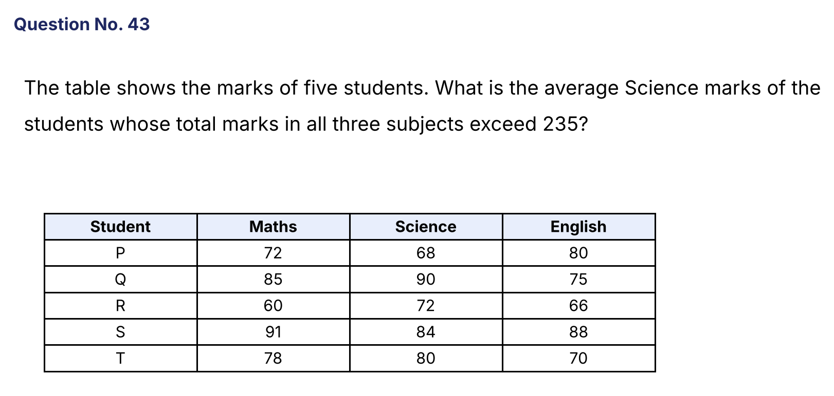
{OPTION 1} 85
{OPTION 2} 84
{OPTION 3} 87
{OPTION 4} 89
{OPTION 5}
{OPTION 6}
{OPTION 7}
{OPTION 8}
{OPTION 9}
{OPTION 10}
{RIGHT ANSWER} 3
{EXPLANATION} Totals: P = 220, Q = 250, R = 198, S = 263, T = 228. Students with a total above 235 are Q and S. Their Science marks are 90 and 84, so the average = 174/2 = 87.
{CORRECT MARKS} 1
{NEGATIVE MARKS} 0
{DIFFICULTY} Hard
{QUESTION ENDS}

{QUESTION BEGINS}
{QUESTION NUMBER} 44
{SUBJECT} Numerical Ability
{TOPIC} Time and Work
{TAGS} tcs nqt, numerical ability, full syllabus mix, hard
{QUESTION TYPE} SINGLECORRECT
{QUESTION TEXT} 12 men can finish a work in 20 days. After 8 days, 4 men leave. In how many days in total is the work finished?
{OPTION 1} 24 days
{OPTION 2} 28 days
{OPTION 3} 30 days
{OPTION 4} 26 days
{OPTION 5}
{OPTION 6}
{OPTION 7}
{OPTION 8}
{OPTION 9}
{OPTION 10}
{RIGHT ANSWER} 4
{EXPLANATION} Total work = 12 × 20 = 240 man-days. In 8 days, 96 man-days are done. The remaining 144 man-days are done by 8 men in 18 days. Total = 8 + 18 = 26 days.
{CORRECT MARKS} 1
{NEGATIVE MARKS} 0
{DIFFICULTY} Hard
{QUESTION ENDS}

{QUESTION BEGINS}
{QUESTION NUMBER} 45
{SUBJECT} Numerical Ability
{TOPIC} Data Interpretation
{TAGS} tcs nqt, numerical ability, full syllabus mix, hard
{QUESTION TYPE} SINGLECORRECT
{QUESTION TEXT} 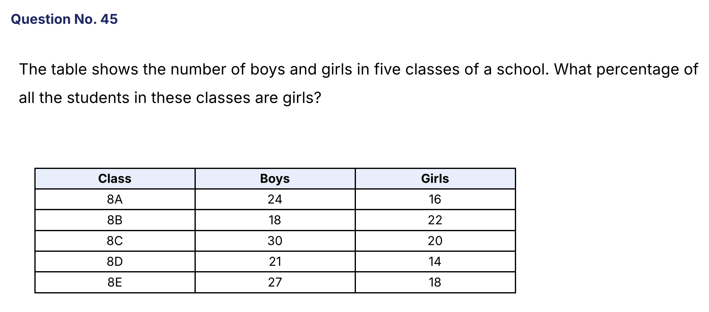
{OPTION 1} 42 6/7 %
{OPTION 2} 43 1/3 %
{OPTION 3} 40%
{OPTION 4} 45%
{OPTION 5}
{OPTION 6}
{OPTION 7}
{OPTION 8}
{OPTION 9}
{OPTION 10}
{RIGHT ANSWER} 1
{EXPLANATION} Boys = 24 + 18 + 30 + 21 + 27 = 120. Girls = 16 + 22 + 20 + 14 + 18 = 90. Total = 210. Girls % = 90/210 × 100 = 42 6/7 %.
{CORRECT MARKS} 1
{NEGATIVE MARKS} 0
{DIFFICULTY} Hard
{QUESTION ENDS}

{QUESTION BEGINS}
{QUESTION NUMBER} 46
{SUBJECT} Numerical Ability
{TOPIC} LCM and HCF
{TAGS} tcs nqt, numerical ability, full syllabus mix, hard
{QUESTION TYPE} SINGLECORRECT
{QUESTION TEXT} The HCF of two numbers is 12 and their sum is 84. How many different pairs of such numbers are possible?
{OPTION 1} 3
{OPTION 2} 6
{OPTION 3} 4
{OPTION 4} 2
{OPTION 5}
{OPTION 6}
{OPTION 7}
{OPTION 8}
{OPTION 9}
{OPTION 10}
{RIGHT ANSWER} 1
{EXPLANATION} Let the numbers be 12a and 12b with a and b co-prime and a + b = 7. The co-prime pairs are (1, 6), (2, 5) and (3, 4). So there are 3 pairs.
{CORRECT MARKS} 1
{NEGATIVE MARKS} 0
{DIFFICULTY} Hard
{QUESTION ENDS}

{QUESTION BEGINS}
{QUESTION NUMBER} 47
{SUBJECT} Numerical Ability
{TOPIC} Time, Speed and Distance
{TAGS} tcs nqt, numerical ability, full syllabus mix, hard
{QUESTION TYPE} SINGLECORRECT
{QUESTION TEXT} A man walking at 5 km/h reaches his destination 12 minutes late. Walking at 6 km/h he reaches 10 minutes early. What is the distance?
{OPTION 1} 10 km
{OPTION 2} 9 km
{OPTION 3} 11 km
{OPTION 4} 12 km
{OPTION 5}
{OPTION 6}
{OPTION 7}
{OPTION 8}
{OPTION 9}
{OPTION 10}
{RIGHT ANSWER} 3
{EXPLANATION} Time difference = 22 min = 11/30 h. d/5 − d/6 = d/30 = 11/30, so d = 11 km.
{CORRECT MARKS} 1
{NEGATIVE MARKS} 0
{DIFFICULTY} Hard
{QUESTION ENDS}

{QUESTION BEGINS}
{QUESTION NUMBER} 48
{SUBJECT} Numerical Ability
{TOPIC} Mensuration
{TAGS} tcs nqt, numerical ability, full syllabus mix, hard
{QUESTION TYPE} SINGLECORRECT
{QUESTION TEXT} A rectangular field is 40 m long and 30 m wide. A path 2 m wide runs all around it on the outside. What is the area of the path?
{OPTION 1} 256 m²
{OPTION 2} 280 m²
{OPTION 3} 296 m²
{OPTION 4} 320 m²
{OPTION 5}
{OPTION 6}
{OPTION 7}
{OPTION 8}
{OPTION 9}
{OPTION 10}
{RIGHT ANSWER} 3
{EXPLANATION} Outer rectangle = (40 + 4) × (30 + 4) = 44 × 34 = 1,496 m². Field = 1,200 m². Path = 1,496 − 1,200 = 296 m².
{CORRECT MARKS} 1
{NEGATIVE MARKS} 0
{DIFFICULTY} Hard
{QUESTION ENDS}

{QUESTION BEGINS}
{QUESTION NUMBER} 49
{SUBJECT} Numerical Ability
{TOPIC} Mixtures
{TAGS} tcs nqt, numerical ability, full syllabus mix, hard
{QUESTION TYPE} SINGLECORRECT
{QUESTION TEXT} How many litres of a 40% acid solution must be added to 12 litres of a 25% acid solution to obtain a 30% acid solution?
{OPTION 1} 4
{OPTION 2} 6
{OPTION 3} 8
{OPTION 4} 9
{OPTION 5}
{OPTION 6}
{OPTION 7}
{OPTION 8}
{OPTION 9}
{OPTION 10}
{RIGHT ANSWER} 2
{EXPLANATION} By alligation: (40 − 30) : (30 − 25) = 10 : 5 = 2 : 1 for (25% solution) : (40% solution). So the 40% solution = 12/2 = 6 litres.
{CORRECT MARKS} 1
{NEGATIVE MARKS} 0
{DIFFICULTY} Hard
{QUESTION ENDS}

{QUESTION BEGINS}
{QUESTION NUMBER} 50
{SUBJECT} Numerical Ability
{TOPIC} Number System
{TAGS} tcs nqt, numerical ability, full syllabus mix, hard
{QUESTION TYPE} SINGLECORRECT
{QUESTION TEXT} What is the sum of all the three-digit numbers that are divisible by 7?
{OPTION 1} 70420
{OPTION 2} 70336
{OPTION 3} 70230
{OPTION 4} 69874
{OPTION 5}
{OPTION 6}
{OPTION 7}
{OPTION 8}
{OPTION 9}
{OPTION 10}
{RIGHT ANSWER} 2
{EXPLANATION} The first such number is 105 and the last is 994. Count = (994 − 105)/7 + 1 = 128. Sum = 128 × (105 + 994)/2 = 64 × 1099 = 70,336.
{CORRECT MARKS} 1
{NEGATIVE MARKS} 0
{DIFFICULTY} Hard
{QUESTION ENDS}

{QUESTION BEGINS}
{QUESTION NUMBER} 51
{SUBJECT} Numerical Ability
{TOPIC} Algebra
{TAGS} tcs nqt, numerical ability, full syllabus mix, hard
{QUESTION TYPE} SINGLECORRECT
{QUESTION TEXT} The sum of the squares of three consecutive odd numbers is 683. What is the largest of the three numbers?
{OPTION 1} 17
{OPTION 2} 19
{OPTION 3} 13
{OPTION 4} 15
{OPTION 5}
{OPTION 6}
{OPTION 7}
{OPTION 8}
{OPTION 9}
{OPTION 10}
{RIGHT ANSWER} 1
{EXPLANATION} Let the numbers be n, n + 2 and n + 4. n² + (n + 2)² + (n + 4)² = 3n² + 12n + 20 = 683, so n² + 4n − 221 = 0 and n = 13. The numbers are 13, 15, 17.
{CORRECT MARKS} 1
{NEGATIVE MARKS} 0
{DIFFICULTY} Hard
{QUESTION ENDS}

{QUESTION BEGINS}
{QUESTION NUMBER} 52
{SUBJECT} Numerical Ability
{TOPIC} Percentages
{TAGS} tcs nqt, numerical ability, full syllabus mix, hard
{QUESTION TYPE} SINGLECORRECT
{QUESTION TEXT} In an election between two candidates, every vote was valid and the loser received 42% of the votes. He lost by 3,360 votes. How many votes were polled?
{OPTION 1} 18,000
{OPTION 2} 21,000
{OPTION 3} 24,000
{OPTION 4} 16,800
{OPTION 5}
{OPTION 6}
{OPTION 7}
{OPTION 8}
{OPTION 9}
{OPTION 10}
{RIGHT ANSWER} 2
{EXPLANATION} The winner got 58% and the loser 42%, a difference of 16% of the votes = 3,360. Total votes = 3360/0.16 = 21,000.
{CORRECT MARKS} 1
{NEGATIVE MARKS} 0
{DIFFICULTY} Hard
{QUESTION ENDS}

{QUESTION BEGINS}
{QUESTION NUMBER} 53
{SUBJECT} Numerical Ability
{TOPIC} Algebra
{TAGS} tcs nqt, numerical ability, full syllabus mix, hard
{QUESTION TYPE} SINGLECORRECT
{QUESTION TEXT} 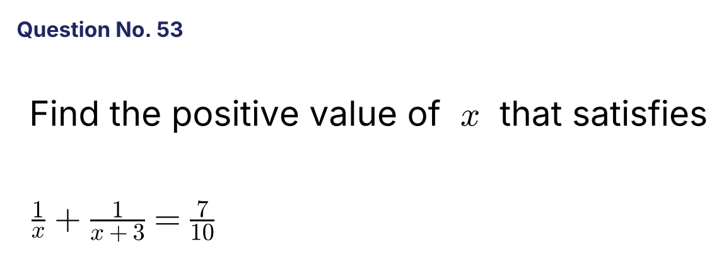
{OPTION 1} 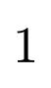
{OPTION 2}
{OPTION 3} 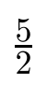
{OPTION 4}
{OPTION 5}
{OPTION 6}
{OPTION 7}
{OPTION 8}
{OPTION 9}
{OPTION 10}
{RIGHT ANSWER} 4
{EXPLANATION} 10(2x + 3) = 7x(x + 3), so 7x² + 21x − 20x − 30 = 0, i.e. 7x² + x − 30 = 0. Then x = (−1 ± 29)/14, giving x = 2 or x = −15/7. The positive value is 2.
{CORRECT MARKS} 1
{NEGATIVE MARKS} 0
{DIFFICULTY} Hard
{QUESTION ENDS}

{QUESTION BEGINS}
{QUESTION NUMBER} 54
{SUBJECT} Numerical Ability
{TOPIC} Time and Work
{TAGS} tcs nqt, numerical ability, full syllabus mix, hard
{QUESTION TYPE} SINGLECORRECT
{QUESTION TEXT} Pipe A can fill a tank in 24 hours and pipe B in 36 hours. They are opened alternately for one hour each, starting with A. How long does the tank take to fill?
{OPTION 1} 28 hours
{OPTION 2} 28 2/3 hours
{OPTION 3} 29 1/3 hours
{OPTION 4} 30 hours
{OPTION 5}
{OPTION 6}
{OPTION 7}
{OPTION 8}
{OPTION 9}
{OPTION 10}
{RIGHT ANSWER} 2
{EXPLANATION} In every 2 hours they fill 1/24 + 1/36 = 5/72. After 28 hours (14 cycles) 70/72 is filled. The remaining 2/72 = 1/36 is filled by A, whose rate is 1/24, in (1/36)/(1/24) = 2/3 hour. Total = 28 2/3 hours.
{CORRECT MARKS} 1
{NEGATIVE MARKS} 0
{DIFFICULTY} Hard
{QUESTION ENDS}

{QUESTION BEGINS}
{QUESTION NUMBER} 55
{SUBJECT} Numerical Ability
{TOPIC} Statistics
{TAGS} tcs nqt, numerical ability, full syllabus mix, hard
{QUESTION TYPE} SINGLECORRECT
{QUESTION TEXT} What is the median of the data 12, 7, 19, 3, 15, 9, 21, 6?
{OPTION 1} 10.5
{OPTION 2} 11
{OPTION 3} 9
{OPTION 4} 12
{OPTION 5}
{OPTION 6}
{OPTION 7}
{OPTION 8}
{OPTION 9}
{OPTION 10}
{RIGHT ANSWER} 1
{EXPLANATION} Arranged in order: 3, 6, 7, 9, 12, 15, 19, 21. With 8 values the median is the mean of the 4th and 5th: (9 + 12)/2 = 10.5.
{CORRECT MARKS} 1
{NEGATIVE MARKS} 0
{DIFFICULTY} Hard
{QUESTION ENDS}

{QUESTION BEGINS}
{QUESTION NUMBER} 56
{SUBJECT} Numerical Ability
{TOPIC} Mensuration
{TAGS} tcs nqt, numerical ability, full syllabus mix, hard
{QUESTION TYPE} SINGLECORRECT
{QUESTION TEXT} The sides of a triangle are 13 cm, 14 cm and 15 cm. What is the radius of its inscribed circle?
{OPTION 1} 3.5 cm
{OPTION 2} 5 cm
{OPTION 3} 4 cm
{OPTION 4} 4.5 cm
{OPTION 5}
{OPTION 6}
{OPTION 7}
{OPTION 8}
{OPTION 9}
{OPTION 10}
{RIGHT ANSWER} 3
{EXPLANATION} s = 21. Area = √[21 × 8 × 7 × 6] = 84 cm². Inradius = Area/s = 84/21 = 4 cm.
{CORRECT MARKS} 1
{NEGATIVE MARKS} 0
{DIFFICULTY} Hard
{QUESTION ENDS}

{QUESTION BEGINS}
{QUESTION NUMBER} 57
{SUBJECT} Numerical Ability
{TOPIC} LCM and HCF
{TAGS} tcs nqt, numerical ability, full syllabus mix, hard
{QUESTION TYPE} SINGLECORRECT
{QUESTION TEXT} Three runners take 40 s, 56 s and 84 s to complete one lap of a circular track. They start together from the same point. After how many minutes will they all be together at the starting point again?
{OPTION 1} 12
{OPTION 2} 10
{OPTION 3} 14
{OPTION 4} 21
{OPTION 5}
{OPTION 6}
{OPTION 7}
{OPTION 8}
{OPTION 9}
{OPTION 10}
{RIGHT ANSWER} 3
{EXPLANATION} LCM(40, 56, 84) = 840 seconds = 14 minutes.
{CORRECT MARKS} 1
{NEGATIVE MARKS} 0
{DIFFICULTY} Hard
{QUESTION ENDS}

{QUESTION BEGINS}
{QUESTION NUMBER} 58
{SUBJECT} Numerical Ability
{TOPIC} Permutation and Combination
{TAGS} tcs nqt, numerical ability, full syllabus mix, hard
{QUESTION TYPE} SINGLECORRECT
{QUESTION TEXT} In how many ways can the letters of the word COMMITTEE be arranged?
{OPTION 1} 362,880
{OPTION 2} 45,360
{OPTION 3} 90,720
{OPTION 4} 22,680
{OPTION 5}
{OPTION 6}
{OPTION 7}
{OPTION 8}
{OPTION 9}
{OPTION 10}
{RIGHT ANSWER} 2
{EXPLANATION} COMMITTEE has 9 letters with M, T and E each appearing twice. Arrangements = 9!/(2! × 2! × 2!) = 362880/8 = 45,360.
{CORRECT MARKS} 1
{NEGATIVE MARKS} 0
{DIFFICULTY} Hard
{QUESTION ENDS}

{QUESTION BEGINS}
{QUESTION NUMBER} 59
{SUBJECT} Numerical Ability
{TOPIC} Averages
{TAGS} tcs nqt, numerical ability, full syllabus mix, hard
{QUESTION TYPE} SINGLECORRECT
{QUESTION TEXT} The average marks of 36 students are 70. If 6 students whose average marks are 40 leave, what is the average marks of the remaining students?
{OPTION 1} 76
{OPTION 2} 78
{OPTION 3} 74
{OPTION 4} 72
{OPTION 5}
{OPTION 6}
{OPTION 7}
{OPTION 8}
{OPTION 9}
{OPTION 10}
{RIGHT ANSWER} 1
{EXPLANATION} Total marks = 36 × 70 = 2,520. Marks of the 6 who left = 240. The remaining 30 students have 2,280, so the average = 76.
{CORRECT MARKS} 1
{NEGATIVE MARKS} 0
{DIFFICULTY} Hard
{QUESTION ENDS}

{QUESTION BEGINS}
{QUESTION NUMBER} 60
{SUBJECT} Numerical Ability
{TOPIC} Mensuration
{TAGS} tcs nqt, numerical ability, full syllabus mix, hard
{QUESTION TYPE} SINGLECORRECT
{QUESTION TEXT} An open cylindrical tank has a base radius of 7 m and a height of 10 m. What is the total area (outer surface including the base) to be painted? (Use π = 22/7.)
{OPTION 1} 594 m²
{OPTION 2} 440 m²
{OPTION 3} 748 m²
{OPTION 4} 594 m³
{OPTION 5}
{OPTION 6}
{OPTION 7}
{OPTION 8}
{OPTION 9}
{OPTION 10}
{RIGHT ANSWER} 1
{EXPLANATION} Curved surface = 2πrh = 2 × (22/7) × 7 × 10 = 440 m². Base = πr² = (22/7) × 49 = 154 m². Total = 594 m².
{CORRECT MARKS} 1
{NEGATIVE MARKS} 0
{DIFFICULTY} Hard
{QUESTION ENDS}

{QUESTION BEGINS}
{QUESTION NUMBER} 61
{SUBJECT} Numerical Ability
{TOPIC} Permutation and Combination
{TAGS} tcs nqt, numerical ability, full syllabus mix, hard
{QUESTION TYPE} SINGLECORRECT
{QUESTION TEXT} In how many ways can 6 identical sweets be distributed among 3 children so that each child gets at least one sweet?
{OPTION 1} 10
{OPTION 2} 15
{OPTION 3} 20
{OPTION 4} 6
{OPTION 5}
{OPTION 6}
{OPTION 7}
{OPTION 8}
{OPTION 9}
{OPTION 10}
{RIGHT ANSWER} 1
{EXPLANATION} Give each child 1 sweet first; 3 identical sweets remain to be distributed freely among 3 children: C(3 + 3 − 1, 2) = C(5, 2) = 10.
{CORRECT MARKS} 1
{NEGATIVE MARKS} 0
{DIFFICULTY} Hard
{QUESTION ENDS}

{QUESTION BEGINS}
{QUESTION NUMBER} 62
{SUBJECT} Numerical Ability
{TOPIC} Percentages
{TAGS} tcs nqt, numerical ability, full syllabus mix, hard
{QUESTION TYPE} SINGLECORRECT
{QUESTION TEXT} In a class, 60% are boys. 25% of the boys and 40% of the girls wear glasses. What percentage of the class wears glasses?
{OPTION 1} 28%
{OPTION 2} 35%
{OPTION 3} 31%
{OPTION 4} 32.5%
{OPTION 5}
{OPTION 6}
{OPTION 7}
{OPTION 8}
{OPTION 9}
{OPTION 10}
{RIGHT ANSWER} 3
{EXPLANATION} Take 100 students: 60 boys and 40 girls. Glasses: 25% of 60 = 15 and 40% of 40 = 16. Total = 31, which is 31%.
{CORRECT MARKS} 1
{NEGATIVE MARKS} 0
{DIFFICULTY} Hard
{QUESTION ENDS}

{QUESTION BEGINS}
{QUESTION NUMBER} 63
{SUBJECT} Numerical Ability
{TOPIC} Compound Interest
{TAGS} tcs nqt, numerical ability, full syllabus mix, hard
{QUESTION TYPE} SINGLECORRECT
{QUESTION TEXT} A loan of ₹6,300 at 10% per annum compound interest is repaid in two equal annual instalments. What is the value of each instalment?
{OPTION 1} ₹3,780
{OPTION 2} ₹3,500
{OPTION 3} ₹3,300
{OPTION 4} ₹3,630
{OPTION 5}
{OPTION 6}
{OPTION 7}
{OPTION 8}
{OPTION 9}
{OPTION 10}
{RIGHT ANSWER} 4
{EXPLANATION} Let each instalment be x. x/1.1 + x/1.21 = 6300, so x(1.1 + 1)/1.21 = 6300, x = 6300 × 1.21/2.1 = ₹3,630.
{CORRECT MARKS} 1
{NEGATIVE MARKS} 0
{DIFFICULTY} Hard
{QUESTION ENDS}

{QUESTION BEGINS}
{QUESTION NUMBER} 64
{SUBJECT} Numerical Ability
{TOPIC} Inequalities
{TAGS} tcs nqt, numerical ability, full syllabus mix, hard
{QUESTION TYPE} SINGLECORRECT
{QUESTION TEXT} How many integers satisfy x² − 4x − 12 < 0?
{OPTION 1} 7
{OPTION 2} 8
{OPTION 3} 6
{OPTION 4} 5
{OPTION 5}
{OPTION 6}
{OPTION 7}
{OPTION 8}
{OPTION 9}
{OPTION 10}
{RIGHT ANSWER} 1
{EXPLANATION} (x − 6)(x + 2) < 0 gives −2 < x < 6. The integers are −1, 0, 1, 2, 3, 4, 5, which is 7.
{CORRECT MARKS} 1
{NEGATIVE MARKS} 0
{DIFFICULTY} Hard
{QUESTION ENDS}

{QUESTION BEGINS}
{QUESTION NUMBER} 65
{SUBJECT} Numerical Ability
{TOPIC} Time, Speed and Distance
{TAGS} tcs nqt, numerical ability, full syllabus mix, hard
{QUESTION TYPE} SINGLECORRECT
{QUESTION TEXT} A 150 m long train crosses a 250 m long platform in 20 seconds. What is the speed of the train in km/h?
{OPTION 1} 72
{OPTION 2} 80
{OPTION 3} 60
{OPTION 4} 54
{OPTION 5}
{OPTION 6}
{OPTION 7}
{OPTION 8}
{OPTION 9}
{OPTION 10}
{RIGHT ANSWER} 1
{EXPLANATION} Distance = 150 + 250 = 400 m in 20 s, so the speed = 20 m/s = 20 × 18/5 = 72 km/h.
{CORRECT MARKS} 1
{NEGATIVE MARKS} 0
{DIFFICULTY} Hard
{QUESTION ENDS}

{QUESTION BEGINS}
{QUESTION NUMBER} 66
{SUBJECT} Numerical Ability
{TOPIC} Data Interpretation
{TAGS} tcs nqt, numerical ability, full syllabus mix, hard
{QUESTION TYPE} SINGLECORRECT
{QUESTION TEXT} 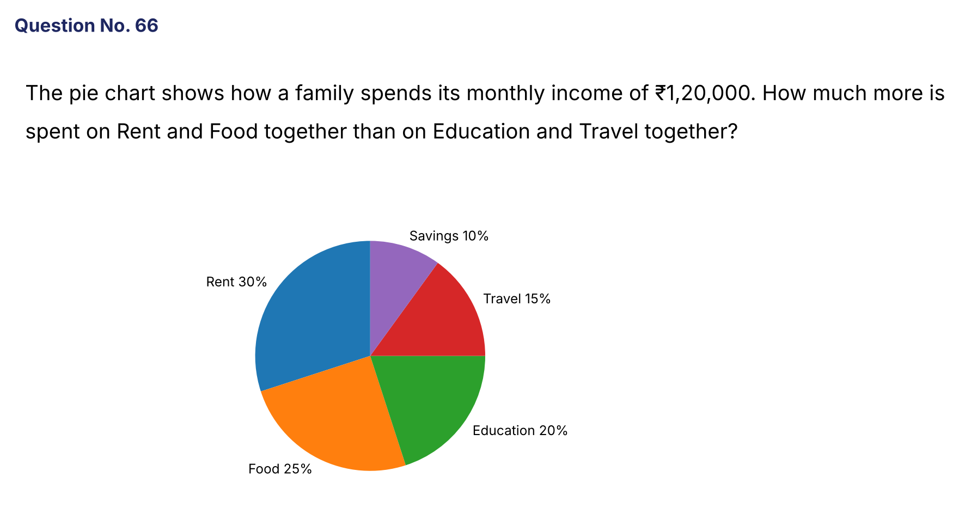
{OPTION 1} ₹24,000
{OPTION 2} ₹30,000
{OPTION 3} ₹18,000
{OPTION 4} ₹36,000
{OPTION 5}
{OPTION 6}
{OPTION 7}
{OPTION 8}
{OPTION 9}
{OPTION 10}
{RIGHT ANSWER} 1
{EXPLANATION} Rent + Food = 30% + 25% = 55%. Education + Travel = 20% + 15% = 35%. Difference = 20% of 1,20,000 = ₹24,000.
{CORRECT MARKS} 1
{NEGATIVE MARKS} 0
{DIFFICULTY} Hard
{QUESTION ENDS}

{QUESTION BEGINS}
{QUESTION NUMBER} 67
{SUBJECT} Numerical Ability
{TOPIC} Number System
{TAGS} tcs nqt, numerical ability, full syllabus mix, hard
{QUESTION TYPE} SINGLECORRECT
{QUESTION TEXT} What is the remainder when 5⁷⁷ + 4⁶⁰ is divided by 7?
{OPTION 1} 6
{OPTION 2} 3
{OPTION 3} 4
{OPTION 4} 2
{OPTION 5}
{OPTION 6}
{OPTION 7}
{OPTION 8}
{OPTION 9}
{OPTION 10}
{RIGHT ANSWER} 3
{EXPLANATION} 5⁶ ≡ 1 (mod 7), so 5⁷⁷ = 5⁷² · 5⁵ ≡ 5⁵ = 3125 ≡ 3. 4³ = 64 ≡ 1, so 4⁶⁰ ≡ 1. The sum ≡ 3 + 1 = 4.
{CORRECT MARKS} 1
{NEGATIVE MARKS} 0
{DIFFICULTY} Hard
{QUESTION ENDS}

{QUESTION BEGINS}
{QUESTION NUMBER} 68
{SUBJECT} Numerical Ability
{TOPIC} Percentages
{TAGS} tcs nqt, numerical ability, full syllabus mix, hard
{QUESTION TYPE} SINGLECORRECT
{QUESTION TEXT} The price of an item rises by 20%. By what percentage must a family cut its consumption so that its expenditure on the item rises by only 10%?
{OPTION 1} 12%
{OPTION 2} 10%
{OPTION 3} 8 1/3 %
{OPTION 4} 9 1/11 %
{OPTION 5}
{OPTION 6}
{OPTION 7}
{OPTION 8}
{OPTION 9}
{OPTION 10}
{RIGHT ANSWER} 3
{EXPLANATION} New expenditure = 1.1 × old. New price = 1.2 × old, so new consumption = 1.1/1.2 = 11/12 of the old. The cut = 1/12 = 8 1/3 %.
{CORRECT MARKS} 1
{NEGATIVE MARKS} 0
{DIFFICULTY} Hard
{QUESTION ENDS}

{QUESTION BEGINS}
{QUESTION NUMBER} 69
{SUBJECT} Numerical Ability
{TOPIC} Mixtures
{TAGS} tcs nqt, numerical ability, full syllabus mix, hard
{QUESTION TYPE} SINGLECORRECT
{QUESTION TEXT} Two varieties of tea costing ₹180 per kg and ₹240 per kg are mixed and the mixture is sold at ₹252 per kg, earning a profit of 20%. In what ratio were they mixed?
{OPTION 1} 3 : 2
{OPTION 2} 2 : 1
{OPTION 3} 1 : 2
{OPTION 4} 1 : 1
{OPTION 5}
{OPTION 6}
{OPTION 7}
{OPTION 8}
{OPTION 9}
{OPTION 10}
{RIGHT ANSWER} 4
{EXPLANATION} Cost price of the mixture = 252/1.2 = ₹210 per kg. By alligation: (240 − 210) : (210 − 180) = 30 : 30 = 1 : 1.
{CORRECT MARKS} 1
{NEGATIVE MARKS} 0
{DIFFICULTY} Hard
{QUESTION ENDS}

{QUESTION BEGINS}
{QUESTION NUMBER} 70
{SUBJECT} Numerical Ability
{TOPIC} Algebra
{TAGS} tcs nqt, numerical ability, full syllabus mix, hard
{QUESTION TYPE} SINGLECORRECT
{QUESTION TEXT} What is the larger root of x/(x − 1) + (x − 1)/x = 13/6?
{OPTION 1} 6
{OPTION 2} 2
{OPTION 3} 3
{OPTION 4} −2
{OPTION 5}
{OPTION 6}
{OPTION 7}
{OPTION 8}
{OPTION 9}
{OPTION 10}
{RIGHT ANSWER} 3
{EXPLANATION} x² + (x − 1)² = (13/6)x(x − 1). Multiply by 6: 12x² − 12x + 6 = 13x² − 13x, so x² − x − 6 = 0 and x = 3 or −2. The larger root is 3.
{CORRECT MARKS} 1
{NEGATIVE MARKS} 0
{DIFFICULTY} Hard
{QUESTION ENDS}

{QUESTION BEGINS}
{QUESTION NUMBER} 71
{SUBJECT} Numerical Ability
{TOPIC} Permutation and Combination
{TAGS} tcs nqt, numerical ability, full syllabus mix, hard
{QUESTION TYPE} SINGLECORRECT
{QUESTION TEXT} How many diagonals does a polygon with 12 sides have?
{OPTION 1} 48
{OPTION 2} 54
{OPTION 3} 60
{OPTION 4} 66
{OPTION 5}
{OPTION 6}
{OPTION 7}
{OPTION 8}
{OPTION 9}
{OPTION 10}
{RIGHT ANSWER} 2
{EXPLANATION} Number of diagonals = C(12, 2) − 12 = 66 − 12 = 54.
{CORRECT MARKS} 1
{NEGATIVE MARKS} 0
{DIFFICULTY} Hard
{QUESTION ENDS}

{QUESTION BEGINS}
{QUESTION NUMBER} 72
{SUBJECT} Numerical Ability
{TOPIC} Percentages
{TAGS} tcs nqt, numerical ability, full syllabus mix, hard
{QUESTION TYPE} SINGLECORRECT
{QUESTION TEXT} A's salary is 25% more than B's, and C's salary is 20% less than B's. By what percent is A's salary more than C's?
{OPTION 1} 45%
{OPTION 2} 62.5%
{OPTION 3} 56.25%
{OPTION 4} 50%
{OPTION 5}
{OPTION 6}
{OPTION 7}
{OPTION 8}
{OPTION 9}
{OPTION 10}
{RIGHT ANSWER} 3
{EXPLANATION} Take B = 100. A = 125 and C = 80. A is more than C by (125 − 80)/80 × 100 = 56.25%.
{CORRECT MARKS} 1
{NEGATIVE MARKS} 0
{DIFFICULTY} Hard
{QUESTION ENDS}

{QUESTION BEGINS}
{QUESTION NUMBER} 73
{SUBJECT} Numerical Ability
{TOPIC} Compound Interest
{TAGS} tcs nqt, numerical ability, full syllabus mix, hard
{QUESTION TYPE} SINGLECORRECT
{QUESTION TEXT} A sum of money becomes ₹14,400 in 2 years at compound interest. What will it become in 4 years at the same rate if it becomes 1.44 times in 2 years?
{OPTION 1} ₹19,200
{OPTION 2} ₹28,800
{OPTION 3} ₹20,736
{OPTION 4} ₹21,600
{OPTION 5}
{OPTION 6}
{OPTION 7}
{OPTION 8}
{OPTION 9}
{OPTION 10}
{RIGHT ANSWER} 3
{EXPLANATION} The amount multiplies by 1.44 every 2 years. The amount in 4 years = 14,400 × 1.44 = ₹20,736.
{CORRECT MARKS} 1
{NEGATIVE MARKS} 0
{DIFFICULTY} Hard
{QUESTION ENDS}

{QUESTION BEGINS}
{QUESTION NUMBER} 74
{SUBJECT} Numerical Ability
{TOPIC} Data Interpretation
{TAGS} tcs nqt, numerical ability, full syllabus mix, hard
{QUESTION TYPE} SINGLECORRECT
{QUESTION TEXT} 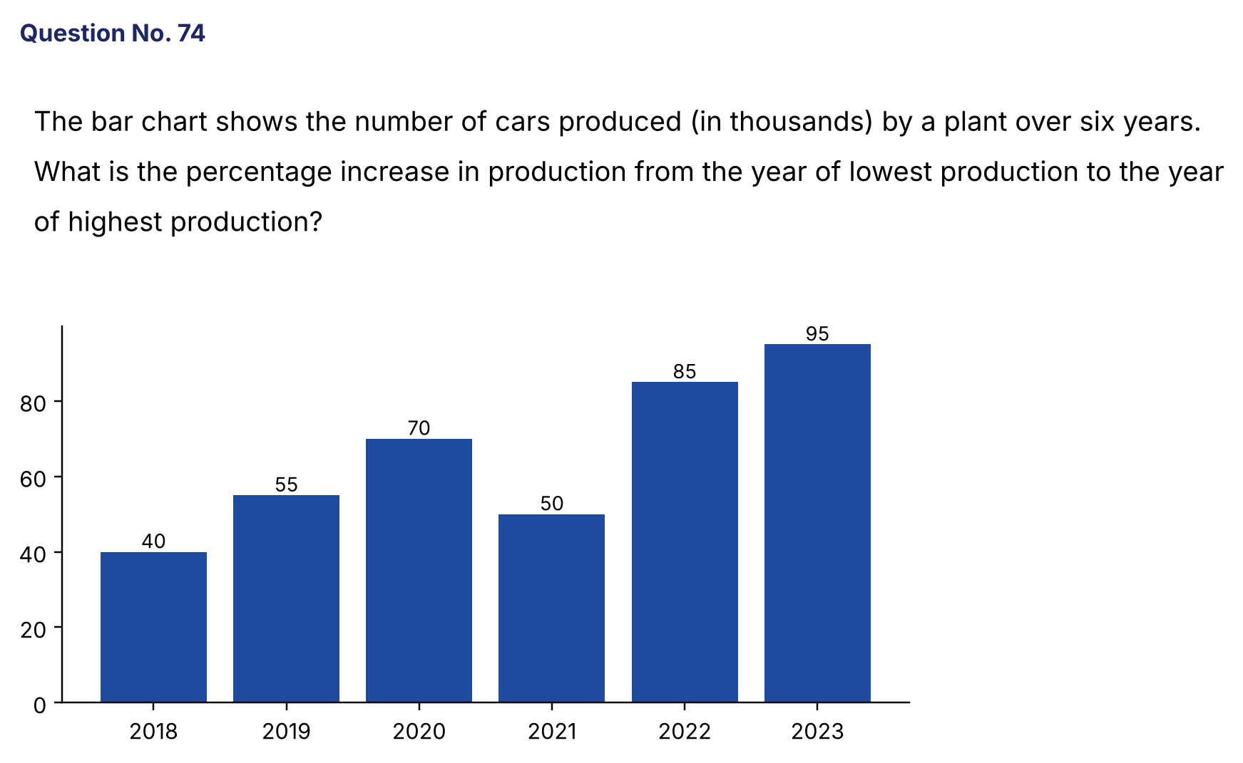
{OPTION 1} 137.5%
{OPTION 2} 147.5%
{OPTION 3} 120%
{OPTION 4} 95%
{OPTION 5}
{OPTION 6}
{OPTION 7}
{OPTION 8}
{OPTION 9}
{OPTION 10}
{RIGHT ANSWER} 1
{EXPLANATION} The lowest production is 40 (2018) and the highest is 95 (2023). Increase = (95 − 40)/40 × 100 = 137.5%.
{CORRECT MARKS} 1
{NEGATIVE MARKS} 0
{DIFFICULTY} Hard
{QUESTION ENDS}

{QUESTION BEGINS}
{QUESTION NUMBER} 75
{SUBJECT} Numerical Ability
{TOPIC} LCM and HCF
{TAGS} tcs nqt, numerical ability, full syllabus mix, hard
{QUESTION TYPE} SINGLECORRECT
{QUESTION TEXT} What is the greatest number that divides 1032, 1853 and 2097 leaving remainders 12, 13 and 17 respectively?
{OPTION 1} 40
{OPTION 2} 30
{OPTION 3} 20
{OPTION 4} 10
{OPTION 5}
{OPTION 6}
{OPTION 7}
{OPTION 8}
{OPTION 9}
{OPTION 10}
{RIGHT ANSWER} 3
{EXPLANATION} The required number is the HCF of 1032 − 12 = 1020, 1853 − 13 = 1840 and 2097 − 17 = 2080. HCF(1020, 1840, 2080) = 20, which is greater than every remainder.
{CORRECT MARKS} 1
{NEGATIVE MARKS} 0
{DIFFICULTY} Hard
{QUESTION ENDS}

{QUESTION BEGINS}
{QUESTION NUMBER} 76
{SUBJECT} Numerical Ability
{TOPIC} Compound Interest
{TAGS} tcs nqt, numerical ability, full syllabus mix, hard
{QUESTION TYPE} SINGLECORRECT
{QUESTION TEXT} The population of a town is 20,000. It grows by 10% every year, but 500 people migrate out at the end of each year (after the growth). What is the population at the end of 2 years?
{OPTION 1} 23,650
{OPTION 2} 23,000
{OPTION 3} 22,000
{OPTION 4} 23,150
{OPTION 5}
{OPTION 6}
{OPTION 7}
{OPTION 8}
{OPTION 9}
{OPTION 10}
{RIGHT ANSWER} 4
{EXPLANATION} End of year 1: 20,000 × 1.1 − 500 = 21,500. End of year 2: 21,500 × 1.1 − 500 = 23,650 − 500 = 23,150.
{CORRECT MARKS} 1
{NEGATIVE MARKS} 0
{DIFFICULTY} Hard
{QUESTION ENDS}

{QUESTION BEGINS}
{QUESTION NUMBER} 77
{SUBJECT} Numerical Ability
{TOPIC} Averages
{TAGS} tcs nqt, numerical ability, full syllabus mix, hard
{QUESTION TYPE} SINGLECORRECT
{QUESTION TEXT} The average of five numbers is 28. If one number is deleted, the average of the remaining four becomes 30. What is the deleted number?
{OPTION 1} 20
{OPTION 2} 18
{OPTION 3} 25
{OPTION 4} 22
{OPTION 5}
{OPTION 6}
{OPTION 7}
{OPTION 8}
{OPTION 9}
{OPTION 10}
{RIGHT ANSWER} 1
{EXPLANATION} Total of five = 140. Total of four = 120. Deleted number = 140 − 120 = 20.
{CORRECT MARKS} 1
{NEGATIVE MARKS} 0
{DIFFICULTY} Hard
{QUESTION ENDS}

{QUESTION BEGINS}
{QUESTION NUMBER} 78
{SUBJECT} Numerical Ability
{TOPIC} Simple Interest
{TAGS} tcs nqt, numerical ability, full syllabus mix, hard
{QUESTION TYPE} SINGLECORRECT
{QUESTION TEXT} A sum of money becomes 3 times itself in 8 years at simple interest. In how many years will it become 5 times itself at the same rate?
{OPTION 1} 20 years
{OPTION 2} 16 years
{OPTION 3} 12 years
{OPTION 4} 13 years
{OPTION 5}
{OPTION 6}
{OPTION 7}
{OPTION 8}
{OPTION 9}
{OPTION 10}
{RIGHT ANSWER} 2
{EXPLANATION} Interest in 8 years = 2P, so the interest per year = P/4. To become 5 times, the interest needed = 4P, which takes 4P/(P/4) = 16 years.
{CORRECT MARKS} 1
{NEGATIVE MARKS} 0
{DIFFICULTY} Hard
{QUESTION ENDS}

{QUESTION BEGINS}
{QUESTION NUMBER} 79
{SUBJECT} Numerical Ability
{TOPIC} Quadratic Equations
{TAGS} tcs nqt, numerical ability, full syllabus mix, hard
{QUESTION TYPE} SINGLECORRECT
{QUESTION TEXT} The roots of x² − kx + 12 = 0 differ by 1. What is the positive value of k?
{OPTION 1} 8
{OPTION 2} 5
{OPTION 3} 6
{OPTION 4} 7
{OPTION 5}
{OPTION 6}
{OPTION 7}
{OPTION 8}
{OPTION 9}
{OPTION 10}
{RIGHT ANSWER} 4
{EXPLANATION} Let the roots be α and α + 1. Product α(α + 1) = 12, so α = 3 (or −4). The roots are 3 and 4, and k = sum of roots = 7.
{CORRECT MARKS} 1
{NEGATIVE MARKS} 0
{DIFFICULTY} Hard
{QUESTION ENDS}

{QUESTION BEGINS}
{QUESTION NUMBER} 80
{SUBJECT} Numerical Ability
{TOPIC} Ages
{TAGS} tcs nqt, numerical ability, full syllabus mix, hard
{QUESTION TYPE} SINGLECORRECT
{QUESTION TEXT} The average age of a family of 5 members is 24 years. The youngest member is 4 years old. What was the average age of the family at the time of the birth of the youngest member?
{OPTION 1} 25 years
{OPTION 2} 24 years
{OPTION 3} 20 years
{OPTION 4} 23.5 years
{OPTION 5}
{OPTION 6}
{OPTION 7}
{OPTION 8}
{OPTION 9}
{OPTION 10}
{RIGHT ANSWER} 1
{EXPLANATION} Present total = 120. The other four now total 116. At the birth of the youngest (4 years ago) the four were each 4 years younger: 116 − 16 = 100. Average of those four = 25 years.
{CORRECT MARKS} 1
{NEGATIVE MARKS} 0
{DIFFICULTY} Hard
{QUESTION ENDS}

{QUESTION BEGINS}
{QUESTION NUMBER} 81
{SUBJECT} Numerical Ability
{TOPIC} Number System
{TAGS} tcs nqt, numerical ability, full syllabus mix, hard
{QUESTION TYPE} SINGLECORRECT
{QUESTION TEXT} How many two-digit numbers are there such that the sum of the number and the number obtained by reversing its digits is 143?
{OPTION 1} 6
{OPTION 2} 8
{OPTION 3} 5
{OPTION 4} 7
{OPTION 5}
{OPTION 6}
{OPTION 7}
{OPTION 8}
{OPTION 9}
{OPTION 10}
{RIGHT ANSWER} 1
{EXPLANATION} (10a + b) + (10b + a) = 11(a + b) = 143, so a + b = 13. The pairs are (4,9), (5,8), (6,7), (7,6), (8,5), (9,4): 6 numbers.
{CORRECT MARKS} 1
{NEGATIVE MARKS} 0
{DIFFICULTY} Hard
{QUESTION ENDS}

{QUESTION BEGINS}
{QUESTION NUMBER} 82
{SUBJECT} Numerical Ability
{TOPIC} Series
{TAGS} tcs nqt, numerical ability, full syllabus mix, hard
{QUESTION TYPE} SINGLECORRECT
{QUESTION TEXT} What is the sum of the first 18 terms of the series 3 + 7 + 11 + 15 + ... ?
{OPTION 1} 684
{OPTION 2} 666
{OPTION 3} 648
{OPTION 4} 702
{OPTION 5}
{OPTION 6}
{OPTION 7}
{OPTION 8}
{OPTION 9}
{OPTION 10}
{RIGHT ANSWER} 2
{EXPLANATION} a = 3 and d = 4. S = (n/2)[2a + (n − 1)d] = 9 × (6 + 68) = 9 × 74 = 666.
{CORRECT MARKS} 1
{NEGATIVE MARKS} 0
{DIFFICULTY} Hard
{QUESTION ENDS}

{QUESTION BEGINS}
{QUESTION NUMBER} 83
{SUBJECT} Numerical Ability
{TOPIC} Number System
{TAGS} tcs nqt, numerical ability, full syllabus mix, hard
{QUESTION TYPE} SINGLECORRECT
{QUESTION TEXT} How many divisors of 2520 are multiples of 6?
{OPTION 1} 18
{OPTION 2} 36
{OPTION 3} 24
{OPTION 4} 30
{OPTION 5}
{OPTION 6}
{OPTION 7}
{OPTION 8}
{OPTION 9}
{OPTION 10}
{RIGHT ANSWER} 3
{EXPLANATION} 2520 = 2³ × 3² × 5 × 7. A multiple of 6 needs at least 2¹ and 3¹: powers of 2 can be 1–3 (3 choices), powers of 3 can be 1–2 (2 choices), 5 and 7 are free (2 choices each). Total = 3 × 2 × 2 × 2 = 24.
{CORRECT MARKS} 1
{NEGATIVE MARKS} 0
{DIFFICULTY} Hard
{QUESTION ENDS}

{QUESTION BEGINS}
{QUESTION NUMBER} 84
{SUBJECT} Numerical Ability
{TOPIC} Mensuration
{TAGS} tcs nqt, numerical ability, full syllabus mix, hard
{QUESTION TYPE} SINGLECORRECT
{QUESTION TEXT} A cube of side 6 cm is cut into 27 identical smaller cubes. By how much does the total surface area increase?
{OPTION 1} 324 cm²
{OPTION 2} 432 cm²
{OPTION 3} 216 cm²
{OPTION 4} 648 cm²
{OPTION 5}
{OPTION 6}
{OPTION 7}
{OPTION 8}
{OPTION 9}
{OPTION 10}
{RIGHT ANSWER} 2
{EXPLANATION} Original surface = 6 × 36 = 216 cm². Each small cube has side 2 cm and surface 24 cm², so the 27 cubes have 648 cm². Increase = 648 − 216 = 432 cm².
{CORRECT MARKS} 1
{NEGATIVE MARKS} 0
{DIFFICULTY} Hard
{QUESTION ENDS}

{QUESTION BEGINS}
{QUESTION NUMBER} 85
{SUBJECT} Numerical Ability
{TOPIC} Time, Speed and Distance
{TAGS} tcs nqt, numerical ability, full syllabus mix, hard
{QUESTION TYPE} SINGLECORRECT
{QUESTION TEXT} Two trains of lengths 180 m and 140 m run in opposite directions at 54 km/h and 36 km/h. In how many seconds do they cross each other?
{OPTION 1} 12.8
{OPTION 2} 10.5
{OPTION 3} 16
{OPTION 4} 8.8
{OPTION 5}
{OPTION 6}
{OPTION 7}
{OPTION 8}
{OPTION 9}
{OPTION 10}
{RIGHT ANSWER} 1
{EXPLANATION} Relative speed = 90 km/h = 25 m/s. Distance = 180 + 140 = 320 m. Time = 320/25 = 12.8 s.
{CORRECT MARKS} 1
{NEGATIVE MARKS} 0
{DIFFICULTY} Hard
{QUESTION ENDS}

{QUESTION BEGINS}
{QUESTION NUMBER} 86
{SUBJECT} Numerical Ability
{TOPIC} Statistics
{TAGS} tcs nqt, numerical ability, full syllabus mix, hard
{QUESTION TYPE} SINGLECORRECT
{QUESTION TEXT} The mean of 10 observations was calculated as 20. Later it was found that one observation, 12, had been wrongly taken as 21. What is the correct mean?
{OPTION 1} 19.5
{OPTION 2} 18.9
{OPTION 3} 19.1
{OPTION 4} 20.9
{OPTION 5}
{OPTION 6}
{OPTION 7}
{OPTION 8}
{OPTION 9}
{OPTION 10}
{RIGHT ANSWER} 3
{EXPLANATION} Wrong total = 200. Correct total = 200 − 21 + 12 = 191. Correct mean = 19.1.
{CORRECT MARKS} 1
{NEGATIVE MARKS} 0
{DIFFICULTY} Hard
{QUESTION ENDS}

{QUESTION BEGINS}
{QUESTION NUMBER} 87
{SUBJECT} Numerical Ability
{TOPIC} Probability
{TAGS} tcs nqt, numerical ability, full syllabus mix, hard
{QUESTION TYPE} SINGLECORRECT
{QUESTION TEXT} Three coins are tossed and a die is rolled. What is the probability of getting at least two heads and an even number on the die?
{OPTION 1} 1/8
{OPTION 2} 1/3
{OPTION 3} 1/4
{OPTION 4} 3/8
{OPTION 5}
{OPTION 6}
{OPTION 7}
{OPTION 8}
{OPTION 9}
{OPTION 10}
{RIGHT ANSWER} 3
{EXPLANATION} P(at least 2 heads) = 4/8 = 1/2. P(even) = 1/2. The events are independent, so the probability = 1/4.
{CORRECT MARKS} 1
{NEGATIVE MARKS} 0
{DIFFICULTY} Hard
{QUESTION ENDS}

{QUESTION BEGINS}
{QUESTION NUMBER} 88
{SUBJECT} Numerical Ability
{TOPIC} Surds
{TAGS} tcs nqt, numerical ability, full syllabus mix, hard
{QUESTION TYPE} SINGLECORRECT
{QUESTION TEXT} 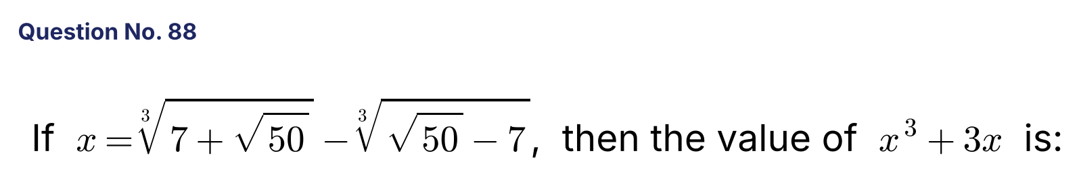
{OPTION 1} 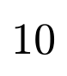
{OPTION 2} 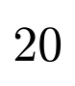
{OPTION 3} 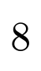
{OPTION 4} 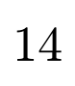
{OPTION 5}
{OPTION 6}
{OPTION 7}
{OPTION 8}
{OPTION 9}
{OPTION 10}
{RIGHT ANSWER} 4
{EXPLANATION} 7 + √50 = (1 + √2)³ and √50 − 7 = (√2 − 1)³. So x = (1 + √2) − (√2 − 1) = 2. Then x³ + 3x = 8 + 6 = 14.
{CORRECT MARKS} 1
{NEGATIVE MARKS} 0
{DIFFICULTY} Hard
{QUESTION ENDS}

{QUESTION BEGINS}
{QUESTION NUMBER} 89
{SUBJECT} Numerical Ability
{TOPIC} Time and Work
{TAGS} tcs nqt, numerical ability, full syllabus mix, hard
{QUESTION TYPE} SINGLECORRECT
{QUESTION TEXT} A can finish a job in 15 days and B can finish it in 10 days. They work together and are paid ₹3,000 in total. What is A's share?
{OPTION 1} ₹1,500
{OPTION 2} ₹1,000
{OPTION 3} ₹1,800
{OPTION 4} ₹1,200
{OPTION 5}
{OPTION 6}
{OPTION 7}
{OPTION 8}
{OPTION 9}
{OPTION 10}
{RIGHT ANSWER} 4
{EXPLANATION} Work rates: A = 1/15 and B = 1/10, in the ratio 2 : 3. A's share = 2/5 × 3000 = ₹1,200.
{CORRECT MARKS} 1
{NEGATIVE MARKS} 0
{DIFFICULTY} Hard
{QUESTION ENDS}

{QUESTION BEGINS}
{QUESTION NUMBER} 90
{SUBJECT} Numerical Ability
{TOPIC} Probability
{TAGS} tcs nqt, numerical ability, full syllabus mix, hard
{QUESTION TYPE} SINGLECORRECT
{QUESTION TEXT} Two dice are thrown. What is the probability that the product of the two numbers is a perfect square?
{OPTION 1} 1/9
{OPTION 2} 1/6
{OPTION 3} 5/18
{OPTION 4} 2/9
{OPTION 5}
{OPTION 6}
{OPTION 7}
{OPTION 8}
{OPTION 9}
{OPTION 10}
{RIGHT ANSWER} 4
{EXPLANATION} The favourable pairs: product 1: (1,1); 4: (1,4), (4,1), (2,2); 9: (3,3); 16: (4,4); 25: (5,5); 36: (6,6). That is 8 outcomes out of 36. Probability = 8/36 = 2/9.
{CORRECT MARKS} 1
{NEGATIVE MARKS} 0
{DIFFICULTY} Hard
{QUESTION ENDS}

{QUESTION BEGINS}
{QUESTION NUMBER} 91
{SUBJECT} Numerical Ability
{TOPIC} Ratio and Proportion
{TAGS} tcs nqt, numerical ability, full syllabus mix, hard
{QUESTION TYPE} SINGLECORRECT
{QUESTION TEXT} What is the third proportional to the mean proportional of 4 and 9 and the number 12?
{OPTION 1} 24
{OPTION 2} 16
{OPTION 3} 36
{OPTION 4} 18
{OPTION 5}
{OPTION 6}
{OPTION 7}
{OPTION 8}
{OPTION 9}
{OPTION 10}
{RIGHT ANSWER} 1
{EXPLANATION} The mean proportional of 4 and 9 is √36 = 6. The third proportional to 6 and 12 is 12²/6 = 24.
{CORRECT MARKS} 1
{NEGATIVE MARKS} 0
{DIFFICULTY} Hard
{QUESTION ENDS}

{QUESTION BEGINS}
{QUESTION NUMBER} 92
{SUBJECT} Numerical Ability
{TOPIC} Number System
{TAGS} tcs nqt, numerical ability, full syllabus mix, hard
{QUESTION TYPE} SINGLECORRECT
{QUESTION TEXT} What is the smallest number which leaves a remainder of 7 when divided by 12, 15 or 20 and is exactly divisible by 11?
{OPTION 1} 187
{OPTION 2} 247
{OPTION 3} 307
{OPTION 4} 127
{OPTION 5}
{OPTION 6}
{OPTION 7}
{OPTION 8}
{OPTION 9}
{OPTION 10}
{RIGHT ANSWER} 1
{EXPLANATION} Numbers of this type are 60k + 7. We need 60k + 7 ≡ 0 (mod 11). Since 60 ≡ 5, 5k ≡ 4 (mod 11), so k ≡ 3. The number = 60 × 3 + 7 = 187 = 11 × 17.
{CORRECT MARKS} 1
{NEGATIVE MARKS} 0
{DIFFICULTY} Hard
{QUESTION ENDS}

{QUESTION BEGINS}
{QUESTION NUMBER} 93
{SUBJECT} Numerical Ability
{TOPIC} Partnership
{TAGS} tcs nqt, numerical ability, full syllabus mix, hard
{QUESTION TYPE} SINGLECORRECT
{QUESTION TEXT} A, B and C invest ₹30,000, ₹40,000 and ₹50,000 respectively. A is in the business for 12 months, B for 9 months and C for 6 months. The total profit is ₹10,200. What is C's share?
{OPTION 1} ₹3,000
{OPTION 2} ₹3,600
{OPTION 3} ₹4,200
{OPTION 4} ₹2,400
{OPTION 5}
{OPTION 6}
{OPTION 7}
{OPTION 8}
{OPTION 9}
{OPTION 10}
{RIGHT ANSWER} 1
{EXPLANATION} Ratio = 30000 × 12 : 40000 × 9 : 50000 × 6 = 360 : 360 : 300 = 6 : 6 : 5. C's share = 5/17 × 10,200 = ₹3,000.
{CORRECT MARKS} 1
{NEGATIVE MARKS} 0
{DIFFICULTY} Hard
{QUESTION ENDS}

{QUESTION BEGINS}
{QUESTION NUMBER} 94
{SUBJECT} Numerical Ability
{TOPIC} Profit and Loss
{TAGS} tcs nqt, numerical ability, full syllabus mix, hard
{QUESTION TYPE} SINGLECORRECT
{QUESTION TEXT} A dealer sells goods at 8% profit on the cost price he declares, but uses a false weight of 900 g for 1 kg. What is his actual profit percentage?
{OPTION 1} 8%
{OPTION 2} 20%
{OPTION 3} 10.8%
{OPTION 4} 18%
{OPTION 5}
{OPTION 6}
{OPTION 7}
{OPTION 8}
{OPTION 9}
{OPTION 10}
{RIGHT ANSWER} 2
{EXPLANATION} For 900 g actually given, he receives the price of 1 kg at 8% profit = 1.08 (taking the cost of 1 kg = 1). The cost of 900 g = 0.9. Profit = (1.08 − 0.9)/0.9 = 20%.
{CORRECT MARKS} 1
{NEGATIVE MARKS} 0
{DIFFICULTY} Hard
{QUESTION ENDS}

{QUESTION BEGINS}
{QUESTION NUMBER} 95
{SUBJECT} Numerical Ability
{TOPIC} Ratio and Proportion
{TAGS} tcs nqt, numerical ability, full syllabus mix, hard
{QUESTION TYPE} SINGLECORRECT
{QUESTION TEXT} A : B = 3 : 5 and B : C = 7 : 9. If ₹10,100 is divided among A, B and C in the ratio A : B : C, how much does C get?
{OPTION 1} ₹5,000
{OPTION 2} ₹3,500
{OPTION 3} ₹4,500
{OPTION 4} ₹4,200
{OPTION 5}
{OPTION 6}
{OPTION 7}
{OPTION 8}
{OPTION 9}
{OPTION 10}
{RIGHT ANSWER} 3
{EXPLANATION} Make B equal: A : B = 21 : 35 and B : C = 35 : 45. So A : B : C = 21 : 35 : 45 (total 101 parts). One part = ₹100. C gets 45 × 100 = ₹4,500.
{CORRECT MARKS} 1
{NEGATIVE MARKS} 0
{DIFFICULTY} Hard
{QUESTION ENDS}

{QUESTION BEGINS}
{QUESTION NUMBER} 96
{SUBJECT} Numerical Ability
{TOPIC} Indices
{TAGS} tcs nqt, numerical ability, full syllabus mix, hard
{QUESTION TYPE} SINGLECORRECT
{QUESTION TEXT} 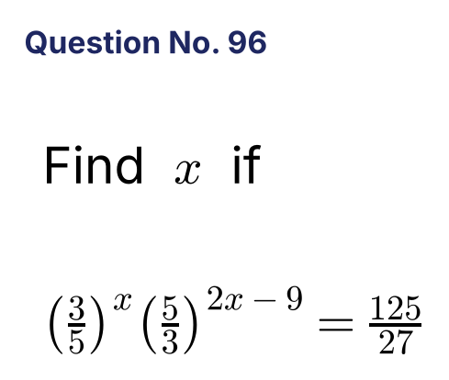
{OPTION 1}
{OPTION 2} 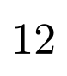
{OPTION 3} 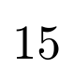
{OPTION 4}
{OPTION 5}
{OPTION 6}
{OPTION 7}
{OPTION 8}
{OPTION 9}
{OPTION 10}
{RIGHT ANSWER} 2
{EXPLANATION} (5/3)^(2x−9) = (3/5)^(−(2x−9)), so the left side = (5/3)^(2x − 9 − x) = (5/3)^(x − 9). The right side = (5/3)³. So x − 9 = 3 and x = 12.
{CORRECT MARKS} 1
{NEGATIVE MARKS} 0
{DIFFICULTY} Hard
{QUESTION ENDS}

{QUESTION BEGINS}
{QUESTION NUMBER} 97
{SUBJECT} Numerical Ability
{TOPIC} Mensuration
{TAGS} tcs nqt, numerical ability, full syllabus mix, hard
{QUESTION TYPE} SINGLECORRECT
{QUESTION TEXT} What is the volume of a cone whose base radius is 7 cm and height is 12 cm? (Use π = 22/7.)
{OPTION 1} 308 cm³
{OPTION 2} 616 cm³
{OPTION 3} 462 cm³
{OPTION 4} 1,848 cm³
{OPTION 5}
{OPTION 6}
{OPTION 7}
{OPTION 8}
{OPTION 9}
{OPTION 10}
{RIGHT ANSWER} 2
{EXPLANATION} Volume = (1/3)πr²h = (1/3) × (22/7) × 49 × 12 = 22 × 7 × 4 = 616 cm³.
{CORRECT MARKS} 1
{NEGATIVE MARKS} 0
{DIFFICULTY} Hard
{QUESTION ENDS}

{QUESTION BEGINS}
{QUESTION NUMBER} 98
{SUBJECT} Numerical Ability
{TOPIC} Indices
{TAGS} tcs nqt, numerical ability, full syllabus mix, hard
{QUESTION TYPE} SINGLECORRECT
{QUESTION TEXT} 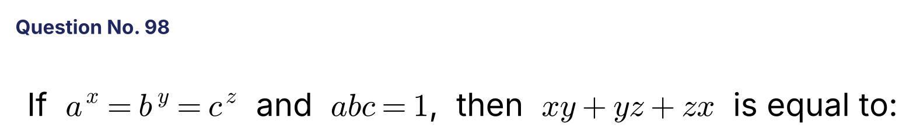
{OPTION 1}
{OPTION 2} 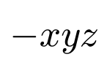
{OPTION 3}
{OPTION 4} 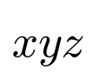
{OPTION 5}
{OPTION 6}
{OPTION 7}
{OPTION 8}
{OPTION 9}
{OPTION 10}
{RIGHT ANSWER} 3
{EXPLANATION} Let aˣ = bʸ = cᶻ = k, so a = k^(1/x), b = k^(1/y), c = k^(1/z). abc = 1 gives k^(1/x + 1/y + 1/z) = 1, so 1/x + 1/y + 1/z = 0. Multiplying by xyz: yz + xz + xy = 0.
{CORRECT MARKS} 1
{NEGATIVE MARKS} 0
{DIFFICULTY} Hard
{QUESTION ENDS}

{QUESTION BEGINS}
{QUESTION NUMBER} 99
{SUBJECT} Numerical Ability
{TOPIC} Time and Work
{TAGS} tcs nqt, numerical ability, full syllabus mix, hard
{QUESTION TYPE} SINGLECORRECT
{QUESTION TEXT} A and B can do a work in 18 days, B and C in 24 days, and A and C in 36 days. In how many days can A alone do the work?
{OPTION 1} 72 days
{OPTION 2} 24 days
{OPTION 3} 48 days
{OPTION 4} 36 days
{OPTION 5}
{OPTION 6}
{OPTION 7}
{OPTION 8}
{OPTION 9}
{OPTION 10}
{RIGHT ANSWER} 3
{EXPLANATION} Adding: 2(A + B + C) = 1/18 + 1/24 + 1/36 = (4 + 3 + 2)/72 = 1/8, so A + B + C = 1/16. A = 1/16 − (B + C) = 1/16 − 1/24 = 1/48. A alone takes 48 days.
{CORRECT MARKS} 1
{NEGATIVE MARKS} 0
{DIFFICULTY} Hard
{QUESTION ENDS}

{QUESTION BEGINS}
{QUESTION NUMBER} 100
{SUBJECT} Numerical Ability
{TOPIC} Probability
{TAGS} tcs nqt, numerical ability, full syllabus mix, hard
{QUESTION TYPE} SINGLECORRECT
{QUESTION TEXT} A bag has 6 white and 4 black balls. Two balls are drawn one after another with replacement. What is the probability that they are of different colours?
{OPTION 1} 12/25
{OPTION 2} 6/25
{OPTION 3} 24/25
{OPTION 4} 1/2
{OPTION 5}
{OPTION 6}
{OPTION 7}
{OPTION 8}
{OPTION 9}
{OPTION 10}
{RIGHT ANSWER} 1
{EXPLANATION} P(white then black) = 6/10 × 4/10 = 6/25. P(black then white) is also 6/25. Total = 12/25.
{CORRECT MARKS} 1
{NEGATIVE MARKS} 0
{DIFFICULTY} Hard
{QUESTION ENDS}

