{QUESTION BEGINS}
{QUESTION NUMBER} 1
{SUBJECT} Numerical Ability
{TOPIC} Ratio and Proportion
{TAGS} tcs nqt, numerical ability, easy
{QUESTION TYPE} SINGLECORRECT
{QUESTION TEXT} 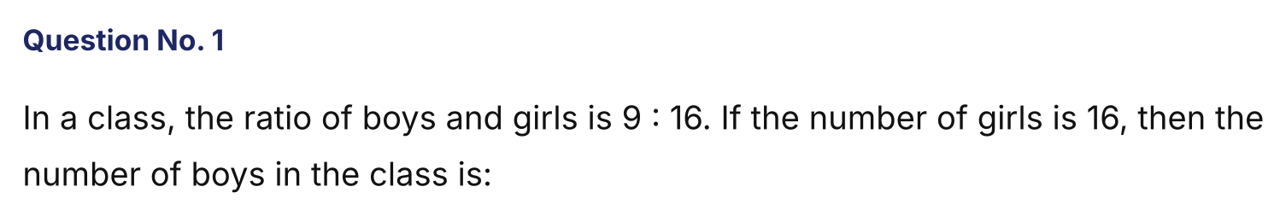
{OPTION 1} 9
{OPTION 2} 16
{OPTION 3} 10
{OPTION 4} 11
{OPTION 5}
{OPTION 6}
{OPTION 7}
{OPTION 8}
{OPTION 9}
{OPTION 10}
{RIGHT ANSWER} 1
{EXPLANATION} Boys : girls = 9 : 16. Girls = 16 means 1 part = 1, so boys = 9.
{CORRECT MARKS} 1
{NEGATIVE MARKS} 0
{DIFFICULTY} Easy
{QUESTION ENDS}

{QUESTION BEGINS}
{QUESTION NUMBER} 2
{SUBJECT} Numerical Ability
{TOPIC} Percentages
{TAGS} tcs nqt, numerical ability, medium
{QUESTION TYPE} SINGLECORRECT
{QUESTION TEXT} 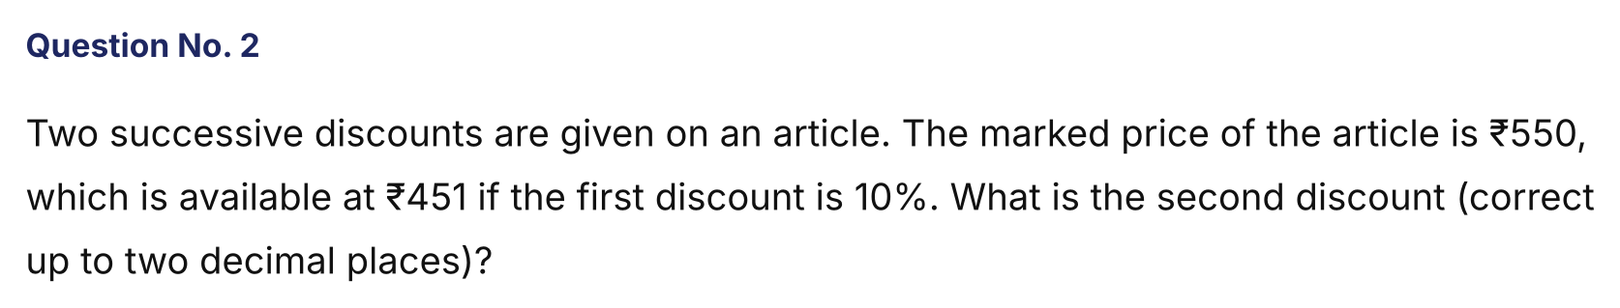
{OPTION 1} 8.09%
{OPTION 2} 11.09%
{OPTION 3} 8.89%
{OPTION 4} 9.09%
{OPTION 5}
{OPTION 6}
{OPTION 7}
{OPTION 8}
{OPTION 9}
{OPTION 10}
{RIGHT ANSWER} 3
{EXPLANATION} After the first discount of 10%, the price is 550 × 0.9 = ₹495. The second discount takes it to ₹451, a reduction of ₹44. Second discount = 44/495 × 100 = 8.89%.
{CORRECT MARKS} 1
{NEGATIVE MARKS} 0
{DIFFICULTY} Medium
{QUESTION ENDS}

{QUESTION BEGINS}
{QUESTION NUMBER} 3
{SUBJECT} Numerical Ability
{TOPIC} Algebra
{TAGS} tcs nqt, numerical ability, medium
{QUESTION TYPE} SINGLECORRECT
{QUESTION TEXT} 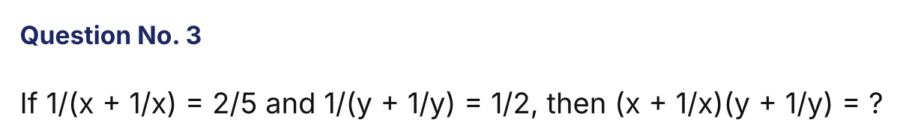
{OPTION 1} 5
{OPTION 2} 10
{OPTION 3} 3
{OPTION 4} 4
{OPTION 5}
{OPTION 6}
{OPTION 7}
{OPTION 8}
{OPTION 9}
{OPTION 10}
{RIGHT ANSWER} 1
{EXPLANATION} From the first equation x + 1/x = 5/2. From the second y + 1/y = 2. The product = 5/2 × 2 = 5.
{CORRECT MARKS} 1
{NEGATIVE MARKS} 0
{DIFFICULTY} Medium
{QUESTION ENDS}

{QUESTION BEGINS}
{QUESTION NUMBER} 4
{SUBJECT} Numerical Ability
{TOPIC} Averages
{TAGS} tcs nqt, numerical ability, medium
{QUESTION TYPE} SINGLECORRECT
{QUESTION TEXT} 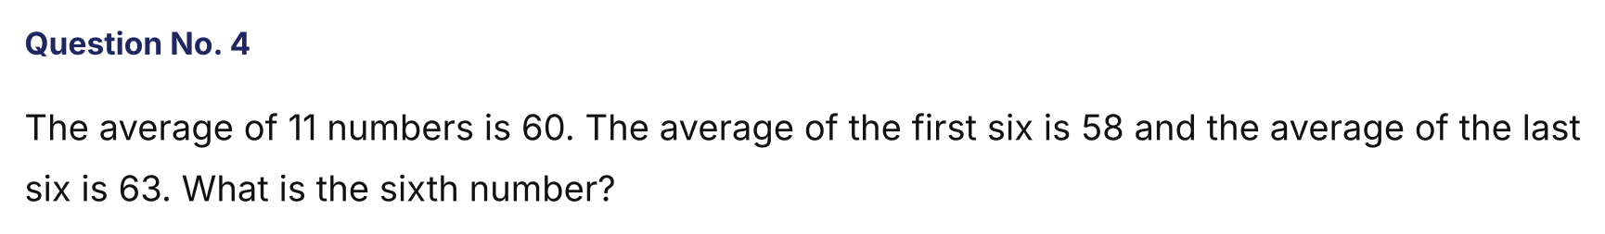
{OPTION 1} 58
{OPTION 2} 66
{OPTION 3} 60
{OPTION 4} 63
{OPTION 5}
{OPTION 6}
{OPTION 7}
{OPTION 8}
{OPTION 9}
{OPTION 10}
{RIGHT ANSWER} 2
{EXPLANATION} Total of all 11 = 660. First six sum = 348, last six sum = 378. Their total counts the sixth number twice: 348 + 378 = 726 = 660 + (6th number), so the 6th number = 66.
{CORRECT MARKS} 1
{NEGATIVE MARKS} 0
{DIFFICULTY} Medium
{QUESTION ENDS}

{QUESTION BEGINS}
{QUESTION NUMBER} 5
{SUBJECT} Numerical Ability
{TOPIC} Probability
{TAGS} tcs nqt, numerical ability, medium
{QUESTION TYPE} SINGLECORRECT
{QUESTION TEXT} 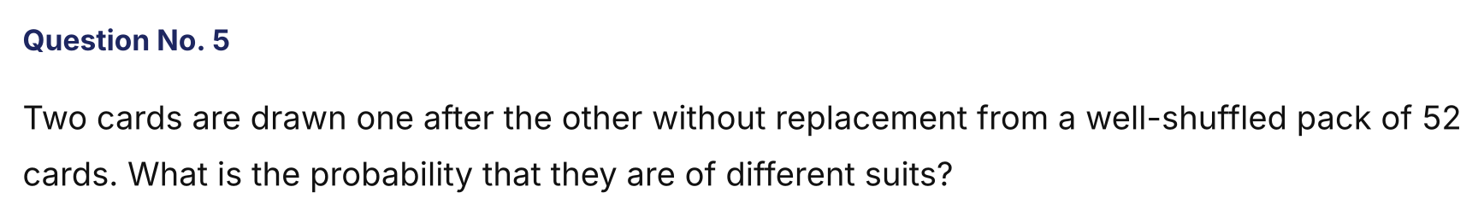
{OPTION 1} 4/17
{OPTION 2} 39/52
{OPTION 3} 13/17
{OPTION 4} 12/17
{OPTION 5}
{OPTION 6}
{OPTION 7}
{OPTION 8}
{OPTION 9}
{OPTION 10}
{RIGHT ANSWER} 3
{EXPLANATION} After the first card, 39 of the remaining 51 cards are of a different suit. Probability = 39/51 = 13/17.
{CORRECT MARKS} 1
{NEGATIVE MARKS} 0
{DIFFICULTY} Medium
{QUESTION ENDS}

{QUESTION BEGINS}
{QUESTION NUMBER} 6
{SUBJECT} Numerical Ability
{TOPIC} Permutation and Combination
{TAGS} tcs nqt, numerical ability, medium
{QUESTION TYPE} SINGLECORRECT
{QUESTION TEXT} 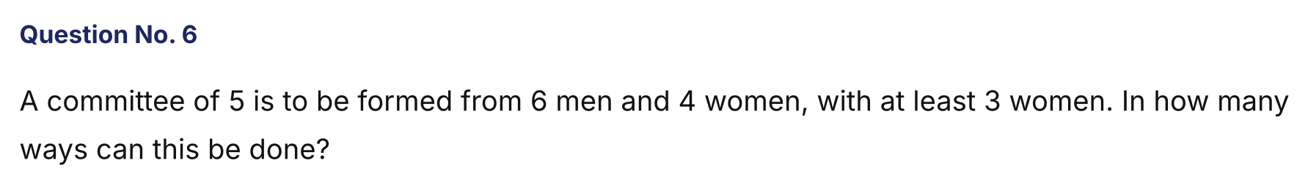
{OPTION 1} 60
{OPTION 2} 66
{OPTION 3} 120
{OPTION 4} 90
{OPTION 5}
{OPTION 6}
{OPTION 7}
{OPTION 8}
{OPTION 9}
{OPTION 10}
{RIGHT ANSWER} 2
{EXPLANATION} 3 women and 2 men: C(4,3) × C(6,2) = 4 × 15 = 60. 4 women and 1 man: C(4,4) × C(6,1) = 6. Total = 66.
{CORRECT MARKS} 1
{NEGATIVE MARKS} 0
{DIFFICULTY} Medium
{QUESTION ENDS}

{QUESTION BEGINS}
{QUESTION NUMBER} 7
{SUBJECT} Numerical Ability
{TOPIC} Series
{TAGS} tcs nqt, numerical ability, medium
{QUESTION TYPE} SINGLECORRECT
{QUESTION TEXT} 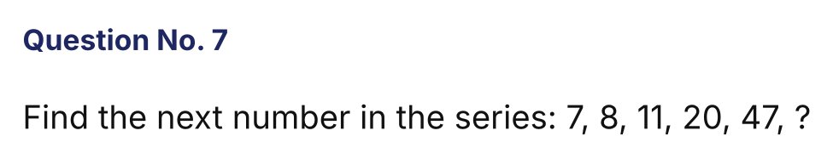
{OPTION 1} 95
{OPTION 2} 128
{OPTION 3} 121
{OPTION 4} 110
{OPTION 5}
{OPTION 6}
{OPTION 7}
{OPTION 8}
{OPTION 9}
{OPTION 10}
{RIGHT ANSWER} 2
{EXPLANATION} The differences are 1, 3, 9, 27, which grow by a factor of 3. The next difference is 81, so the next number is 47 + 81 = 128.
{CORRECT MARKS} 1
{NEGATIVE MARKS} 0
{DIFFICULTY} Medium
{QUESTION ENDS}

{QUESTION BEGINS}
{QUESTION NUMBER} 8
{SUBJECT} Numerical Ability
{TOPIC} LCM and HCF
{TAGS} tcs nqt, numerical ability, medium
{QUESTION TYPE} SINGLECORRECT
{QUESTION TEXT} 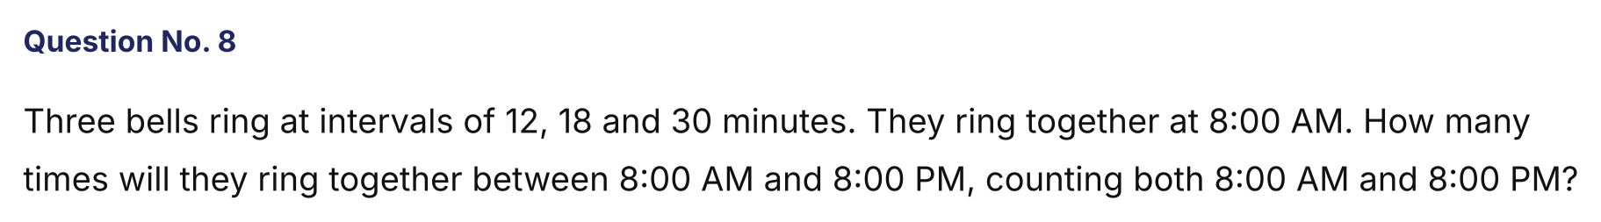
{OPTION 1} 3
{OPTION 2} 6
{OPTION 3} 5
{OPTION 4} 4
{OPTION 5}
{OPTION 6}
{OPTION 7}
{OPTION 8}
{OPTION 9}
{OPTION 10}
{RIGHT ANSWER} 3
{EXPLANATION} LCM(12, 18, 30) = 180 minutes = 3 hours. From 8 AM to 8 PM is 12 hours = 4 × 3 hours, so the bells ring together at 8, 11, 2, 5 and 8 — a total of 5 times.
{CORRECT MARKS} 1
{NEGATIVE MARKS} 0
{DIFFICULTY} Medium
{QUESTION ENDS}

{QUESTION BEGINS}
{QUESTION NUMBER} 9
{SUBJECT} Numerical Ability
{TOPIC} Algebra
{TAGS} tcs nqt, numerical ability, medium
{QUESTION TYPE} SINGLECORRECT
{QUESTION TEXT} 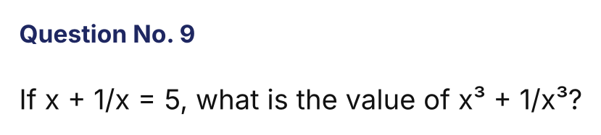
{OPTION 1} 115
{OPTION 2} 125
{OPTION 3} 120
{OPTION 4} 110
{OPTION 5}
{OPTION 6}
{OPTION 7}
{OPTION 8}
{OPTION 9}
{OPTION 10}
{RIGHT ANSWER} 4
{EXPLANATION} x³ + 1/x³ = (x + 1/x)³ − 3(x + 1/x) = 125 − 15 = 110.
{CORRECT MARKS} 1
{NEGATIVE MARKS} 0
{DIFFICULTY} Medium
{QUESTION ENDS}

{QUESTION BEGINS}
{QUESTION NUMBER} 10
{SUBJECT} Numerical Ability
{TOPIC} Profit and Loss
{TAGS} tcs nqt, numerical ability, medium
{QUESTION TYPE} SINGLECORRECT
{QUESTION TEXT} 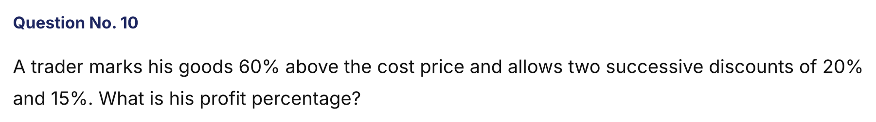
{OPTION 1} 8.8%
{OPTION 2} 6.4%
{OPTION 3} 9.2%
{OPTION 4} 12%
{OPTION 5}
{OPTION 6}
{OPTION 7}
{OPTION 8}
{OPTION 9}
{OPTION 10}
{RIGHT ANSWER} 1
{EXPLANATION} Take CP = 100. MP = 160. After the discounts: 160 × 0.80 × 0.85 = 108.8. Profit = 8.8%.
{CORRECT MARKS} 1
{NEGATIVE MARKS} 0
{DIFFICULTY} Medium
{QUESTION ENDS}

{QUESTION BEGINS}
{QUESTION NUMBER} 11
{SUBJECT} Numerical Ability
{TOPIC} Averages
{TAGS} tcs nqt, numerical ability, hard
{QUESTION TYPE} SINGLECORRECT
{QUESTION TEXT} 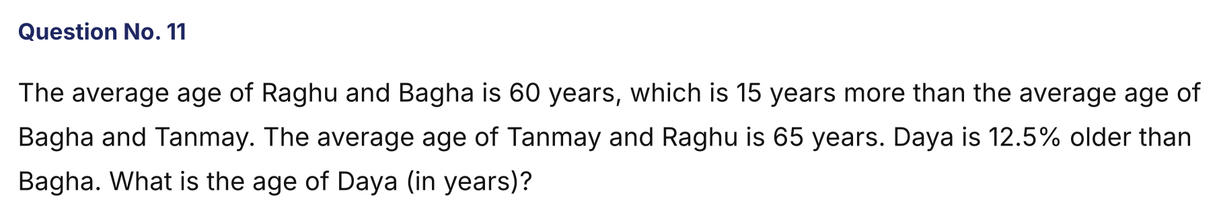
{OPTION 1} 35
{OPTION 2} 40
{OPTION 3} 45
{OPTION 4} 30
{OPTION 5}
{OPTION 6}
{OPTION 7}
{OPTION 8}
{OPTION 9}
{OPTION 10}
{RIGHT ANSWER} 3
{EXPLANATION} R + B = 120, B + T = 2 × 45 = 90 and T + R = 130. Adding: 2(R + B + T) = 340, so R + B + T = 170. Bagha = 170 − 130 = 40. Daya = 40 × 1.125 = 45 years.
{CORRECT MARKS} 1
{NEGATIVE MARKS} 0
{DIFFICULTY} Hard
{QUESTION ENDS}

{QUESTION BEGINS}
{QUESTION NUMBER} 12
{SUBJECT} Numerical Ability
{TOPIC} Percentages
{TAGS} tcs nqt, numerical ability, hard
{QUESTION TYPE} SINGLECORRECT
{QUESTION TEXT} 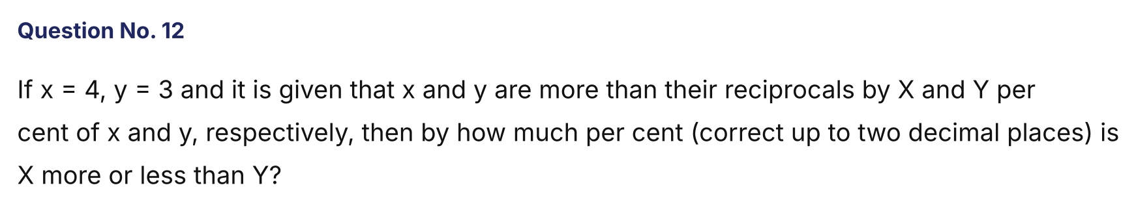
{OPTION 1} Less by 5.47%
{OPTION 2} More by 5.18%
{OPTION 3} More by 5.47%
{OPTION 4} Less by 5.18%
{OPTION 5}
{OPTION 6}
{OPTION 7}
{OPTION 8}
{OPTION 9}
{OPTION 10}
{RIGHT ANSWER} 3
{EXPLANATION} X = (4 − 1/4)/4 × 100 = 93.75% and Y = (3 − 1/3)/3 × 100 = 88.89%. X is more than Y by (93.75 − 88.89)/88.89 × 100 = 5.47%.
{CORRECT MARKS} 1
{NEGATIVE MARKS} 0
{DIFFICULTY} Hard
{QUESTION ENDS}

{QUESTION BEGINS}
{QUESTION NUMBER} 13
{SUBJECT} Numerical Ability
{TOPIC} Time, Speed and Distance
{TAGS} tcs nqt, numerical ability, hard
{QUESTION TYPE} SINGLECORRECT
{QUESTION TEXT} 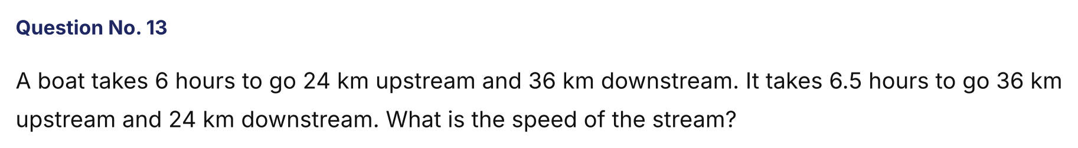
{OPTION 1} 2 km/h
{OPTION 2} 1.5 km/h
{OPTION 3} 3 km/h
{OPTION 4} 4 km/h
{OPTION 5}
{OPTION 6}
{OPTION 7}
{OPTION 8}
{OPTION 9}
{OPTION 10}
{RIGHT ANSWER} 1
{EXPLANATION} Let 1/(upstream speed) = a and 1/(downstream speed) = b. Then 24a + 36b = 6 and 36a + 24b = 6.5. Solving gives a = 1/8 and b = 1/12, so upstream = 8 km/h and downstream = 12 km/h. Stream speed = (12 − 8)/2 = 2 km/h.
{CORRECT MARKS} 1
{NEGATIVE MARKS} 0
{DIFFICULTY} Hard
{QUESTION ENDS}

{QUESTION BEGINS}
{QUESTION NUMBER} 14
{SUBJECT} Numerical Ability
{TOPIC} Compound Interest
{TAGS} tcs nqt, numerical ability, hard
{QUESTION TYPE} NUMERICAL
{QUESTION TEXT} 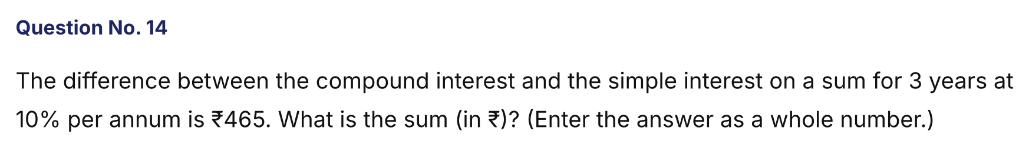
{OPTION 1}
{OPTION 2}
{OPTION 3}
{OPTION 4}
{OPTION 5}
{OPTION 6}
{OPTION 7}
{OPTION 8}
{OPTION 9}
{OPTION 10}
{RIGHT ANSWER} 15000
{EXPLANATION} For 3 years at 10%: CI − SI = P[(1.1)³ − 1 − 0.3] = P × 0.031. So 0.031P = 465 and P = 15,000.
{CORRECT MARKS} 1
{NEGATIVE MARKS} 0
{DIFFICULTY} Hard
{QUESTION ENDS}

{QUESTION BEGINS}
{QUESTION NUMBER} 15
{SUBJECT} Numerical Ability
{TOPIC} Ratio and Proportion
{TAGS} tcs nqt, numerical ability, hard
{QUESTION TYPE} SINGLECORRECT
{QUESTION TEXT} 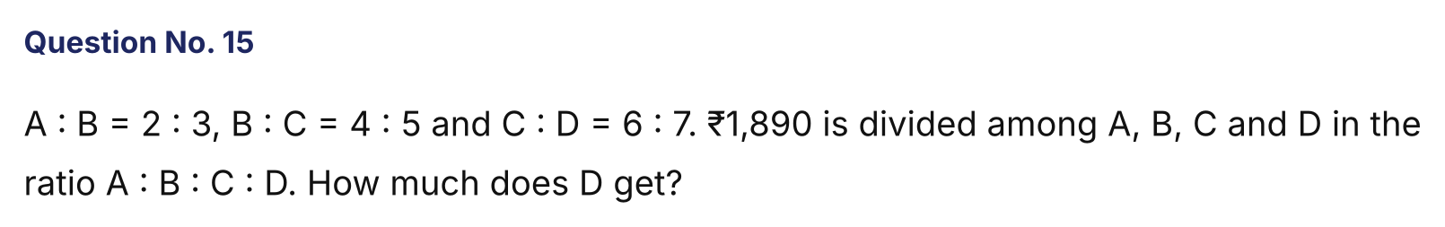
{OPTION 1} ₹570
{OPTION 2} ₹540
{OPTION 3} ₹630
{OPTION 4} ₹600
{OPTION 5}
{OPTION 6}
{OPTION 7}
{OPTION 8}
{OPTION 9}
{OPTION 10}
{RIGHT ANSWER} 3
{EXPLANATION} Make B equal: A : B = 8 : 12, B : C = 12 : 15. Now C : D = 6 : 7 = 15 : 17.5. So A : B : C : D = 8 : 12 : 15 : 17.5 = 16 : 24 : 30 : 35. Total = 105 parts, 1 part = 1890/105 = ₹18. D = 35 × 18 = ₹630.
{CORRECT MARKS} 1
{NEGATIVE MARKS} 0
{DIFFICULTY} Hard
{QUESTION ENDS}

{QUESTION BEGINS}
{QUESTION NUMBER} 16
{SUBJECT} Numerical Ability
{TOPIC} Probability
{TAGS} tcs nqt, numerical ability, hard
{QUESTION TYPE} SINGLECORRECT
{QUESTION TEXT} 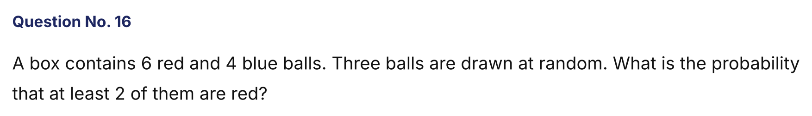
{OPTION 1} 1/2
{OPTION 2} 3/5
{OPTION 3} 5/6
{OPTION 4} 2/3
{OPTION 5}
{OPTION 6}
{OPTION 7}
{OPTION 8}
{OPTION 9}
{OPTION 10}
{RIGHT ANSWER} 4
{EXPLANATION} Favourable = (2 red, 1 blue) + (3 red) = C(6,2)×4 + C(6,3) = 60 + 20 = 80. Total = C(10,3) = 120. Probability = 80/120 = 2/3.
{CORRECT MARKS} 1
{NEGATIVE MARKS} 0
{DIFFICULTY} Hard
{QUESTION ENDS}

{QUESTION BEGINS}
{QUESTION NUMBER} 17
{SUBJECT} Numerical Ability
{TOPIC} Mensuration
{TAGS} tcs nqt, numerical ability, hard
{QUESTION TYPE} SINGLECORRECT
{QUESTION TEXT} 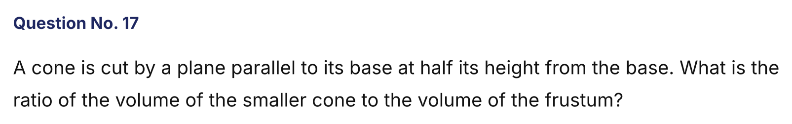
{OPTION 1} 1 : 7
{OPTION 2} 1 : 3
{OPTION 3} 1 : 8
{OPTION 4} 1 : 6
{OPTION 5}
{OPTION 6}
{OPTION 7}
{OPTION 8}
{OPTION 9}
{OPTION 10}
{RIGHT ANSWER} 1
{EXPLANATION} The smaller cone has half the height and half the radius, so its volume is (1/2)³ = 1/8 of the whole cone. The frustum is the remaining 7/8. Ratio = 1 : 7.
{CORRECT MARKS} 1
{NEGATIVE MARKS} 0
{DIFFICULTY} Hard
{QUESTION ENDS}

{QUESTION BEGINS}
{QUESTION NUMBER} 18
{SUBJECT} Numerical Ability
{TOPIC} Series
{TAGS} tcs nqt, numerical ability, hard
{QUESTION TYPE} NUMERICAL
{QUESTION TEXT} 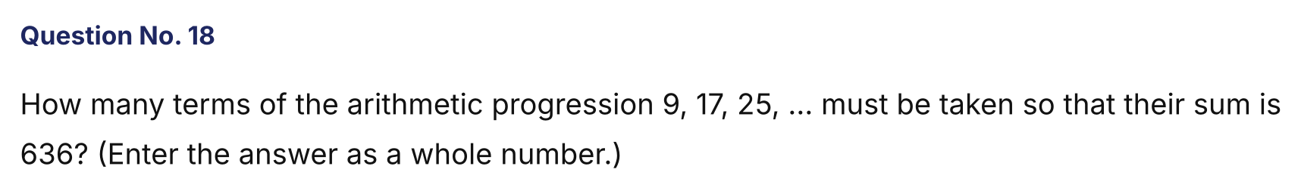
{OPTION 1}
{OPTION 2}
{OPTION 3}
{OPTION 4}
{OPTION 5}
{OPTION 6}
{OPTION 7}
{OPTION 8}
{OPTION 9}
{OPTION 10}
{RIGHT ANSWER} 12
{EXPLANATION} Sum = n/2 [2 × 9 + (n − 1) × 8] = n(4n + 5) = 636, i.e. 4n² + 5n − 636 = 0. The positive root is n = 12 (since 12 × 53 = 636).
{CORRECT MARKS} 1
{NEGATIVE MARKS} 0
{DIFFICULTY} Hard
{QUESTION ENDS}

{QUESTION BEGINS}
{QUESTION NUMBER} 19
{SUBJECT} Numerical Ability
{TOPIC} LCM and HCF
{TAGS} tcs nqt, numerical ability, hard
{QUESTION TYPE} SINGLECORRECT
{QUESTION TEXT} 
{OPTION 1} 2240
{OPTION 2} 560
{OPTION 3} 1680
{OPTION 4} 1120
{OPTION 5}
{OPTION 6}
{OPTION 7}
{OPTION 8}
{OPTION 9}
{OPTION 10}
{RIGHT ANSWER} 4
{EXPLANATION} The required number is the HCF of the differences: 4665 − 1305 = 3360 and 6905 − 4665 = 2240. HCF(3360, 2240) = 1120.
{CORRECT MARKS} 1
{NEGATIVE MARKS} 0
{DIFFICULTY} Hard
{QUESTION ENDS}

{QUESTION BEGINS}
{QUESTION NUMBER} 20
{SUBJECT} Numerical Ability
{TOPIC} Profit and Loss
{TAGS} tcs nqt, numerical ability, hard
{QUESTION TYPE} SINGLECORRECT
{QUESTION TEXT} 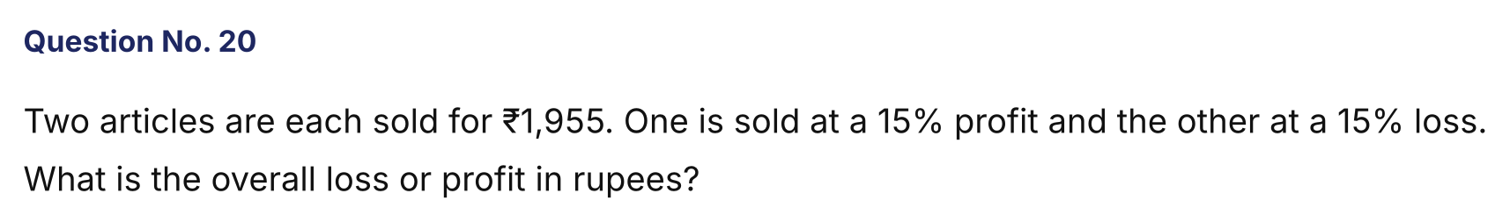
{OPTION 1} ₹45 loss
{OPTION 2} No profit, no loss
{OPTION 3} ₹90 loss
{OPTION 4} ₹100 loss
{OPTION 5}
{OPTION 6}
{OPTION 7}
{OPTION 8}
{OPTION 9}
{OPTION 10}
{RIGHT ANSWER} 3
{EXPLANATION} CP of the first = 1955/1.15 = ₹1,700; CP of the second = 1955/0.85 = ₹2,300. Total CP = ₹4,000, total SP = ₹3,910. Loss = ₹90.
{CORRECT MARKS} 1
{NEGATIVE MARKS} 0
{DIFFICULTY} Hard
{QUESTION ENDS}

