{QUESTION BEGINS}
{QUESTION NUMBER} 1
{SUBJECT} Numerical Ability
{TOPIC} Statistics
{TAGS} tcs nqt, numerical ability, medium
{QUESTION TYPE} SINGLECORRECT
{QUESTION TEXT} 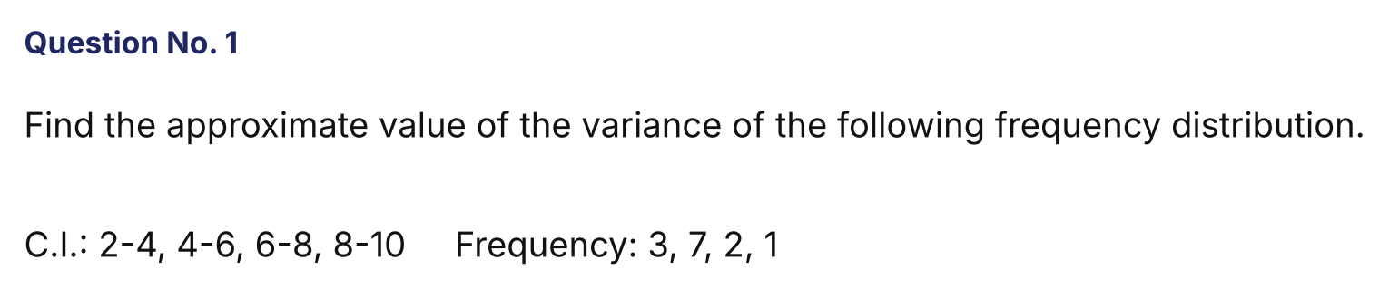
{OPTION 1} 2.65
{OPTION 2} 2.56
{OPTION 3} 2.75
{OPTION 4} 2.83
{OPTION 5}
{OPTION 6}
{OPTION 7}
{OPTION 8}
{OPTION 9}
{OPTION 10}
{RIGHT ANSWER} 3
{EXPLANATION} Class marks are 3, 5, 7, 9 with frequencies 3, 7, 2, 1 (n = 13). Mean = (9 + 35 + 14 + 9)/13 = 67/13 = 5.154. Mean of squares = (27 + 175 + 98 + 81)/13 = 381/13 = 29.308. Variance = 29.308 − 5.154² = 29.308 − 26.562 ≈ 2.75.
{CORRECT MARKS} 1
{NEGATIVE MARKS} 0
{DIFFICULTY} Medium
{QUESTION ENDS}

{QUESTION BEGINS}
{QUESTION NUMBER} 2
{SUBJECT} Numerical Ability
{TOPIC} Time, Speed and Distance
{TAGS} tcs nqt, numerical ability, medium
{QUESTION TYPE} SINGLECORRECT
{QUESTION TEXT} 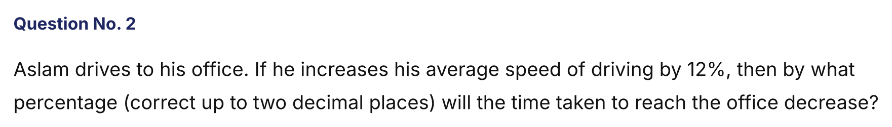
{OPTION 1} 10.71%
{OPTION 2} 12.00%
{OPTION 3} 10.34%
{OPTION 4} 11.02%
{OPTION 5}
{OPTION 6}
{OPTION 7}
{OPTION 8}
{OPTION 9}
{OPTION 10}
{RIGHT ANSWER} 1
{EXPLANATION} For a fixed distance, time ∝ 1/speed. New time = 1/1.12 = 0.8929 of the old time. Decrease = 1 − 0.8929 = 10.71%.
{CORRECT MARKS} 1
{NEGATIVE MARKS} 0
{DIFFICULTY} Medium
{QUESTION ENDS}

{QUESTION BEGINS}
{QUESTION NUMBER} 3
{SUBJECT} Numerical Ability
{TOPIC} Time and Work
{TAGS} tcs nqt, numerical ability, medium
{QUESTION TYPE} SINGLECORRECT
{QUESTION TEXT} 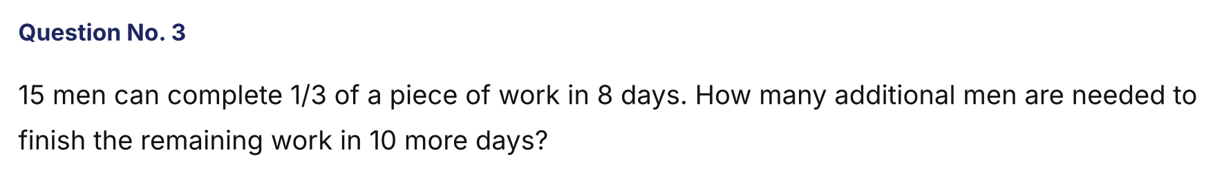
{OPTION 1} 10
{OPTION 2} 6
{OPTION 3} 9
{OPTION 4} 12
{OPTION 5}
{OPTION 6}
{OPTION 7}
{OPTION 8}
{OPTION 9}
{OPTION 10}
{RIGHT ANSWER} 3
{EXPLANATION} 15 men × 8 days = 120 man-days for 1/3 of the work, so the whole work needs 360 man-days. Remaining = 240 man-days. In 10 days this needs 24 men, so 24 − 15 = 9 additional men.
{CORRECT MARKS} 1
{NEGATIVE MARKS} 0
{DIFFICULTY} Medium
{QUESTION ENDS}

{QUESTION BEGINS}
{QUESTION NUMBER} 4
{SUBJECT} Numerical Ability
{TOPIC} Averages
{TAGS} tcs nqt, numerical ability, medium
{QUESTION TYPE} SINGLECORRECT
{QUESTION TEXT} 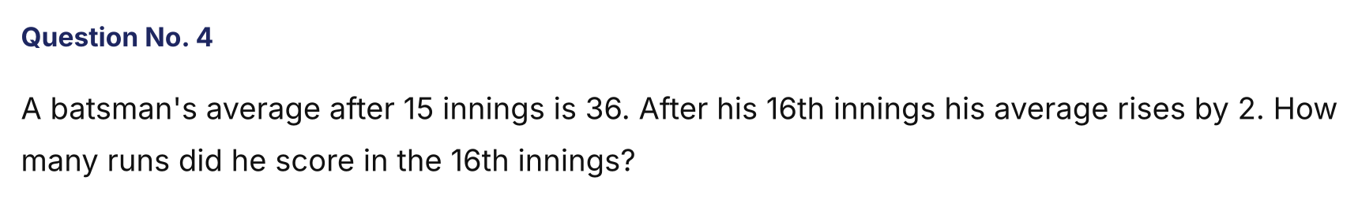
{OPTION 1} 66
{OPTION 2} 64
{OPTION 3} 68
{OPTION 4} 72
{OPTION 5}
{OPTION 6}
{OPTION 7}
{OPTION 8}
{OPTION 9}
{OPTION 10}
{RIGHT ANSWER} 3
{EXPLANATION} Runs in 15 innings = 540. New average = 38, so total after 16 innings = 608. Runs in the 16th innings = 608 − 540 = 68.
{CORRECT MARKS} 1
{NEGATIVE MARKS} 0
{DIFFICULTY} Medium
{QUESTION ENDS}

{QUESTION BEGINS}
{QUESTION NUMBER} 5
{SUBJECT} Numerical Ability
{TOPIC} Number System
{TAGS} tcs nqt, numerical ability, medium
{QUESTION TYPE} NUMERICAL
{QUESTION TEXT} 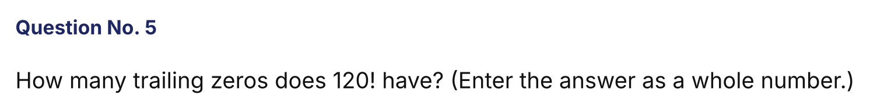
{OPTION 1}
{OPTION 2}
{OPTION 3}
{OPTION 4}
{OPTION 5}
{OPTION 6}
{OPTION 7}
{OPTION 8}
{OPTION 9}
{OPTION 10}
{RIGHT ANSWER} 28
{EXPLANATION} Zeros = ⌊120/5⌋ + ⌊120/25⌋ + ⌊120/125⌋ = 24 + 4 + 0 = 28.
{CORRECT MARKS} 1
{NEGATIVE MARKS} 0
{DIFFICULTY} Medium
{QUESTION ENDS}

{QUESTION BEGINS}
{QUESTION NUMBER} 6
{SUBJECT} Numerical Ability
{TOPIC} Mensuration
{TAGS} tcs nqt, numerical ability, medium
{QUESTION TYPE} SINGLECORRECT
{QUESTION TEXT} 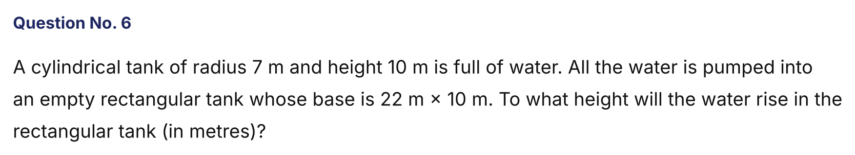
{OPTION 1} 7 m
{OPTION 2} 8 m
{OPTION 3} 5 m
{OPTION 4} 6 m
{OPTION 5}
{OPTION 6}
{OPTION 7}
{OPTION 8}
{OPTION 9}
{OPTION 10}
{RIGHT ANSWER} 1
{EXPLANATION} Volume = π r² h = (22/7) × 49 × 10 = 1540 m³. Height in the rectangular tank = 1540/(22 × 10) = 7 m.
{CORRECT MARKS} 1
{NEGATIVE MARKS} 0
{DIFFICULTY} Medium
{QUESTION ENDS}

{QUESTION BEGINS}
{QUESTION NUMBER} 7
{SUBJECT} Numerical Ability
{TOPIC} Statistics
{TAGS} tcs nqt, numerical ability, medium
{QUESTION TYPE} SINGLECORRECT
{QUESTION TEXT} 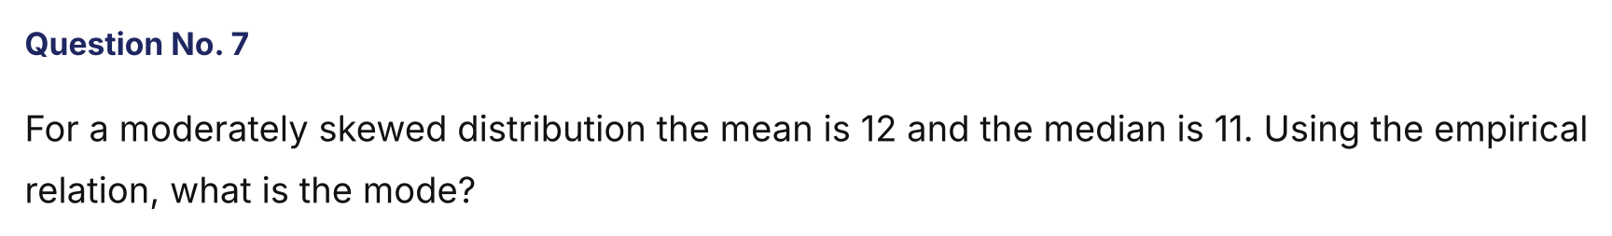
{OPTION 1} 13
{OPTION 2} 12
{OPTION 3} 10
{OPTION 4} 9
{OPTION 5}
{OPTION 6}
{OPTION 7}
{OPTION 8}
{OPTION 9}
{OPTION 10}
{RIGHT ANSWER} 4
{EXPLANATION} Mode = 3 × Median − 2 × Mean = 33 − 24 = 9.
{CORRECT MARKS} 1
{NEGATIVE MARKS} 0
{DIFFICULTY} Medium
{QUESTION ENDS}

{QUESTION BEGINS}
{QUESTION NUMBER} 8
{SUBJECT} Numerical Ability
{TOPIC} Number System
{TAGS} tcs nqt, numerical ability, medium
{QUESTION TYPE} SINGLECORRECT
{QUESTION TEXT} 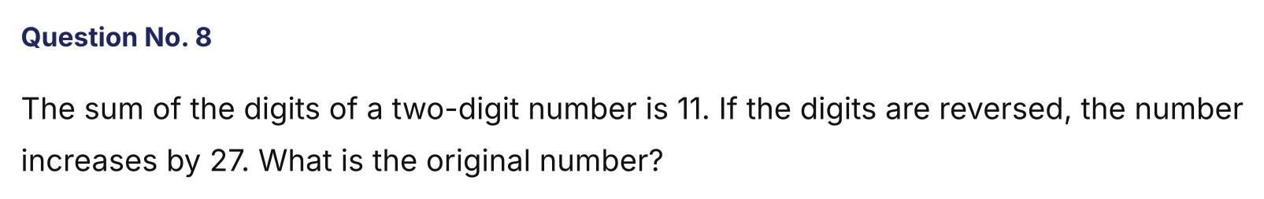
{OPTION 1} 29
{OPTION 2} 47
{OPTION 3} 38
{OPTION 4} 56
{OPTION 5}
{OPTION 6}
{OPTION 7}
{OPTION 8}
{OPTION 9}
{OPTION 10}
{RIGHT ANSWER} 2
{EXPLANATION} Let the number be 10a + b with a + b = 11. Reversed − original = 9(b − a) = 27, so b − a = 3. Then a = 4 and b = 7, so the number is 47.
{CORRECT MARKS} 1
{NEGATIVE MARKS} 0
{DIFFICULTY} Medium
{QUESTION ENDS}

{QUESTION BEGINS}
{QUESTION NUMBER} 9
{SUBJECT} Numerical Ability
{TOPIC} Percentages
{TAGS} tcs nqt, numerical ability, medium
{QUESTION TYPE} SINGLECORRECT
{QUESTION TEXT} 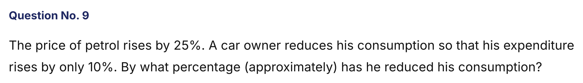
{OPTION 1} 12%
{OPTION 2} 15%
{OPTION 3} 10%
{OPTION 4} 8%
{OPTION 5}
{OPTION 6}
{OPTION 7}
{OPTION 8}
{OPTION 9}
{OPTION 10}
{RIGHT ANSWER} 1
{EXPLANATION} New expenditure = 1.25 × (new consumption) × old price = 1.10 × old expenditure, so new consumption = 1.10/1.25 = 0.88 of the old. The reduction is 12%.
{CORRECT MARKS} 1
{NEGATIVE MARKS} 0
{DIFFICULTY} Medium
{QUESTION ENDS}

{QUESTION BEGINS}
{QUESTION NUMBER} 10
{SUBJECT} Numerical Ability
{TOPIC} Mixtures
{TAGS} tcs nqt, numerical ability, hard
{QUESTION TYPE} SINGLECORRECT
{QUESTION TEXT} 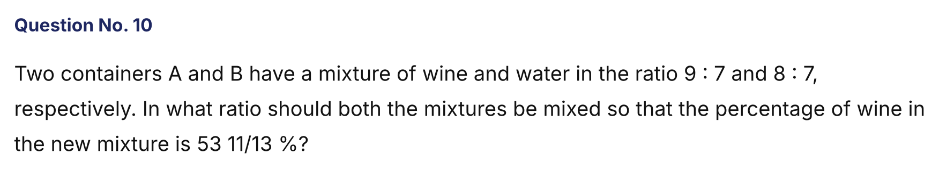
{OPTION 1} 16 : 45
{OPTION 2} 5 : 7
{OPTION 3} 16 : 75
{OPTION 4} 3 : 5
{OPTION 5}
{OPTION 6}
{OPTION 7}
{OPTION 8}
{OPTION 9}
{OPTION 10}
{RIGHT ANSWER} 3
{EXPLANATION} Wine in A = 9/16 and in B = 8/15. Required wine = 53 11/13 % = 700/13 % = 7/13. By alligation: (A quantity) : (B quantity) = (7/13 − 8/15) : (9/16 − 7/13) = (1/195) : (5/208) = 208 : 975 = 16 : 75.
{CORRECT MARKS} 1
{NEGATIVE MARKS} 0
{DIFFICULTY} Hard
{QUESTION ENDS}

{QUESTION BEGINS}
{QUESTION NUMBER} 11
{SUBJECT} Numerical Ability
{TOPIC} Percentages
{TAGS} tcs nqt, numerical ability, hard
{QUESTION TYPE} SINGLECORRECT
{QUESTION TEXT} 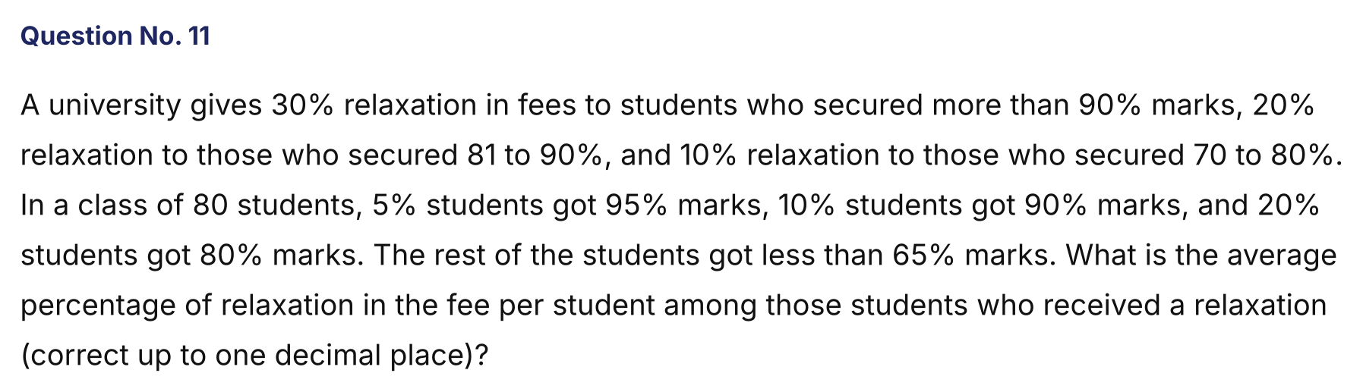
{OPTION 1} 16.8%
{OPTION 2} 14.6%
{OPTION 3} 15.7%
{OPTION 4} 13.5%
{OPTION 5}
{OPTION 6}
{OPTION 7}
{OPTION 8}
{OPTION 9}
{OPTION 10}
{RIGHT ANSWER} 3
{EXPLANATION} Students: 5% of 80 = 4 (30% relaxation), 10% of 80 = 8 (20% relaxation), 20% of 80 = 16 (10% relaxation). Relaxed students = 28. Total relaxation (in %-points) = 4 × 30 + 8 × 20 + 16 × 10 = 440. Average = 440/28 = 15.7%.
{CORRECT MARKS} 1
{NEGATIVE MARKS} 0
{DIFFICULTY} Hard
{QUESTION ENDS}

{QUESTION BEGINS}
{QUESTION NUMBER} 12
{SUBJECT} Numerical Ability
{TOPIC} Number System
{TAGS} tcs nqt, numerical ability, hard
{QUESTION TYPE} SINGLECORRECT
{QUESTION TEXT} 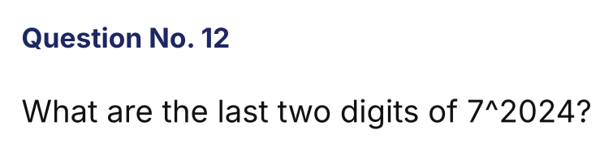
{OPTION 1} 49
{OPTION 2} 43
{OPTION 3} 01
{OPTION 4} 07
{OPTION 5}
{OPTION 6}
{OPTION 7}
{OPTION 8}
{OPTION 9}
{OPTION 10}
{RIGHT ANSWER} 3
{EXPLANATION} 7² = 49, 7⁴ = 2401, which ends in 01. 2024 is a multiple of 4, so 7^2024 = (7⁴)^506 ends in 01.
{CORRECT MARKS} 1
{NEGATIVE MARKS} 0
{DIFFICULTY} Hard
{QUESTION ENDS}

{QUESTION BEGINS}
{QUESTION NUMBER} 13
{SUBJECT} Numerical Ability
{TOPIC} Time and Work
{TAGS} tcs nqt, numerical ability, hard
{QUESTION TYPE} SINGLECORRECT
{QUESTION TEXT} 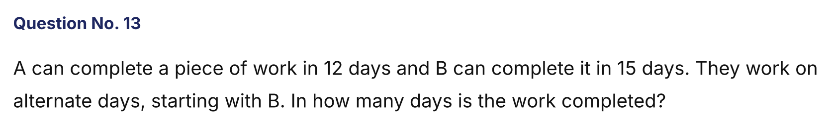
{OPTION 1} 13.4 days
{OPTION 2} 13 days
{OPTION 3} 14 days
{OPTION 4} 12.8 days
{OPTION 5}
{OPTION 6}
{OPTION 7}
{OPTION 8}
{OPTION 9}
{OPTION 10}
{RIGHT ANSWER} 1
{EXPLANATION} In 2 days (B then A) they do 1/15 + 1/12 = 3/20. In 12 days (6 such pairs) they do 18/20 = 9/10. On day 13, B does 1/15, so 29/30 is done. The remaining 1/30 is done by A in (1/30)/(1/12) = 0.4 of a day. Total = 13.4 days.
{CORRECT MARKS} 1
{NEGATIVE MARKS} 0
{DIFFICULTY} Hard
{QUESTION ENDS}

{QUESTION BEGINS}
{QUESTION NUMBER} 14
{SUBJECT} Numerical Ability
{TOPIC} Compound Interest
{TAGS} tcs nqt, numerical ability, hard
{QUESTION TYPE} SINGLECORRECT
{QUESTION TEXT} 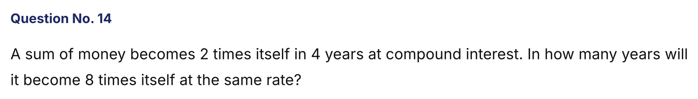
{OPTION 1} 12 years
{OPTION 2} 16 years
{OPTION 3} 10 years
{OPTION 4} 8 years
{OPTION 5}
{OPTION 6}
{OPTION 7}
{OPTION 8}
{OPTION 9}
{OPTION 10}
{RIGHT ANSWER} 1
{EXPLANATION} 8 = 2³, so the time is 3 times the time taken to double: 3 × 4 = 12 years.
{CORRECT MARKS} 1
{NEGATIVE MARKS} 0
{DIFFICULTY} Hard
{QUESTION ENDS}

{QUESTION BEGINS}
{QUESTION NUMBER} 15
{SUBJECT} Numerical Ability
{TOPIC} Mixtures
{TAGS} tcs nqt, numerical ability, hard
{QUESTION TYPE} SINGLECORRECT
{QUESTION TEXT} 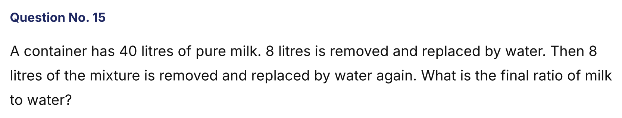
{OPTION 1} 8 : 5
{OPTION 2} 9 : 16
{OPTION 3} 4 : 3
{OPTION 4} 16 : 9
{OPTION 5}
{OPTION 6}
{OPTION 7}
{OPTION 8}
{OPTION 9}
{OPTION 10}
{RIGHT ANSWER} 4
{EXPLANATION} Milk left = 40 × (1 − 8/40)² = 40 × 0.64 = 25.6 L. Water = 40 − 25.6 = 14.4 L. Ratio = 25.6 : 14.4 = 16 : 9.
{CORRECT MARKS} 1
{NEGATIVE MARKS} 0
{DIFFICULTY} Hard
{QUESTION ENDS}

{QUESTION BEGINS}
{QUESTION NUMBER} 16
{SUBJECT} Numerical Ability
{TOPIC} Permutation and Combination
{TAGS} tcs nqt, numerical ability, hard
{QUESTION TYPE} SINGLECORRECT
{QUESTION TEXT} 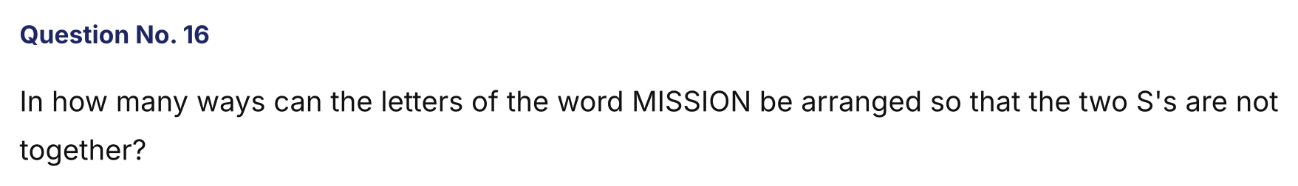
{OPTION 1} 360
{OPTION 2} 1260
{OPTION 3} 720
{OPTION 4} 900
{OPTION 5}
{OPTION 6}
{OPTION 7}
{OPTION 8}
{OPTION 9}
{OPTION 10}
{RIGHT ANSWER} 4
{EXPLANATION} MISSION has 7 letters with I twice and S twice: total = 7!/(2! 2!) = 1260. With the two S's together (treated as one): 6!/2! = 360. Not together = 1260 − 360 = 900.
{CORRECT MARKS} 1
{NEGATIVE MARKS} 0
{DIFFICULTY} Hard
{QUESTION ENDS}

{QUESTION BEGINS}
{QUESTION NUMBER} 17
{SUBJECT} Numerical Ability
{TOPIC} Ages
{TAGS} tcs nqt, numerical ability, hard
{QUESTION TYPE} SINGLECORRECT
{QUESTION TEXT} 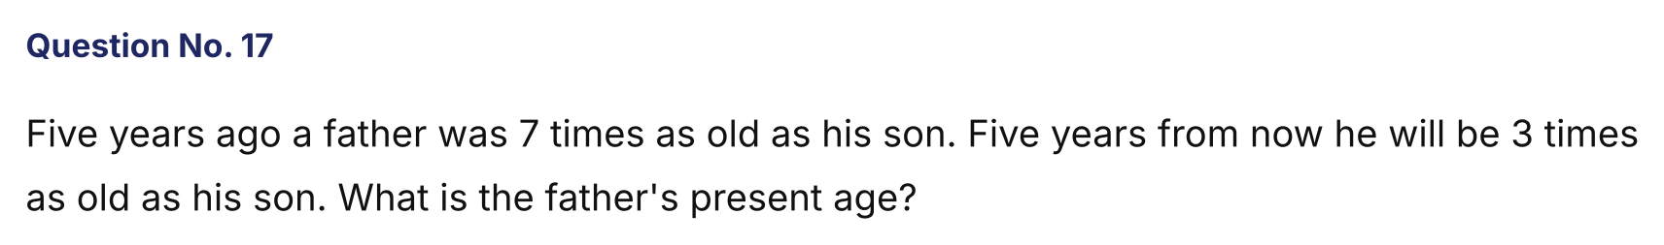
{OPTION 1} 50 years
{OPTION 2} 45 years
{OPTION 3} 35 years
{OPTION 4} 40 years
{OPTION 5}
{OPTION 6}
{OPTION 7}
{OPTION 8}
{OPTION 9}
{OPTION 10}
{RIGHT ANSWER} 4
{EXPLANATION} F − 5 = 7(S − 5) and F + 5 = 3(S + 5). So F = 7S − 30 and F = 3S + 10. Then 4S = 40, S = 10 and F = 40.
{CORRECT MARKS} 1
{NEGATIVE MARKS} 0
{DIFFICULTY} Hard
{QUESTION ENDS}

{QUESTION BEGINS}
{QUESTION NUMBER} 18
{SUBJECT} Numerical Ability
{TOPIC} Data Interpretation
{TAGS} tcs nqt, numerical ability, hard
{QUESTION TYPE} SINGLECORRECT
{QUESTION TEXT} 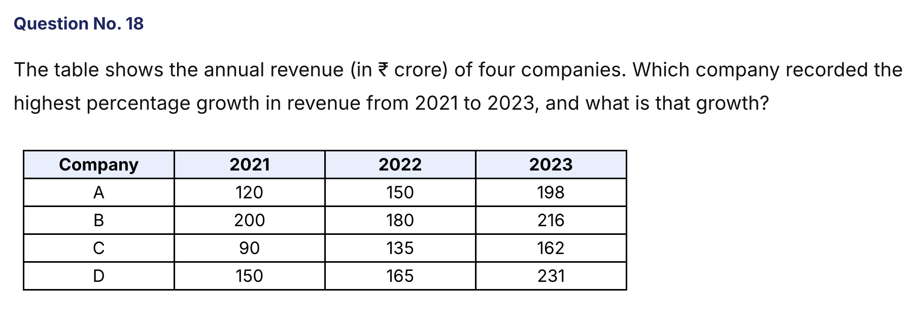
{OPTION 1} C, 72%
{OPTION 2} A, 65%
{OPTION 3} D, 54%
{OPTION 4} C, 80%
{OPTION 5}
{OPTION 6}
{OPTION 7}
{OPTION 8}
{OPTION 9}
{OPTION 10}
{RIGHT ANSWER} 4
{EXPLANATION} Growth 2021 → 2023: A = (198 − 120)/120 = 65%; B = (216 − 200)/200 = 8%; C = (162 − 90)/90 = 80%; D = (231 − 150)/150 = 54%. The highest is company C with 80%.
{CORRECT MARKS} 1
{NEGATIVE MARKS} 0
{DIFFICULTY} Hard
{QUESTION ENDS}

{QUESTION BEGINS}
{QUESTION NUMBER} 19
{SUBJECT} Numerical Ability
{TOPIC} Percentages
{TAGS} tcs nqt, numerical ability, hard
{QUESTION TYPE} SINGLECORRECT
{QUESTION TEXT} 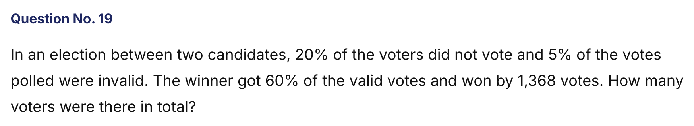
{OPTION 1} 10000
{OPTION 2} 9000
{OPTION 3} 7200
{OPTION 4} 8500
{OPTION 5}
{OPTION 6}
{OPTION 7}
{OPTION 8}
{OPTION 9}
{OPTION 10}
{RIGHT ANSWER} 2
{EXPLANATION} Winner − loser = 60% − 40% = 20% of the valid votes = 1368, so valid votes = 6840. Valid votes are 95% of the votes polled, so polled = 7200. Polled votes are 80% of the voters, so voters = 9000.
{CORRECT MARKS} 1
{NEGATIVE MARKS} 0
{DIFFICULTY} Hard
{QUESTION ENDS}

{QUESTION BEGINS}
{QUESTION NUMBER} 20
{SUBJECT} Numerical Ability
{TOPIC} Time, Speed and Distance
{TAGS} tcs nqt, numerical ability, hard
{QUESTION TYPE} SINGLECORRECT
{QUESTION TEXT} 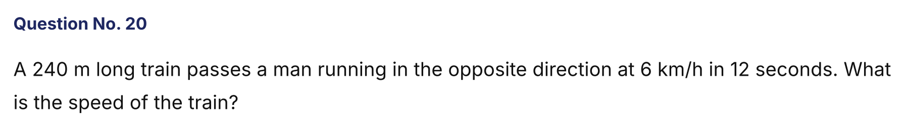
{OPTION 1} 60 km/h
{OPTION 2} 72 km/h
{OPTION 3} 66 km/h
{OPTION 4} 78 km/h
{OPTION 5}
{OPTION 6}
{OPTION 7}
{OPTION 8}
{OPTION 9}
{OPTION 10}
{RIGHT ANSWER} 3
{EXPLANATION} Relative speed = 240/12 = 20 m/s = 72 km/h. This equals train speed + man speed, so the train's speed = 72 − 6 = 66 km/h.
{CORRECT MARKS} 1
{NEGATIVE MARKS} 0
{DIFFICULTY} Hard
{QUESTION ENDS}

