{QUESTION BEGINS}
{QUESTION NUMBER} 1
{SUBJECT} Reasoning Ability
{TOPIC} Figure Based
{TAGS} tcs nqt, reasoning ability, actual question, figure, photo R06
{QUESTION TYPE} SINGLECORRECT
{QUESTION TEXT} 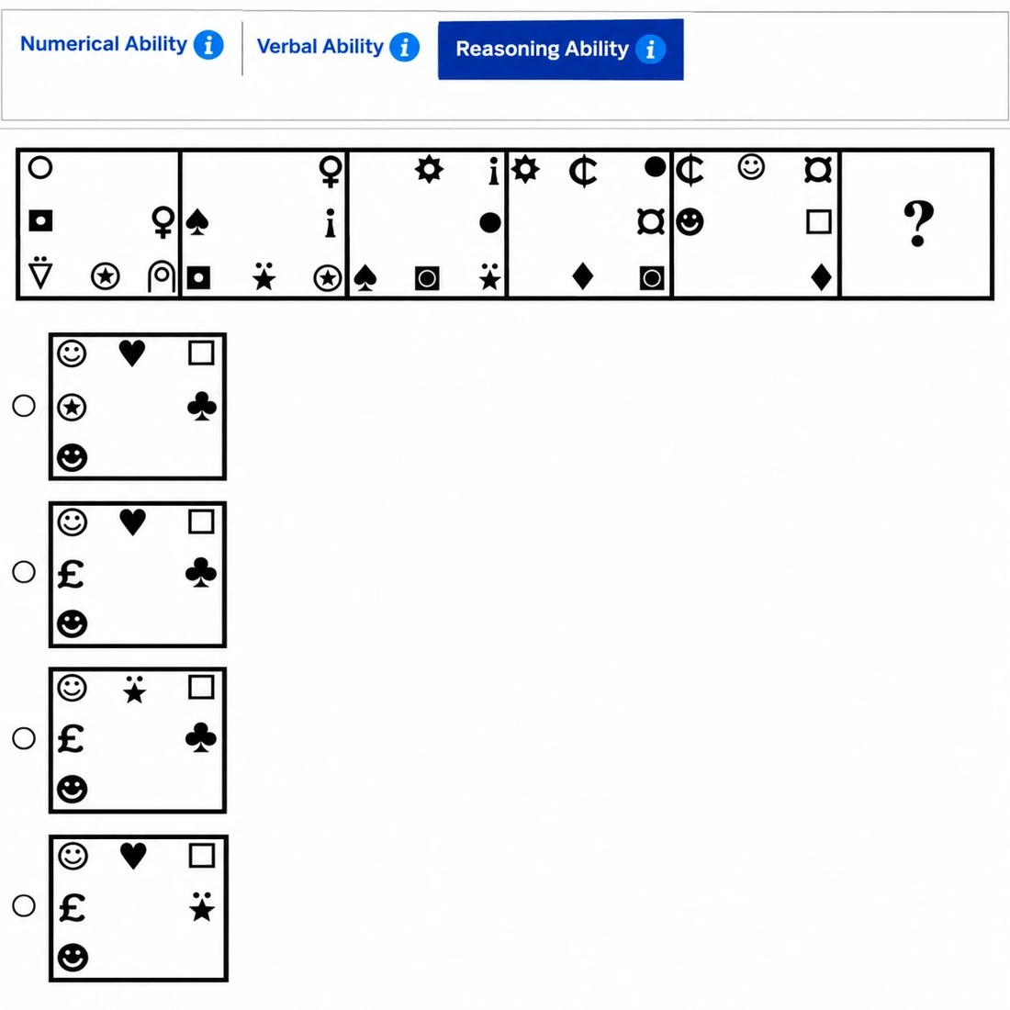
{OPTION 1} Option 1
{OPTION 2} Option 2
{OPTION 3} Option 3
{OPTION 4} Option 4
{OPTION 5}
{OPTION 6}
{OPTION 7}
{OPTION 8}
{OPTION 9}
{OPTION 10}
{RIGHT ANSWER} 2
{EXPLANATION} Symbols on the border move one step anticlockwise each figure (left side down, bottom to the right, right side up, top to the left). A symbol that sits in a corner changes into the next symbol of its own sequence as it moves out of the corner. In figure 5 the corner symbols are the currency sign at top-left, the other currency sign at top-right and the diamond at bottom-right; they become the pound sign, the heart and the club in figure 6, while the edge symbols simply move (smiley to top-left, black smiley to bottom-left, square to top-right). This is option 2.
{CORRECT MARKS} 1
{NEGATIVE MARKS} 0
{DIFFICULTY} Hard
{QUESTION ENDS}

{QUESTION BEGINS}
{QUESTION NUMBER} 2
{SUBJECT} Reasoning Ability
{TOPIC} Figure Based
{TAGS} tcs nqt, reasoning ability, actual question, figure, photo R15
{QUESTION TYPE} SINGLECORRECT
{QUESTION TEXT} 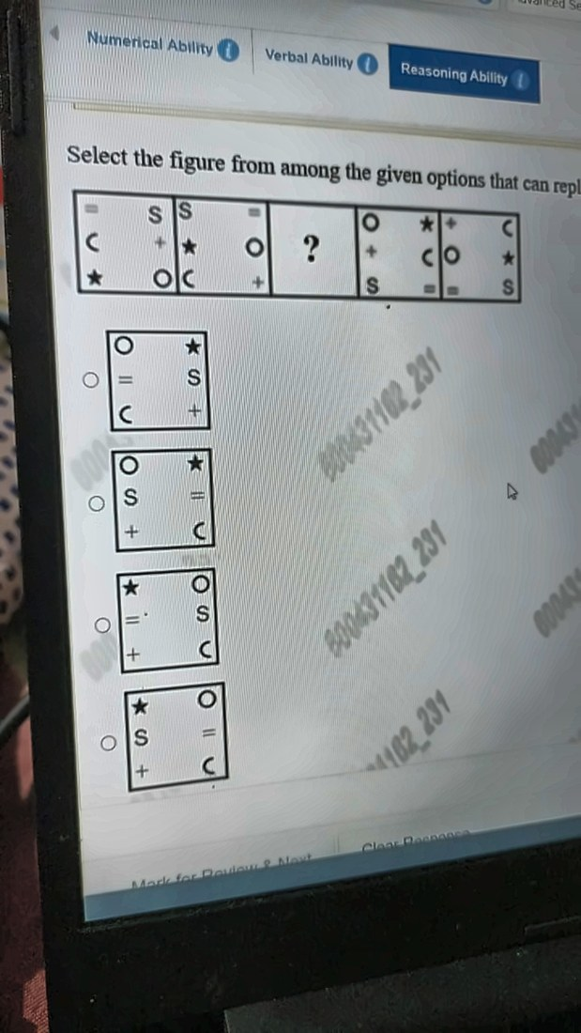
{OPTION 1} Option 1
{OPTION 2} Option 2
{OPTION 3} Option 3
{OPTION 4} Option 4
{OPTION 5}
{OPTION 6}
{OPTION 7}
{OPTION 8}
{OPTION 9}
{OPTION 10}
{RIGHT ANSWER} 4
{EXPLANATION} The figures change in two alternating ways. Step A: the top row swaps its two symbols left-right, and the second and third rows swap places. Step B: the first and second rows swap places, and the bottom row swaps its two symbols left-right. Figure 1 to 2 is step A, 2 to 3 is step B, 3 to 4 is step A and 4 to 5 is step B, so the missing figure is figure 3 = step B applied to figure 2: top row star, O; middle row S, =; bottom row +, C. That is option 4.
{CORRECT MARKS} 1
{NEGATIVE MARKS} 0
{DIFFICULTY} Hard
{QUESTION ENDS}

{QUESTION BEGINS}
{QUESTION NUMBER} 3
{SUBJECT} Reasoning Ability
{TOPIC} Figure Based
{TAGS} tcs nqt, reasoning ability, actual question, figure, photo R18
{QUESTION TYPE} SINGLECORRECT
{QUESTION TEXT} 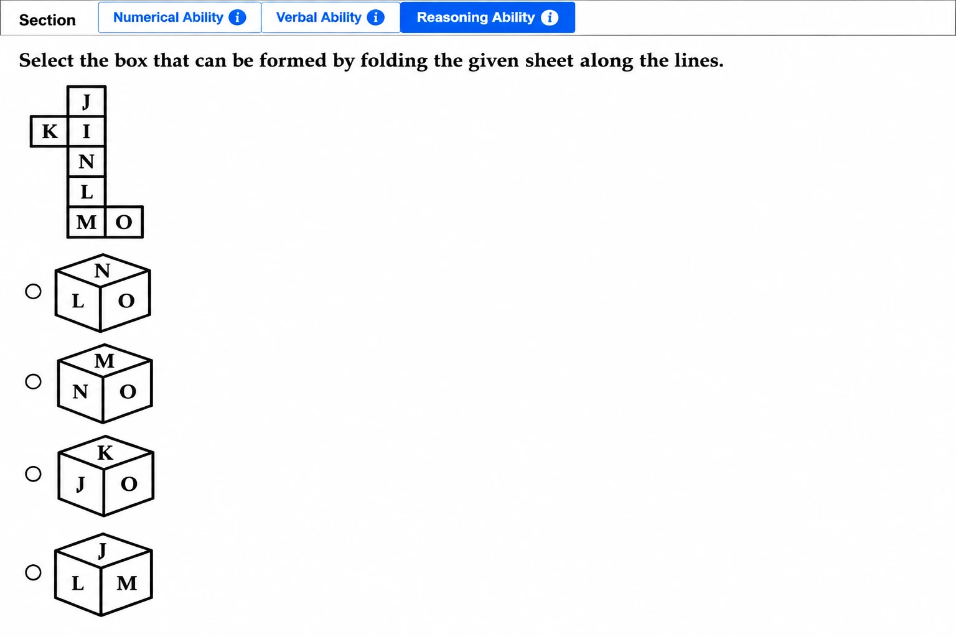
{OPTION 1} Option 1
{OPTION 2} Option 2
{OPTION 3} Option 3
{OPTION 4} Option 4
{OPTION 5}
{OPTION 6}
{OPTION 7}
{OPTION 8}
{OPTION 9}
{OPTION 10}
{RIGHT ANSWER} 1
{EXPLANATION} The strip J, I, N, L, M has 5 squares, so M folds onto the same face as J. K (left of I) and O (right of M) then land on opposite faces. Option 3 puts K and O on adjacent faces: impossible. Option 2 shows M (same face as J) next to N (opposite J): impossible. Option 4 shows J and M together, but they are the same face: impossible. Option 1 (N, L, O) is the only one with faces that can meet at a corner, and a fold check on the net gives the same left-right arrangement as shown.
{CORRECT MARKS} 1
{NEGATIVE MARKS} 0
{DIFFICULTY} Hard
{QUESTION ENDS}

{QUESTION BEGINS}
{QUESTION NUMBER} 4
{SUBJECT} Reasoning Ability
{TOPIC} Figure Based
{TAGS} tcs nqt, reasoning ability, actual question, figure, photo R21
{QUESTION TYPE} SINGLECORRECT
{QUESTION TEXT} 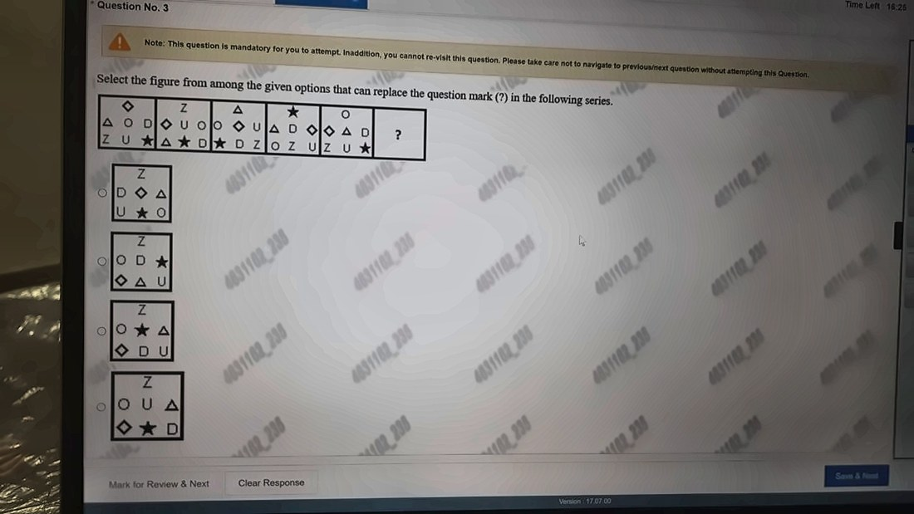
{OPTION 1} Option 1
{OPTION 2} Option 2
{OPTION 3} Option 3
{OPTION 4} Option 4
{OPTION 5}
{OPTION 6}
{OPTION 7}
{OPTION 8}
{OPTION 9}
{OPTION 10}
{RIGHT ANSWER} 4
{EXPLANATION} Number the 7 positions: top, middle left, middle centre, middle right, bottom left, bottom centre, bottom right. Figures 1 to 2 and 3 to 4 move the symbols by one fixed shuffle (top to middle-left, middle-left to bottom-left, middle-centre to middle-right, middle-right to bottom-right, bottom-left to top, bottom-centre to middle-centre, bottom-right to bottom-centre). Figures 2 to 3 and 4 to 5 use a second shuffle, and the two alternate. Applying the first shuffle to figure 5 gives Z at the top, O U triangle in the middle row and diamond star D in the bottom row, which is option 4.
{CORRECT MARKS} 1
{NEGATIVE MARKS} 0
{DIFFICULTY} Hard
{QUESTION ENDS}

{QUESTION BEGINS}
{QUESTION NUMBER} 5
{SUBJECT} Reasoning Ability
{TOPIC} Figure Based
{TAGS} tcs nqt, reasoning ability, actual question, figure, photo R31
{QUESTION TYPE} SINGLECORRECT
{QUESTION TEXT} 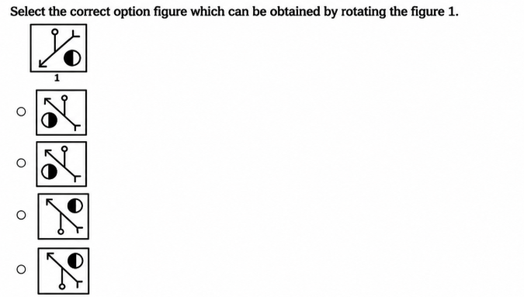
{OPTION 1} Option 1
{OPTION 2} Option 2
{OPTION 3} Option 3
{OPTION 4} Option 4
{OPTION 5}
{OPTION 6}
{OPTION 7}
{OPTION 8}
{OPTION 9}
{OPTION 10}
{RIGHT ANSWER} 3
{EXPLANATION} Figure 1 is turned over (flipped about a horizontal axis). Left-right order stays the same and top-bottom swap: the arrow end goes to the top-left, the fork end to the bottom-right, the stem with the small circle now hangs below the line (same position along the line, about 40% from the arrow end), and the half circle (black left, white right) moves to the top-right. Option 3 matches all of this. Option 4 has the stem joined too far along the line and too short. Options 1 and 2 show the half circle with white on the left, which is mirrored.
{CORRECT MARKS} 1
{NEGATIVE MARKS} 0
{DIFFICULTY} Hard
{QUESTION ENDS}

{QUESTION BEGINS}
{QUESTION NUMBER} 6
{SUBJECT} Reasoning Ability
{TOPIC} Venn Diagram
{TAGS} tcs nqt, reasoning ability, actual question, venn, photo R23
{QUESTION TYPE} NUMERICAL
{QUESTION TEXT} 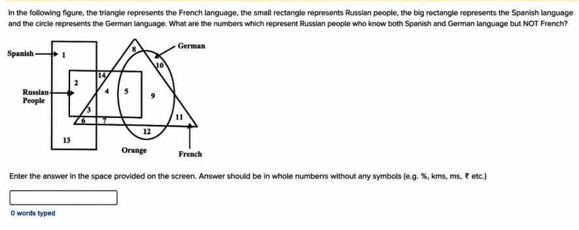
{OPTION 1}
{OPTION 2}
{OPTION 3}
{OPTION 4}
{OPTION 5}
{OPTION 6}
{OPTION 7}
{OPTION 8}
{OPTION 9}
{OPTION 10}
{RIGHT ANSWER} 0
{EXPLANATION} Russian people = small rectangle, Spanish = big rectangle, German = oval, French = triangle. The big rectangle ends at the left of the oval, so no region lies inside both Spanish and German. Hence no number represents Russian people who know both Spanish and German, and the count asked is 0. (Region 5 is Russian and German but outside Spanish, and it is inside the triangle too.)
{CORRECT MARKS} 1
{NEGATIVE MARKS} 0
{DIFFICULTY} Hard
{QUESTION ENDS}

{QUESTION BEGINS}
{QUESTION NUMBER} 7
{SUBJECT} Reasoning Ability
{TOPIC} Venn Diagram
{TAGS} tcs nqt, reasoning ability, actual question, venn, photo R29
{QUESTION TYPE} SINGLECORRECT
{QUESTION TEXT} 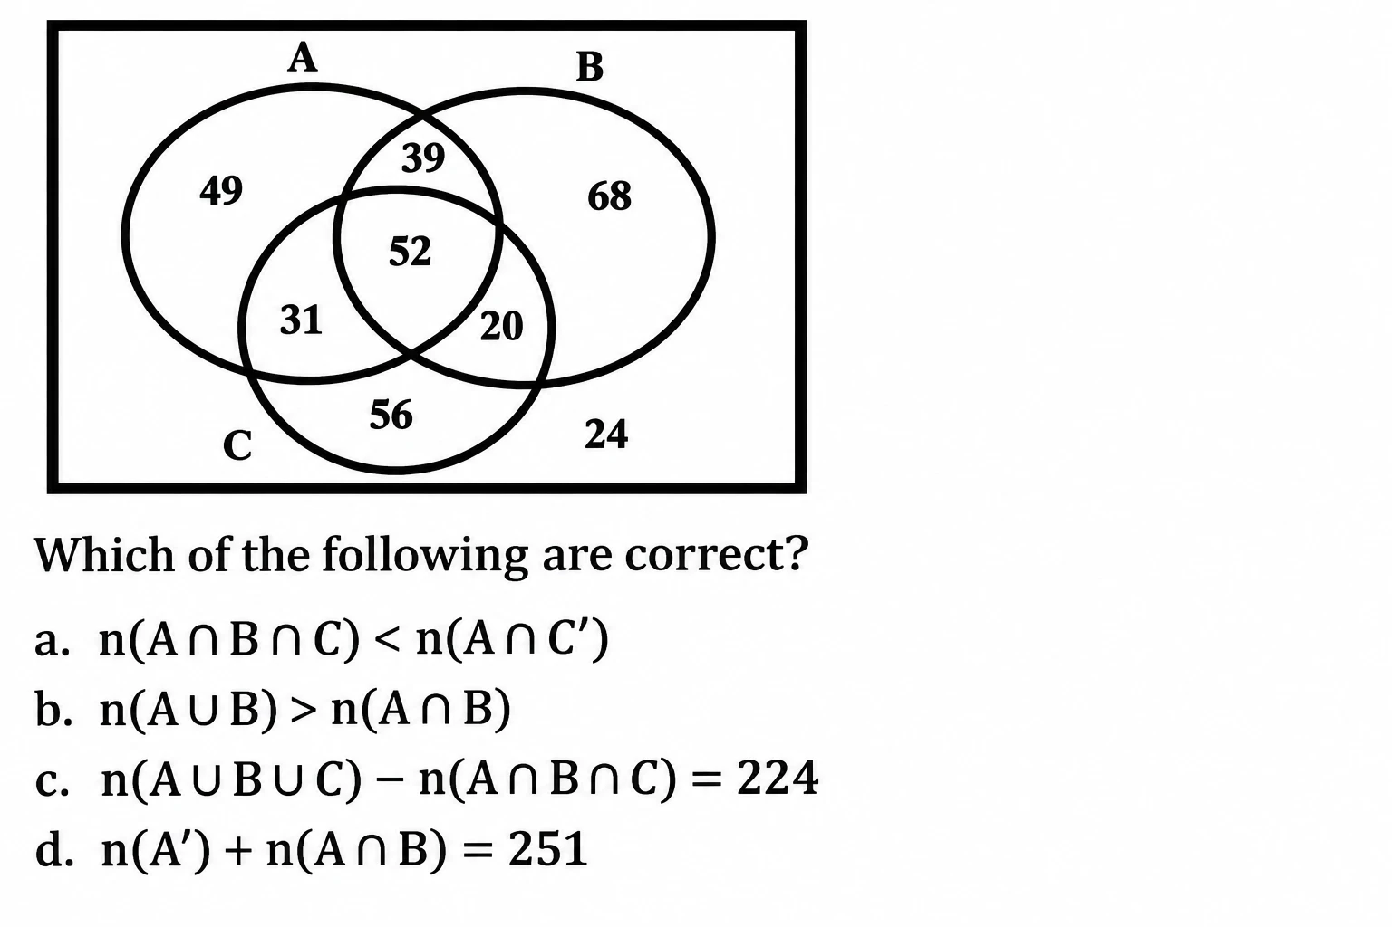
{OPTION 1} a and b only
{OPTION 2} b and c only
{OPTION 3} a, c and d
{OPTION 4} c and d only
{OPTION 5}
{OPTION 6}
{OPTION 7}
{OPTION 8}
{OPTION 9}
{OPTION 10}
{RIGHT ANSWER} 1
{EXPLANATION} From the diagram: only A = 49, A and B only = 39, only B = 68, A, B and C = 52, A and C only = 31, B and C only = 20, only C = 56, outside = 24. (a) n(A and B and C) = 52 and n(A and not C) = 49 + 39 = 88, so 52 < 88: correct. (b) n(A or B) = 49+39+68+52+31+20 = 259 and n(A and B) = 39+52 = 91, so 259 > 91: correct. (c) n(A or B or C) = 315, and 315 - 52 = 263, not 224: wrong. (d) n(not A) = 68+20+56+24 = 168, and 168 + 91 = 259, not 251: wrong. So only a and b are correct.
{CORRECT MARKS} 1
{NEGATIVE MARKS} 0
{DIFFICULTY} Hard
{QUESTION ENDS}

