{QUESTION BEGINS}
{QUESTION NUMBER} 1
{SUBJECT} Reasoning Ability
{TOPIC} Letter Series
{TAGS} tcs nqt, reasoning ability, actual question, letter series
{QUESTION TYPE} SINGLECORRECT
{QUESTION TEXT} Identify the letter-cluster that does NOT belong to the following series.
BC, GH, LM, EF, JK, PQ, IJ, NO, ST
{OPTION 1} PQ
{OPTION 2} NO
{OPTION 3} ST
{OPTION 4} IJ
{OPTION 5}
{OPTION 6}
{OPTION 7}
{OPTION 8}
{OPTION 9}
{OPTION 10}
{RIGHT ANSWER} 1
{EXPLANATION} Every cluster is two consecutive letters, and the clusters fall in three chains where the first letter moves 5 steps each time: B, G, L; E, J, (O); I, N, S. So after EF and JK the next cluster should be OP. PQ does not fit any chain, so PQ does not belong.
{CORRECT MARKS} 1
{NEGATIVE MARKS} 0
{DIFFICULTY} Hard
{QUESTION ENDS}

{QUESTION BEGINS}
{QUESTION NUMBER} 2
{SUBJECT} Reasoning Ability
{TOPIC} Cubes and Nets
{TAGS} tcs nqt, reasoning ability, actual question, cube net
{QUESTION TYPE} SINGLECORRECT
{QUESTION TEXT} Select the box that can be formed by folding the given sheet along the lines.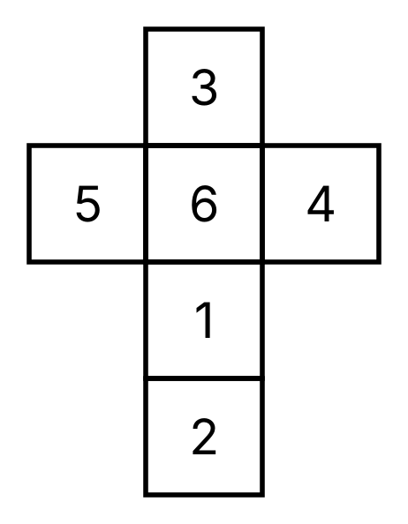
{OPTION 1} 2 on top, 4 on the left face, 6 on the right face
{OPTION 2} 5 on top, 2 on the left face, 4 on the right face
{OPTION 3} 3 on top, 6 on the left face, 4 on the right face
{OPTION 4} 3 on top, 6 on the left face, 1 on the right face
{OPTION 5}
{OPTION 6}
{OPTION 7}
{OPTION 8}
{OPTION 9}
{OPTION 10}
{RIGHT ANSWER} 3
{EXPLANATION} In the strip 3, 6, 1, 2 the faces 3 and 1 are opposite and 6 and 2 are opposite; 5 and 4 are opposite. Option 1 shows 2 and 6 together, option 2 shows 5 and 4 together and option 4 shows 3 and 1 together, so all three are impossible. Option 3 (3, 6, 4) uses faces that meet at a corner and matches the folded net.
{CORRECT MARKS} 1
{NEGATIVE MARKS} 0
{DIFFICULTY} Hard
{QUESTION ENDS}

