{QUESTION BEGINS}
{QUESTION NUMBER} 1
{SUBJECT} Reasoning Ability
{TOPIC} Venn Diagram
{TAGS} tcs nqt, reasoning ability, figure based, hard
{QUESTION TYPE} SINGLECORRECT
{QUESTION TEXT} The Venn diagram shows the number of students who like three games A, B and C (the rectangle represents all 80 students). How many students like exactly two of the three games?
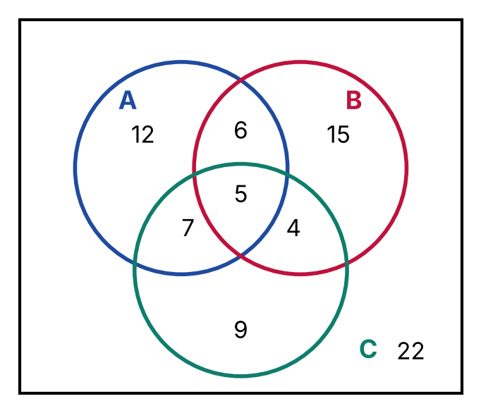
{OPTION 1} 12
{OPTION 2} 15
{OPTION 3} 22
{OPTION 4} 17
{OPTION 5}
{OPTION 6}
{OPTION 7}
{OPTION 8}
{OPTION 9}
{OPTION 10}
{RIGHT ANSWER} 4
{EXPLANATION} Exactly two games = only A and B + only B and C + only A and C = 6 + 4 + 7 = 17.
{CORRECT MARKS} 1
{NEGATIVE MARKS} 0
{DIFFICULTY} Hard
{QUESTION ENDS}

{QUESTION BEGINS}
{QUESTION NUMBER} 2
{SUBJECT} Reasoning Ability
{TOPIC} Venn Diagram
{TAGS} tcs nqt, reasoning ability, figure based, hard
{QUESTION TYPE} SINGLECORRECT
{QUESTION TEXT} In the Venn diagram, the numbers show how many people read newspapers A, B and C. How many people read A but do not read B?
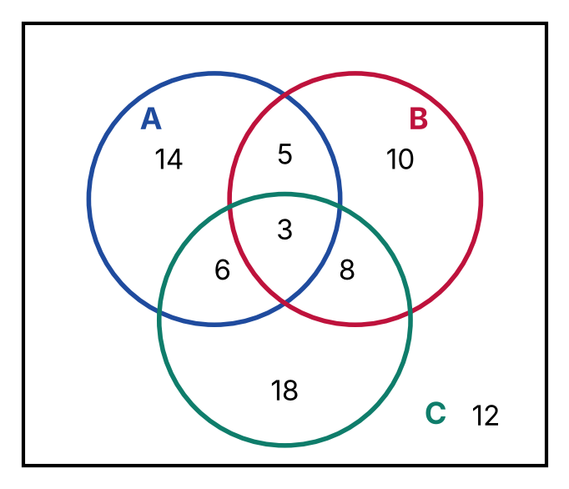
{OPTION 1} 28
{OPTION 2} 14
{OPTION 3} 20
{OPTION 4} 23
{OPTION 5}
{OPTION 6}
{OPTION 7}
{OPTION 8}
{OPTION 9}
{OPTION 10}
{RIGHT ANSWER} 3
{EXPLANATION} A but not B = only A + A and C only = 14 + 6 = 20.
{CORRECT MARKS} 1
{NEGATIVE MARKS} 0
{DIFFICULTY} Hard
{QUESTION ENDS}

{QUESTION BEGINS}
{QUESTION NUMBER} 3
{SUBJECT} Reasoning Ability
{TOPIC} Venn Diagram
{TAGS} tcs nqt, reasoning ability, figure based, hard
{QUESTION TYPE} SINGLECORRECT
{QUESTION TEXT} Refer to the Venn diagram. What is the value of n(A ∪ B ∪ C) − n(A ∩ B ∩ C)?
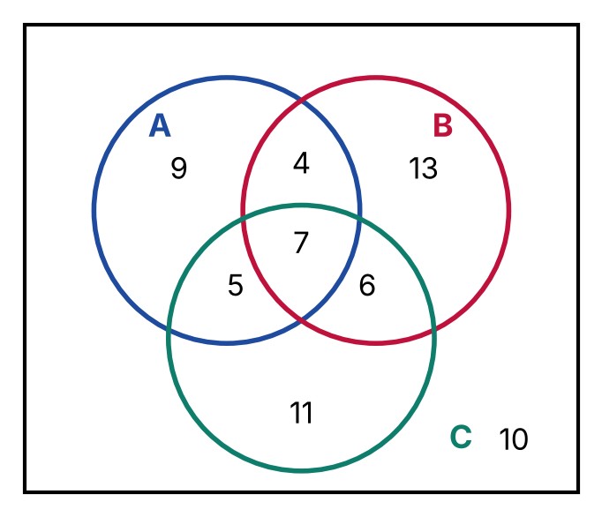
{OPTION 1} 58
{OPTION 2} 41
{OPTION 3} 48
{OPTION 4} 55
{OPTION 5}
{OPTION 6}
{OPTION 7}
{OPTION 8}
{OPTION 9}
{OPTION 10}
{RIGHT ANSWER} 3
{EXPLANATION} n(A ∪ B ∪ C) = 9 + 13 + 11 + 4 + 6 + 5 + 7 = 55 (the outside value 10 is not included). n(A ∩ B ∩ C) = 7. Difference = 55 − 7 = 48.
{CORRECT MARKS} 1
{NEGATIVE MARKS} 0
{DIFFICULTY} Hard
{QUESTION ENDS}

{QUESTION BEGINS}
{QUESTION NUMBER} 4
{SUBJECT} Reasoning Ability
{TOPIC} Venn Diagram
{TAGS} tcs nqt, reasoning ability, figure based, hard
{QUESTION TYPE} SINGLECORRECT
{QUESTION TEXT} Refer to the Venn diagram. How many of the following statements are correct?
(i) The number of people in all three sets is less than the number in only A and B.
(ii) n(A) > n(B).
(iii) The number of people in exactly one set is 42.
(iv) n(C) − n(A ∩ B ∩ C) = (only C) + (B and C only) + (A and C only).
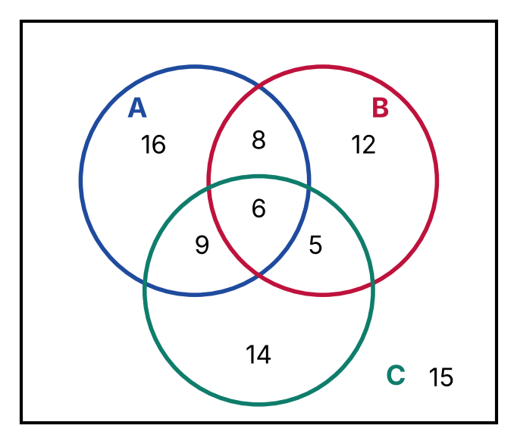
{OPTION 1} 1
{OPTION 2} 2
{OPTION 3} 4
{OPTION 4} 3
{OPTION 5}
{OPTION 6}
{OPTION 7}
{OPTION 8}
{OPTION 9}
{OPTION 10}
{RIGHT ANSWER} 3
{EXPLANATION} n(A) = 16 + 8 + 9 + 6 = 39 and n(B) = 12 + 8 + 5 + 6 = 31, so (ii) is true. All three = 6 < 8, so (i) is true. Exactly one = 16 + 12 + 14 = 42, so (iii) is true. n(C) = 14 + 5 + 9 + 6 = 34, and 34 − 6 = 28 = 14 + 5 + 9, so (iv) is true. All 4 are correct.
{CORRECT MARKS} 1
{NEGATIVE MARKS} 0
{DIFFICULTY} Hard
{QUESTION ENDS}

{QUESTION BEGINS}
{QUESTION NUMBER} 5
{SUBJECT} Reasoning Ability
{TOPIC} Venn Diagram
{TAGS} tcs nqt, reasoning ability, figure based, hard
{QUESTION TYPE} SINGLECORRECT
{QUESTION TEXT} In a group of 100 people (the rectangle), 40 read only English, 20 read both English and Hindi and 30 read only Hindi. How many read neither language?
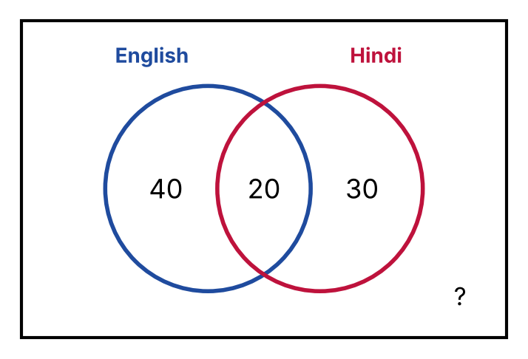
{OPTION 1} 20
{OPTION 2} 5
{OPTION 3} 15
{OPTION 4} 10
{OPTION 5}
{OPTION 6}
{OPTION 7}
{OPTION 8}
{OPTION 9}
{OPTION 10}
{RIGHT ANSWER} 4
{EXPLANATION} People who read at least one language = 40 + 20 + 30 = 90. Neither = 100 − 90 = 10.
{CORRECT MARKS} 1
{NEGATIVE MARKS} 0
{DIFFICULTY} Hard
{QUESTION ENDS}

{QUESTION BEGINS}
{QUESTION NUMBER} 6
{SUBJECT} Reasoning Ability
{TOPIC} Venn Diagram
{TAGS} tcs nqt, reasoning ability, figure based, hard
{QUESTION TYPE} SINGLECORRECT
{QUESTION TEXT} The Venn diagram shows the number of people who like only tea, only coffee and both. How many people like coffee?
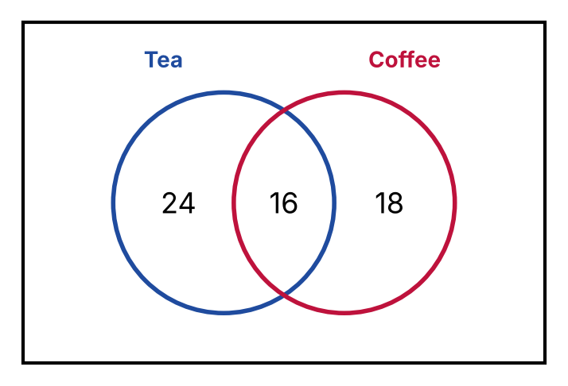
{OPTION 1} 34
{OPTION 2} 18
{OPTION 3} 42
{OPTION 4} 24
{OPTION 5}
{OPTION 6}
{OPTION 7}
{OPTION 8}
{OPTION 9}
{OPTION 10}
{RIGHT ANSWER} 1
{EXPLANATION} People who like coffee = only coffee + both = 18 + 16 = 34.
{CORRECT MARKS} 1
{NEGATIVE MARKS} 0
{DIFFICULTY} Hard
{QUESTION ENDS}

{QUESTION BEGINS}
{QUESTION NUMBER} 7
{SUBJECT} Reasoning Ability
{TOPIC} Venn Diagram
{TAGS} tcs nqt, reasoning ability, figure based, hard
{QUESTION TYPE} SINGLECORRECT
{QUESTION TEXT} Which diagram best represents the relationship among Animals (circle 1, the big circle), Cats (circle 2) and Dogs (circle 3)?
{OPTION 1} 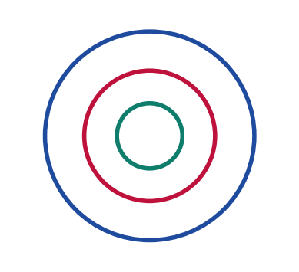
{OPTION 2} 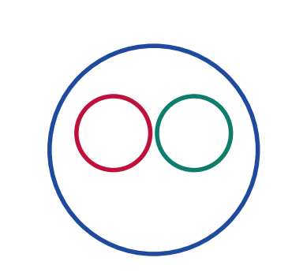
{OPTION 3} 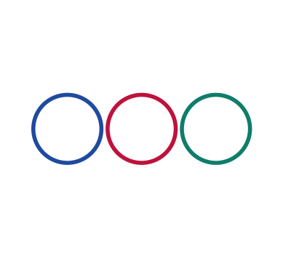
{OPTION 4} 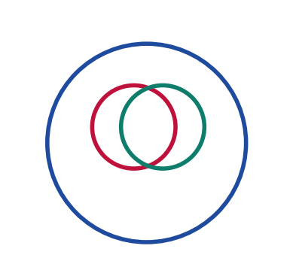
{OPTION 5}
{OPTION 6}
{OPTION 7}
{OPTION 8}
{OPTION 9}
{OPTION 10}
{RIGHT ANSWER} 2
{EXPLANATION} Cats and Dogs are both animals but no cat is a dog, so they are two separate circles inside the big circle of Animals.
{CORRECT MARKS} 1
{NEGATIVE MARKS} 0
{DIFFICULTY} Hard
{QUESTION ENDS}

{QUESTION BEGINS}
{QUESTION NUMBER} 8
{SUBJECT} Reasoning Ability
{TOPIC} Venn Diagram
{TAGS} tcs nqt, reasoning ability, figure based, hard
{QUESTION TYPE} SINGLECORRECT
{QUESTION TEXT} Which diagram best represents Women (circle 1, the big circle), Mothers (circle 2) and Doctors (circle 3)?
{OPTION 1} 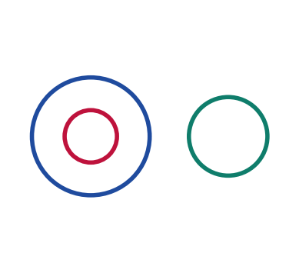
{OPTION 2} 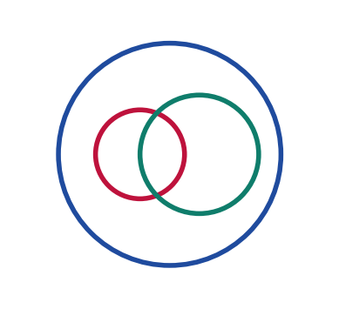
{OPTION 3} 
{OPTION 4} 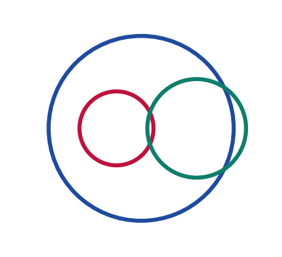
{OPTION 5}
{OPTION 6}
{OPTION 7}
{OPTION 8}
{OPTION 9}
{OPTION 10}
{RIGHT ANSWER} 4
{EXPLANATION} All mothers are women, so circle 2 lies inside circle 1. Doctors can be women or men, so circle 3 crosses the boundary of circle 1, and some doctors are mothers, so circle 3 overlaps circle 2.
{CORRECT MARKS} 1
{NEGATIVE MARKS} 0
{DIFFICULTY} Hard
{QUESTION ENDS}

{QUESTION BEGINS}
{QUESTION NUMBER} 9
{SUBJECT} Reasoning Ability
{TOPIC} Cube Net
{TAGS} tcs nqt, reasoning ability, figure based, hard
{QUESTION TYPE} SINGLECORRECT
{QUESTION TEXT} The given figure is a net of a cube. Which letter is on the face opposite to the face marked C?
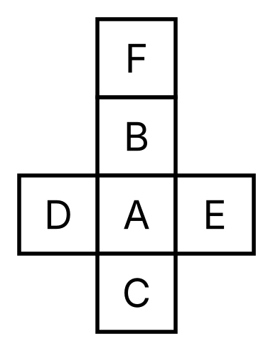
{OPTION 1} A
{OPTION 2} F
{OPTION 3} B
{OPTION 4} D
{OPTION 5}
{OPTION 6}
{OPTION 7}
{OPTION 8}
{OPTION 9}
{OPTION 10}
{RIGHT ANSWER} 3
{EXPLANATION} In a vertical strip of four squares (F, B, A, C), the squares separated by exactly one square are opposite. So C is opposite B.
{CORRECT MARKS} 1
{NEGATIVE MARKS} 0
{DIFFICULTY} Hard
{QUESTION ENDS}

{QUESTION BEGINS}
{QUESTION NUMBER} 10
{SUBJECT} Reasoning Ability
{TOPIC} Cube Net
{TAGS} tcs nqt, reasoning ability, figure based, hard
{QUESTION TYPE} SINGLECORRECT
{QUESTION TEXT} The given figure is a net of a cube. Which letter is on the face opposite to the face marked R?
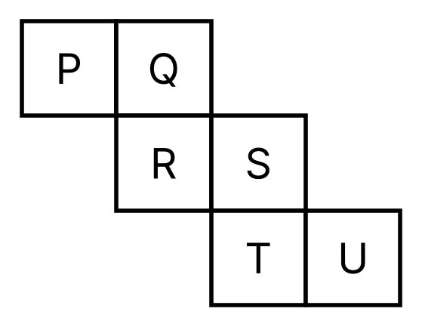
{OPTION 1} U
{OPTION 2} Q
{OPTION 3} P
{OPTION 4} S
{OPTION 5}
{OPTION 6}
{OPTION 7}
{OPTION 8}
{OPTION 9}
{OPTION 10}
{RIGHT ANSWER} 1
{EXPLANATION} Fold the staircase net: Q, R, S, T, U, P around the cube. R and U are opposite faces (opposite pairs here: Q-T, P-S, R-U).
{CORRECT MARKS} 1
{NEGATIVE MARKS} 0
{DIFFICULTY} Hard
{QUESTION ENDS}

{QUESTION BEGINS}
{QUESTION NUMBER} 11
{SUBJECT} Reasoning Ability
{TOPIC} Cube Net
{TAGS} tcs nqt, reasoning ability, figure based, hard
{QUESTION TYPE} SINGLECORRECT
{QUESTION TEXT} The given figure is a net of a cube. Which number is on the face opposite to the face marked 3?
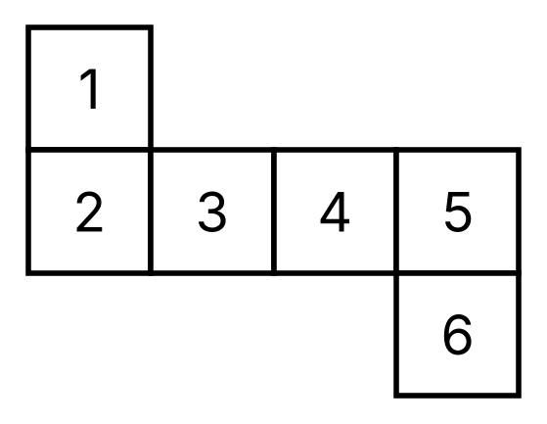
{OPTION 1} 6
{OPTION 2} 4
{OPTION 3} 5
{OPTION 4} 2
{OPTION 5}
{OPTION 6}
{OPTION 7}
{OPTION 8}
{OPTION 9}
{OPTION 10}
{RIGHT ANSWER} 3
{EXPLANATION} Folding the net gives the opposite pairs: 1-6, 3-5, 2-4. So 3 is opposite 5.
{CORRECT MARKS} 1
{NEGATIVE MARKS} 0
{DIFFICULTY} Hard
{QUESTION ENDS}

{QUESTION BEGINS}
{QUESTION NUMBER} 12
{SUBJECT} Reasoning Ability
{TOPIC} Dice
{TAGS} tcs nqt, reasoning ability, figure based, hard
{QUESTION TYPE} SINGLECORRECT
{QUESTION TEXT} Three different positions of the same dice are shown. Which letter is on the face opposite to the face marked B?
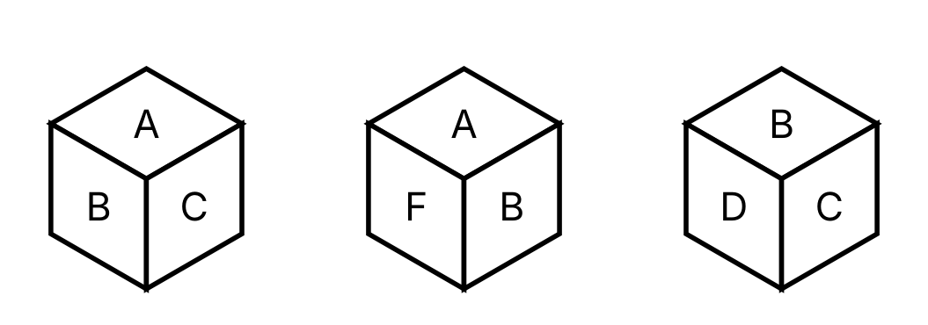
{OPTION 1} A
{OPTION 2} E
{OPTION 3} C
{OPTION 4} F
{OPTION 5}
{OPTION 6}
{OPTION 7}
{OPTION 8}
{OPTION 9}
{OPTION 10}
{RIGHT ANSWER} 2
{EXPLANATION} The face B is seen next to four different faces across the three views, so those four faces are adjacent to B. The only face never seen next to B is its opposite: E.
{CORRECT MARKS} 1
{NEGATIVE MARKS} 0
{DIFFICULTY} Hard
{QUESTION ENDS}

{QUESTION BEGINS}
{QUESTION NUMBER} 13
{SUBJECT} Reasoning Ability
{TOPIC} Figure Series
{TAGS} tcs nqt, reasoning ability, figure based, hard
{QUESTION TYPE} SINGLECORRECT
{QUESTION TEXT} Select the figure that replaces the question mark (?) in the series. The black square moves around the border of the grid.
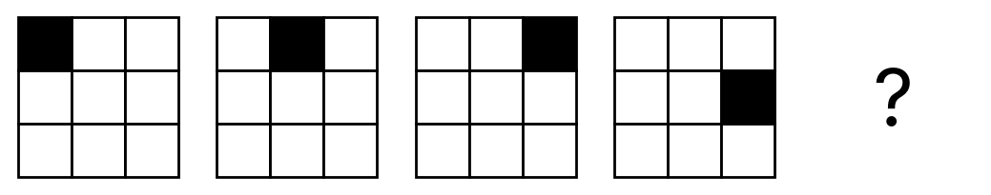
{OPTION 1} 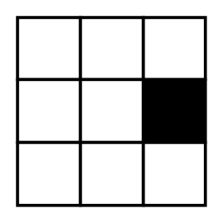
{OPTION 2} 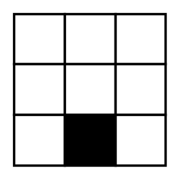
{OPTION 3} 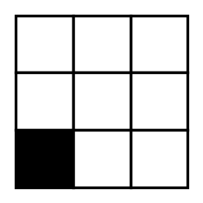
{OPTION 4} 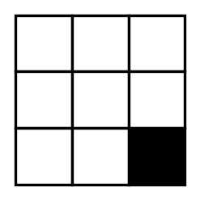
{OPTION 5}
{OPTION 6}
{OPTION 7}
{OPTION 8}
{OPTION 9}
{OPTION 10}
{RIGHT ANSWER} 4
{EXPLANATION} The black square moves one border cell clockwise in every step: top-left, top-middle, top-right, right-middle. The next position is bottom-right.
{CORRECT MARKS} 1
{NEGATIVE MARKS} 0
{DIFFICULTY} Hard
{QUESTION ENDS}

{QUESTION BEGINS}
{QUESTION NUMBER} 14
{SUBJECT} Reasoning Ability
{TOPIC} Figure Series
{TAGS} tcs nqt, reasoning ability, figure based, hard
{QUESTION TYPE} SINGLECORRECT
{QUESTION TEXT} Select the figure that replaces the question mark (?) in the series. The arrow turns anticlockwise by the same angle in every step.
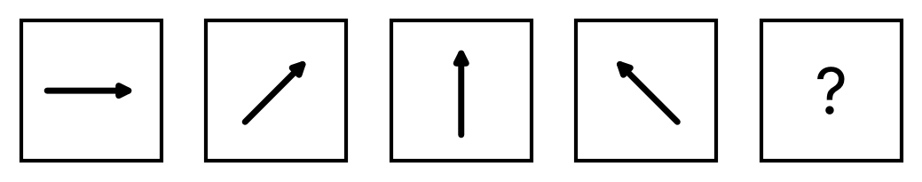
{OPTION 1} 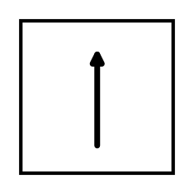
{OPTION 2} 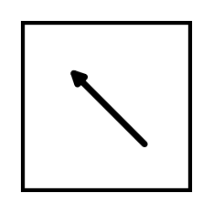
{OPTION 3} 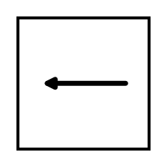
{OPTION 4} 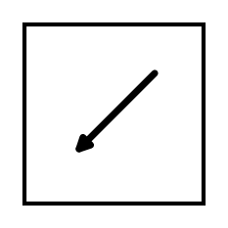
{OPTION 5}
{OPTION 6}
{OPTION 7}
{OPTION 8}
{OPTION 9}
{OPTION 10}
{RIGHT ANSWER} 3
{EXPLANATION} The arrow points at 0°, 45°, 90° and 135°, turning 45° anticlockwise each step. The next angle is 180°, which points to the left.
{CORRECT MARKS} 1
{NEGATIVE MARKS} 0
{DIFFICULTY} Hard
{QUESTION ENDS}

{QUESTION BEGINS}
{QUESTION NUMBER} 15
{SUBJECT} Reasoning Ability
{TOPIC} Figure Series
{TAGS} tcs nqt, reasoning ability, figure based, hard
{QUESTION TYPE} SINGLECORRECT
{QUESTION TEXT} Select the figure that replaces the question mark (?). Squares are filled one more at a time in reading order.
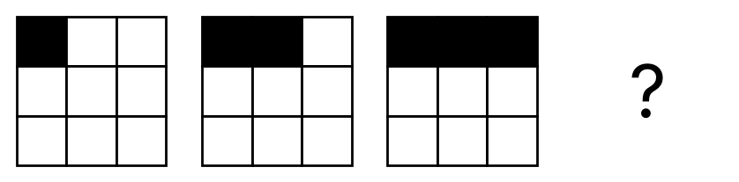
{OPTION 1} 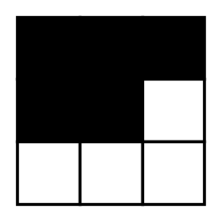
{OPTION 2} 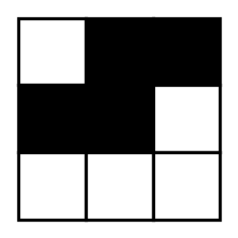
{OPTION 3} 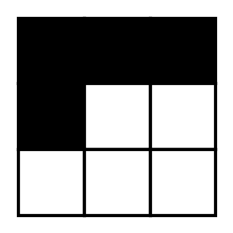
{OPTION 4} 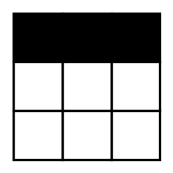
{OPTION 5}
{OPTION 6}
{OPTION 7}
{OPTION 8}
{OPTION 9}
{OPTION 10}
{RIGHT ANSWER} 3
{EXPLANATION} Each figure fills one more square in left-to-right, top-to-bottom order: 1, 2, 3 squares, so the next has the first 4 squares filled.
{CORRECT MARKS} 1
{NEGATIVE MARKS} 0
{DIFFICULTY} Hard
{QUESTION ENDS}

{QUESTION BEGINS}
{QUESTION NUMBER} 16
{SUBJECT} Reasoning Ability
{TOPIC} Mirror Image
{TAGS} tcs nqt, reasoning ability, figure based, hard
{QUESTION TYPE} SINGLECORRECT
{QUESTION TEXT} Select the figure that is the mirror image of the given figure when a mirror is placed on its right side (vertical mirror).
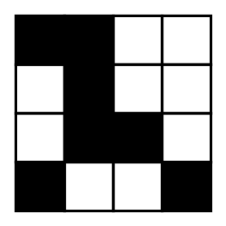
{OPTION 1} 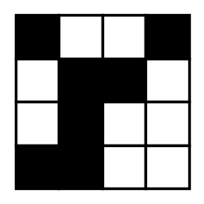
{OPTION 2} 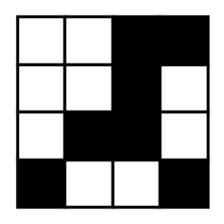
{OPTION 3} 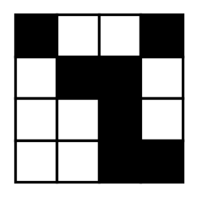
{OPTION 4} 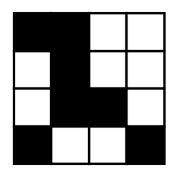
{OPTION 5}
{OPTION 6}
{OPTION 7}
{OPTION 8}
{OPTION 9}
{OPTION 10}
{RIGHT ANSWER} 2
{EXPLANATION} A mirror on the right side reverses left and right while keeping the top and bottom as they are. Option 1 is the figure flipped left-to-right.
{CORRECT MARKS} 1
{NEGATIVE MARKS} 0
{DIFFICULTY} Hard
{QUESTION ENDS}

{QUESTION BEGINS}
{QUESTION NUMBER} 17
{SUBJECT} Reasoning Ability
{TOPIC} Figure Analogy
{TAGS} tcs nqt, reasoning ability, figure based, hard
{QUESTION TYPE} SINGLECORRECT
{QUESTION TEXT} Select the figure that is related to the third figure in the same way as the second figure is related to the first (A : B :: C : ?).
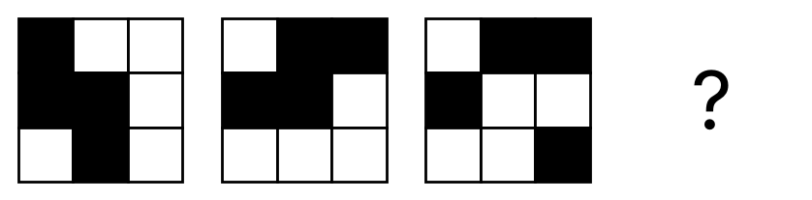
{OPTION 1} 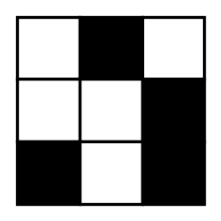
{OPTION 2} 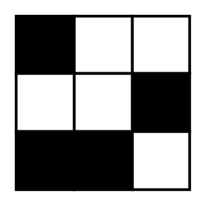
{OPTION 3} 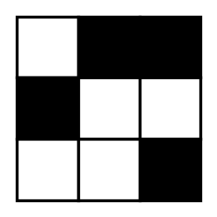
{OPTION 4} 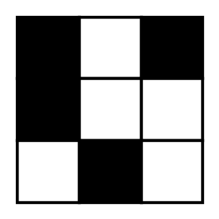
{OPTION 5}
{OPTION 6}
{OPTION 7}
{OPTION 8}
{OPTION 9}
{OPTION 10}
{RIGHT ANSWER} 1
{EXPLANATION} The first figure is turned 90° clockwise to get the second. Doing the same to the third figure gives the answer.
{CORRECT MARKS} 1
{NEGATIVE MARKS} 0
{DIFFICULTY} Hard
{QUESTION ENDS}

{QUESTION BEGINS}
{QUESTION NUMBER} 18
{SUBJECT} Reasoning Ability
{TOPIC} Paper Folding
{TAGS} tcs nqt, reasoning ability, figure based, hard
{QUESTION TYPE} SINGLECORRECT
{QUESTION TEXT} A square sheet (4 × 4 squares) is folded in half along the vertical middle line, left half over the right half. The grey square shows where a hole is punched in the folded paper (second row, first column of the folded sheet). How will the sheet look when unfolded?
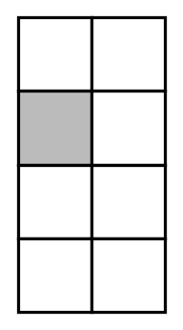
{OPTION 1} 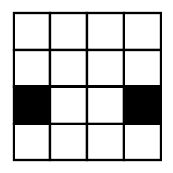
{OPTION 2} 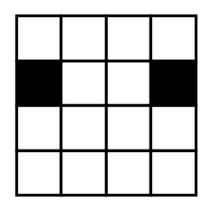
{OPTION 3} 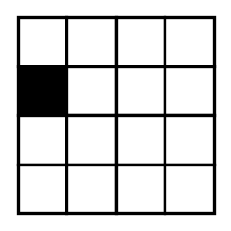
{OPTION 4} 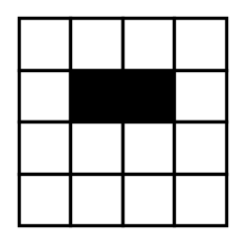
{OPTION 5}
{OPTION 6}
{OPTION 7}
{OPTION 8}
{OPTION 9}
{OPTION 10}
{RIGHT ANSWER} 2
{EXPLANATION} The hole goes through both layers, so on unfolding there are two holes, one at the punched position and its mirror image across the fold line: second row, first and fourth columns.
{CORRECT MARKS} 1
{NEGATIVE MARKS} 0
{DIFFICULTY} Hard
{QUESTION ENDS}

{QUESTION BEGINS}
{QUESTION NUMBER} 19
{SUBJECT} Reasoning Ability
{TOPIC} Counting Figures
{TAGS} tcs nqt, reasoning ability, figure based, hard
{QUESTION TYPE} SINGLECORRECT
{QUESTION TEXT} How many triangles are there in the given figure? (A triangle has its apex at the top and three lines are drawn from the apex to the base.)
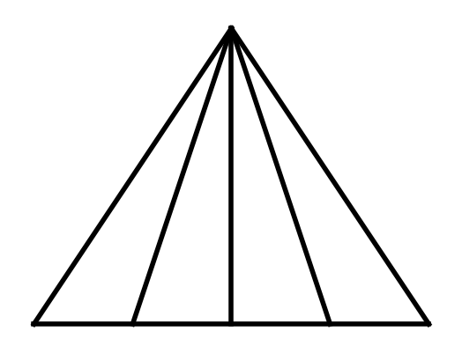
{OPTION 1} 8
{OPTION 2} 6
{OPTION 3} 10
{OPTION 4} 15
{OPTION 5}
{OPTION 6}
{OPTION 7}
{OPTION 8}
{OPTION 9}
{OPTION 10}
{RIGHT ANSWER} 3
{EXPLANATION} The base has 5 points (the 2 corners and 3 points where the lines meet it). Every triangle has the top apex and two of the 5 base points: C(5, 2) = 10.
{CORRECT MARKS} 1
{NEGATIVE MARKS} 0
{DIFFICULTY} Hard
{QUESTION ENDS}

{QUESTION BEGINS}
{QUESTION NUMBER} 20
{SUBJECT} Reasoning Ability
{TOPIC} Counting Figures
{TAGS} tcs nqt, reasoning ability, figure based, hard
{QUESTION TYPE} SINGLECORRECT
{QUESTION TEXT} How many squares of all sizes are there in the given 4 × 4 grid?
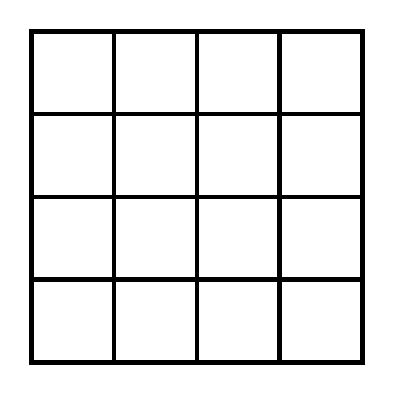
{OPTION 1} 30
{OPTION 2} 20
{OPTION 3} 16
{OPTION 4} 25
{OPTION 5}
{OPTION 6}
{OPTION 7}
{OPTION 8}
{OPTION 9}
{OPTION 10}
{RIGHT ANSWER} 1
{EXPLANATION} 1 × 1 squares: 16, 2 × 2: 9, 3 × 3: 4, 4 × 4: 1. Total = 16 + 9 + 4 + 1 = 30.
{CORRECT MARKS} 1
{NEGATIVE MARKS} 0
{DIFFICULTY} Hard
{QUESTION ENDS}

