{QUESTION BEGINS}
{QUESTION NUMBER} 1
{SUBJECT} Numerical Ability
{TOPIC} Algebra
{TAGS} tcs nqt, numerical ability, equation based, hard
{QUESTION TYPE} SINGLECORRECT
{QUESTION TEXT} 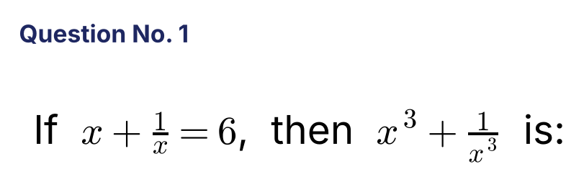
{OPTION 1} 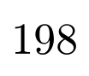
{OPTION 2} 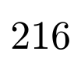
{OPTION 3} 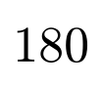
{OPTION 4} 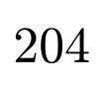
{OPTION 5}
{OPTION 6}
{OPTION 7}
{OPTION 8}
{OPTION 9}
{OPTION 10}
{RIGHT ANSWER} 1
{EXPLANATION} (x + 1/x)³ = x³ + 1/x³ + 3(x + 1/x), so x³ + 1/x³ = 216 − 18 = 198.
{CORRECT MARKS} 1
{NEGATIVE MARKS} 0
{DIFFICULTY} Hard
{QUESTION ENDS}

{QUESTION BEGINS}
{QUESTION NUMBER} 2
{SUBJECT} Numerical Ability
{TOPIC} Algebra
{TAGS} tcs nqt, numerical ability, equation based, hard
{QUESTION TYPE} SINGLECORRECT
{QUESTION TEXT} 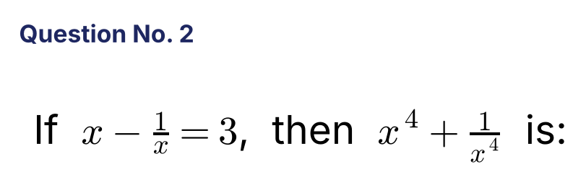
{OPTION 1} 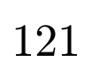
{OPTION 2} 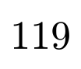
{OPTION 3} 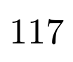
{OPTION 4} 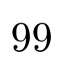
{OPTION 5}
{OPTION 6}
{OPTION 7}
{OPTION 8}
{OPTION 9}
{OPTION 10}
{RIGHT ANSWER} 2
{EXPLANATION} x² + 1/x² = 3² + 2 = 11. Then x⁴ + 1/x⁴ = 11² − 2 = 119.
{CORRECT MARKS} 1
{NEGATIVE MARKS} 0
{DIFFICULTY} Hard
{QUESTION ENDS}

{QUESTION BEGINS}
{QUESTION NUMBER} 3
{SUBJECT} Numerical Ability
{TOPIC} Surds
{TAGS} tcs nqt, numerical ability, equation based, hard
{QUESTION TYPE} SINGLECORRECT
{QUESTION TEXT} 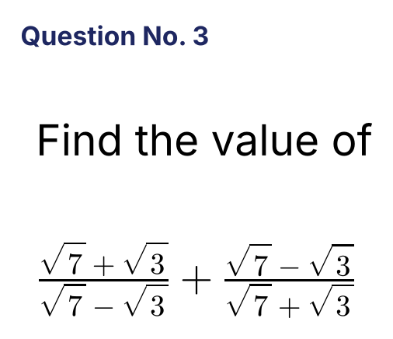
{OPTION 1} 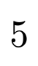
{OPTION 2} 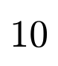
{OPTION 3} 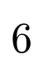
{OPTION 4} 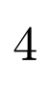
{OPTION 5}
{OPTION 6}
{OPTION 7}
{OPTION 8}
{OPTION 9}
{OPTION 10}
{RIGHT ANSWER} 1
{EXPLANATION} Combine: [(√7 + √3)² + (√7 − √3)²]/(7 − 3) = (10 + 10 + 2√21 − 2√21)/4 = 20/4 = 5.
{CORRECT MARKS} 1
{NEGATIVE MARKS} 0
{DIFFICULTY} Hard
{QUESTION ENDS}

{QUESTION BEGINS}
{QUESTION NUMBER} 4
{SUBJECT} Numerical Ability
{TOPIC} Surds
{TAGS} tcs nqt, numerical ability, equation based, hard
{QUESTION TYPE} SINGLECORRECT
{QUESTION TEXT} 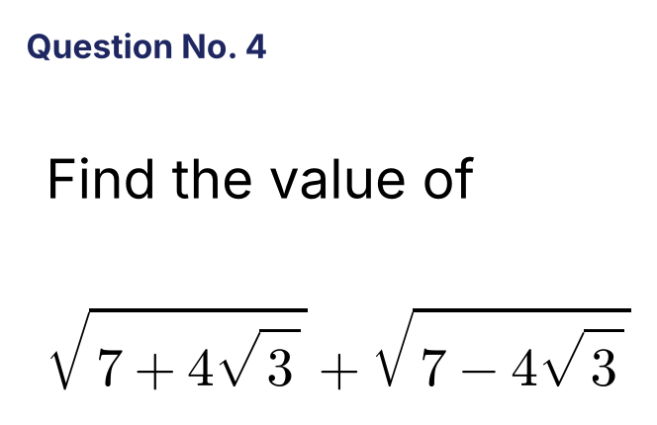
{OPTION 1}
{OPTION 2} 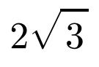
{OPTION 3}
{OPTION 4} 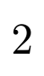
{OPTION 5}
{OPTION 6}
{OPTION 7}
{OPTION 8}
{OPTION 9}
{OPTION 10}
{RIGHT ANSWER} 3
{EXPLANATION} 7 + 4√3 = (2 + √3)² and 7 − 4√3 = (2 − √3)². So the sum = (2 + √3) + (2 − √3) = 4.
{CORRECT MARKS} 1
{NEGATIVE MARKS} 0
{DIFFICULTY} Hard
{QUESTION ENDS}

{QUESTION BEGINS}
{QUESTION NUMBER} 5
{SUBJECT} Numerical Ability
{TOPIC} Surds
{TAGS} tcs nqt, numerical ability, equation based, hard
{QUESTION TYPE} SINGLECORRECT
{QUESTION TEXT} 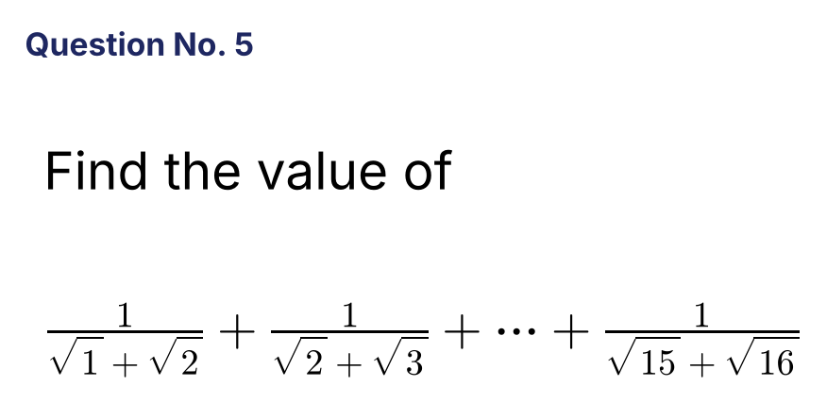
{OPTION 1}
{OPTION 2}
{OPTION 3} 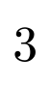
{OPTION 4}
{OPTION 5}
{OPTION 6}
{OPTION 7}
{OPTION 8}
{OPTION 9}
{OPTION 10}
{RIGHT ANSWER} 3
{EXPLANATION} Each term 1/(√k + √(k+1)) = √(k+1) − √k, so the sum telescopes to √16 − √1 = 4 − 1 = 3.
{CORRECT MARKS} 1
{NEGATIVE MARKS} 0
{DIFFICULTY} Hard
{QUESTION ENDS}

{QUESTION BEGINS}
{QUESTION NUMBER} 6
{SUBJECT} Numerical Ability
{TOPIC} Indices
{TAGS} tcs nqt, numerical ability, equation based, hard
{QUESTION TYPE} SINGLECORRECT
{QUESTION TEXT} 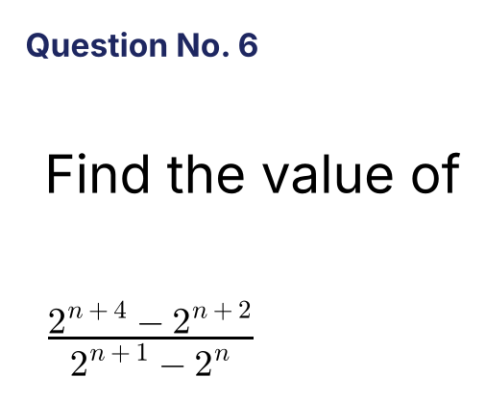
{OPTION 1}
{OPTION 2} 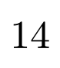
{OPTION 3}
{OPTION 4} 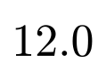
{OPTION 5}
{OPTION 6}
{OPTION 7}
{OPTION 8}
{OPTION 9}
{OPTION 10}
{RIGHT ANSWER} 4
{EXPLANATION} Numerator = 2ⁿ(16 − 4) = 12 · 2ⁿ. Denominator = 2ⁿ(2 − 1) = 2ⁿ. The ratio = 12.
{CORRECT MARKS} 1
{NEGATIVE MARKS} 0
{DIFFICULTY} Hard
{QUESTION ENDS}

{QUESTION BEGINS}
{QUESTION NUMBER} 7
{SUBJECT} Numerical Ability
{TOPIC} Surds
{TAGS} tcs nqt, numerical ability, equation based, hard
{QUESTION TYPE} SINGLECORRECT
{QUESTION TEXT} 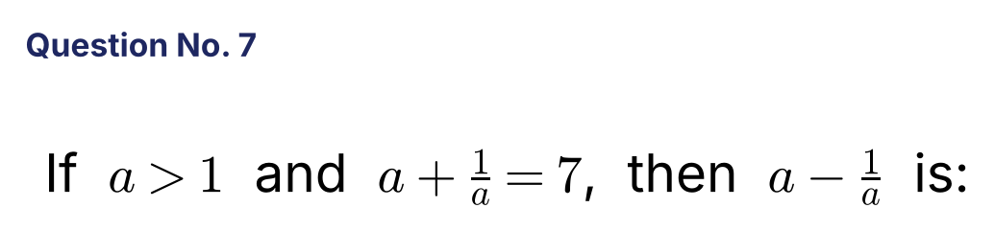
{OPTION 1}
{OPTION 2} 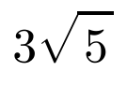
{OPTION 3} 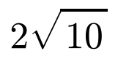
{OPTION 4} 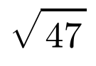
{OPTION 5}
{OPTION 6}
{OPTION 7}
{OPTION 8}
{OPTION 9}
{OPTION 10}
{RIGHT ANSWER} 2
{EXPLANATION} (a − 1/a)² = (a + 1/a)² − 4 = 45. Since a > 1, a − 1/a = √45 = 3√5.
{CORRECT MARKS} 1
{NEGATIVE MARKS} 0
{DIFFICULTY} Hard
{QUESTION ENDS}

{QUESTION BEGINS}
{QUESTION NUMBER} 8
{SUBJECT} Numerical Ability
{TOPIC} Surds
{TAGS} tcs nqt, numerical ability, equation based, hard
{QUESTION TYPE} SINGLECORRECT
{QUESTION TEXT} 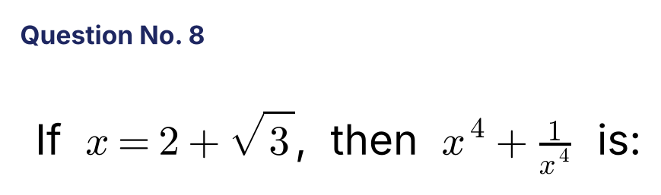
{OPTION 1} 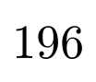
{OPTION 2} 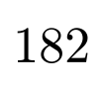
{OPTION 3} 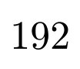
{OPTION 4} 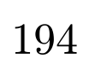
{OPTION 5}
{OPTION 6}
{OPTION 7}
{OPTION 8}
{OPTION 9}
{OPTION 10}
{RIGHT ANSWER} 4
{EXPLANATION} 1/x = 2 − √3, so x + 1/x = 4. x² + 1/x² = 14 and x⁴ + 1/x⁴ = 14² − 2 = 194.
{CORRECT MARKS} 1
{NEGATIVE MARKS} 0
{DIFFICULTY} Hard
{QUESTION ENDS}

{QUESTION BEGINS}
{QUESTION NUMBER} 9
{SUBJECT} Numerical Ability
{TOPIC} Algebra
{TAGS} tcs nqt, numerical ability, equation based, hard
{QUESTION TYPE} SINGLECORRECT
{QUESTION TEXT} 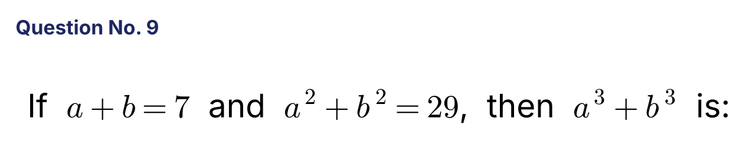
{OPTION 1}
{OPTION 2} 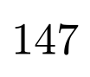
{OPTION 3} 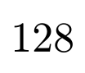
{OPTION 4} 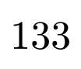
{OPTION 5}
{OPTION 6}
{OPTION 7}
{OPTION 8}
{OPTION 9}
{OPTION 10}
{RIGHT ANSWER} 4
{EXPLANATION} ab = (49 − 29)/2 = 10. a³ + b³ = (a + b)³ − 3ab(a + b) = 343 − 210 = 133.
{CORRECT MARKS} 1
{NEGATIVE MARKS} 0
{DIFFICULTY} Hard
{QUESTION ENDS}

{QUESTION BEGINS}
{QUESTION NUMBER} 10
{SUBJECT} Numerical Ability
{TOPIC} Algebra
{TAGS} tcs nqt, numerical ability, equation based, hard
{QUESTION TYPE} SINGLECORRECT
{QUESTION TEXT} 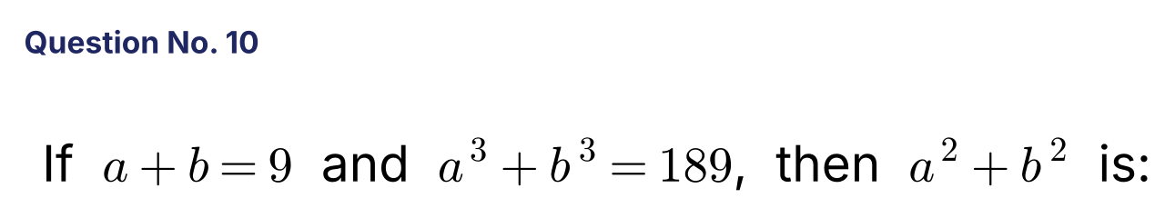
{OPTION 1} 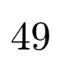
{OPTION 2} 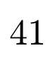
{OPTION 3} 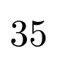
{OPTION 4} 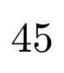
{OPTION 5}
{OPTION 6}
{OPTION 7}
{OPTION 8}
{OPTION 9}
{OPTION 10}
{RIGHT ANSWER} 2
{EXPLANATION} a³ + b³ = (a + b)³ − 3ab(a + b) = 729 − 27ab = 189, so ab = 20. a² + b² = 81 − 40 = 41.
{CORRECT MARKS} 1
{NEGATIVE MARKS} 0
{DIFFICULTY} Hard
{QUESTION ENDS}

{QUESTION BEGINS}
{QUESTION NUMBER} 11
{SUBJECT} Numerical Ability
{TOPIC} Algebra
{TAGS} tcs nqt, numerical ability, equation based, hard
{QUESTION TYPE} SINGLECORRECT
{QUESTION TEXT} 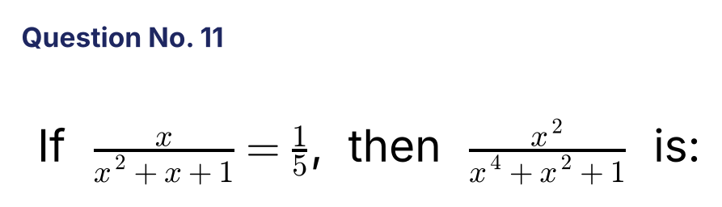
{OPTION 1} 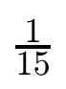
{OPTION 2} 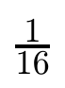
{OPTION 3} 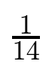
{OPTION 4} 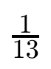
{OPTION 5}
{OPTION 6}
{OPTION 7}
{OPTION 8}
{OPTION 9}
{OPTION 10}
{RIGHT ANSWER} 1
{EXPLANATION} x² + x + 1 = 5x gives x² − 4x + 1 = 0, so x + 1/x = 4. Then x² + 1/x² = 14, and (x⁴ + x² + 1)/x² = x² + 1 + 1/x² = 15. Hence the required value = 1/15.
{CORRECT MARKS} 1
{NEGATIVE MARKS} 0
{DIFFICULTY} Hard
{QUESTION ENDS}

{QUESTION BEGINS}
{QUESTION NUMBER} 12
{SUBJECT} Numerical Ability
{TOPIC} Surds
{TAGS} tcs nqt, numerical ability, equation based, hard
{QUESTION TYPE} SINGLECORRECT
{QUESTION TEXT} 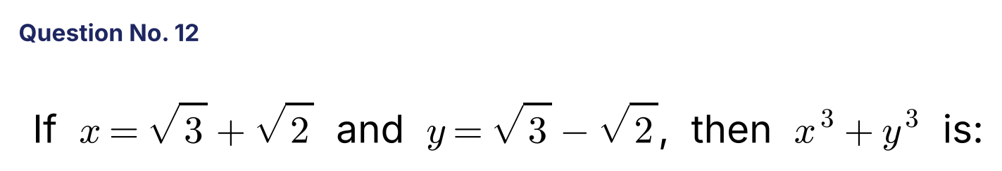
{OPTION 1} 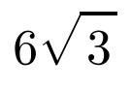
{OPTION 2} 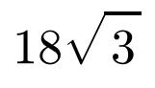
{OPTION 3} 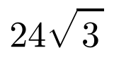
{OPTION 4} 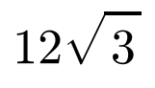
{OPTION 5}
{OPTION 6}
{OPTION 7}
{OPTION 8}
{OPTION 9}
{OPTION 10}
{RIGHT ANSWER} 2
{EXPLANATION} x + y = 2√3 and xy = 3 − 2 = 1. x³ + y³ = (x + y)³ − 3xy(x + y) = 24√3 − 6√3 = 18√3.
{CORRECT MARKS} 1
{NEGATIVE MARKS} 0
{DIFFICULTY} Hard
{QUESTION ENDS}

{QUESTION BEGINS}
{QUESTION NUMBER} 13
{SUBJECT} Numerical Ability
{TOPIC} Indices
{TAGS} tcs nqt, numerical ability, equation based, hard
{QUESTION TYPE} SINGLECORRECT
{QUESTION TEXT} 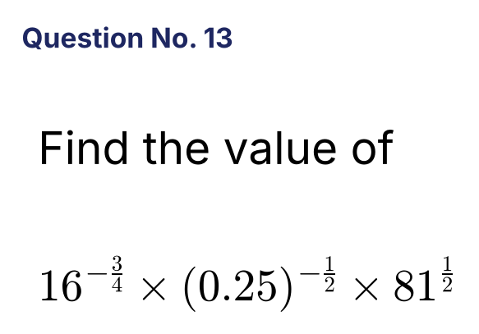
{OPTION 1} 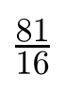
{OPTION 2} 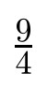
{OPTION 3} 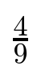
{OPTION 4} 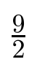
{OPTION 5}
{OPTION 6}
{OPTION 7}
{OPTION 8}
{OPTION 9}
{OPTION 10}
{RIGHT ANSWER} 2
{EXPLANATION} 16^(−3/4) = 1/8, (0.25)^(−1/2) = 2 and 81^(1/2) = 9. The product = (1/8) × 2 × 9 = 9/4.
{CORRECT MARKS} 1
{NEGATIVE MARKS} 0
{DIFFICULTY} Hard
{QUESTION ENDS}

{QUESTION BEGINS}
{QUESTION NUMBER} 14
{SUBJECT} Numerical Ability
{TOPIC} Indices
{TAGS} tcs nqt, numerical ability, equation based, hard
{QUESTION TYPE} SINGLECORRECT
{QUESTION TEXT} 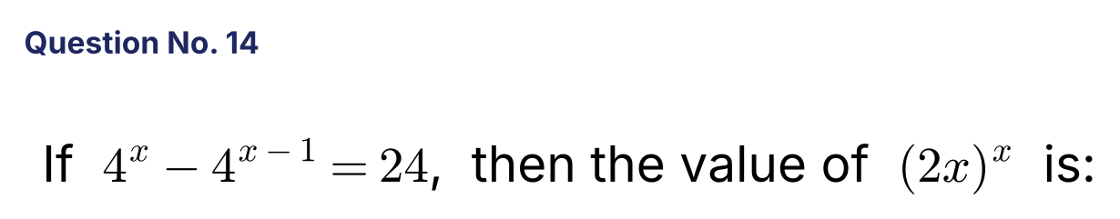
{OPTION 1} 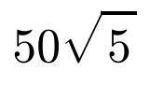
{OPTION 2} 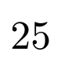
{OPTION 3} 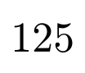
{OPTION 4} 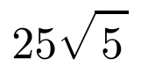
{OPTION 5}
{OPTION 6}
{OPTION 7}
{OPTION 8}
{OPTION 9}
{OPTION 10}
{RIGHT ANSWER} 4
{EXPLANATION} 4ˣ − 4^(x−1) = 4^(x−1)(4 − 1) = 24, so 4^(x−1) = 8 = 2³. Then 2(x − 1) = 3 and x = 5/2. (2x)ˣ = 5^(5/2) = 25√5.
{CORRECT MARKS} 1
{NEGATIVE MARKS} 0
{DIFFICULTY} Hard
{QUESTION ENDS}

{QUESTION BEGINS}
{QUESTION NUMBER} 15
{SUBJECT} Numerical Ability
{TOPIC} Indices
{TAGS} tcs nqt, numerical ability, equation based, hard
{QUESTION TYPE} SINGLECORRECT
{QUESTION TEXT} 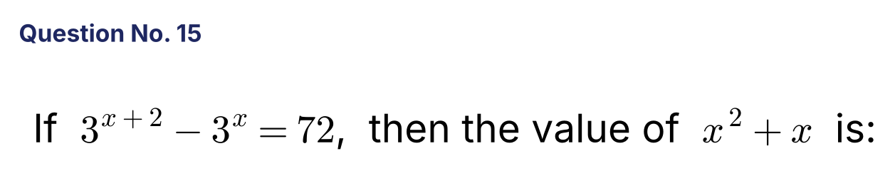
{OPTION 1}
{OPTION 2}
{OPTION 3} 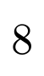
{OPTION 4} 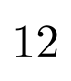
{OPTION 5}
{OPTION 6}
{OPTION 7}
{OPTION 8}
{OPTION 9}
{OPTION 10}
{RIGHT ANSWER} 2
{EXPLANATION} 3ˣ(9 − 1) = 72, so 3ˣ = 9 and x = 2. Then x² + x = 4 + 2 = 6.
{CORRECT MARKS} 1
{NEGATIVE MARKS} 0
{DIFFICULTY} Hard
{QUESTION ENDS}

{QUESTION BEGINS}
{QUESTION NUMBER} 16
{SUBJECT} Numerical Ability
{TOPIC} Number System
{TAGS} tcs nqt, numerical ability, equation based, hard
{QUESTION TYPE} SINGLECORRECT
{QUESTION TEXT} 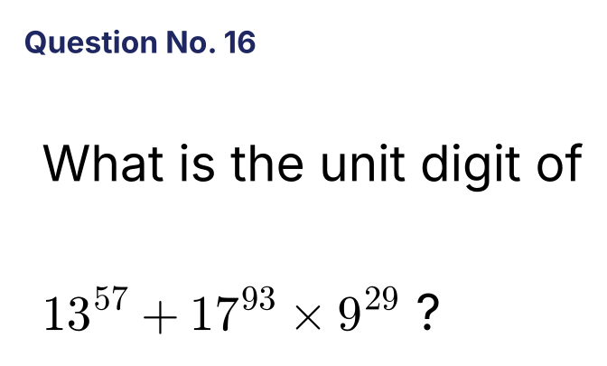
{OPTION 1}
{OPTION 2}
{OPTION 3}
{OPTION 4}
{OPTION 5}
{OPTION 6}
{OPTION 7}
{OPTION 8}
{OPTION 9}
{OPTION 10}
{RIGHT ANSWER} 2
{EXPLANATION} 13⁵⁷: 57 mod 4 = 1, unit digit 3. 17⁹³: 93 mod 4 = 1, unit digit 7. 9²⁹: odd power, unit digit 9. So 7 × 9 = 63 gives 3, and 3 + 3 = 6. Unit digit = 6.
{CORRECT MARKS} 1
{NEGATIVE MARKS} 0
{DIFFICULTY} Hard
{QUESTION ENDS}

{QUESTION BEGINS}
{QUESTION NUMBER} 17
{SUBJECT} Numerical Ability
{TOPIC} Number System
{TAGS} tcs nqt, numerical ability, equation based, hard
{QUESTION TYPE} SINGLECORRECT
{QUESTION TEXT} 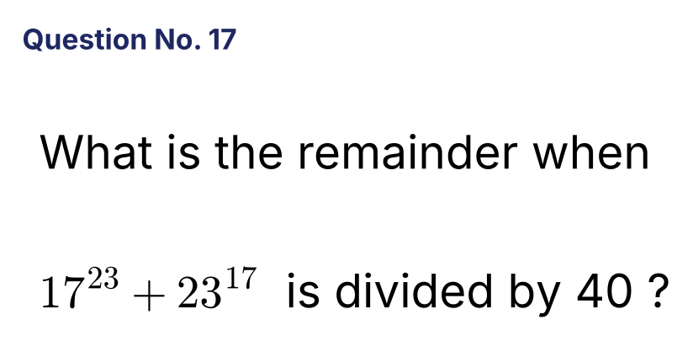
{OPTION 1}
{OPTION 2} 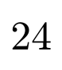
{OPTION 3} 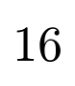
{OPTION 4} 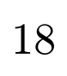
{OPTION 5}
{OPTION 6}
{OPTION 7}
{OPTION 8}
{OPTION 9}
{OPTION 10}
{RIGHT ANSWER} 3
{EXPLANATION} 17² = 289 ≡ 9 (mod 40), 17⁴ ≡ 81 ≡ 1, so 17²³ = 17²⁰ · 17³ ≡ 17³ = 17 · 9 = 153 ≡ 33. 23² = 529 ≡ 9, 23⁴ ≡ 1, so 23¹⁷ = 23¹⁶ · 23 ≡ 23. Sum = 33 + 23 = 56 ≡ 16.
{CORRECT MARKS} 1
{NEGATIVE MARKS} 0
{DIFFICULTY} Hard
{QUESTION ENDS}

{QUESTION BEGINS}
{QUESTION NUMBER} 18
{SUBJECT} Numerical Ability
{TOPIC} Number System
{TAGS} tcs nqt, numerical ability, equation based, hard
{QUESTION TYPE} SINGLECORRECT
{QUESTION TEXT} 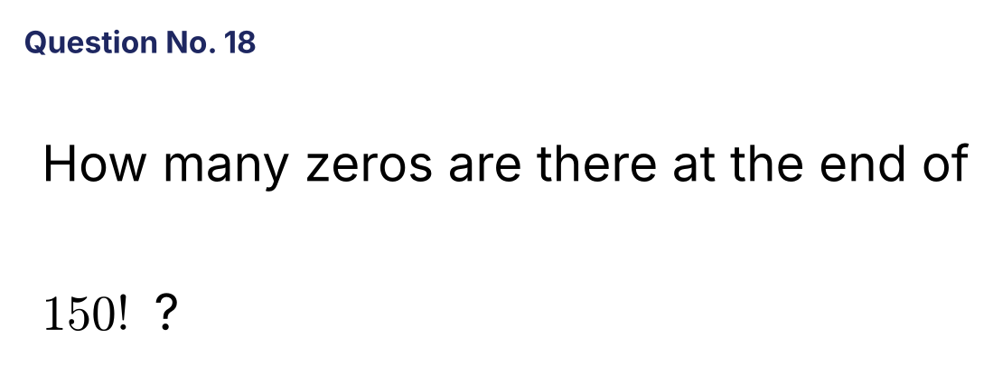
{OPTION 1} 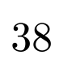
{OPTION 2}
{OPTION 3} 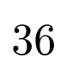
{OPTION 4} 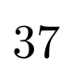
{OPTION 5}
{OPTION 6}
{OPTION 7}
{OPTION 8}
{OPTION 9}
{OPTION 10}
{RIGHT ANSWER} 4
{EXPLANATION} Zeros = ⌊150/5⌋ + ⌊150/25⌋ + ⌊150/125⌋ = 30 + 6 + 1 = 37.
{CORRECT MARKS} 1
{NEGATIVE MARKS} 0
{DIFFICULTY} Hard
{QUESTION ENDS}

{QUESTION BEGINS}
{QUESTION NUMBER} 19
{SUBJECT} Numerical Ability
{TOPIC} Number System
{TAGS} tcs nqt, numerical ability, equation based, hard
{QUESTION TYPE} SINGLECORRECT
{QUESTION TEXT} 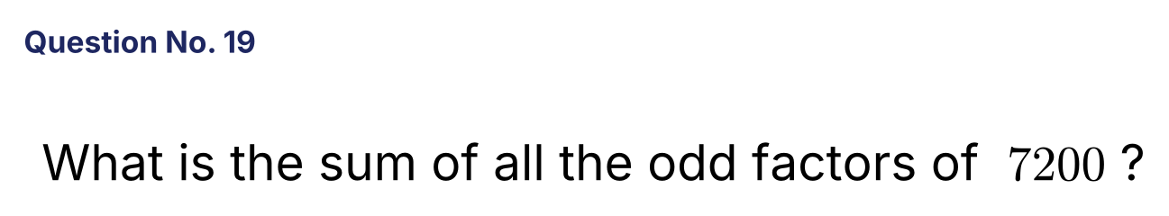
{OPTION 1} 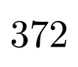
{OPTION 2} 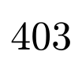
{OPTION 3} 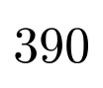
{OPTION 4} 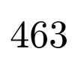
{OPTION 5}
{OPTION 6}
{OPTION 7}
{OPTION 8}
{OPTION 9}
{OPTION 10}
{RIGHT ANSWER} 2
{EXPLANATION} 7200 = 2⁵ × 3² × 5². The odd factors come from 3² × 5²: sum = (1 + 3 + 9)(1 + 5 + 25) = 13 × 31 = 403.
{CORRECT MARKS} 1
{NEGATIVE MARKS} 0
{DIFFICULTY} Hard
{QUESTION ENDS}

{QUESTION BEGINS}
{QUESTION NUMBER} 20
{SUBJECT} Numerical Ability
{TOPIC} Series
{TAGS} tcs nqt, numerical ability, equation based, hard
{QUESTION TYPE} SINGLECORRECT
{QUESTION TEXT} 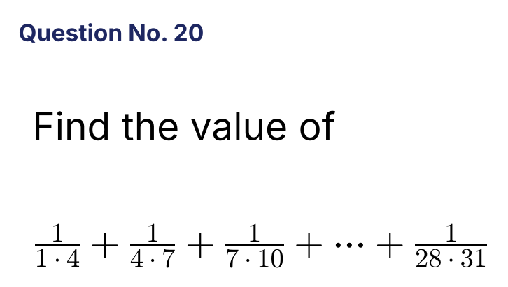
{OPTION 1} 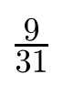
{OPTION 2} 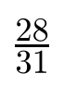
{OPTION 3} 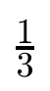
{OPTION 4} 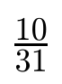
{OPTION 5}
{OPTION 6}
{OPTION 7}
{OPTION 8}
{OPTION 9}
{OPTION 10}
{RIGHT ANSWER} 4
{EXPLANATION} 1/(n(n + 3)) = (1/3)[1/n − 1/(n + 3)]. The sum telescopes to (1/3)(1 − 1/31) = (1/3)(30/31) = 10/31.
{CORRECT MARKS} 1
{NEGATIVE MARKS} 0
{DIFFICULTY} Hard
{QUESTION ENDS}

{QUESTION BEGINS}
{QUESTION NUMBER} 21
{SUBJECT} Numerical Ability
{TOPIC} Simplification
{TAGS} tcs nqt, numerical ability, equation based, hard
{QUESTION TYPE} SINGLECORRECT
{QUESTION TEXT} 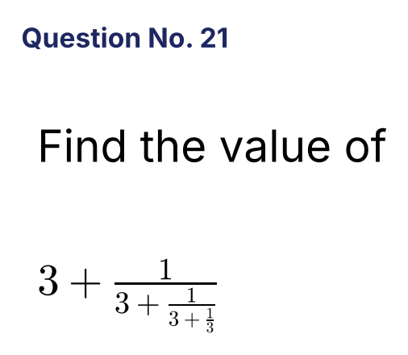
{OPTION 1} 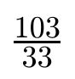
{OPTION 2} 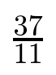
{OPTION 3} 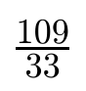
{OPTION 4} 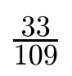
{OPTION 5}
{OPTION 6}
{OPTION 7}
{OPTION 8}
{OPTION 9}
{OPTION 10}
{RIGHT ANSWER} 3
{EXPLANATION} Work from the bottom: 3 + 1/3 = 10/3. Then 3 + 3/10 = 33/10. Then 3 + 10/33 = 109/33.
{CORRECT MARKS} 1
{NEGATIVE MARKS} 0
{DIFFICULTY} Hard
{QUESTION ENDS}

{QUESTION BEGINS}
{QUESTION NUMBER} 22
{SUBJECT} Numerical Ability
{TOPIC} Series
{TAGS} tcs nqt, numerical ability, equation based, hard
{QUESTION TYPE} SINGLECORRECT
{QUESTION TEXT} 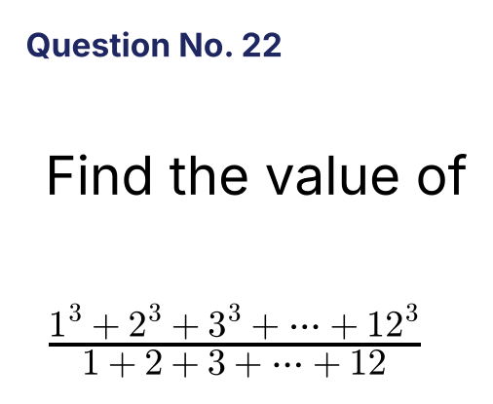
{OPTION 1} 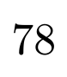
{OPTION 2} 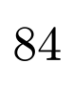
{OPTION 3} 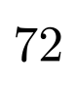
{OPTION 4} 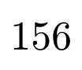
{OPTION 5}
{OPTION 6}
{OPTION 7}
{OPTION 8}
{OPTION 9}
{OPTION 10}
{RIGHT ANSWER} 1
{EXPLANATION} Sum of cubes = (12 × 13/2)² = 78². Sum of numbers = 78. The ratio = 78²/78 = 78.
{CORRECT MARKS} 1
{NEGATIVE MARKS} 0
{DIFFICULTY} Hard
{QUESTION ENDS}

{QUESTION BEGINS}
{QUESTION NUMBER} 23
{SUBJECT} Numerical Ability
{TOPIC} Quadratic Equations
{TAGS} tcs nqt, numerical ability, equation based, hard
{QUESTION TYPE} SINGLECORRECT
{QUESTION TEXT} 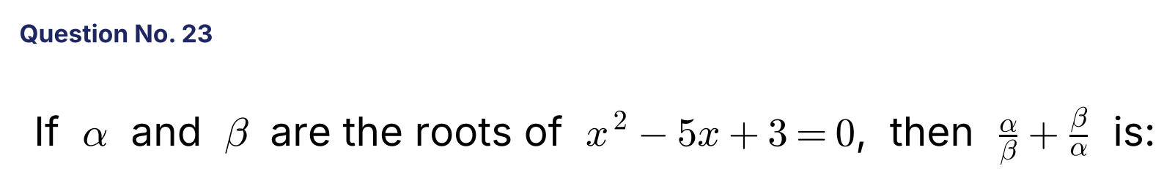
{OPTION 1} 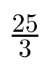
{OPTION 2} 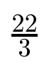
{OPTION 3} 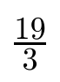
{OPTION 4} 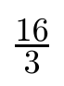
{OPTION 5}
{OPTION 6}
{OPTION 7}
{OPTION 8}
{OPTION 9}
{OPTION 10}
{RIGHT ANSWER} 3
{EXPLANATION} α + β = 5 and αβ = 3. α/β + β/α = (α² + β²)/αβ = (25 − 6)/3 = 19/3.
{CORRECT MARKS} 1
{NEGATIVE MARKS} 0
{DIFFICULTY} Hard
{QUESTION ENDS}

{QUESTION BEGINS}
{QUESTION NUMBER} 24
{SUBJECT} Numerical Ability
{TOPIC} Quadratic Equations
{TAGS} tcs nqt, numerical ability, equation based, hard
{QUESTION TYPE} SINGLECORRECT
{QUESTION TEXT} 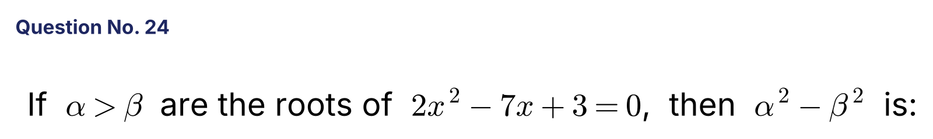
{OPTION 1} 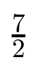
{OPTION 2} 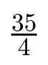
{OPTION 3} 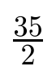
{OPTION 4} 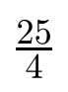
{OPTION 5}
{OPTION 6}
{OPTION 7}
{OPTION 8}
{OPTION 9}
{OPTION 10}
{RIGHT ANSWER} 2
{EXPLANATION} The roots are 3 and 1/2 (sum 7/2, difference √(49 − 24)/2 = 5/2). α² − β² = (α + β)(α − β) = (7/2)(5/2) = 35/4.
{CORRECT MARKS} 1
{NEGATIVE MARKS} 0
{DIFFICULTY} Hard
{QUESTION ENDS}

{QUESTION BEGINS}
{QUESTION NUMBER} 25
{SUBJECT} Numerical Ability
{TOPIC} Algebra
{TAGS} tcs nqt, numerical ability, equation based, hard
{QUESTION TYPE} SINGLECORRECT
{QUESTION TEXT} 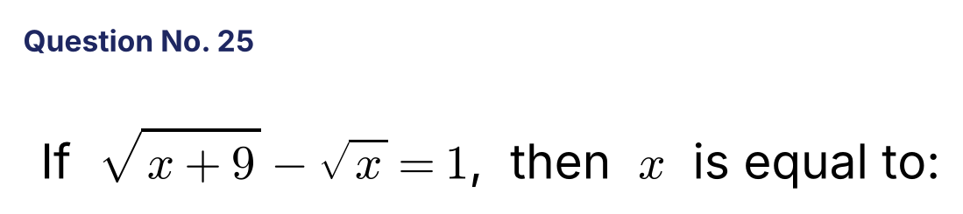
{OPTION 1}
{OPTION 2}
{OPTION 3} 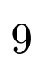
{OPTION 4}
{OPTION 5}
{OPTION 6}
{OPTION 7}
{OPTION 8}
{OPTION 9}
{OPTION 10}
{RIGHT ANSWER} 2
{EXPLANATION} √(x + 9) = 1 + √x. Squaring: x + 9 = 1 + 2√x + x, so 2√x = 8, √x = 4 and x = 16. Check: √25 − √16 = 1.
{CORRECT MARKS} 1
{NEGATIVE MARKS} 0
{DIFFICULTY} Hard
{QUESTION ENDS}

{QUESTION BEGINS}
{QUESTION NUMBER} 26
{SUBJECT} Numerical Ability
{TOPIC} Algebra
{TAGS} tcs nqt, numerical ability, equation based, hard
{QUESTION TYPE} SINGLECORRECT
{QUESTION TEXT} 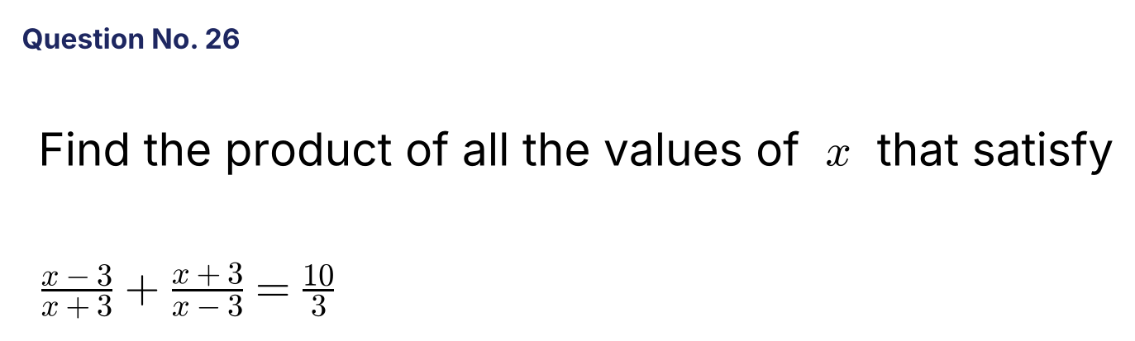
{OPTION 1}
{OPTION 2} 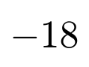
{OPTION 3} 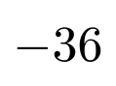
{OPTION 4} 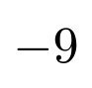
{OPTION 5}
{OPTION 6}
{OPTION 7}
{OPTION 8}
{OPTION 9}
{OPTION 10}
{RIGHT ANSWER} 3
{EXPLANATION} (x − 3)² + (x + 3)² = (10/3)(x² − 9), so 2x² + 18 = (10/3)x² − 30. Multiply by 3: 6x² + 54 = 10x² − 90, so x² = 36 and x = ±6. Product = 6 × (−6) = −36.
{CORRECT MARKS} 1
{NEGATIVE MARKS} 0
{DIFFICULTY} Hard
{QUESTION ENDS}

{QUESTION BEGINS}
{QUESTION NUMBER} 27
{SUBJECT} Numerical Ability
{TOPIC} Algebra
{TAGS} tcs nqt, numerical ability, equation based, hard
{QUESTION TYPE} SINGLECORRECT
{QUESTION TEXT} 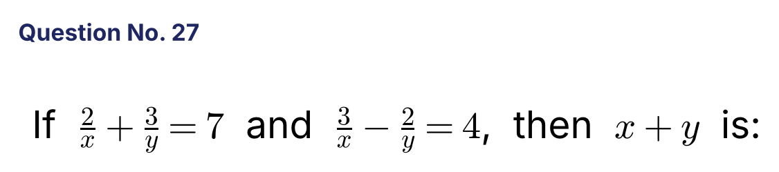
{OPTION 1} 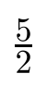
{OPTION 2} 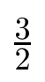
{OPTION 3}
{OPTION 4} 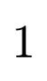
{OPTION 5}
{OPTION 6}
{OPTION 7}
{OPTION 8}
{OPTION 9}
{OPTION 10}
{RIGHT ANSWER} 2
{EXPLANATION} Let 1/x = a and 1/y = b. 2a + 3b = 7 and 3a − 2b = 4. Multiply the first by 2 and the second by 3 and add: 13a = 26, so a = 2 and b = 1. Then x = 1/2, y = 1 and x + y = 3/2.
{CORRECT MARKS} 1
{NEGATIVE MARKS} 0
{DIFFICULTY} Hard
{QUESTION ENDS}

{QUESTION BEGINS}
{QUESTION NUMBER} 28
{SUBJECT} Numerical Ability
{TOPIC} Algebra
{TAGS} tcs nqt, numerical ability, equation based, hard
{QUESTION TYPE} SINGLECORRECT
{QUESTION TEXT} 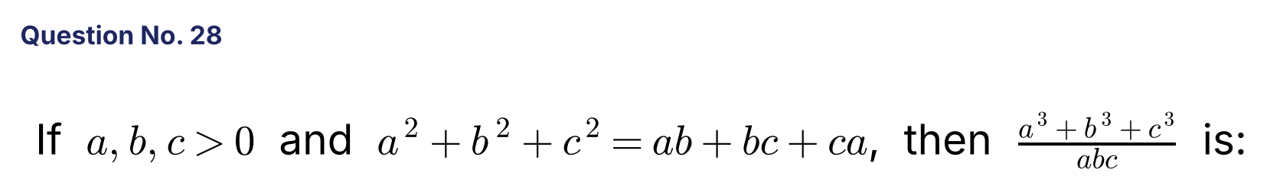
{OPTION 1}
{OPTION 2}
{OPTION 3}
{OPTION 4}
{OPTION 5}
{OPTION 6}
{OPTION 7}
{OPTION 8}
{OPTION 9}
{OPTION 10}
{RIGHT ANSWER} 4
{EXPLANATION} a² + b² + c² − ab − bc − ca = ½[(a − b)² + (b − c)² + (c − a)²] = 0, so a = b = c. Then (3a³)/(a³) = 3.
{CORRECT MARKS} 1
{NEGATIVE MARKS} 0
{DIFFICULTY} Hard
{QUESTION ENDS}

{QUESTION BEGINS}
{QUESTION NUMBER} 29
{SUBJECT} Numerical Ability
{TOPIC} Algebra
{TAGS} tcs nqt, numerical ability, equation based, hard
{QUESTION TYPE} SINGLECORRECT
{QUESTION TEXT} 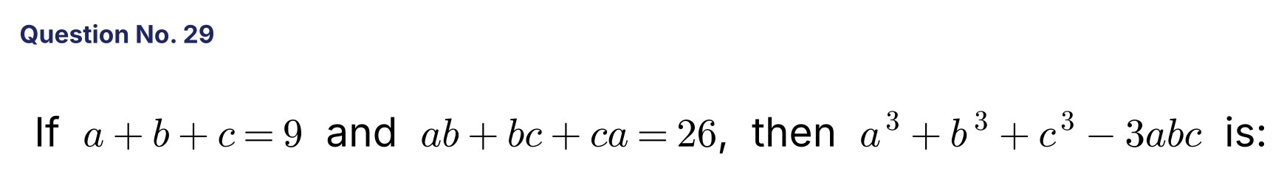
{OPTION 1} 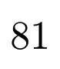
{OPTION 2}
{OPTION 3} 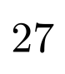
{OPTION 4}
{OPTION 5}
{OPTION 6}
{OPTION 7}
{OPTION 8}
{OPTION 9}
{OPTION 10}
{RIGHT ANSWER} 3
{EXPLANATION} a² + b² + c² = 81 − 52 = 29. a³ + b³ + c³ − 3abc = (a + b + c)(a² + b² + c² − ab − bc − ca) = 9 × (29 − 26) = 27.
{CORRECT MARKS} 1
{NEGATIVE MARKS} 0
{DIFFICULTY} Hard
{QUESTION ENDS}

{QUESTION BEGINS}
{QUESTION NUMBER} 30
{SUBJECT} Numerical Ability
{TOPIC} Surds
{TAGS} tcs nqt, numerical ability, equation based, hard
{QUESTION TYPE} SINGLECORRECT
{QUESTION TEXT} 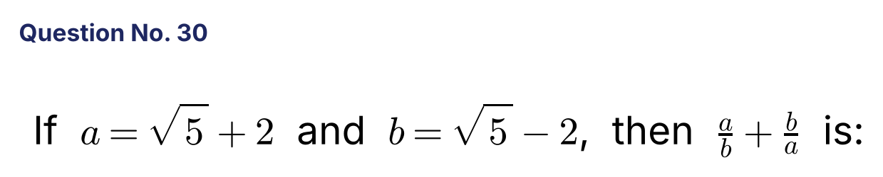
{OPTION 1}
{OPTION 2}
{OPTION 3} 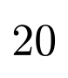
{OPTION 4}
{OPTION 5}
{OPTION 6}
{OPTION 7}
{OPTION 8}
{OPTION 9}
{OPTION 10}
{RIGHT ANSWER} 2
{EXPLANATION} ab = 5 − 4 = 1 and a² + b² = 2(5 + 4) = 18. So a/b + b/a = (a² + b²)/ab = 18.
{CORRECT MARKS} 1
{NEGATIVE MARKS} 0
{DIFFICULTY} Hard
{QUESTION ENDS}

{QUESTION BEGINS}
{QUESTION NUMBER} 31
{SUBJECT} Numerical Ability
{TOPIC} Surds
{TAGS} tcs nqt, numerical ability, equation based, hard
{QUESTION TYPE} SINGLECORRECT
{QUESTION TEXT} 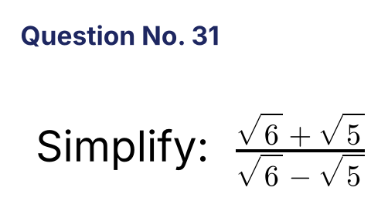
{OPTION 1} 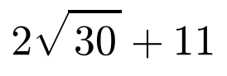
{OPTION 2} 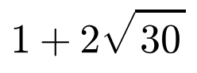
{OPTION 3} 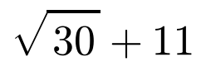
{OPTION 4} 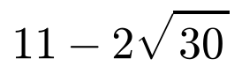
{OPTION 5}
{OPTION 6}
{OPTION 7}
{OPTION 8}
{OPTION 9}
{OPTION 10}
{RIGHT ANSWER} 1
{EXPLANATION} Multiply by (√6 + √5)/(√6 + √5): numerator = (√6 + √5)² = 11 + 2√30 and denominator = 6 − 5 = 1. So the value = 11 + 2√30.
{CORRECT MARKS} 1
{NEGATIVE MARKS} 0
{DIFFICULTY} Hard
{QUESTION ENDS}

{QUESTION BEGINS}
{QUESTION NUMBER} 32
{SUBJECT} Numerical Ability
{TOPIC} Surds
{TAGS} tcs nqt, numerical ability, equation based, hard
{QUESTION TYPE} SINGLECORRECT
{QUESTION TEXT} 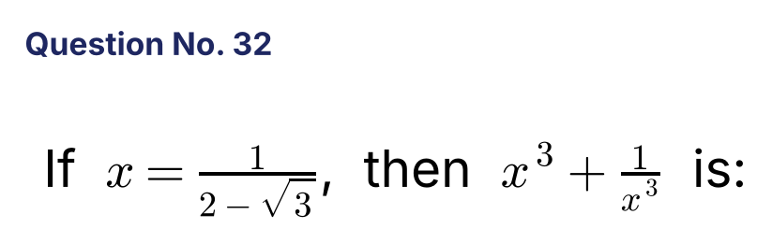
{OPTION 1} 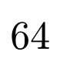
{OPTION 2} 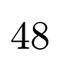
{OPTION 3} 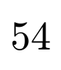
{OPTION 4} 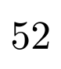
{OPTION 5}
{OPTION 6}
{OPTION 7}
{OPTION 8}
{OPTION 9}
{OPTION 10}
{RIGHT ANSWER} 4
{EXPLANATION} x = 2 + √3 and 1/x = 2 − √3, so x + 1/x = 4. x³ + 1/x³ = 4³ − 3 × 4 = 64 − 12 = 52.
{CORRECT MARKS} 1
{NEGATIVE MARKS} 0
{DIFFICULTY} Hard
{QUESTION ENDS}

{QUESTION BEGINS}
{QUESTION NUMBER} 33
{SUBJECT} Numerical Ability
{TOPIC} Simplification
{TAGS} tcs nqt, numerical ability, equation based, hard
{QUESTION TYPE} SINGLECORRECT
{QUESTION TEXT} 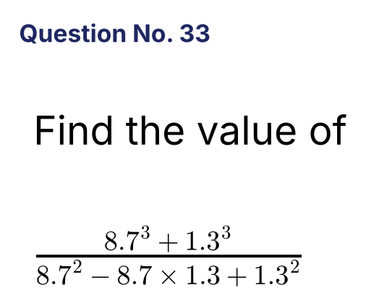
{OPTION 1}
{OPTION 2} 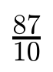
{OPTION 3}
{OPTION 4} 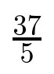
{OPTION 5}
{OPTION 6}
{OPTION 7}
{OPTION 8}
{OPTION 9}
{OPTION 10}
{RIGHT ANSWER} 3
{EXPLANATION} a³ + b³ = (a + b)(a² − ab + b²). So the expression = a + b = 8.7 + 1.3 = 10.
{CORRECT MARKS} 1
{NEGATIVE MARKS} 0
{DIFFICULTY} Hard
{QUESTION ENDS}

{QUESTION BEGINS}
{QUESTION NUMBER} 34
{SUBJECT} Numerical Ability
{TOPIC} Simplification
{TAGS} tcs nqt, numerical ability, equation based, hard
{QUESTION TYPE} SINGLECORRECT
{QUESTION TEXT} 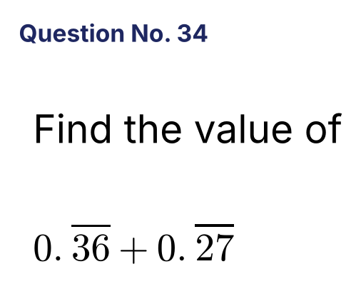
{OPTION 1} 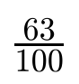
{OPTION 2} 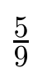
{OPTION 3} 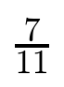
{OPTION 4} 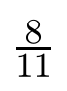
{OPTION 5}
{OPTION 6}
{OPTION 7}
{OPTION 8}
{OPTION 9}
{OPTION 10}
{RIGHT ANSWER} 3
{EXPLANATION} 0.36 recurring = 36/99 = 4/11 and 0.27 recurring = 27/99 = 3/11. The sum = 7/11.
{CORRECT MARKS} 1
{NEGATIVE MARKS} 0
{DIFFICULTY} Hard
{QUESTION ENDS}

{QUESTION BEGINS}
{QUESTION NUMBER} 35
{SUBJECT} Numerical Ability
{TOPIC} Series
{TAGS} tcs nqt, numerical ability, equation based, hard
{QUESTION TYPE} SINGLECORRECT
{QUESTION TEXT} 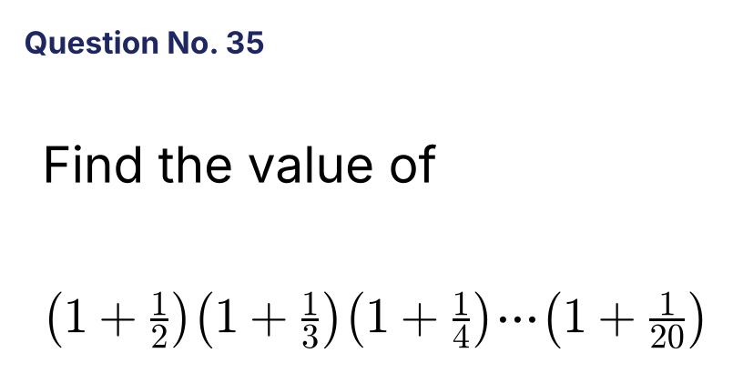
{OPTION 1}
{OPTION 2} 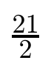
{OPTION 3} 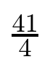
{OPTION 4}
{OPTION 5}
{OPTION 6}
{OPTION 7}
{OPTION 8}
{OPTION 9}
{OPTION 10}
{RIGHT ANSWER} 2
{EXPLANATION} (1 + 1/k) = (k + 1)/k, so the product = (3/2)(4/3)(5/4)...(21/20) = 21/2.
{CORRECT MARKS} 1
{NEGATIVE MARKS} 0
{DIFFICULTY} Hard
{QUESTION ENDS}

{QUESTION BEGINS}
{QUESTION NUMBER} 36
{SUBJECT} Numerical Ability
{TOPIC} Series
{TAGS} tcs nqt, numerical ability, equation based, hard
{QUESTION TYPE} SINGLECORRECT
{QUESTION TEXT} 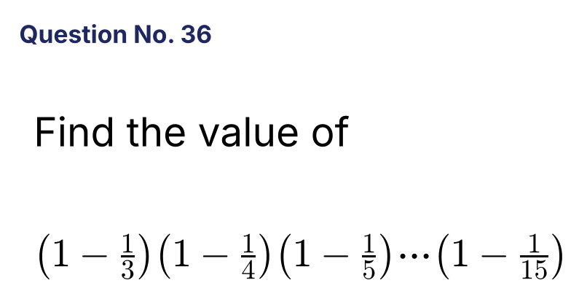
{OPTION 1} 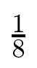
{OPTION 2}
{OPTION 3} 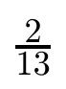
{OPTION 4} 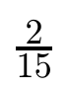
{OPTION 5}
{OPTION 6}
{OPTION 7}
{OPTION 8}
{OPTION 9}
{OPTION 10}
{RIGHT ANSWER} 4
{EXPLANATION} (1 − 1/k) = (k − 1)/k, so the product = (2/3)(3/4)(4/5)...(14/15) = 2/15.
{CORRECT MARKS} 1
{NEGATIVE MARKS} 0
{DIFFICULTY} Hard
{QUESTION ENDS}

{QUESTION BEGINS}
{QUESTION NUMBER} 37
{SUBJECT} Numerical Ability
{TOPIC} Indices
{TAGS} tcs nqt, numerical ability, equation based, hard
{QUESTION TYPE} SINGLECORRECT
{QUESTION TEXT} 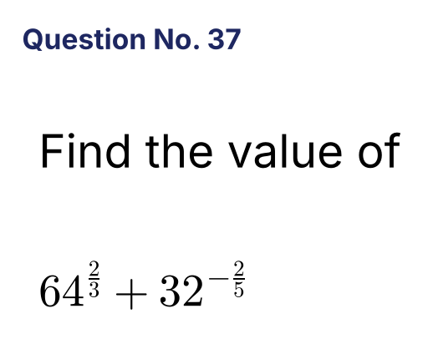
{OPTION 1} 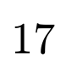
{OPTION 2} 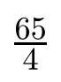
{OPTION 3} 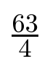
{OPTION 4} 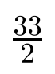
{OPTION 5}
{OPTION 6}
{OPTION 7}
{OPTION 8}
{OPTION 9}
{OPTION 10}
{RIGHT ANSWER} 2
{EXPLANATION} 64^(2/3) = 4² = 16. 32^(−2/5) = 2^(−2) = 1/4. The sum = 16 + 1/4 = 65/4.
{CORRECT MARKS} 1
{NEGATIVE MARKS} 0
{DIFFICULTY} Hard
{QUESTION ENDS}

{QUESTION BEGINS}
{QUESTION NUMBER} 38
{SUBJECT} Numerical Ability
{TOPIC} Surds
{TAGS} tcs nqt, numerical ability, equation based, hard
{QUESTION TYPE} SINGLECORRECT
{QUESTION TEXT} 
{OPTION 1} 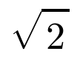
{OPTION 2} 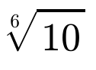
{OPTION 3} 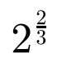
{OPTION 4} 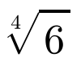
{OPTION 5}
{OPTION 6}
{OPTION 7}
{OPTION 8}
{OPTION 9}
{OPTION 10}
{RIGHT ANSWER} 1
{EXPLANATION} Raise each to the power 12: (∛4)¹² = 4⁴ = 256; (√2)¹² = 2⁶ = 64; (⁴√6)¹² = 6³ = 216; (⁶√10)¹² = 10² = 100. The smallest is 64, so √2 is the smallest.
{CORRECT MARKS} 1
{NEGATIVE MARKS} 0
{DIFFICULTY} Hard
{QUESTION ENDS}

{QUESTION BEGINS}
{QUESTION NUMBER} 39
{SUBJECT} Numerical Ability
{TOPIC} Series
{TAGS} tcs nqt, numerical ability, equation based, hard
{QUESTION TYPE} SINGLECORRECT
{QUESTION TEXT} 
{OPTION 1} 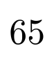
{OPTION 2} 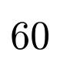
{OPTION 3} 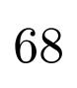
{OPTION 4} 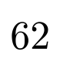
{OPTION 5}
{OPTION 6}
{OPTION 7}
{OPTION 8}
{OPTION 9}
{OPTION 10}
{RIGHT ANSWER} 4
{EXPLANATION} a₁₀ = S₁₀ − S₉ = (300 + 50) − (243 + 45) = 350 − 288 = 62. (In general aₙ = 6n + 2.)
{CORRECT MARKS} 1
{NEGATIVE MARKS} 0
{DIFFICULTY} Hard
{QUESTION ENDS}

{QUESTION BEGINS}
{QUESTION NUMBER} 40
{SUBJECT} Numerical Ability
{TOPIC} Series
{TAGS} tcs nqt, numerical ability, equation based, hard
{QUESTION TYPE} SINGLECORRECT
{QUESTION TEXT} 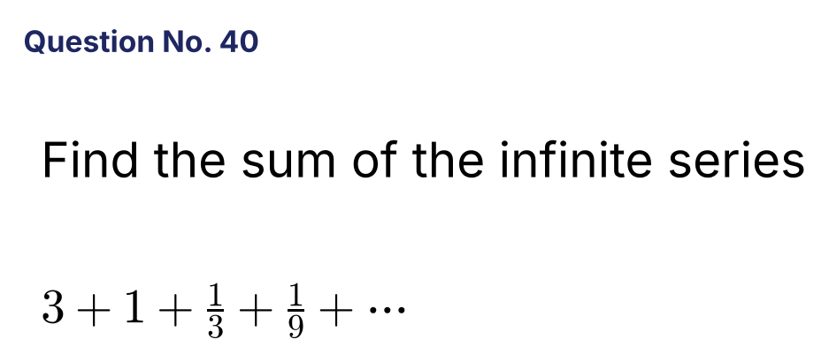
{OPTION 1}
{OPTION 2}
{OPTION 3}
{OPTION 4}
{OPTION 5}
{OPTION 6}
{OPTION 7}
{OPTION 8}
{OPTION 9}
{OPTION 10}
{RIGHT ANSWER} 2
{EXPLANATION} This is a GP with first term 3 and ratio 1/3. Sum to infinity = 3/(1 − 1/3) = 9/2.
{CORRECT MARKS} 1
{NEGATIVE MARKS} 0
{DIFFICULTY} Hard
{QUESTION ENDS}

{QUESTION BEGINS}
{QUESTION NUMBER} 41
{SUBJECT} Numerical Ability
{TOPIC} Logarithms
{TAGS} tcs nqt, numerical ability, equation based, hard
{QUESTION TYPE} SINGLECORRECT
{QUESTION TEXT} 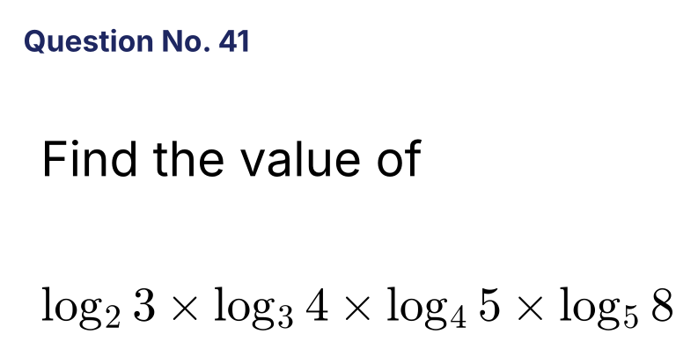
{OPTION 1}
{OPTION 2}
{OPTION 3}
{OPTION 4}
{OPTION 5}
{OPTION 6}
{OPTION 7}
{OPTION 8}
{OPTION 9}
{OPTION 10}
{RIGHT ANSWER} 4
{EXPLANATION} Using the change of base: log₂3 × log₃4 × log₄5 × log₅8 = (ln3/ln2)(ln4/ln3)(ln5/ln4)(ln8/ln5) = ln8/ln2 = log₂8 = 3.
{CORRECT MARKS} 1
{NEGATIVE MARKS} 0
{DIFFICULTY} Hard
{QUESTION ENDS}

{QUESTION BEGINS}
{QUESTION NUMBER} 42
{SUBJECT} Numerical Ability
{TOPIC} Inequalities
{TAGS} tcs nqt, numerical ability, equation based, hard
{QUESTION TYPE} SINGLECORRECT
{QUESTION TEXT} 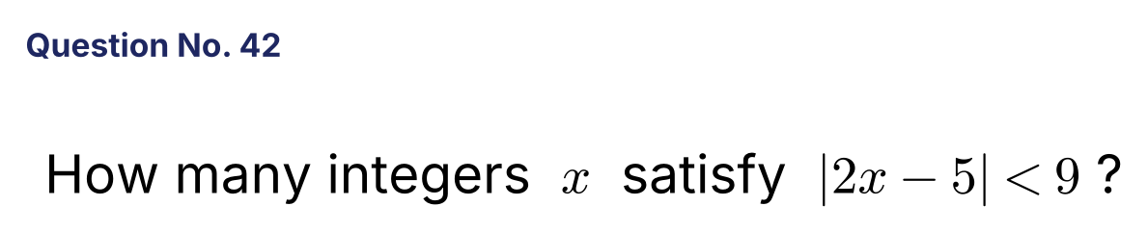
{OPTION 1}
{OPTION 2} 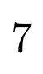
{OPTION 3}
{OPTION 4}
{OPTION 5}
{OPTION 6}
{OPTION 7}
{OPTION 8}
{OPTION 9}
{OPTION 10}
{RIGHT ANSWER} 1
{EXPLANATION} −9 < 2x − 5 < 9 gives −4 < 2x < 14, so −2 < x < 7. The integers are −1, 0, 1, 2, 3, 4, 5, 6, which is 8.
{CORRECT MARKS} 1
{NEGATIVE MARKS} 0
{DIFFICULTY} Hard
{QUESTION ENDS}

{QUESTION BEGINS}
{QUESTION NUMBER} 43
{SUBJECT} Numerical Ability
{TOPIC} Algebra
{TAGS} tcs nqt, numerical ability, equation based, hard
{QUESTION TYPE} SINGLECORRECT
{QUESTION TEXT} 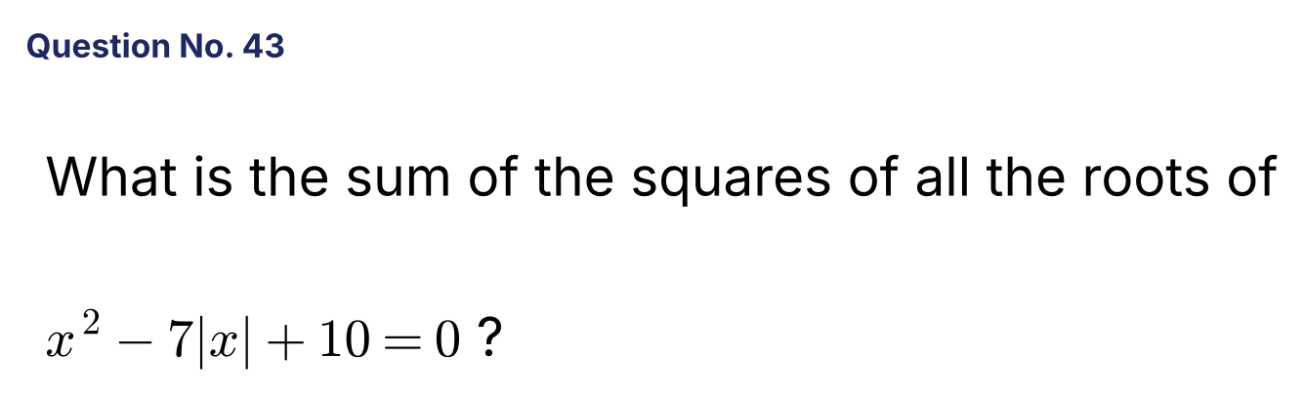
{OPTION 1} 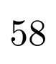
{OPTION 2}
{OPTION 3}
{OPTION 4} 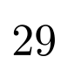
{OPTION 5}
{OPTION 6}
{OPTION 7}
{OPTION 8}
{OPTION 9}
{OPTION 10}
{RIGHT ANSWER} 1
{EXPLANATION} Put |x| = m: m² − 7m + 10 = 0, so m = 2 or 5. The roots are ±2 and ±5. Sum of squares = 4 + 4 + 25 + 25 = 58.
{CORRECT MARKS} 1
{NEGATIVE MARKS} 0
{DIFFICULTY} Hard
{QUESTION ENDS}

{QUESTION BEGINS}
{QUESTION NUMBER} 44
{SUBJECT} Numerical Ability
{TOPIC} Algebra
{TAGS} tcs nqt, numerical ability, equation based, hard
{QUESTION TYPE} SINGLECORRECT
{QUESTION TEXT} 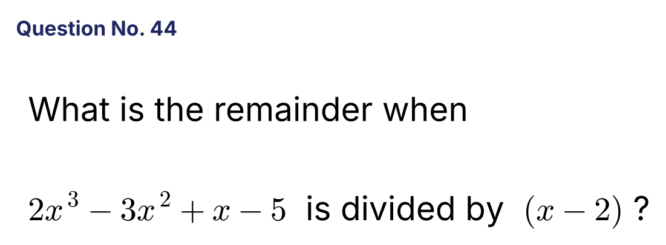
{OPTION 1} 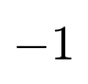
{OPTION 2}
{OPTION 3}
{OPTION 4}
{OPTION 5}
{OPTION 6}
{OPTION 7}
{OPTION 8}
{OPTION 9}
{OPTION 10}
{RIGHT ANSWER} 2
{EXPLANATION} By the remainder theorem, put x = 2: 2(8) − 3(4) + 2 − 5 = 16 − 12 + 2 − 5 = 1.
{CORRECT MARKS} 1
{NEGATIVE MARKS} 0
{DIFFICULTY} Hard
{QUESTION ENDS}

{QUESTION BEGINS}
{QUESTION NUMBER} 45
{SUBJECT} Numerical Ability
{TOPIC} Quadratic Equations
{TAGS} tcs nqt, numerical ability, equation based, hard
{QUESTION TYPE} SINGLECORRECT
{QUESTION TEXT} 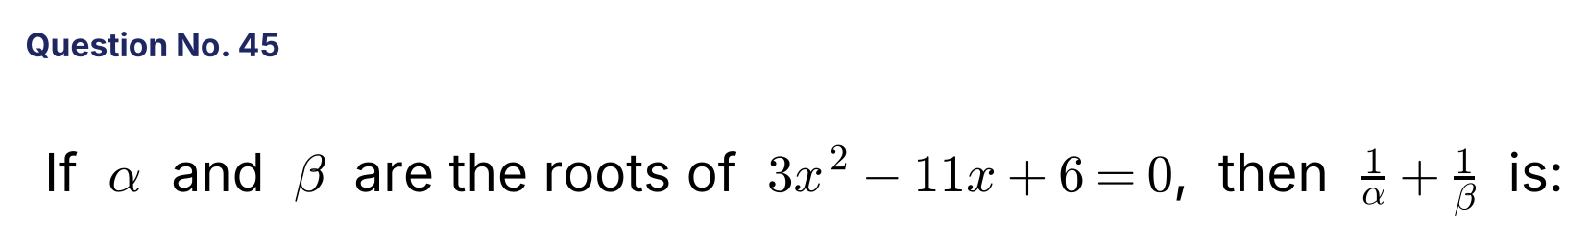
{OPTION 1} 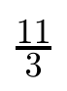
{OPTION 2} 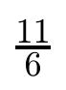
{OPTION 3}
{OPTION 4} 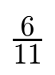
{OPTION 5}
{OPTION 6}
{OPTION 7}
{OPTION 8}
{OPTION 9}
{OPTION 10}
{RIGHT ANSWER} 2
{EXPLANATION} α + β = 11/3 and αβ = 2. 1/α + 1/β = (α + β)/αβ = (11/3)/2 = 11/6.
{CORRECT MARKS} 1
{NEGATIVE MARKS} 0
{DIFFICULTY} Hard
{QUESTION ENDS}

{QUESTION BEGINS}
{QUESTION NUMBER} 46
{SUBJECT} Numerical Ability
{TOPIC} Percentages
{TAGS} tcs nqt, numerical ability, equation based, hard
{QUESTION TYPE} SINGLECORRECT
{QUESTION TEXT} 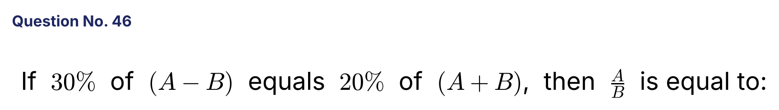
{OPTION 1}
{OPTION 2}
{OPTION 3}
{OPTION 4}
{OPTION 5}
{OPTION 6}
{OPTION 7}
{OPTION 8}
{OPTION 9}
{OPTION 10}
{RIGHT ANSWER} 2
{EXPLANATION} 0.3A − 0.3B = 0.2A + 0.2B, so 0.1A = 0.5B and A/B = 5.
{CORRECT MARKS} 1
{NEGATIVE MARKS} 0
{DIFFICULTY} Hard
{QUESTION ENDS}

{QUESTION BEGINS}
{QUESTION NUMBER} 47
{SUBJECT} Numerical Ability
{TOPIC} Ratio and Proportion
{TAGS} tcs nqt, numerical ability, equation based, hard
{QUESTION TYPE} SINGLECORRECT
{QUESTION TEXT} 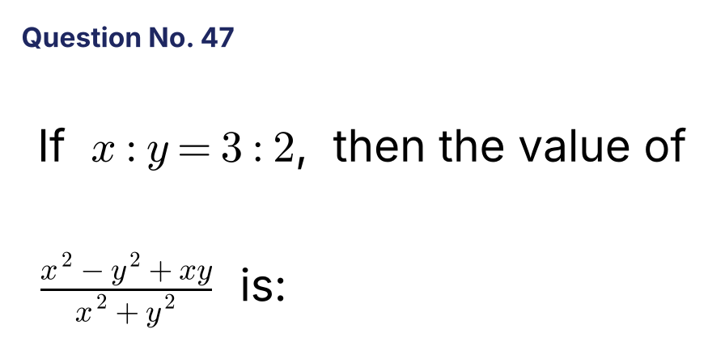
{OPTION 1} 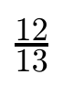
{OPTION 2} 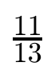
{OPTION 3} 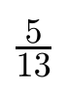
{OPTION 4} 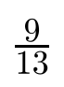
{OPTION 5}
{OPTION 6}
{OPTION 7}
{OPTION 8}
{OPTION 9}
{OPTION 10}
{RIGHT ANSWER} 2
{EXPLANATION} Let x = 3k and y = 2k. Numerator = 9k² − 4k² + 6k² = 11k². Denominator = 9k² + 4k² = 13k². The ratio = 11/13.
{CORRECT MARKS} 1
{NEGATIVE MARKS} 0
{DIFFICULTY} Hard
{QUESTION ENDS}

{QUESTION BEGINS}
{QUESTION NUMBER} 48
{SUBJECT} Numerical Ability
{TOPIC} Number System
{TAGS} tcs nqt, numerical ability, equation based, hard
{QUESTION TYPE} SINGLECORRECT
{QUESTION TEXT} 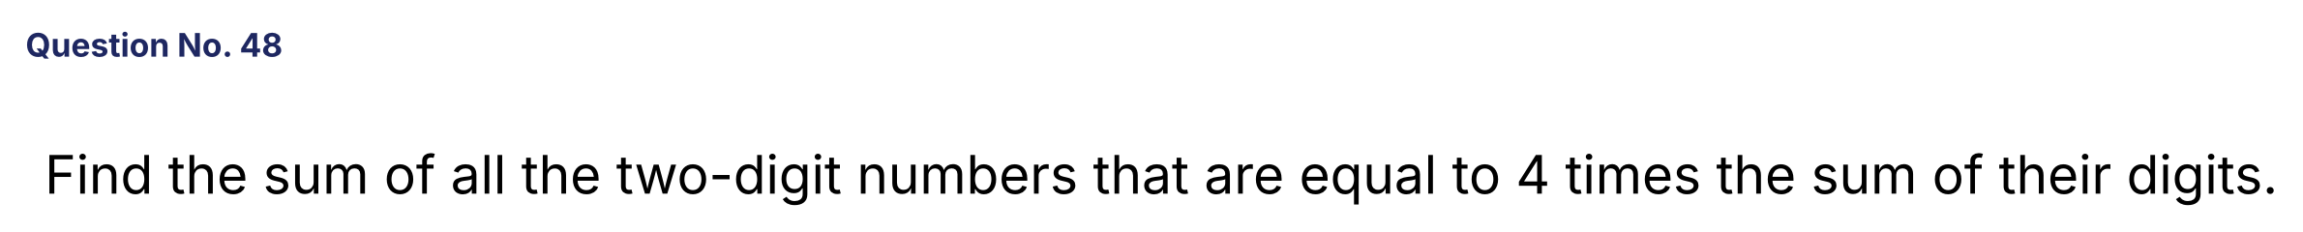
{OPTION 1} 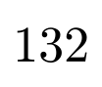
{OPTION 2} 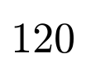
{OPTION 3} 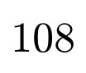
{OPTION 4} 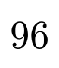
{OPTION 5}
{OPTION 6}
{OPTION 7}
{OPTION 8}
{OPTION 9}
{OPTION 10}
{RIGHT ANSWER} 2
{EXPLANATION} 10a + b = 4(a + b) gives 6a = 3b, so b = 2a. The numbers are 12, 24, 36 and 48. Sum = 12 + 24 + 36 + 48 = 120.
{CORRECT MARKS} 1
{NEGATIVE MARKS} 0
{DIFFICULTY} Hard
{QUESTION ENDS}

{QUESTION BEGINS}
{QUESTION NUMBER} 49
{SUBJECT} Numerical Ability
{TOPIC} Surds
{TAGS} tcs nqt, numerical ability, equation based, hard
{QUESTION TYPE} SINGLECORRECT
{QUESTION TEXT} 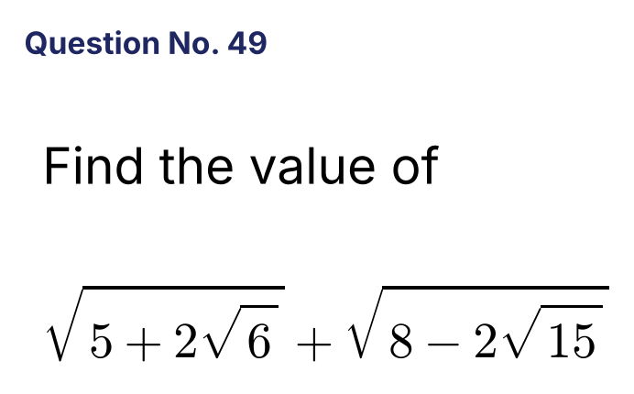
{OPTION 1} 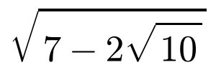
{OPTION 2} 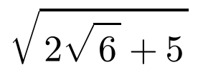
{OPTION 3} 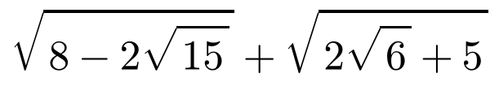
{OPTION 4} 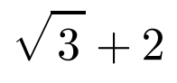
{OPTION 5}
{OPTION 6}
{OPTION 7}
{OPTION 8}
{OPTION 9}
{OPTION 10}
{RIGHT ANSWER} 3
{EXPLANATION} 5 + 2√6 = (√3 + √2)² and 8 − 2√15 = (√5 − √3)². So the sum = (√3 + √2) + (√5 − √3) = √5 + √2.
{CORRECT MARKS} 1
{NEGATIVE MARKS} 0
{DIFFICULTY} Hard
{QUESTION ENDS}

{QUESTION BEGINS}
{QUESTION NUMBER} 50
{SUBJECT} Numerical Ability
{TOPIC} Algebra
{TAGS} tcs nqt, numerical ability, equation based, hard
{QUESTION TYPE} SINGLECORRECT
{QUESTION TEXT} 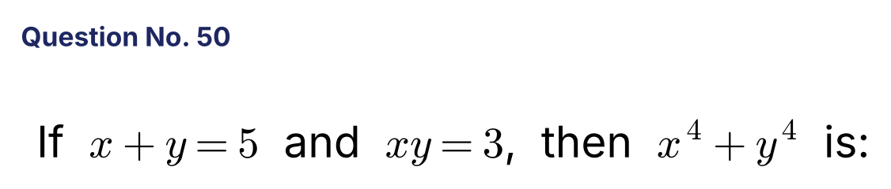
{OPTION 1} 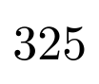
{OPTION 2} 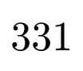
{OPTION 3} 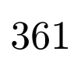
{OPTION 4} 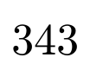
{OPTION 5}
{OPTION 6}
{OPTION 7}
{OPTION 8}
{OPTION 9}
{OPTION 10}
{RIGHT ANSWER} 4
{EXPLANATION} x² + y² = 25 − 6 = 19. x⁴ + y⁴ = 19² − 2(xy)² = 361 − 18 = 343.
{CORRECT MARKS} 1
{NEGATIVE MARKS} 0
{DIFFICULTY} Hard
{QUESTION ENDS}

