{QUESTION BEGINS}
{QUESTION NUMBER} 1
{SUBJECT} Advanced Quantitative Ability
{TOPIC} Data Interpretation
{TAGS} tcs nqt, advanced quantitative, MCQ, hard
{QUESTION TYPE} SINGLECORRECT
{QUESTION TEXT} 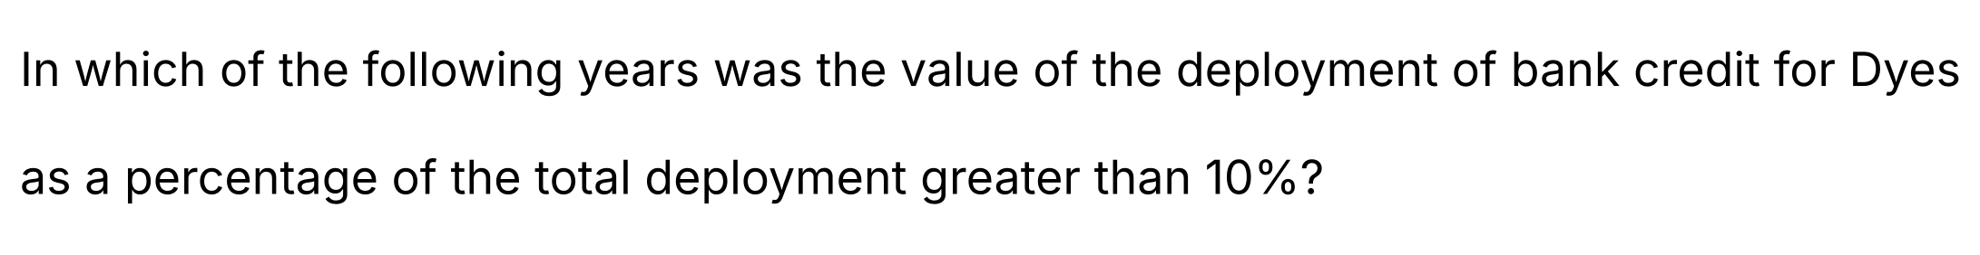
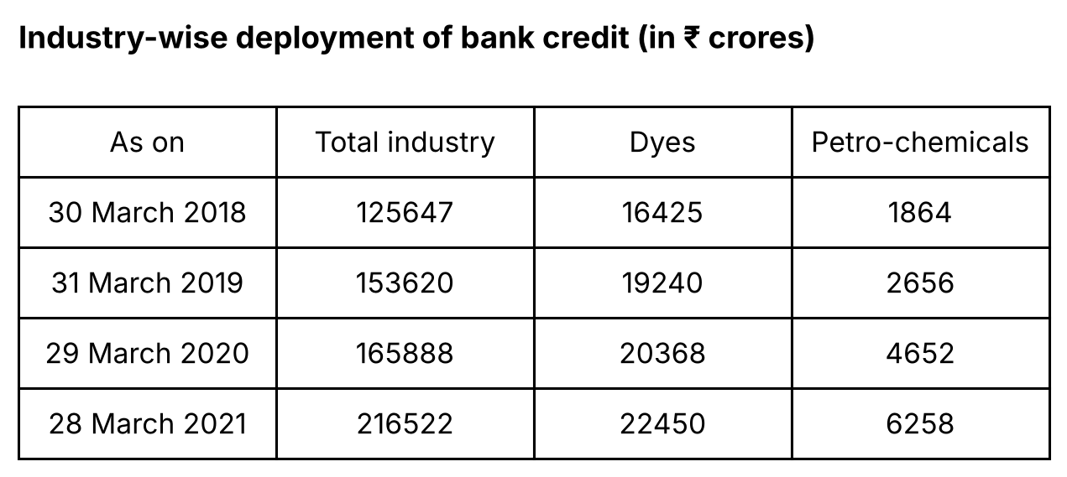
{OPTION 1} Only 2020, 2021
{OPTION 2} Only 2019, 2020
{OPTION 3} Only 2018, 2019
{OPTION 4} 2018, 2019, 2020, 2021
{OPTION 5}
{OPTION 6}
{OPTION 7}
{OPTION 8}
{OPTION 9}
{OPTION 10}
{RIGHT ANSWER} 4
{EXPLANATION} Dyes as a percentage of the total deployment: 2018: 16425/125647 = 13.07%; 2019: 19240/153620 = 12.52%; 2020: 20368/165888 = 12.28%; 2021: 22450/216522 = 10.37%. All four values are greater than 10%, so the answer is 2018, 2019, 2020 and 2021.
{CORRECT MARKS} 1
{NEGATIVE MARKS} 0
{DIFFICULTY} Hard
{QUESTION ENDS}

{QUESTION BEGINS}
{QUESTION NUMBER} 2
{SUBJECT} Advanced Quantitative Ability
{TOPIC} Probability
{TAGS} tcs nqt, advanced quantitative, MCQ, hard
{QUESTION TYPE} SINGLECORRECT
{QUESTION TEXT} 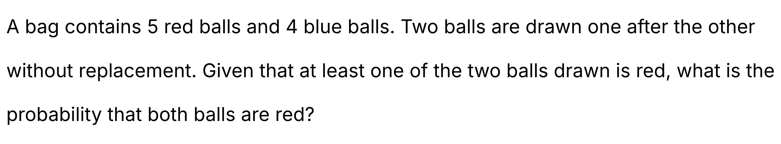
{OPTION 1} 5/6
{OPTION 2} 1/2
{OPTION 3} 2/3
{OPTION 4} 1/3
{OPTION 5}
{OPTION 6}
{OPTION 7}
{OPTION 8}
{OPTION 9}
{OPTION 10}
{RIGHT ANSWER} 4
{EXPLANATION} Total ways to draw 2 balls = C(9,2) = 36. Ways with no red ball = C(4,2) = 6, so at least one red = 36 − 6 = 30. Both red = C(5,2) = 10. By conditional probability, required probability = 10/30 = 1/3.
{CORRECT MARKS} 1
{NEGATIVE MARKS} 0
{DIFFICULTY} Hard
{QUESTION ENDS}

{QUESTION BEGINS}
{QUESTION NUMBER} 3
{SUBJECT} Advanced Quantitative Ability
{TOPIC} Coordinate Geometry
{TAGS} tcs nqt, advanced quantitative, MCQ, hard
{QUESTION TYPE} SINGLECORRECT
{QUESTION TEXT} 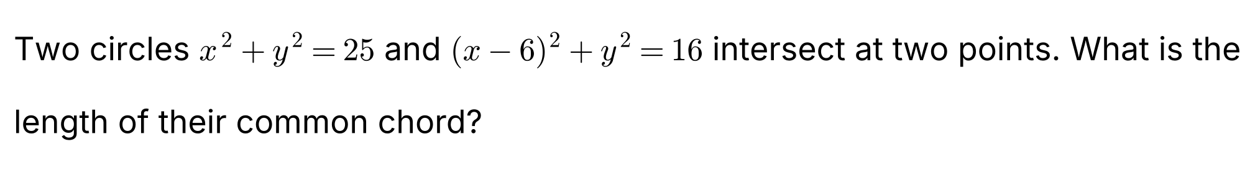
{OPTION 1} 5√7/4
{OPTION 2} 5√7/2
{OPTION 3} 3√7
{OPTION 4} 15/4
{OPTION 5}
{OPTION 6}
{OPTION 7}
{OPTION 8}
{OPTION 9}
{OPTION 10}
{RIGHT ANSWER} 2
{EXPLANATION} Subtracting the two circle equations gives the radical axis (common chord): x² + y² − 25 − [(x − 6)² + y² − 16] = 0, i.e. 12x − 45 = 0, so x = 15/4. Then y² = 25 − (15/4)² = 25 − 225/16 = 175/16, so y = ±5√7/4. The chord length = 2 × 5√7/4 = 5√7/2.
{CORRECT MARKS} 1
{NEGATIVE MARKS} 0
{DIFFICULTY} Hard
{QUESTION ENDS}

{QUESTION BEGINS}
{QUESTION NUMBER} 4
{SUBJECT} Advanced Quantitative Ability
{TOPIC} Complex Numbers
{TAGS} tcs nqt, advanced quantitative, MCQ, hard
{QUESTION TYPE} SINGLECORRECT
{QUESTION TEXT} 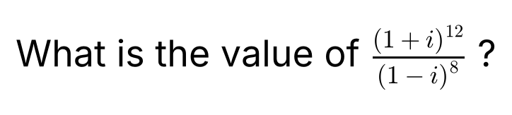
{OPTION 1} −16
{OPTION 2} 4
{OPTION 3} −4
{OPTION 4} 16
{OPTION 5}
{OPTION 6}
{OPTION 7}
{OPTION 8}
{OPTION 9}
{OPTION 10}
{RIGHT ANSWER} 3
{EXPLANATION} (1 + i)² = 2i, so (1 + i)¹² = (2i)⁶ = 64 × i⁶ = 64 × (−1) = −64. (1 − i)² = −2i, so (1 − i)⁸ = (−2i)⁴ = 16 × i⁴ = 16. The value = −64/16 = −4.
{CORRECT MARKS} 1
{NEGATIVE MARKS} 0
{DIFFICULTY} Hard
{QUESTION ENDS}

{QUESTION BEGINS}
{QUESTION NUMBER} 5
{SUBJECT} Advanced Quantitative Ability
{TOPIC} Triangles
{TAGS} tcs nqt, advanced quantitative, MCQ, hard
{QUESTION TYPE} SINGLECORRECT
{QUESTION TEXT} 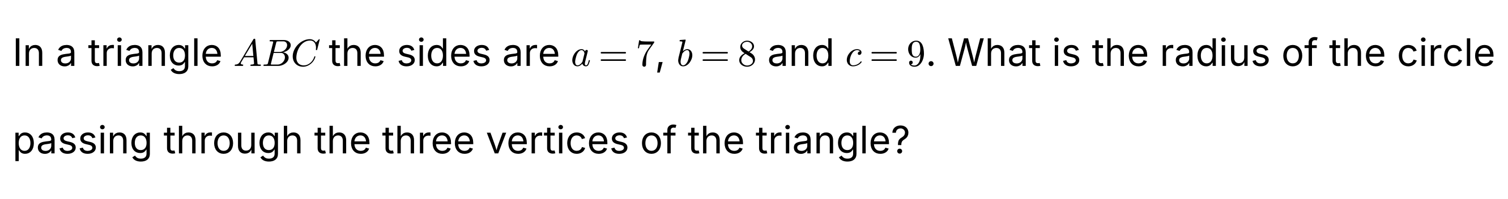
{OPTION 1} 21√5/10
{OPTION 2} 7√5/2
{OPTION 3} 9√5/4
{OPTION 4} 21/10
{OPTION 5}
{OPTION 6}
{OPTION 7}
{OPTION 8}
{OPTION 9}
{OPTION 10}
{RIGHT ANSWER} 1
{EXPLANATION} Semi-perimeter s = 12. By Heron's formula the area = √(12 × 5 × 4 × 3) = √720 = 12√5. Circumradius R = abc/(4 × area) = (7 × 8 × 9)/(4 × 12√5) = 504/(48√5) = 21/(2√5) = 21√5/10.
{CORRECT MARKS} 1
{NEGATIVE MARKS} 0
{DIFFICULTY} Hard
{QUESTION ENDS}

{QUESTION BEGINS}
{QUESTION NUMBER} 6
{SUBJECT} Advanced Quantitative Ability
{TOPIC} Quadratic Equations
{TAGS} tcs nqt, advanced quantitative, MCQ, hard
{QUESTION TYPE} SINGLECORRECT
{QUESTION TEXT} 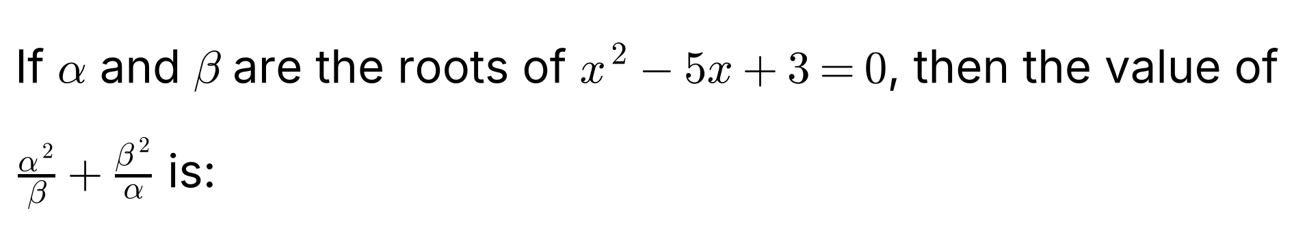
{OPTION 1} 15
{OPTION 2} 40/3
{OPTION 3} 25/3
{OPTION 4} 80/3
{OPTION 5}
{OPTION 6}
{OPTION 7}
{OPTION 8}
{OPTION 9}
{OPTION 10}
{RIGHT ANSWER} 4
{EXPLANATION} α + β = 5 and αβ = 3. α²/β + β²/α = (α³ + β³)/(αβ). α³ + β³ = (α + β)³ − 3αβ(α + β) = 125 − 45 = 80. So the value = 80/3.
{CORRECT MARKS} 1
{NEGATIVE MARKS} 0
{DIFFICULTY} Hard
{QUESTION ENDS}

{QUESTION BEGINS}
{QUESTION NUMBER} 7
{SUBJECT} Advanced Quantitative Ability
{TOPIC} Coordinate Geometry
{TAGS} tcs nqt, advanced quantitative, MCQ, hard
{QUESTION TYPE} SINGLECORRECT
{QUESTION TEXT}
{OPTION 1} 1/2
{OPTION 2} 3
{OPTION 3} 5/2
{OPTION 4} 3/2
{OPTION 5}
{OPTION 6}
{OPTION 7}
{OPTION 8}
{OPTION 9}
{OPTION 10}
{RIGHT ANSWER} 3
{EXPLANATION} Write the second line with the same coefficients: 6x + 8y = −5 becomes 3x + 4y = −5/2. For parallel lines ax + by = c₁ and ax + by = c₂ the distance = |c₁ − c₂|/√(a² + b²) = |10 + 5/2|/5 = (25/2)/5 = 5/2.
{CORRECT MARKS} 1
{NEGATIVE MARKS} 0
{DIFFICULTY} Hard
{QUESTION ENDS}

{QUESTION BEGINS}
{QUESTION NUMBER} 8
{SUBJECT} Advanced Quantitative Ability
{TOPIC} Logarithms
{TAGS} tcs nqt, advanced quantitative, MCQ, hard
{QUESTION TYPE} SINGLECORRECT
{QUESTION TEXT} 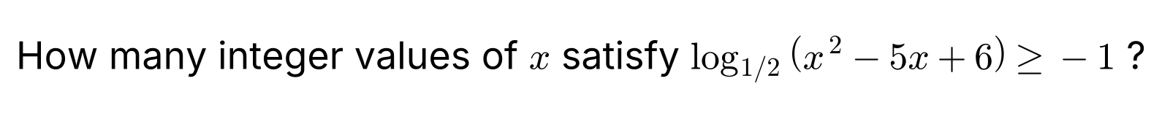
{OPTION 1} 1
{OPTION 2} 2
{OPTION 3} 3
{OPTION 4} 4
{OPTION 5}
{OPTION 6}
{OPTION 7}
{OPTION 8}
{OPTION 9}
{OPTION 10}
{RIGHT ANSWER} 2
{EXPLANATION} Since the base 1/2 is less than 1, log_{1/2}(t) ≥ −1 means 0 < t ≤ 2 (the inequality reverses). So 0 < x² − 5x + 6 ≤ 2. The first part gives x < 2 or x > 3. The second gives x² − 5x + 4 ≤ 0, i.e. 1 ≤ x ≤ 4. Together: 1 ≤ x < 2 or 3 < x ≤ 4. The integers are x = 1 and x = 4, so there are 2 values.
{CORRECT MARKS} 1
{NEGATIVE MARKS} 0
{DIFFICULTY} Hard
{QUESTION ENDS}

{QUESTION BEGINS}
{QUESTION NUMBER} 9
{SUBJECT} Advanced Quantitative Ability
{TOPIC} Permutations
{TAGS} tcs nqt, advanced quantitative, MCQ, hard
{QUESTION TYPE} SINGLECORRECT
{QUESTION TEXT} 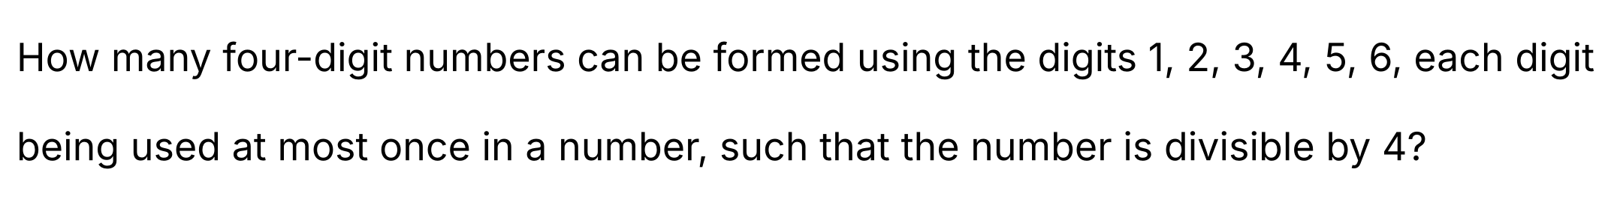
{OPTION 1} 96
{OPTION 2} 84
{OPTION 3} 120
{OPTION 4} 72
{OPTION 5}
{OPTION 6}
{OPTION 7}
{OPTION 8}
{OPTION 9}
{OPTION 10}
{RIGHT ANSWER} 1
{EXPLANATION} A number is divisible by 4 when its last two digits form a multiple of 4. With distinct digits from 1 to 6 the possible endings are 12, 16, 24, 32, 36, 52, 56 and 64 (8 endings). For each ending the first two places can be filled from the remaining 4 digits in 4 × 3 = 12 ways. Total = 8 × 12 = 96.
{CORRECT MARKS} 1
{NEGATIVE MARKS} 0
{DIFFICULTY} Hard
{QUESTION ENDS}

{QUESTION BEGINS}
{QUESTION NUMBER} 10
{SUBJECT} Advanced Quantitative Ability
{TOPIC} Series
{TAGS} tcs nqt, advanced quantitative, MCQ, hard
{QUESTION TYPE} SINGLECORRECT
{QUESTION TEXT} 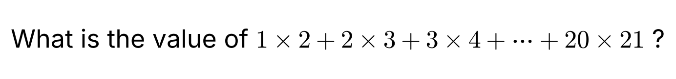
{OPTION 1} 2940
{OPTION 2} 2870
{OPTION 3} 3080
{OPTION 4} 3360
{OPTION 5}
{OPTION 6}
{OPTION 7}
{OPTION 8}
{OPTION 9}
{OPTION 10}
{RIGHT ANSWER} 3
{EXPLANATION} Σk(k + 1) = Σk² + Σk. For n = 20: Σk² = 20 × 21 × 41/6 = 2870 and Σk = 210. The sum = 2870 + 210 = 3080. (Also n(n + 1)(n + 2)/3 = 20 × 21 × 22/3 = 3080.)
{CORRECT MARKS} 1
{NEGATIVE MARKS} 0
{DIFFICULTY} Hard
{QUESTION ENDS}

{QUESTION BEGINS}
{QUESTION NUMBER} 11
{SUBJECT} Advanced Quantitative Ability
{TOPIC} Number Theory
{TAGS} tcs nqt, advanced quantitative, TITA, hard
{QUESTION TYPE} NUMERICAL
{QUESTION TEXT}
{OPTION 1}
{OPTION 2}
{OPTION 3}
{OPTION 4}
{OPTION 5}
{OPTION 6}
{OPTION 7}
{OPTION 8}
{OPTION 9}
{OPTION 10}
{RIGHT ANSWER} 3
{EXPLANATION} a² − b² = (a − b)(a + b) = 2023 = 7 × 17². The factor pairs of 2023 with a − b < a + b are (1, 2023), (7, 289) and (17, 119). Both factors are odd in every pair, so a = (sum)/2 and b = (difference)/2 are integers, giving (1012, 1011), (148, 141) and (68, 51). So there are 3 pairs.
{CORRECT MARKS} 1
{NEGATIVE MARKS} 0
{DIFFICULTY} Hard
{QUESTION ENDS}

{QUESTION BEGINS}
{QUESTION NUMBER} 12
{SUBJECT} Advanced Quantitative Ability
{TOPIC} Binomial Theorem
{TAGS} tcs nqt, advanced quantitative, TITA, hard
{QUESTION TYPE} NUMERICAL
{QUESTION TEXT} 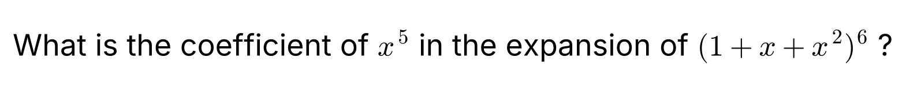
{OPTION 1}
{OPTION 2}
{OPTION 3}
{OPTION 4}
{OPTION 5}
{OPTION 6}
{OPTION 7}
{OPTION 8}
{OPTION 9}
{OPTION 10}
{RIGHT ANSWER} 126
{EXPLANATION} The coefficient of x⁵ equals the number of ways of choosing exponents e₁, …, e₆ ∈ {0, 1, 2} that add up to 5. Using (1 + x + x²)⁶ = ((1 − x³)/(1 − x))⁶, the coefficient of x⁵ = 126 after applying inclusion–exclusion, which agrees with the direct expansion.
{CORRECT MARKS} 1
{NEGATIVE MARKS} 0
{DIFFICULTY} Hard
{QUESTION ENDS}

{QUESTION BEGINS}
{QUESTION NUMBER} 13
{SUBJECT} Advanced Quantitative Ability
{TOPIC} Number Theory
{TAGS} tcs nqt, advanced quantitative, TITA, hard
{QUESTION TYPE} NUMERICAL
{QUESTION TEXT}
{OPTION 1}
{OPTION 2}
{OPTION 3}
{OPTION 4}
{OPTION 5}
{OPTION 6}
{OPTION 7}
{OPTION 8}
{OPTION 9}
{OPTION 10}
{RIGHT ANSWER} 43
{EXPLANATION} 7² = 49 and 7⁴ = 2401, which ends in 01. So 7⁴ ≡ 1 (mod 100). 2023 = 4 × 505 + 3, so 7²⁰²³ ≡ 7³ = 343 ≡ 43 (mod 100). The last two digits are 43.
{CORRECT MARKS} 1
{NEGATIVE MARKS} 0
{DIFFICULTY} Hard
{QUESTION ENDS}

{QUESTION BEGINS}
{QUESTION NUMBER} 14
{SUBJECT} Advanced Quantitative Ability
{TOPIC} Counting
{TAGS} tcs nqt, advanced quantitative, TITA, hard
{QUESTION TYPE} NUMERICAL
{QUESTION TEXT}
{OPTION 1}
{OPTION 2}
{OPTION 3}
{OPTION 4}
{OPTION 5}
{OPTION 6}
{OPTION 7}
{OPTION 8}
{OPTION 9}
{OPTION 10}
{RIGHT ANSWER} 46
{EXPLANATION} Without the upper limit, the number of solutions with x, y, z ≥ 1 is C(14, 2) = 91. A solution breaks the limit if some variable is at least 9: for x ≥ 9 write x = 8 + x′ with x′ ≥ 1, so x′ + y + z = 7 with all three ≥ 1, which has C(6, 2) = 15 solutions. The same holds for y and z, and two variables cannot both be ≥ 9 (their sum would exceed 15 − 1). So the count = 91 − 3 × 15 = 46.
{CORRECT MARKS} 1
{NEGATIVE MARKS} 0
{DIFFICULTY} Hard
{QUESTION ENDS}

