{QUESTION BEGINS}
{QUESTION NUMBER} 1
{SUBJECT} Reasoning Ability
{TOPIC} Alphabet Test
{TAGS} tcs nqt, reasoning ability, hard
{QUESTION TYPE} SINGLECORRECT
{QUESTION TEXT} If the English alphabet is written in the reverse order (Z, Y, X, … , B, A), which letter is the 7th to the right of the 12th letter from the left end?
{OPTION 1} I
{OPTION 2} G
{OPTION 3} H
{OPTION 4} J
{OPTION 5}
{OPTION 6}
{OPTION 7}
{OPTION 8}
{OPTION 9}
{OPTION 10}
{RIGHT ANSWER} 3
{EXPLANATION} In the reversed alphabet the 12th letter from the left is O (Z, Y, X, W, V, U, T, S, R, Q, P, O). The 7th letter to its right is the 19th letter from the left: N, M, L, K, J, I, H → H.
{CORRECT MARKS} 1
{NEGATIVE MARKS} 0
{DIFFICULTY} Hard
{QUESTION ENDS}

{QUESTION BEGINS}
{QUESTION NUMBER} 2
{SUBJECT} Reasoning Ability
{TOPIC} Set Reasoning
{TAGS} tcs nqt, reasoning ability, hard
{QUESTION TYPE} SINGLECORRECT
{QUESTION TEXT} In a survey of 220 people, 120 read The Times, 90 read The Hindu and 70 read The Express. 40 read both the Times and the Hindu, 30 read both the Hindu and the Express, 25 read both the Times and the Express, and 15 read all three newspapers. How many people read exactly two of the three newspapers?
{OPTION 1} 65
{OPTION 2} 35
{OPTION 3} 50
{OPTION 4} 95
{OPTION 5}
{OPTION 6}
{OPTION 7}
{OPTION 8}
{OPTION 9}
{OPTION 10}
{RIGHT ANSWER} 3
{EXPLANATION} Exactly two = (sum of the pairwise overlaps) − 3 × (all three) = (40 + 30 + 25) − 3 × 15 = 95 − 45 = 50. (Check: people reading at least one = 120 + 90 + 70 − 95 + 15 = 200, so 20 read none.)
{CORRECT MARKS} 1
{NEGATIVE MARKS} 0
{DIFFICULTY} Hard
{QUESTION ENDS}

{QUESTION BEGINS}
{QUESTION NUMBER} 3
{SUBJECT} Reasoning Ability
{TOPIC} Arrangements
{TAGS} tcs nqt, reasoning ability, hard
{QUESTION TYPE} SINGLECORRECT
{QUESTION TEXT} In how many ways can five friends A, B, C, D and E stand in a line so that A and B are NOT standing next to each other?
{OPTION 1} 48
{OPTION 2} 60
{OPTION 3} 72
{OPTION 4} 96
{OPTION 5}
{OPTION 6}
{OPTION 7}
{OPTION 8}
{OPTION 9}
{OPTION 10}
{RIGHT ANSWER} 3
{EXPLANATION} Total arrangements = 5! = 120. Arrangements in which A and B stand together: treat AB as one block: 4! × 2 = 48. So the required number = 120 − 48 = 72.
{CORRECT MARKS} 1
{NEGATIVE MARKS} 0
{DIFFICULTY} Hard
{QUESTION ENDS}

{QUESTION BEGINS}
{QUESTION NUMBER} 4
{SUBJECT} Reasoning Ability
{TOPIC} Venn Diagram
{TAGS} tcs nqt, reasoning ability, figure based, hard
{QUESTION TYPE} SINGLECORRECT
{QUESTION TEXT} In a survey of 800 people, 60% drink tea, 45% drink coffee and 25% drink both, as shown in the Venn diagram. How many people drink exactly one of the two beverages?
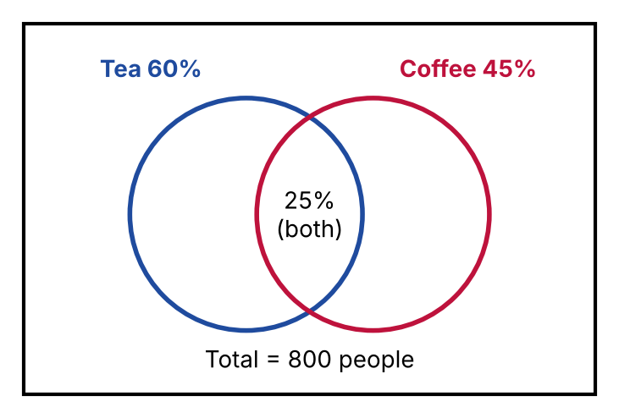
{OPTION 1} 440
{OPTION 2} 480
{OPTION 3} 360
{OPTION 4} 520
{OPTION 5}
{OPTION 6}
{OPTION 7}
{OPTION 8}
{OPTION 9}
{OPTION 10}
{RIGHT ANSWER} 1
{EXPLANATION} Only tea = 60% − 25% = 35%; only coffee = 45% − 25% = 20%. Exactly one beverage = 35% + 20% = 55% of 800 = 440. (Check: both = 200, so tea or coffee = 640 people and neither = 160.)
{CORRECT MARKS} 1
{NEGATIVE MARKS} 0
{DIFFICULTY} Hard
{QUESTION ENDS}

{QUESTION BEGINS}
{QUESTION NUMBER} 5
{SUBJECT} Reasoning Ability
{TOPIC} Clock
{TAGS} tcs nqt, reasoning ability, hard
{QUESTION TYPE} SINGLECORRECT
{QUESTION TEXT} How many times do the hour hand and the minute hand of a clock coincide (lie exactly on top of each other) in a full day of 24 hours, counting the 12:00 at the start of the day but not the 12:00 at the end?
{OPTION 1} 21
{OPTION 2} 23
{OPTION 3} 22
{OPTION 4} 24
{OPTION 5}
{OPTION 6}
{OPTION 7}
{OPTION 8}
{OPTION 9}
{OPTION 10}
{RIGHT ANSWER} 3
{EXPLANATION} In 12 hours the hands coincide 11 times (every 12/11 hours: 12:00, 1:05 5/11, …). In 24 hours they coincide 22 times, counting 12:00 at the start of the day once and not counting the next midnight.
{CORRECT MARKS} 1
{NEGATIVE MARKS} 0
{DIFFICULTY} Hard
{QUESTION ENDS}

{QUESTION BEGINS}
{QUESTION NUMBER} 6
{SUBJECT} Reasoning Ability
{TOPIC} Clock
{TAGS} tcs nqt, reasoning ability, figure based, hard
{QUESTION TYPE} SINGLECORRECT
{QUESTION TEXT} The two clocks show the starting and the finishing time of a journey (the journey lasted less than 12 hours). If the vehicle covered 215 km in this time, what was its average speed?
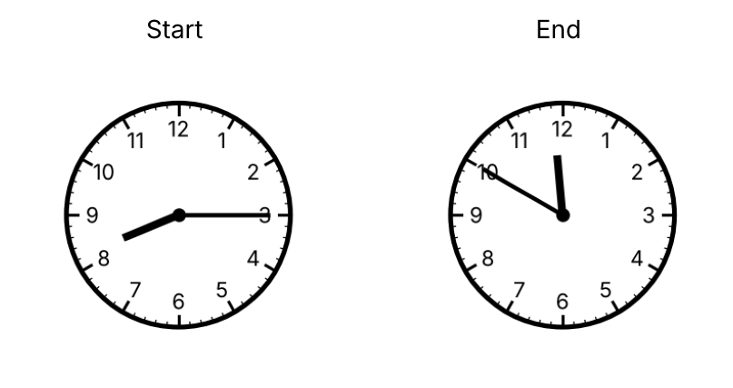
{OPTION 1} 64.5 km/h
{OPTION 2} 58 km/h
{OPTION 3} 62 km/h
{OPTION 4} 60 km/h
{OPTION 5}
{OPTION 6}
{OPTION 7}
{OPTION 8}
{OPTION 9}
{OPTION 10}
{RIGHT ANSWER} 4
{EXPLANATION} The first clock shows 8:15 and the second shows 11:50, so the time taken = 3 h 35 min = 215 minutes. Speed = 215 km ÷ (215/60 h) = 60 km/h.
{CORRECT MARKS} 1
{NEGATIVE MARKS} 0
{DIFFICULTY} Hard
{QUESTION ENDS}

{QUESTION BEGINS}
{QUESTION NUMBER} 7
{SUBJECT} Reasoning Ability
{TOPIC} Classification
{TAGS} tcs nqt, reasoning ability, hard
{QUESTION TYPE} SINGLECORRECT
{QUESTION TEXT} Four of the following five number groups follow the same rule. Which group does NOT belong?
{OPTION 1} 3 – 4 – 7
{OPTION 2} 7 – 5 – 13
{OPTION 3} 5 – 8 – 13
{OPTION 4} 6 – 9 – 15
{OPTION 5}
{OPTION 6}
{OPTION 7}
{OPTION 8}
{OPTION 9}
{OPTION 10}
{RIGHT ANSWER} 2
{EXPLANATION} In 3 – 4 – 7, 5 – 8 – 13 and 6 – 9 – 15 the third number is the sum of the first two. In 7 – 5 – 13, 7 + 5 = 12, not 13.
{CORRECT MARKS} 1
{NEGATIVE MARKS} 0
{DIFFICULTY} Hard
{QUESTION ENDS}

{QUESTION BEGINS}
{QUESTION NUMBER} 8
{SUBJECT} Reasoning Ability
{TOPIC} Counting Figures
{TAGS} tcs nqt, reasoning ability, figure based, hard
{QUESTION TYPE} SINGLECORRECT
{QUESTION TEXT} Nine dots are arranged in a 3 × 3 square grid as shown. How many different triangles can be formed by joining any three of the dots (the three dots must not lie on one straight line)?
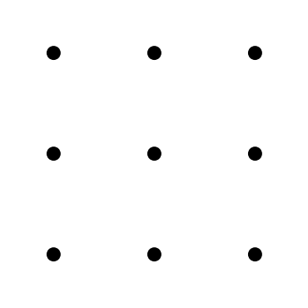
{OPTION 1} 84
{OPTION 2} 68
{OPTION 3} 72
{OPTION 4} 76
{OPTION 5}
{OPTION 6}
{OPTION 7}
{OPTION 8}
{OPTION 9}
{OPTION 10}
{RIGHT ANSWER} 4
{EXPLANATION} Three dots can be chosen in C(9, 3) = 84 ways. The three dots lie on one line in 8 cases (3 rows, 3 columns and 2 diagonals). So the number of triangles = 84 − 8 = 76.
{CORRECT MARKS} 1
{NEGATIVE MARKS} 0
{DIFFICULTY} Hard
{QUESTION ENDS}

{QUESTION BEGINS}
{QUESTION NUMBER} 9
{SUBJECT} Reasoning Ability
{TOPIC} Figure Series
{TAGS} tcs nqt, reasoning ability, figure based, hard
{QUESTION TYPE} SINGLECORRECT
{QUESTION TEXT} The shaded sector moves round the circle and its shade alternates. Select the figure that replaces the question mark (?).
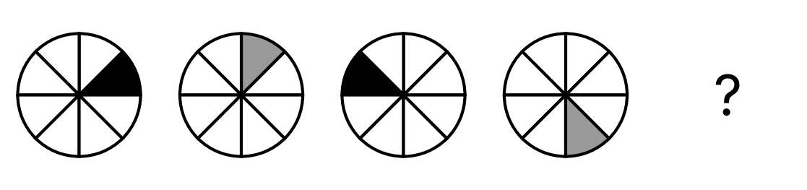
{OPTION 1} 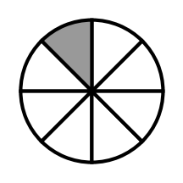
{OPTION 2} 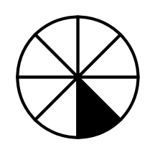
{OPTION 3} 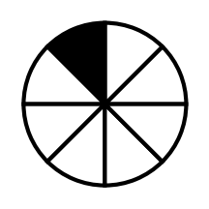
{OPTION 4} 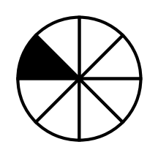
{OPTION 5}
{OPTION 6}
{OPTION 7}
{OPTION 8}
{OPTION 9}
{OPTION 10}
{RIGHT ANSWER} 3
{EXPLANATION} The shaded sector moves 1, 2, 3 and then 4 places anticlockwise at each step (positions 0, 1, 3, 6, then 6 + 4 = 10, which is position 2 of the 8 sectors), and the shade alternates black, grey, black, grey, so the next shade is black.
{CORRECT MARKS} 1
{NEGATIVE MARKS} 0
{DIFFICULTY} Hard
{QUESTION ENDS}

{QUESTION BEGINS}
{QUESTION NUMBER} 10
{SUBJECT} Reasoning Ability
{TOPIC} Logical Deduction
{TAGS} tcs nqt, reasoning ability, hard
{QUESTION TYPE} SINGLECORRECT
{QUESTION TEXT} Statements: If a person is a member of the club, then the person has a membership card. Ravi does not have a membership card.
Which of the following conclusions is definitely true?
{OPTION 1} Ravi is a member of the club
{OPTION 2} Ravi may or may not be a member of the club
{OPTION 3} Ravi is not a member of the club
{OPTION 4} Some people without cards are members
{OPTION 5}
{OPTION 6}
{OPTION 7}
{OPTION 8}
{OPTION 9}
{OPTION 10}
{RIGHT ANSWER} 3
{EXPLANATION} 'If member then card' means that every member has a card. Ravi has no card, so he cannot be a member (if he were, he would have a card). Hence Ravi is not a member.
{CORRECT MARKS} 1
{NEGATIVE MARKS} 0
{DIFFICULTY} Hard
{QUESTION ENDS}

{QUESTION BEGINS}
{QUESTION NUMBER} 11
{SUBJECT} Reasoning Ability
{TOPIC} Ranking
{TAGS} tcs nqt, reasoning ability, hard
{QUESTION TYPE} SINGLECORRECT
{QUESTION TEXT} Seven people stand in a line facing the front, with heights (in cm) of 150, 158, 154, 161, 156, 165 and 148 from the front to the back. A person can see the front only if everyone ahead is shorter. How many of the seven persons can see the front (the first person always can)?
{OPTION 1} 2
{OPTION 2} 4
{OPTION 3} 3
{OPTION 4} 5
{OPTION 5}
{OPTION 6}
{OPTION 7}
{OPTION 8}
{OPTION 9}
{OPTION 10}
{RIGHT ANSWER} 2
{EXPLANATION} A person can see the front if he or she is taller than everyone in front: 150 (first), 158 (taller than 150), 161 (taller than 150, 158 and 154) and 165 are such persons. 154, 156 and 148 are not taller than all those ahead. So 4 persons can see.
{CORRECT MARKS} 1
{NEGATIVE MARKS} 0
{DIFFICULTY} Hard
{QUESTION ENDS}

{QUESTION BEGINS}
{QUESTION NUMBER} 12
{SUBJECT} Reasoning Ability
{TOPIC} Puzzle
{TAGS} tcs nqt, reasoning ability, hard
{QUESTION TYPE} SINGLECORRECT
{QUESTION TEXT} A card carries four statements.
Statement 1: Exactly one of these four statements is false.
Statement 2: Exactly two of these four statements are false.
Statement 3: Exactly three of these four statements are false.
Statement 4: All four of these statements are false.
Which statement is true?
{OPTION 1} Statement 1
{OPTION 2} Statement 3
{OPTION 3} Statement 4
{OPTION 4} Statement 2
{OPTION 5}
{OPTION 6}
{OPTION 7}
{OPTION 8}
{OPTION 9}
{OPTION 10}
{RIGHT ANSWER} 2
{EXPLANATION} At most one of the statements can be true, because they say different numbers of false statements. If all four were false, Statement 4 would be true, a contradiction. So exactly one statement is true and three are false, which is exactly what Statement 3 says. So Statement 3 is true.
{CORRECT MARKS} 1
{NEGATIVE MARKS} 0
{DIFFICULTY} Hard
{QUESTION ENDS}

{QUESTION BEGINS}
{QUESTION NUMBER} 13
{SUBJECT} Reasoning Ability
{TOPIC} Number Puzzle
{TAGS} tcs nqt, reasoning ability, figure based, hard
{QUESTION TYPE} SINGLECORRECT
{QUESTION TEXT} In the number pyramid every number in the upper rows is the sum of the two numbers directly below it. The top number is 87 and the bottom row is 7, x, 5, 11 (the squares in the middle rows are empty). Find x.
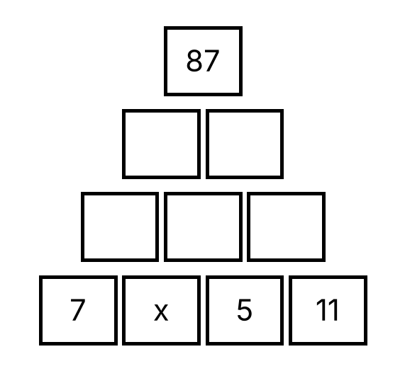
{OPTION 1} 15
{OPTION 2} 18
{OPTION 3} 20
{OPTION 4} 21
{OPTION 5}
{OPTION 6}
{OPTION 7}
{OPTION 8}
{OPTION 9}
{OPTION 10}
{RIGHT ANSWER} 2
{EXPLANATION} Row 3 = (7 + x), (x + 5), 16. Row 2 = (12 + 2x), (x + 21). Top = (12 + 2x) + (x + 21) = 3x + 33 = 87, so 3x = 54 and x = 18.
{CORRECT MARKS} 1
{NEGATIVE MARKS} 0
{DIFFICULTY} Hard
{QUESTION ENDS}

{QUESTION BEGINS}
{QUESTION NUMBER} 14
{SUBJECT} Reasoning Ability
{TOPIC} Water Image
{TAGS} tcs nqt, reasoning ability, figure based, hard
{QUESTION TYPE} SINGLECORRECT
{QUESTION TEXT} Select the figure that is the water image (reflection in a mirror placed horizontally below) of the given number.
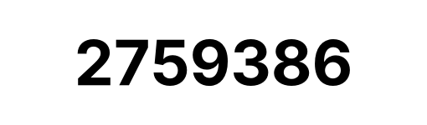
{OPTION 1} 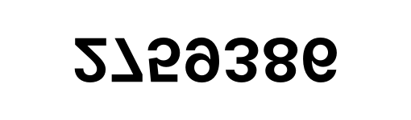
{OPTION 2} 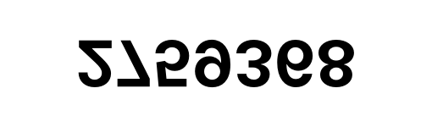
{OPTION 3} 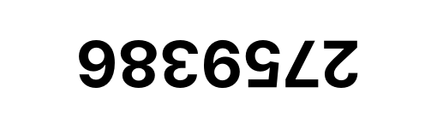
{OPTION 4} 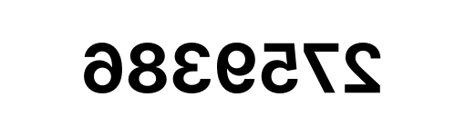
{OPTION 5}
{OPTION 6}
{OPTION 7}
{OPTION 8}
{OPTION 9}
{OPTION 10}
{RIGHT ANSWER} 1
{EXPLANATION} A mirror placed below the number turns it upside down (top and bottom exchange) but keeps the order of the digits from left to right. Option 2 is a left–right mirror image, option 3 is turned through 180° (the order is also reversed), and option 4 reflects a different number.
{CORRECT MARKS} 1
{NEGATIVE MARKS} 0
{DIFFICULTY} Hard
{QUESTION ENDS}

{QUESTION BEGINS}
{QUESTION NUMBER} 15
{SUBJECT} Reasoning Ability
{TOPIC} Number Puzzle
{TAGS} tcs nqt, reasoning ability, hard
{QUESTION TYPE} SINGLECORRECT
{QUESTION TEXT} What is the smallest number greater than 100 that leaves a remainder of 2 when divided by each of 3, 4 and 5?
{OPTION 1} 102
{OPTION 2} 122
{OPTION 3} 120
{OPTION 4} 180
{OPTION 5}
{OPTION 6}
{OPTION 7}
{OPTION 8}
{OPTION 9}
{OPTION 10}
{RIGHT ANSWER} 2
{EXPLANATION} The number is 2 more than a common multiple of 3, 4 and 5. Their LCM is 60, so the possible numbers are 62, 122, 182, … The smallest of these greater than 100 is 122.
{CORRECT MARKS} 1
{NEGATIVE MARKS} 0
{DIFFICULTY} Hard
{QUESTION ENDS}

{QUESTION BEGINS}
{QUESTION NUMBER} 16
{SUBJECT} Reasoning Ability
{TOPIC} Calendar
{TAGS} tcs nqt, reasoning ability, hard
{QUESTION TYPE} SINGLECORRECT
{QUESTION TEXT} If the day after tomorrow is Thursday, what day of the week was it three days before yesterday?
{OPTION 1} Thursday
{OPTION 2} Wednesday
{OPTION 3} Friday
{OPTION 4} Saturday
{OPTION 5}
{OPTION 6}
{OPTION 7}
{OPTION 8}
{OPTION 9}
{OPTION 10}
{RIGHT ANSWER} 3
{EXPLANATION} The day after tomorrow is Thursday, so today is Tuesday and yesterday was Monday. Three days before Monday is Friday.
{CORRECT MARKS} 1
{NEGATIVE MARKS} 0
{DIFFICULTY} Hard
{QUESTION ENDS}

{QUESTION BEGINS}
{QUESTION NUMBER} 17
{SUBJECT} Reasoning Ability
{TOPIC} Cubes
{TAGS} tcs nqt, reasoning ability, figure based, hard
{QUESTION TYPE} SINGLECORRECT
{QUESTION TEXT} A 3 × 3 × 3 cube made of 27 unit cubes has one corner unit cube (the top front one) removed, as shown. How many unit squares make up the whole outer surface of the remaining solid (including the bottom)?
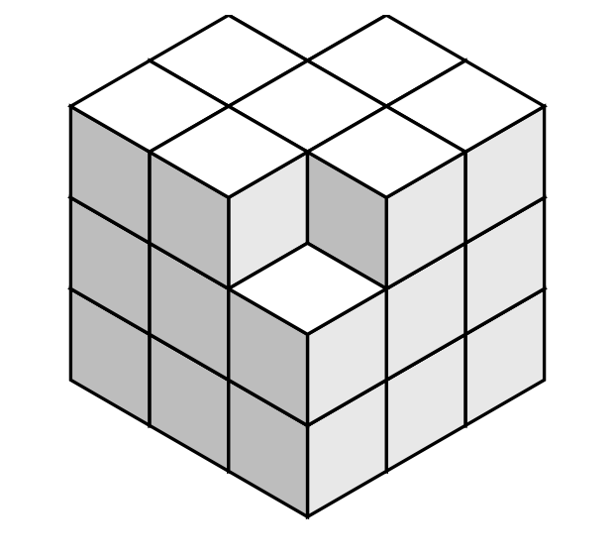
{OPTION 1} 55
{OPTION 2} 51
{OPTION 3} 53
{OPTION 4} 54
{OPTION 5}
{OPTION 6}
{OPTION 7}
{OPTION 8}
{OPTION 9}
{OPTION 10}
{RIGHT ANSWER} 4
{EXPLANATION} The original cube has 6 × 9 = 54 unit squares on its surface. Removing a corner cube takes away 3 outer squares, but it exposes 3 new squares of the neighbouring cubes inside, so the surface area is unchanged: 54.
{CORRECT MARKS} 1
{NEGATIVE MARKS} 0
{DIFFICULTY} Hard
{QUESTION ENDS}

{QUESTION BEGINS}
{QUESTION NUMBER} 18
{SUBJECT} Reasoning Ability
{TOPIC} Puzzle
{TAGS} tcs nqt, reasoning ability, figure based, hard
{QUESTION TYPE} SINGLECORRECT
{QUESTION TEXT} Four discs of different sizes are stacked on Peg 1 with the largest at the bottom, as shown. The aim is to move the whole stack to Peg 3, moving only one disc at a time, never placing a larger disc on a smaller disc, and using Peg 2 as a spare. What is the minimum number of moves required?
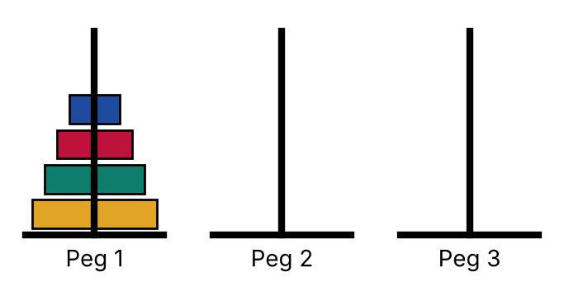
{OPTION 1} 31
{OPTION 2} 15
{OPTION 3} 12
{OPTION 4} 16
{OPTION 5}
{OPTION 6}
{OPTION 7}
{OPTION 8}
{OPTION 9}
{OPTION 10}
{RIGHT ANSWER} 2
{EXPLANATION} For n discs the minimum number of moves is 2ⁿ − 1 (move n − 1 discs to the spare peg, move the largest disc, then move the n − 1 discs on top of it). For 4 discs: 2⁴ − 1 = 15.
{CORRECT MARKS} 1
{NEGATIVE MARKS} 0
{DIFFICULTY} Hard
{QUESTION ENDS}

{QUESTION BEGINS}
{QUESTION NUMBER} 19
{SUBJECT} Reasoning Ability
{TOPIC} Number Puzzle
{TAGS} tcs nqt, reasoning ability, hard
{QUESTION TYPE} SINGLECORRECT
{QUESTION TEXT} A two-digit number is 27 more than the number obtained by reversing its digits, and the sum of its digits is 11. What is the number?
{OPTION 1} 74
{OPTION 2} 92
{OPTION 3} 83
{OPTION 4} 65
{OPTION 5}
{OPTION 6}
{OPTION 7}
{OPTION 8}
{OPTION 9}
{OPTION 10}
{RIGHT ANSWER} 1
{EXPLANATION} Let the digits be a and b: (10a + b) − (10b + a) = 9(a − b) = 27, so a − b = 3. With a + b = 11, a = 7 and b = 4. The number is 74.
{CORRECT MARKS} 1
{NEGATIVE MARKS} 0
{DIFFICULTY} Hard
{QUESTION ENDS}

{QUESTION BEGINS}
{QUESTION NUMBER} 20
{SUBJECT} Reasoning Ability
{TOPIC} Number Puzzle
{TAGS} tcs nqt, reasoning ability, figure based, hard
{QUESTION TYPE} SINGLECORRECT
{QUESTION TEXT} Find the number that replaces the question mark in the matrix.
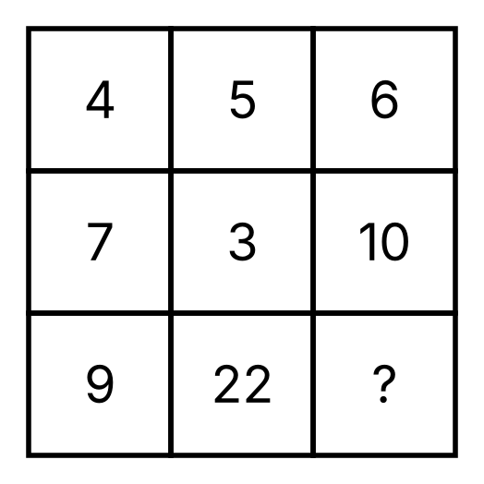
{OPTION 1} 30
{OPTION 2} 24
{OPTION 3} 28
{OPTION 4} 26
{OPTION 5}
{OPTION 6}
{OPTION 7}
{OPTION 8}
{OPTION 9}
{OPTION 10}
{RIGHT ANSWER} 4
{EXPLANATION} In every column the bottom number = (top number)² − (middle number): 4² − 7 = 9, 5² − 3 = 22, so in the last column 6² − 10 = 26.
{CORRECT MARKS} 1
{NEGATIVE MARKS} 0
{DIFFICULTY} Hard
{QUESTION ENDS}

