{QUESTION BEGINS}
{QUESTION NUMBER} 1
{SUBJECT} Reasoning Ability
{TOPIC} Dice
{TAGS} tcs nqt, reasoning ability, figure based, hard
{QUESTION TYPE} SINGLECORRECT
{QUESTION TEXT} A die has the numbers 1 to 6 on its faces, with 3 and 6, 1 and 4, 2 and 5 on opposite faces. It is placed at the Start cell with the faces shown in the figure (3 on top, 1 in front, 2 on the right). It is rolled over its edges, one cell at a time, along the path shown by the arrows (East, East, North, North, West, South, East). Which number is on the top face when the die is in the End cell?
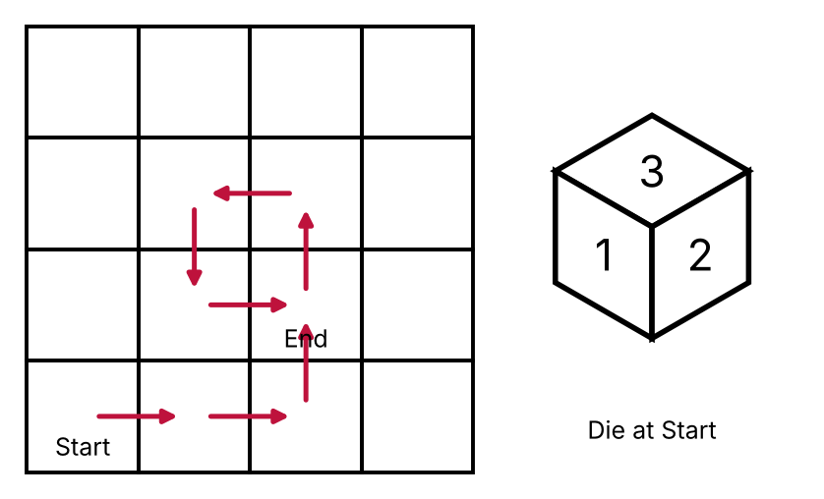
{OPTION 1} 1
{OPTION 2} 4
{OPTION 3} 2
{OPTION 4} 3
{OPTION 5}
{OPTION 6}
{OPTION 7}
{OPTION 8}
{OPTION 9}
{OPTION 10}
{RIGHT ANSWER} 4
{EXPLANATION} Start: top 3, front 1, right 2 (so bottom 6, back 4, left 5). Rolling step by step: East: top 5, front 1, right 3; East: top 6, front 1, right 5; North: top 1, front 3, right 5; North: top 3, front 4, right 5; West: top 5, front 4, right 6; South: top 1, front 5, right 6; East: top 3, front 5, right 1. At the End cell the top face is 3.
{CORRECT MARKS} 1
{NEGATIVE MARKS} 0
{DIFFICULTY} Hard
{QUESTION ENDS}

{QUESTION BEGINS}
{QUESTION NUMBER} 2
{SUBJECT} Reasoning Ability
{TOPIC} Number Puzzle
{TAGS} tcs nqt, reasoning ability, figure based, hard
{QUESTION TYPE} SINGLECORRECT
{QUESTION TEXT} Find the missing number in the third triangle if the numbers in all the triangles follow the same rule.
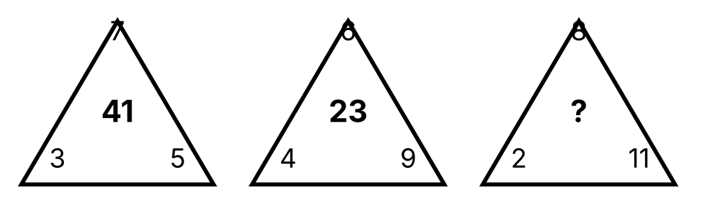
{OPTION 1} 51
{OPTION 2} 45
{OPTION 3} 49
{OPTION 4} 53
{OPTION 5}
{OPTION 6}
{OPTION 7}
{OPTION 8}
{OPTION 9}
{OPTION 10}
{RIGHT ANSWER} 1
{EXPLANATION} First triangle: 7² − (3 + 5) = 49 − 8 = 41. Second triangle: 6² − (4 + 9) = 36 − 13 = 23. So the number in the middle is (top number)² − (sum of the two bottom numbers). Third triangle: 8² − (2 + 11) = 64 − 13 = 51.
{CORRECT MARKS} 1
{NEGATIVE MARKS} 0
{DIFFICULTY} Hard
{QUESTION ENDS}

{QUESTION BEGINS}
{QUESTION NUMBER} 3
{SUBJECT} Reasoning Ability
{TOPIC} Syllogism
{TAGS} tcs nqt, reasoning ability, hard
{QUESTION TYPE} SINGLECORRECT
{QUESTION TEXT} Statements: All pencils are pens. Some pens are erasers. No eraser is a ruler.
Conclusions:
I. Some pencils are erasers.
II. No pencil is an eraser.
III. Some rulers are not pens.
Which of the following is correct?
{OPTION 1} None of the conclusions follows
{OPTION 2} Both I and II follow
{OPTION 3} Either I or II follows
{OPTION 4} Only III follows
{OPTION 5}
{OPTION 6}
{OPTION 7}
{OPTION 8}
{OPTION 9}
{OPTION 10}
{RIGHT ANSWER} 3
{EXPLANATION} The pens that are erasers may or may not be pencils, so neither 'some pencils are erasers' (I) nor 'no pencil is an eraser' (II) is certain on its own. But they are exactly opposite possibilities (a 'some' statement and its 'no' statement), so one of them must be true: either I or II follows. III is not certain because rulers may all be pens.
{CORRECT MARKS} 1
{NEGATIVE MARKS} 0
{DIFFICULTY} Hard
{QUESTION ENDS}

{QUESTION BEGINS}
{QUESTION NUMBER} 4
{SUBJECT} Reasoning Ability
{TOPIC} Blood Relations
{TAGS} tcs nqt, reasoning ability, hard
{QUESTION TYPE} SINGLECORRECT
{QUESTION TEXT} Study the statements: G is the father of I. K is the mother of L, who is a boy. I is the husband of K. J is the sister of I. N is the husband of J.
How is L related to N?
{OPTION 1} Brother-in-law
{OPTION 2} Cousin
{OPTION 3} Son-in-law
{OPTION 4} Nephew
{OPTION 5}
{OPTION 6}
{OPTION 7}
{OPTION 8}
{OPTION 9}
{OPTION 10}
{RIGHT ANSWER} 4
{EXPLANATION} I and K are the parents of L. J is I's sister and N is J's husband. So L is the son of N's wife's brother, which makes L the nephew of N (by marriage).
{CORRECT MARKS} 1
{NEGATIVE MARKS} 0
{DIFFICULTY} Hard
{QUESTION ENDS}

{QUESTION BEGINS}
{QUESTION NUMBER} 5
{SUBJECT} Reasoning Ability
{TOPIC} Puzzle
{TAGS} tcs nqt, reasoning ability, hard
{QUESTION TYPE} SINGLECORRECT
{QUESTION TEXT} Three persons X, Y and Z are each either a truth-teller (always tells the truth) or a liar (always lies). X says, "Y is a liar." Y says, "Z is a liar." Z says, "X and Y are both liars."
Who among them is the truth-teller?
{OPTION 1} X and Z
{OPTION 2} Only Y
{OPTION 3} Only X
{OPTION 4} Only Z
{OPTION 5}
{OPTION 6}
{OPTION 7}
{OPTION 8}
{OPTION 9}
{OPTION 10}
{RIGHT ANSWER} 2
{EXPLANATION} If X were truthful, Y would be a liar, so Z would be truthful; but then Z's statement 'X and Y are both liars' would be false, which is a contradiction. So X is a liar, hence Y is truthful, so Z is a liar. Check: Z (a liar) says 'both are liars', which is false because Y is truthful. Only Y tells the truth.
{CORRECT MARKS} 1
{NEGATIVE MARKS} 0
{DIFFICULTY} Hard
{QUESTION ENDS}

{QUESTION BEGINS}
{QUESTION NUMBER} 6
{SUBJECT} Reasoning Ability
{TOPIC} Venn Diagram
{TAGS} tcs nqt, reasoning ability, figure based, hard
{QUESTION TYPE} SINGLECORRECT
{QUESTION TEXT} Refer to the Venn diagram (the rectangle is the universal set).
Which of the following are correct?
a. n(A ∩ B′) + n(B ∩ C′) = 154
b. n(A′ ∩ B′ ∩ C′) < n(A ∩ B ∩ C) − n(A ∩ C ∩ B′)
c. n(A ∪ B ∪ C) − n(A ∩ B) = 218
d. n(B′) + n(A ∩ C) = 179
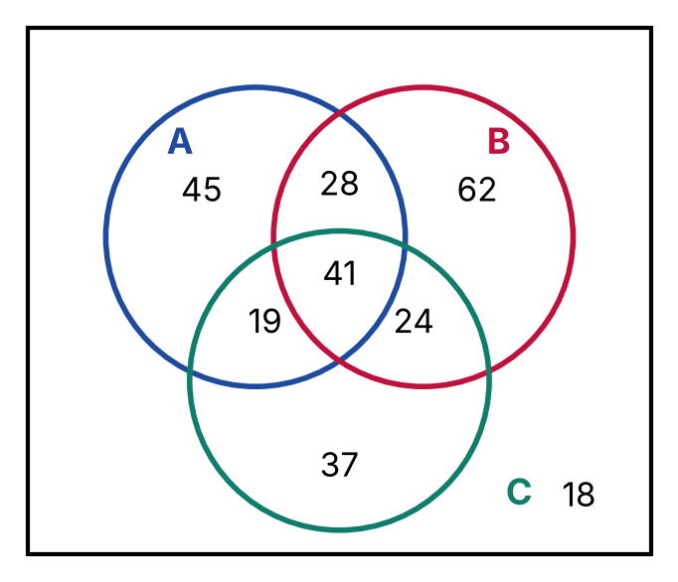
{OPTION 1} b, c and d only
{OPTION 2} a, b and d only
{OPTION 3} a, b and c only
{OPTION 4} a and d only
{OPTION 5}
{OPTION 6}
{OPTION 7}
{OPTION 8}
{OPTION 9}
{OPTION 10}
{RIGHT ANSWER} 2
{EXPLANATION} From the diagram: A∩B′ = 45 + 19 = 64 and B∩C′ = 62 + 28 = 90, so (a) 64 + 90 = 154 is correct. (b) Outside all circles = 18 and 41 − 19 = 22, and 18 < 22, so (b) is correct. (c) n(A ∪ B ∪ C) = 45+62+37+28+19+24+41 = 256, and 256 − (28 + 41) = 187, not 218, so (c) is wrong. (d) n(B′) = 45 + 37 + 19 + 18 = 119 and n(A ∩ C) = 19 + 41 = 60, so 119 + 60 = 179, so (d) is correct. Correct: a, b and d.
{CORRECT MARKS} 1
{NEGATIVE MARKS} 0
{DIFFICULTY} Hard
{QUESTION ENDS}

{QUESTION BEGINS}
{QUESTION NUMBER} 7
{SUBJECT} Reasoning Ability
{TOPIC} Alphabet Test
{TAGS} tcs nqt, reasoning ability, hard
{QUESTION TYPE} SINGLECORRECT
{QUESTION TEXT} How many letters of the word STRANGELY remain at the same position when they are arranged in alphabetical order (from left to right)?
{OPTION 1} 5
{OPTION 2} 2
{OPTION 3} 1
{OPTION 4} 4
{OPTION 5}
{OPTION 6}
{OPTION 7}
{OPTION 8}
{OPTION 9}
{OPTION 10}
{RIGHT ANSWER} 2
{EXPLANATION} STRANGELY in alphabetical order is AEGLNRSTY. Comparing position by position: S/A, T/E, R/G, A/L, N/N, G/R, E/S, L/T, Y/Y. Only N (5th place) and Y (9th place) stay in the same place, so the answer is 2.
{CORRECT MARKS} 1
{NEGATIVE MARKS} 0
{DIFFICULTY} Hard
{QUESTION ENDS}

{QUESTION BEGINS}
{QUESTION NUMBER} 8
{SUBJECT} Reasoning Ability
{TOPIC} Clock
{TAGS} tcs nqt, reasoning ability, hard
{QUESTION TYPE} SINGLECORRECT
{QUESTION TEXT} At what time between 4 and 5 o'clock will the hands of a clock point in exactly opposite directions?
{OPTION 1} 54 minutes past 4
{OPTION 2} 49 1/11 minutes past 4
{OPTION 3} 54 6/11 minutes past 4
{OPTION 4} 53 7/11 minutes past 4
{OPTION 5}
{OPTION 6}
{OPTION 7}
{OPTION 8}
{OPTION 9}
{OPTION 10}
{RIGHT ANSWER} 3
{EXPLANATION} At m minutes past 4, the hour hand is at 120 + m/2 degrees and the minute hand at 6m degrees. For opposite hands: 6m − (120 + m/2) = 180, so 5.5m = 300 and m = 600/11 = 54 6/11 minutes.
{CORRECT MARKS} 1
{NEGATIVE MARKS} 0
{DIFFICULTY} Hard
{QUESTION ENDS}

{QUESTION BEGINS}
{QUESTION NUMBER} 9
{SUBJECT} Reasoning Ability
{TOPIC} Venn Diagram
{TAGS} tcs nqt, reasoning ability, figure based, hard
{QUESTION TYPE} SINGLECORRECT
{QUESTION TEXT} In the Venn diagram (the rectangle is the universal set), what is the value of n(A′ ∩ (B ∪ C)) + n(A ∩ B ∩ C′) + n((A ∪ B ∪ C)′) ?
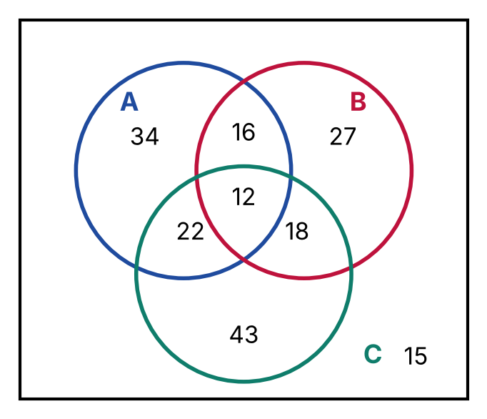
{OPTION 1} 146
{OPTION 2} 110
{OPTION 3} 131
{OPTION 4} 119
{OPTION 5}
{OPTION 6}
{OPTION 7}
{OPTION 8}
{OPTION 9}
{OPTION 10}
{RIGHT ANSWER} 4
{EXPLANATION} A′ ∩ (B ∪ C) = only B + only C + B and C only = 27 + 43 + 18 = 88. A ∩ B ∩ C′ = A and B only = 16. (A ∪ B ∪ C)′ = outside = 15. Total = 88 + 16 + 15 = 119.
{CORRECT MARKS} 1
{NEGATIVE MARKS} 0
{DIFFICULTY} Hard
{QUESTION ENDS}

{QUESTION BEGINS}
{QUESTION NUMBER} 10
{SUBJECT} Reasoning Ability
{TOPIC} Coding-Decoding
{TAGS} tcs nqt, reasoning ability, hard
{QUESTION TYPE} SINGLECORRECT
{QUESTION TEXT} In a certain code language, 'mop dil sar' means 'big red fruit', 'sar toe pan' means 'sweet red tree' and 'toe mop zel' means 'sweet big house'. What is the code for 'fruit' in that language?
{OPTION 1} dil
{OPTION 2} mop
{OPTION 3} zel
{OPTION 4} pan
{OPTION 5}
{OPTION 6}
{OPTION 7}
{OPTION 8}
{OPTION 9}
{OPTION 10}
{RIGHT ANSWER} 1
{EXPLANATION} 'red' is the only word common to the first two statements, so 'sar' = red. 'big' is common to the first and third statements, so 'mop' = big. 'sweet' is common to the second and third, so 'toe' = sweet. In the first statement the remaining code is 'dil', which is therefore 'fruit'.
{CORRECT MARKS} 1
{NEGATIVE MARKS} 0
{DIFFICULTY} Hard
{QUESTION ENDS}

{QUESTION BEGINS}
{QUESTION NUMBER} 11
{SUBJECT} Reasoning Ability
{TOPIC} Number Puzzle
{TAGS} tcs nqt, reasoning ability, hard
{QUESTION TYPE} SINGLECORRECT
{QUESTION TEXT} Find the missing number:
8 3 61
9 5 76
7 4 ?
{OPTION 1} 43
{OPTION 2} 45
{OPTION 3} 47
{OPTION 4} 49
{OPTION 5}
{OPTION 6}
{OPTION 7}
{OPTION 8}
{OPTION 9}
{OPTION 10}
{RIGHT ANSWER} 2
{EXPLANATION} In each row the third number is (first number)² − (second number): 8² − 3 = 61, 9² − 5 = 76, so 7² − 4 = 45.
{CORRECT MARKS} 1
{NEGATIVE MARKS} 0
{DIFFICULTY} Hard
{QUESTION ENDS}

{QUESTION BEGINS}
{QUESTION NUMBER} 12
{SUBJECT} Reasoning Ability
{TOPIC} Directions
{TAGS} tcs nqt, reasoning ability, hard
{QUESTION TYPE} SINGLECORRECT
{QUESTION TEXT} Meena starts from her house and walks 20 m North and then 15 m East. Sheela starts from the same house, walks 9 m West and then 13 m North. How far is Sheela from Meena now, and in which direction is Sheela with respect to Meena?
{OPTION 1} 25 m, South-West
{OPTION 2} 25 m, North-West
{OPTION 3} 25 m, West
{OPTION 4} 24 m, South-West
{OPTION 5}
{OPTION 6}
{OPTION 7}
{OPTION 8}
{OPTION 9}
{OPTION 10}
{RIGHT ANSWER} 1
{EXPLANATION} Take the house as (0, 0), East as +x and North as +y. Meena is at (15, 20). Sheela is at (−9, 13). Difference = 24 m in the x-direction and 7 m in the y-direction, so the distance is √(24² + 7²) = 25 m. Sheela has a smaller x and a smaller y, so she is to the South-West of Meena.
{CORRECT MARKS} 1
{NEGATIVE MARKS} 0
{DIFFICULTY} Hard
{QUESTION ENDS}

{QUESTION BEGINS}
{QUESTION NUMBER} 13
{SUBJECT} Reasoning Ability
{TOPIC} Ranking
{TAGS} tcs nqt, reasoning ability, hard
{QUESTION TYPE} SINGLECORRECT
{QUESTION TEXT} Six friends P, Q, R, S, T and U have different ages. R is older than P. P is older than Q. S is younger than Q. T is older than P but younger than R. U is younger than Q but older than S.
Who is the third oldest among them?
{OPTION 1} T
{OPTION 2} P
{OPTION 3} Q
{OPTION 4} U
{OPTION 5}
{OPTION 6}
{OPTION 7}
{OPTION 8}
{OPTION 9}
{OPTION 10}
{RIGHT ANSWER} 2
{EXPLANATION} R is older than T, T is older than P, P is older than Q, Q is older than U and U is older than S. So the order from the oldest is R, T, P, Q, U, S. The third oldest is P.
{CORRECT MARKS} 1
{NEGATIVE MARKS} 0
{DIFFICULTY} Hard
{QUESTION ENDS}

{QUESTION BEGINS}
{QUESTION NUMBER} 14
{SUBJECT} Reasoning Ability
{TOPIC} Cubes & Nets
{TAGS} tcs nqt, reasoning ability, figure based, hard
{QUESTION TYPE} SINGLECORRECT
{QUESTION TEXT} Which of the following boxes CANNOT be formed by folding the given sheet along the lines?
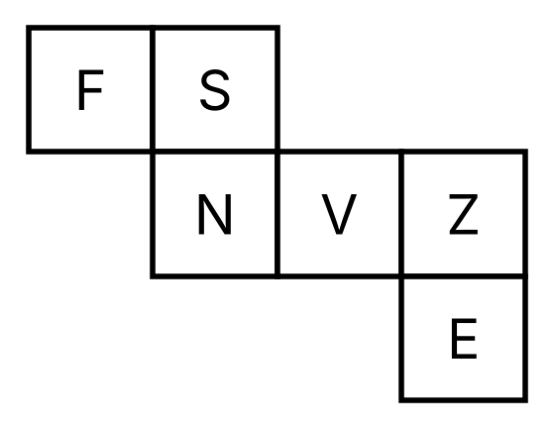
{OPTION 1} 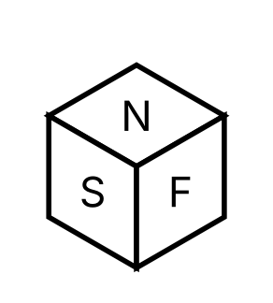
{OPTION 2} 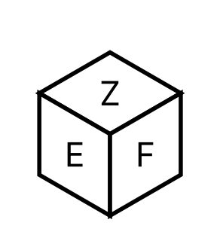
{OPTION 3} 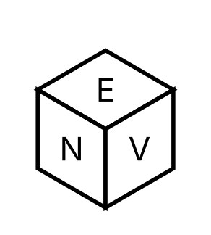
{OPTION 4} 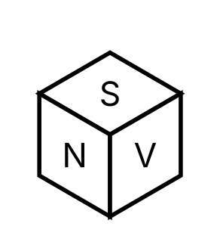
{OPTION 5}
{OPTION 6}
{OPTION 7}
{OPTION 8}
{OPTION 9}
{OPTION 10}
{RIGHT ANSWER} 3
{EXPLANATION} Three of the boxes show three faces that meet at a corner in the order the net produces. The fourth shows the same three faces but with the left and right faces interchanged, which is the mirror image and cannot be obtained by folding.
{CORRECT MARKS} 1
{NEGATIVE MARKS} 0
{DIFFICULTY} Hard
{QUESTION ENDS}

{QUESTION BEGINS}
{QUESTION NUMBER} 15
{SUBJECT} Reasoning Ability
{TOPIC} Seating Arrangement
{TAGS} tcs nqt, reasoning ability, hard
{QUESTION TYPE} SINGLECORRECT
{QUESTION TEXT} Eight friends A, B, C, D, E, F, G and H sit around a circular table facing the centre. B sits third to the left of A. C sits opposite A. D sits second to the left of C. E is an immediate neighbour of B but not of A. G sits opposite F. F is an immediate neighbour of A. H is not an immediate neighbour of C.
Who sits second to the right of G?
{OPTION 1} E
{OPTION 2} C
{OPTION 3} B
{OPTION 4} D
{OPTION 5}
{OPTION 6}
{OPTION 7}
{OPTION 8}
{OPTION 9}
{OPTION 10}
{RIGHT ANSWER} 3
{EXPLANATION} Put A at seat 0 and count clockwise (for people facing the centre, left means clockwise). B is at seat 3, C opposite A at seat 4 and D two places to the left of C at seat 6. E must be next to B (seat 2 or 4), and seat 4 is C's, so E is at seat 2. F is next to A, so F is at seat 1 or 7; seat 7 would put G opposite at seat 3, which is B's, so F is at seat 1, G is opposite at seat 5 and H takes the last seat, 7. The table is A, F, E, B, C, G, D, H. Second to the right of G (anticlockwise, two seats back from seat 5) is seat 3, which is B.
{CORRECT MARKS} 1
{NEGATIVE MARKS} 0
{DIFFICULTY} Hard
{QUESTION ENDS}

{QUESTION BEGINS}
{QUESTION NUMBER} 16
{SUBJECT} Reasoning Ability
{TOPIC} Figure Series
{TAGS} tcs nqt, reasoning ability, figure based, hard
{QUESTION TYPE} SINGLECORRECT
{QUESTION TEXT} Select the figure that can replace the question mark (?) in the series. (Each figure has seven symbols placed at the top-centre, the middle row and the bottom row.)
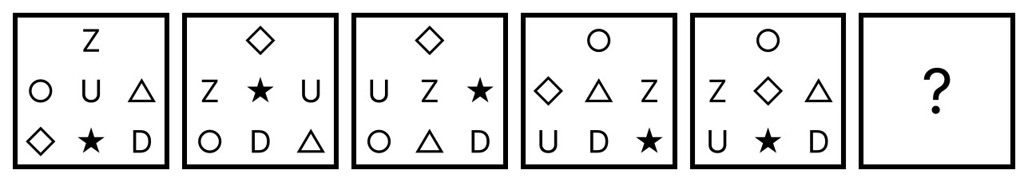
{OPTION 1} 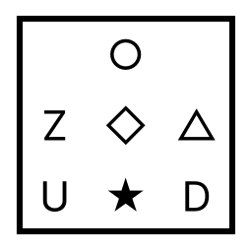
{OPTION 2} 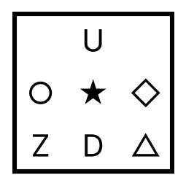
{OPTION 3} 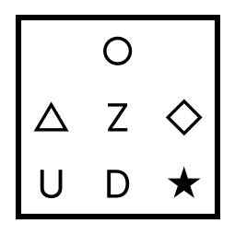
{OPTION 4} 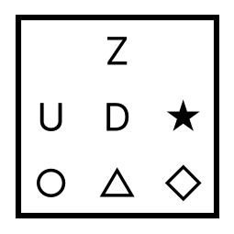
{OPTION 5}
{OPTION 6}
{OPTION 7}
{OPTION 8}
{OPTION 9}
{OPTION 10}
{RIGHT ANSWER} 2
{EXPLANATION} Number the positions: 1 top, 2 middle-left, 3 middle-centre, 4 middle-right, 5 bottom-left, 6 bottom-centre, 7 bottom-right. Steps alternate between two fixed shuffles. Shuffle A moves the symbol at 1→2, 2→5, 3→4, 4→7, 5→1, 6→3, 7→6. Shuffle B moves 1→1, 2→3, 3→4, 4→2, 5→5, 6→7, 7→6. Figures 1→2, 3→4 and 5→6 use A, and figures 2→3 and 4→5 use B. Applying A to figure 5 gives the answer.
{CORRECT MARKS} 1
{NEGATIVE MARKS} 0
{DIFFICULTY} Hard
{QUESTION ENDS}

{QUESTION BEGINS}
{QUESTION NUMBER} 17
{SUBJECT} Reasoning Ability
{TOPIC} Number Series
{TAGS} tcs nqt, reasoning ability, hard
{QUESTION TYPE} SINGLECORRECT
{QUESTION TEXT} Find the next term of the series: 5, 6, 14, 45, 184, ?
{OPTION 1} 915
{OPTION 2} 925
{OPTION 3} 920
{OPTION 4} 930
{OPTION 5}
{OPTION 6}
{OPTION 7}
{OPTION 8}
{OPTION 9}
{OPTION 10}
{RIGHT ANSWER} 2
{EXPLANATION} Each term is the previous term multiplied by 1, 2, 3, 4, 5 and then increased by the same number: 5×1+1 = 6, 6×2+2 = 14, 14×3+3 = 45, 45×4+4 = 184, so the next term is 184×5+5 = 925.
{CORRECT MARKS} 1
{NEGATIVE MARKS} 0
{DIFFICULTY} Hard
{QUESTION ENDS}

{QUESTION BEGINS}
{QUESTION NUMBER} 18
{SUBJECT} Reasoning Ability
{TOPIC} Cubes & Nets
{TAGS} tcs nqt, reasoning ability, figure based, hard
{QUESTION TYPE} SINGLECORRECT
{QUESTION TEXT} Select the box that can be formed by folding the given sheet along the lines.
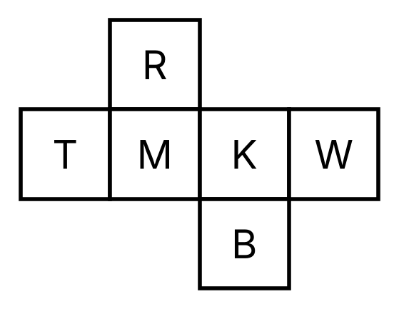
{OPTION 1} 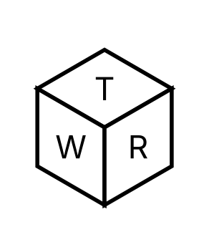
{OPTION 2} 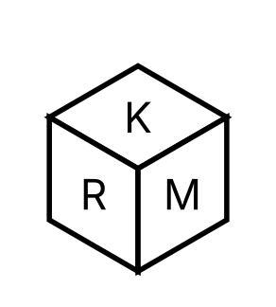
{OPTION 3} 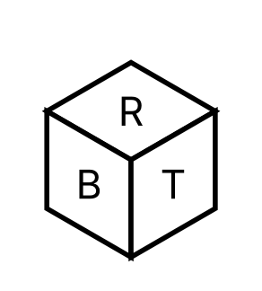
{OPTION 4} 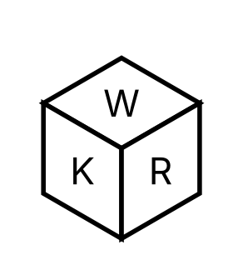
{OPTION 5}
{OPTION 6}
{OPTION 7}
{OPTION 8}
{OPTION 9}
{OPTION 10}
{RIGHT ANSWER} 2
{EXPLANATION} Fold the sheet: opposite faces are B-R, K-T, M-W. Options with a pair of opposite faces visible together cannot be formed, and a box that shows the right faces in the wrong left-right order is the mirror image. Only option 1 shows faces that meet at a corner in the correct order.
{CORRECT MARKS} 1
{NEGATIVE MARKS} 0
{DIFFICULTY} Hard
{QUESTION ENDS}

{QUESTION BEGINS}
{QUESTION NUMBER} 19
{SUBJECT} Reasoning Ability
{TOPIC} Pattern Completion
{TAGS} tcs nqt, reasoning ability, figure based, hard
{QUESTION TYPE} SINGLECORRECT
{QUESTION TEXT} The pattern on the 6 × 6 board has the same design when it is turned through 90°, 180° and 270° about its centre. The grey 2 × 2 part is missing. Which piece, placed in the grey part in the orientation shown, completes the pattern?
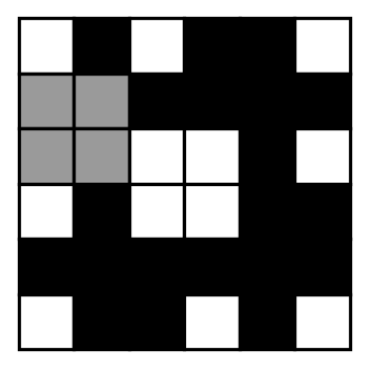
{OPTION 1} 
{OPTION 2} 
{OPTION 3} 
{OPTION 4} 
{OPTION 5}
{OPTION 6}
{OPTION 7}
{OPTION 8}
{OPTION 9}
{OPTION 10}
{RIGHT ANSWER} 3
{EXPLANATION} Because the pattern repeats after every 90° turn, the missing part is a rotated copy of the corresponding part of another quarter of the board. Turning the matching 2 × 2 part of the neighbouring quarter back through 90° gives the missing piece; only option 1 matches.
{CORRECT MARKS} 1
{NEGATIVE MARKS} 0
{DIFFICULTY} Hard
{QUESTION ENDS}

{QUESTION BEGINS}
{QUESTION NUMBER} 20
{SUBJECT} Reasoning Ability
{TOPIC} Figure Series
{TAGS} tcs nqt, reasoning ability, figure based, hard
{QUESTION TYPE} SINGLECORRECT
{QUESTION TEXT} Select the figure from among the given options that can replace the question mark (?) in the following series.
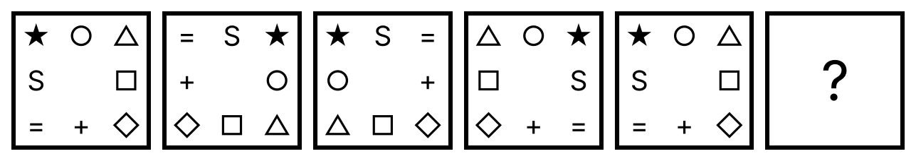
{OPTION 1} 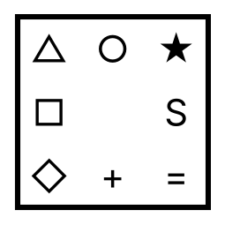
{OPTION 2} 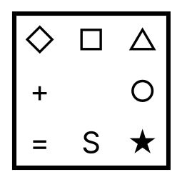
{OPTION 3} 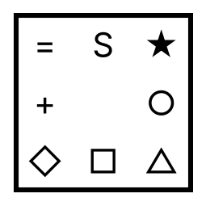
{OPTION 4} 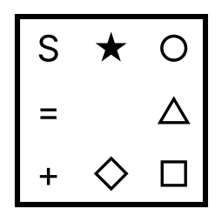
{OPTION 5}
{OPTION 6}
{OPTION 7}
{OPTION 8}
{OPTION 9}
{OPTION 10}
{RIGHT ANSWER} 3
{EXPLANATION} The eight border symbols change in two alternating steps. Step A: every symbol moves 2 places clockwise along the border. Step B: the figure is reflected left to right (left and right columns swap, the middle column stays). Figure 1 to 2 is step A, 2 to 3 is step B, 3 to 4 is step A and 4 to 5 is step B, so 5 to 6 is step A: every symbol moves 2 places clockwise.
{CORRECT MARKS} 1
{NEGATIVE MARKS} 0
{DIFFICULTY} Hard
{QUESTION ENDS}

