{QUESTION BEGINS}
{QUESTION NUMBER} 1
{SUBJECT} Advanced Quantitative Ability
{TOPIC} Probability
{TAGS} tcs nqt, advanced quantitative, actual question, hard
{QUESTION TYPE} SINGLECORRECT
{QUESTION TEXT} 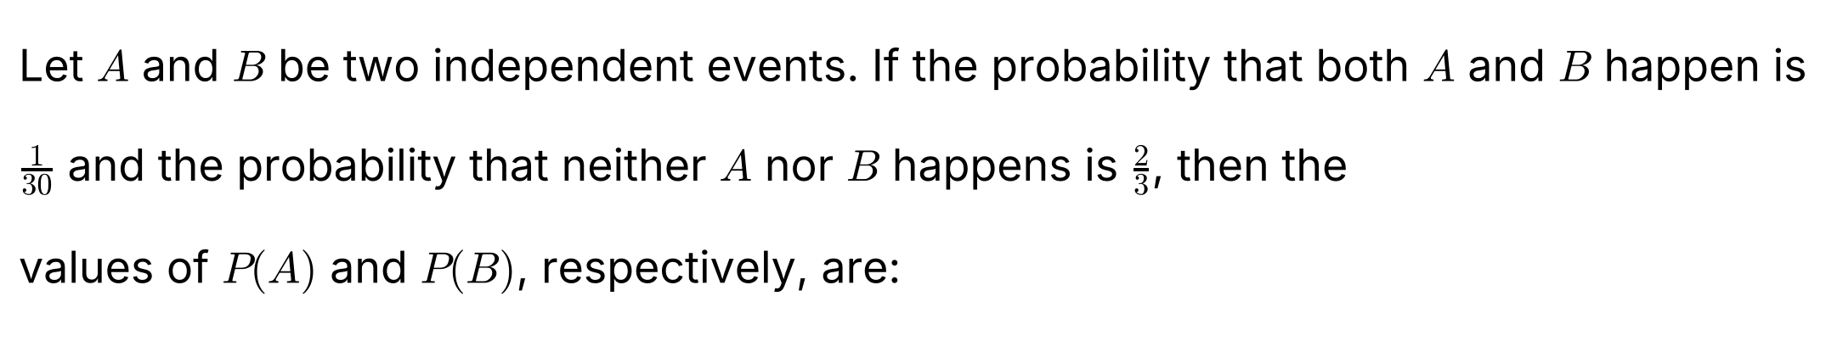
{OPTION 1} 3/10 and 1/9
{OPTION 2} 2/5 and 1/12
{OPTION 3} 1/15 and 1/2
{OPTION 4} 1/5 and 1/6
{OPTION 5}
{OPTION 6}
{OPTION 7}
{OPTION 8}
{OPTION 9}
{OPTION 10}
{RIGHT ANSWER} 4
{EXPLANATION} P(A)P(B) = 1/30 and (1 − P(A))(1 − P(B)) = 2/3. Expanding the second: 1 − (P(A) + P(B)) + 1/30 = 2/3, so P(A) + P(B) = 11/30. The numbers with sum 11/30 and product 1/30 are 1/5 and 1/6 (1/5 + 1/6 = 11/30, 1/5 × 1/6 = 1/30).
{CORRECT MARKS} 1
{NEGATIVE MARKS} 0
{DIFFICULTY} Hard
{QUESTION ENDS}

{QUESTION BEGINS}
{QUESTION NUMBER} 2
{SUBJECT} Advanced Quantitative Ability
{TOPIC} Probability
{TAGS} tcs nqt, advanced quantitative, actual question, hard
{QUESTION TYPE} SINGLECORRECT
{QUESTION TEXT} 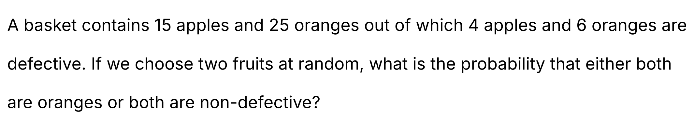
{OPTION 1} 19/55
{OPTION 2} 47/65
{OPTION 3} 31/45
{OPTION 4} 23/35
{OPTION 5}
{OPTION 6}
{OPTION 7}
{OPTION 8}
{OPTION 9}
{OPTION 10}
{RIGHT ANSWER} 2
{EXPLANATION} Total fruits = 40, so two can be chosen in C(40,2) = 780 ways. Defective fruits = 10, non-defective = 30; oranges = 25, non-defective oranges = 25 − 6 = 19. Both oranges: C(25,2) = 300. Both non-defective: C(30,2) = 435. Both oranges and non-defective (counted twice): C(19,2) = 171. Favourable = 300 + 435 − 171 = 564. Probability = 564/780 = 47/65.
{CORRECT MARKS} 1
{NEGATIVE MARKS} 0
{DIFFICULTY} Hard
{QUESTION ENDS}

{QUESTION BEGINS}
{QUESTION NUMBER} 3
{SUBJECT} Advanced Quantitative Ability
{TOPIC} Mensuration
{TAGS} tcs nqt, advanced quantitative, actual question, hard
{QUESTION TYPE} SINGLECORRECT
{QUESTION TEXT} 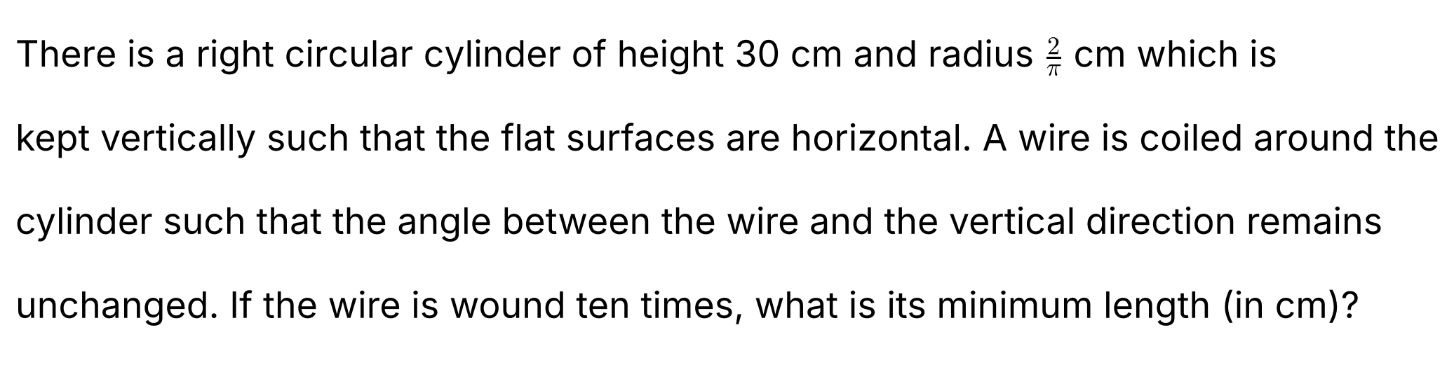
{OPTION 1} 45
{OPTION 2} 50
{OPTION 3} 40
{OPTION 4} 60
{OPTION 5}
{OPTION 6}
{OPTION 7}
{OPTION 8}
{OPTION 9}
{OPTION 10}
{RIGHT ANSWER} 2
{EXPLANATION} Cut the curved surface along a vertical line and unroll it into a rectangle. The circumference = 2π × (2/π) = 4 cm, so ten turns cover a horizontal distance of 10 × 4 = 40 cm while rising 30 cm. Because the angle with the vertical is constant, the wire is a straight line on the unrolled rectangle, so its length = √(40² + 30²) = 50 cm.
{CORRECT MARKS} 1
{NEGATIVE MARKS} 0
{DIFFICULTY} Hard
{QUESTION ENDS}

{QUESTION BEGINS}
{QUESTION NUMBER} 4
{SUBJECT} Advanced Quantitative Ability
{TOPIC} Inequalities
{TAGS} tcs nqt, advanced quantitative, actual question, hard
{QUESTION TYPE} SINGLECORRECT
{QUESTION TEXT} 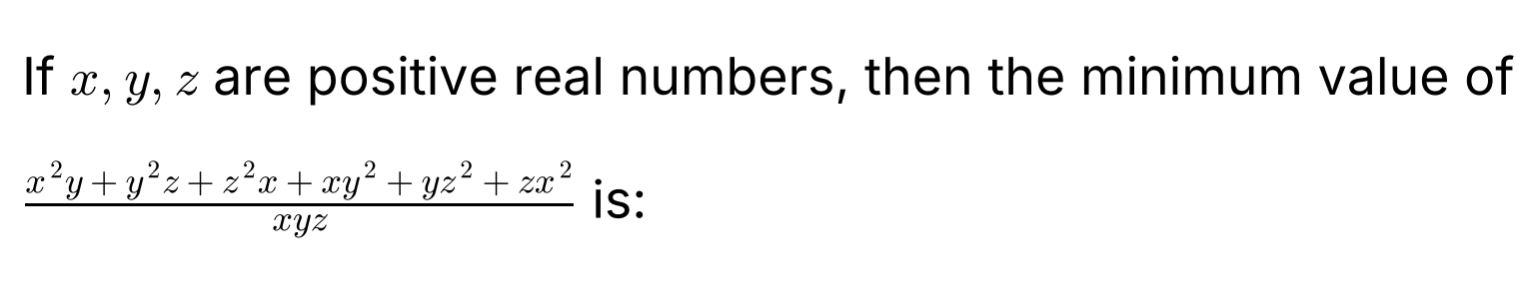
{OPTION 1} 9
{OPTION 2} 12
{OPTION 3} 14
{OPTION 4} 6
{OPTION 5}
{OPTION 6}
{OPTION 7}
{OPTION 8}
{OPTION 9}
{OPTION 10}
{RIGHT ANSWER} 4
{EXPLANATION} Split the fraction: the expression = (x/z + z/x) + (y/x + x/y) + (z/y + y/z) (for example x²y/(xyz) = x/z and xy²/(xyz) = y/z). Each pair a/b + b/a ≥ 2 (AM–GM) for positive numbers, with equality when they are equal. So the minimum = 2 + 2 + 2 = 6, attained at x = y = z.
{CORRECT MARKS} 1
{NEGATIVE MARKS} 0
{DIFFICULTY} Hard
{QUESTION ENDS}

{QUESTION BEGINS}
{QUESTION NUMBER} 5
{SUBJECT} Advanced Quantitative Ability
{TOPIC} Algebra
{TAGS} tcs nqt, advanced quantitative, actual question, hard
{QUESTION TYPE} NUMERICAL
{QUESTION TEXT} 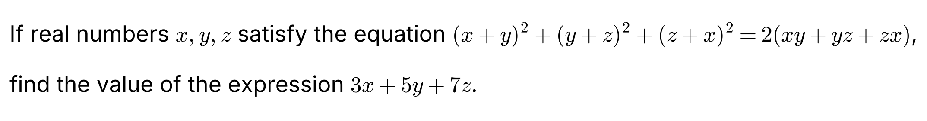
{OPTION 1}
{OPTION 2}
{OPTION 3}
{OPTION 4}
{OPTION 5}
{OPTION 6}
{OPTION 7}
{OPTION 8}
{OPTION 9}
{OPTION 10}
{RIGHT ANSWER} 0
{EXPLANATION} Expand the left side: 2(x² + y² + z²) + 2(xy + yz + zx). Setting this equal to 2(xy + yz + zx) gives 2(x² + y² + z²) = 0, so x² + y² + z² = 0. For real numbers this forces x = y = z = 0. So 3x + 5y + 7z = 0.
{CORRECT MARKS} 1
{NEGATIVE MARKS} 0
{DIFFICULTY} Hard
{QUESTION ENDS}

{QUESTION BEGINS}
{QUESTION NUMBER} 6
{SUBJECT} Advanced Quantitative Ability
{TOPIC} Coordinate Geometry
{TAGS} tcs nqt, advanced quantitative, actual question, hard
{QUESTION TYPE} SINGLECORRECT
{QUESTION TEXT} 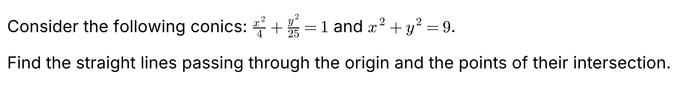
{OPTION 1} y = ±(4√3/5)x
{OPTION 2} y = ±(8√3/5)x
{OPTION 3} y = ±(√5/2)x
{OPTION 4} y = ±(5√5/8)x
{OPTION 5}
{OPTION 6}
{OPTION 7}
{OPTION 8}
{OPTION 9}
{OPTION 10}
{RIGHT ANSWER} 4
{EXPLANATION} At an intersection point y² = 9 − x². Substituting in x²/4 + y²/25 = 1: 25x² + 4(9 − x²) = 100, so 21x² = 64, x² = 64/21 and y² = 9 − 64/21 = 125/21. Then (y/x)² = 125/64, so y/x = ±5√5/8. The lines are y = ±(5√5/8)x.
{CORRECT MARKS} 1
{NEGATIVE MARKS} 0
{DIFFICULTY} Hard
{QUESTION ENDS}

{QUESTION BEGINS}
{QUESTION NUMBER} 7
{SUBJECT} Advanced Quantitative Ability
{TOPIC} Ratio
{TAGS} tcs nqt, advanced quantitative, actual question, hard
{QUESTION TYPE} NUMERICAL
{QUESTION TEXT} 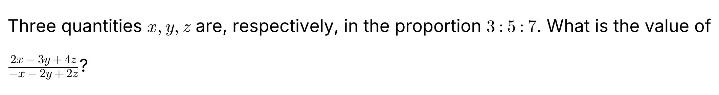
{OPTION 1}
{OPTION 2}
{OPTION 3}
{OPTION 4}
{OPTION 5}
{OPTION 6}
{OPTION 7}
{OPTION 8}
{OPTION 9}
{OPTION 10}
{RIGHT ANSWER} 19
{EXPLANATION} Let x = 3k, y = 5k, z = 7k. Numerator = 6k − 15k + 28k = 19k. Denominator = −3k − 10k + 14k = k. The ratio = 19k/k = 19.
{CORRECT MARKS} 1
{NEGATIVE MARKS} 0
{DIFFICULTY} Hard
{QUESTION ENDS}

{QUESTION BEGINS}
{QUESTION NUMBER} 8
{SUBJECT} Advanced Quantitative Ability
{TOPIC} Indices
{TAGS} tcs nqt, advanced quantitative, actual question, hard
{QUESTION TYPE} SINGLECORRECT
{QUESTION TEXT} 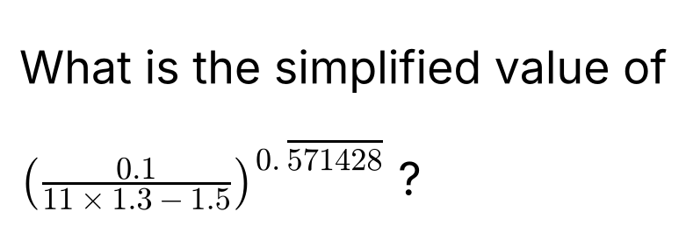
{OPTION 1} 0.03125
{OPTION 2} 0.0625
{OPTION 3} 0.015625
{OPTION 4} 0.08
{OPTION 5}
{OPTION 6}
{OPTION 7}
{OPTION 8}
{OPTION 9}
{OPTION 10}
{RIGHT ANSWER} 2
{EXPLANATION} 11 × 1.3 − 1.5 = 14.3 − 1.5 = 12.8, so the base = 0.1/12.8 = 1/128 = 2⁻⁷. The recurring decimal 0.571428571428… = 4/7 (since 4/7 = 0.571428…). So the value = (2⁻⁷)^(4/7) = 2⁻⁴ = 1/16 = 0.0625.
{CORRECT MARKS} 1
{NEGATIVE MARKS} 0
{DIFFICULTY} Hard
{QUESTION ENDS}

{QUESTION BEGINS}
{QUESTION NUMBER} 9
{SUBJECT} Advanced Quantitative Ability
{TOPIC} LCM
{TAGS} tcs nqt, advanced quantitative, actual question, hard
{QUESTION TYPE} SINGLECORRECT
{QUESTION TEXT} 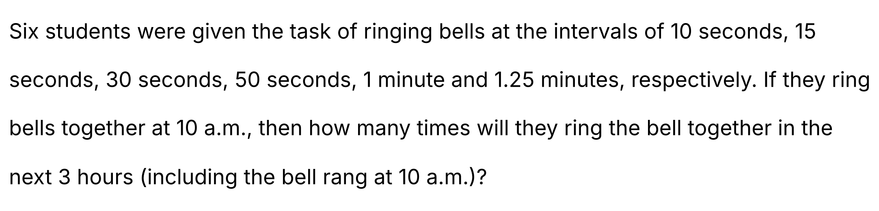
{OPTION 1} 35 times
{OPTION 2} 33 times
{OPTION 3} 37 times
{OPTION 4} 31 times
{OPTION 5}
{OPTION 6}
{OPTION 7}
{OPTION 8}
{OPTION 9}
{OPTION 10}
{RIGHT ANSWER} 3
{EXPLANATION} The intervals in seconds are 10, 15, 30, 50, 60 and 75. Their LCM = 300 seconds (2² × 3 × 5²), so all the bells ring together every 5 minutes. In 3 hours = 180 minutes there are 180/5 = 36 further times, and including the ring at 10 a.m. the total is 37 times.
{CORRECT MARKS} 1
{NEGATIVE MARKS} 0
{DIFFICULTY} Hard
{QUESTION ENDS}

{QUESTION BEGINS}
{QUESTION NUMBER} 10
{SUBJECT} Advanced Quantitative Ability
{TOPIC} Coordinate Geometry
{TAGS} tcs nqt, advanced quantitative, actual question, hard
{QUESTION TYPE} SINGLECORRECT
{QUESTION TEXT} 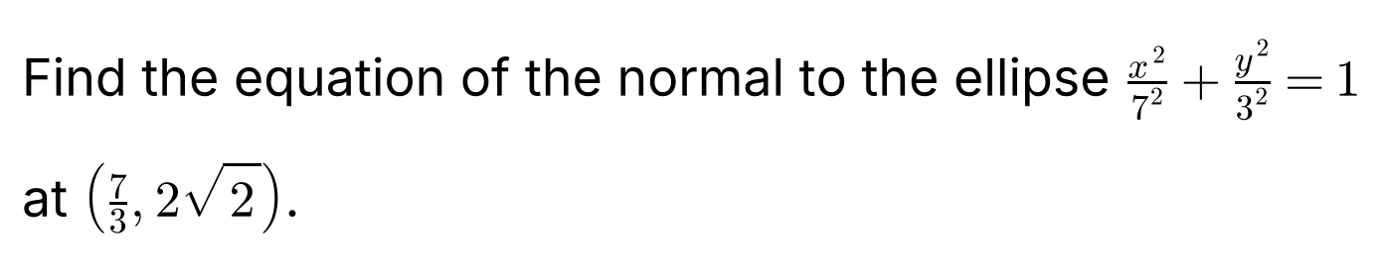
{OPTION 1} y − 2√2 = (8/3)√2 (x − 7/3)
{OPTION 2} y − 2√2 = (16/3)√2 (x − 7/3)
{OPTION 3} y − 2√2 = (17/3)√2 (x − 7/3)
{OPTION 4} y − 2√2 = (14/3)√2 (x − 7/3)
{OPTION 5}
{OPTION 6}
{OPTION 7}
{OPTION 8}
{OPTION 9}
{OPTION 10}
{RIGHT ANSWER} 4
{EXPLANATION} For the ellipse x²/a² + y²/b² = 1 with a² = 49 and b² = 9, the tangent at (x₁, y₁) has slope −b²x₁/(a²y₁), so the normal has slope a²y₁/(b²x₁) = (49 × 2√2)/(9 × 7/3) = 98√2/21 = (14/3)√2. (The point lies on the ellipse: (7/3)²/49 + 8/9 = 1/9 + 8/9 = 1.) The normal is y − 2√2 = (14/3)√2 (x − 7/3).
{CORRECT MARKS} 1
{NEGATIVE MARKS} 0
{DIFFICULTY} Hard
{QUESTION ENDS}

{QUESTION BEGINS}
{QUESTION NUMBER} 11
{SUBJECT} Advanced Quantitative Ability
{TOPIC} Probability
{TAGS} tcs nqt, advanced quantitative, actual question, hard
{QUESTION TYPE} SINGLECORRECT
{QUESTION TEXT} 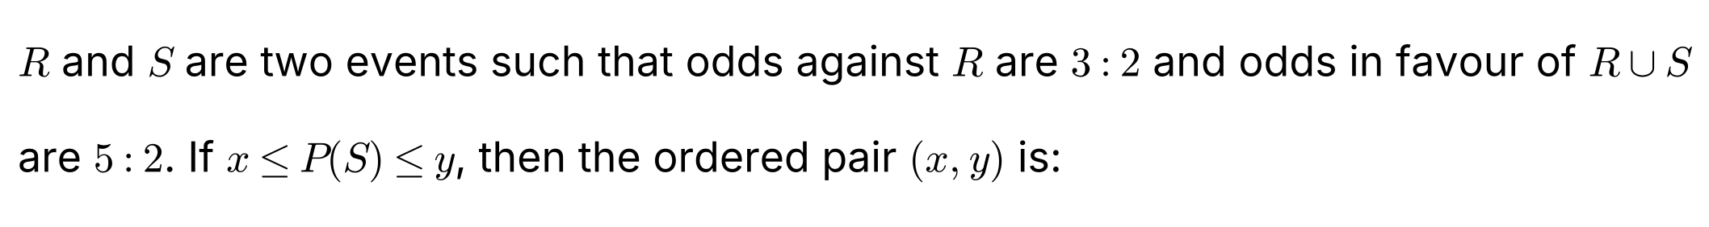
{OPTION 1} (2/5, 5/7)
{OPTION 2} (3/25, 2/7)
{OPTION 3} (1/7, 3/5)
{OPTION 4} (11/35, 5/7)
{OPTION 5}
{OPTION 6}
{OPTION 7}
{OPTION 8}
{OPTION 9}
{OPTION 10}
{RIGHT ANSWER} 4
{EXPLANATION} Odds against R are 3 : 2, so P(R) = 2/5. Odds in favour of R ∪ S are 5 : 2, so P(R ∪ S) = 5/7. Since P(R ∪ S) ≥ P(S) we get P(S) ≤ 5/7. Since P(R ∪ S) ≤ P(R) + P(S) we get P(S) ≥ 5/7 − 2/5 = 11/35. So (x, y) = (11/35, 5/7).
{CORRECT MARKS} 1
{NEGATIVE MARKS} 0
{DIFFICULTY} Hard
{QUESTION ENDS}

{QUESTION BEGINS}
{QUESTION NUMBER} 12
{SUBJECT} Advanced Quantitative Ability
{TOPIC} Polynomials
{TAGS} tcs nqt, advanced quantitative, actual question, hard
{QUESTION TYPE} NUMERICAL
{QUESTION TEXT} 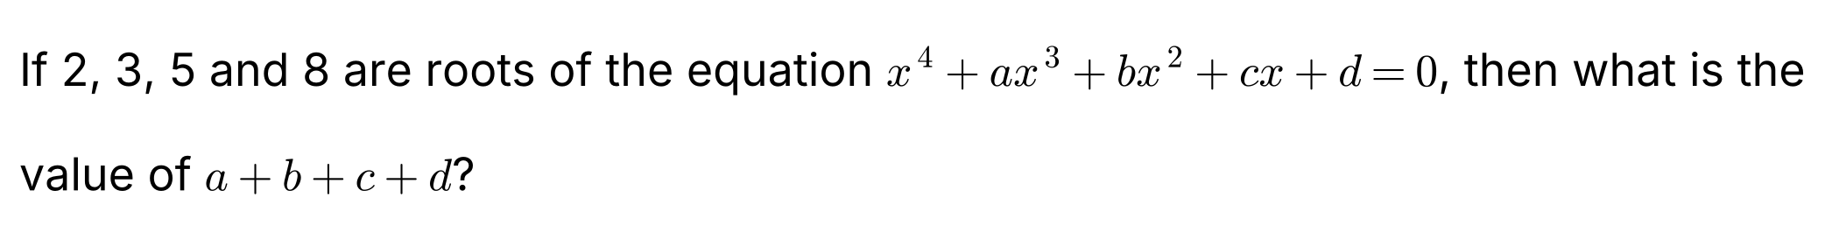
{OPTION 1}
{OPTION 2}
{OPTION 3}
{OPTION 4}
{OPTION 5}
{OPTION 6}
{OPTION 7}
{OPTION 8}
{OPTION 9}
{OPTION 10}
{RIGHT ANSWER} 55
{EXPLANATION} Since the polynomial is monic with roots 2, 3, 5, 8, it equals (x − 2)(x − 3)(x − 5)(x − 8). Putting x = 1: 1 + a + b + c + d = (1 − 2)(1 − 3)(1 − 5)(1 − 8) = (−1)(−2)(−4)(−7) = 56. So a + b + c + d = 56 − 1 = 55.
{CORRECT MARKS} 1
{NEGATIVE MARKS} 0
{DIFFICULTY} Hard
{QUESTION ENDS}

{QUESTION BEGINS}
{QUESTION NUMBER} 13
{SUBJECT} Advanced Quantitative Ability
{TOPIC} Inequalities
{TAGS} tcs nqt, advanced quantitative, actual question, hard
{QUESTION TYPE} SINGLECORRECT
{QUESTION TEXT} 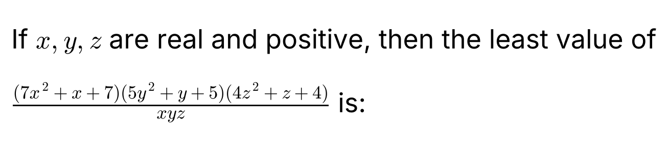
{OPTION 1} 1485
{OPTION 2} 1235
{OPTION 3} 1500
{OPTION 4} 1125
{OPTION 5}
{OPTION 6}
{OPTION 7}
{OPTION 8}
{OPTION 9}
{OPTION 10}
{RIGHT ANSWER} 1
{EXPLANATION} Write each factor over its variable: (7x² + x + 7)/x = 7x + 7/x + 1 ≥ 14 + 1 = 15 (AM–GM, equality at x = 1). Similarly (5y² + y + 5)/y = 5y + 5/y + 1 ≥ 11 and (4z² + z + 4)/z = 4z + 4/z + 1 ≥ 9. The expression is the product of the three, so its least value = 15 × 11 × 9 = 1485.
{CORRECT MARKS} 1
{NEGATIVE MARKS} 0
{DIFFICULTY} Hard
{QUESTION ENDS}

{QUESTION BEGINS}
{QUESTION NUMBER} 14
{SUBJECT} Advanced Quantitative Ability
{TOPIC} 3D Geometry
{TAGS} tcs nqt, advanced quantitative, actual question, hard
{QUESTION TYPE} SINGLECORRECT
{QUESTION TEXT} 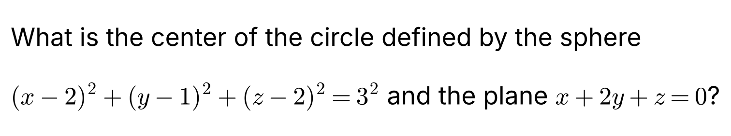
{OPTION 1} (0, 1, −2)
{OPTION 2} (−2, 1, 0)
{OPTION 3} (1, 0, −1)
{OPTION 4} (1, −1, 1)
{OPTION 5}
{OPTION 6}
{OPTION 7}
{OPTION 8}
{OPTION 9}
{OPTION 10}
{RIGHT ANSWER} 4
{EXPLANATION} The centre of the circle is the foot of the perpendicular from the centre of the sphere (2, 1, 2) to the plane x + 2y + z = 0. The normal direction is (1, 2, 1). The point (2 + t, 1 + 2t, 2 + t) lies on the plane when 2 + t + 2 + 4t + 2 + t = 0, i.e. 6 + 6t = 0, so t = −1. The centre of the circle is (1, −1, 1). (Check: 1 − 2 + 1 = 0, and the distance from the sphere's centre is √6 < 3.)
{CORRECT MARKS} 1
{NEGATIVE MARKS} 0
{DIFFICULTY} Hard
{QUESTION ENDS}

