{QUESTION BEGINS}
{QUESTION NUMBER} 1
{SUBJECT} Technical Assessment
{TOPIC} Pseudocode
{TAGS} accenture, technical assessment, pseudocode, mock test 6, hard
{QUESTION TYPE} SINGLECORRECT
{QUESTION TEXT} What will be the value of calls printed by the following pseudocode?
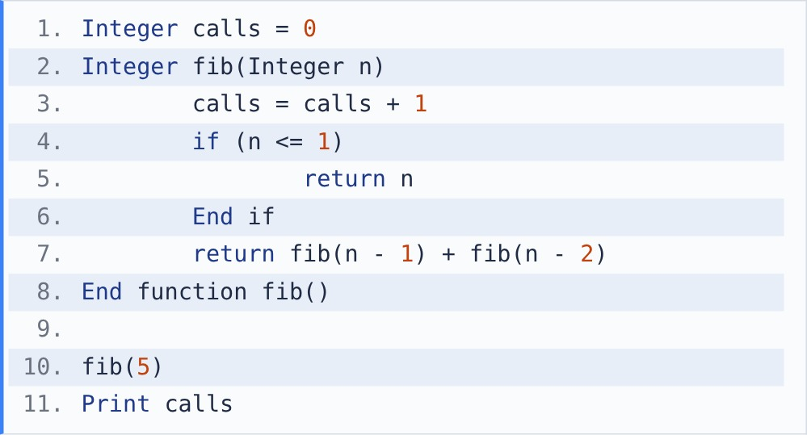
[Note - calls is a global variable shared by every call of fib().]

{OPTION 1} 8
{OPTION 2} 5
{OPTION 3} 9
{OPTION 4} 15
{OPTION 5}
{OPTION 6}
{OPTION 7}
{OPTION 8}
{OPTION 9}
{OPTION 10}
{RIGHT ANSWER} 4
{EXPLANATION} Calls C(n) = 1 + C(n-1) + C(n-2), with C(0) = C(1) = 1. C(2) = 3, C(3) = 5, C(4) = 9, C(5) = 1 + 9 + 5 = 15. (fib(5) itself is 5, a trap option.)
{CORRECT MARKS} 1
{NEGATIVE MARKS} 0
{DIFFICULTY} Hard
{QUESTION ENDS}

{QUESTION BEGINS}
{QUESTION NUMBER} 2
{SUBJECT} Technical Assessment
{TOPIC} Pseudocode
{TAGS} accenture, technical assessment, pseudocode, mock test 6, medium
{QUESTION TYPE} SINGLECORRECT
{QUESTION TEXT} What will be the output of the following pseudocode?
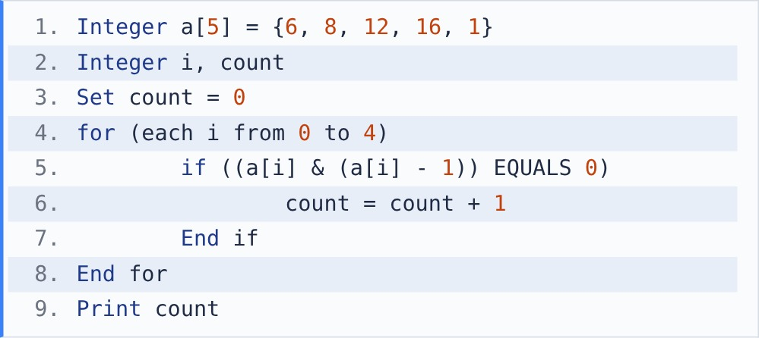
[Note - &: bitwise AND. A result bit is 1 only if both bits are 1.]

{OPTION 1} 2
{OPTION 2} 1
{OPTION 3} 3
{OPTION 4} 4
{OPTION 5}
{OPTION 6}
{OPTION 7}
{OPTION 8}
{OPTION 9}
{OPTION 10}
{RIGHT ANSWER} 3
{EXPLANATION} x & (x - 1) is 0 only when x has a single 1-bit, i.e. x is a power of two. 8, 16 and 1 (2^0) pass; 6 and 12 do not. count = 3.
{CORRECT MARKS} 1
{NEGATIVE MARKS} 0
{DIFFICULTY} Medium
{QUESTION ENDS}

{QUESTION BEGINS}
{QUESTION NUMBER} 3
{SUBJECT} Technical Assessment
{TOPIC} Pseudocode
{TAGS} accenture, technical assessment, pseudocode, mock test 6, hard
{QUESTION TYPE} SINGLECORRECT
{QUESTION TEXT} What will be the output of the following pseudocode?
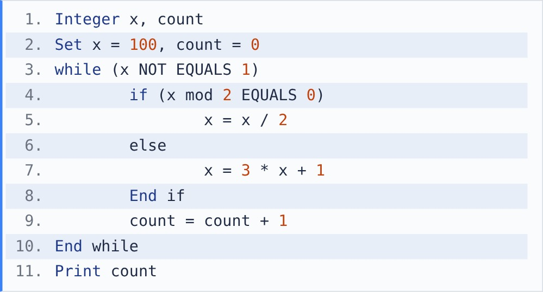
[Note - mod gives the remainder after division. / between integers is integer division.]

{OPTION 1} 24
{OPTION 2} 26
{OPTION 3} 100
{OPTION 4} 25
{OPTION 5}
{OPTION 6}
{OPTION 7}
{OPTION 8}
{OPTION 9}
{OPTION 10}
{RIGHT ANSWER} 4
{EXPLANATION} This is the Collatz sequence: 100, 50, 25, 76, 38, 19, 58, 29, 88, 44, 22, 11, 34, 17, 52, 26, 13, 40, 20, 10, 5, 16, 8, 4, 2, 1. Counting the steps to reach 1 gives 25.
{CORRECT MARKS} 1
{NEGATIVE MARKS} 0
{DIFFICULTY} Hard
{QUESTION ENDS}

{QUESTION BEGINS}
{QUESTION NUMBER} 4
{SUBJECT} Technical Assessment
{TOPIC} Pseudocode
{TAGS} accenture, technical assessment, pseudocode, mock test 6, medium
{QUESTION TYPE} SINGLECORRECT
{QUESTION TEXT} What will be the output of the following pseudocode?
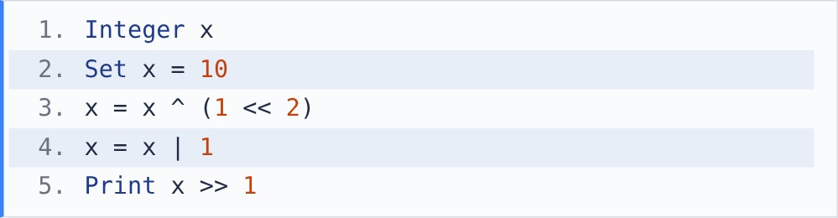
[Note - ^: XOR, |: OR, &: AND, <<: left shift (multiply by 2 per place), >>: right shift (integer divide by 2 per place).]

{OPTION 1} 7
{OPTION 2} 15
{OPTION 3} 6
{OPTION 4} 3
{OPTION 5}
{OPTION 6}
{OPTION 7}
{OPTION 8}
{OPTION 9}
{OPTION 10}
{RIGHT ANSWER} 1
{EXPLANATION} 10 = 1010. 1 << 2 = 0100, so x ^ 4 = 1110 = 14 (bit 2 toggled on). 14 | 1 = 1111 = 15. 15 >> 1 = 7.
{CORRECT MARKS} 1
{NEGATIVE MARKS} 0
{DIFFICULTY} Medium
{QUESTION ENDS}

{QUESTION BEGINS}
{QUESTION NUMBER} 5
{SUBJECT} Technical Assessment
{TOPIC} Pseudocode
{TAGS} accenture, technical assessment, pseudocode, mock test 6, medium
{QUESTION TYPE} SINGLECORRECT
{QUESTION TEXT} What will be the output of the following pseudocode?
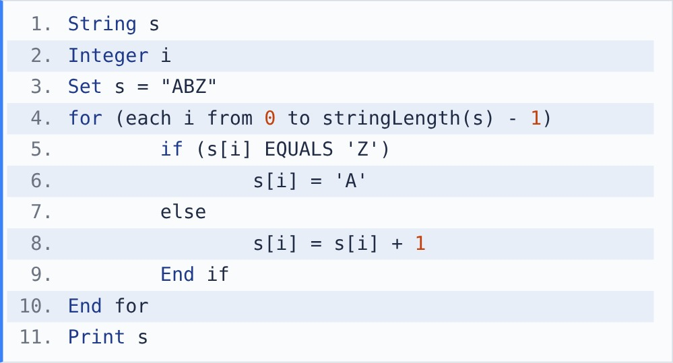
[Note - s[i] is the character at index i (starting at 0). stringLength(s) gives the number of characters. + joins strings.] [Note - Characters are stored as ASCII codes: 'A' = 65 ... 'Z' = 90, 'a' = 97 ... 'z' = 122. Adding 1 to a character gives the next character.]

{OPTION 1} BC[
{OPTION 2} ZAB
{OPTION 3} BCA
{OPTION 4} BCZ
{OPTION 5}
{OPTION 6}
{OPTION 7}
{OPTION 8}
{OPTION 9}
{OPTION 10}
{RIGHT ANSWER} 3
{EXPLANATION} Each letter moves one step forward (a Caesar shift) and 'Z' wraps round to 'A': A -> B, B -> C, Z -> A. Output: BCA. ('[' comes after 'Z' in ASCII, which is why the wrap is needed.)
{CORRECT MARKS} 1
{NEGATIVE MARKS} 0
{DIFFICULTY} Medium
{QUESTION ENDS}

{QUESTION BEGINS}
{QUESTION NUMBER} 6
{SUBJECT} Technical Assessment
{TOPIC} Pseudocode
{TAGS} accenture, technical assessment, pseudocode, mock test 6, medium
{QUESTION TYPE} SINGLECORRECT
{QUESTION TEXT} What will be the output of the following pseudocode?
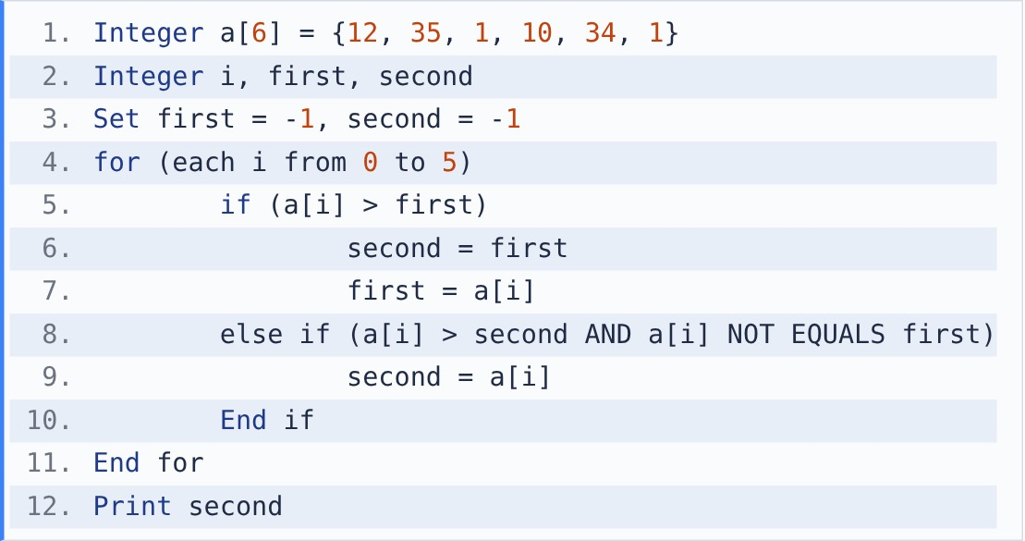

{OPTION 1} 35
{OPTION 2} 12
{OPTION 3} 10
{OPTION 4} 34
{OPTION 5}
{OPTION 6}
{OPTION 7}
{OPTION 8}
{OPTION 9}
{OPTION 10}
{RIGHT ANSWER} 4
{EXPLANATION} first keeps the largest, second the runner-up. After 12 and 35: first 35, second 12. 34 > 12, so second = 34. No other value beats it. Output: 34 (the second largest).
{CORRECT MARKS} 1
{NEGATIVE MARKS} 0
{DIFFICULTY} Medium
{QUESTION ENDS}

{QUESTION BEGINS}
{QUESTION NUMBER} 7
{SUBJECT} Technical Assessment
{TOPIC} Pseudocode
{TAGS} accenture, technical assessment, pseudocode, mock test 6, hard
{QUESTION TYPE} SINGLECORRECT
{QUESTION TEXT} What will be the output of the following pseudocode?
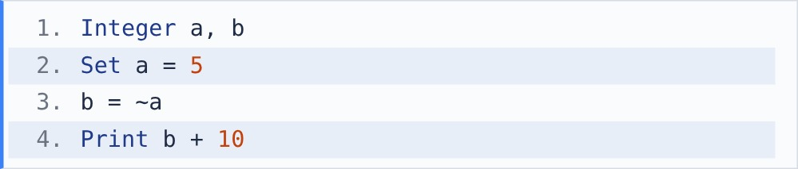
[Note - ~: bitwise NOT flips every bit. For integers stored in two's complement, ~x = -x - 1.]

{OPTION 1} 4
{OPTION 2} 15
{OPTION 3} 5
{OPTION 4} -4
{OPTION 5}
{OPTION 6}
{OPTION 7}
{OPTION 8}
{OPTION 9}
{OPTION 10}
{RIGHT ANSWER} 1
{EXPLANATION} ~5 = -5 - 1 = -6 (all bits of 0101 flipped in two's complement). -6 + 10 = 4.
{CORRECT MARKS} 1
{NEGATIVE MARKS} 0
{DIFFICULTY} Hard
{QUESTION ENDS}

{QUESTION BEGINS}
{QUESTION NUMBER} 8
{SUBJECT} Technical Assessment
{TOPIC} Pseudocode
{TAGS} accenture, technical assessment, pseudocode, mock test 6, medium
{QUESTION TYPE} SINGLECORRECT
{QUESTION TEXT} Which statement about the following pseudocode is correct?
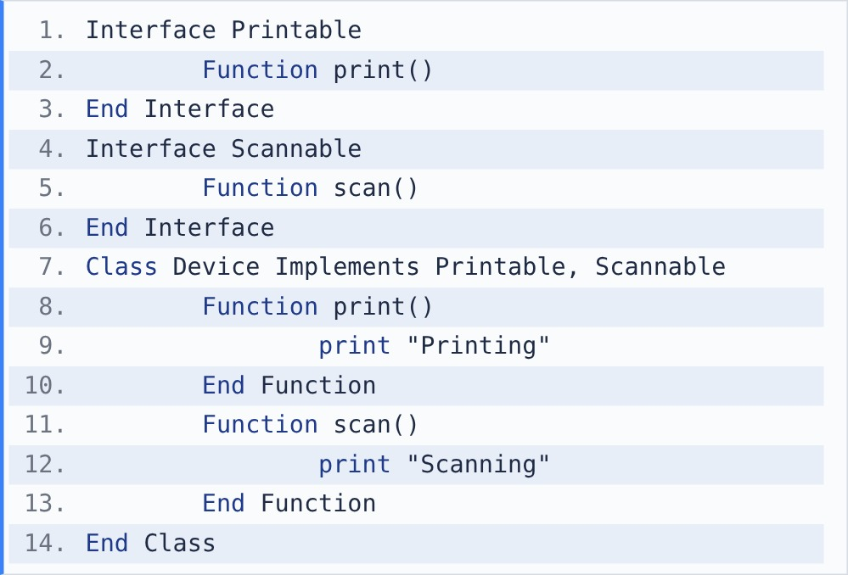

{OPTION 1} Device gets multiple inheritance through interfaces and must define both print() and scan()
{OPTION 2} Compilation error: a class cannot implement two interfaces
{OPTION 3} Device may skip scan(), because Printable is implemented first
{OPTION 4} Interfaces can be created directly like classes, e.g. Create Printable()
{OPTION 5}
{OPTION 6}
{OPTION 7}
{OPTION 8}
{OPTION 9}
{OPTION 10}
{RIGHT ANSWER} 1
{EXPLANATION} A class can implement several interfaces, which is how languages like Java get multiple inheritance. An interface only declares methods (abstraction), so the class must define every one of them. Interfaces cannot be instantiated.
{CORRECT MARKS} 1
{NEGATIVE MARKS} 0
{DIFFICULTY} Medium
{QUESTION ENDS}

{QUESTION BEGINS}
{QUESTION NUMBER} 9
{SUBJECT} Technical Assessment
{TOPIC} Pseudocode
{TAGS} accenture, technical assessment, pseudocode, mock test 6, medium
{QUESTION TYPE} SINGLECORRECT
{QUESTION TEXT} What will be the output of the following pseudocode?
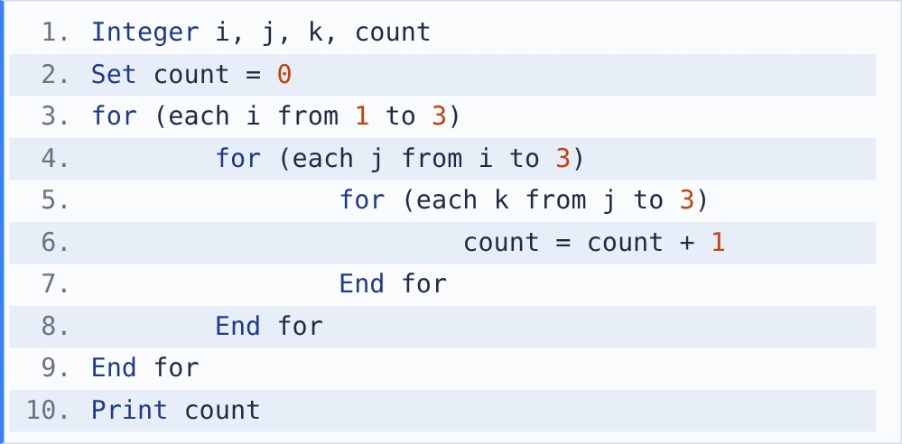

{OPTION 1} 27
{OPTION 2} 10
{OPTION 3} 6
{OPTION 4} 14
{OPTION 5}
{OPTION 6}
{OPTION 7}
{OPTION 8}
{OPTION 9}
{OPTION 10}
{RIGHT ANSWER} 2
{EXPLANATION} It counts triples with 1 <= i <= j <= k <= 3. i=1: 3 + 2 + 1 = 6. i=2: 2 + 1 = 3. i=3: 1. Total = 10.
{CORRECT MARKS} 1
{NEGATIVE MARKS} 0
{DIFFICULTY} Medium
{QUESTION ENDS}

{QUESTION BEGINS}
{QUESTION NUMBER} 10
{SUBJECT} Technical Assessment
{TOPIC} Pseudocode
{TAGS} accenture, technical assessment, pseudocode, mock test 6, medium
{QUESTION TYPE} SINGLECORRECT
{QUESTION TEXT} What will be the output of the following pseudocode?
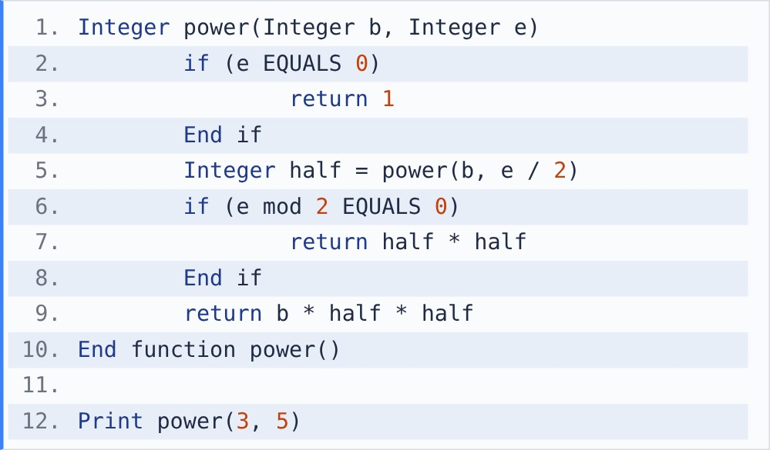
[Note - mod gives the remainder after division. / between integers is integer division.]

{OPTION 1} 15
{OPTION 2} 81
{OPTION 3} 243
{OPTION 4} 125
{OPTION 5}
{OPTION 6}
{OPTION 7}
{OPTION 8}
{OPTION 9}
{OPTION 10}
{RIGHT ANSWER} 3
{EXPLANATION} Fast exponentiation. power(3,0) = 1. power(3,1) = 3*1*1 = 3. power(3,2) = 3*3 = 9. power(3,5) = 3 * 9 * 9 = 243 = 3^5.
{CORRECT MARKS} 1
{NEGATIVE MARKS} 0
{DIFFICULTY} Medium
{QUESTION ENDS}

{QUESTION BEGINS}
{QUESTION NUMBER} 11
{SUBJECT} Technical Assessment
{TOPIC} Pseudocode
{TAGS} accenture, technical assessment, pseudocode, mock test 6, hard
{QUESTION TYPE} SINGLECORRECT
{QUESTION TEXT} What will be the output of the following pseudocode?
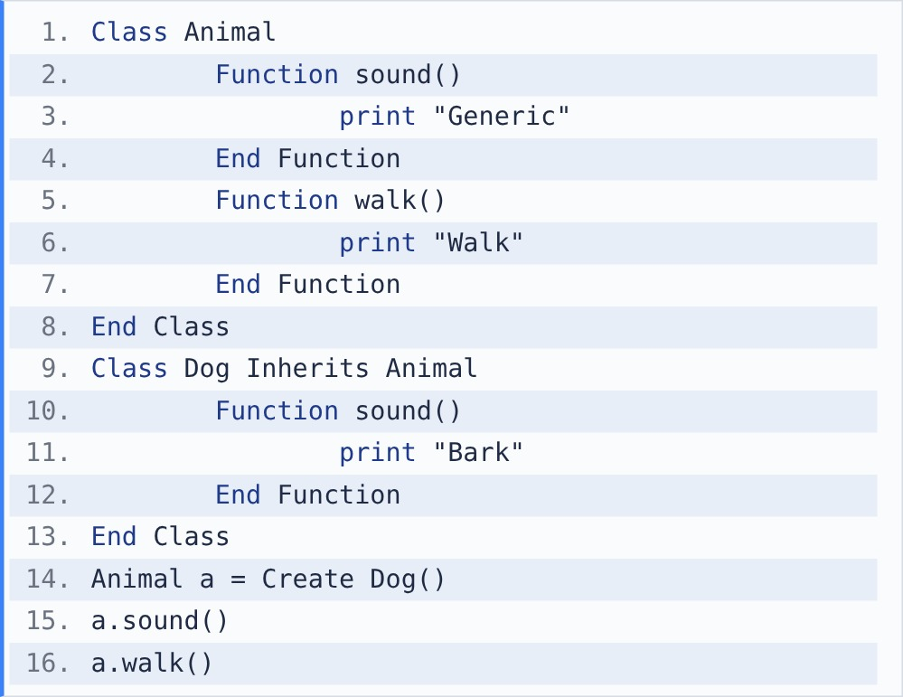

{OPTION 1} Generic Walk
{OPTION 2} Bark
{OPTION 3} Bark Walk
{OPTION 4} Compilation error
{OPTION 5}
{OPTION 6}
{OPTION 7}
{OPTION 8}
{OPTION 9}
{OPTION 10}
{RIGHT ANSWER} 3
{EXPLANATION} Runtime polymorphism: a is an Animal reference to a Dog object. sound() is overridden, so Dog's version runs (Bark). walk() is not overridden, so the inherited Animal version runs (Walk).
{CORRECT MARKS} 1
{NEGATIVE MARKS} 0
{DIFFICULTY} Hard
{QUESTION ENDS}

{QUESTION BEGINS}
{QUESTION NUMBER} 12
{SUBJECT} Technical Assessment
{TOPIC} Pseudocode
{TAGS} accenture, technical assessment, pseudocode, mock test 6, hard
{QUESTION TYPE} SINGLECORRECT
{QUESTION TEXT} What will be the output of the following pseudocode?
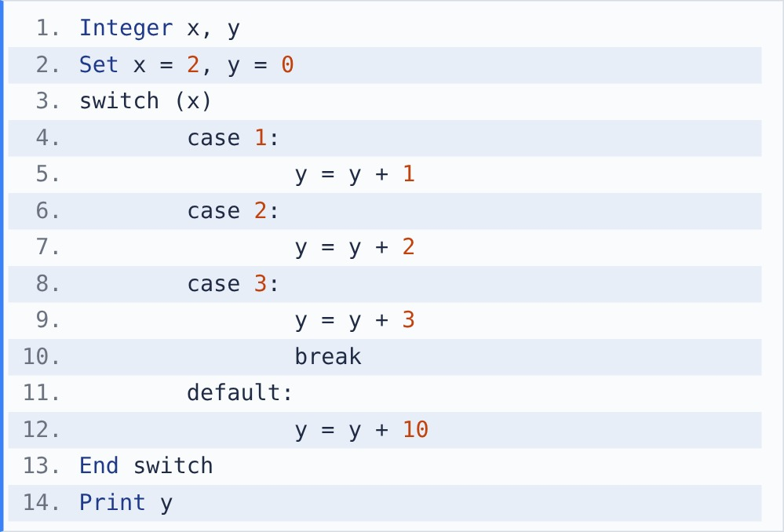
[Note - In a switch, execution starts at the matching case and falls through into the following cases until a break is reached.]

{OPTION 1} 5
{OPTION 2} 2
{OPTION 3} 15
{OPTION 4} 6
{OPTION 5}
{OPTION 6}
{OPTION 7}
{OPTION 8}
{OPTION 9}
{OPTION 10}
{RIGHT ANSWER} 1
{EXPLANATION} Execution starts at case 2 (y = 2). There is no break, so it falls through into case 3 (y = 5), where break stops it before default. Output: 5.
{CORRECT MARKS} 1
{NEGATIVE MARKS} 0
{DIFFICULTY} Hard
{QUESTION ENDS}

{QUESTION BEGINS}
{QUESTION NUMBER} 13
{SUBJECT} Technical Assessment
{TOPIC} Pseudocode
{TAGS} accenture, technical assessment, pseudocode, mock test 6, medium
{QUESTION TYPE} SINGLECORRECT
{QUESTION TEXT} What will be the output of the following pseudocode?
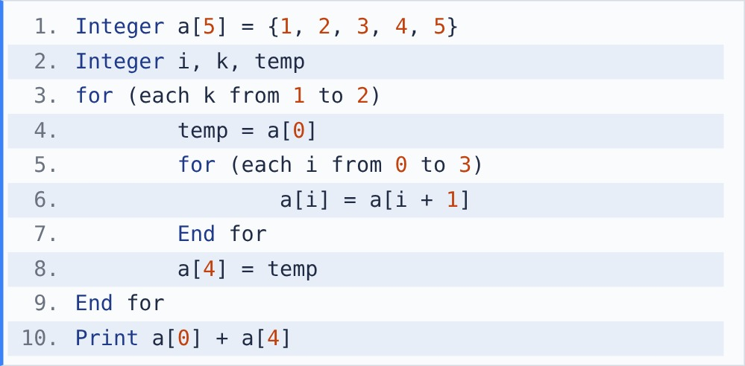

{OPTION 1} 6
{OPTION 2} 8
{OPTION 3} 4
{OPTION 4} 5
{OPTION 5}
{OPTION 6}
{OPTION 7}
{OPTION 8}
{OPTION 9}
{OPTION 10}
{RIGHT ANSWER} 4
{EXPLANATION} Each outer pass rotates the array left by one. After 2 passes: {3, 4, 5, 1, 2}. a[0] + a[4] = 3 + 2 = 5.
{CORRECT MARKS} 1
{NEGATIVE MARKS} 0
{DIFFICULTY} Medium
{QUESTION ENDS}

{QUESTION BEGINS}
{QUESTION NUMBER} 14
{SUBJECT} Technical Assessment
{TOPIC} Pseudocode
{TAGS} accenture, technical assessment, pseudocode, mock test 6, hard
{QUESTION TYPE} SINGLECORRECT
{QUESTION TEXT} What will be the output of the following pseudocode?
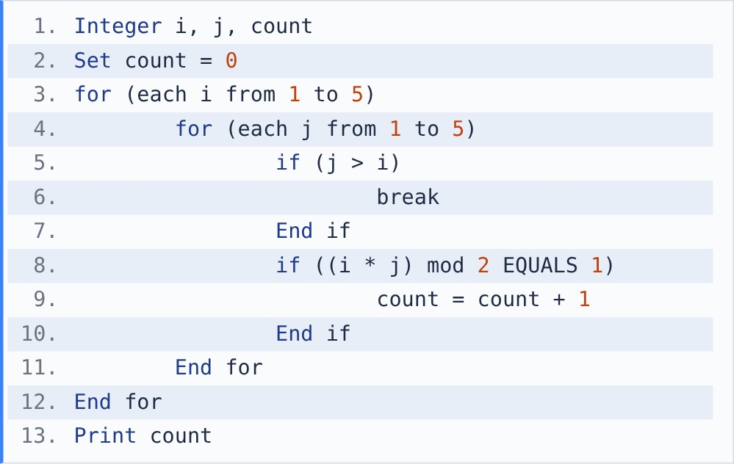
[Note - break exits the innermost loop immediately.] [Note - mod gives the remainder after division. / between integers is integer division.]

{OPTION 1} 9
{OPTION 2} 4
{OPTION 3} 3
{OPTION 4} 6
{OPTION 5}
{OPTION 6}
{OPTION 7}
{OPTION 8}
{OPTION 9}
{OPTION 10}
{RIGHT ANSWER} 4
{EXPLANATION} break limits j to 1..i. i * j is odd only when both are odd: i=1: (1,1); i=3: j=1,3; i=5: j=1,3,5. Even i give nothing. count = 1 + 2 + 3 = 6.
{CORRECT MARKS} 1
{NEGATIVE MARKS} 0
{DIFFICULTY} Hard
{QUESTION ENDS}

{QUESTION BEGINS}
{QUESTION NUMBER} 15
{SUBJECT} Technical Assessment
{TOPIC} Pseudocode
{TAGS} accenture, technical assessment, pseudocode, mock test 6, medium
{QUESTION TYPE} SINGLECORRECT
{QUESTION TEXT} What will be the output of the following pseudocode?
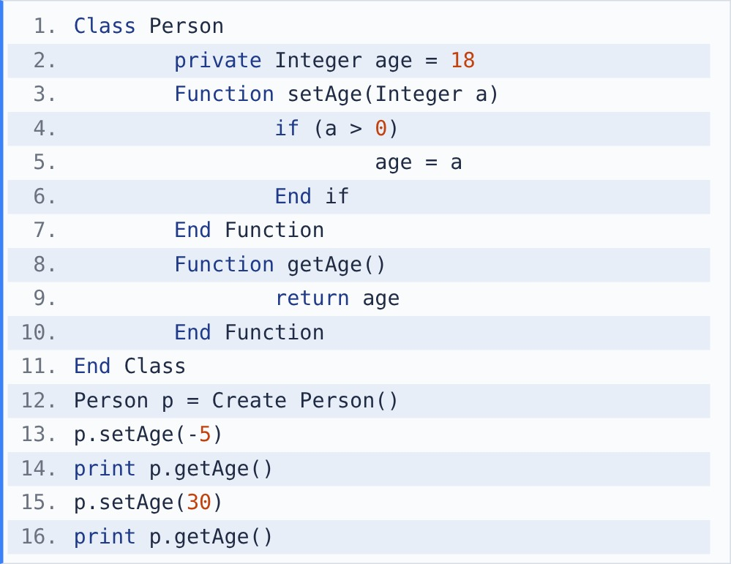

{OPTION 1} -5 30
{OPTION 2} 18 30
{OPTION 3} 18 18
{OPTION 4} 0 30
{OPTION 5}
{OPTION 6}
{OPTION 7}
{OPTION 8}
{OPTION 9}
{OPTION 10}
{RIGHT ANSWER} 2
{EXPLANATION} age is private and can change only through setAge(), which rejects values <= 0. setAge(-5) is ignored, so age stays 18. setAge(30) is valid. Output: 18 30.
{CORRECT MARKS} 1
{NEGATIVE MARKS} 0
{DIFFICULTY} Medium
{QUESTION ENDS}

{QUESTION BEGINS}
{QUESTION NUMBER} 16
{SUBJECT} Technical Assessment
{TOPIC} Pseudocode
{TAGS} accenture, technical assessment, pseudocode, mock test 6, easy
{QUESTION TYPE} SINGLECORRECT
{QUESTION TEXT} What will be the output of the following pseudocode?
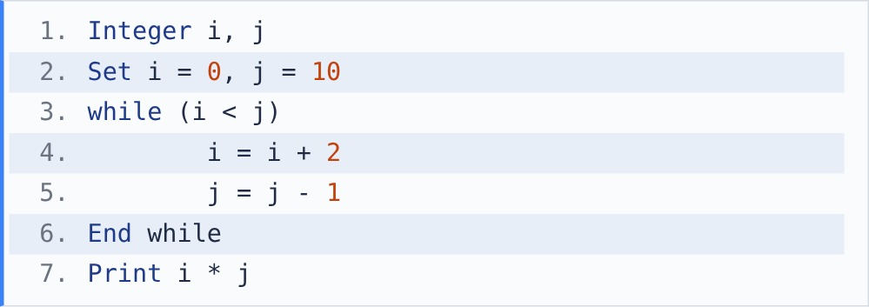

{OPTION 1} 56
{OPTION 2} 48
{OPTION 3} 40
{OPTION 4} 42
{OPTION 5}
{OPTION 6}
{OPTION 7}
{OPTION 8}
{OPTION 9}
{OPTION 10}
{RIGHT ANSWER} 2
{EXPLANATION} (i, j): (2, 9), (4, 8), (6, 7), (8, 6). Now 8 < 6 is false, so the loop stops. 8 * 6 = 48.
{CORRECT MARKS} 1
{NEGATIVE MARKS} 0
{DIFFICULTY} Easy
{QUESTION ENDS}

{QUESTION BEGINS}
{QUESTION NUMBER} 17
{SUBJECT} Technical Assessment
{TOPIC} Pseudocode
{TAGS} accenture, technical assessment, pseudocode, mock test 6, medium
{QUESTION TYPE} SINGLECORRECT
{QUESTION TEXT} What will be the output of the following pseudocode?
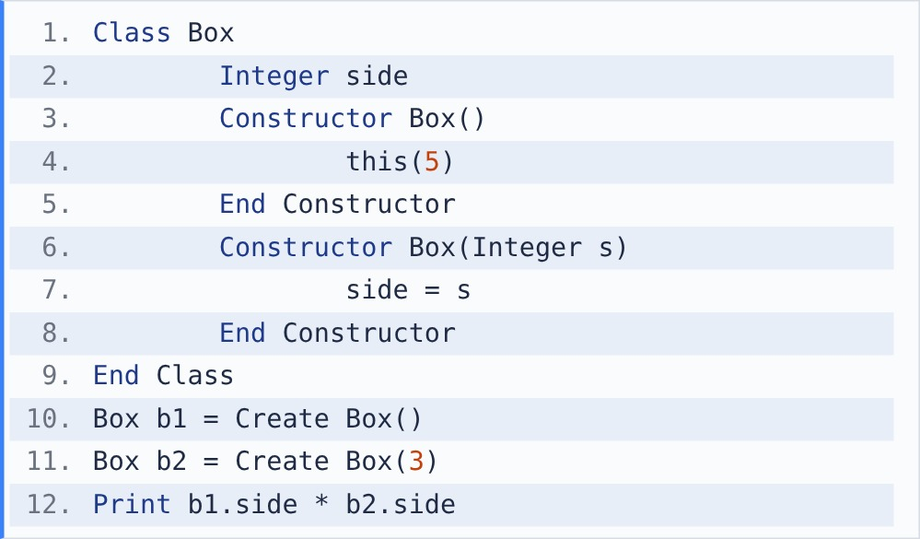
[Note - this(...) inside a constructor calls another constructor of the same class.]

{OPTION 1} 0
{OPTION 2} 15
{OPTION 3} 25
{OPTION 4} 9
{OPTION 5}
{OPTION 6}
{OPTION 7}
{OPTION 8}
{OPTION 9}
{OPTION 10}
{RIGHT ANSWER} 2
{EXPLANATION} Constructor overloading: Box() has no parameter and passes 5 to Box(Integer s) using this(5), so b1.side = 5. b2 calls Box(3) directly, so b2.side = 3. 5 * 3 = 15.
{CORRECT MARKS} 1
{NEGATIVE MARKS} 0
{DIFFICULTY} Medium
{QUESTION ENDS}

{QUESTION BEGINS}
{QUESTION NUMBER} 18
{SUBJECT} Technical Assessment
{TOPIC} Pseudocode
{TAGS} accenture, technical assessment, pseudocode, mock test 6, hard
{QUESTION TYPE} SINGLECORRECT
{QUESTION TEXT} What will be the output of the following pseudocode?
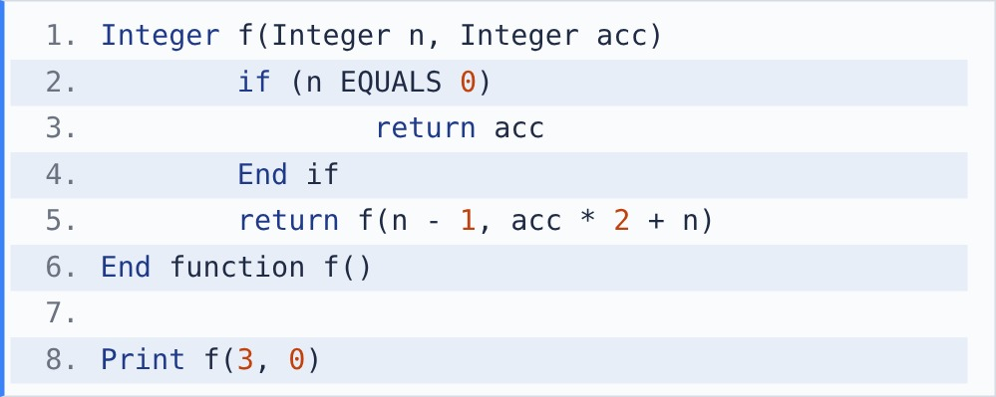

{OPTION 1} 17
{OPTION 2} 6
{OPTION 3} 14
{OPTION 4} 11
{OPTION 5}
{OPTION 6}
{OPTION 7}
{OPTION 8}
{OPTION 9}
{OPTION 10}
{RIGHT ANSWER} 1
{EXPLANATION} The accumulator carries the result down (tail recursion). f(3,0) -> f(2, 0*2+3 = 3) -> f(1, 3*2+2 = 8) -> f(0, 8*2+1 = 17) -> returns 17.
{CORRECT MARKS} 1
{NEGATIVE MARKS} 0
{DIFFICULTY} Hard
{QUESTION ENDS}

{QUESTION BEGINS}
{QUESTION NUMBER} 19
{SUBJECT} Technical Assessment
{TOPIC} Pseudocode
{TAGS} accenture, technical assessment, pseudocode, mock test 6, hard
{QUESTION TYPE} SINGLECORRECT
{QUESTION TEXT} What will be the output of the following pseudocode?
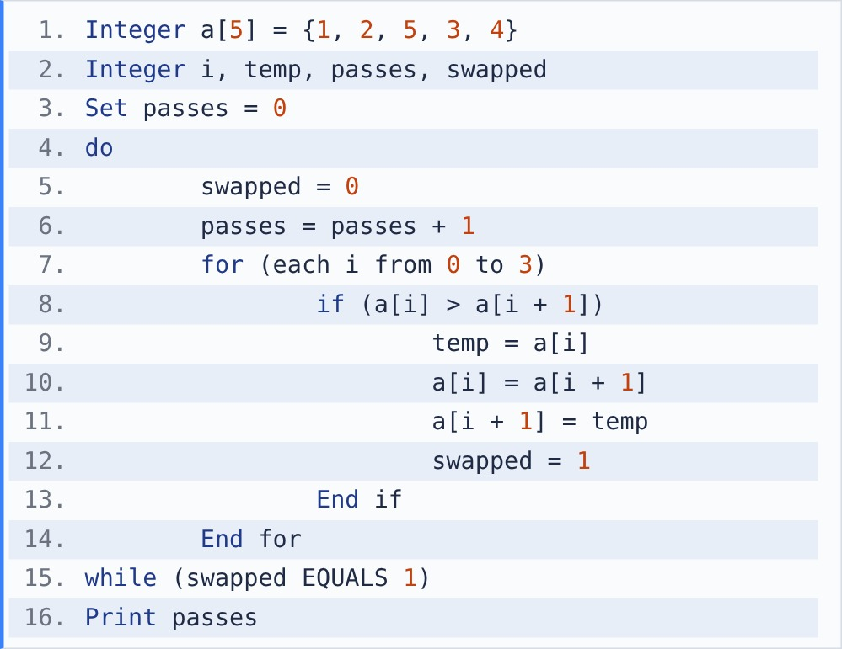

{OPTION 1} 2
{OPTION 2} 4
{OPTION 3} 1
{OPTION 4} 5
{OPTION 5}
{OPTION 6}
{OPTION 7}
{OPTION 8}
{OPTION 9}
{OPTION 10}
{RIGHT ANSWER} 1
{EXPLANATION} Bubble sort with an early exit. Pass 1 swaps 5/3 and 5/4, giving {1, 2, 3, 4, 5} (swapped = 1). Pass 2 makes no swap, so the loop stops. passes = 2.
{CORRECT MARKS} 1
{NEGATIVE MARKS} 0
{DIFFICULTY} Hard
{QUESTION ENDS}

{QUESTION BEGINS}
{QUESTION NUMBER} 20
{SUBJECT} Technical Assessment
{TOPIC} Pseudocode
{TAGS} accenture, technical assessment, pseudocode, mock test 6, medium
{QUESTION TYPE} SINGLECORRECT
{QUESTION TEXT} What will be the output of the following pseudocode?
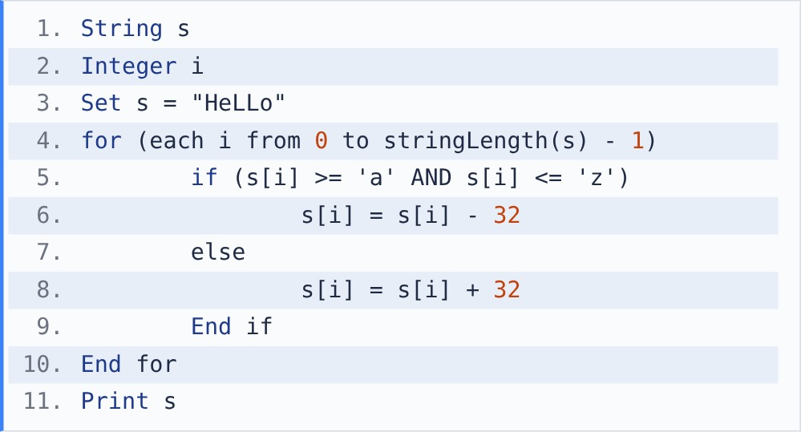
[Note - s[i] is the character at index i (starting at 0). stringLength(s) gives the number of characters. + joins strings.] [Note - Characters are stored as ASCII codes: 'A' = 65 ... 'Z' = 90, 'a' = 97 ... 'z' = 122. Adding 1 to a character gives the next character.]

{OPTION 1} HELLO
{OPTION 2} hello
{OPTION 3} HeLLo
{OPTION 4} hEllO
{OPTION 5}
{OPTION 6}
{OPTION 7}
{OPTION 8}
{OPTION 9}
{OPTION 10}
{RIGHT ANSWER} 4
{EXPLANATION} Upper and lower case letters differ by 32 in ASCII ('a' = 97, 'A' = 65). Lowercase letters become uppercase (- 32) and uppercase become lowercase (+ 32): HeLLo -> hEllO.
{CORRECT MARKS} 1
{NEGATIVE MARKS} 0
{DIFFICULTY} Medium
{QUESTION ENDS}

{QUESTION BEGINS}
{QUESTION NUMBER} 21
{SUBJECT} Technical Assessment
{TOPIC} Pseudocode
{TAGS} accenture, technical assessment, pseudocode, mock test 6, medium
{QUESTION TYPE} SINGLECORRECT
{QUESTION TEXT} What will be the output of the following pseudocode?
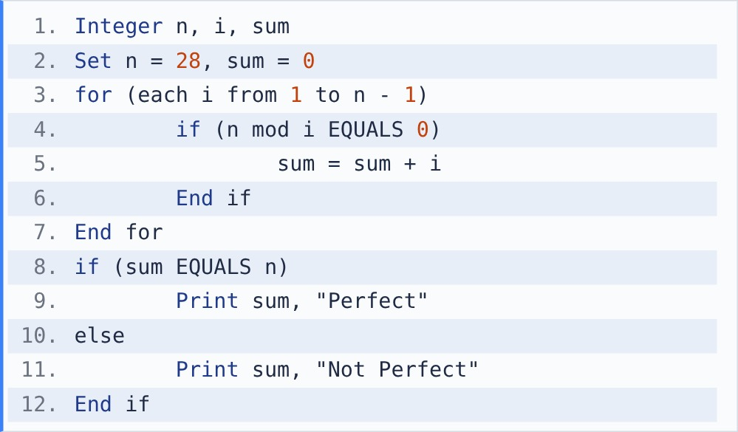
[Note - mod gives the remainder after division. / between integers is integer division.]

{OPTION 1} 28 Perfect
{OPTION 2} 56 Not Perfect
{OPTION 3} 27 Not Perfect
{OPTION 4} 28 Not Perfect
{OPTION 5}
{OPTION 6}
{OPTION 7}
{OPTION 8}
{OPTION 9}
{OPTION 10}
{RIGHT ANSWER} 1
{EXPLANATION} Divisors of 28 below 28: 1, 2, 4, 7, 14. Their sum is 28, equal to n, so it prints 28 Perfect.
{CORRECT MARKS} 1
{NEGATIVE MARKS} 0
{DIFFICULTY} Medium
{QUESTION ENDS}

{QUESTION BEGINS}
{QUESTION NUMBER} 22
{SUBJECT} Technical Assessment
{TOPIC} Pseudocode
{TAGS} accenture, technical assessment, pseudocode, mock test 6, medium
{QUESTION TYPE} SINGLECORRECT
{QUESTION TEXT} What will be the output of the following pseudocode?
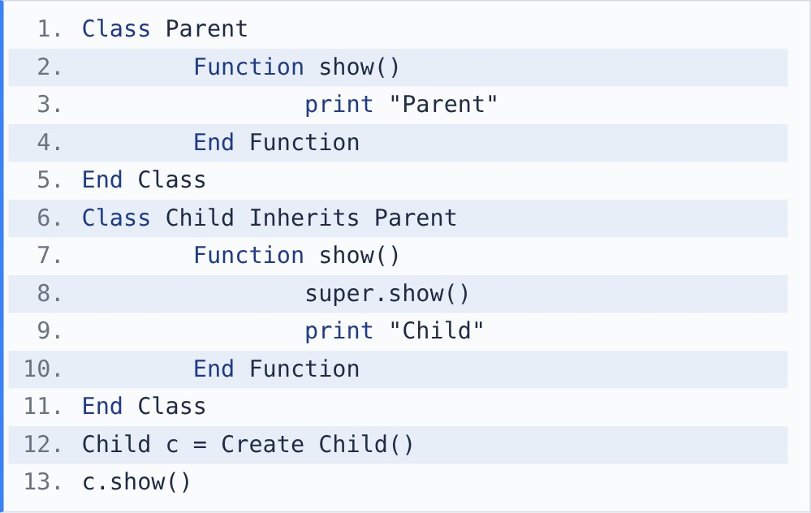
[Note - super refers to the parent class.]

{OPTION 1} Child Parent
{OPTION 2} Parent Child
{OPTION 3} Child
{OPTION 4} Parent
{OPTION 5}
{OPTION 6}
{OPTION 7}
{OPTION 8}
{OPTION 9}
{OPTION 10}
{RIGHT ANSWER} 2
{EXPLANATION} Child overrides show() but first calls super.show(), which runs the Parent version. So Parent is printed, then Child.
{CORRECT MARKS} 1
{NEGATIVE MARKS} 0
{DIFFICULTY} Medium
{QUESTION ENDS}

{QUESTION BEGINS}
{QUESTION NUMBER} 23
{SUBJECT} Technical Assessment
{TOPIC} Pseudocode
{TAGS} accenture, technical assessment, pseudocode, mock test 6, easy
{QUESTION TYPE} SINGLECORRECT
{QUESTION TEXT} What will be the output of the following pseudocode?
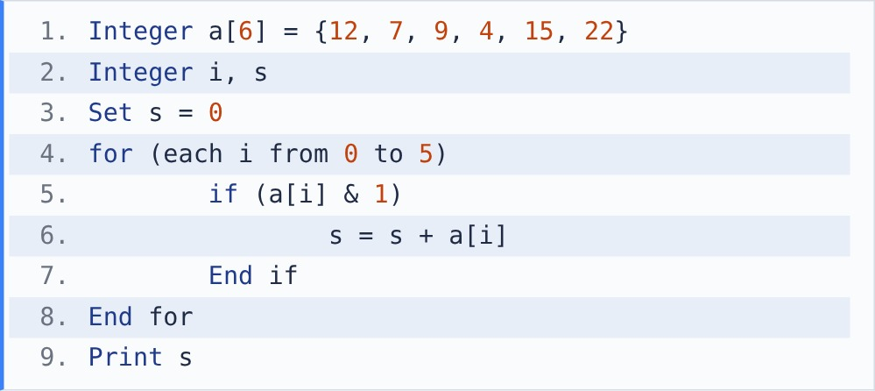
[Note - &: bitwise AND. A result bit is 1 only if both bits are 1.]

{OPTION 1} 38
{OPTION 2} 69
{OPTION 3} 31
{OPTION 4} 3
{OPTION 5}
{OPTION 6}
{OPTION 7}
{OPTION 8}
{OPTION 9}
{OPTION 10}
{RIGHT ANSWER} 3
{EXPLANATION} a[i] & 1 is 1 for odd numbers (last bit set). Odd values: 7, 9, 15. s = 7 + 9 + 15 = 31.
{CORRECT MARKS} 1
{NEGATIVE MARKS} 0
{DIFFICULTY} Easy
{QUESTION ENDS}

{QUESTION BEGINS}
{QUESTION NUMBER} 24
{SUBJECT} Technical Assessment
{TOPIC} Pseudocode
{TAGS} accenture, technical assessment, pseudocode, mock test 6, medium
{QUESTION TYPE} SINGLECORRECT
{QUESTION TEXT} What will be the output of the following pseudocode?
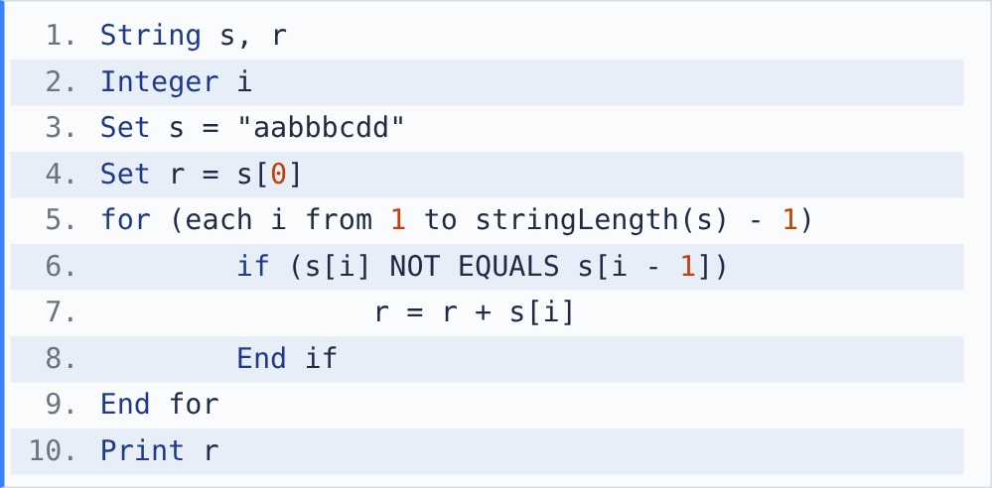
[Note - s[i] is the character at index i (starting at 0). stringLength(s) gives the number of characters. + joins strings.]

{OPTION 1} abd
{OPTION 2} abcd
{OPTION 3} aabbcd
{OPTION 4} abcdd
{OPTION 5}
{OPTION 6}
{OPTION 7}
{OPTION 8}
{OPTION 9}
{OPTION 10}
{RIGHT ANSWER} 2
{EXPLANATION} A character is added only when it differs from the one just before it, so each run of equal letters keeps one copy: aa -> a, bbb -> b, c, dd -> d. Output: abcd.
{CORRECT MARKS} 1
{NEGATIVE MARKS} 0
{DIFFICULTY} Medium
{QUESTION ENDS}

{QUESTION BEGINS}
{QUESTION NUMBER} 25
{SUBJECT} Technical Assessment
{TOPIC} Pseudocode
{TAGS} accenture, technical assessment, pseudocode, mock test 6, medium
{QUESTION TYPE} SINGLECORRECT
{QUESTION TEXT} What will be the output of the following pseudocode?
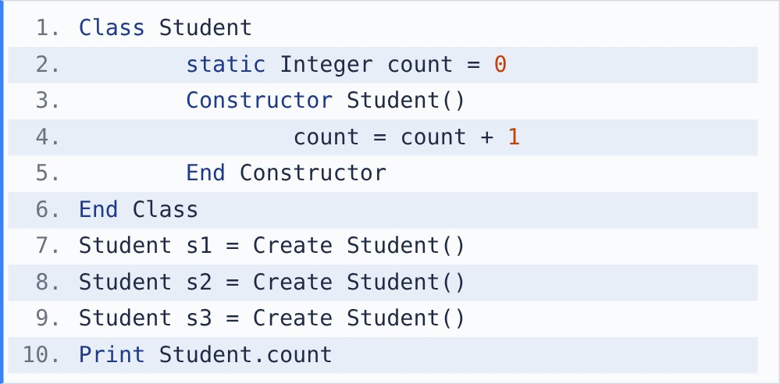
[Note - A static class variable is shared by all objects of the class.]

{OPTION 1} 1
{OPTION 2} 0
{OPTION 3} 3
{OPTION 4} Compilation error
{OPTION 5}
{OPTION 6}
{OPTION 7}
{OPTION 8}
{OPTION 9}
{OPTION 10}
{RIGHT ANSWER} 3
{EXPLANATION} count is static, so all objects share one copy. Each constructor call adds 1: three objects give count = 3. (A normal instance variable would be 1 in each object.)
{CORRECT MARKS} 1
{NEGATIVE MARKS} 0
{DIFFICULTY} Medium
{QUESTION ENDS}

{QUESTION BEGINS}
{QUESTION NUMBER} 26
{SUBJECT} Technical Assessment
{TOPIC} Pseudocode
{TAGS} accenture, technical assessment, pseudocode, mock test 6, hard
{QUESTION TYPE} SINGLECORRECT
{QUESTION TEXT} What will be the output of the following pseudocode?
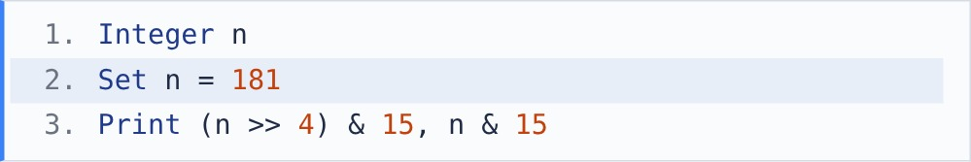
[Note - ^: XOR, |: OR, &: AND, <<: left shift (multiply by 2 per place), >>: right shift (integer divide by 2 per place).]

{OPTION 1} 5 11
{OPTION 2} 10 5
{OPTION 3} 11 4
{OPTION 4} 11 5
{OPTION 5}
{OPTION 6}
{OPTION 7}
{OPTION 8}
{OPTION 9}
{OPTION 10}
{RIGHT ANSWER} 4
{EXPLANATION} 181 = 1011 0101. n >> 4 = 1011, and & 15 keeps the low 4 bits: 11. n & 15 = 0101 = 5. These are the upper and lower halves (nibbles) of the byte: 11 5.
{CORRECT MARKS} 1
{NEGATIVE MARKS} 0
{DIFFICULTY} Hard
{QUESTION ENDS}

{QUESTION BEGINS}
{QUESTION NUMBER} 27
{SUBJECT} Technical Assessment
{TOPIC} Pseudocode
{TAGS} accenture, technical assessment, pseudocode, mock test 6, hard
{QUESTION TYPE} SINGLECORRECT
{QUESTION TEXT} What will be printed when bs(a, 0, 6, 57) is called?
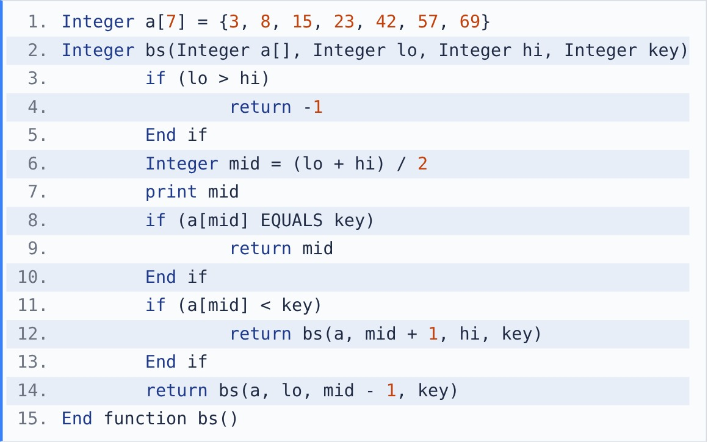
[Note - mod gives the remainder after division. / between integers is integer division.]

{OPTION 1} 3 4 5
{OPTION 2} 3 5
{OPTION 3} 5
{OPTION 4} 3 5 6
{OPTION 5}
{OPTION 6}
{OPTION 7}
{OPTION 8}
{OPTION 9}
{OPTION 10}
{RIGHT ANSWER} 2
{EXPLANATION} Recursive binary search prints each mid. mid = (0+6)/2 = 3: a[3] = 23 < 57, search 4..6. mid = (4+6)/2 = 5: a[5] = 57, found. Printed: 3 5.
{CORRECT MARKS} 1
{NEGATIVE MARKS} 0
{DIFFICULTY} Hard
{QUESTION ENDS}

{QUESTION BEGINS}
{QUESTION NUMBER} 28
{SUBJECT} Technical Assessment
{TOPIC} Pseudocode
{TAGS} accenture, technical assessment, pseudocode, mock test 6, medium
{QUESTION TYPE} SINGLECORRECT
{QUESTION TEXT} What will be the output of the following pseudocode?
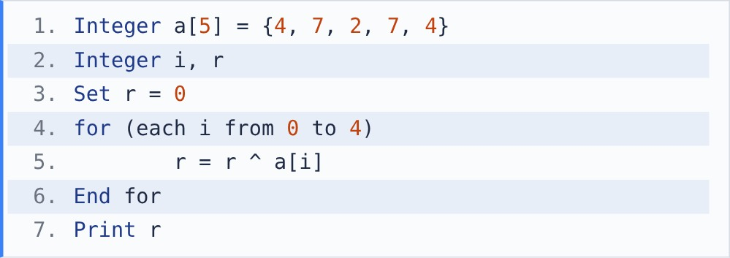
[Note - ^: bitwise XOR. A result bit is 1 only when the two bits are different.]

{OPTION 1} 0
{OPTION 2} 24
{OPTION 3} 2
{OPTION 4} 7
{OPTION 5}
{OPTION 6}
{OPTION 7}
{OPTION 8}
{OPTION 9}
{OPTION 10}
{RIGHT ANSWER} 3
{EXPLANATION} x ^ x = 0 and x ^ 0 = x, so every number that appears twice cancels out. Only 2 appears once, so r = 2.
{CORRECT MARKS} 1
{NEGATIVE MARKS} 0
{DIFFICULTY} Medium
{QUESTION ENDS}

{QUESTION BEGINS}
{QUESTION NUMBER} 29
{SUBJECT} Technical Assessment
{TOPIC} Pseudocode
{TAGS} accenture, technical assessment, pseudocode, mock test 6, hard
{QUESTION TYPE} SINGLECORRECT
{QUESTION TEXT} What will be the output of the following pseudocode?
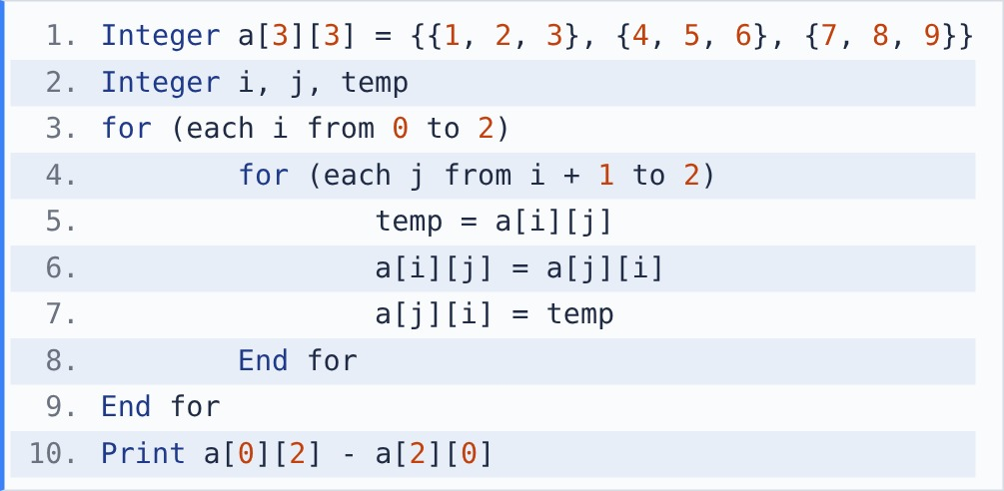

{OPTION 1} -4
{OPTION 2} 0
{OPTION 3} 4
{OPTION 4} 6
{OPTION 5}
{OPTION 6}
{OPTION 7}
{OPTION 8}
{OPTION 9}
{OPTION 10}
{RIGHT ANSWER} 3
{EXPLANATION} Swapping a[i][j] with a[j][i] above the diagonal transposes the matrix: rows become columns. After it a[0][2] = 7 and a[2][0] = 3, so 7 - 3 = 4.
{CORRECT MARKS} 1
{NEGATIVE MARKS} 0
{DIFFICULTY} Hard
{QUESTION ENDS}

{QUESTION BEGINS}
{QUESTION NUMBER} 30
{SUBJECT} Technical Assessment
{TOPIC} Pseudocode
{TAGS} accenture, technical assessment, pseudocode, mock test 6, medium
{QUESTION TYPE} SINGLECORRECT
{QUESTION TEXT} What will be the output of the following pseudocode?
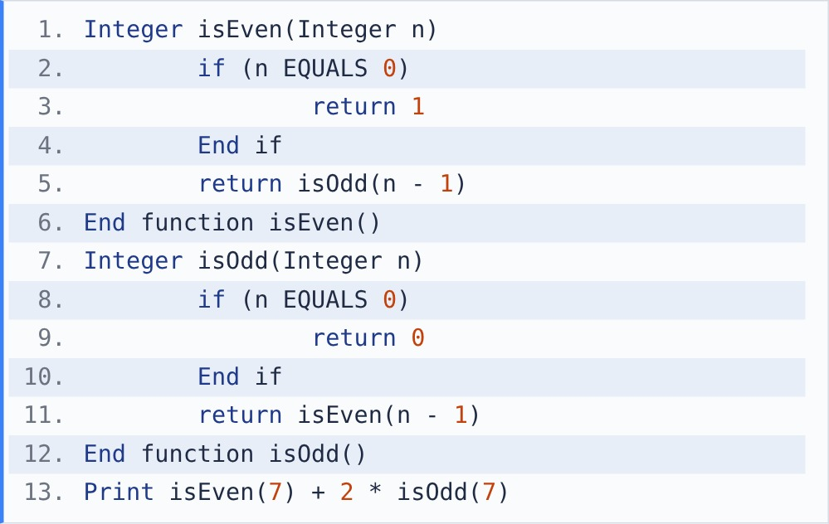

{OPTION 1} 2
{OPTION 2} 1
{OPTION 3} 0
{OPTION 4} 3
{OPTION 5}
{OPTION 6}
{OPTION 7}
{OPTION 8}
{OPTION 9}
{OPTION 10}
{RIGHT ANSWER} 1
{EXPLANATION} The two functions call each other (mutual recursion), flipping between them until n = 0. 7 is odd, so isEven(7) = 0 and isOdd(7) = 1. 0 + 2 * 1 = 2.
{CORRECT MARKS} 1
{NEGATIVE MARKS} 0
{DIFFICULTY} Medium
{QUESTION ENDS}

{QUESTION BEGINS}
{QUESTION NUMBER} 31
{SUBJECT} Technical Assessment
{TOPIC} Pseudocode
{TAGS} accenture, technical assessment, pseudocode, mock test 6, medium
{QUESTION TYPE} SINGLECORRECT
{QUESTION TEXT} What will be the output of the following pseudocode?
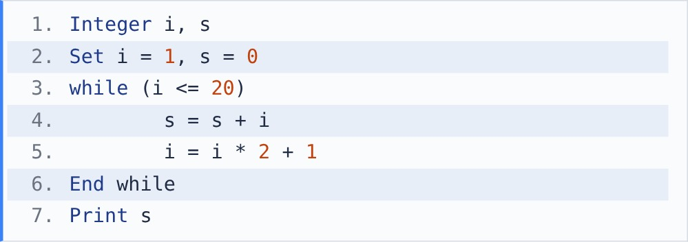

{OPTION 1} 57
{OPTION 2} 26
{OPTION 3} 11
{OPTION 4} 15
{OPTION 5}
{OPTION 6}
{OPTION 7}
{OPTION 8}
{OPTION 9}
{OPTION 10}
{RIGHT ANSWER} 2
{EXPLANATION} i takes 1, 3, 7, 15 (next would be 31 > 20). s = 1 + 3 + 7 + 15 = 26.
{CORRECT MARKS} 1
{NEGATIVE MARKS} 0
{DIFFICULTY} Medium
{QUESTION ENDS}

{QUESTION BEGINS}
{QUESTION NUMBER} 32
{SUBJECT} Technical Assessment
{TOPIC} Pseudocode
{TAGS} accenture, technical assessment, pseudocode, mock test 6, medium
{QUESTION TYPE} SINGLECORRECT
{QUESTION TEXT} What will be the output of the following pseudocode?
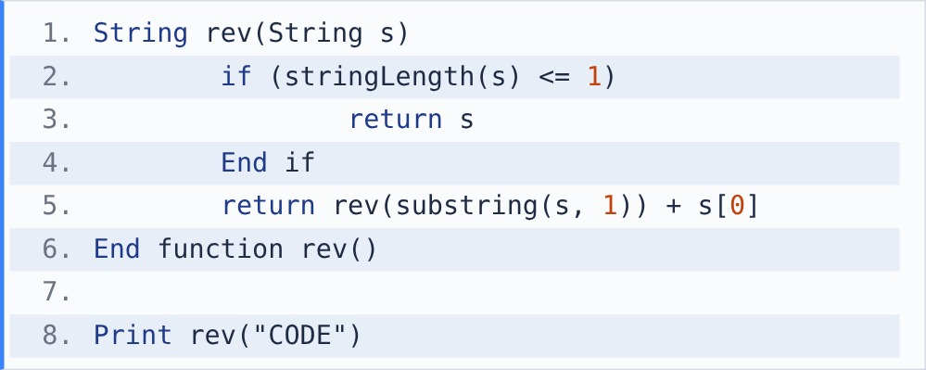
[Note - s[i] is the character at index i (starting at 0). stringLength(s) gives the number of characters. + joins strings.] [Note - substring(s, i) returns the part of s from index i to the end. substring(s, i, k) returns k characters starting at index i.]

{OPTION 1} CODE
{OPTION 2} EDOC
{OPTION 3} ODEC
{OPTION 4} EDO
{OPTION 5}
{OPTION 6}
{OPTION 7}
{OPTION 8}
{OPTION 9}
{OPTION 10}
{RIGHT ANSWER} 2
{EXPLANATION} rev puts the first character after the reversed rest: rev("E") = E, rev("DE") = E + D, rev("ODE") = ED + O, rev("CODE") = EDO + C = EDOC.
{CORRECT MARKS} 1
{NEGATIVE MARKS} 0
{DIFFICULTY} Medium
{QUESTION ENDS}

{QUESTION BEGINS}
{QUESTION NUMBER} 33
{SUBJECT} Technical Assessment
{TOPIC} Pseudocode
{TAGS} accenture, technical assessment, pseudocode, mock test 6, medium
{QUESTION TYPE} SINGLECORRECT
{QUESTION TEXT} What will be the output of the following pseudocode?
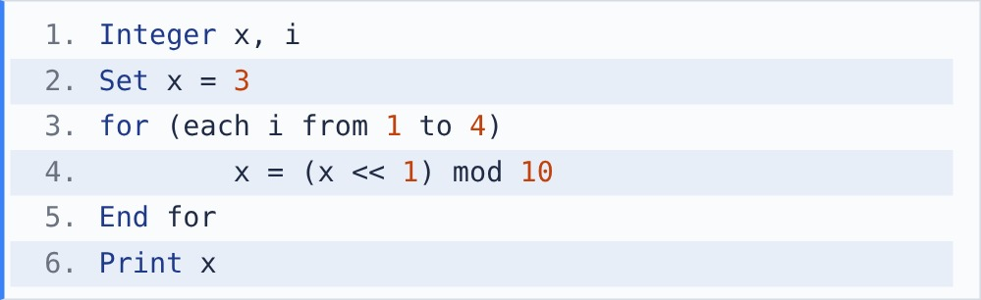
[Note - ^: XOR, |: OR, &: AND, <<: left shift (multiply by 2 per place), >>: right shift (integer divide by 2 per place).] [Note - mod gives the remainder after division. / between integers is integer division.]

{OPTION 1} 8
{OPTION 2} 48
{OPTION 3} 6
{OPTION 4} 4
{OPTION 5}
{OPTION 6}
{OPTION 7}
{OPTION 8}
{OPTION 9}
{OPTION 10}
{RIGHT ANSWER} 1
{EXPLANATION} Each step doubles x and keeps the last digit: 3 -> 6 -> 12 mod 10 = 2 -> 4 -> 8. Output: 8.
{CORRECT MARKS} 1
{NEGATIVE MARKS} 0
{DIFFICULTY} Medium
{QUESTION ENDS}

{QUESTION BEGINS}
{QUESTION NUMBER} 34
{SUBJECT} Technical Assessment
{TOPIC} Pseudocode
{TAGS} accenture, technical assessment, pseudocode, mock test 6, hard
{QUESTION TYPE} SINGLECORRECT
{QUESTION TEXT} What will be the output of the following pseudocode?
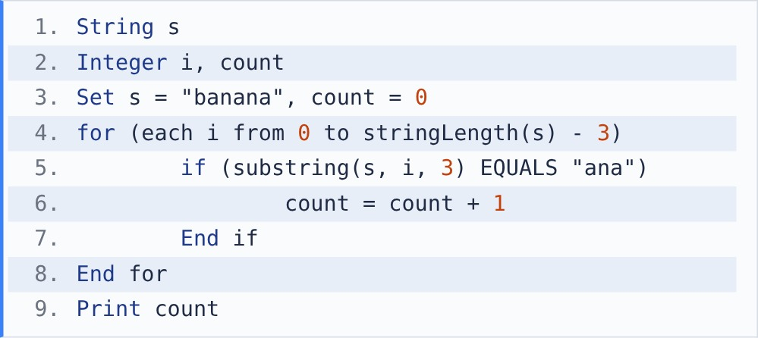
[Note - s[i] is the character at index i (starting at 0). stringLength(s) gives the number of characters. + joins strings.] [Note - substring(s, i) returns the part of s from index i to the end. substring(s, i, k) returns k characters starting at index i.]

{OPTION 1} 2
{OPTION 2} 1
{OPTION 3} 3
{OPTION 4} 0
{OPTION 5}
{OPTION 6}
{OPTION 7}
{OPTION 8}
{OPTION 9}
{OPTION 10}
{RIGHT ANSWER} 1
{EXPLANATION} Windows of 3 characters: ban, ana, nan, ana. "ana" matches at index 1 and index 3 (the matches overlap). count = 2.
{CORRECT MARKS} 1
{NEGATIVE MARKS} 0
{DIFFICULTY} Hard
{QUESTION ENDS}

{QUESTION BEGINS}
{QUESTION NUMBER} 35
{SUBJECT} Technical Assessment
{TOPIC} Pseudocode
{TAGS} accenture, technical assessment, pseudocode, mock test 6, easy
{QUESTION TYPE} SINGLECORRECT
{QUESTION TEXT} What will be the output of the following pseudocode?
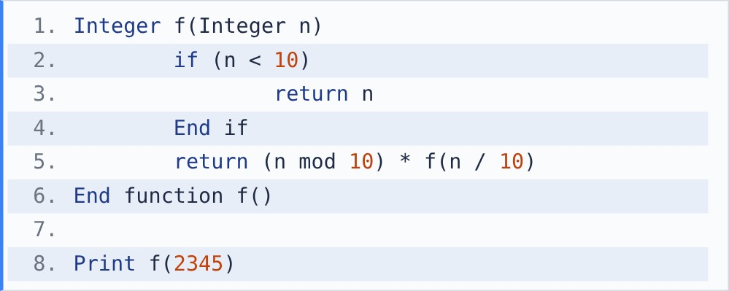
[Note - mod gives the remainder after division. / between integers is integer division.]

{OPTION 1} 14
{OPTION 2} 5432
{OPTION 3} 120
{OPTION 4} 24
{OPTION 5}
{OPTION 6}
{OPTION 7}
{OPTION 8}
{OPTION 9}
{OPTION 10}
{RIGHT ANSWER} 3
{EXPLANATION} It multiplies the digits: 5 * f(234) = 5 * 4 * f(23) = 5 * 4 * 3 * f(2) = 5 * 4 * 3 * 2 = 120.
{CORRECT MARKS} 1
{NEGATIVE MARKS} 0
{DIFFICULTY} Easy
{QUESTION ENDS}

{QUESTION BEGINS}
{QUESTION NUMBER} 36
{SUBJECT} Technical Assessment
{TOPIC} Pseudocode
{TAGS} accenture, technical assessment, pseudocode, mock test 6, medium
{QUESTION TYPE} SINGLECORRECT
{QUESTION TEXT} What will be the output of the following pseudocode?
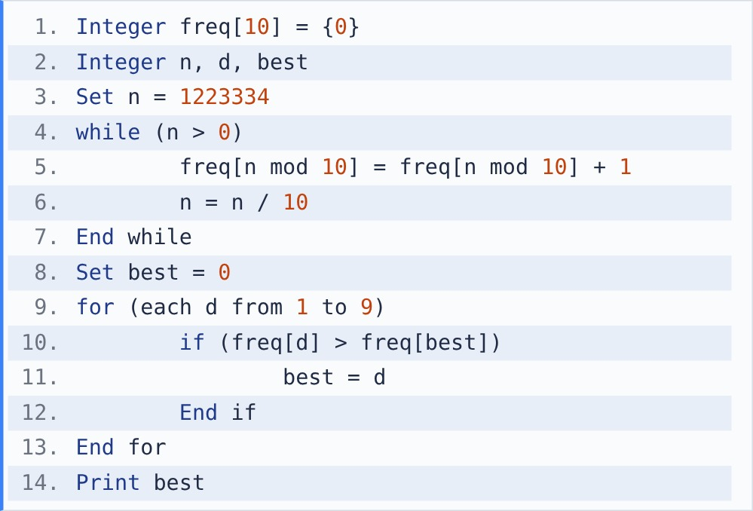
[Note - mod gives the remainder after division. / between integers is integer division.]

{OPTION 1} 2
{OPTION 2} 7
{OPTION 3} 1
{OPTION 4} 3
{OPTION 5}
{OPTION 6}
{OPTION 7}
{OPTION 8}
{OPTION 9}
{OPTION 10}
{RIGHT ANSWER} 4
{EXPLANATION} freq counts each digit of 1223334: 1 -> 1, 2 -> 2, 3 -> 3, 4 -> 1. best ends as the digit with the highest count, which is 3.
{CORRECT MARKS} 1
{NEGATIVE MARKS} 0
{DIFFICULTY} Medium
{QUESTION ENDS}

{QUESTION BEGINS}
{QUESTION NUMBER} 37
{SUBJECT} Technical Assessment
{TOPIC} Pseudocode
{TAGS} accenture, technical assessment, pseudocode, mock test 6, easy
{QUESTION TYPE} SINGLECORRECT
{QUESTION TEXT} What will be the output of the following pseudocode?
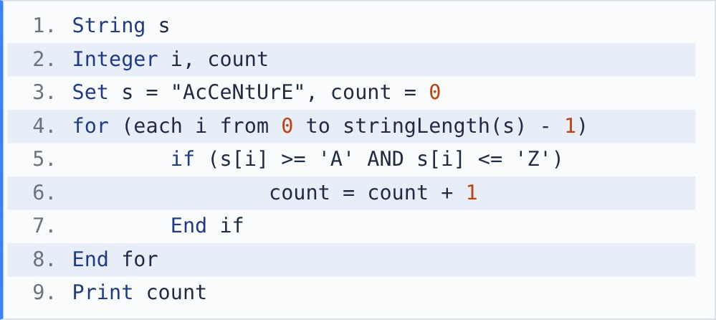
[Note - s[i] is the character at index i (starting at 0). stringLength(s) gives the number of characters. + joins strings.] [Note - Characters are stored as ASCII codes: 'A' = 65 ... 'Z' = 90, 'a' = 97 ... 'z' = 122. Adding 1 to a character gives the next character.]

{OPTION 1} 4
{OPTION 2} 9
{OPTION 3} 5
{OPTION 4} 6
{OPTION 5}
{OPTION 6}
{OPTION 7}
{OPTION 8}
{OPTION 9}
{OPTION 10}
{RIGHT ANSWER} 3
{EXPLANATION} Characters between 'A' and 'Z' are uppercase: A, C, N, U, E. count = 5.
{CORRECT MARKS} 1
{NEGATIVE MARKS} 0
{DIFFICULTY} Easy
{QUESTION ENDS}

{QUESTION BEGINS}
{QUESTION NUMBER} 38
{SUBJECT} Technical Assessment
{TOPIC} Pseudocode
{TAGS} accenture, technical assessment, pseudocode, mock test 6, hard
{QUESTION TYPE} SINGLECORRECT
{QUESTION TEXT} What will be the output of the following pseudocode?
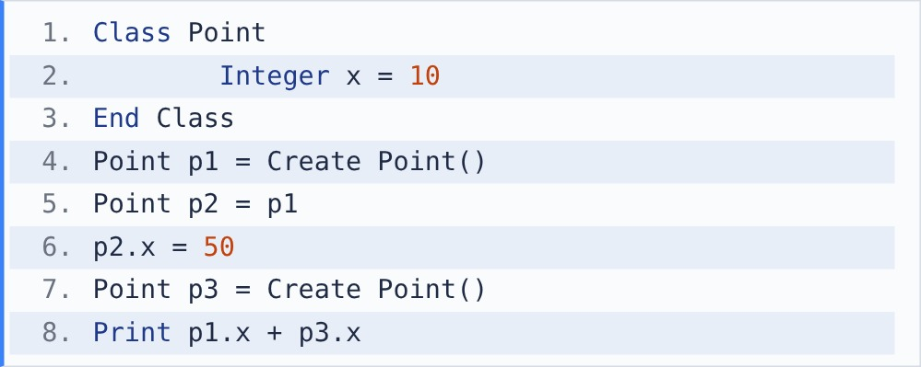
[Note - Assigning one object variable to another copies the reference, not the object.]

{OPTION 1} 20
{OPTION 2} 100
{OPTION 3} 60
{OPTION 4} 110
{OPTION 5}
{OPTION 6}
{OPTION 7}
{OPTION 8}
{OPTION 9}
{OPTION 10}
{RIGHT ANSWER} 3
{EXPLANATION} p2 = p1 makes both names refer to the same object, so p2.x = 50 also changes p1.x. p3 is a new object with x = 10. 50 + 10 = 60.
{CORRECT MARKS} 1
{NEGATIVE MARKS} 0
{DIFFICULTY} Hard
{QUESTION ENDS}

{QUESTION BEGINS}
{QUESTION NUMBER} 39
{SUBJECT} Technical Assessment
{TOPIC} Pseudocode
{TAGS} accenture, technical assessment, pseudocode, mock test 6, hard
{QUESTION TYPE} SINGLECORRECT
{QUESTION TEXT} What will be the output of the following pseudocode?
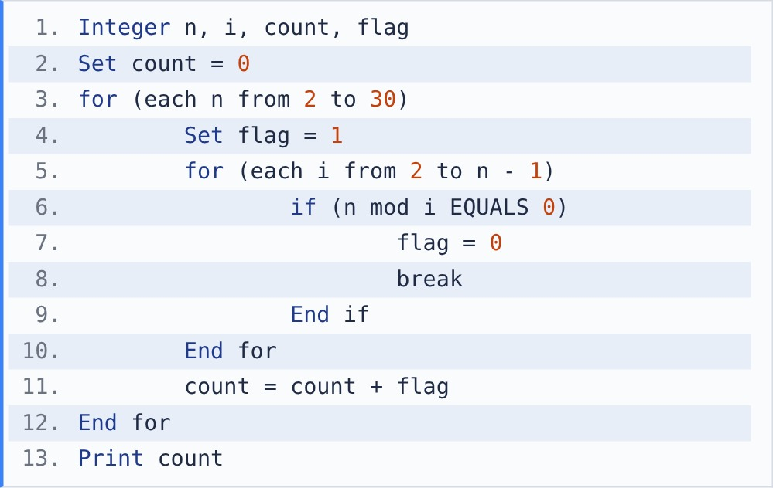
[Note - break exits the innermost loop immediately.] [Note - mod gives the remainder after division. / between integers is integer division.]

{OPTION 1} 11
{OPTION 2} 10
{OPTION 3} 9
{OPTION 4} 15
{OPTION 5}
{OPTION 6}
{OPTION 7}
{OPTION 8}
{OPTION 9}
{OPTION 10}
{RIGHT ANSWER} 2
{EXPLANATION} flag stays 1 only when n has no divisor between 2 and n - 1, i.e. n is prime. Primes up to 30: 2, 3, 5, 7, 11, 13, 17, 19, 23, 29. count = 10.
{CORRECT MARKS} 1
{NEGATIVE MARKS} 0
{DIFFICULTY} Hard
{QUESTION ENDS}

{QUESTION BEGINS}
{QUESTION NUMBER} 40
{SUBJECT} Technical Assessment
{TOPIC} Pseudocode
{TAGS} accenture, technical assessment, pseudocode, mock test 6, medium
{QUESTION TYPE} SINGLECORRECT
{QUESTION TEXT} What will be the output of the following pseudocode?
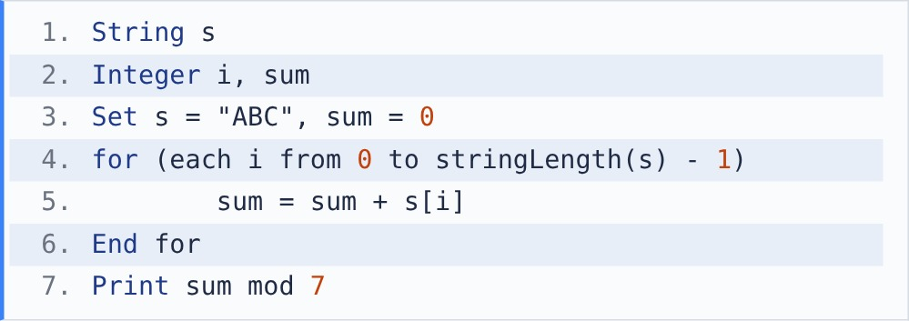
[Note - s[i] is the character at index i (starting at 0). stringLength(s) gives the number of characters. + joins strings.] [Note - Characters are stored as ASCII codes: 'A' = 65 ... 'Z' = 90, 'a' = 97 ... 'z' = 122. Adding 1 to a character gives the next character.] [Note - mod gives the remainder after division. / between integers is integer division.]

{OPTION 1} 198
{OPTION 2} 6
{OPTION 3} 0
{OPTION 4} 2
{OPTION 5}
{OPTION 6}
{OPTION 7}
{OPTION 8}
{OPTION 9}
{OPTION 10}
{RIGHT ANSWER} 4
{EXPLANATION} Adding characters adds their ASCII codes: 65 + 66 + 67 = 198. 198 = 7 * 28 + 2, so 198 mod 7 = 2.
{CORRECT MARKS} 1
{NEGATIVE MARKS} 0
{DIFFICULTY} Medium
{QUESTION ENDS}

{QUESTION BEGINS}
{QUESTION NUMBER} 41
{SUBJECT} Technical Assessment
{TOPIC} Pseudocode
{TAGS} accenture, technical assessment, pseudocode, mock test 6, medium
{QUESTION TYPE} SINGLECORRECT
{QUESTION TEXT} What will be the output of the following pseudocode?
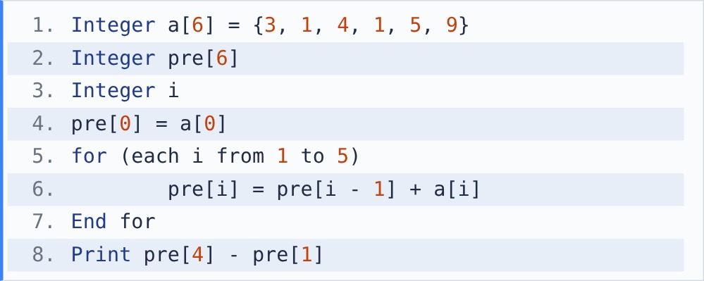

{OPTION 1} 9
{OPTION 2} 14
{OPTION 3} 10
{OPTION 4} 6
{OPTION 5}
{OPTION 6}
{OPTION 7}
{OPTION 8}
{OPTION 9}
{OPTION 10}
{RIGHT ANSWER} 3
{EXPLANATION} pre[i] is the running total: {3, 4, 8, 9, 14, 23}. pre[4] - pre[1] = 14 - 4 = 10, which is the sum of a[2..4] = 4 + 1 + 5.
{CORRECT MARKS} 1
{NEGATIVE MARKS} 0
{DIFFICULTY} Medium
{QUESTION ENDS}

{QUESTION BEGINS}
{QUESTION NUMBER} 42
{SUBJECT} Technical Assessment
{TOPIC} Pseudocode
{TAGS} accenture, technical assessment, pseudocode, mock test 6, hard
{QUESTION TYPE} SINGLECORRECT
{QUESTION TEXT} What will be the output of the following pseudocode?
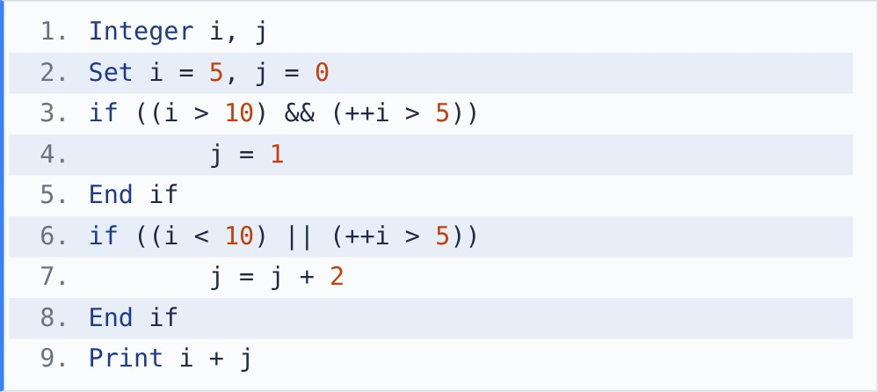
[Note - && and || use short-circuit evaluation: the right side is not evaluated if the left side already decides the result. ++i increases i by 1 before it is used.]

{OPTION 1} 9
{OPTION 2} 8
{OPTION 3} 6
{OPTION 4} 7
{OPTION 5}
{OPTION 6}
{OPTION 7}
{OPTION 8}
{OPTION 9}
{OPTION 10}
{RIGHT ANSWER} 4
{EXPLANATION} First if: i > 10 is false, so && skips ++i. Second if: i < 10 is true, so || skips ++i and j = 2. i never changes from 5, so 5 + 2 = 7.
{CORRECT MARKS} 1
{NEGATIVE MARKS} 0
{DIFFICULTY} Hard
{QUESTION ENDS}

{QUESTION BEGINS}
{QUESTION NUMBER} 43
{SUBJECT} Technical Assessment
{TOPIC} Pseudocode
{TAGS} accenture, technical assessment, pseudocode, mock test 6, easy
{QUESTION TYPE} SINGLECORRECT
{QUESTION TEXT} Which type of inheritance is shown in the following pseudocode?
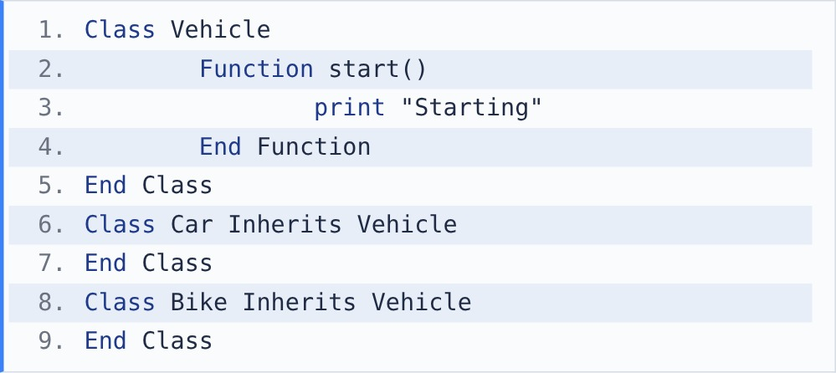

{OPTION 1} Hierarchical inheritance
{OPTION 2} Multilevel inheritance
{OPTION 3} Multiple inheritance
{OPTION 4} Hybrid inheritance
{OPTION 5}
{OPTION 6}
{OPTION 7}
{OPTION 8}
{OPTION 9}
{OPTION 10}
{RIGHT ANSWER} 1
{EXPLANATION} Two or more classes (Car, Bike) inherit from the same parent (Vehicle): that is hierarchical inheritance. Multilevel would be a chain (A -> B -> C); multiple would be one class with two parents.
{CORRECT MARKS} 1
{NEGATIVE MARKS} 0
{DIFFICULTY} Easy
{QUESTION ENDS}

{QUESTION BEGINS}
{QUESTION NUMBER} 44
{SUBJECT} Technical Assessment
{TOPIC} Pseudocode
{TAGS} accenture, technical assessment, pseudocode, mock test 6, hard
{QUESTION TYPE} SINGLECORRECT
{QUESTION TEXT} What will be the output of the following pseudocode?
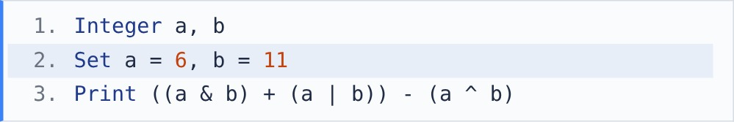
[Note - ^: XOR, |: OR, &: AND, <<: left shift (multiply by 2 per place), >>: right shift (integer divide by 2 per place).]

{OPTION 1} 17
{OPTION 2} 4
{OPTION 3} 13
{OPTION 4} 2
{OPTION 5}
{OPTION 6}
{OPTION 7}
{OPTION 8}
{OPTION 9}
{OPTION 10}
{RIGHT ANSWER} 2
{EXPLANATION} 6 = 0110, 11 = 1011. a & b = 0010 = 2, a | b = 1111 = 15, a ^ b = 1101 = 13. (2 + 15) - 13 = 4. (Shortcut: (a & b) + (a | b) is always a + b = 17.)
{CORRECT MARKS} 1
{NEGATIVE MARKS} 0
{DIFFICULTY} Hard
{QUESTION ENDS}

{QUESTION BEGINS}
{QUESTION NUMBER} 45
{SUBJECT} Technical Assessment
{TOPIC} Pseudocode
{TAGS} accenture, technical assessment, pseudocode, mock test 6, medium
{QUESTION TYPE} SINGLECORRECT
{QUESTION TEXT} What will be the output of the following pseudocode?
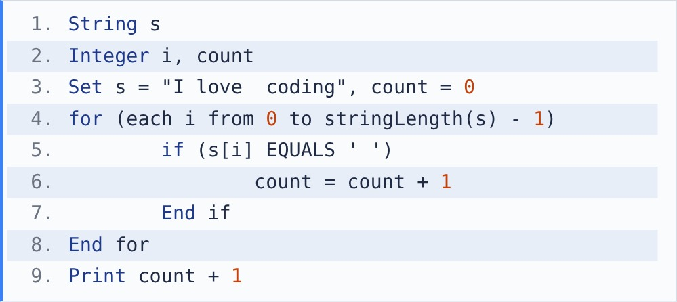
[Note - s[i] is the character at index i (starting at 0). stringLength(s) gives the number of characters. + joins strings.] [Note - There are two spaces between "love" and "coding".]

{OPTION 1} 3
{OPTION 2} 5
{OPTION 3} 4
{OPTION 4} 14
{OPTION 5}
{OPTION 6}
{OPTION 7}
{OPTION 8}
{OPTION 9}
{OPTION 10}
{RIGHT ANSWER} 3
{EXPLANATION} The code counts spaces, not words. There are 3 spaces (one after I, two after love), so it prints 3 + 1 = 4 even though the sentence has only 3 words.
{CORRECT MARKS} 1
{NEGATIVE MARKS} 0
{DIFFICULTY} Medium
{QUESTION ENDS}

{QUESTION BEGINS}
{QUESTION NUMBER} 46
{SUBJECT} Technical Assessment
{TOPIC} Pseudocode
{TAGS} accenture, technical assessment, pseudocode, mock test 6, medium
{QUESTION TYPE} SINGLECORRECT
{QUESTION TEXT} What will be the output of the following pseudocode?
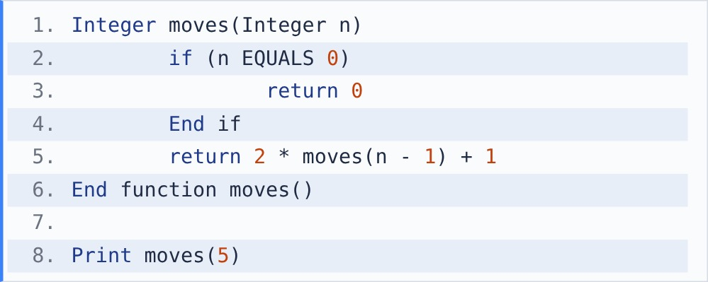

{OPTION 1} 31
{OPTION 2} 32
{OPTION 3} 25
{OPTION 4} 63
{OPTION 5}
{OPTION 6}
{OPTION 7}
{OPTION 8}
{OPTION 9}
{OPTION 10}
{RIGHT ANSWER} 1
{EXPLANATION} This is the Tower of Hanoi move count: 1, 3, 7, 15, 31 for n = 1..5, i.e. 2^n - 1. moves(5) = 31.
{CORRECT MARKS} 1
{NEGATIVE MARKS} 0
{DIFFICULTY} Medium
{QUESTION ENDS}

{QUESTION BEGINS}
{QUESTION NUMBER} 47
{SUBJECT} Technical Assessment
{TOPIC} Pseudocode
{TAGS} accenture, technical assessment, pseudocode, mock test 6, medium
{QUESTION TYPE} SINGLECORRECT
{QUESTION TEXT} What will be the output of the following pseudocode?
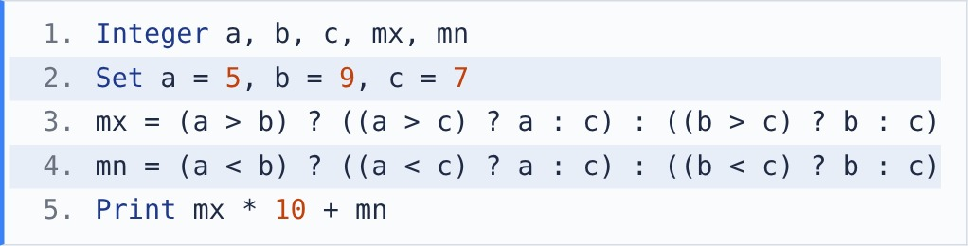
[Note - (condition) ? x : y gives x if the condition is true, otherwise y.]

{OPTION 1} 97
{OPTION 2} 95
{OPTION 3} 59
{OPTION 4} 75
{OPTION 5}
{OPTION 6}
{OPTION 7}
{OPTION 8}
{OPTION 9}
{OPTION 10}
{RIGHT ANSWER} 2
{EXPLANATION} mx: a > b is false, so take (b > c) ? b : c = 9. mn: a < b is true, so take (a < c) ? a : c = 5. 9 * 10 + 5 = 95.
{CORRECT MARKS} 1
{NEGATIVE MARKS} 0
{DIFFICULTY} Medium
{QUESTION ENDS}

{QUESTION BEGINS}
{QUESTION NUMBER} 48
{SUBJECT} Technical Assessment
{TOPIC} Pseudocode
{TAGS} accenture, technical assessment, pseudocode, mock test 6, medium
{QUESTION TYPE} SINGLECORRECT
{QUESTION TEXT} What will be the output of the following pseudocode?
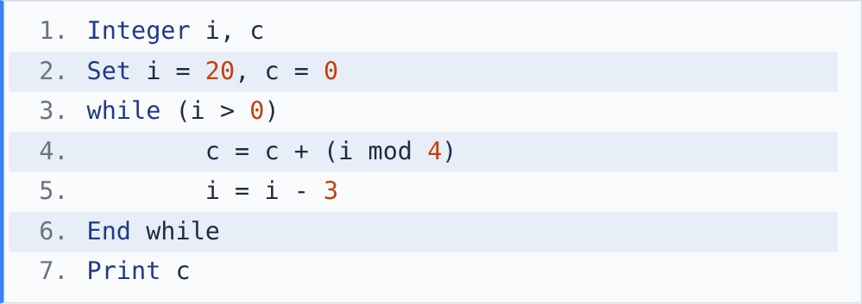
[Note - mod gives the remainder after division. / between integers is integer division.]

{OPTION 1} 7
{OPTION 2} 9
{OPTION 3} 11
{OPTION 4} 12
{OPTION 5}
{OPTION 6}
{OPTION 7}
{OPTION 8}
{OPTION 9}
{OPTION 10}
{RIGHT ANSWER} 2
{EXPLANATION} i takes 20, 17, 14, 11, 8, 5, 2 (then -1 stops). i mod 4 = 0, 1, 2, 3, 0, 1, 2. Sum = 9.
{CORRECT MARKS} 1
{NEGATIVE MARKS} 0
{DIFFICULTY} Medium
{QUESTION ENDS}

{QUESTION BEGINS}
{QUESTION NUMBER} 49
{SUBJECT} Technical Assessment
{TOPIC} Pseudocode
{TAGS} accenture, technical assessment, pseudocode, mock test 6, medium
{QUESTION TYPE} SINGLECORRECT
{QUESTION TEXT} What will be the output of the following pseudocode?
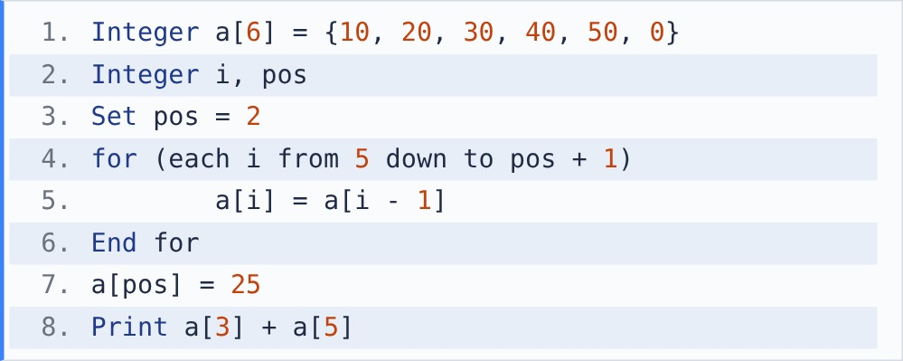

{OPTION 1} 90
{OPTION 2} 70
{OPTION 3} 80
{OPTION 4} 75
{OPTION 5}
{OPTION 6}
{OPTION 7}
{OPTION 8}
{OPTION 9}
{OPTION 10}
{RIGHT ANSWER} 3
{EXPLANATION} Elements from pos onwards shift one place right (from the end, so nothing is overwritten): {10, 20, 30, 30, 40, 50}. Then a[2] = 25: {10, 20, 25, 30, 40, 50}. a[3] + a[5] = 30 + 50 = 80.
{CORRECT MARKS} 1
{NEGATIVE MARKS} 0
{DIFFICULTY} Medium
{QUESTION ENDS}

{QUESTION BEGINS}
{QUESTION NUMBER} 50
{SUBJECT} Technical Assessment
{TOPIC} Pseudocode
{TAGS} accenture, technical assessment, pseudocode, mock test 6, medium
{QUESTION TYPE} SINGLECORRECT
{QUESTION TEXT} What will be printed when f(3) is called?
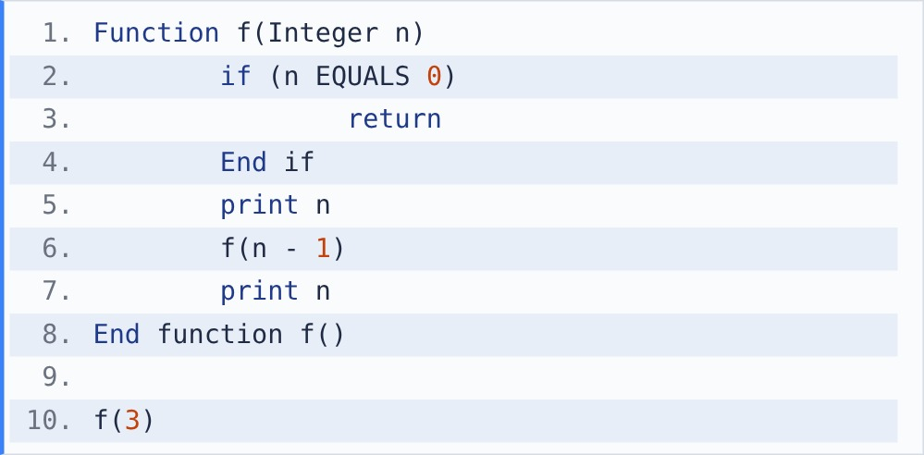

{OPTION 1} 3 2 1
{OPTION 2} 1 2 3 3 2 1
{OPTION 3} 3 2 1 0 1 2 3
{OPTION 4} 3 2 1 1 2 3
{OPTION 5}
{OPTION 6}
{OPTION 7}
{OPTION 8}
{OPTION 9}
{OPTION 10}
{RIGHT ANSWER} 4
{EXPLANATION} Each call prints n before going deeper and again after returning. Going down prints 3 2 1; f(0) prints nothing; coming back up prints 1 2 3.
{CORRECT MARKS} 1
{NEGATIVE MARKS} 0
{DIFFICULTY} Medium
{QUESTION ENDS}

