{QUESTION BEGINS}
{QUESTION NUMBER} 1
{SUBJECT} Numerical Ability
{TOPIC} Compound Interest
{TAGS} tcs nqt, numerical ability, medium
{QUESTION TYPE} SINGLECORRECT
{QUESTION TEXT} What is the compound interest on ₹10,000 for 1½ years at 20% per annum, compounded half-yearly?
{OPTION 1} ₹3,150
{OPTION 2} ₹3,600
{OPTION 3} ₹3,000
{OPTION 4} ₹3,310
{OPTION 5}
{OPTION 6}
{OPTION 7}
{OPTION 8}
{OPTION 9}
{OPTION 10}
{RIGHT ANSWER} 4
{EXPLANATION} Half-yearly rate = 10% and the number of half-years = 3. Amount = 10000 × (1.1)³ = 10000 × 1.331 = ₹13,310. Compound interest = 13310 − 10000 = ₹3,310.
{CORRECT MARKS} 1
{NEGATIVE MARKS} 0
{DIFFICULTY} Medium
{QUESTION ENDS}

{QUESTION BEGINS}
{QUESTION NUMBER} 2
{SUBJECT} Numerical Ability
{TOPIC} Surds
{TAGS} tcs nqt, numerical ability, medium
{QUESTION TYPE} SINGLECORRECT
{QUESTION TEXT} 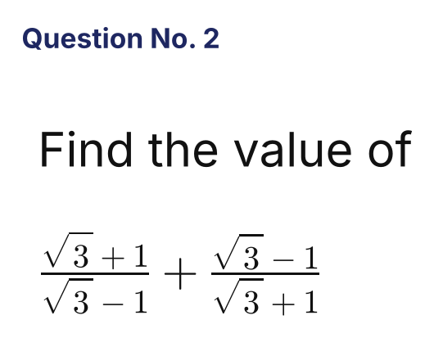
{OPTION 1} 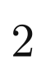
{OPTION 2} 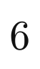
{OPTION 3} 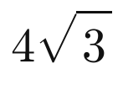
{OPTION 4} 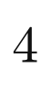
{OPTION 5}
{OPTION 6}
{OPTION 7}
{OPTION 8}
{OPTION 9}
{OPTION 10}
{RIGHT ANSWER} 4
{EXPLANATION} (√3+1)²/(3−1) + (√3−1)²/(3−1) = [(4 + 2√3) + (4 − 2√3)]/2 = 8/2 = 4.
{CORRECT MARKS} 1
{NEGATIVE MARKS} 0
{DIFFICULTY} Medium
{QUESTION ENDS}

{QUESTION BEGINS}
{QUESTION NUMBER} 3
{SUBJECT} Numerical Ability
{TOPIC} Time and Work
{TAGS} tcs nqt, numerical ability, medium
{QUESTION TYPE} SINGLECORRECT
{QUESTION TEXT} A pipe fills a tank in 6 hours. Because of a leak at the bottom, it takes 8 hours to fill the tank. If the tank is full, in how many hours will the leak alone empty it?
{OPTION 1} 24 hours
{OPTION 2} 12 hours
{OPTION 3} 48 hours
{OPTION 4} 14 hours
{OPTION 5}
{OPTION 6}
{OPTION 7}
{OPTION 8}
{OPTION 9}
{OPTION 10}
{RIGHT ANSWER} 1
{EXPLANATION} Leak rate = 1/6 − 1/8 = 1/24 of the tank per hour. So the leak alone empties a full tank in 24 hours.
{CORRECT MARKS} 1
{NEGATIVE MARKS} 0
{DIFFICULTY} Medium
{QUESTION ENDS}

{QUESTION BEGINS}
{QUESTION NUMBER} 4
{SUBJECT} Numerical Ability
{TOPIC} Averages
{TAGS} tcs nqt, numerical ability, medium
{QUESTION TYPE} SINGLECORRECT
{QUESTION TEXT} The average of five consecutive odd numbers is 31. If the next two odd numbers are also included, what will be the new average?
{OPTION 1} 35
{OPTION 2} 32
{OPTION 3} 33
{OPTION 4} 34
{OPTION 5}
{OPTION 6}
{OPTION 7}
{OPTION 8}
{OPTION 9}
{OPTION 10}
{RIGHT ANSWER} 3
{EXPLANATION} The five numbers are 27, 29, 31, 33, 35 (sum 155). The next two odd numbers are 37 and 39 (sum 76). New average = (155 + 76)/7 = 231/7 = 33.
{CORRECT MARKS} 1
{NEGATIVE MARKS} 0
{DIFFICULTY} Medium
{QUESTION ENDS}

{QUESTION BEGINS}
{QUESTION NUMBER} 5
{SUBJECT} Numerical Ability
{TOPIC} Mensuration
{TAGS} tcs nqt, numerical ability, medium
{QUESTION TYPE} SINGLECORRECT
{QUESTION TEXT} A hemispherical bowl of radius 9 cm is full of water. This water is poured into a cylindrical bottle of base radius 3 cm. What is the height of the water in the bottle?
{OPTION 1} 27 cm
{OPTION 2} 36 cm
{OPTION 3} 54 cm
{OPTION 4} 72 cm
{OPTION 5}
{OPTION 6}
{OPTION 7}
{OPTION 8}
{OPTION 9}
{OPTION 10}
{RIGHT ANSWER} 3
{EXPLANATION} Volume of the hemisphere = (2/3)π × 9³ = 486π. Volume of water in the cylinder = π × 3² × h = 9πh. So 9πh = 486π and h = 54 cm.
{CORRECT MARKS} 1
{NEGATIVE MARKS} 0
{DIFFICULTY} Medium
{QUESTION ENDS}

{QUESTION BEGINS}
{QUESTION NUMBER} 6
{SUBJECT} Numerical Ability
{TOPIC} Algebra
{TAGS} tcs nqt, numerical ability, hard
{QUESTION TYPE} SINGLECORRECT
{QUESTION TEXT} 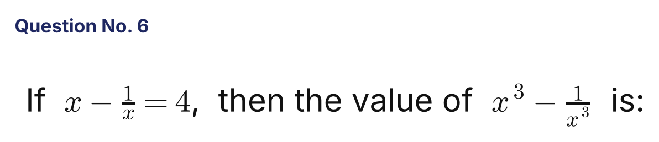
{OPTION 1} 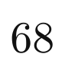
{OPTION 2} 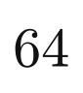
{OPTION 3} 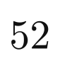
{OPTION 4} 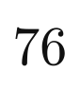
{OPTION 5}
{OPTION 6}
{OPTION 7}
{OPTION 8}
{OPTION 9}
{OPTION 10}
{RIGHT ANSWER} 4
{EXPLANATION} x³ − 1/x³ = (x − 1/x)³ + 3(x − 1/x) = 64 + 12 = 76.
{CORRECT MARKS} 1
{NEGATIVE MARKS} 0
{DIFFICULTY} Hard
{QUESTION ENDS}

{QUESTION BEGINS}
{QUESTION NUMBER} 7
{SUBJECT} Numerical Ability
{TOPIC} Ages
{TAGS} tcs nqt, numerical ability, medium
{QUESTION TYPE} SINGLECORRECT
{QUESTION TEXT} The present ages of A and B are in the ratio 3 : 5. Four years from now the ratio of their ages will be 7 : 11. What is the sum of their ages 10 years ago?
{OPTION 1} 48 years
{OPTION 2} 40 years
{OPTION 3} 54 years
{OPTION 4} 44 years
{OPTION 5}
{OPTION 6}
{OPTION 7}
{OPTION 8}
{OPTION 9}
{OPTION 10}
{RIGHT ANSWER} 4
{EXPLANATION} Let the present ages be 3k and 5k. (3k + 4)/(5k + 4) = 7/11, so 33k + 44 = 35k + 28 and k = 8. Present ages are 24 and 40. Ten years ago they were 14 and 30, whose sum is 44.
{CORRECT MARKS} 1
{NEGATIVE MARKS} 0
{DIFFICULTY} Medium
{QUESTION ENDS}

{QUESTION BEGINS}
{QUESTION NUMBER} 8
{SUBJECT} Numerical Ability
{TOPIC} Partnership
{TAGS} tcs nqt, numerical ability, hard
{QUESTION TYPE} SINGLECORRECT
{QUESTION TEXT} A invests ₹40,000 in a business. After 4 months B joins with ₹50,000, and 3 months after B joined, C joins with ₹60,000. At the end of the year the profit is ₹88,500. What is C's share of the profit?
{OPTION 1} ₹25,000
{OPTION 2} ₹18,000
{OPTION 3} ₹20,000
{OPTION 4} ₹22,500
{OPTION 5}
{OPTION 6}
{OPTION 7}
{OPTION 8}
{OPTION 9}
{OPTION 10}
{RIGHT ANSWER} 4
{EXPLANATION} A invests for 12 months, B for 8 months and C for 5 months. Profit ratio = 40000 × 12 : 50000 × 8 : 60000 × 5 = 480 : 400 : 300 = 24 : 20 : 15. Total parts = 59, so 1 part = 88500/59 = ₹1,500. C's share = 15 × 1500 = ₹22,500.
{CORRECT MARKS} 1
{NEGATIVE MARKS} 0
{DIFFICULTY} Hard
{QUESTION ENDS}

{QUESTION BEGINS}
{QUESTION NUMBER} 9
{SUBJECT} Numerical Ability
{TOPIC} Percentages
{TAGS} tcs nqt, numerical ability, hard
{QUESTION TYPE} SINGLECORRECT
{QUESTION TEXT} The population of a town increased by 10% in the first year, decreased by 10% in the second year and increased by 20% in the third year. If the population at the end of the third year is 11,880, what was the population at the beginning of the first year?
{OPTION 1} 11,000
{OPTION 2} 10,000
{OPTION 3} 10,800
{OPTION 4} 9,900
{OPTION 5}
{OPTION 6}
{OPTION 7}
{OPTION 8}
{OPTION 9}
{OPTION 10}
{RIGHT ANSWER} 2
{EXPLANATION} Population factor = 1.10 × 0.90 × 1.20 = 1.188. So the original population = 11880/1.188 = 10,000.
{CORRECT MARKS} 1
{NEGATIVE MARKS} 0
{DIFFICULTY} Hard
{QUESTION ENDS}

{QUESTION BEGINS}
{QUESTION NUMBER} 10
{SUBJECT} Numerical Ability
{TOPIC} Indices
{TAGS} tcs nqt, numerical ability, hard
{QUESTION TYPE} SINGLECORRECT
{QUESTION TEXT} 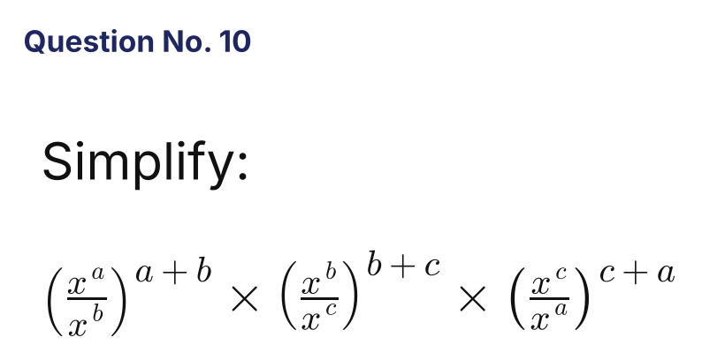
{OPTION 1} 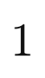
{OPTION 2} 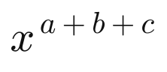
{OPTION 3} 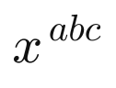
{OPTION 4} 
{OPTION 5}
{OPTION 6}
{OPTION 7}
{OPTION 8}
{OPTION 9}
{OPTION 10}
{RIGHT ANSWER} 1
{EXPLANATION} The exponent of x is (a−b)(a+b) + (b−c)(b+c) + (c−a)(c+a) = (a² − b²) + (b² − c²) + (c² − a²) = 0. So the value is x⁰ = 1.
{CORRECT MARKS} 1
{NEGATIVE MARKS} 0
{DIFFICULTY} Hard
{QUESTION ENDS}

{QUESTION BEGINS}
{QUESTION NUMBER} 11
{SUBJECT} Numerical Ability
{TOPIC} Profit and Loss
{TAGS} tcs nqt, numerical ability, hard
{QUESTION TYPE} SINGLECORRECT
{QUESTION TEXT} A shopkeeper allows a discount of 25% on the marked price and still gains 20%. If he had sold the article at the marked price, what would his gain percentage have been?
{OPTION 1} 50%
{OPTION 2} 45%
{OPTION 3} 80%
{OPTION 4} 60%
{OPTION 5}
{OPTION 6}
{OPTION 7}
{OPTION 8}
{OPTION 9}
{OPTION 10}
{RIGHT ANSWER} 4
{EXPLANATION} Let CP = 100. SP = 120, which is 75% of the marked price, so MP = 160. Selling at MP gives a gain of 60%.
{CORRECT MARKS} 1
{NEGATIVE MARKS} 0
{DIFFICULTY} Hard
{QUESTION ENDS}

{QUESTION BEGINS}
{QUESTION NUMBER} 12
{SUBJECT} Numerical Ability
{TOPIC} Time, Speed and Distance
{TAGS} tcs nqt, numerical ability, hard
{QUESTION TYPE} SINGLECORRECT
{QUESTION TEXT} A thief steals a bag at 2:00 PM and runs away at 12 km/h. The owner finds out at 2:30 PM and chases him on a bike at 20 km/h. At what time will the owner catch the thief?
{OPTION 1} 3:45 PM
{OPTION 2} 3:15 PM
{OPTION 3} 3:30 PM
{OPTION 4} 3:00 PM
{OPTION 5}
{OPTION 6}
{OPTION 7}
{OPTION 8}
{OPTION 9}
{OPTION 10}
{RIGHT ANSWER} 2
{EXPLANATION} In 30 minutes the thief covers 6 km. The owner gains 20 − 12 = 8 km/h, so he needs 6/8 = 0.75 hour = 45 minutes. He catches the thief at 2:30 + 0:45 = 3:15 PM.
{CORRECT MARKS} 1
{NEGATIVE MARKS} 0
{DIFFICULTY} Hard
{QUESTION ENDS}

{QUESTION BEGINS}
{QUESTION NUMBER} 13
{SUBJECT} Numerical Ability
{TOPIC} Ratio and Proportion
{TAGS} tcs nqt, numerical ability, hard
{QUESTION TYPE} SINGLECORRECT
{QUESTION TEXT} The incomes of two persons are in the ratio 5 : 4 and their expenditures are in the ratio 3 : 2. If each of them saves ₹2,000, what is the income of the first person?
{OPTION 1} ₹7,500
{OPTION 2} ₹4,000
{OPTION 3} ₹6,000
{OPTION 4} ₹5,000
{OPTION 5}
{OPTION 6}
{OPTION 7}
{OPTION 8}
{OPTION 9}
{OPTION 10}
{RIGHT ANSWER} 4
{EXPLANATION} Let the incomes be 5x and 4x and the expenditures 3y and 2y. Then 5x − 3y = 2000 and 4x − 2y = 2000. From the second, y = 2x − 1000. Substituting: 5x − 6x + 3000 = 2000, so x = 1000. The first income is 5x = ₹5,000.
{CORRECT MARKS} 1
{NEGATIVE MARKS} 0
{DIFFICULTY} Hard
{QUESTION ENDS}

{QUESTION BEGINS}
{QUESTION NUMBER} 14
{SUBJECT} Numerical Ability
{TOPIC} Series
{TAGS} tcs nqt, numerical ability, hard
{QUESTION TYPE} SINGLECORRECT
{QUESTION TEXT} 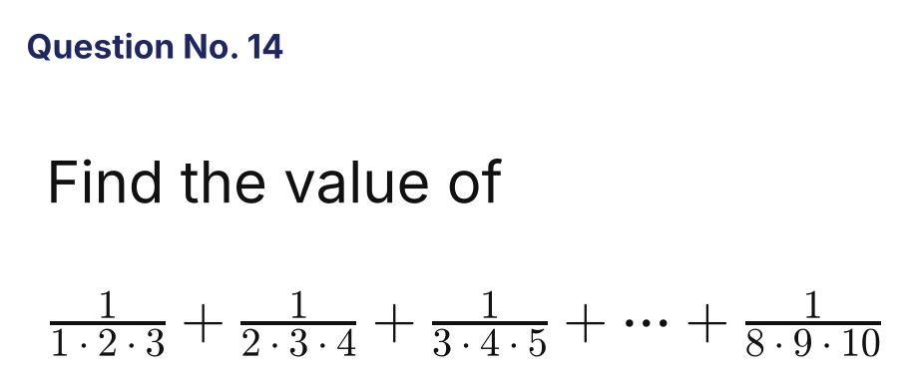
{OPTION 1} 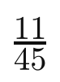
{OPTION 2} 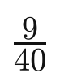
{OPTION 3} 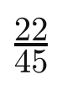
{OPTION 4} 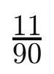
{OPTION 5}
{OPTION 6}
{OPTION 7}
{OPTION 8}
{OPTION 9}
{OPTION 10}
{RIGHT ANSWER} 1
{EXPLANATION} 1/(n(n+1)(n+2)) = ½[1/(n(n+1)) − 1/((n+1)(n+2))]. The sum telescopes to ½[1/(1·2) − 1/(9·10)] = ½[1/2 − 1/90] = ½ × 44/90 = 11/45.
{CORRECT MARKS} 1
{NEGATIVE MARKS} 0
{DIFFICULTY} Hard
{QUESTION ENDS}

{QUESTION BEGINS}
{QUESTION NUMBER} 15
{SUBJECT} Numerical Ability
{TOPIC} Mixtures
{TAGS} tcs nqt, numerical ability, hard
{QUESTION TYPE} SINGLECORRECT
{QUESTION TEXT} Two alloys contain gold and copper in the ratios 3 : 1 and 2 : 3 respectively. In what ratio should they be mixed so that the new alloy has gold and copper in the ratio 1 : 1?
{OPTION 1} 1 : 3
{OPTION 2} 2 : 5
{OPTION 3} 5 : 2
{OPTION 4} 3 : 7
{OPTION 5}
{OPTION 6}
{OPTION 7}
{OPTION 8}
{OPTION 9}
{OPTION 10}
{RIGHT ANSWER} 2
{EXPLANATION} Gold fractions: first alloy = 3/4, second = 2/5, required = 1/2. By alligation: (first) : (second) = (1/2 − 2/5) : (3/4 − 1/2) = 1/10 : 1/4 = 2 : 5.
{CORRECT MARKS} 1
{NEGATIVE MARKS} 0
{DIFFICULTY} Hard
{QUESTION ENDS}

{QUESTION BEGINS}
{QUESTION NUMBER} 16
{SUBJECT} Numerical Ability
{TOPIC} Probability
{TAGS} tcs nqt, numerical ability, hard
{QUESTION TYPE} SINGLECORRECT
{QUESTION TEXT} A fair die is thrown three times. What is the probability that the three numbers obtained are in strictly increasing order?
{OPTION 1} 1/6
{OPTION 2} 1/27
{OPTION 3} 5/36
{OPTION 4} 5/54
{OPTION 5}
{OPTION 6}
{OPTION 7}
{OPTION 8}
{OPTION 9}
{OPTION 10}
{RIGHT ANSWER} 4
{EXPLANATION} Three different numbers can be chosen from 6 in C(6,3) = 20 ways, and each set can appear in increasing order in only one way. Total outcomes = 6³ = 216. Probability = 20/216 = 5/54.
{CORRECT MARKS} 1
{NEGATIVE MARKS} 0
{DIFFICULTY} Hard
{QUESTION ENDS}

{QUESTION BEGINS}
{QUESTION NUMBER} 17
{SUBJECT} Numerical Ability
{TOPIC} Permutation and Combination
{TAGS} tcs nqt, numerical ability, hard
{QUESTION TYPE} SINGLECORRECT
{QUESTION TEXT} How many 4-digit even numbers can be formed using the digits 0, 1, 2, 3, 4, 5 if no digit is repeated?
{OPTION 1} 144
{OPTION 2} 180
{OPTION 3} 120
{OPTION 4} 156
{OPTION 5}
{OPTION 6}
{OPTION 7}
{OPTION 8}
{OPTION 9}
{OPTION 10}
{RIGHT ANSWER} 4
{EXPLANATION} Last digit 0: the other three places can be filled in 5 × 4 × 3 = 60 ways. Last digit 2 or 4 (2 choices): the first digit can be any of the remaining non-zero digits (4 choices), then 4 × 3 for the middle places = 2 × 4 × 4 × 3 = 96. Total = 60 + 96 = 156.
{CORRECT MARKS} 1
{NEGATIVE MARKS} 0
{DIFFICULTY} Hard
{QUESTION ENDS}

{QUESTION BEGINS}
{QUESTION NUMBER} 18
{SUBJECT} Numerical Ability
{TOPIC} Indices
{TAGS} tcs nqt, numerical ability, hard
{QUESTION TYPE} SINGLECORRECT
{QUESTION TEXT} 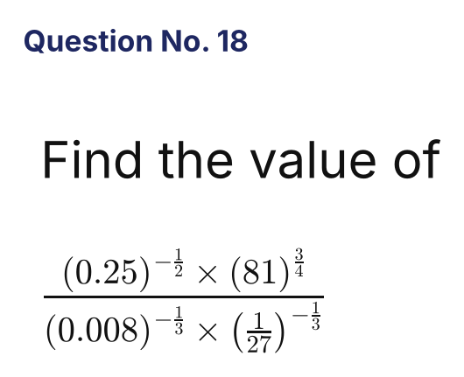
{OPTION 1} 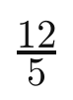
{OPTION 2} 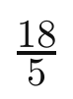
{OPTION 3} 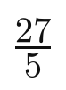
{OPTION 4} 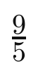
{OPTION 5}
{OPTION 6}
{OPTION 7}
{OPTION 8}
{OPTION 9}
{OPTION 10}
{RIGHT ANSWER} 2
{EXPLANATION} (0.25)^(−1/2) = 2 and 81^(3/4) = 27, so the numerator = 54. (0.008)^(−1/3) = 5 and (1/27)^(−1/3) = 3, so the denominator = 15. The value = 54/15 = 18/5.
{CORRECT MARKS} 1
{NEGATIVE MARKS} 0
{DIFFICULTY} Hard
{QUESTION ENDS}

{QUESTION BEGINS}
{QUESTION NUMBER} 19
{SUBJECT} Numerical Ability
{TOPIC} Statistics
{TAGS} tcs nqt, numerical ability, hard
{QUESTION TYPE} SINGLECORRECT
{QUESTION TEXT} The standard deviation of five numbers is 4. Each number is multiplied by 3 and then increased by 2. What is the variance of the new set of numbers?
{OPTION 1} 146
{OPTION 2} 144
{OPTION 3} 16
{OPTION 4} 48
{OPTION 5}
{OPTION 6}
{OPTION 7}
{OPTION 8}
{OPTION 9}
{OPTION 10}
{RIGHT ANSWER} 2
{EXPLANATION} Adding a constant does not change the spread, and multiplying by 3 multiplies the standard deviation by 3. New SD = 12, so the new variance = 12² = 144.
{CORRECT MARKS} 1
{NEGATIVE MARKS} 0
{DIFFICULTY} Hard
{QUESTION ENDS}

{QUESTION BEGINS}
{QUESTION NUMBER} 20
{SUBJECT} Numerical Ability
{TOPIC} LCM and HCF
{TAGS} tcs nqt, numerical ability, hard
{QUESTION TYPE} SINGLECORRECT
{QUESTION TEXT} What is the smallest number which leaves a remainder of 5 when divided by 8, 12 or 15, and is exactly divisible by 13?
{OPTION 1} 605
{OPTION 2} 845
{OPTION 3} 965
{OPTION 4} 725
{OPTION 5}
{OPTION 6}
{OPTION 7}
{OPTION 8}
{OPTION 9}
{OPTION 10}
{RIGHT ANSWER} 2
{EXPLANATION} Such numbers have the form LCM(8, 12, 15) × k + 5 = 120k + 5. We need 120k + 5 ≡ 0 (mod 13). Since 120 ≡ 3 (mod 13), 3k ≡ 8 (mod 13), so k ≡ 7. The number is 120 × 7 + 5 = 845 = 13 × 65.
{CORRECT MARKS} 1
{NEGATIVE MARKS} 0
{DIFFICULTY} Hard
{QUESTION ENDS}

