{QUESTION BEGINS}
{QUESTION NUMBER} 1
{SUBJECT} Numerical Ability
{TOPIC} Simplification
{TAGS} tcs nqt, numerical ability, equation based, medium
{QUESTION TYPE} SINGLECORRECT
{QUESTION TEXT} 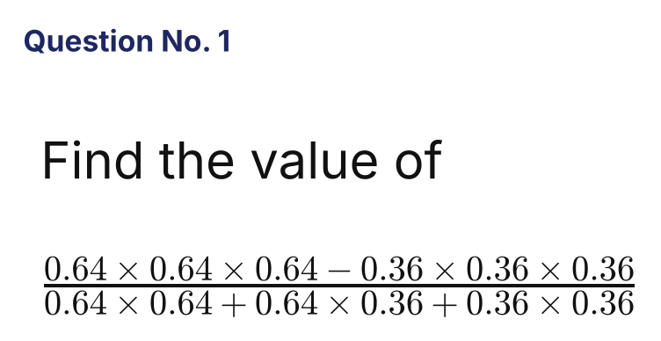
{OPTION 1} 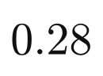
{OPTION 2} 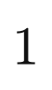
{OPTION 3} 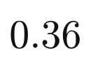
{OPTION 4} 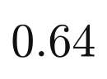
{OPTION 5}
{OPTION 6}
{OPTION 7}
{OPTION 8}
{OPTION 9}
{OPTION 10}
{RIGHT ANSWER} 1
{EXPLANATION} With a = 0.64 and b = 0.36, the expression is (a³ − b³)/(a² + ab + b²) = a − b = 0.64 − 0.36 = 0.28.
{CORRECT MARKS} 1
{NEGATIVE MARKS} 0
{DIFFICULTY} Medium
{QUESTION ENDS}

{QUESTION BEGINS}
{QUESTION NUMBER} 2
{SUBJECT} Numerical Ability
{TOPIC} Ratio and Proportion
{TAGS} tcs nqt, numerical ability, equation based, medium
{QUESTION TYPE} SINGLECORRECT
{QUESTION TEXT} 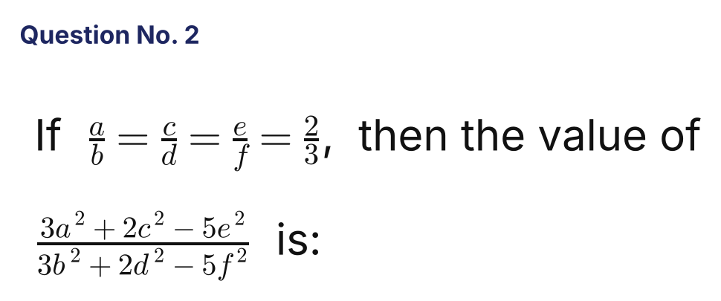
{OPTION 1} 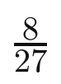
{OPTION 2} 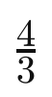
{OPTION 3} 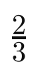
{OPTION 4} 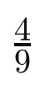
{OPTION 5}
{OPTION 6}
{OPTION 7}
{OPTION 8}
{OPTION 9}
{OPTION 10}
{RIGHT ANSWER} 4
{EXPLANATION} Write a = 2t, b = 3t, c = 2u, d = 3u, e = 2v, f = 3v. Numerator = 12t² + 8u² − 20v² = 4(3t² + 2u² − 5v²). Denominator = 27t² + 18u² − 45v² = 9(3t² + 2u² − 5v²). The ratio = 4/9.
{CORRECT MARKS} 1
{NEGATIVE MARKS} 0
{DIFFICULTY} Medium
{QUESTION ENDS}

{QUESTION BEGINS}
{QUESTION NUMBER} 3
{SUBJECT} Numerical Ability
{TOPIC} Indices
{TAGS} tcs nqt, numerical ability, equation based, medium
{QUESTION TYPE} SINGLECORRECT
{QUESTION TEXT} 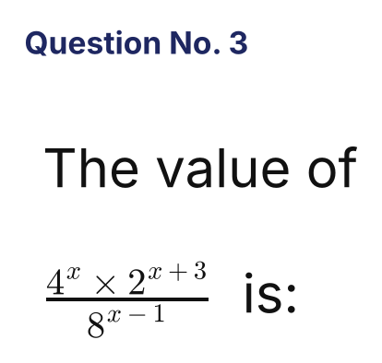
{OPTION 1} 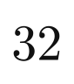
{OPTION 2} 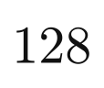
{OPTION 3} 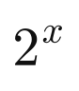
{OPTION 4} 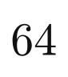
{OPTION 5}
{OPTION 6}
{OPTION 7}
{OPTION 8}
{OPTION 9}
{OPTION 10}
{RIGHT ANSWER} 4
{EXPLANATION} 4ˣ = 2^(2x), 2^(x+3) and 8^(x−1) = 2^(3x−3). The expression = 2^(2x + x + 3 − 3x + 3) = 2⁶ = 64, independent of x.
{CORRECT MARKS} 1
{NEGATIVE MARKS} 0
{DIFFICULTY} Medium
{QUESTION ENDS}

{QUESTION BEGINS}
{QUESTION NUMBER} 4
{SUBJECT} Numerical Ability
{TOPIC} Surds
{TAGS} tcs nqt, numerical ability, equation based, hard
{QUESTION TYPE} SINGLECORRECT
{QUESTION TEXT} 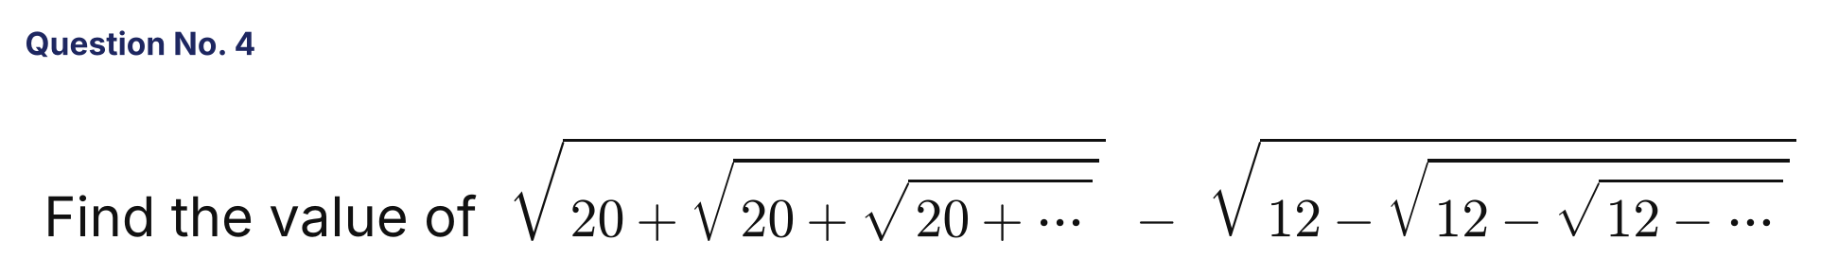
{OPTION 1} 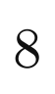
{OPTION 2} 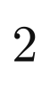
{OPTION 3} 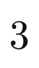
{OPTION 4}
{OPTION 5}
{OPTION 6}
{OPTION 7}
{OPTION 8}
{OPTION 9}
{OPTION 10}
{RIGHT ANSWER} 2
{EXPLANATION} Let the first expression be a: a² = 20 + a, so a = 5. Let the second be b: b² = 12 − b, so b = 3. The difference = 5 − 3 = 2.
{CORRECT MARKS} 1
{NEGATIVE MARKS} 0
{DIFFICULTY} Hard
{QUESTION ENDS}

{QUESTION BEGINS}
{QUESTION NUMBER} 5
{SUBJECT} Numerical Ability
{TOPIC} Indices
{TAGS} tcs nqt, numerical ability, equation based, hard
{QUESTION TYPE} SINGLECORRECT
{QUESTION TEXT} 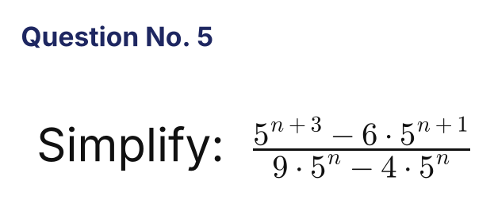
{OPTION 1} 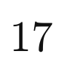
{OPTION 2} 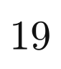
{OPTION 3} 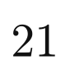
{OPTION 4} 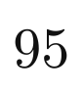
{OPTION 5}
{OPTION 6}
{OPTION 7}
{OPTION 8}
{OPTION 9}
{OPTION 10}
{RIGHT ANSWER} 2
{EXPLANATION} Numerator = 5ⁿ(125 − 30) = 95 · 5ⁿ. Denominator = 5ⁿ(9 − 4) = 5 · 5ⁿ. The ratio = 95/5 = 19.
{CORRECT MARKS} 1
{NEGATIVE MARKS} 0
{DIFFICULTY} Hard
{QUESTION ENDS}

{QUESTION BEGINS}
{QUESTION NUMBER} 6
{SUBJECT} Numerical Ability
{TOPIC} Algebra
{TAGS} tcs nqt, numerical ability, equation based, hard
{QUESTION TYPE} SINGLECORRECT
{QUESTION TEXT} 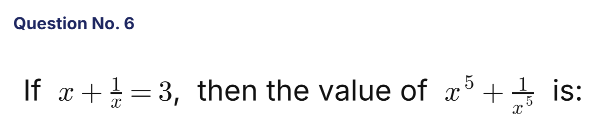
{OPTION 1} 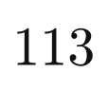
{OPTION 2} 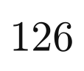
{OPTION 3} 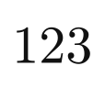
{OPTION 4} 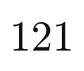
{OPTION 5}
{OPTION 6}
{OPTION 7}
{OPTION 8}
{OPTION 9}
{OPTION 10}
{RIGHT ANSWER} 3
{EXPLANATION} x² + 1/x² = 9 − 2 = 7 and x³ + 1/x³ = 27 − 9 = 18. Then (x² + 1/x²)(x³ + 1/x³) = x⁵ + 1/x⁵ + (x + 1/x), so x⁵ + 1/x⁵ = 7 × 18 − 3 = 123.
{CORRECT MARKS} 1
{NEGATIVE MARKS} 0
{DIFFICULTY} Hard
{QUESTION ENDS}

{QUESTION BEGINS}
{QUESTION NUMBER} 7
{SUBJECT} Numerical Ability
{TOPIC} Algebra
{TAGS} tcs nqt, numerical ability, equation based, hard
{QUESTION TYPE} SINGLECORRECT
{QUESTION TEXT} 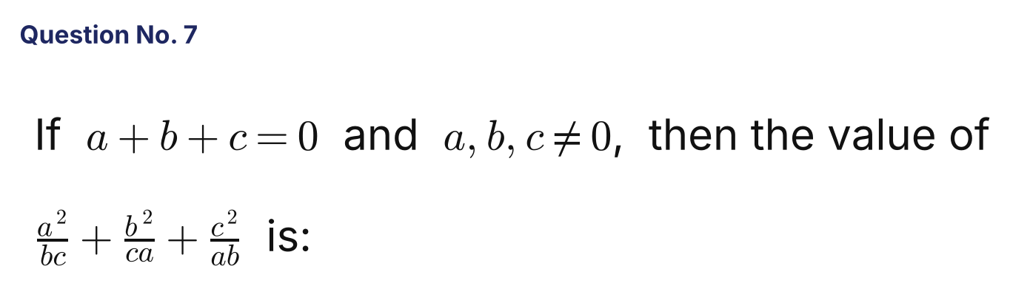
{OPTION 1}
{OPTION 2}
{OPTION 3} 
{OPTION 4} 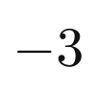
{OPTION 5}
{OPTION 6}
{OPTION 7}
{OPTION 8}
{OPTION 9}
{OPTION 10}
{RIGHT ANSWER} 2
{EXPLANATION} The sum = (a³ + b³ + c³)/(abc). When a + b + c = 0, a³ + b³ + c³ = 3abc. So the value is 3.
{CORRECT MARKS} 1
{NEGATIVE MARKS} 0
{DIFFICULTY} Hard
{QUESTION ENDS}

{QUESTION BEGINS}
{QUESTION NUMBER} 8
{SUBJECT} Numerical Ability
{TOPIC} Surds
{TAGS} tcs nqt, numerical ability, equation based, hard
{QUESTION TYPE} SINGLECORRECT
{QUESTION TEXT} 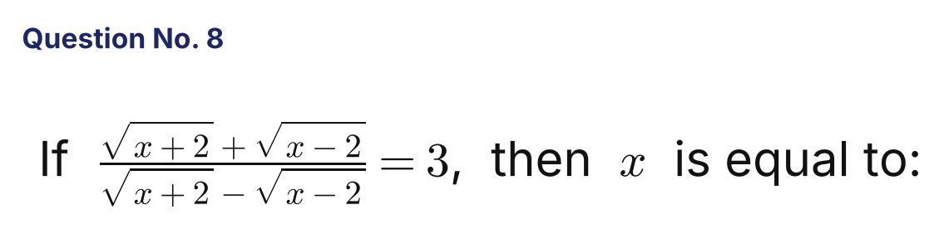
{OPTION 1} 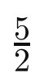
{OPTION 2}
{OPTION 3} 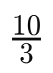
{OPTION 4} 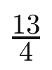
{OPTION 5}
{OPTION 6}
{OPTION 7}
{OPTION 8}
{OPTION 9}
{OPTION 10}
{RIGHT ANSWER} 3
{EXPLANATION} Rationalising: (√(x+2) + √(x−2))²/4 = (x + √(x²−4))/2 = 3, so √(x²−4) = 6 − x. Squaring: x² − 4 = 36 − 12x + x², so 12x = 40 and x = 10/3. Check: √(100/9 − 4) = 8/3 and 10/3 + 8/3 = 6. ✓
{CORRECT MARKS} 1
{NEGATIVE MARKS} 0
{DIFFICULTY} Hard
{QUESTION ENDS}

{QUESTION BEGINS}
{QUESTION NUMBER} 9
{SUBJECT} Numerical Ability
{TOPIC} Quadratic Equations
{TAGS} tcs nqt, numerical ability, equation based, hard
{QUESTION TYPE} SINGLECORRECT
{QUESTION TEXT} 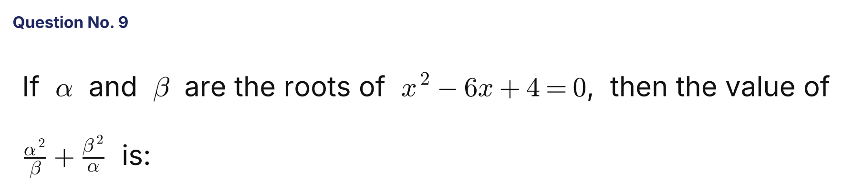
{OPTION 1} 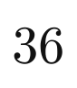
{OPTION 2} 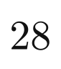
{OPTION 3} 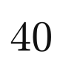
{OPTION 4}
{OPTION 5}
{OPTION 6}
{OPTION 7}
{OPTION 8}
{OPTION 9}
{OPTION 10}
{RIGHT ANSWER} 1
{EXPLANATION} α + β = 6 and αβ = 4. α³ + β³ = 6³ − 3(4)(6) = 216 − 72 = 144. The expression = (α³ + β³)/(αβ) = 144/4 = 36.
{CORRECT MARKS} 1
{NEGATIVE MARKS} 0
{DIFFICULTY} Hard
{QUESTION ENDS}

{QUESTION BEGINS}
{QUESTION NUMBER} 10
{SUBJECT} Numerical Ability
{TOPIC} Surds
{TAGS} tcs nqt, numerical ability, equation based, hard
{QUESTION TYPE} SINGLECORRECT
{QUESTION TEXT} 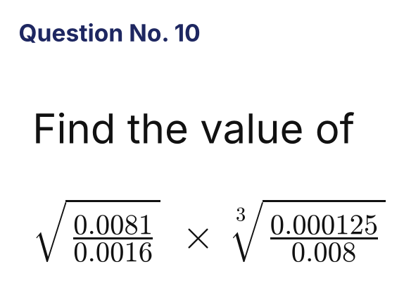
{OPTION 1} 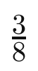
{OPTION 2} 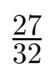
{OPTION 3} 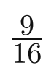
{OPTION 4} 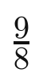
{OPTION 5}
{OPTION 6}
{OPTION 7}
{OPTION 8}
{OPTION 9}
{OPTION 10}
{RIGHT ANSWER} 3
{EXPLANATION} 0.0081/0.0016 = 81/16, whose square root is 9/4. 0.000125/0.008 = 1/64, whose cube root is 1/4. The product = 9/4 × 1/4 = 9/16.
{CORRECT MARKS} 1
{NEGATIVE MARKS} 0
{DIFFICULTY} Hard
{QUESTION ENDS}

{QUESTION BEGINS}
{QUESTION NUMBER} 11
{SUBJECT} Numerical Ability
{TOPIC} Surds
{TAGS} tcs nqt, numerical ability, equation based, hard
{QUESTION TYPE} SINGLECORRECT
{QUESTION TEXT} 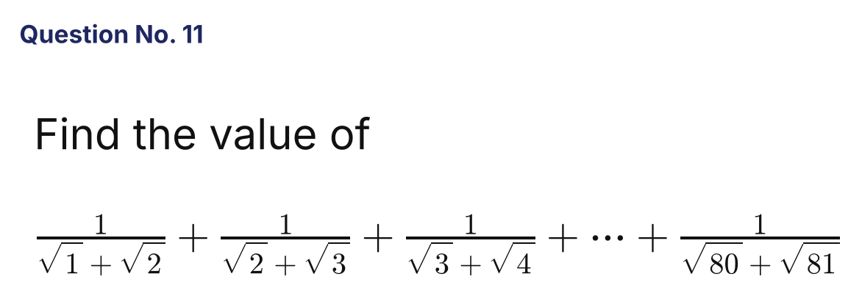
{OPTION 1} 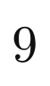
{OPTION 2} 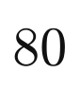
{OPTION 3} 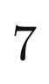
{OPTION 4}
{OPTION 5}
{OPTION 6}
{OPTION 7}
{OPTION 8}
{OPTION 9}
{OPTION 10}
{RIGHT ANSWER} 4
{EXPLANATION} Rationalising each term: 1/(√k + √(k+1)) = √(k+1) − √k. The sum telescopes to √81 − √1 = 9 − 1 = 8.
{CORRECT MARKS} 1
{NEGATIVE MARKS} 0
{DIFFICULTY} Hard
{QUESTION ENDS}

{QUESTION BEGINS}
{QUESTION NUMBER} 12
{SUBJECT} Numerical Ability
{TOPIC} Indices
{TAGS} tcs nqt, numerical ability, equation based, hard
{QUESTION TYPE} SINGLECORRECT
{QUESTION TEXT} 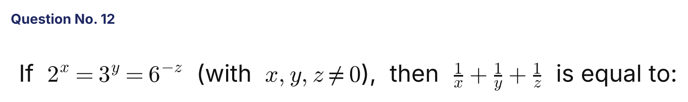
{OPTION 1} 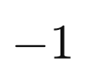
{OPTION 2} 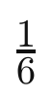
{OPTION 3}
{OPTION 4}
{OPTION 5}
{OPTION 6}
{OPTION 7}
{OPTION 8}
{OPTION 9}
{OPTION 10}
{RIGHT ANSWER} 3
{EXPLANATION} Let 2ˣ = 3ʸ = 6⁻ᶻ = k. Then 2 = k^(1/x), 3 = k^(1/y) and 6 = k^(−1/z). Since 2 × 3 = 6: k^(1/x + 1/y) = k^(−1/z), so 1/x + 1/y = −1/z and 1/x + 1/y + 1/z = 0.
{CORRECT MARKS} 1
{NEGATIVE MARKS} 0
{DIFFICULTY} Hard
{QUESTION ENDS}

{QUESTION BEGINS}
{QUESTION NUMBER} 13
{SUBJECT} Numerical Ability
{TOPIC} Simplification
{TAGS} tcs nqt, numerical ability, equation based, hard
{QUESTION TYPE} SINGLECORRECT
{QUESTION TEXT} 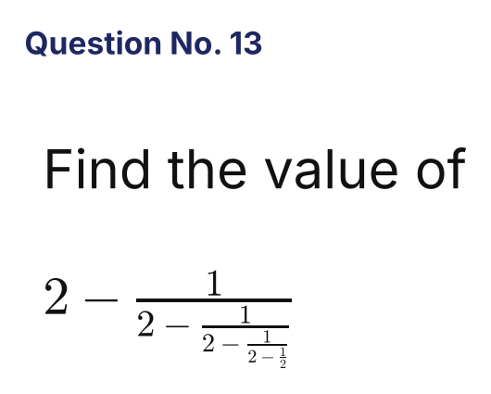
{OPTION 1} 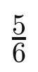
{OPTION 2} 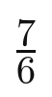
{OPTION 3} 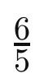
{OPTION 4} 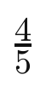
{OPTION 5}
{OPTION 6}
{OPTION 7}
{OPTION 8}
{OPTION 9}
{OPTION 10}
{RIGHT ANSWER} 3
{EXPLANATION} Start from the bottom: 2 − 1/2 = 3/2. Then 2 − 2/3 = 4/3. Then 2 − 3/4 = 5/4. Finally 2 − 4/5 = 6/5.
{CORRECT MARKS} 1
{NEGATIVE MARKS} 0
{DIFFICULTY} Hard
{QUESTION ENDS}

{QUESTION BEGINS}
{QUESTION NUMBER} 14
{SUBJECT} Numerical Ability
{TOPIC} Number System
{TAGS} tcs nqt, numerical ability, equation based, hard
{QUESTION TYPE} SINGLECORRECT
{QUESTION TEXT} 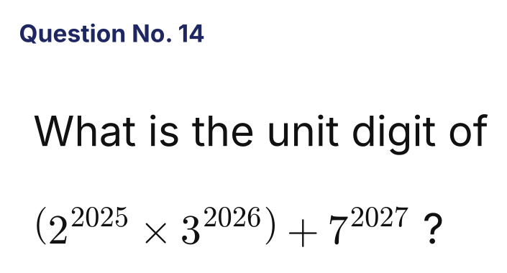
{OPTION 1}
{OPTION 2}
{OPTION 3}
{OPTION 4}
{OPTION 5}
{OPTION 6}
{OPTION 7}
{OPTION 8}
{OPTION 9}
{OPTION 10}
{RIGHT ANSWER} 2
{EXPLANATION} Unit digits repeat every 4 powers. 2^2025: 2025 mod 4 = 1, so unit digit 2. 3^2026: 2026 mod 4 = 2, so unit digit 9. Their product ends in 2 × 9 = 18 → 8. 7^2027: 2027 mod 4 = 3, so unit digit 3. Total = 8 + 3 = 11, so the unit digit is 1.
{CORRECT MARKS} 1
{NEGATIVE MARKS} 0
{DIFFICULTY} Hard
{QUESTION ENDS}

{QUESTION BEGINS}
{QUESTION NUMBER} 15
{SUBJECT} Numerical Ability
{TOPIC} Surds
{TAGS} tcs nqt, numerical ability, equation based, hard
{QUESTION TYPE} SINGLECORRECT
{QUESTION TEXT} 
{OPTION 1} 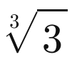
{OPTION 2} 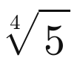
{OPTION 3} 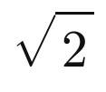
{OPTION 4} 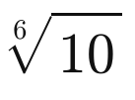
{OPTION 5}
{OPTION 6}
{OPTION 7}
{OPTION 8}
{OPTION 9}
{OPTION 10}
{RIGHT ANSWER} 2
{EXPLANATION} Raise all four numbers to the power 12 (the LCM of 2, 3, 4, 6): (√2)¹² = 2⁶ = 64; (∛3)¹² = 3⁴ = 81; (⁴√5)¹² = 5³ = 125; (⁶√10)¹² = 10² = 100. The largest is 125, so ⁴√5 is the greatest.
{CORRECT MARKS} 1
{NEGATIVE MARKS} 0
{DIFFICULTY} Hard
{QUESTION ENDS}

{QUESTION BEGINS}
{QUESTION NUMBER} 16
{SUBJECT} Numerical Ability
{TOPIC} Algebra
{TAGS} tcs nqt, numerical ability, equation based, hard
{QUESTION TYPE} SINGLECORRECT
{QUESTION TEXT} 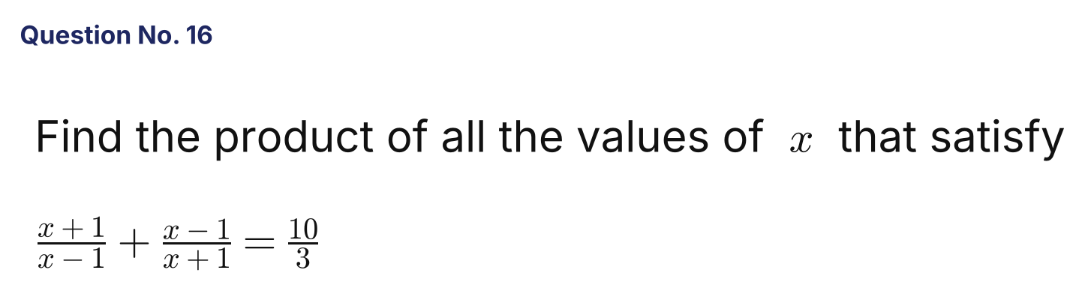
{OPTION 1}
{OPTION 2} 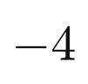
{OPTION 3} 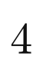
{OPTION 4} 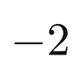
{OPTION 5}
{OPTION 6}
{OPTION 7}
{OPTION 8}
{OPTION 9}
{OPTION 10}
{RIGHT ANSWER} 2
{EXPLANATION} (x+1)² + (x−1)² = (10/3)(x² − 1) gives 2x² + 2 = (10/3)x² − 10/3. Multiply by 3: 6x² + 6 = 10x² − 10, so 4x² = 16 and x = ±2. Product of the values = 2 × (−2) = −4.
{CORRECT MARKS} 1
{NEGATIVE MARKS} 0
{DIFFICULTY} Hard
{QUESTION ENDS}

{QUESTION BEGINS}
{QUESTION NUMBER} 17
{SUBJECT} Numerical Ability
{TOPIC} Surds
{TAGS} tcs nqt, numerical ability, equation based, hard
{QUESTION TYPE} SINGLECORRECT
{QUESTION TEXT} 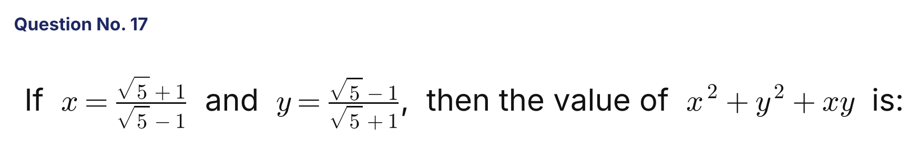
{OPTION 1}
{OPTION 2}
{OPTION 3} 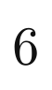
{OPTION 4}
{OPTION 5}
{OPTION 6}
{OPTION 7}
{OPTION 8}
{OPTION 9}
{OPTION 10}
{RIGHT ANSWER} 2
{EXPLANATION} x = (√5+1)²/4 = (3 + √5)/2 and y = (3 − √5)/2. So x + y = 3 and xy = 1. x² + y² = 9 − 2 = 7. Therefore x² + y² + xy = 7 + 1 = 8.
{CORRECT MARKS} 1
{NEGATIVE MARKS} 0
{DIFFICULTY} Hard
{QUESTION ENDS}

{QUESTION BEGINS}
{QUESTION NUMBER} 18
{SUBJECT} Numerical Ability
{TOPIC} Surds
{TAGS} tcs nqt, numerical ability, equation based, hard
{QUESTION TYPE} SINGLECORRECT
{QUESTION TEXT} 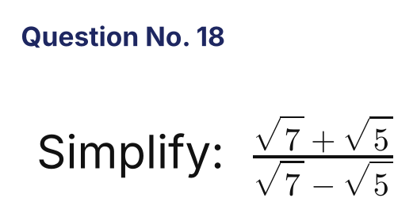
{OPTION 1} 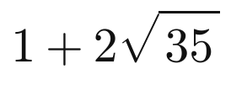
{OPTION 2} 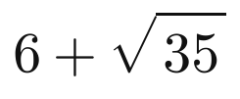
{OPTION 3} 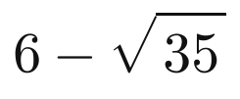
{OPTION 4} 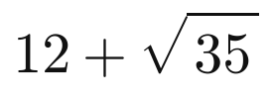
{OPTION 5}
{OPTION 6}
{OPTION 7}
{OPTION 8}
{OPTION 9}
{OPTION 10}
{RIGHT ANSWER} 2
{EXPLANATION} Multiply the numerator and denominator by (√7 + √5): numerator = (√7 + √5)² = 12 + 2√35 and denominator = 7 − 5 = 2. So the value = 6 + √35.
{CORRECT MARKS} 1
{NEGATIVE MARKS} 0
{DIFFICULTY} Hard
{QUESTION ENDS}

{QUESTION BEGINS}
{QUESTION NUMBER} 19
{SUBJECT} Numerical Ability
{TOPIC} Series
{TAGS} tcs nqt, numerical ability, equation based, hard
{QUESTION TYPE} SINGLECORRECT
{QUESTION TEXT} 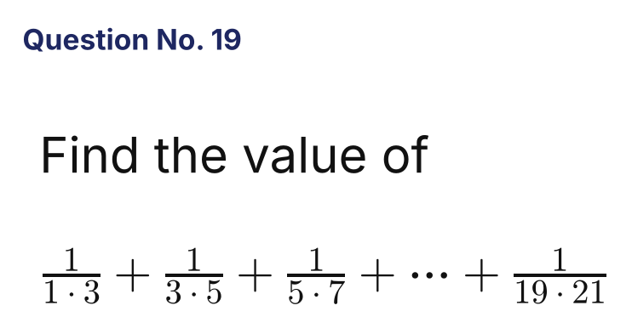
{OPTION 1} 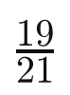
{OPTION 2} 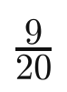
{OPTION 3} 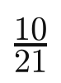
{OPTION 4} 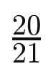
{OPTION 5}
{OPTION 6}
{OPTION 7}
{OPTION 8}
{OPTION 9}
{OPTION 10}
{RIGHT ANSWER} 3
{EXPLANATION} Each term 1/((2k−1)(2k+1)) = ½[1/(2k−1) − 1/(2k+1)]. The sum telescopes to ½(1 − 1/21) = ½ × 20/21 = 10/21.
{CORRECT MARKS} 1
{NEGATIVE MARKS} 0
{DIFFICULTY} Hard
{QUESTION ENDS}

{QUESTION BEGINS}
{QUESTION NUMBER} 20
{SUBJECT} Numerical Ability
{TOPIC} Surds
{TAGS} tcs nqt, numerical ability, equation based, hard
{QUESTION TYPE} SINGLECORRECT
{QUESTION TEXT} 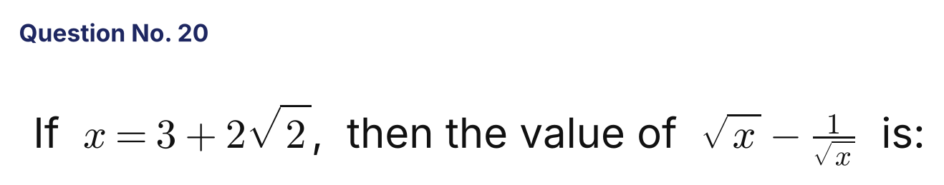
{OPTION 1}
{OPTION 2}
{OPTION 3} 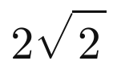
{OPTION 4}
{OPTION 5}
{OPTION 6}
{OPTION 7}
{OPTION 8}
{OPTION 9}
{OPTION 10}
{RIGHT ANSWER} 1
{EXPLANATION} 3 + 2√2 = (1 + √2)², so √x = 1 + √2 and 1/√x = 1/(1 + √2) = √2 − 1. The difference = (1 + √2) − (√2 − 1) = 2.
{CORRECT MARKS} 1
{NEGATIVE MARKS} 0
{DIFFICULTY} Hard
{QUESTION ENDS}

