{QUESTION BEGINS}
{QUESTION NUMBER} 1
{SUBJECT} Technical Assessment
{TOPIC} Pseudocode
{TAGS} accenture, technical assessment, pseudocode, mock test 3, easy
{QUESTION TYPE} SINGLECORRECT
{QUESTION TEXT} Consider the following pseudocode snippet. What will be the output of the code?
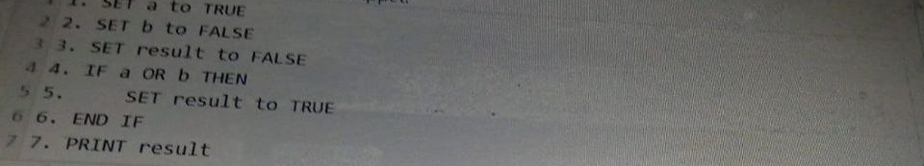

{OPTION 1} TRUE
{OPTION 2} FALSE
{OPTION 3} TRUE and FALSE
{OPTION 4} ERROR
{OPTION 5}
{OPTION 6}
{OPTION 7}
{OPTION 8}
{OPTION 9}
{OPTION 10}
{RIGHT ANSWER} 1
{EXPLANATION} a OR b is true when at least one of them is true. a is TRUE, so the IF condition holds and result is set to TRUE. PRINT result prints TRUE.
{CORRECT MARKS} 1
{NEGATIVE MARKS} 0
{DIFFICULTY} Easy
{QUESTION ENDS}

{QUESTION BEGINS}
{QUESTION NUMBER} 2
{SUBJECT} Technical Assessment
{TOPIC} Pseudocode
{TAGS} accenture, technical assessment, pseudocode, mock test 3, hard
{QUESTION TYPE} SINGLECORRECT
{QUESTION TEXT} What will be the output of the following pseudocode?
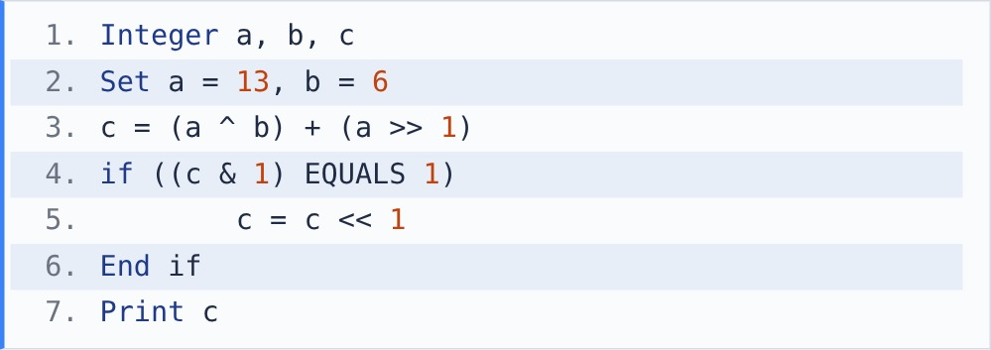
[Note - ^: bitwise XOR sets a result bit to 1 only when the two bits are different. >>: right shift moves the bits right (x >> 1 is integer division by 2). <<: left shift moves the bits left (x << 1 multiplies by 2). &: bitwise AND.]

{OPTION 1} 17
{OPTION 2} 46
{OPTION 3} 34
{OPTION 4} 23
{OPTION 5}
{OPTION 6}
{OPTION 7}
{OPTION 8}
{OPTION 9}
{OPTION 10}
{RIGHT ANSWER} 3
{EXPLANATION} 13 = 1101, 6 = 0110, so 13 ^ 6 = 1011 = 11. 13 >> 1 = 6. c = 11 + 6 = 17. 17 is odd, so c & 1 = 1 and the if runs: c = 17 << 1 = 34.
{CORRECT MARKS} 1
{NEGATIVE MARKS} 0
{DIFFICULTY} Hard
{QUESTION ENDS}

{QUESTION BEGINS}
{QUESTION NUMBER} 3
{SUBJECT} Technical Assessment
{TOPIC} Pseudocode
{TAGS} accenture, technical assessment, pseudocode, mock test 3, easy
{QUESTION TYPE} SINGLECORRECT
{QUESTION TEXT} Consider the below pseudocode. Which output is produced when calling the getRateOfInterest() method?
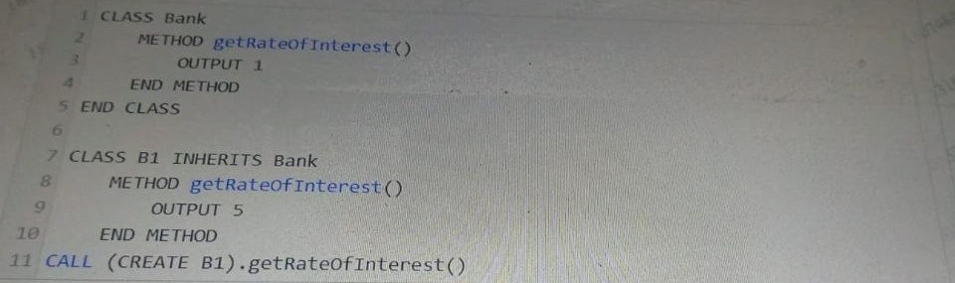

{OPTION 1} 1
{OPTION 2} 9
{OPTION 3} 5
{OPTION 4} None of the above
{OPTION 5}
{OPTION 6}
{OPTION 7}
{OPTION 8}
{OPTION 9}
{OPTION 10}
{RIGHT ANSWER} 3
{EXPLANATION} B1 inherits Bank and overrides getRateOfInterest(). The object is created as B1, so at run time the B1 version runs (method overriding / runtime polymorphism) and outputs 5. The Bank version is not called.
{CORRECT MARKS} 1
{NEGATIVE MARKS} 0
{DIFFICULTY} Easy
{QUESTION ENDS}

{QUESTION BEGINS}
{QUESTION NUMBER} 4
{SUBJECT} Technical Assessment
{TOPIC} Pseudocode
{TAGS} accenture, technical assessment, pseudocode, mock test 3, medium
{QUESTION TYPE} SINGLECORRECT
{QUESTION TEXT} What will be the output of the following pseudocode?
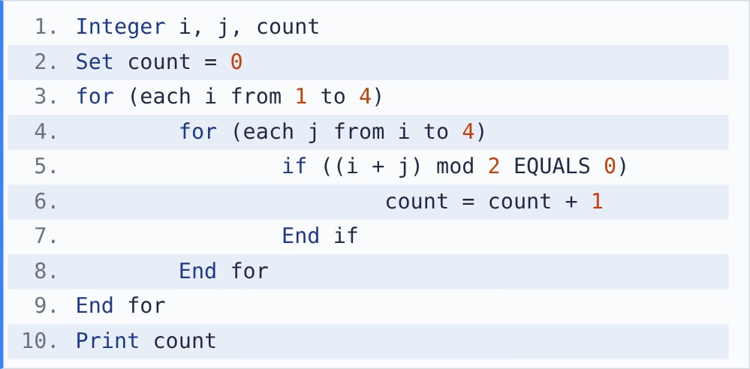
[Note - mod finds the remainder after division. For example, 17 mod 5 = 2.]

{OPTION 1} 4
{OPTION 2} 8
{OPTION 3} 10
{OPTION 4} 6
{OPTION 5}
{OPTION 6}
{OPTION 7}
{OPTION 8}
{OPTION 9}
{OPTION 10}
{RIGHT ANSWER} 4
{EXPLANATION} count increases when i + j is even. i=1: j=1, 3 (2 pairs). i=2: j=2, 4 (2). i=3: j=3 (1). i=4: j=4 (1). Total = 2 + 2 + 1 + 1 = 6.
{CORRECT MARKS} 1
{NEGATIVE MARKS} 0
{DIFFICULTY} Medium
{QUESTION ENDS}

{QUESTION BEGINS}
{QUESTION NUMBER} 5
{SUBJECT} Technical Assessment
{TOPIC} Pseudocode
{TAGS} accenture, technical assessment, pseudocode, mock test 3, easy
{QUESTION TYPE} SINGLECORRECT
{QUESTION TEXT} Consider the following pseudocode snippet. What is the data type of the result variable?
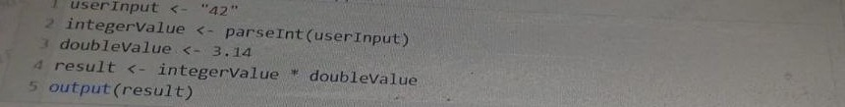

{OPTION 1} Integer
{OPTION 2} Float
{OPTION 3} String
{OPTION 4} Boolean
{OPTION 5}
{OPTION 6}
{OPTION 7}
{OPTION 8}
{OPTION 9}
{OPTION 10}
{RIGHT ANSWER} 2
{EXPLANATION} parseInt turns "42" into the integer 42. 3.14 is a decimal. An integer multiplied by a decimal is promoted to a decimal, so result = 131.88, which is a Float.
{CORRECT MARKS} 1
{NEGATIVE MARKS} 0
{DIFFICULTY} Easy
{QUESTION ENDS}

{QUESTION BEGINS}
{QUESTION NUMBER} 6
{SUBJECT} Technical Assessment
{TOPIC} Pseudocode
{TAGS} accenture, technical assessment, pseudocode, mock test 3, medium
{QUESTION TYPE} SINGLECORRECT
{QUESTION TEXT} What will be the output of the following pseudocode?
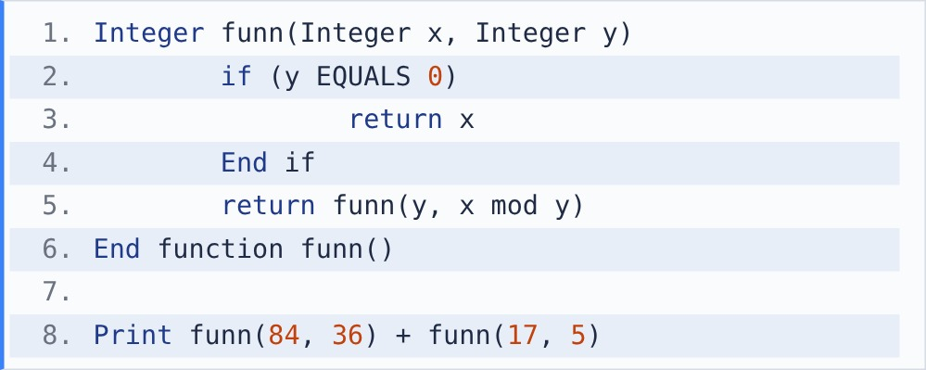
[Note - mod finds the remainder after division. For example, 17 mod 5 = 2.]

{OPTION 1} 12
{OPTION 2} 17
{OPTION 3} 6
{OPTION 4} 13
{OPTION 5}
{OPTION 6}
{OPTION 7}
{OPTION 8}
{OPTION 9}
{OPTION 10}
{RIGHT ANSWER} 4
{EXPLANATION} funn is Euclid's GCD algorithm. funn(84,36) -> funn(36,12) -> funn(12,0) = 12. funn(17,5) -> funn(5,2) -> funn(2,1) -> funn(1,0) = 1. Print 12 + 1 = 13.
{CORRECT MARKS} 1
{NEGATIVE MARKS} 0
{DIFFICULTY} Medium
{QUESTION ENDS}

{QUESTION BEGINS}
{QUESTION NUMBER} 7
{SUBJECT} Technical Assessment
{TOPIC} Pseudocode
{TAGS} accenture, technical assessment, pseudocode, mock test 3, easy
{QUESTION TYPE} SINGLECORRECT
{QUESTION TEXT} In the provided pseudocode, what does the "Vowels" function do?
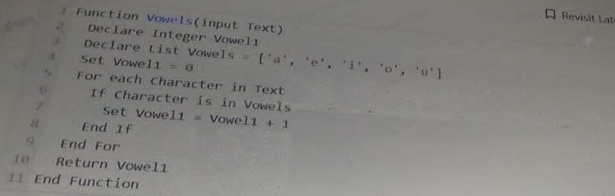

{OPTION 1} Reverses the input text
{OPTION 2} Counts the number of vowels in the input text
{OPTION 3} Concatenates vowels from the input text
{OPTION 4} Checks if the input text is a palindrome
{OPTION 5}
{OPTION 6}
{OPTION 7}
{OPTION 8}
{OPTION 9}
{OPTION 10}
{RIGHT ANSWER} 2
{EXPLANATION} Vowel1 starts at 0 and goes up by 1 for every character that is in the list [a, e, i, o, u]. The function returns this number, so it counts the vowels in the text.
{CORRECT MARKS} 1
{NEGATIVE MARKS} 0
{DIFFICULTY} Easy
{QUESTION ENDS}

{QUESTION BEGINS}
{QUESTION NUMBER} 8
{SUBJECT} Technical Assessment
{TOPIC} Pseudocode
{TAGS} accenture, technical assessment, pseudocode, mock test 3, medium
{QUESTION TYPE} SINGLECORRECT
{QUESTION TEXT} What will be the output of the following pseudocode?
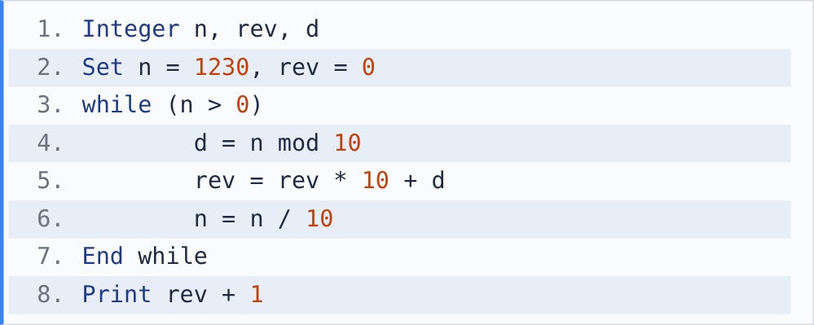
[Note - / between two integers gives integer division, which drops the remainder: 123 / 10 = 12.]

{OPTION 1} 3211
{OPTION 2} 0322
{OPTION 3} 322
{OPTION 4} 1231
{OPTION 5}
{OPTION 6}
{OPTION 7}
{OPTION 8}
{OPTION 9}
{OPTION 10}
{RIGHT ANSWER} 3
{EXPLANATION} Each pass takes the last digit and appends it to rev. n=1230: d=0, rev=0, n=123. d=3, rev=3, n=12. d=2, rev=32, n=1. d=1, rev=321, n=0. The leading 0 disappears, so rev = 321 and it prints 321 + 1 = 322.
{CORRECT MARKS} 1
{NEGATIVE MARKS} 0
{DIFFICULTY} Medium
{QUESTION ENDS}

{QUESTION BEGINS}
{QUESTION NUMBER} 9
{SUBJECT} Technical Assessment
{TOPIC} Pseudocode
{TAGS} accenture, technical assessment, pseudocode, mock test 3, medium
{QUESTION TYPE} SINGLECORRECT
{QUESTION TEXT} What does the pseudocode do?
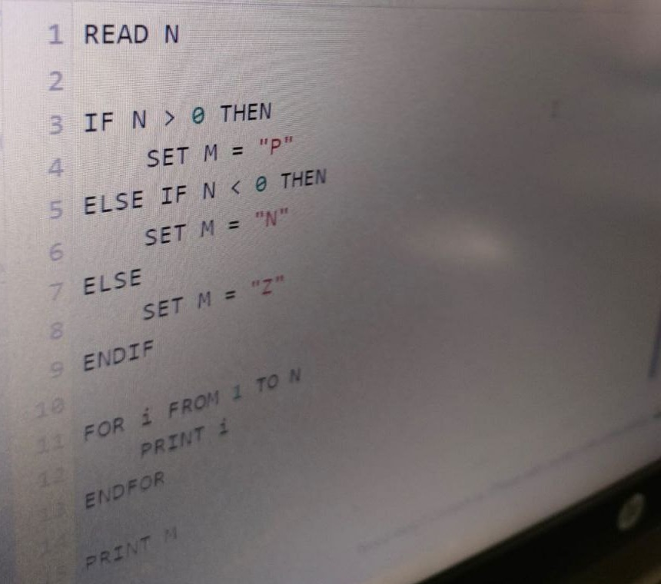

{OPTION 1} It prints only P, N or Z depending on the sign of N
{OPTION 2} It prints the numbers from 1 to N and then prints P, N or Z depending on whether N is positive, negative or zero
{OPTION 3} It prints the numbers from 1 to N only when N is negative
{OPTION 4} It prints the numbers from N down to 1 and then the sign of N
{OPTION 5}
{OPTION 6}
{OPTION 7}
{OPTION 8}
{OPTION 9}
{OPTION 10}
{RIGHT ANSWER} 2
{EXPLANATION} The IF block stores "P" (N > 0), "N" (N < 0) or "Z" (N = 0) in M. The FOR loop then prints 1 to N (nothing when N is 0 or negative), and finally PRINT M prints the letter.
{CORRECT MARKS} 1
{NEGATIVE MARKS} 0
{DIFFICULTY} Medium
{QUESTION ENDS}

{QUESTION BEGINS}
{QUESTION NUMBER} 10
{SUBJECT} Technical Assessment
{TOPIC} Pseudocode
{TAGS} accenture, technical assessment, pseudocode, mock test 3, hard
{QUESTION TYPE} SINGLECORRECT
{QUESTION TEXT} Analyse the given algorithm. Which of the following statements is correct?
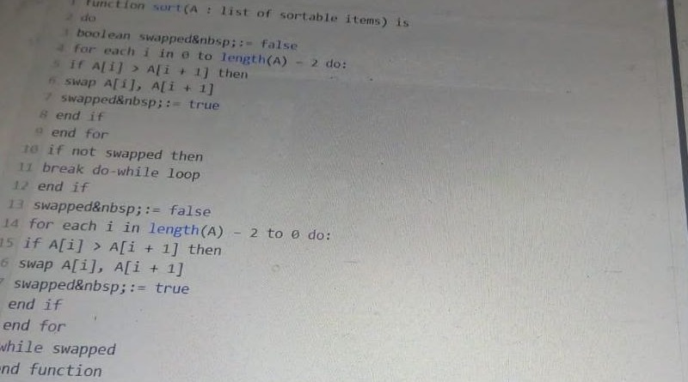

{OPTION 1} The worst case time complexity of this algorithm is O(n log n)
{OPTION 2} The worst case space complexity of this algorithm is O(n)
{OPTION 3} The algorithm extends bubble sort by operating in two directions
{OPTION 4} It is a divide-and-conquer algorithm like merge sort
{OPTION 5}
{OPTION 6}
{OPTION 7}
{OPTION 8}
{OPTION 9}
{OPTION 10}
{RIGHT ANSWER} 3
{EXPLANATION} Each pass bubbles the largest item forward (left to right), then the smallest item backward (right to left), and stops when no swap happens. That is cocktail shaker sort, a two-way bubble sort. It is still O(n^2) in the worst case and sorts in place with O(1) extra space.
{CORRECT MARKS} 1
{NEGATIVE MARKS} 0
{DIFFICULTY} Hard
{QUESTION ENDS}

