{QUESTION BEGINS}
{QUESTION NUMBER} 1
{SUBJECT} Advanced Quantitative Ability
{TOPIC} Calculus
{TAGS} tcs nqt, advanced quantitative, MCQ, hard
{QUESTION TYPE} SINGLECORRECT
{QUESTION TEXT}
{OPTION 1} 2/3
{OPTION 2} 1
{OPTION 3} 4/3
{OPTION 4} 8/3
{OPTION 5}
{OPTION 6}
{OPTION 7}
{OPTION 8}
{OPTION 9}
{OPTION 10}
{RIGHT ANSWER} 3
{EXPLANATION} The curves meet where x² = 2x, that is x = 0 and x = 2. For 0 < x < 2 the line y = 2x lies above the parabola. Area = ∫₀² (2x − x²) dx = [x² − x³/3]₀² = 4 − 8/3 = 4/3.
{CORRECT MARKS} 1
{NEGATIVE MARKS} 0
{DIFFICULTY} Hard
{QUESTION ENDS}

{QUESTION BEGINS}
{QUESTION NUMBER} 2
{SUBJECT} Advanced Quantitative Ability
{TOPIC} Number Theory
{TAGS} tcs nqt, advanced quantitative, TITA, hard
{QUESTION TYPE} NUMERICAL
{QUESTION TEXT} 
{OPTION 1}
{OPTION 2}
{OPTION 3}
{OPTION 4}
{OPTION 5}
{OPTION 6}
{OPTION 7}
{OPTION 8}
{OPTION 9}
{OPTION 10}
{RIGHT ANSWER} 1170
{EXPLANATION} 360 = 2³ × 3² × 5. The sum of divisors = (1 + 2 + 4 + 8)(1 + 3 + 9)(1 + 5) = 15 × 13 × 6 = 1170.
{CORRECT MARKS} 1
{NEGATIVE MARKS} 0
{DIFFICULTY} Hard
{QUESTION ENDS}

{QUESTION BEGINS}
{QUESTION NUMBER} 3
{SUBJECT} Advanced Quantitative Ability
{TOPIC} Discounts
{TAGS} tcs nqt, advanced quantitative, MCQ, hard
{QUESTION TYPE} SINGLECORRECT
{QUESTION TEXT} 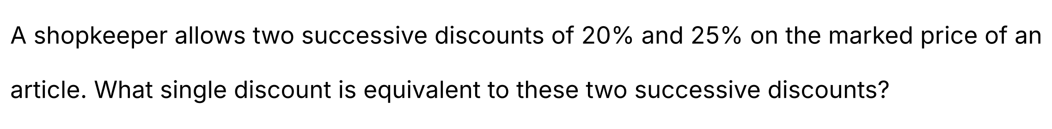
{OPTION 1} 40%
{OPTION 2} 50%
{OPTION 3} 45%
{OPTION 4} 35%
{OPTION 5}
{OPTION 6}
{OPTION 7}
{OPTION 8}
{OPTION 9}
{OPTION 10}
{RIGHT ANSWER} 1
{EXPLANATION} The final price = 100 × 0.8 × 0.75 = 60 per 100 of marked price. So the single equivalent discount = 100 − 60 = 40%.
{CORRECT MARKS} 1
{NEGATIVE MARKS} 0
{DIFFICULTY} Hard
{QUESTION ENDS}

{QUESTION BEGINS}
{QUESTION NUMBER} 4
{SUBJECT} Advanced Quantitative Ability
{TOPIC} Probability
{TAGS} tcs nqt, advanced quantitative, MCQ, hard
{QUESTION TYPE} SINGLECORRECT
{QUESTION TEXT} 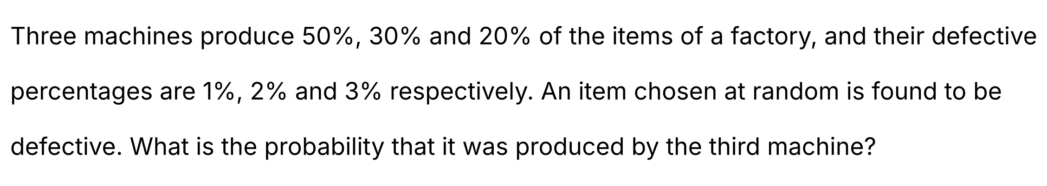
{OPTION 1} 1/3
{OPTION 2} 6/17
{OPTION 3} 2/5
{OPTION 4} 3/10
{OPTION 5}
{OPTION 6}
{OPTION 7}
{OPTION 8}
{OPTION 9}
{OPTION 10}
{RIGHT ANSWER} 2
{EXPLANATION} By Bayes' theorem: P(M₃ | defective) = (0.2 × 0.03)/(0.5 × 0.01 + 0.3 × 0.02 + 0.2 × 0.03) = 0.006/(0.005 + 0.006 + 0.006) = 0.006/0.017 = 6/17.
{CORRECT MARKS} 1
{NEGATIVE MARKS} 0
{DIFFICULTY} Hard
{QUESTION ENDS}

{QUESTION BEGINS}
{QUESTION NUMBER} 5
{SUBJECT} Advanced Quantitative Ability
{TOPIC} Probability
{TAGS} tcs nqt, advanced quantitative, MCQ, hard
{QUESTION TYPE} SINGLECORRECT
{QUESTION TEXT} 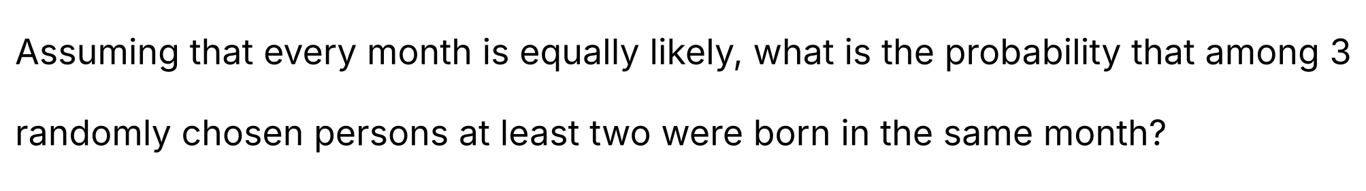
{OPTION 1} 17/72
{OPTION 2} 5/12
{OPTION 3} 11/72
{OPTION 4} 1/12
{OPTION 5}
{OPTION 6}
{OPTION 7}
{OPTION 8}
{OPTION 9}
{OPTION 10}
{RIGHT ANSWER} 1
{EXPLANATION} P(all three have different birth months) = (12 × 11 × 10)/12³ = 1320/1728 = 55/72. So P(at least two share a month) = 1 − 55/72 = 17/72.
{CORRECT MARKS} 1
{NEGATIVE MARKS} 0
{DIFFICULTY} Hard
{QUESTION ENDS}

{QUESTION BEGINS}
{QUESTION NUMBER} 6
{SUBJECT} Advanced Quantitative Ability
{TOPIC} Statistics
{TAGS} tcs nqt, advanced quantitative, TITA, hard
{QUESTION TYPE} NUMERICAL
{QUESTION TEXT} 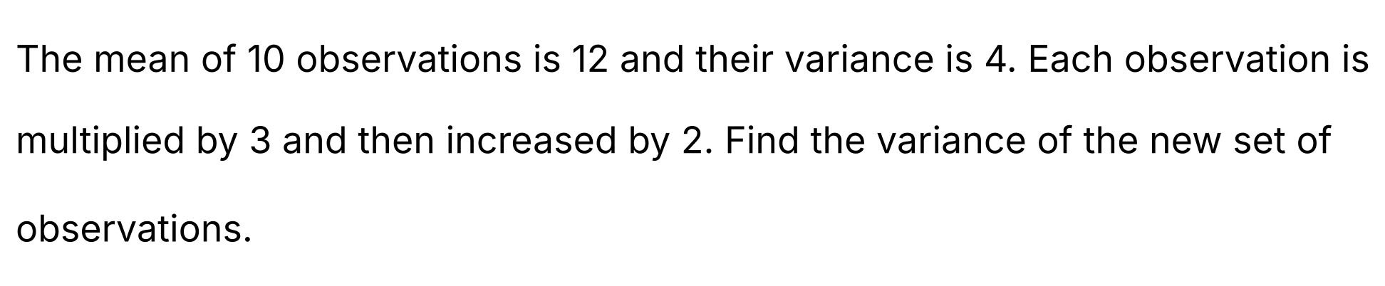
{OPTION 1}
{OPTION 2}
{OPTION 3}
{OPTION 4}
{OPTION 5}
{OPTION 6}
{OPTION 7}
{OPTION 8}
{OPTION 9}
{OPTION 10}
{RIGHT ANSWER} 36
{EXPLANATION} If each observation x is replaced by 3x + 2, the variance becomes 3² × (old variance) = 9 × 4 = 36 (adding a constant does not change the variance).
{CORRECT MARKS} 1
{NEGATIVE MARKS} 0
{DIFFICULTY} Hard
{QUESTION ENDS}

{QUESTION BEGINS}
{QUESTION NUMBER} 7
{SUBJECT} Advanced Quantitative Ability
{TOPIC} Modulus
{TAGS} tcs nqt, advanced quantitative, TITA, hard
{QUESTION TYPE} NUMERICAL
{QUESTION TEXT}
{OPTION 1}
{OPTION 2}
{OPTION 3}
{OPTION 4}
{OPTION 5}
{OPTION 6}
{OPTION 7}
{OPTION 8}
{OPTION 9}
{OPTION 10}
{RIGHT ANSWER} 1
{EXPLANATION} The sum |x − 2| + |x + 1| is 3 between −1 and 2 and larger outside it. For x ≥ 2: (x − 2) + (x + 1) = 7 gives 2x − 1 = 7, so x = 4. For x ≤ −1: (2 − x) + (−x − 1) = 7 gives 1 − 2x = 7, so x = −3. Both are valid, and their sum = 4 + (−3) = 1.
{CORRECT MARKS} 1
{NEGATIVE MARKS} 0
{DIFFICULTY} Hard
{QUESTION ENDS}

{QUESTION BEGINS}
{QUESTION NUMBER} 8
{SUBJECT} Advanced Quantitative Ability
{TOPIC} Parabola
{TAGS} tcs nqt, advanced quantitative, TITA, hard
{QUESTION TYPE} NUMERICAL
{QUESTION TEXT} 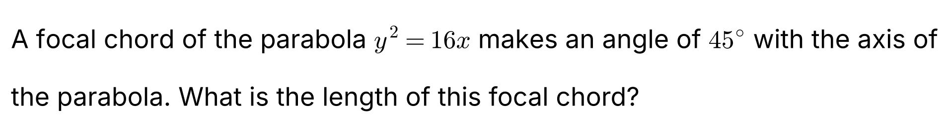
{OPTION 1}
{OPTION 2}
{OPTION 3}
{OPTION 4}
{OPTION 5}
{OPTION 6}
{OPTION 7}
{OPTION 8}
{OPTION 9}
{OPTION 10}
{RIGHT ANSWER} 32
{EXPLANATION} For y² = 4ax we have a = 4. The length of a focal chord inclined at angle θ to the axis is 4a/sin²θ = 16/sin²45° = 16/(1/2) = 32. (Check: the chord through (4, 0) with slope 1 meets y² = 16x at x = 12 ± 8√2, and the chord length = √2 × |x₁ − x₂| = √2 × 16√2 = 32.)
{CORRECT MARKS} 1
{NEGATIVE MARKS} 0
{DIFFICULTY} Hard
{QUESTION ENDS}

{QUESTION BEGINS}
{QUESTION NUMBER} 9
{SUBJECT} Advanced Quantitative Ability
{TOPIC} Straight Lines
{TAGS} tcs nqt, advanced quantitative, TITA, hard
{QUESTION TYPE} NUMERICAL
{QUESTION TEXT} 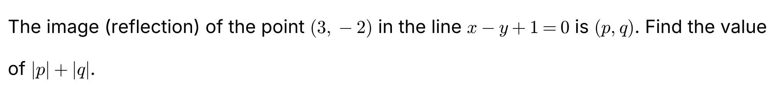
{OPTION 1}
{OPTION 2}
{OPTION 3}
{OPTION 4}
{OPTION 5}
{OPTION 6}
{OPTION 7}
{OPTION 8}
{OPTION 9}
{OPTION 10}
{RIGHT ANSWER} 7
{EXPLANATION} For the line x − y + 1 = 0 the reflection of (x₁, y₁) is (x₁, y₁) − 2(x₁ − y₁ + 1)/(1² + 1²) × (1, −1). Here x₁ − y₁ + 1 = 3 + 2 + 1 = 6, so the image = (3, −2) − 6 × (1, −1) = (−3, 4). Then |p| + |q| = 3 + 4 = 7.
{CORRECT MARKS} 1
{NEGATIVE MARKS} 0
{DIFFICULTY} Hard
{QUESTION ENDS}

{QUESTION BEGINS}
{QUESTION NUMBER} 10
{SUBJECT} Advanced Quantitative Ability
{TOPIC} Complex Numbers
{TAGS} tcs nqt, advanced quantitative, MCQ, hard
{QUESTION TYPE} SINGLECORRECT
{QUESTION TEXT}
{OPTION 1} The line x − y = 0
{OPTION 2} The line x + y = 1
{OPTION 3} A circle of radius 1
{OPTION 4} The line x + y = 0
{OPTION 5}
{OPTION 6}
{OPTION 7}
{OPTION 8}
{OPTION 9}
{OPTION 10}
{RIGHT ANSWER} 4
{EXPLANATION} Let z = x + iy. |z − 1|² = (x − 1)² + y² and |z + i|² = x² + (y + 1)². Equating: −2x + 1 = 2y + 1, so x + y = 0. The locus is the perpendicular bisector of the points 1 and −i, that is the line x + y = 0.
{CORRECT MARKS} 1
{NEGATIVE MARKS} 0
{DIFFICULTY} Hard
{QUESTION ENDS}

{QUESTION BEGINS}
{QUESTION NUMBER} 11
{SUBJECT} Advanced Quantitative Ability
{TOPIC} Permutations & Combinations
{TAGS} tcs nqt, advanced quantitative, TITA, hard
{QUESTION TYPE} NUMERICAL
{QUESTION TEXT} 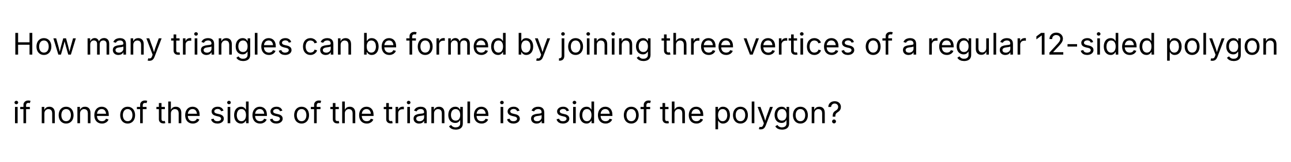
{OPTION 1}
{OPTION 2}
{OPTION 3}
{OPTION 4}
{OPTION 5}
{OPTION 6}
{OPTION 7}
{OPTION 8}
{OPTION 9}
{OPTION 10}
{RIGHT ANSWER} 112
{EXPLANATION} Total triangles = C(12, 3) = 220. Triangles having at least one polygon side: those with exactly two sides in common with the polygon = 12 (three consecutive vertices); those with exactly one side in common = 12 × (12 − 4) = 96 (choose a side and a third vertex that is not adjacent to either end). So the triangles with at least one side in common = 12 + 96 = 108, and the required number = 220 − 108 = 112.
{CORRECT MARKS} 1
{NEGATIVE MARKS} 0
{DIFFICULTY} Hard
{QUESTION ENDS}

{QUESTION BEGINS}
{QUESTION NUMBER} 12
{SUBJECT} Advanced Quantitative Ability
{TOPIC} Algebra
{TAGS} tcs nqt, advanced quantitative, TITA, hard
{QUESTION TYPE} NUMERICAL
{QUESTION TEXT} 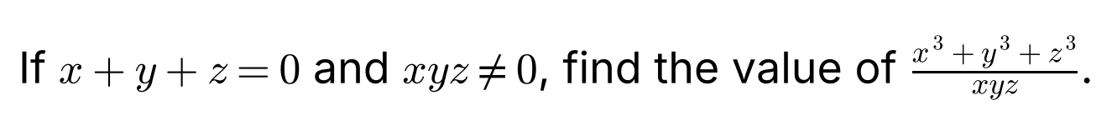
{OPTION 1}
{OPTION 2}
{OPTION 3}
{OPTION 4}
{OPTION 5}
{OPTION 6}
{OPTION 7}
{OPTION 8}
{OPTION 9}
{OPTION 10}
{RIGHT ANSWER} 3
{EXPLANATION} If x + y + z = 0 then x³ + y³ + z³ = 3xyz (from x³ + y³ + z³ − 3xyz = (x + y + z)(x² + y² + z² − xy − yz − zx)). So the ratio = 3xyz/xyz = 3.
{CORRECT MARKS} 1
{NEGATIVE MARKS} 0
{DIFFICULTY} Hard
{QUESTION ENDS}

{QUESTION BEGINS}
{QUESTION NUMBER} 13
{SUBJECT} Advanced Quantitative Ability
{TOPIC} Ages
{TAGS} tcs nqt, advanced quantitative, MCQ, hard
{QUESTION TYPE} SINGLECORRECT
{QUESTION TEXT} 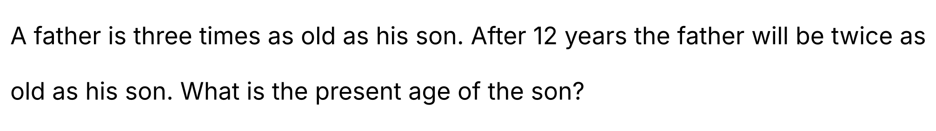
{OPTION 1} 9 years
{OPTION 2} 15 years
{OPTION 3} 12 years
{OPTION 4} 10 years
{OPTION 5}
{OPTION 6}
{OPTION 7}
{OPTION 8}
{OPTION 9}
{OPTION 10}
{RIGHT ANSWER} 3
{EXPLANATION} Let the son's present age be s, so the father's age is 3s. After 12 years: 3s + 12 = 2(s + 12) = 2s + 24, which gives s = 12.
{CORRECT MARKS} 1
{NEGATIVE MARKS} 0
{DIFFICULTY} Hard
{QUESTION ENDS}

{QUESTION BEGINS}
{QUESTION NUMBER} 14
{SUBJECT} Advanced Quantitative Ability
{TOPIC} Heights and Distances
{TAGS} tcs nqt, advanced quantitative, TITA, hard
{QUESTION TYPE} NUMERICAL
{QUESTION TEXT} 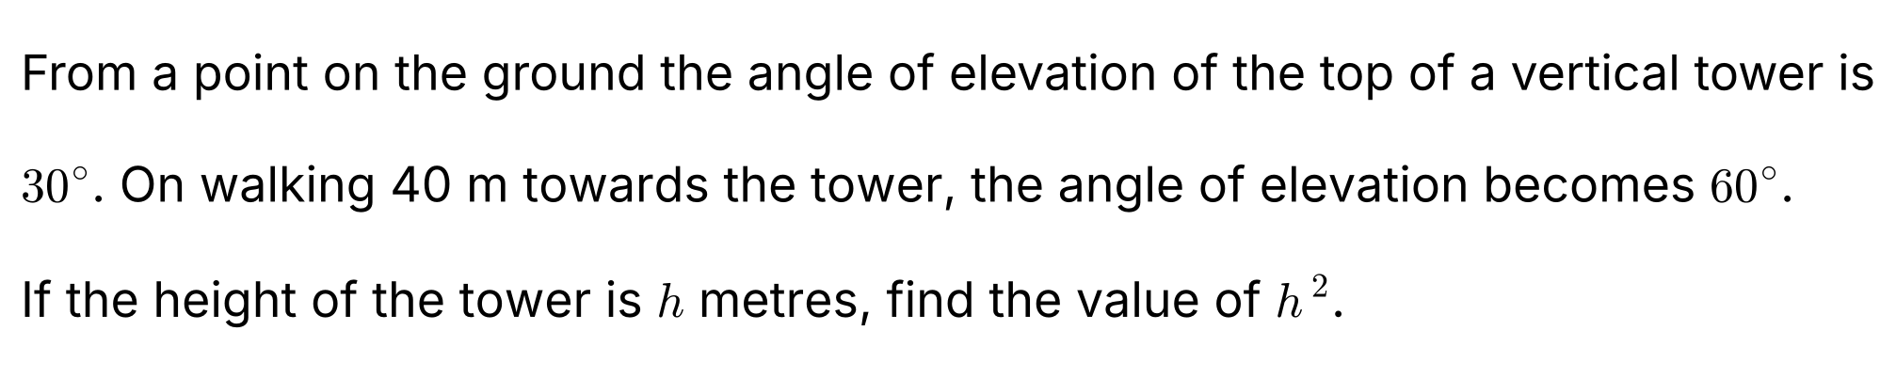
{OPTION 1}
{OPTION 2}
{OPTION 3}
{OPTION 4}
{OPTION 5}
{OPTION 6}
{OPTION 7}
{OPTION 8}
{OPTION 9}
{OPTION 10}
{RIGHT ANSWER} 1200
{EXPLANATION} Let h be the height. From the first point the distance to the tower's foot is h/tan 30° = h√3; from the second it is h/tan 60° = h/√3. The difference is 40: h√3 − h/√3 = 40, so h(3 − 1)/√3 = 40, giving h = 20√3. So h² = 400 × 3 = 1200.
{CORRECT MARKS} 1
{NEGATIVE MARKS} 0
{DIFFICULTY} Hard
{QUESTION ENDS}

{QUESTION BEGINS}
{QUESTION NUMBER} 15
{SUBJECT} Advanced Quantitative Ability
{TOPIC} Functions
{TAGS} tcs nqt, advanced quantitative, TITA, hard
{QUESTION TYPE} NUMERICAL
{QUESTION TEXT} 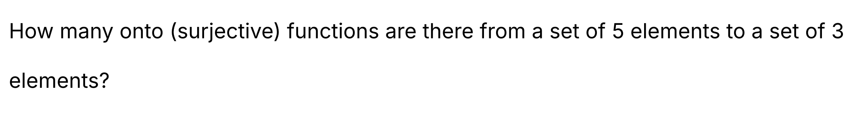
{OPTION 1}
{OPTION 2}
{OPTION 3}
{OPTION 4}
{OPTION 5}
{OPTION 6}
{OPTION 7}
{OPTION 8}
{OPTION 9}
{OPTION 10}
{RIGHT ANSWER} 150
{EXPLANATION} Total functions = 3⁵ = 243. By inclusion–exclusion, onto functions = 3⁵ − C(3, 1) × 2⁵ + C(3, 2) × 1⁵ = 243 − 96 + 3 = 150.
{CORRECT MARKS} 1
{NEGATIVE MARKS} 0
{DIFFICULTY} Hard
{QUESTION ENDS}

{QUESTION BEGINS}
{QUESTION NUMBER} 16
{SUBJECT} Advanced Quantitative Ability
{TOPIC} Permutations & Combinations
{TAGS} tcs nqt, advanced quantitative, TITA, hard
{QUESTION TYPE} NUMERICAL
{QUESTION TEXT} 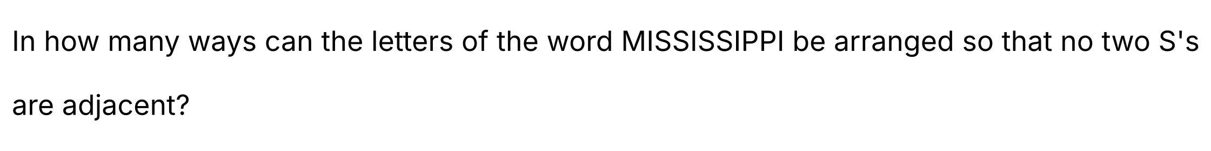
{OPTION 1}
{OPTION 2}
{OPTION 3}
{OPTION 4}
{OPTION 5}
{OPTION 6}
{OPTION 7}
{OPTION 8}
{OPTION 9}
{OPTION 10}
{RIGHT ANSWER} 7350
{EXPLANATION} First arrange the 7 letters other than S: M, I, I, I, I, P, P in 7!/(4! × 2!) = 105 ways. These leave 8 gaps (including both ends), and the 4 S's go into 4 different gaps in C(8, 4) = 70 ways. Total = 105 × 70 = 7350.
{CORRECT MARKS} 1
{NEGATIVE MARKS} 0
{DIFFICULTY} Hard
{QUESTION ENDS}

{QUESTION BEGINS}
{QUESTION NUMBER} 17
{SUBJECT} Advanced Quantitative Ability
{TOPIC} Complex Numbers
{TAGS} tcs nqt, advanced quantitative, MCQ, hard
{QUESTION TYPE} SINGLECORRECT
{QUESTION TEXT} 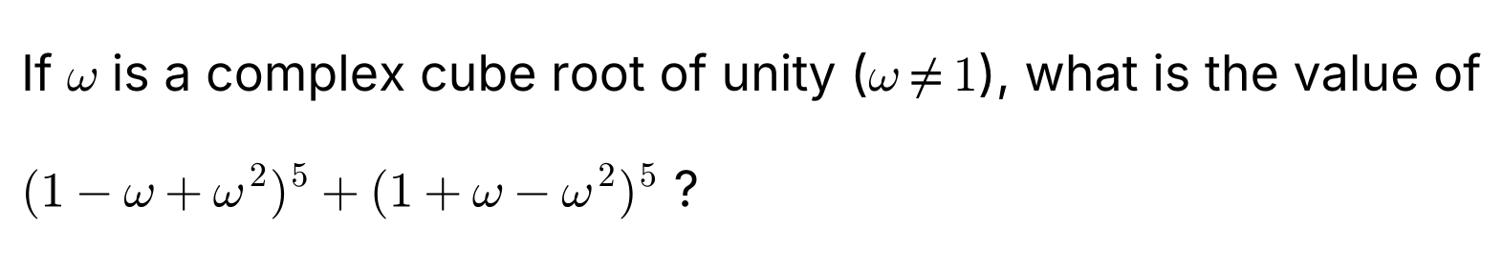
{OPTION 1} 64
{OPTION 2} 32
{OPTION 3} −32
{OPTION 4} 0
{OPTION 5}
{OPTION 6}
{OPTION 7}
{OPTION 8}
{OPTION 9}
{OPTION 10}
{RIGHT ANSWER} 2
{EXPLANATION} Since 1 + ω + ω² = 0, we have 1 + ω² = −ω and 1 + ω = −ω². So 1 − ω + ω² = −2ω and 1 + ω − ω² = −2ω². The expression = (−2ω)⁵ + (−2ω²)⁵ = −32(ω⁵ + ω¹⁰) = −32(ω² + ω) = −32 × (−1) = 32.
{CORRECT MARKS} 1
{NEGATIVE MARKS} 0
{DIFFICULTY} Hard
{QUESTION ENDS}

{QUESTION BEGINS}
{QUESTION NUMBER} 18
{SUBJECT} Advanced Quantitative Ability
{TOPIC} Number Theory
{TAGS} tcs nqt, advanced quantitative, MCQ, hard
{QUESTION TYPE} SINGLECORRECT
{QUESTION TEXT} 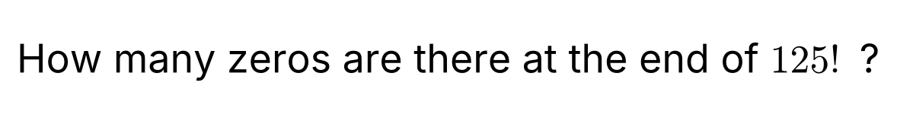
{OPTION 1} 30
{OPTION 2} 31
{OPTION 3} 25
{OPTION 4} 28
{OPTION 5}
{OPTION 6}
{OPTION 7}
{OPTION 8}
{OPTION 9}
{OPTION 10}
{RIGHT ANSWER} 2
{EXPLANATION} The number of trailing zeros = the power of 5 in 125! = ⌊125/5⌋ + ⌊125/25⌋ + ⌊125/125⌋ = 25 + 5 + 1 = 31 (powers of 2 are far more plentiful).
{CORRECT MARKS} 1
{NEGATIVE MARKS} 0
{DIFFICULTY} Hard
{QUESTION ENDS}

{QUESTION BEGINS}
{QUESTION NUMBER} 19
{SUBJECT} Advanced Quantitative Ability
{TOPIC} Statistics
{TAGS} tcs nqt, advanced quantitative, TITA, hard
{QUESTION TYPE} NUMERICAL
{QUESTION TEXT} 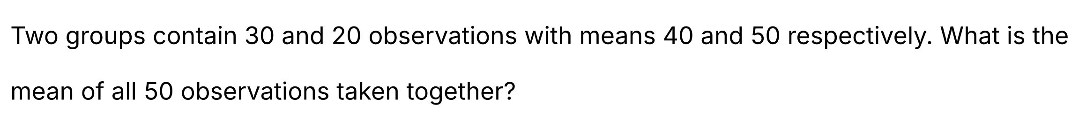
{OPTION 1}
{OPTION 2}
{OPTION 3}
{OPTION 4}
{OPTION 5}
{OPTION 6}
{OPTION 7}
{OPTION 8}
{OPTION 9}
{OPTION 10}
{RIGHT ANSWER} 44
{EXPLANATION} Combined mean = (30 × 40 + 20 × 50)/50 = (1200 + 1000)/50 = 2200/50 = 44.
{CORRECT MARKS} 1
{NEGATIVE MARKS} 0
{DIFFICULTY} Hard
{QUESTION ENDS}

{QUESTION BEGINS}
{QUESTION NUMBER} 20
{SUBJECT} Advanced Quantitative Ability
{TOPIC} Binomial Theorem
{TAGS} tcs nqt, advanced quantitative, TITA, hard
{QUESTION TYPE} NUMERICAL
{QUESTION TEXT} 
{OPTION 1}
{OPTION 2}
{OPTION 3}
{OPTION 4}
{OPTION 5}
{OPTION 6}
{OPTION 7}
{OPTION 8}
{OPTION 9}
{OPTION 10}
{RIGHT ANSWER} 51
{EXPLANATION} Write 11²⁵ = (10 + 1)²⁵ = 1 + 25 × 10 + C(25, 2) × 10² + … All terms from the third onwards are multiples of 100. So the remainder = (1 + 250) mod 100 = 251 mod 100 = 51.
{CORRECT MARKS} 1
{NEGATIVE MARKS} 0
{DIFFICULTY} Hard
{QUESTION ENDS}

{QUESTION BEGINS}
{QUESTION NUMBER} 21
{SUBJECT} Advanced Quantitative Ability
{TOPIC} Probability
{TAGS} tcs nqt, advanced quantitative, TITA, hard
{QUESTION TYPE} NUMERICAL
{QUESTION TEXT} 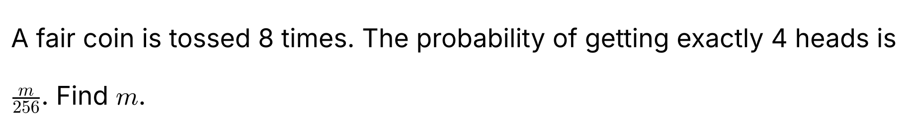
{OPTION 1}
{OPTION 2}
{OPTION 3}
{OPTION 4}
{OPTION 5}
{OPTION 6}
{OPTION 7}
{OPTION 8}
{OPTION 9}
{OPTION 10}
{RIGHT ANSWER} 70
{EXPLANATION} The number of sequences with exactly 4 heads is C(8, 4) = 70 out of 2⁸ = 256 equally likely sequences. So the probability is 70/256 and m = 70.
{CORRECT MARKS} 1
{NEGATIVE MARKS} 0
{DIFFICULTY} Hard
{QUESTION ENDS}

{QUESTION BEGINS}
{QUESTION NUMBER} 22
{SUBJECT} Advanced Quantitative Ability
{TOPIC} Complex Numbers
{TAGS} tcs nqt, advanced quantitative, TITA, hard
{QUESTION TYPE} NUMERICAL
{QUESTION TEXT} 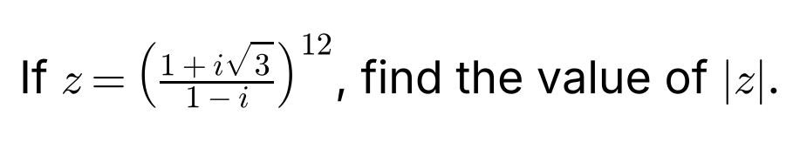
{OPTION 1}
{OPTION 2}
{OPTION 3}
{OPTION 4}
{OPTION 5}
{OPTION 6}
{OPTION 7}
{OPTION 8}
{OPTION 9}
{OPTION 10}
{RIGHT ANSWER} 64
{EXPLANATION} |1 + i√3| = 2 and |1 − i| = √2, so the modulus of the fraction = 2/√2 = √2. Therefore |z| = (√2)¹² = 2⁶ = 64.
{CORRECT MARKS} 1
{NEGATIVE MARKS} 0
{DIFFICULTY} Hard
{QUESTION ENDS}

{QUESTION BEGINS}
{QUESTION NUMBER} 23
{SUBJECT} Advanced Quantitative Ability
{TOPIC} Algebra
{TAGS} tcs nqt, advanced quantitative, TITA, hard
{QUESTION TYPE} NUMERICAL
{QUESTION TEXT} 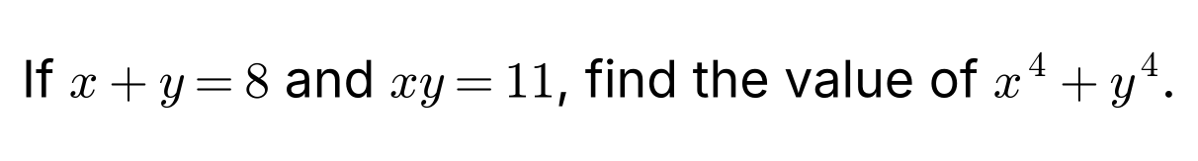
{OPTION 1}
{OPTION 2}
{OPTION 3}
{OPTION 4}
{OPTION 5}
{OPTION 6}
{OPTION 7}
{OPTION 8}
{OPTION 9}
{OPTION 10}
{RIGHT ANSWER} 1522
{EXPLANATION} x² + y² = (x + y)² − 2xy = 64 − 22 = 42. x⁴ + y⁴ = (x² + y²)² − 2(xy)² = 1764 − 2 × 121 = 1764 − 242 = 1522.
{CORRECT MARKS} 1
{NEGATIVE MARKS} 0
{DIFFICULTY} Hard
{QUESTION ENDS}

{QUESTION BEGINS}
{QUESTION NUMBER} 24
{SUBJECT} Advanced Quantitative Ability
{TOPIC} Permutations & Combinations
{TAGS} tcs nqt, advanced quantitative, TITA, hard
{QUESTION TYPE} NUMERICAL
{QUESTION TEXT} 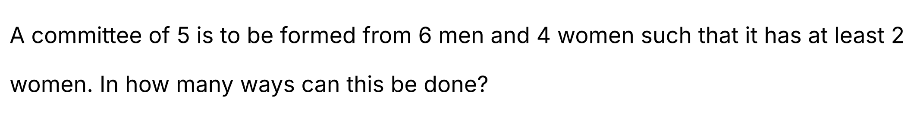
{OPTION 1}
{OPTION 2}
{OPTION 3}
{OPTION 4}
{OPTION 5}
{OPTION 6}
{OPTION 7}
{OPTION 8}
{OPTION 9}
{OPTION 10}
{RIGHT ANSWER} 186
{EXPLANATION} Total committees = C(10, 5) = 252. Committees with fewer than 2 women: 0 women: C(6, 5) = 6; exactly 1 woman: C(6, 4) × 4 = 60. So the number with at least 2 women = 252 − 6 − 60 = 186.
{CORRECT MARKS} 1
{NEGATIVE MARKS} 0
{DIFFICULTY} Hard
{QUESTION ENDS}

{QUESTION BEGINS}
{QUESTION NUMBER} 25
{SUBJECT} Advanced Quantitative Ability
{TOPIC} Calculus
{TAGS} tcs nqt, advanced quantitative, TITA, hard
{QUESTION TYPE} NUMERICAL
{QUESTION TEXT} 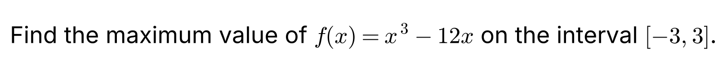
{OPTION 1}
{OPTION 2}
{OPTION 3}
{OPTION 4}
{OPTION 5}
{OPTION 6}
{OPTION 7}
{OPTION 8}
{OPTION 9}
{OPTION 10}
{RIGHT ANSWER} 16
{EXPLANATION} f′(x) = 3x² − 12 = 0 gives x = ±2. Values: f(−3) = −27 + 36 = 9, f(−2) = −8 + 24 = 16, f(2) = 8 − 24 = −16, f(3) = 27 − 36 = −9. The maximum value is 16 (at x = −2).
{CORRECT MARKS} 1
{NEGATIVE MARKS} 0
{DIFFICULTY} Hard
{QUESTION ENDS}

{QUESTION BEGINS}
{QUESTION NUMBER} 26
{SUBJECT} Advanced Quantitative Ability
{TOPIC} Trigonometry
{TAGS} tcs nqt, advanced quantitative, MCQ, hard
{QUESTION TYPE} SINGLECORRECT
{QUESTION TEXT} 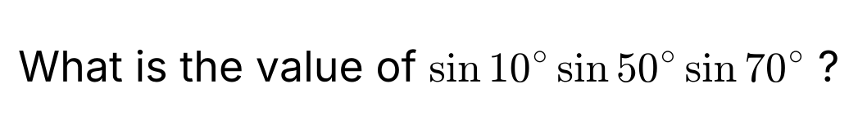
{OPTION 1} 1/8
{OPTION 2} 1/4
{OPTION 3} √3/8
{OPTION 4} 1/16
{OPTION 5}
{OPTION 6}
{OPTION 7}
{OPTION 8}
{OPTION 9}
{OPTION 10}
{RIGHT ANSWER} 1
{EXPLANATION} Use sin(60° − A) sin A sin(60° + A) = (1/4) sin 3A with A = 10°: sin 50° sin 10° sin 70° = (1/4) sin 30° = (1/4)(1/2) = 1/8.
{CORRECT MARKS} 1
{NEGATIVE MARKS} 0
{DIFFICULTY} Hard
{QUESTION ENDS}

{QUESTION BEGINS}
{QUESTION NUMBER} 27
{SUBJECT} Advanced Quantitative Ability
{TOPIC} Quadratic Equations
{TAGS} tcs nqt, advanced quantitative, TITA, hard
{QUESTION TYPE} NUMERICAL
{QUESTION TEXT}
{OPTION 1}
{OPTION 2}
{OPTION 3}
{OPTION 4}
{OPTION 5}
{OPTION 6}
{OPTION 7}
{OPTION 8}
{OPTION 9}
{OPTION 10}
{RIGHT ANSWER} 11977
{EXPLANATION} Let S_n = αⁿ + βⁿ. S₀ = 2, S₁ = 7 and S_n = 7S_(n−1) − 3S_(n−2). S₂ = 43, S₃ = 280, S₄ = 1831, and S₅ = 7 × 1831 − 3 × 280 = 11977.
{CORRECT MARKS} 1
{NEGATIVE MARKS} 0
{DIFFICULTY} Hard
{QUESTION ENDS}

{QUESTION BEGINS}
{QUESTION NUMBER} 28
{SUBJECT} Advanced Quantitative Ability
{TOPIC} 3D Geometry
{TAGS} tcs nqt, advanced quantitative, MCQ, hard
{QUESTION TYPE} SINGLECORRECT
{QUESTION TEXT} 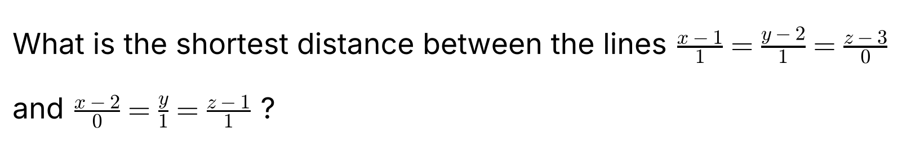
{OPTION 1} 2/√3
{OPTION 2} 1/3
{OPTION 3} √3
{OPTION 4} 1/√3
{OPTION 5}
{OPTION 6}
{OPTION 7}
{OPTION 8}
{OPTION 9}
{OPTION 10}
{RIGHT ANSWER} 4
{EXPLANATION} The lines have direction vectors d₁ = (1, 1, 0) and d₂ = (0, 1, 1), and pass through (1, 2, 3) and (2, 0, 1). d₁ × d₂ = (1, −1, 1), whose magnitude is √3. The vector between the points is (1, −2, −2), and its dot product with d₁ × d₂ is 1 + 2 − 2 = 1. Shortest distance = |1|/√3 = 1/√3.
{CORRECT MARKS} 1
{NEGATIVE MARKS} 0
{DIFFICULTY} Hard
{QUESTION ENDS}

{QUESTION BEGINS}
{QUESTION NUMBER} 29
{SUBJECT} Advanced Quantitative Ability
{TOPIC} Mensuration
{TAGS} tcs nqt, advanced quantitative, MCQ, hard
{QUESTION TYPE} SINGLECORRECT
{QUESTION TEXT} 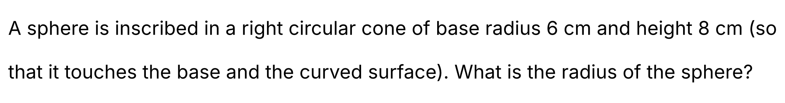
{OPTION 1} 3 cm
{OPTION 2} 4 cm
{OPTION 3} 2.5 cm
{OPTION 4} 3.6 cm
{OPTION 5}
{OPTION 6}
{OPTION 7}
{OPTION 8}
{OPTION 9}
{OPTION 10}
{RIGHT ANSWER} 1
{EXPLANATION} The slant height = √(6² + 8²) = 10 cm. Looking at the axial section (an isosceles triangle with sides 10, 10, 12), the radius of the inscribed circle = area/semi-perimeter = (1/2 × 12 × 8)/16 = 48/16 = 3 cm.
{CORRECT MARKS} 1
{NEGATIVE MARKS} 0
{DIFFICULTY} Hard
{QUESTION ENDS}

{QUESTION BEGINS}
{QUESTION NUMBER} 30
{SUBJECT} Advanced Quantitative Ability
{TOPIC} Ellipse
{TAGS} tcs nqt, advanced quantitative, MCQ, hard
{QUESTION TYPE} SINGLECORRECT
{QUESTION TEXT} 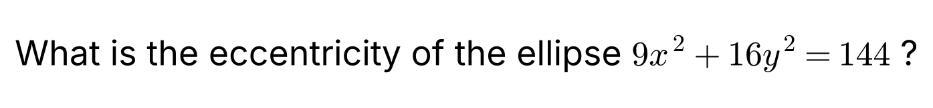
{OPTION 1} √7/3
{OPTION 2} √7/4
{OPTION 3} 1/2
{OPTION 4} 3/4
{OPTION 5}
{OPTION 6}
{OPTION 7}
{OPTION 8}
{OPTION 9}
{OPTION 10}
{RIGHT ANSWER} 2
{EXPLANATION} Divide by 144: x²/16 + y²/9 = 1, so a² = 16 and b² = 9. e = √(1 − b²/a²) = √(1 − 9/16) = √7/4.
{CORRECT MARKS} 1
{NEGATIVE MARKS} 0
{DIFFICULTY} Hard
{QUESTION ENDS}

{QUESTION BEGINS}
{QUESTION NUMBER} 31
{SUBJECT} Advanced Quantitative Ability
{TOPIC} Polynomials
{TAGS} tcs nqt, advanced quantitative, MCQ, hard
{QUESTION TYPE} SINGLECORRECT
{QUESTION TEXT} 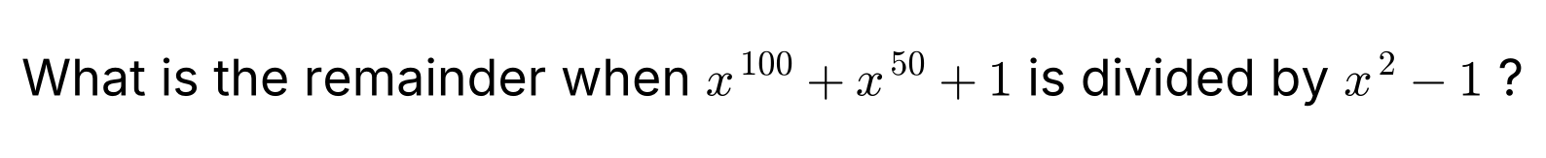
{OPTION 1} 2x + 1
{OPTION 2} 3
{OPTION 3} 1
{OPTION 4} x + 2
{OPTION 5}
{OPTION 6}
{OPTION 7}
{OPTION 8}
{OPTION 9}
{OPTION 10}
{RIGHT ANSWER} 2
{EXPLANATION} x² ≡ 1 modulo (x² − 1), so x¹⁰⁰ = (x²)⁵⁰ ≡ 1 and x⁵⁰ = (x²)²⁵ ≡ 1. Hence the remainder is 1 + 1 + 1 = 3 (a constant, since the divisor has degree 2 and the result is a polynomial of degree less than 2 that does not depend on x).
{CORRECT MARKS} 1
{NEGATIVE MARKS} 0
{DIFFICULTY} Hard
{QUESTION ENDS}

{QUESTION BEGINS}
{QUESTION NUMBER} 32
{SUBJECT} Advanced Quantitative Ability
{TOPIC} Number Theory
{TAGS} tcs nqt, advanced quantitative, TITA, hard
{QUESTION TYPE} NUMERICAL
{QUESTION TEXT} 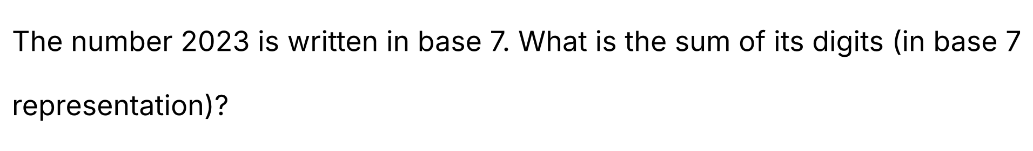
{OPTION 1}
{OPTION 2}
{OPTION 3}
{OPTION 4}
{OPTION 5}
{OPTION 6}
{OPTION 7}
{OPTION 8}
{OPTION 9}
{OPTION 10}
{RIGHT ANSWER} 13
{EXPLANATION} 2023 = 5 × 343 + 308; 308 = 6 × 49 + 14; 14 = 2 × 7 + 0. So 2023 = (5620) in base 7 and the sum of the digits = 5 + 6 + 2 + 0 = 13.
{CORRECT MARKS} 1
{NEGATIVE MARKS} 0
{DIFFICULTY} Hard
{QUESTION ENDS}

{QUESTION BEGINS}
{QUESTION NUMBER} 33
{SUBJECT} Advanced Quantitative Ability
{TOPIC} Trigonometry
{TAGS} tcs nqt, advanced quantitative, TITA, hard
{QUESTION TYPE} NUMERICAL
{QUESTION TEXT} 
{OPTION 1}
{OPTION 2}
{OPTION 3}
{OPTION 4}
{OPTION 5}
{OPTION 6}
{OPTION 7}
{OPTION 8}
{OPTION 9}
{OPTION 10}
{RIGHT ANSWER} 7
{EXPLANATION} Since |sin x| ≤ 1, any solution has |x| ≤ 10. For x > 0: in (0, π) the sine curve starts above the line y = x/10 (which has a much smaller slope than sin x near 0) and meets it once; in (2π, 3π) the sine hump rises to 1 while the line lies between about 0.63 and 0.94, so the line cuts the hump twice; in (π, 2π) the sine is negative and on (3π, 10] it is negative while the line is positive, so there are no more roots. That gives 3 positive solutions, and by symmetry 3 negative ones, plus x = 0: 3 + 3 + 1 = 7 (confirmed by counting sign changes).
{CORRECT MARKS} 1
{NEGATIVE MARKS} 0
{DIFFICULTY} Hard
{QUESTION ENDS}

{QUESTION BEGINS}
{QUESTION NUMBER} 34
{SUBJECT} Advanced Quantitative Ability
{TOPIC} Quadratic Equations
{TAGS} tcs nqt, advanced quantitative, MCQ, hard
{QUESTION TYPE} SINGLECORRECT
{QUESTION TEXT} 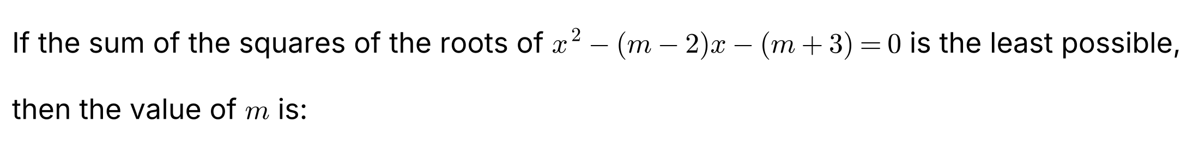
{OPTION 1} 3
{OPTION 2} 2
{OPTION 3} 1
{OPTION 4} −1
{OPTION 5}
{OPTION 6}
{OPTION 7}
{OPTION 8}
{OPTION 9}
{OPTION 10}
{RIGHT ANSWER} 3
{EXPLANATION} If the roots are p and q then p + q = m − 2 and pq = −(m + 3). p² + q² = (m − 2)² + 2(m + 3) = m² − 2m + 10 = (m − 1)² + 9. This is least when m = 1 (least value 9).
{CORRECT MARKS} 1
{NEGATIVE MARKS} 0
{DIFFICULTY} Hard
{QUESTION ENDS}

{QUESTION BEGINS}
{QUESTION NUMBER} 35
{SUBJECT} Advanced Quantitative Ability
{TOPIC} Series
{TAGS} tcs nqt, advanced quantitative, TITA, hard
{QUESTION TYPE} NUMERICAL
{QUESTION TEXT} 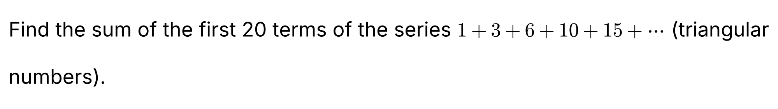
{OPTION 1}
{OPTION 2}
{OPTION 3}
{OPTION 4}
{OPTION 5}
{OPTION 6}
{OPTION 7}
{OPTION 8}
{OPTION 9}
{OPTION 10}
{RIGHT ANSWER} 1540
{EXPLANATION} The nth term is n(n + 1)/2, so the sum of n terms = Σn(n + 1)/2 = n(n + 1)(n + 2)/6. For n = 20: 20 × 21 × 22/6 = 1540.
{CORRECT MARKS} 1
{NEGATIVE MARKS} 0
{DIFFICULTY} Hard
{QUESTION ENDS}

{QUESTION BEGINS}
{QUESTION NUMBER} 36
{SUBJECT} Advanced Quantitative Ability
{TOPIC} Probability
{TAGS} tcs nqt, advanced quantitative, TITA, hard
{QUESTION TYPE} NUMERICAL
{QUESTION TEXT} 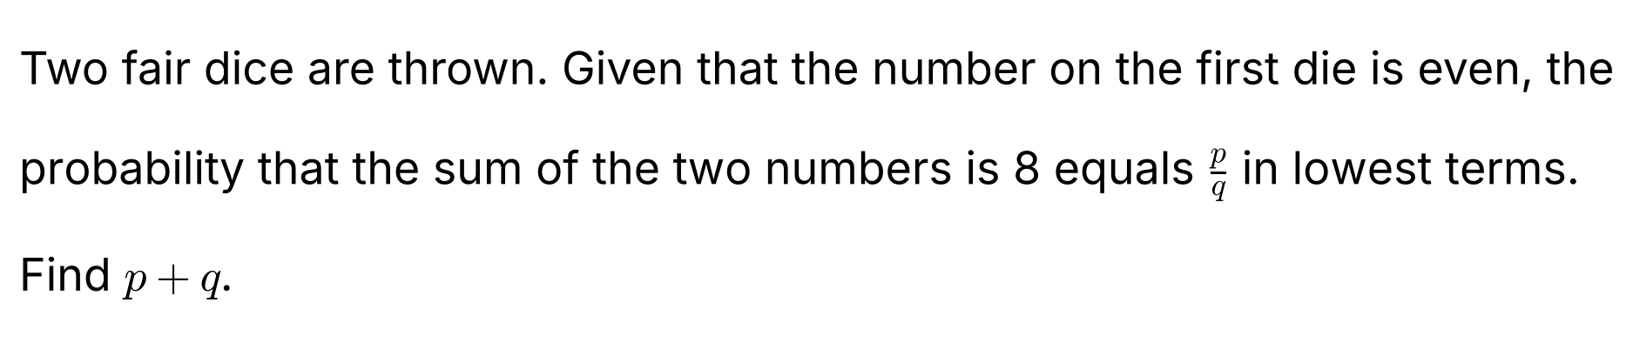
{OPTION 1}
{OPTION 2}
{OPTION 3}
{OPTION 4}
{OPTION 5}
{OPTION 6}
{OPTION 7}
{OPTION 8}
{OPTION 9}
{OPTION 10}
{RIGHT ANSWER} 7
{EXPLANATION} Given that the first die is even there are 3 × 6 = 18 equally likely outcomes. For a sum of 8: (2, 6), (4, 4) and (6, 2) are the favourable ones, so 3 outcomes. Probability = 3/18 = 1/6, so p + q = 1 + 6 = 7.
{CORRECT MARKS} 1
{NEGATIVE MARKS} 0
{DIFFICULTY} Hard
{QUESTION ENDS}

{QUESTION BEGINS}
{QUESTION NUMBER} 37
{SUBJECT} Advanced Quantitative Ability
{TOPIC} 3D Geometry
{TAGS} tcs nqt, advanced quantitative, MCQ, hard
{QUESTION TYPE} SINGLECORRECT
{QUESTION TEXT} 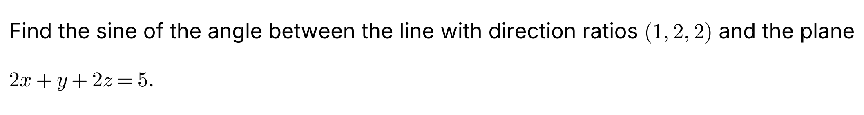
{OPTION 1} 2/3
{OPTION 2} 8/9
{OPTION 3} 4/9
{OPTION 4} 1/3
{OPTION 5}
{OPTION 6}
{OPTION 7}
{OPTION 8}
{OPTION 9}
{OPTION 10}
{RIGHT ANSWER} 2
{EXPLANATION} The direction vector of the line is d = (1, 2, 2) with |d| = 3. The normal of the plane is n = (2, 1, 2) with |n| = 3. sin θ = |d · n|/(|d||n|) = |2 + 2 + 4|/(3 × 3) = 8/9.
{CORRECT MARKS} 1
{NEGATIVE MARKS} 0
{DIFFICULTY} Hard
{QUESTION ENDS}

{QUESTION BEGINS}
{QUESTION NUMBER} 38
{SUBJECT} Advanced Quantitative Ability
{TOPIC} Probability
{TAGS} tcs nqt, advanced quantitative, MCQ, hard
{QUESTION TYPE} SINGLECORRECT
{QUESTION TEXT} 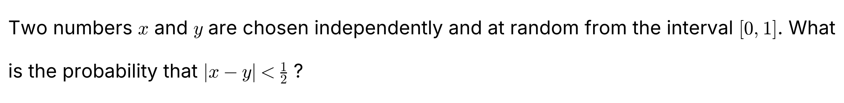
{OPTION 1} 3/4
{OPTION 2} 1/2
{OPTION 3} 7/8
{OPTION 4} 5/8
{OPTION 5}
{OPTION 6}
{OPTION 7}
{OPTION 8}
{OPTION 9}
{OPTION 10}
{RIGHT ANSWER} 1
{EXPLANATION} In the unit square the region where |x − y| ≥ 1/2 consists of two right triangles with legs 1/2, each of area 1/8, so a total of 1/4. Hence P(|x − y| < 1/2) = 1 − 1/4 = 3/4.
{CORRECT MARKS} 1
{NEGATIVE MARKS} 0
{DIFFICULTY} Hard
{QUESTION ENDS}

{QUESTION BEGINS}
{QUESTION NUMBER} 39
{SUBJECT} Advanced Quantitative Ability
{TOPIC} Locus
{TAGS} tcs nqt, advanced quantitative, MCQ, hard
{QUESTION TYPE} SINGLECORRECT
{QUESTION TEXT} 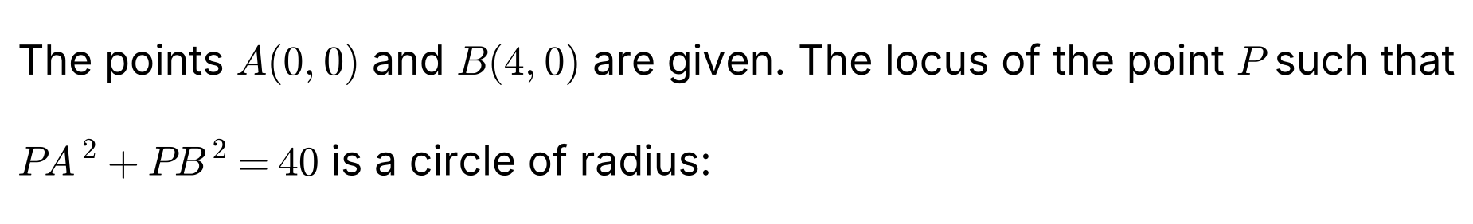
{OPTION 1} 4
{OPTION 2} 8
{OPTION 3} 6
{OPTION 4} 2√3
{OPTION 5}
{OPTION 6}
{OPTION 7}
{OPTION 8}
{OPTION 9}
{OPTION 10}
{RIGHT ANSWER} 1
{EXPLANATION} Let P = (x, y). PA² + PB² = x² + y² + (x − 4)² + y² = 40, so 2x² + 2y² − 8x + 16 = 40, i.e. x² + y² − 4x − 12 = 0, which is (x − 2)² + y² = 16. The radius is 4 (the centre is the midpoint of AB).
{CORRECT MARKS} 1
{NEGATIVE MARKS} 0
{DIFFICULTY} Hard
{QUESTION ENDS}

{QUESTION BEGINS}
{QUESTION NUMBER} 40
{SUBJECT} Advanced Quantitative Ability
{TOPIC} 3D Geometry
{TAGS} tcs nqt, advanced quantitative, TITA, hard
{QUESTION TYPE} NUMERICAL
{QUESTION TEXT}
{OPTION 1}
{OPTION 2}
{OPTION 3}
{OPTION 4}
{OPTION 5}
{OPTION 6}
{OPTION 7}
{OPTION 8}
{OPTION 9}
{OPTION 10}
{RIGHT ANSWER} 3
{EXPLANATION} Distance = |2 × 3 + 3 × 2 + 6 × 1 + 3|/√(2² + 3² + 6²) = |6 + 6 + 6 + 3|/√49 = 21/7 = 3.
{CORRECT MARKS} 1
{NEGATIVE MARKS} 0
{DIFFICULTY} Hard
{QUESTION ENDS}

{QUESTION BEGINS}
{QUESTION NUMBER} 41
{SUBJECT} Advanced Quantitative Ability
{TOPIC} Permutations & Combinations
{TAGS} tcs nqt, advanced quantitative, TITA, hard
{QUESTION TYPE} NUMERICAL
{QUESTION TEXT} 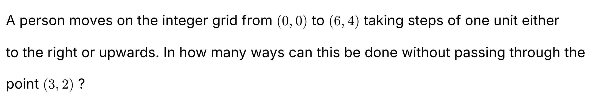
{OPTION 1}
{OPTION 2}
{OPTION 3}
{OPTION 4}
{OPTION 5}
{OPTION 6}
{OPTION 7}
{OPTION 8}
{OPTION 9}
{OPTION 10}
{RIGHT ANSWER} 110
{EXPLANATION} Total paths = C(10, 4) = 210. Paths through (3, 2) = [paths from (0, 0) to (3, 2)] × [paths from (3, 2) to (6, 4)] = C(5, 2) × C(5, 2) = 10 × 10 = 100. Paths avoiding (3, 2) = 210 − 100 = 110.
{CORRECT MARKS} 1
{NEGATIVE MARKS} 0
{DIFFICULTY} Hard
{QUESTION ENDS}

{QUESTION BEGINS}
{QUESTION NUMBER} 42
{SUBJECT} Advanced Quantitative Ability
{TOPIC} Algebra
{TAGS} tcs nqt, advanced quantitative, TITA, hard
{QUESTION TYPE} NUMERICAL
{QUESTION TEXT} 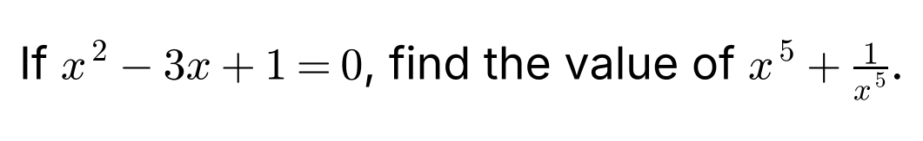
{OPTION 1}
{OPTION 2}
{OPTION 3}
{OPTION 4}
{OPTION 5}
{OPTION 6}
{OPTION 7}
{OPTION 8}
{OPTION 9}
{OPTION 10}
{RIGHT ANSWER} 123
{EXPLANATION} Since x ≠ 0, divide by x: x + 1/x = 3. Let s_n = xⁿ + 1/xⁿ; then s₁ = 3 and s_(n+1) = 3s_n − s_(n−1). s₂ = 7, s₃ = 18, s₄ = 47 and s₅ = 3 × 47 − 18 = 123.
{CORRECT MARKS} 1
{NEGATIVE MARKS} 0
{DIFFICULTY} Hard
{QUESTION ENDS}

{QUESTION BEGINS}
{QUESTION NUMBER} 43
{SUBJECT} Advanced Quantitative Ability
{TOPIC} Coordinate Geometry
{TAGS} tcs nqt, advanced quantitative, TITA, hard
{QUESTION TYPE} NUMERICAL
{QUESTION TEXT} 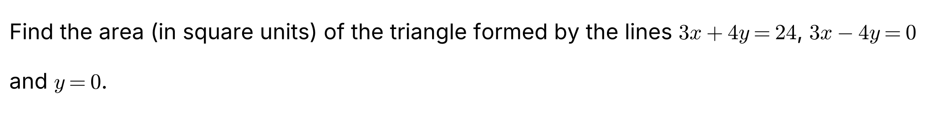
{OPTION 1}
{OPTION 2}
{OPTION 3}
{OPTION 4}
{OPTION 5}
{OPTION 6}
{OPTION 7}
{OPTION 8}
{OPTION 9}
{OPTION 10}
{RIGHT ANSWER} 12
{EXPLANATION} Intersections: 3x + 4y = 24 with y = 0 gives (8, 0); 3x − 4y = 0 with y = 0 gives (0, 0); the two slanted lines meet where 3x = 4y; substituting in 3x + 4y = 24 gives 4y + 4y = 24, so y = 3 and x = 4: the point (4, 3). Base = 8 (along y = 0), height = 3. Area = (1/2) × 8 × 3 = 12.
{CORRECT MARKS} 1
{NEGATIVE MARKS} 0
{DIFFICULTY} Hard
{QUESTION ENDS}

{QUESTION BEGINS}
{QUESTION NUMBER} 44
{SUBJECT} Advanced Quantitative Ability
{TOPIC} Functions
{TAGS} tcs nqt, advanced quantitative, MCQ, hard
{QUESTION TYPE} SINGLECORRECT
{QUESTION TEXT} 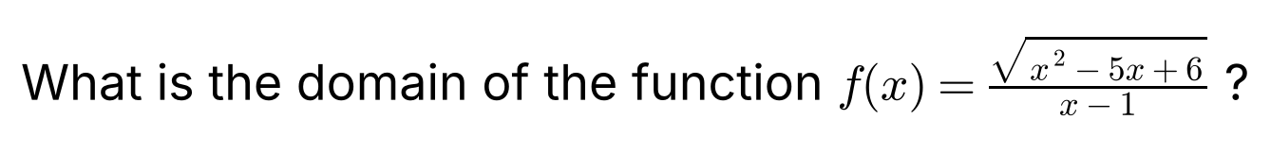
{OPTION 1} (1, 2] ∪ [3, ∞)
{OPTION 2} (−∞, 1) ∪ (1, 2] ∪ [3, ∞)
{OPTION 3} [2, 3]
{OPTION 4} (−∞, 2] ∪ [3, ∞)
{OPTION 5}
{OPTION 6}
{OPTION 7}
{OPTION 8}
{OPTION 9}
{OPTION 10}
{RIGHT ANSWER} 2
{EXPLANATION} For the square root: x² − 5x + 6 = (x − 2)(x − 3) ≥ 0, so x ≤ 2 or x ≥ 3. The denominator requires x ≠ 1, and 1 lies in x ≤ 2 so it must be removed. The domain is (−∞, 1) ∪ (1, 2] ∪ [3, ∞).
{CORRECT MARKS} 1
{NEGATIVE MARKS} 0
{DIFFICULTY} Hard
{QUESTION ENDS}

{QUESTION BEGINS}
{QUESTION NUMBER} 45
{SUBJECT} Advanced Quantitative Ability
{TOPIC} Probability
{TAGS} tcs nqt, advanced quantitative, TITA, hard
{QUESTION TYPE} NUMERICAL
{QUESTION TEXT} 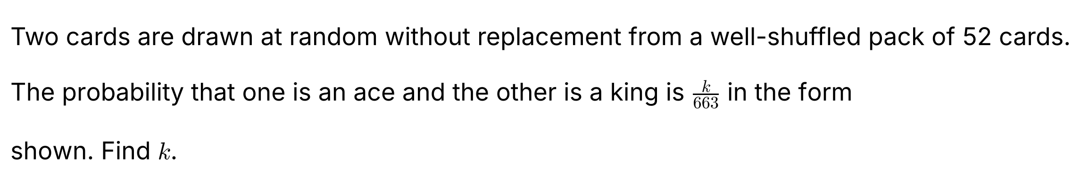
{OPTION 1}
{OPTION 2}
{OPTION 3}
{OPTION 4}
{OPTION 5}
{OPTION 6}
{OPTION 7}
{OPTION 8}
{OPTION 9}
{OPTION 10}
{RIGHT ANSWER} 8
{EXPLANATION} The number of ways to choose one ace and one king = 4 × 4 = 16. Total ways = C(52, 2) = 1326. Probability = 16/1326 = 8/663, so k = 8.
{CORRECT MARKS} 1
{NEGATIVE MARKS} 0
{DIFFICULTY} Hard
{QUESTION ENDS}

{QUESTION BEGINS}
{QUESTION NUMBER} 46
{SUBJECT} Advanced Quantitative Ability
{TOPIC} Matrices
{TAGS} tcs nqt, advanced quantitative, TITA, hard
{QUESTION TYPE} NUMERICAL
{QUESTION TEXT} 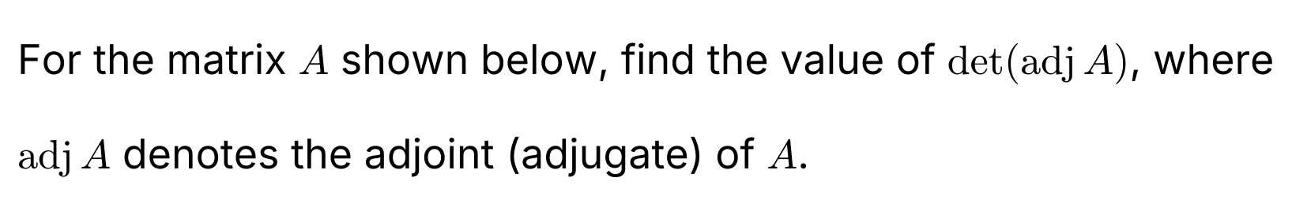
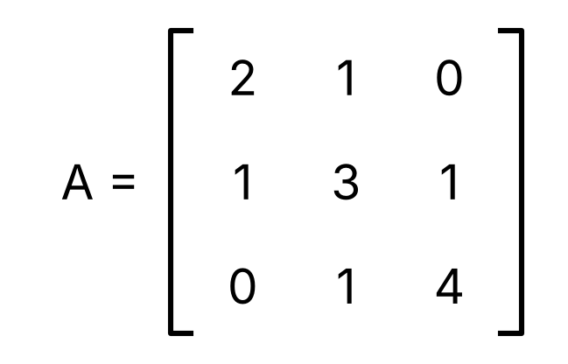
{OPTION 1}
{OPTION 2}
{OPTION 3}
{OPTION 4}
{OPTION 5}
{OPTION 6}
{OPTION 7}
{OPTION 8}
{OPTION 9}
{OPTION 10}
{RIGHT ANSWER} 324
{EXPLANATION} det A = 2(3 × 4 − 1 × 1) − 1(1 × 4 − 1 × 0) + 0 = 2 × 11 − 4 = 18. For an n × n matrix det(adj A) = (det A)^(n − 1). Here n = 3, so det(adj A) = 18² = 324.
{CORRECT MARKS} 1
{NEGATIVE MARKS} 0
{DIFFICULTY} Hard
{QUESTION ENDS}

{QUESTION BEGINS}
{QUESTION NUMBER} 47
{SUBJECT} Advanced Quantitative Ability
{TOPIC} Hyperbola
{TAGS} tcs nqt, advanced quantitative, TITA, hard
{QUESTION TYPE} NUMERICAL
{QUESTION TEXT} 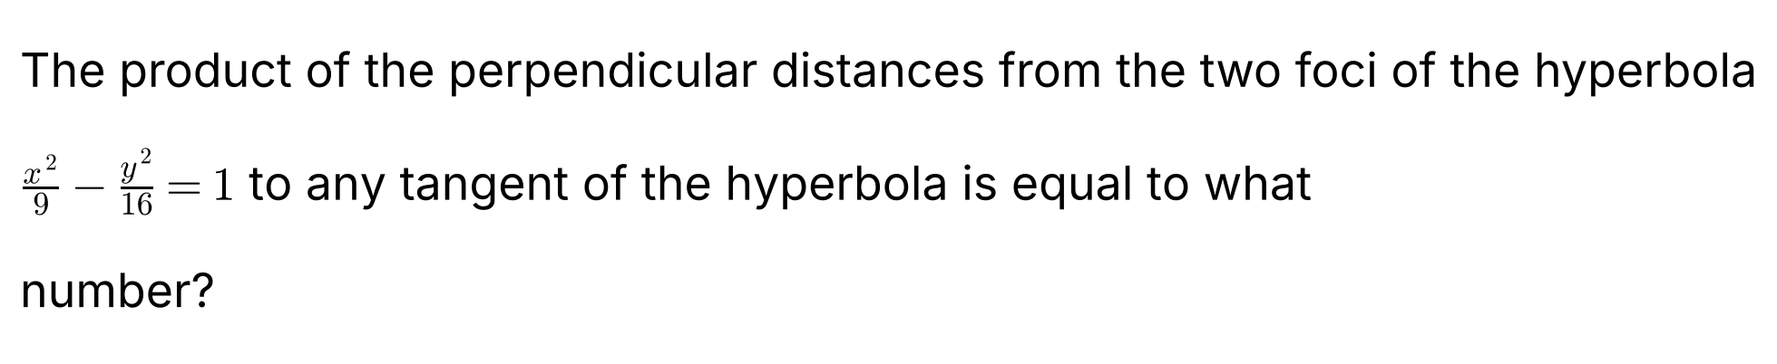
{OPTION 1}
{OPTION 2}
{OPTION 3}
{OPTION 4}
{OPTION 5}
{OPTION 6}
{OPTION 7}
{OPTION 8}
{OPTION 9}
{OPTION 10}
{RIGHT ANSWER} 16
{EXPLANATION} For a hyperbola x²/a² − y²/b² = 1, the product of the perpendicular distances from the foci (±ae, 0) to any tangent equals b². Here b² = 16. (Verified directly: for the tangent at (3 cosh t, 4 sinh t) the product is 16 for every t.)
{CORRECT MARKS} 1
{NEGATIVE MARKS} 0
{DIFFICULTY} Hard
{QUESTION ENDS}

{QUESTION BEGINS}
{QUESTION NUMBER} 48
{SUBJECT} Advanced Quantitative Ability
{TOPIC} Mensuration
{TAGS} tcs nqt, advanced quantitative, TITA, hard
{QUESTION TYPE} NUMERICAL
{QUESTION TEXT} 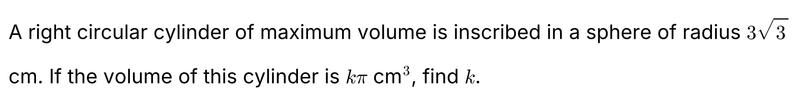
{OPTION 1}
{OPTION 2}
{OPTION 3}
{OPTION 4}
{OPTION 5}
{OPTION 6}
{OPTION 7}
{OPTION 8}
{OPTION 9}
{OPTION 10}
{RIGHT ANSWER} 108
{EXPLANATION} Let the cylinder have height h and base radius r, so that r² + (h/2)² = R² = 27. Volume = π r² h = π(27 − h²/4)h. Setting the derivative to zero: 27 − 3h²/4 = 0, so h² = 36 and h = 6. Then r² = 27 − 9 = 18 and V = π × 18 × 6 = 108π, so k = 108.
{CORRECT MARKS} 1
{NEGATIVE MARKS} 0
{DIFFICULTY} Hard
{QUESTION ENDS}

{QUESTION BEGINS}
{QUESTION NUMBER} 49
{SUBJECT} Advanced Quantitative Ability
{TOPIC} Functions
{TAGS} tcs nqt, advanced quantitative, TITA, hard
{QUESTION TYPE} NUMERICAL
{QUESTION TEXT} 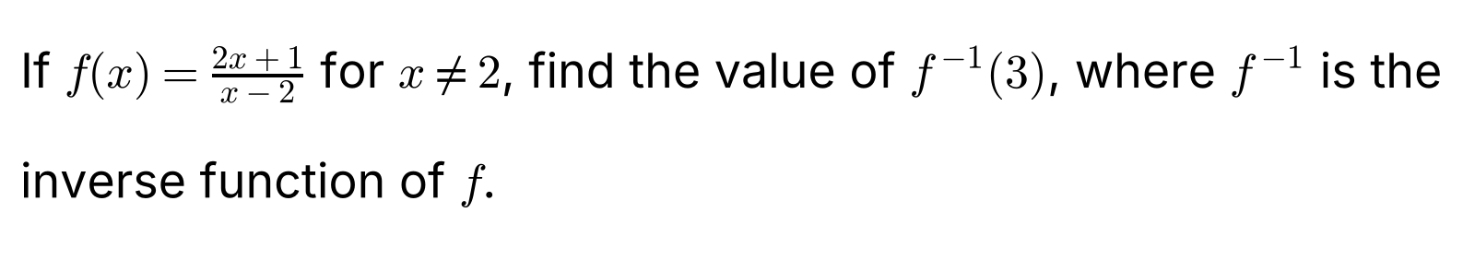
{OPTION 1}
{OPTION 2}
{OPTION 3}
{OPTION 4}
{OPTION 5}
{OPTION 6}
{OPTION 7}
{OPTION 8}
{OPTION 9}
{OPTION 10}
{RIGHT ANSWER} 7
{EXPLANATION} We need the x for which f(x) = 3: (2x + 1)/(x − 2) = 3, so 2x + 1 = 3x − 6 and x = 7. So f⁻¹(3) = 7. (Check: f(7) = 15/5 = 3.)
{CORRECT MARKS} 1
{NEGATIVE MARKS} 0
{DIFFICULTY} Hard
{QUESTION ENDS}

{QUESTION BEGINS}
{QUESTION NUMBER} 50
{SUBJECT} Advanced Quantitative Ability
{TOPIC} Trigonometry
{TAGS} tcs nqt, advanced quantitative, MCQ, hard
{QUESTION TYPE} SINGLECORRECT
{QUESTION TEXT}
{OPTION 1} √13
{OPTION 2} √19
{OPTION 3} 5
{OPTION 4} √7
{OPTION 5}
{OPTION 6}
{OPTION 7}
{OPTION 8}
{OPTION 9}
{OPTION 10}
{RIGHT ANSWER} 4
{EXPLANATION} By the cosine rule: a² = b² + c² − 2bc cos A = 4 + 9 − 2 × 2 × 3 × (1/2) = 13 − 6 = 7. So a = √7.
{CORRECT MARKS} 1
{NEGATIVE MARKS} 0
{DIFFICULTY} Hard
{QUESTION ENDS}

{QUESTION BEGINS}
{QUESTION NUMBER} 51
{SUBJECT} Advanced Quantitative Ability
{TOPIC} Matrices
{TAGS} tcs nqt, advanced quantitative, MCQ, hard
{QUESTION TYPE} SINGLECORRECT
{QUESTION TEXT} 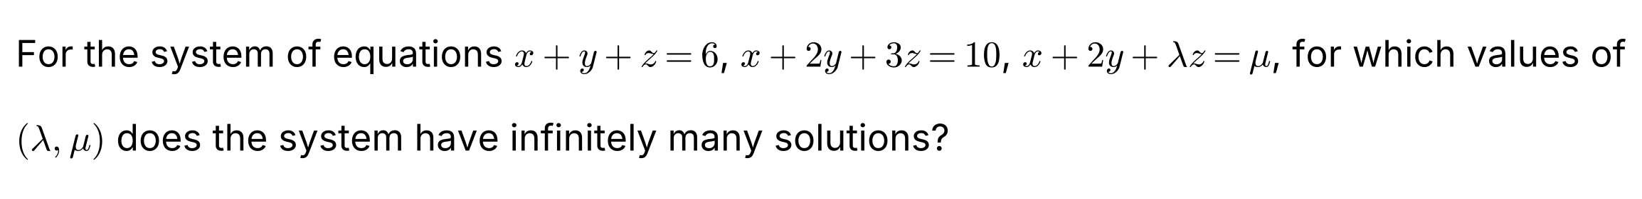
{OPTION 1} λ = 3, μ = 10
{OPTION 2} λ ≠ 3, μ = 10
{OPTION 3} λ = 2, μ = 10
{OPTION 4} λ = 3, μ = 6
{OPTION 5}
{OPTION 6}
{OPTION 7}
{OPTION 8}
{OPTION 9}
{OPTION 10}
{RIGHT ANSWER} 1
{EXPLANATION} Subtracting the second equation from the third gives (λ − 3)z = μ − 10. If λ ≠ 3 there is a unique z and so a unique solution. If λ = 3 and μ ≠ 10 the equation becomes 0 = μ − 10 which is false (no solution). If λ = 3 and μ = 10 the third equation is the same as the second, giving infinitely many solutions. So (λ, μ) = (3, 10).
{CORRECT MARKS} 1
{NEGATIVE MARKS} 0
{DIFFICULTY} Hard
{QUESTION ENDS}

{QUESTION BEGINS}
{QUESTION NUMBER} 52
{SUBJECT} Advanced Quantitative Ability
{TOPIC} Modulus
{TAGS} tcs nqt, advanced quantitative, TITA, hard
{QUESTION TYPE} NUMERICAL
{QUESTION TEXT} 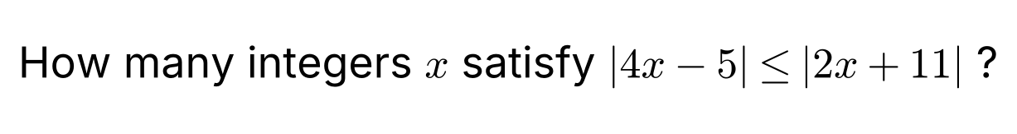
{OPTION 1}
{OPTION 2}
{OPTION 3}
{OPTION 4}
{OPTION 5}
{OPTION 6}
{OPTION 7}
{OPTION 8}
{OPTION 9}
{OPTION 10}
{RIGHT ANSWER} 10
{EXPLANATION} Squaring both sides (both are non-negative): (4x − 5)² ≤ (2x + 11)², so (4x − 5 − 2x − 11)(4x − 5 + 2x + 11) ≤ 0, i.e. (2x − 16)(6x + 6) ≤ 0, which gives −1 ≤ x ≤ 8. The integers are −1, 0, 1, …, 8, which is 10 integers.
{CORRECT MARKS} 1
{NEGATIVE MARKS} 0
{DIFFICULTY} Hard
{QUESTION ENDS}

{QUESTION BEGINS}
{QUESTION NUMBER} 53
{SUBJECT} Advanced Quantitative Ability
{TOPIC} Permutations & Combinations
{TAGS} tcs nqt, advanced quantitative, MCQ, hard
{QUESTION TYPE} SINGLECORRECT
{QUESTION TEXT} 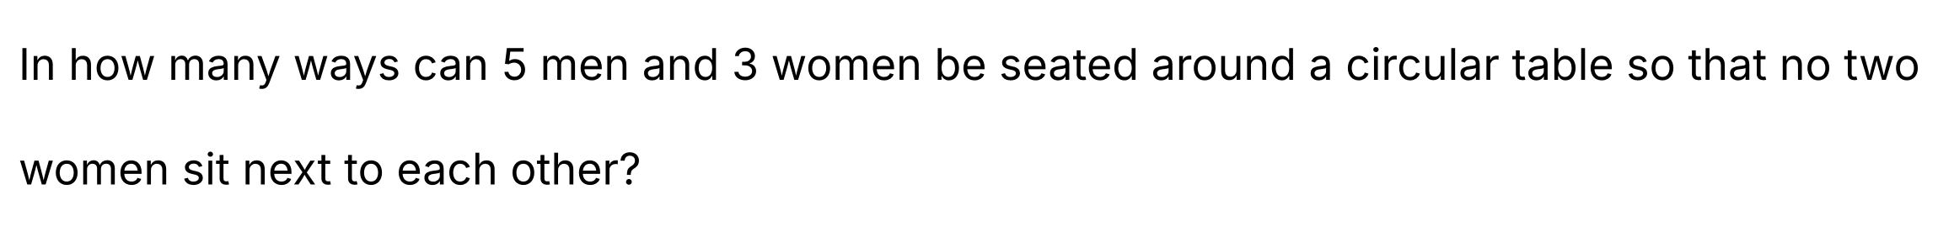
{OPTION 1} 1440
{OPTION 2} 720
{OPTION 3} 2880
{OPTION 4} 960
{OPTION 5}
{OPTION 6}
{OPTION 7}
{OPTION 8}
{OPTION 9}
{OPTION 10}
{RIGHT ANSWER} 1
{EXPLANATION} First seat the 5 men around the table: (5 − 1)! = 24 ways. This creates 5 gaps between the men. Choose 3 of these gaps for the women: C(5, 3) = 10, and arrange the 3 women in them in 3! = 6 ways. Total = 24 × 10 × 6 = 1440.
{CORRECT MARKS} 1
{NEGATIVE MARKS} 0
{DIFFICULTY} Hard
{QUESTION ENDS}

{QUESTION BEGINS}
{QUESTION NUMBER} 54
{SUBJECT} Advanced Quantitative Ability
{TOPIC} Binomial Theorem
{TAGS} tcs nqt, advanced quantitative, TITA, hard
{QUESTION TYPE} NUMERICAL
{QUESTION TEXT} 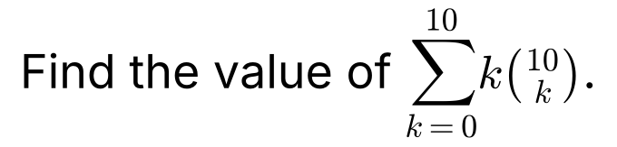
{OPTION 1}
{OPTION 2}
{OPTION 3}
{OPTION 4}
{OPTION 5}
{OPTION 6}
{OPTION 7}
{OPTION 8}
{OPTION 9}
{OPTION 10}
{RIGHT ANSWER} 5120
{EXPLANATION} Using k C(n, k) = n C(n − 1, k − 1): Σk C(10, k) = 10 Σ C(9, k − 1) = 10 × 2⁹ = 5120.
{CORRECT MARKS} 1
{NEGATIVE MARKS} 0
{DIFFICULTY} Hard
{QUESTION ENDS}

{QUESTION BEGINS}
{QUESTION NUMBER} 55
{SUBJECT} Advanced Quantitative Ability
{TOPIC} Logarithms
{TAGS} tcs nqt, advanced quantitative, MCQ, hard
{QUESTION TYPE} SINGLECORRECT
{QUESTION TEXT} 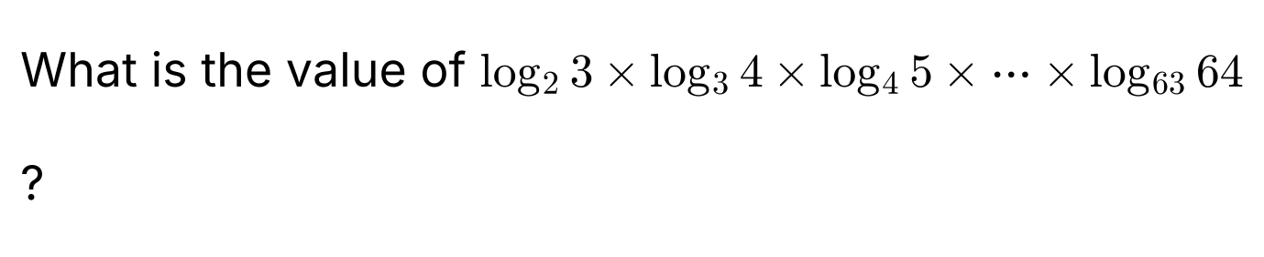
{OPTION 1} 6
{OPTION 2} 5
{OPTION 3} 32
{OPTION 4} 63
{OPTION 5}
{OPTION 6}
{OPTION 7}
{OPTION 8}
{OPTION 9}
{OPTION 10}
{RIGHT ANSWER} 1
{EXPLANATION} Using the change of base, log_a b = (ln b)/(ln a). The product telescopes: (ln 3/ln 2)(ln 4/ln 3)…(ln 64/ln 63) = ln 64/ln 2 = log₂ 64 = 6.
{CORRECT MARKS} 1
{NEGATIVE MARKS} 0
{DIFFICULTY} Hard
{QUESTION ENDS}

{QUESTION BEGINS}
{QUESTION NUMBER} 56
{SUBJECT} Advanced Quantitative Ability
{TOPIC} Permutations & Combinations
{TAGS} tcs nqt, advanced quantitative, MCQ, hard
{QUESTION TYPE} SINGLECORRECT
{QUESTION TEXT} 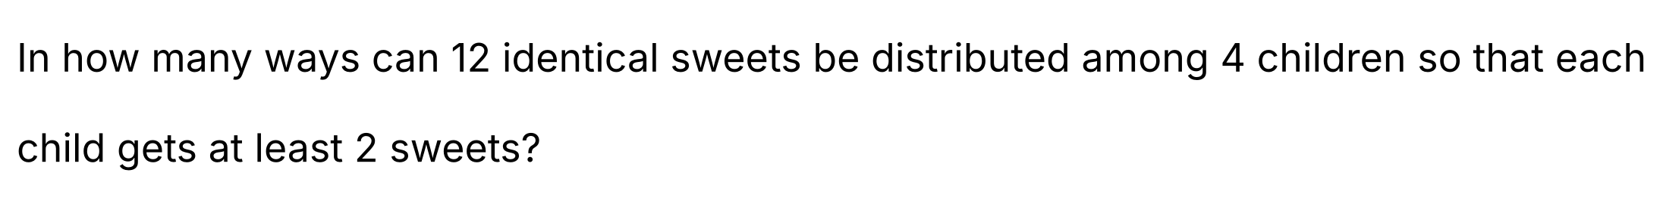
{OPTION 1} 35
{OPTION 2} 55
{OPTION 3} 70
{OPTION 4} 165
{OPTION 5}
{OPTION 6}
{OPTION 7}
{OPTION 8}
{OPTION 9}
{OPTION 10}
{RIGHT ANSWER} 1
{EXPLANATION} Give each child 2 sweets first (8 sweets). The remaining 4 sweets are distributed freely among 4 children: C(4 + 4 − 1, 4 − 1) = C(7, 3) = 35.
{CORRECT MARKS} 1
{NEGATIVE MARKS} 0
{DIFFICULTY} Hard
{QUESTION ENDS}

{QUESTION BEGINS}
{QUESTION NUMBER} 57
{SUBJECT} Advanced Quantitative Ability
{TOPIC} Circles
{TAGS} tcs nqt, advanced quantitative, TITA, hard
{QUESTION TYPE} NUMERICAL
{QUESTION TEXT} 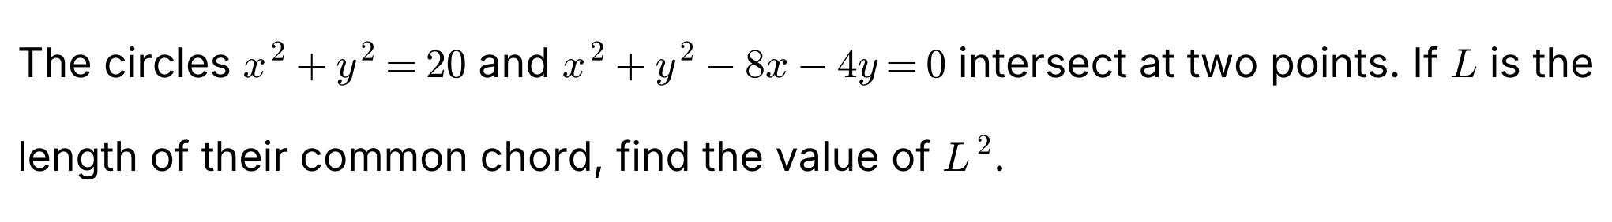
{OPTION 1}
{OPTION 2}
{OPTION 3}
{OPTION 4}
{OPTION 5}
{OPTION 6}
{OPTION 7}
{OPTION 8}
{OPTION 9}
{OPTION 10}
{RIGHT ANSWER} 60
{EXPLANATION} Subtracting the equations: 8x + 4y = 20, i.e. 2x + y = 5 (the common chord). Its distance from the origin (the centre of the first circle) = 5/√5 = √5. The chord length L = 2√(r² − d²) = 2√(20 − 5) = 2√15, so L² = 4 × 15 = 60.
{CORRECT MARKS} 1
{NEGATIVE MARKS} 0
{DIFFICULTY} Hard
{QUESTION ENDS}

{QUESTION BEGINS}
{QUESTION NUMBER} 58
{SUBJECT} Advanced Quantitative Ability
{TOPIC} Calculus
{TAGS} tcs nqt, advanced quantitative, MCQ, hard
{QUESTION TYPE} SINGLECORRECT
{QUESTION TEXT} 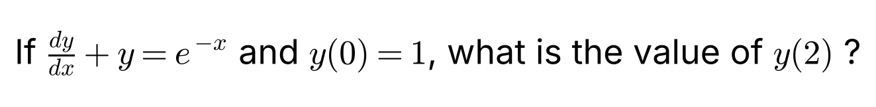
{OPTION 1} 3e⁻¹
{OPTION 2} e⁻²
{OPTION 3} 2e⁻²
{OPTION 4} 3e⁻²
{OPTION 5}
{OPTION 6}
{OPTION 7}
{OPTION 8}
{OPTION 9}
{OPTION 10}
{RIGHT ANSWER} 4
{EXPLANATION} This is a linear equation with integrating factor eˣ: d(y eˣ)/dx = 1, so y eˣ = x + C. Since y(0) = 1, C = 1 and y = (x + 1)e⁻ˣ. Hence y(2) = 3e⁻².
{CORRECT MARKS} 1
{NEGATIVE MARKS} 0
{DIFFICULTY} Hard
{QUESTION ENDS}

{QUESTION BEGINS}
{QUESTION NUMBER} 59
{SUBJECT} Advanced Quantitative Ability
{TOPIC} Trigonometry
{TAGS} tcs nqt, advanced quantitative, MCQ, hard
{QUESTION TYPE} SINGLECORRECT
{QUESTION TEXT} 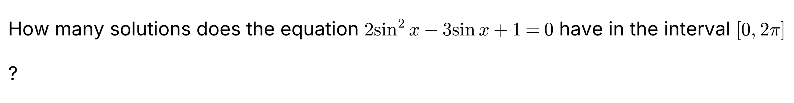
{OPTION 1} 2
{OPTION 2} 1
{OPTION 3} 4
{OPTION 4} 3
{OPTION 5}
{OPTION 6}
{OPTION 7}
{OPTION 8}
{OPTION 9}
{OPTION 10}
{RIGHT ANSWER} 4
{EXPLANATION} Let t = sin x: 2t² − 3t + 1 = 0 gives (2t − 1)(t − 1) = 0, so t = 1/2 or t = 1. sin x = 1/2 has 2 solutions in [0, 2π] (π/6 and 5π/6) and sin x = 1 has 1 solution (π/2). Total 3.
{CORRECT MARKS} 1
{NEGATIVE MARKS} 0
{DIFFICULTY} Hard
{QUESTION ENDS}

{QUESTION BEGINS}
{QUESTION NUMBER} 60
{SUBJECT} Advanced Quantitative Ability
{TOPIC} Series
{TAGS} tcs nqt, advanced quantitative, MCQ, hard
{QUESTION TYPE} SINGLECORRECT
{QUESTION TEXT} 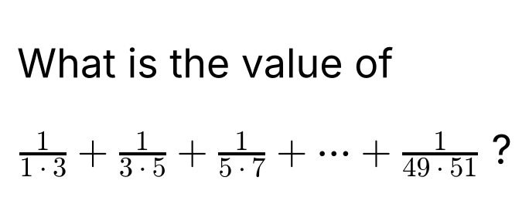
{OPTION 1} 1/2
{OPTION 2} 25/51
{OPTION 3} 50/51
{OPTION 4} 24/51
{OPTION 5}
{OPTION 6}
{OPTION 7}
{OPTION 8}
{OPTION 9}
{OPTION 10}
{RIGHT ANSWER} 2
{EXPLANATION} Each term 1/((2k − 1)(2k + 1)) = (1/2)[1/(2k − 1) − 1/(2k + 1)]. The sum telescopes to (1/2)(1 − 1/51) = (1/2)(50/51) = 25/51.
{CORRECT MARKS} 1
{NEGATIVE MARKS} 0
{DIFFICULTY} Hard
{QUESTION ENDS}

{QUESTION BEGINS}
{QUESTION NUMBER} 61
{SUBJECT} Advanced Quantitative Ability
{TOPIC} Calculus
{TAGS} tcs nqt, advanced quantitative, MCQ, hard
{QUESTION TYPE} SINGLECORRECT
{QUESTION TEXT} 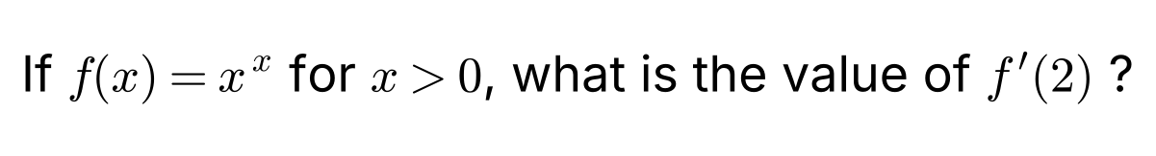
{OPTION 1} 4
{OPTION 2} 4 ln 2
{OPTION 3} 2(1 + ln 2)
{OPTION 4} 4(1 + ln 2)
{OPTION 5}
{OPTION 6}
{OPTION 7}
{OPTION 8}
{OPTION 9}
{OPTION 10}
{RIGHT ANSWER} 4
{EXPLANATION} Take logarithms: ln f = x ln x, so f′/f = ln x + 1 and f′(x) = xˣ(1 + ln x). At x = 2: f′(2) = 4(1 + ln 2).
{CORRECT MARKS} 1
{NEGATIVE MARKS} 0
{DIFFICULTY} Hard
{QUESTION ENDS}

{QUESTION BEGINS}
{QUESTION NUMBER} 62
{SUBJECT} Advanced Quantitative Ability
{TOPIC} Straight Lines
{TAGS} tcs nqt, advanced quantitative, TITA, hard
{QUESTION TYPE} NUMERICAL
{QUESTION TEXT} 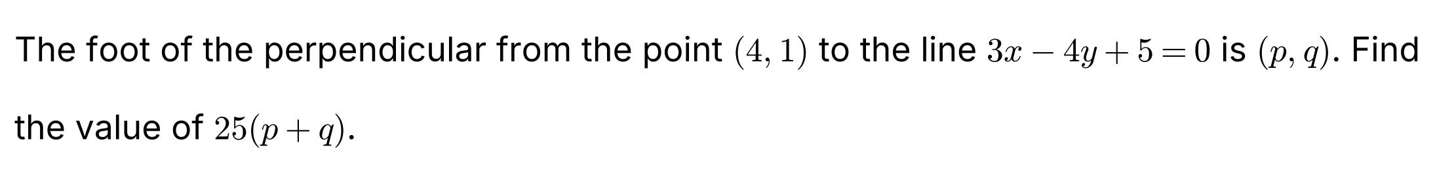
{OPTION 1}
{OPTION 2}
{OPTION 3}
{OPTION 4}
{OPTION 5}
{OPTION 6}
{OPTION 7}
{OPTION 8}
{OPTION 9}
{OPTION 10}
{RIGHT ANSWER} 138
{EXPLANATION} The line has normal vector (3, −4). The signed value of the line at (4, 1) is 3 × 4 − 4 × 1 + 5 = 13, so the foot = (4, 1) − (13/25)(3, −4) = (4 − 39/25, 1 + 52/25) = (61/25, 77/25). Then 25(p + q) = 61 + 77 = 138. (Check: 3 × 61/25 − 4 × 77/25 + 5 = (183 − 308 + 125)/25 = 0.)
{CORRECT MARKS} 1
{NEGATIVE MARKS} 0
{DIFFICULTY} Hard
{QUESTION ENDS}

{QUESTION BEGINS}
{QUESTION NUMBER} 63
{SUBJECT} Advanced Quantitative Ability
{TOPIC} Matrices
{TAGS} tcs nqt, advanced quantitative, TITA, hard
{QUESTION TYPE} NUMERICAL
{QUESTION TEXT} 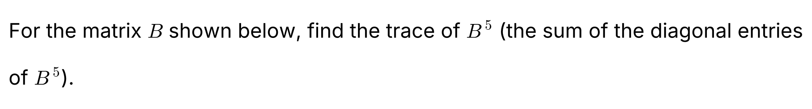
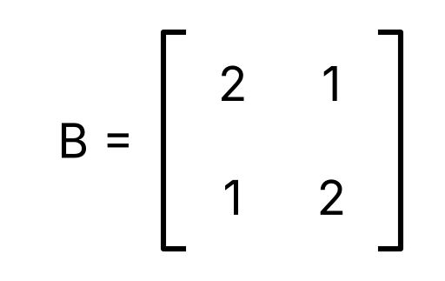
{OPTION 1}
{OPTION 2}
{OPTION 3}
{OPTION 4}
{OPTION 5}
{OPTION 6}
{OPTION 7}
{OPTION 8}
{OPTION 9}
{OPTION 10}
{RIGHT ANSWER} 244
{EXPLANATION} The eigenvalues of B satisfy (2 − λ)² − 1 = 0, so λ = 1 and λ = 3. The eigenvalues of B⁵ are 1⁵ = 1 and 3⁵ = 243, and the trace is their sum: 1 + 243 = 244. (Direct multiplication gives B⁵ = [[122, 121], [121, 122]], whose trace is 244.)
{CORRECT MARKS} 1
{NEGATIVE MARKS} 0
{DIFFICULTY} Hard
{QUESTION ENDS}

{QUESTION BEGINS}
{QUESTION NUMBER} 64
{SUBJECT} Advanced Quantitative Ability
{TOPIC} Calculus
{TAGS} tcs nqt, advanced quantitative, TITA, hard
{QUESTION TYPE} NUMERICAL
{QUESTION TEXT} 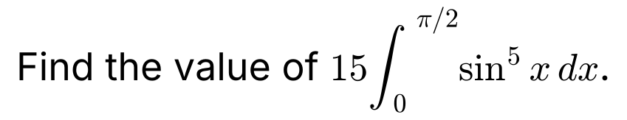
{OPTION 1}
{OPTION 2}
{OPTION 3}
{OPTION 4}
{OPTION 5}
{OPTION 6}
{OPTION 7}
{OPTION 8}
{OPTION 9}
{OPTION 10}
{RIGHT ANSWER} 8
{EXPLANATION} Using Wallis' formula, ∫₀^{π/2} sin⁵x dx = (4 × 2)/(5 × 3) = 8/15. So 15 × (8/15) = 8.
{CORRECT MARKS} 1
{NEGATIVE MARKS} 0
{DIFFICULTY} Hard
{QUESTION ENDS}

{QUESTION BEGINS}
{QUESTION NUMBER} 65
{SUBJECT} Advanced Quantitative Ability
{TOPIC} Progressions
{TAGS} tcs nqt, advanced quantitative, TITA, hard
{QUESTION TYPE} NUMERICAL
{QUESTION TEXT} 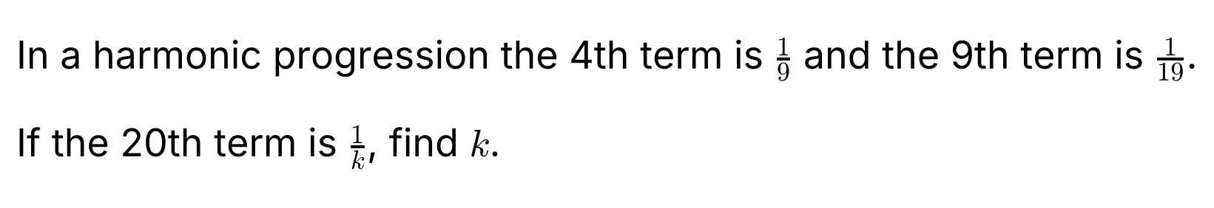
{OPTION 1}
{OPTION 2}
{OPTION 3}
{OPTION 4}
{OPTION 5}
{OPTION 6}
{OPTION 7}
{OPTION 8}
{OPTION 9}
{OPTION 10}
{RIGHT ANSWER} 41
{EXPLANATION} The reciprocals of the terms of an HP form an AP. The 4th term of this AP is 9 and the 9th term is 19, so 5d = 10 and d = 2. The 20th term of the AP = 9 + 16 × 2 = 41, so the 20th term of the HP is 1/41 and k = 41.
{CORRECT MARKS} 1
{NEGATIVE MARKS} 0
{DIFFICULTY} Hard
{QUESTION ENDS}

{QUESTION BEGINS}
{QUESTION NUMBER} 66
{SUBJECT} Advanced Quantitative Ability
{TOPIC} Number Theory
{TAGS} tcs nqt, advanced quantitative, TITA, hard
{QUESTION TYPE} NUMERICAL
{QUESTION TEXT}
{OPTION 1}
{OPTION 2}
{OPTION 3}
{OPTION 4}
{OPTION 5}
{OPTION 6}
{OPTION 7}
{OPTION 8}
{OPTION 9}
{OPTION 10}
{RIGHT ANSWER} 12
{EXPLANATION} The power of 2 in n!: for n = 12 it is 6 + 3 + 1 = 10, while for n = 11 it is 5 + 2 + 1 = 8 < 10. The power of 3 in 12! is 4 + 1 = 5 ≥ 4. So the smallest n is 12.
{CORRECT MARKS} 1
{NEGATIVE MARKS} 0
{DIFFICULTY} Hard
{QUESTION ENDS}

{QUESTION BEGINS}
{QUESTION NUMBER} 67
{SUBJECT} Advanced Quantitative Ability
{TOPIC} Functions
{TAGS} tcs nqt, advanced quantitative, TITA, hard
{QUESTION TYPE} NUMERICAL
{QUESTION TEXT}
{OPTION 1}
{OPTION 2}
{OPTION 3}
{OPTION 4}
{OPTION 5}
{OPTION 6}
{OPTION 7}
{OPTION 8}
{OPTION 9}
{OPTION 10}
{RIGHT ANSWER} 7
{EXPLANATION} Replacing x by 1 − x gives f(1 − x) + 2f(x) = (1 − x)². Solving the two equations: from the first f(x) = x² − 2f(1 − x); substitute in the second: f(1 − x) + 2x² − 4f(1 − x) = (1 − x)², so 3f(1 − x) = 2x² − (1 − x)². Putting x = 1 − t: 3f(t) = 2(1 − t)² − t². For t = 5: 3f(5) = 2 × 16 − 25 = 7.
{CORRECT MARKS} 1
{NEGATIVE MARKS} 0
{DIFFICULTY} Hard
{QUESTION ENDS}

{QUESTION BEGINS}
{QUESTION NUMBER} 68
{SUBJECT} Advanced Quantitative Ability
{TOPIC} Trigonometry
{TAGS} tcs nqt, advanced quantitative, TITA, hard
{QUESTION TYPE} NUMERICAL
{QUESTION TEXT}
{OPTION 1}
{OPTION 2}
{OPTION 3}
{OPTION 4}
{OPTION 5}
{OPTION 6}
{OPTION 7}
{OPTION 8}
{OPTION 9}
{OPTION 10}
{RIGHT ANSWER} 6
{EXPLANATION} Since A + B + C = 180°, tan C = −tan(A + B) = −(tan A + tan B)/(1 − tan A tan B) = −5/(1 − 6) = 1. Then tan A + tan B + tan C = 2 + 3 + 1 = 6 (which also equals tan A tan B tan C = 6).
{CORRECT MARKS} 1
{NEGATIVE MARKS} 0
{DIFFICULTY} Hard
{QUESTION ENDS}

{QUESTION BEGINS}
{QUESTION NUMBER} 69
{SUBJECT} Advanced Quantitative Ability
{TOPIC} Series
{TAGS} tcs nqt, advanced quantitative, TITA, hard
{QUESTION TYPE} NUMERICAL
{QUESTION TEXT} 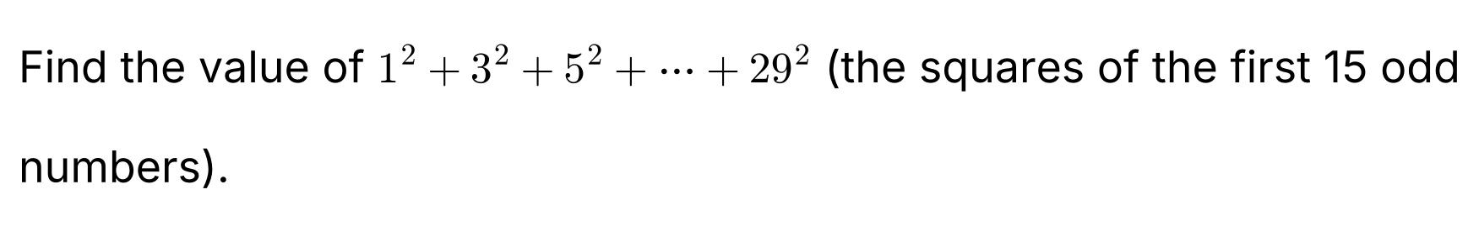
{OPTION 1}
{OPTION 2}
{OPTION 3}
{OPTION 4}
{OPTION 5}
{OPTION 6}
{OPTION 7}
{OPTION 8}
{OPTION 9}
{OPTION 10}
{RIGHT ANSWER} 4495
{EXPLANATION} The sum of the squares of the first n odd numbers is n(2n − 1)(2n + 1)/3. For n = 15: 15 × 29 × 31/3 = 5 × 29 × 31 = 4495.
{CORRECT MARKS} 1
{NEGATIVE MARKS} 0
{DIFFICULTY} Hard
{QUESTION ENDS}

{QUESTION BEGINS}
{QUESTION NUMBER} 70
{SUBJECT} Advanced Quantitative Ability
{TOPIC} Straight Lines
{TAGS} tcs nqt, advanced quantitative, MCQ, hard
{QUESTION TYPE} SINGLECORRECT
{QUESTION TEXT}
{OPTION 1} 30°
{OPTION 2} 60°
{OPTION 3} 45°
{OPTION 4} 90°
{OPTION 5}
{OPTION 6}
{OPTION 7}
{OPTION 8}
{OPTION 9}
{OPTION 10}
{RIGHT ANSWER} 3
{EXPLANATION} The slopes are m₁ = 2 and m₂ = 1/3. tan θ = |(m₁ − m₂)/(1 + m₁m₂)| = |(2 − 1/3)/(1 + 2/3)| = (5/3)/(5/3) = 1, so θ = 45°.
{CORRECT MARKS} 1
{NEGATIVE MARKS} 0
{DIFFICULTY} Hard
{QUESTION ENDS}

{QUESTION BEGINS}
{QUESTION NUMBER} 71
{SUBJECT} Advanced Quantitative Ability
{TOPIC} Number Theory
{TAGS} tcs nqt, advanced quantitative, TITA, hard
{QUESTION TYPE} NUMERICAL
{QUESTION TEXT} 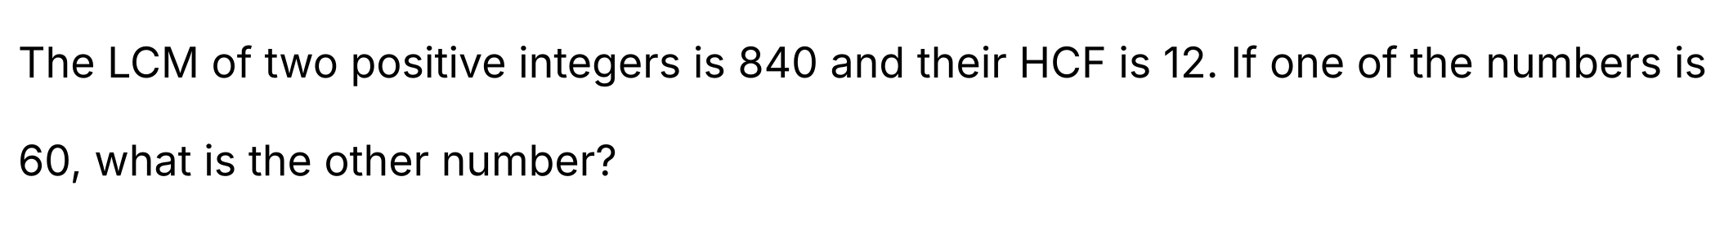
{OPTION 1}
{OPTION 2}
{OPTION 3}
{OPTION 4}
{OPTION 5}
{OPTION 6}
{OPTION 7}
{OPTION 8}
{OPTION 9}
{OPTION 10}
{RIGHT ANSWER} 168
{EXPLANATION} For two numbers a × b = LCM × HCF. So the other number = (840 × 12)/60 = 168. (Check: HCF(60, 168) = 12 and LCM = 840.)
{CORRECT MARKS} 1
{NEGATIVE MARKS} 0
{DIFFICULTY} Hard
{QUESTION ENDS}

{QUESTION BEGINS}
{QUESTION NUMBER} 72
{SUBJECT} Advanced Quantitative Ability
{TOPIC} Probability
{TAGS} tcs nqt, advanced quantitative, TITA, hard
{QUESTION TYPE} NUMERICAL
{QUESTION TEXT} 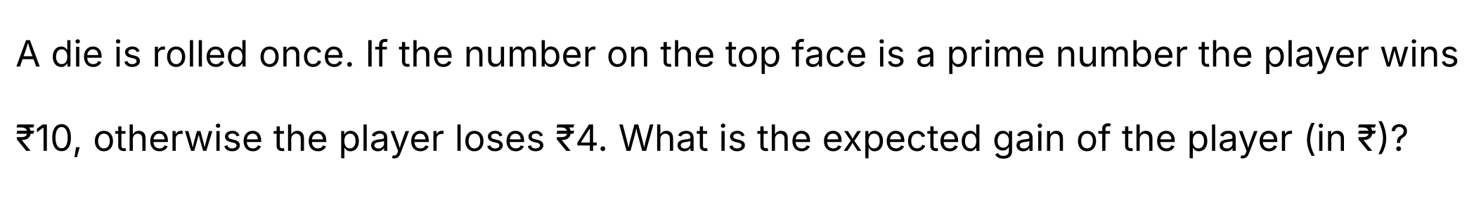
{OPTION 1}
{OPTION 2}
{OPTION 3}
{OPTION 4}
{OPTION 5}
{OPTION 6}
{OPTION 7}
{OPTION 8}
{OPTION 9}
{OPTION 10}
{RIGHT ANSWER} 3
{EXPLANATION} The prime numbers on a die are 2, 3 and 5, so P(win) = 3/6 = 1/2 and P(lose) = 1/2. Expected gain = (1/2)(10) + (1/2)(−4) = 5 − 2 = 3 rupees.
{CORRECT MARKS} 1
{NEGATIVE MARKS} 0
{DIFFICULTY} Hard
{QUESTION ENDS}

{QUESTION BEGINS}
{QUESTION NUMBER} 73
{SUBJECT} Advanced Quantitative Ability
{TOPIC} Statistics
{TAGS} tcs nqt, advanced quantitative, MCQ, hard
{QUESTION TYPE} SINGLECORRECT
{QUESTION TEXT}
{OPTION 1} √11
{OPTION 2} 3
{OPTION 3} √8
{OPTION 4} √33/2
{OPTION 5}
{OPTION 6}
{OPTION 7}
{OPTION 8}
{OPTION 9}
{OPTION 10}
{RIGHT ANSWER} 4
{EXPLANATION} For the first n natural numbers the variance = (n² − 1)/12. For n = 10: (100 − 1)/12 = 99/12 = 33/4. The standard deviation = √(33/4) = √33/2.
{CORRECT MARKS} 1
{NEGATIVE MARKS} 0
{DIFFICULTY} Hard
{QUESTION ENDS}

{QUESTION BEGINS}
{QUESTION NUMBER} 74
{SUBJECT} Advanced Quantitative Ability
{TOPIC} Alligation
{TAGS} tcs nqt, advanced quantitative, MCQ, hard
{QUESTION TYPE} SINGLECORRECT
{QUESTION TEXT} 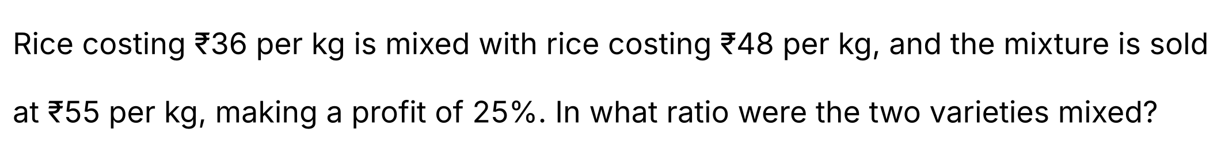
{OPTION 1} 1 : 3
{OPTION 2} 2 : 1
{OPTION 3} 3 : 2
{OPTION 4} 1 : 2
{OPTION 5}
{OPTION 6}
{OPTION 7}
{OPTION 8}
{OPTION 9}
{OPTION 10}
{RIGHT ANSWER} 4
{EXPLANATION} Cost price of the mixture = 55/1.25 = ₹44 per kg. By alligation: (48 − 44) : (44 − 36) = 4 : 8 = 1 : 2 (₹36 rice : ₹48 rice).
{CORRECT MARKS} 1
{NEGATIVE MARKS} 0
{DIFFICULTY} Hard
{QUESTION ENDS}

{QUESTION BEGINS}
{QUESTION NUMBER} 75
{SUBJECT} Advanced Quantitative Ability
{TOPIC} Mensuration
{TAGS} tcs nqt, advanced quantitative, TITA, hard
{QUESTION TYPE} NUMERICAL
{QUESTION TEXT} 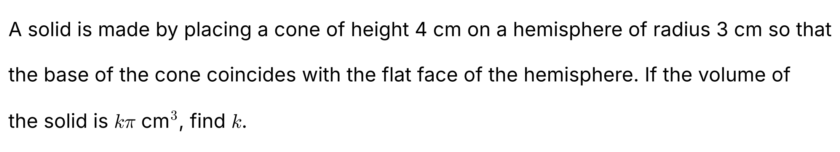
{OPTION 1}
{OPTION 2}
{OPTION 3}
{OPTION 4}
{OPTION 5}
{OPTION 6}
{OPTION 7}
{OPTION 8}
{OPTION 9}
{OPTION 10}
{RIGHT ANSWER} 30
{EXPLANATION} Volume of the hemisphere = (2/3)π × 3³ = 18π. Volume of the cone = (1/3)π × 3² × 4 = 12π. Total volume = 18π + 12π = 30π, so k = 30.
{CORRECT MARKS} 1
{NEGATIVE MARKS} 0
{DIFFICULTY} Hard
{QUESTION ENDS}

{QUESTION BEGINS}
{QUESTION NUMBER} 76
{SUBJECT} Advanced Quantitative Ability
{TOPIC} Calculus
{TAGS} tcs nqt, advanced quantitative, MCQ, hard
{QUESTION TYPE} SINGLECORRECT
{QUESTION TEXT} 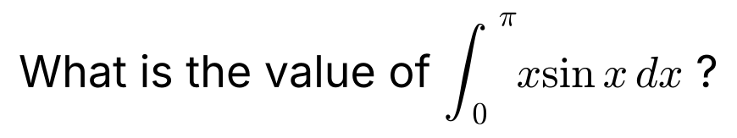
{OPTION 1} 2π
{OPTION 2} π
{OPTION 3} 0
{OPTION 4} π/2
{OPTION 5}
{OPTION 6}
{OPTION 7}
{OPTION 8}
{OPTION 9}
{OPTION 10}
{RIGHT ANSWER} 2
{EXPLANATION} Integrate by parts: ∫x sin x dx = −x cos x + sin x. From 0 to π: (−π cos π + sin π) − (0) = π.
{CORRECT MARKS} 1
{NEGATIVE MARKS} 0
{DIFFICULTY} Hard
{QUESTION ENDS}

{QUESTION BEGINS}
{QUESTION NUMBER} 77
{SUBJECT} Advanced Quantitative Ability
{TOPIC} Time and Work
{TAGS} tcs nqt, advanced quantitative, TITA, hard
{QUESTION TYPE} NUMERICAL
{QUESTION TEXT} 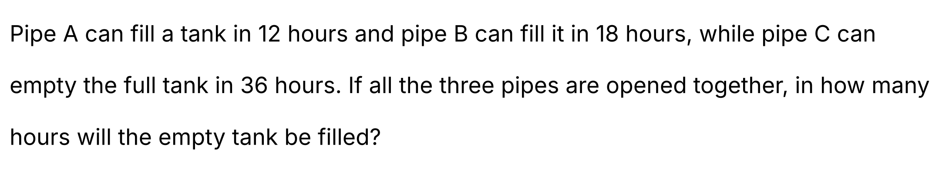
{OPTION 1}
{OPTION 2}
{OPTION 3}
{OPTION 4}
{OPTION 5}
{OPTION 6}
{OPTION 7}
{OPTION 8}
{OPTION 9}
{OPTION 10}
{RIGHT ANSWER} 9
{EXPLANATION} Per hour the net part filled = 1/12 + 1/18 − 1/36 = (3 + 2 − 1)/36 = 4/36 = 1/9. So the tank is filled in 9 hours.
{CORRECT MARKS} 1
{NEGATIVE MARKS} 0
{DIFFICULTY} Hard
{QUESTION ENDS}

{QUESTION BEGINS}
{QUESTION NUMBER} 78
{SUBJECT} Advanced Quantitative Ability
{TOPIC} Compound Interest
{TAGS} tcs nqt, advanced quantitative, TITA, hard
{QUESTION TYPE} NUMERICAL
{QUESTION TEXT} 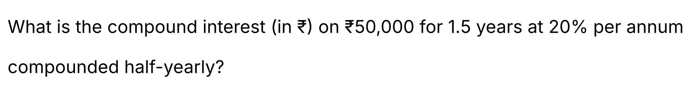
{OPTION 1}
{OPTION 2}
{OPTION 3}
{OPTION 4}
{OPTION 5}
{OPTION 6}
{OPTION 7}
{OPTION 8}
{OPTION 9}
{OPTION 10}
{RIGHT ANSWER} 16550
{EXPLANATION} The rate per half-year = 10% and the number of half-years = 3. Amount = 50000 × (1.1)³ = 50000 × 1.331 = ₹66,550. Compound interest = 66550 − 50000 = ₹16,550.
{CORRECT MARKS} 1
{NEGATIVE MARKS} 0
{DIFFICULTY} Hard
{QUESTION ENDS}

{QUESTION BEGINS}
{QUESTION NUMBER} 79
{SUBJECT} Advanced Quantitative Ability
{TOPIC} Polynomials
{TAGS} tcs nqt, advanced quantitative, TITA, hard
{QUESTION TYPE} NUMERICAL
{QUESTION TEXT} 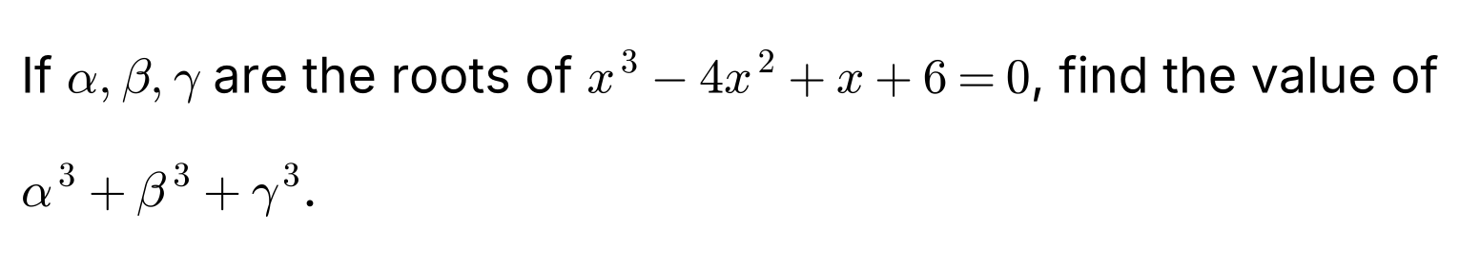
{OPTION 1}
{OPTION 2}
{OPTION 3}
{OPTION 4}
{OPTION 5}
{OPTION 6}
{OPTION 7}
{OPTION 8}
{OPTION 9}
{OPTION 10}
{RIGHT ANSWER} 34
{EXPLANATION} For x³ − 4x² + x + 6 = 0: e₁ = α + β + γ = 4, e₂ = αβ + βγ + γα = 1 and e₃ = αβγ = −6. Using α³ + β³ + γ³ = e₁³ − 3e₁e₂ + 3e₃ = 64 − 12 − 18 = 34. (The roots are 2, 3 and −1: 8 + 27 − 1 = 34.)
{CORRECT MARKS} 1
{NEGATIVE MARKS} 0
{DIFFICULTY} Hard
{QUESTION ENDS}

{QUESTION BEGINS}
{QUESTION NUMBER} 80
{SUBJECT} Advanced Quantitative Ability
{TOPIC} Polynomials
{TAGS} tcs nqt, advanced quantitative, TITA, hard
{QUESTION TYPE} NUMERICAL
{QUESTION TEXT} 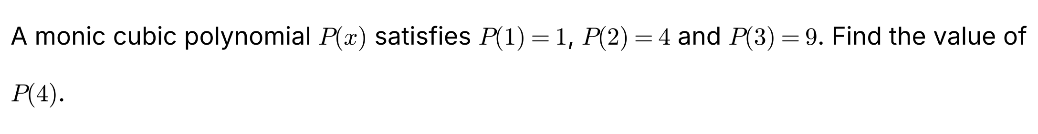
{OPTION 1}
{OPTION 2}
{OPTION 3}
{OPTION 4}
{OPTION 5}
{OPTION 6}
{OPTION 7}
{OPTION 8}
{OPTION 9}
{OPTION 10}
{RIGHT ANSWER} 22
{EXPLANATION} Let Q(x) = P(x) − x². Then Q(1) = Q(2) = Q(3) = 0 and Q is a monic cubic, so Q(x) = (x − 1)(x − 2)(x − 3). Hence P(x) = x² + (x − 1)(x − 2)(x − 3) and P(4) = 16 + 3 × 2 × 1 = 22.
{CORRECT MARKS} 1
{NEGATIVE MARKS} 0
{DIFFICULTY} Hard
{QUESTION ENDS}

{QUESTION BEGINS}
{QUESTION NUMBER} 81
{SUBJECT} Advanced Quantitative Ability
{TOPIC} Number Theory
{TAGS} tcs nqt, advanced quantitative, MCQ, hard
{QUESTION TYPE} SINGLECORRECT
{QUESTION TEXT} 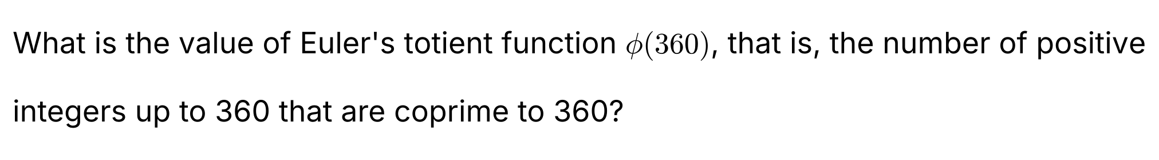
{OPTION 1} 96
{OPTION 2} 120
{OPTION 3} 144
{OPTION 4} 72
{OPTION 5}
{OPTION 6}
{OPTION 7}
{OPTION 8}
{OPTION 9}
{OPTION 10}
{RIGHT ANSWER} 1
{EXPLANATION} 360 = 2³ × 3² × 5, so φ(360) = 360 × (1 − 1/2)(1 − 1/3)(1 − 1/5) = 360 × (1/2)(2/3)(4/5) = 96.
{CORRECT MARKS} 1
{NEGATIVE MARKS} 0
{DIFFICULTY} Hard
{QUESTION ENDS}

{QUESTION BEGINS}
{QUESTION NUMBER} 82
{SUBJECT} Advanced Quantitative Ability
{TOPIC} Inequalities
{TAGS} tcs nqt, advanced quantitative, MCQ, hard
{QUESTION TYPE} SINGLECORRECT
{QUESTION TEXT} 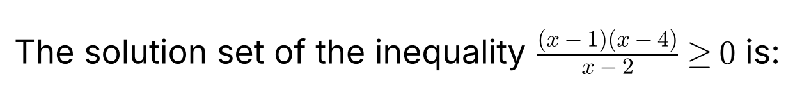
{OPTION 1} [1, 2] ∪ [4, ∞)
{OPTION 2} [1, 2) ∪ [4, ∞)
{OPTION 3} (1, 2) ∪ (4, ∞)
{OPTION 4} (−∞, 1] ∪ (2, 4]
{OPTION 5}
{OPTION 6}
{OPTION 7}
{OPTION 8}
{OPTION 9}
{OPTION 10}
{RIGHT ANSWER} 2
{EXPLANATION} The critical points are 1, 2 and 4. Sign of (x − 1)(x − 4)/(x − 2): for x < 1 it is (−)(−)/(−) = negative; for 1 < x < 2 it is (+)(−)/(−) = positive; for 2 < x < 4 it is (+)(−)/(+) = negative; for x > 4 it is positive. The value is 0 at x = 1 and x = 4 (included) and the expression is undefined at x = 2 (excluded). So the solution is [1, 2) ∪ [4, ∞).
{CORRECT MARKS} 1
{NEGATIVE MARKS} 0
{DIFFICULTY} Hard
{QUESTION ENDS}

{QUESTION BEGINS}
{QUESTION NUMBER} 83
{SUBJECT} Advanced Quantitative Ability
{TOPIC} Progressions
{TAGS} tcs nqt, advanced quantitative, TITA, hard
{QUESTION TYPE} NUMERICAL
{QUESTION TEXT} 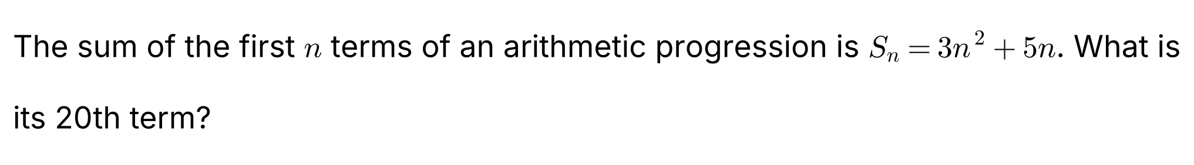
{OPTION 1}
{OPTION 2}
{OPTION 3}
{OPTION 4}
{OPTION 5}
{OPTION 6}
{OPTION 7}
{OPTION 8}
{OPTION 9}
{OPTION 10}
{RIGHT ANSWER} 122
{EXPLANATION} The nth term a_n = S_n − S_(n−1) = (3n² + 5n) − [3(n − 1)² + 5(n − 1)] = 6n + 2. So a₂₀ = 6 × 20 + 2 = 122. (Check: S₂₀ − S₁₉ = 1300 − 1178 = 122.)
{CORRECT MARKS} 1
{NEGATIVE MARKS} 0
{DIFFICULTY} Hard
{QUESTION ENDS}

{QUESTION BEGINS}
{QUESTION NUMBER} 84
{SUBJECT} Advanced Quantitative Ability
{TOPIC} Progressions
{TAGS} tcs nqt, advanced quantitative, MCQ, hard
{QUESTION TYPE} SINGLECORRECT
{QUESTION TEXT} 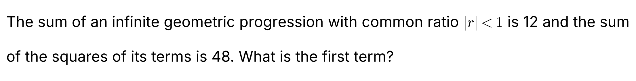
{OPTION 1} 4
{OPTION 2} 3
{OPTION 3} 6
{OPTION 4} 8
{OPTION 5}
{OPTION 6}
{OPTION 7}
{OPTION 8}
{OPTION 9}
{OPTION 10}
{RIGHT ANSWER} 3
{EXPLANATION} Let the first term be a and the ratio r. a/(1 − r) = 12 and a²/(1 − r²) = 48. Dividing the second by the first gives a/(1 + r) = 4. Then 12(1 − r) = 4(1 + r), so r = 1/2, and a = 12(1 − 1/2) = 6.
{CORRECT MARKS} 1
{NEGATIVE MARKS} 0
{DIFFICULTY} Hard
{QUESTION ENDS}

{QUESTION BEGINS}
{QUESTION NUMBER} 85
{SUBJECT} Advanced Quantitative Ability
{TOPIC} Binomial Theorem
{TAGS} tcs nqt, advanced quantitative, MCQ, hard
{QUESTION TYPE} SINGLECORRECT
{QUESTION TEXT}
{OPTION 1} 50
{OPTION 2} 75
{OPTION 3} 95
{OPTION 4} 65
{OPTION 5}
{OPTION 6}
{OPTION 7}
{OPTION 8}
{OPTION 9}
{OPTION 10}
{RIGHT ANSWER} 4
{EXPLANATION} (1 + x + x² + x³)⁵ = ((1 − x⁴)/(1 − x))⁵ = (1 − 5x⁴ + …)(1 − x)⁻⁵. The coefficient of x⁴ in (1 − x)⁻⁵ is C(8, 4) = 70, and the term −5x⁴ multiplies the constant term 1. So the coefficient = 70 − 5 = 65.
{CORRECT MARKS} 1
{NEGATIVE MARKS} 0
{DIFFICULTY} Hard
{QUESTION ENDS}

{QUESTION BEGINS}
{QUESTION NUMBER} 86
{SUBJECT} Advanced Quantitative Ability
{TOPIC} Matrices
{TAGS} tcs nqt, advanced quantitative, MCQ, hard
{QUESTION TYPE} SINGLECORRECT
{QUESTION TEXT}
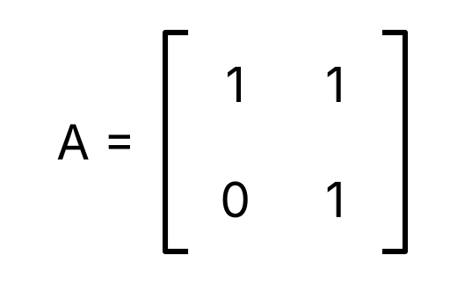
{OPTION 1} 100
{OPTION 2} 52
{OPTION 3} 50
{OPTION 4} 51
{OPTION 5}
{OPTION 6}
{OPTION 7}
{OPTION 8}
{OPTION 9}
{OPTION 10}
{RIGHT ANSWER} 2
{EXPLANATION} A² = [[1, 2], [0, 1]], and by induction Aⁿ = [[1, n], [0, 1]]. So A⁵⁰ = [[1, 50], [0, 1]], and the sum of its entries = 1 + 50 + 0 + 1 = 52.
{CORRECT MARKS} 1
{NEGATIVE MARKS} 0
{DIFFICULTY} Hard
{QUESTION ENDS}

{QUESTION BEGINS}
{QUESTION NUMBER} 87
{SUBJECT} Advanced Quantitative Ability
{TOPIC} Trigonometry
{TAGS} tcs nqt, advanced quantitative, TITA, hard
{QUESTION TYPE} NUMERICAL
{QUESTION TEXT} 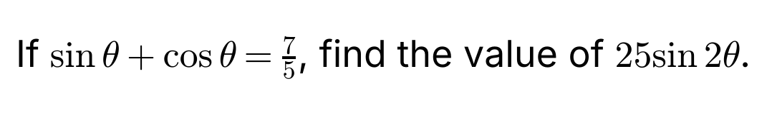
{OPTION 1}
{OPTION 2}
{OPTION 3}
{OPTION 4}
{OPTION 5}
{OPTION 6}
{OPTION 7}
{OPTION 8}
{OPTION 9}
{OPTION 10}
{RIGHT ANSWER} 24
{EXPLANATION} Squaring: 1 + sin 2θ = 49/25, so sin 2θ = 24/25. Therefore 25 sin 2θ = 24. (Such a θ exists since 7/5 < √2.)
{CORRECT MARKS} 1
{NEGATIVE MARKS} 0
{DIFFICULTY} Hard
{QUESTION ENDS}

{QUESTION BEGINS}
{QUESTION NUMBER} 88
{SUBJECT} Advanced Quantitative Ability
{TOPIC} Mensuration
{TAGS} tcs nqt, advanced quantitative, TITA, hard
{QUESTION TYPE} NUMERICAL
{QUESTION TEXT} 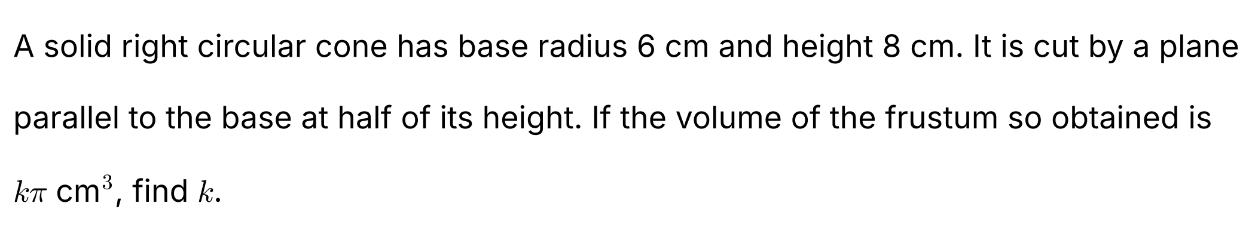
{OPTION 1}
{OPTION 2}
{OPTION 3}
{OPTION 4}
{OPTION 5}
{OPTION 6}
{OPTION 7}
{OPTION 8}
{OPTION 9}
{OPTION 10}
{RIGHT ANSWER} 84
{EXPLANATION} Volume of the full cone = (1/3)π(6²)(8) = 96π. The small cone cut off above the plane has half the height and half the radius: radius 3, height 4, volume = (1/3)π(3²)(4) = 12π. Frustum = 96π − 12π = 84π, so k = 84.
{CORRECT MARKS} 1
{NEGATIVE MARKS} 0
{DIFFICULTY} Hard
{QUESTION ENDS}

{QUESTION BEGINS}
{QUESTION NUMBER} 89
{SUBJECT} Advanced Quantitative Ability
{TOPIC} Calculus
{TAGS} tcs nqt, advanced quantitative, TITA, hard
{QUESTION TYPE} NUMERICAL
{QUESTION TEXT} 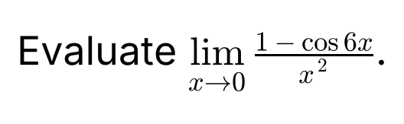
{OPTION 1}
{OPTION 2}
{OPTION 3}
{OPTION 4}
{OPTION 5}
{OPTION 6}
{OPTION 7}
{OPTION 8}
{OPTION 9}
{OPTION 10}
{RIGHT ANSWER} 18
{EXPLANATION} Use 1 − cos 6x = 2 sin²3x. Then (1 − cos 6x)/x² = 2 (sin 3x/x)² → 2 × 3² = 18 as x → 0.
{CORRECT MARKS} 1
{NEGATIVE MARKS} 0
{DIFFICULTY} Hard
{QUESTION ENDS}

{QUESTION BEGINS}
{QUESTION NUMBER} 90
{SUBJECT} Advanced Quantitative Ability
{TOPIC} Calculus
{TAGS} tcs nqt, advanced quantitative, TITA, hard
{QUESTION TYPE} NUMERICAL
{QUESTION TEXT}
{OPTION 1}
{OPTION 2}
{OPTION 3}
{OPTION 4}
{OPTION 5}
{OPTION 6}
{OPTION 7}
{OPTION 8}
{OPTION 9}
{OPTION 10}
{RIGHT ANSWER} 3
{EXPLANATION} f′(x) = 5x⁴ − 15x² = 5x²(x² − 3). It is zero at x = 0 and x = ±√3, which are 3 real values.
{CORRECT MARKS} 1
{NEGATIVE MARKS} 0
{DIFFICULTY} Hard
{QUESTION ENDS}

{QUESTION BEGINS}
{QUESTION NUMBER} 91
{SUBJECT} Advanced Quantitative Ability
{TOPIC} Time and Work
{TAGS} tcs nqt, advanced quantitative, TITA, hard
{QUESTION TYPE} NUMERICAL
{QUESTION TEXT} 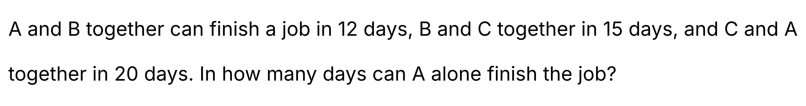
{OPTION 1}
{OPTION 2}
{OPTION 3}
{OPTION 4}
{OPTION 5}
{OPTION 6}
{OPTION 7}
{OPTION 8}
{OPTION 9}
{OPTION 10}
{RIGHT ANSWER} 30
{EXPLANATION} Adding the three rates: 2(A + B + C) = 1/12 + 1/15 + 1/20 = (5 + 4 + 3)/60 = 1/5, so A + B + C = 1/10 per day. Then A = (A + B + C) − (B + C) = 1/10 − 1/15 = 1/30. A alone takes 30 days.
{CORRECT MARKS} 1
{NEGATIVE MARKS} 0
{DIFFICULTY} Hard
{QUESTION ENDS}

{QUESTION BEGINS}
{QUESTION NUMBER} 92
{SUBJECT} Advanced Quantitative Ability
{TOPIC} Means
{TAGS} tcs nqt, advanced quantitative, TITA, hard
{QUESTION TYPE} NUMERICAL
{QUESTION TEXT} 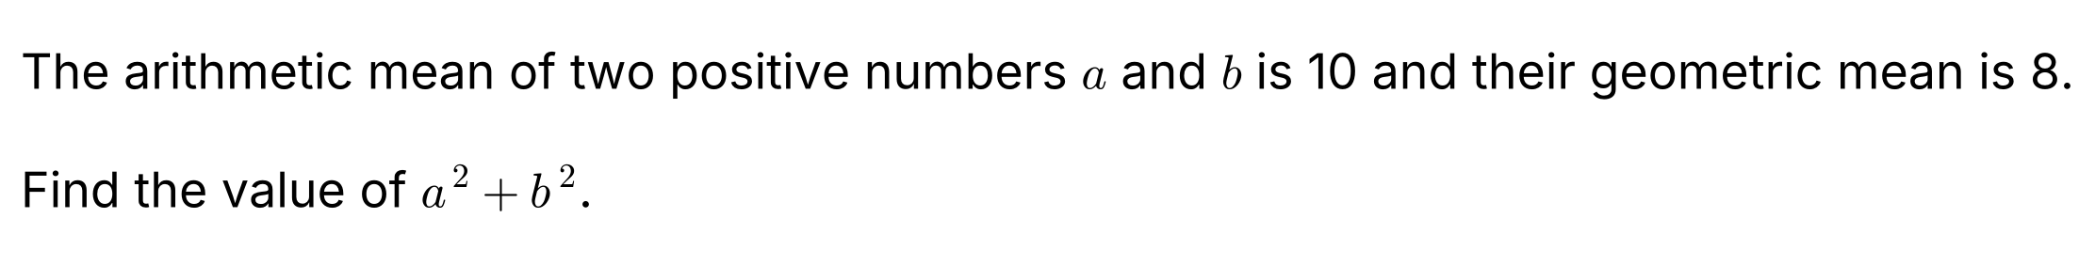
{OPTION 1}
{OPTION 2}
{OPTION 3}
{OPTION 4}
{OPTION 5}
{OPTION 6}
{OPTION 7}
{OPTION 8}
{OPTION 9}
{OPTION 10}
{RIGHT ANSWER} 272
{EXPLANATION} AM = (a + b)/2 = 10, so a + b = 20. GM = √(ab) = 8, so ab = 64. Then a² + b² = (a + b)² − 2ab = 400 − 128 = 272. (The numbers are 10 ± 6, that is 16 and 4: 256 + 16 = 272.)
{CORRECT MARKS} 1
{NEGATIVE MARKS} 0
{DIFFICULTY} Hard
{QUESTION ENDS}

{QUESTION BEGINS}
{QUESTION NUMBER} 93
{SUBJECT} Advanced Quantitative Ability
{TOPIC} 3D Geometry
{TAGS} tcs nqt, advanced quantitative, TITA, hard
{QUESTION TYPE} NUMERICAL
{QUESTION TEXT} 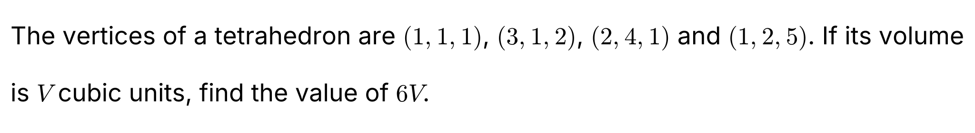
{OPTION 1}
{OPTION 2}
{OPTION 3}
{OPTION 4}
{OPTION 5}
{OPTION 6}
{OPTION 7}
{OPTION 8}
{OPTION 9}
{OPTION 10}
{RIGHT ANSWER} 25
{EXPLANATION} Take (1, 1, 1) as the common vertex; the edge vectors are (2, 0, 1), (1, 3, 0) and (0, 1, 4). The scalar triple product = 2(3 × 4 − 0 × 1) − 0 × (1 × 4 − 0) + 1(1 × 1 − 3 × 0) = 24 + 1 = 25. Volume V = |triple product|/6, so 6V = 25.
{CORRECT MARKS} 1
{NEGATIVE MARKS} 0
{DIFFICULTY} Hard
{QUESTION ENDS}

{QUESTION BEGINS}
{QUESTION NUMBER} 94
{SUBJECT} Advanced Quantitative Ability
{TOPIC} Number Theory
{TAGS} tcs nqt, advanced quantitative, TITA, hard
{QUESTION TYPE} NUMERICAL
{QUESTION TEXT} 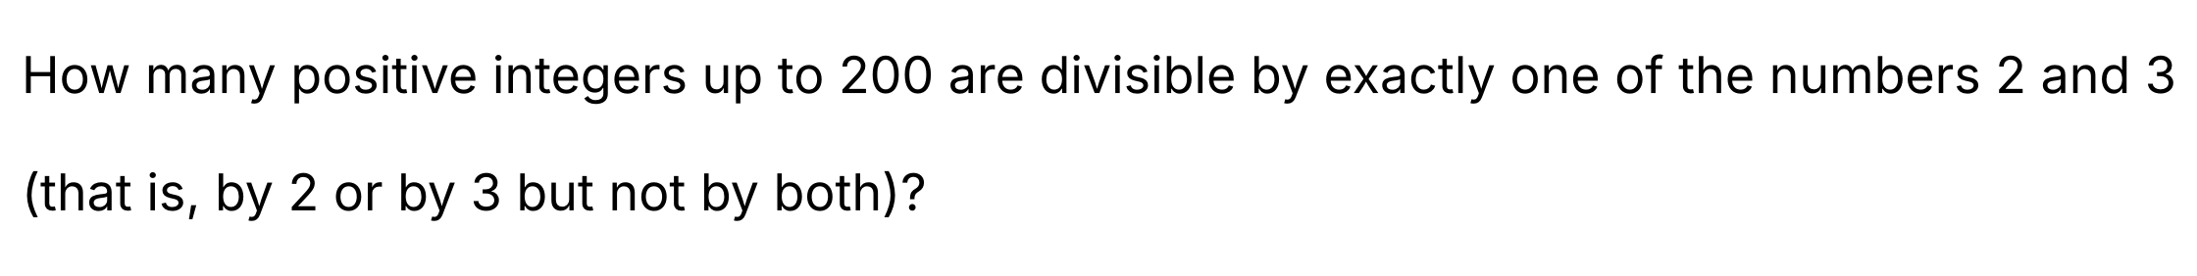
{OPTION 1}
{OPTION 2}
{OPTION 3}
{OPTION 4}
{OPTION 5}
{OPTION 6}
{OPTION 7}
{OPTION 8}
{OPTION 9}
{OPTION 10}
{RIGHT ANSWER} 100
{EXPLANATION} Multiples of 2: 100. Multiples of 3: 66. Multiples of both (that is of 6): 33. Divisible by exactly one = 100 + 66 − 2 × 33 = 100.
{CORRECT MARKS} 1
{NEGATIVE MARKS} 0
{DIFFICULTY} Hard
{QUESTION ENDS}

{QUESTION BEGINS}
{QUESTION NUMBER} 95
{SUBJECT} Advanced Quantitative Ability
{TOPIC} Binomial Theorem
{TAGS} tcs nqt, advanced quantitative, TITA, hard
{QUESTION TYPE} NUMERICAL
{QUESTION TEXT} 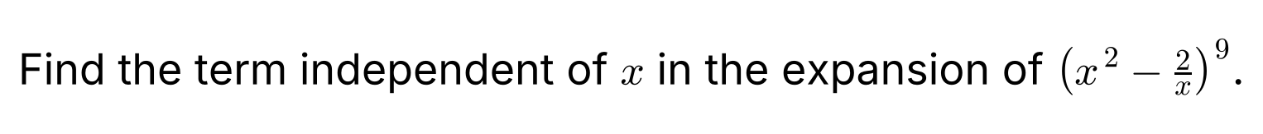
{OPTION 1}
{OPTION 2}
{OPTION 3}
{OPTION 4}
{OPTION 5}
{OPTION 6}
{OPTION 7}
{OPTION 8}
{OPTION 9}
{OPTION 10}
{RIGHT ANSWER} 5376
{EXPLANATION} The general term is T_(k+1) = C(9, k)(x²)^(9−k)(−2/x)^k = C(9, k)(−2)^k x^(18−3k). The term independent of x needs 18 − 3k = 0, so k = 6. Then T₇ = C(9, 6)(−2)⁶ = 84 × 64 = 5376.
{CORRECT MARKS} 1
{NEGATIVE MARKS} 0
{DIFFICULTY} Hard
{QUESTION ENDS}

{QUESTION BEGINS}
{QUESTION NUMBER} 96
{SUBJECT} Advanced Quantitative Ability
{TOPIC} Mensuration
{TAGS} tcs nqt, advanced quantitative, MCQ, hard
{QUESTION TYPE} SINGLECORRECT
{QUESTION TEXT} 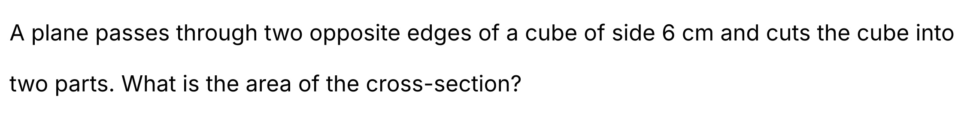
{OPTION 1} 72 cm²
{OPTION 2} 36 cm²
{OPTION 3} 18√2 cm²
{OPTION 4} 36√2 cm²
{OPTION 5}
{OPTION 6}
{OPTION 7}
{OPTION 8}
{OPTION 9}
{OPTION 10}
{RIGHT ANSWER} 4
{EXPLANATION} The plane through two opposite (parallel, diagonally opposite) edges cuts the cube in a rectangle. One side is the edge, 6 cm, and the other is the face diagonal 6√2 cm. Area = 6 × 6√2 = 36√2 cm².
{CORRECT MARKS} 1
{NEGATIVE MARKS} 0
{DIFFICULTY} Hard
{QUESTION ENDS}

{QUESTION BEGINS}
{QUESTION NUMBER} 97
{SUBJECT} Advanced Quantitative Ability
{TOPIC} Complex Numbers
{TAGS} tcs nqt, advanced quantitative, TITA, hard
{QUESTION TYPE} NUMERICAL
{QUESTION TEXT} 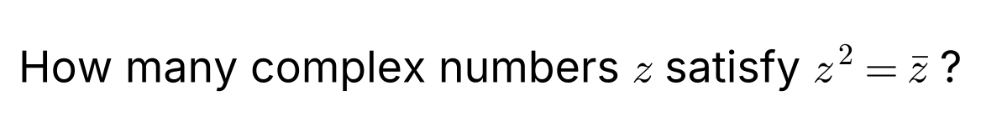
{OPTION 1}
{OPTION 2}
{OPTION 3}
{OPTION 4}
{OPTION 5}
{OPTION 6}
{OPTION 7}
{OPTION 8}
{OPTION 9}
{OPTION 10}
{RIGHT ANSWER} 4
{EXPLANATION} Taking the modulus: |z|² = |z|, so |z| = 0 or |z| = 1. z = 0 works. If |z| = 1 then z̄ = 1/z, so z² = 1/z, i.e. z³ = 1, which has 3 solutions (1, ω, ω²). Total = 1 + 3 = 4 complex numbers.
{CORRECT MARKS} 1
{NEGATIVE MARKS} 0
{DIFFICULTY} Hard
{QUESTION ENDS}

{QUESTION BEGINS}
{QUESTION NUMBER} 98
{SUBJECT} Advanced Quantitative Ability
{TOPIC} Boats and Streams
{TAGS} tcs nqt, advanced quantitative, TITA, hard
{QUESTION TYPE} NUMERICAL
{QUESTION TEXT} 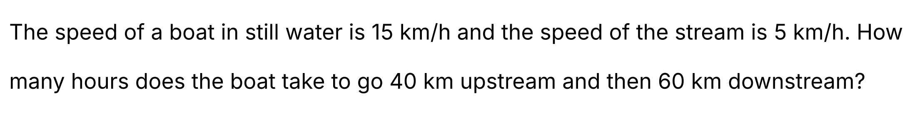
{OPTION 1}
{OPTION 2}
{OPTION 3}
{OPTION 4}
{OPTION 5}
{OPTION 6}
{OPTION 7}
{OPTION 8}
{OPTION 9}
{OPTION 10}
{RIGHT ANSWER} 7
{EXPLANATION} Upstream speed = 15 − 5 = 10 km/h and downstream speed = 15 + 5 = 20 km/h. Time upstream = 40/10 = 4 h and time downstream = 60/20 = 3 h. Total time = 4 + 3 = 7 hours.
{CORRECT MARKS} 1
{NEGATIVE MARKS} 0
{DIFFICULTY} Hard
{QUESTION ENDS}

{QUESTION BEGINS}
{QUESTION NUMBER} 99
{SUBJECT} Advanced Quantitative Ability
{TOPIC} Circles
{TAGS} tcs nqt, advanced quantitative, MCQ, hard
{QUESTION TYPE} SINGLECORRECT
{QUESTION TEXT} 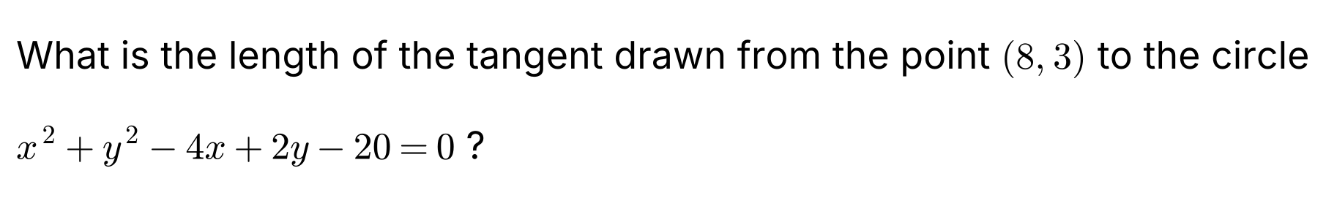
{OPTION 1} √27 + 1
{OPTION 2} 3√3
{OPTION 3} 5
{OPTION 4} 6
{OPTION 5}
{OPTION 6}
{OPTION 7}
{OPTION 8}
{OPTION 9}
{OPTION 10}
{RIGHT ANSWER} 2
{EXPLANATION} The length of the tangent from (x₁, y₁) to the circle S = 0 is √S₁. Here S₁ = 8² + 3² − 4 × 8 + 2 × 3 − 20 = 64 + 9 − 32 + 6 − 20 = 27. So the length = √27 = 3√3.
{CORRECT MARKS} 1
{NEGATIVE MARKS} 0
{DIFFICULTY} Hard
{QUESTION ENDS}

{QUESTION BEGINS}
{QUESTION NUMBER} 100
{SUBJECT} Advanced Quantitative Ability
{TOPIC} Permutations & Combinations
{TAGS} tcs nqt, advanced quantitative, TITA, hard
{QUESTION TYPE} NUMERICAL
{QUESTION TEXT} 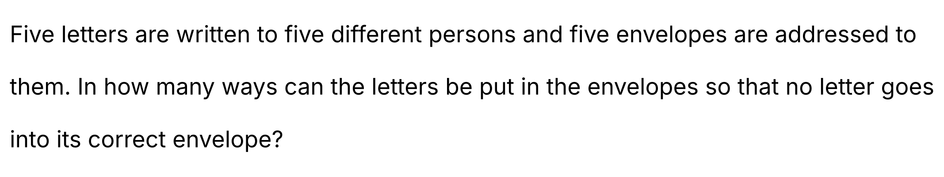
{OPTION 1}
{OPTION 2}
{OPTION 3}
{OPTION 4}
{OPTION 5}
{OPTION 6}
{OPTION 7}
{OPTION 8}
{OPTION 9}
{OPTION 10}
{RIGHT ANSWER} 44
{EXPLANATION} This is the number of derangements D₅ = 5!(1 − 1/1! + 1/2! − 1/3! + 1/4! − 1/5!) = 120 × (1/2 − 1/6 + 1/24 − 1/120) = 60 − 20 + 5 − 1 = 44.
{CORRECT MARKS} 1
{NEGATIVE MARKS} 0
{DIFFICULTY} Hard
{QUESTION ENDS}

