{QUESTION BEGINS}
{QUESTION NUMBER} 1
{SUBJECT} Reasoning Ability
{TOPIC} Letter Matrix
{TAGS} tcs nqt, reasoning ability, figure based, hard
{QUESTION TYPE} SINGLECORRECT
{QUESTION TEXT} Find the letter that replaces the question mark. (Use the alphabet positions A = 1, …, Z = 26 and continue from A after Z.)
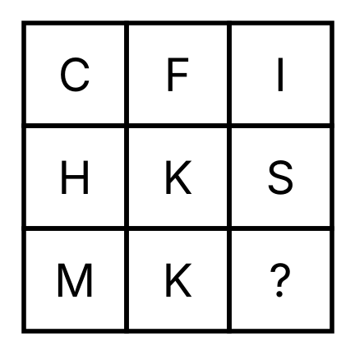
{OPTION 1} C
{OPTION 2} X
{OPTION 3} A
{OPTION 4} B
{OPTION 5}
{OPTION 6}
{OPTION 7}
{OPTION 8}
{OPTION 9}
{OPTION 10}
{RIGHT ANSWER} 2
{EXPLANATION} In every row the third letter has the position (first letter position + second letter position), counted round the alphabet: C(3) + F(6) = 9 = I; H(8) + K(11) = 19 = S; so M(13) + K(11) = 24 = X.
{CORRECT MARKS} 1
{NEGATIVE MARKS} 0
{DIFFICULTY} Hard
{QUESTION ENDS}

{QUESTION BEGINS}
{QUESTION NUMBER} 2
{SUBJECT} Reasoning Ability
{TOPIC} Seating Arrangement
{TAGS} tcs nqt, reasoning ability, hard
{QUESTION TYPE} SINGLECORRECT
{QUESTION TEXT} Eight friends A, B, C, D, E, F, G and H sit in two rows of four seats each. The friends in the first row face south and the friends in the second row face north, so every person in one row faces exactly one person of the other row. F sits in the first row. A sits opposite D. H sits at one of the ends of a row. B is an immediate neighbour of C. A does not sit at an end of a row. B does not sit at an end of a row. G is an immediate neighbour of H.
Who sits opposite B?
{OPTION 1} D
{OPTION 2} G
{OPTION 3} A
{OPTION 4} C
{OPTION 5}
{OPTION 6}
{OPTION 7}
{OPTION 8}
{OPTION 9}
{OPTION 10}
{RIGHT ANSWER} 2
{EXPLANATION} All 8 seatings that satisfy every statement were examined. One of them is: first row C B A F and second row H G D E. In every one of them G sits opposite B, so the answer is G.
{CORRECT MARKS} 1
{NEGATIVE MARKS} 0
{DIFFICULTY} Hard
{QUESTION ENDS}

{QUESTION BEGINS}
{QUESTION NUMBER} 3
{SUBJECT} Reasoning Ability
{TOPIC} Blood Relations
{TAGS} tcs nqt, reasoning ability, hard
{QUESTION TYPE} SINGLECORRECT
{QUESTION TEXT} Read the information and answer. There are six members in a family. J is the father of K. K is the only sister of L. L's wife is M. M's only son is N. O is the wife of J.
How is O related to N?
{OPTION 1} Maternal grandmother
{OPTION 2} Mother-in-law
{OPTION 3} Aunt
{OPTION 4} Paternal grandmother
{OPTION 5}
{OPTION 6}
{OPTION 7}
{OPTION 8}
{OPTION 9}
{OPTION 10}
{RIGHT ANSWER} 4
{EXPLANATION} J and O are husband and wife, and J is the father of K, so O is K's mother (K is a daughter of J, as K is L's sister). K and L are siblings, so O is also the mother of L. L's wife M is the mother of N, so L is N's father. O is the mother of N's father, that is N's paternal grandmother.
{CORRECT MARKS} 1
{NEGATIVE MARKS} 0
{DIFFICULTY} Hard
{QUESTION ENDS}

{QUESTION BEGINS}
{QUESTION NUMBER} 4
{SUBJECT} Reasoning Ability
{TOPIC} Classification
{TAGS} tcs nqt, reasoning ability, hard
{QUESTION TYPE} SINGLECORRECT
{QUESTION TEXT} Four of the following five numbers belong to the same group. Which number does NOT belong? 6, 28, 126, 496, 8128
{OPTION 1} 8128
{OPTION 2} 28
{OPTION 3} 496
{OPTION 4} 126
{OPTION 5}
{OPTION 6}
{OPTION 7}
{OPTION 8}
{OPTION 9}
{OPTION 10}
{RIGHT ANSWER} 4
{EXPLANATION} 6 = 1 + 2 + 3, 28 = 1 + 2 + 4 + 7 + 14, 496 and 8128 are all perfect numbers (each equals the sum of its proper factors). 126 is not a perfect number.
{CORRECT MARKS} 1
{NEGATIVE MARKS} 0
{DIFFICULTY} Hard
{QUESTION ENDS}

{QUESTION BEGINS}
{QUESTION NUMBER} 5
{SUBJECT} Reasoning Ability
{TOPIC} Figure Rotation
{TAGS} tcs nqt, reasoning ability, figure based, hard
{QUESTION TYPE} SINGLECORRECT
{QUESTION TEXT} The given figure is first turned through 90° clockwise, then flipped left to right (as seen in a vertical mirror), and finally turned through 180°. Which option shows the final figure?
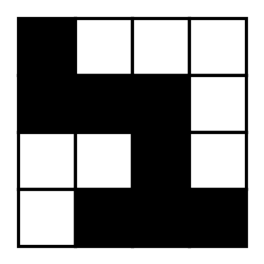
{OPTION 1} 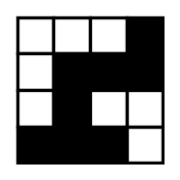
{OPTION 2} 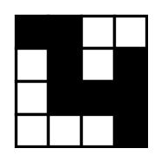
{OPTION 3} 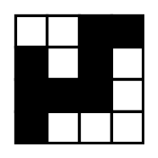
{OPTION 4} 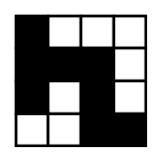
{OPTION 5}
{OPTION 6}
{OPTION 7}
{OPTION 8}
{OPTION 9}
{OPTION 10}
{RIGHT ANSWER} 4
{EXPLANATION} Apply the three changes in order: a 90° clockwise turn, a left-right flip, and a 180° turn. Doing this to every cell of the figure gives the figure in option 1; the other options apply fewer changes or the changes in a different order.
{CORRECT MARKS} 1
{NEGATIVE MARKS} 0
{DIFFICULTY} Hard
{QUESTION ENDS}

{QUESTION BEGINS}
{QUESTION NUMBER} 6
{SUBJECT} Reasoning Ability
{TOPIC} Puzzle
{TAGS} tcs nqt, reasoning ability, hard
{QUESTION TYPE} SINGLECORRECT
{QUESTION TEXT} You have two empty jugs of capacity 7 litres and 4 litres and an unlimited supply of water (no markings on the jugs). One 'operation' is filling a jug completely, emptying a jug completely, or pouring from one jug into the other until the source is empty or the target is full. What is the minimum number of operations needed to get exactly 5 litres in one of the jugs?
{OPTION 1} 7
{OPTION 2} 6
{OPTION 3} 3
{OPTION 4} 8
{OPTION 5}
{OPTION 6}
{OPTION 7}
{OPTION 8}
{OPTION 9}
{OPTION 10}
{RIGHT ANSWER} 4
{EXPLANATION} A shortest sequence of states (7 L jug, 4 L jug): (0, 0) → (0, 4) → (4, 0) → (4, 4) → (7, 1) → (0, 1) → (1, 0) → (1, 4) → (5, 0). That is 8 operations, and a search of all possible states shows that no shorter sequence gives exactly 5 litres.
{CORRECT MARKS} 1
{NEGATIVE MARKS} 0
{DIFFICULTY} Hard
{QUESTION ENDS}

{QUESTION BEGINS}
{QUESTION NUMBER} 7
{SUBJECT} Reasoning Ability
{TOPIC} Clock
{TAGS} tcs nqt, reasoning ability, figure based, hard
{QUESTION TYPE} SINGLECORRECT
{QUESTION TEXT} The figure shows the image of a clock as seen in a mirror (note that the numbers appear reversed). What is the actual time?
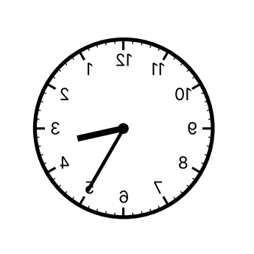
{OPTION 1} 2:35
{OPTION 2} 9:25
{OPTION 3} 8:35
{OPTION 4} 3:25
{OPTION 5}
{OPTION 6}
{OPTION 7}
{OPTION 8}
{OPTION 9}
{OPTION 10}
{RIGHT ANSWER} 4
{EXPLANATION} In a mirror, the actual hour hand and minute hand are reflected left to right. The reflected clock shows 8:35 (the hands point where the reversed numbers 8 and 7 appear), and actual time = 11:60 − 8:35 = 3:25.
{CORRECT MARKS} 1
{NEGATIVE MARKS} 0
{DIFFICULTY} Hard
{QUESTION ENDS}

{QUESTION BEGINS}
{QUESTION NUMBER} 8
{SUBJECT} Reasoning Ability
{TOPIC} Number Analogy
{TAGS} tcs nqt, reasoning ability, hard
{QUESTION TYPE} SINGLECORRECT
{QUESTION TEXT} Find the number that will replace the question mark: 132 : 30 :: 245 : ?
{OPTION 1} 91
{OPTION 2} 83
{OPTION 3} 81
{OPTION 4} 79
{OPTION 5}
{OPTION 6}
{OPTION 7}
{OPTION 8}
{OPTION 9}
{OPTION 10}
{RIGHT ANSWER} 3
{EXPLANATION} For 132: (1 + 3 + 2)² − (1 × 3 × 2) = 36 − 6 = 30. For 245: (2 + 4 + 5)² − (2 × 4 × 5) = 121 − 40 = 81.
{CORRECT MARKS} 1
{NEGATIVE MARKS} 0
{DIFFICULTY} Hard
{QUESTION ENDS}

{QUESTION BEGINS}
{QUESTION NUMBER} 9
{SUBJECT} Reasoning Ability
{TOPIC} Letter Series
{TAGS} tcs nqt, reasoning ability, hard
{QUESTION TYPE} SINGLECORRECT
{QUESTION TEXT} Find the missing cluster in the series: ACE, FHJ, KMO, ?, UWY
{OPTION 1} PQR
{OPTION 2} PRT
{OPTION 3} OQS
{OPTION 4} QSU
{OPTION 5}
{OPTION 6}
{OPTION 7}
{OPTION 8}
{OPTION 9}
{OPTION 10}
{RIGHT ANSWER} 2
{EXPLANATION} Every cluster has letters two apart, and every cluster starts five letters after the previous one: A, F, K, P, U. So the missing cluster starts with P: PRT.
{CORRECT MARKS} 1
{NEGATIVE MARKS} 0
{DIFFICULTY} Hard
{QUESTION ENDS}

{QUESTION BEGINS}
{QUESTION NUMBER} 10
{SUBJECT} Reasoning Ability
{TOPIC} Venn Diagram
{TAGS} tcs nqt, reasoning ability, figure based, hard
{QUESTION TYPE} SINGLECORRECT
{QUESTION TEXT} In the figure, the circles show Teachers, Writers and Singers (the letters mark the regions). Which regions together represent the people who are either teachers or singers, but not both, and who are not writers?
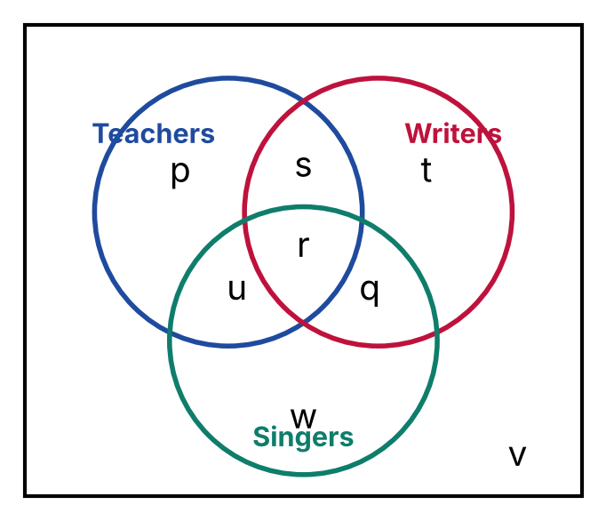
{OPTION 1} u
{OPTION 2} p, u, w
{OPTION 3} p, q, s, w
{OPTION 4} p, w
{OPTION 5}
{OPTION 6}
{OPTION 7}
{OPTION 8}
{OPTION 9}
{OPTION 10}
{RIGHT ANSWER} 4
{EXPLANATION} Teachers or singers but not both means the parts of the Teachers and Singers circles that do not overlap each other, and 'not writers' removes any part inside the Writers circle. These are the regions that lie only in Teachers (without Writers) and only in Singers (without Writers): p, w.
{CORRECT MARKS} 1
{NEGATIVE MARKS} 0
{DIFFICULTY} Hard
{QUESTION ENDS}

{QUESTION BEGINS}
{QUESTION NUMBER} 11
{SUBJECT} Reasoning Ability
{TOPIC} Clock
{TAGS} tcs nqt, reasoning ability, hard
{QUESTION TYPE} SINGLECORRECT
{QUESTION TEXT} A watch gains 3 minutes in every 2 hours. It is set right at 6:00 a.m. on Monday. What time will it show when the correct time is 6:00 p.m. on the same day?
{OPTION 1} 6:36 p.m.
{OPTION 2} 6:12 p.m.
{OPTION 3} 6:24 p.m.
{OPTION 4} 6:18 p.m.
{OPTION 5}
{OPTION 6}
{OPTION 7}
{OPTION 8}
{OPTION 9}
{OPTION 10}
{RIGHT ANSWER} 4
{EXPLANATION} In 12 hours the watch gains (3/2) × 12 = 18 minutes. So when the correct time is 6:00 p.m., the watch shows 6:18 p.m.
{CORRECT MARKS} 1
{NEGATIVE MARKS} 0
{DIFFICULTY} Hard
{QUESTION ENDS}

{QUESTION BEGINS}
{QUESTION NUMBER} 12
{SUBJECT} Reasoning Ability
{TOPIC} Cubes & Nets
{TAGS} tcs nqt, reasoning ability, figure based, hard
{QUESTION TYPE} SINGLECORRECT
{QUESTION TEXT} The figure shows a net made of six faces with symbols, followed by four boxes (1) to (4). How many of the four boxes can be formed by folding the net along the lines?
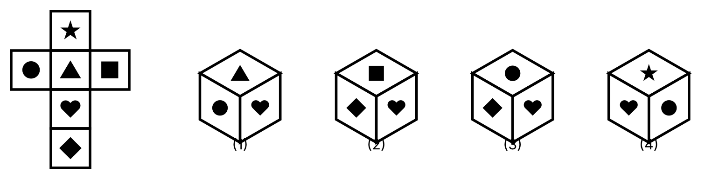
{OPTION 1} Two
{OPTION 2} All four
{OPTION 3} One
{OPTION 4} Three
{OPTION 5}
{OPTION 6}
{OPTION 7}
{OPTION 8}
{OPTION 9}
{OPTION 10}
{RIGHT ANSWER} 1
{EXPLANATION} Opposite faces of the net: ■–●, ▲–◆, ★–♥. Box (4) shows two opposite faces together, so it is impossible. Box (2) has the right faces at a corner, but the left and right faces are interchanged (mirror image), so it cannot be formed. Boxes (1) and (3) show faces meeting at a corner in the correct order. So two boxes can be formed.
{CORRECT MARKS} 1
{NEGATIVE MARKS} 0
{DIFFICULTY} Hard
{QUESTION ENDS}

{QUESTION BEGINS}
{QUESTION NUMBER} 13
{SUBJECT} Reasoning Ability
{TOPIC} Calendar
{TAGS} tcs nqt, reasoning ability, figure based, hard
{QUESTION TYPE} SINGLECORRECT
{QUESTION TEXT} The calendar of September 2026 is shown. On which day of the week will it be exactly 100 days after 17 September 2026?
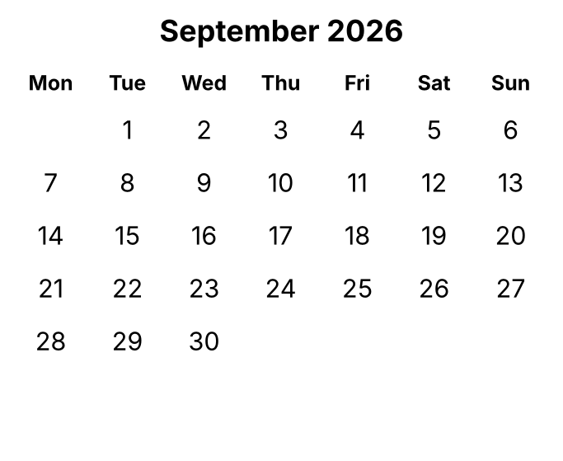
{OPTION 1} Tuesday
{OPTION 2} Wednesday
{OPTION 3} Saturday
{OPTION 4} Monday
{OPTION 5}
{OPTION 6}
{OPTION 7}
{OPTION 8}
{OPTION 9}
{OPTION 10}
{RIGHT ANSWER} 3
{EXPLANATION} In the calendar 17 September is a Thursday. 100 days = 14 weeks + 2 days, so the day is 2 days after Thursday: Saturday (the date is 26 December 2026).
{CORRECT MARKS} 1
{NEGATIVE MARKS} 0
{DIFFICULTY} Hard
{QUESTION ENDS}

{QUESTION BEGINS}
{QUESTION NUMBER} 14
{SUBJECT} Reasoning Ability
{TOPIC} Coding-Decoding
{TAGS} tcs nqt, reasoning ability, hard
{QUESTION TYPE} SINGLECORRECT
{QUESTION TEXT} In a certain code language, every letter of a word is replaced by its opposite letter in the alphabet (A ↔ Z, B ↔ Y, C ↔ X, and so on) and the letters of the resulting word are then written in the reverse order. How will DREAM be written in that code?
{OPTION 1} NZVIW
{OPTION 2} WIVZN
{OPTION 3} MZVIW
{OPTION 4} NYVIW
{OPTION 5}
{OPTION 6}
{OPTION 7}
{OPTION 8}
{OPTION 9}
{OPTION 10}
{RIGHT ANSWER} 1
{EXPLANATION} Opposite letters: D → W, R → I, E → V, A → Z, M → N, giving WIVZN. Writing this in reverse order gives NZVIW.
{CORRECT MARKS} 1
{NEGATIVE MARKS} 0
{DIFFICULTY} Hard
{QUESTION ENDS}

{QUESTION BEGINS}
{QUESTION NUMBER} 15
{SUBJECT} Reasoning Ability
{TOPIC} Odd One Out
{TAGS} tcs nqt, reasoning ability, figure based, hard
{QUESTION TYPE} SINGLECORRECT
{QUESTION TEXT} Select the odd figure out. (All figures have the same number of black squares; squares that touch along an edge belong to the same black group.)
{OPTION 1} 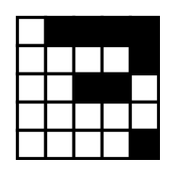
{OPTION 2} 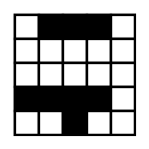
{OPTION 3} 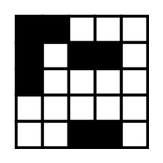
{OPTION 4} 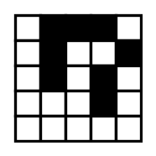
{OPTION 5}
{OPTION 6}
{OPTION 7}
{OPTION 8}
{OPTION 9}
{OPTION 10}
{RIGHT ANSWER} 2
{EXPLANATION} Count the separate black groups (squares joined along edges form one group). Three of the figures have 3 separate groups, but the fourth figure has only 2 groups, so it is the odd one out.
{CORRECT MARKS} 1
{NEGATIVE MARKS} 0
{DIFFICULTY} Hard
{QUESTION ENDS}

{QUESTION BEGINS}
{QUESTION NUMBER} 16
{SUBJECT} Reasoning Ability
{TOPIC} Chart Reasoning
{TAGS} tcs nqt, reasoning ability, figure based, hard
{QUESTION TYPE} SINGLECORRECT
{QUESTION TEXT} The bar chart shows the number of units produced (in thousands) by a factory in five years. In which year was the absolute percentage change in production, compared with the previous year, the highest?
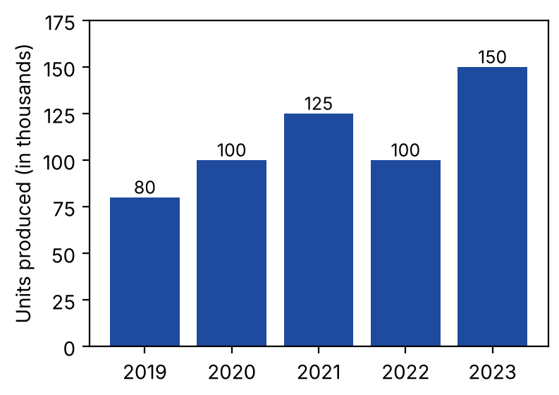
{OPTION 1} 2021 (25% rise)
{OPTION 2} 2022 (20% fall)
{OPTION 3} 2020 (25% rise)
{OPTION 4} 2023 (50% rise)
{OPTION 5}
{OPTION 6}
{OPTION 7}
{OPTION 8}
{OPTION 9}
{OPTION 10}
{RIGHT ANSWER} 4
{EXPLANATION} Year-on-year changes: 2020: (100−80)/80 = 25% rise; 2021: (125−100)/100 = 25% rise; 2022: (100−125)/125 = 20% fall; 2023: (150−100)/100 = 50% rise. The largest change is 50% in 2023.
{CORRECT MARKS} 1
{NEGATIVE MARKS} 0
{DIFFICULTY} Hard
{QUESTION ENDS}

{QUESTION BEGINS}
{QUESTION NUMBER} 17
{SUBJECT} Reasoning Ability
{TOPIC} Dice
{TAGS} tcs nqt, reasoning ability, figure based, hard
{QUESTION TYPE} SINGLECORRECT
{QUESTION TEXT} Three different positions of the same dice are shown. Which number is on the face opposite to the face carrying 1?
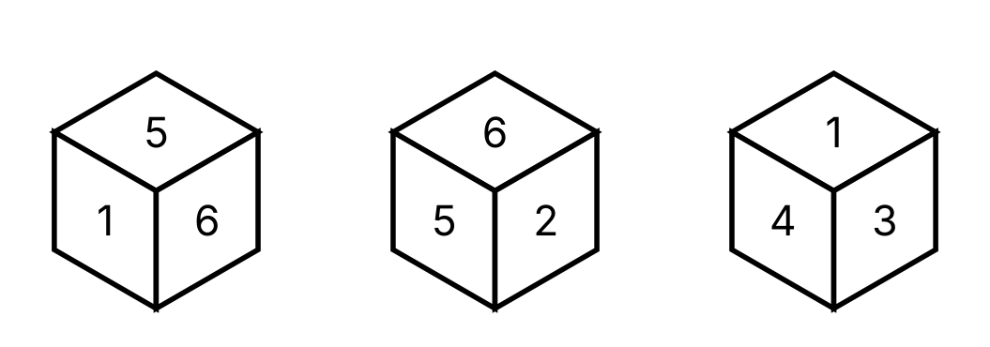
{OPTION 1} 5
{OPTION 2} 2
{OPTION 3} 3
{OPTION 4} 4
{OPTION 5}
{OPTION 6}
{OPTION 7}
{OPTION 8}
{OPTION 9}
{OPTION 10}
{RIGHT ANSWER} 2
{EXPLANATION} In every position the three visible faces meet at a corner, so no two of them can be opposite. Using the three positions, 1 cannot be opposite to any number it appears next to, and the only number left for it is 2.
{CORRECT MARKS} 1
{NEGATIVE MARKS} 0
{DIFFICULTY} Hard
{QUESTION ENDS}

{QUESTION BEGINS}
{QUESTION NUMBER} 18
{SUBJECT} Reasoning Ability
{TOPIC} Counting
{TAGS} tcs nqt, reasoning ability, hard
{QUESTION TYPE} SINGLECORRECT
{QUESTION TEXT} In the following arrangement of letters, how many consonants are immediately followed by a vowel?
R U E K O T B A S L I M
{OPTION 1} 5
{OPTION 2} 3
{OPTION 3} 4
{OPTION 4} 6
{OPTION 5}
{OPTION 6}
{OPTION 7}
{OPTION 8}
{OPTION 9}
{OPTION 10}
{RIGHT ANSWER} 3
{EXPLANATION} Check each consonant with the letter on its right: R–U (yes), K–O (yes), T–B (no), B–A (yes), S–L (no), L–I (yes), M is last (no). So there are 4 such consonants.
{CORRECT MARKS} 1
{NEGATIVE MARKS} 0
{DIFFICULTY} Hard
{QUESTION ENDS}

{QUESTION BEGINS}
{QUESTION NUMBER} 19
{SUBJECT} Reasoning Ability
{TOPIC} Number Series
{TAGS} tcs nqt, reasoning ability, hard
{QUESTION TYPE} SINGLECORRECT
{QUESTION TEXT} Find the next term of the series: 2, 5, 12, 27, 58, ?
{OPTION 1} 117
{OPTION 2} 123
{OPTION 3} 121
{OPTION 4} 119
{OPTION 5}
{OPTION 6}
{OPTION 7}
{OPTION 8}
{OPTION 9}
{OPTION 10}
{RIGHT ANSWER} 3
{EXPLANATION} The differences are 3, 7, 15, 31, which are 2² − 1, 2³ − 1, 2⁴ − 1, 2⁵ − 1. The next difference is 2⁶ − 1 = 63, so the next term is 58 + 63 = 121.
{CORRECT MARKS} 1
{NEGATIVE MARKS} 0
{DIFFICULTY} Hard
{QUESTION ENDS}

{QUESTION BEGINS}
{QUESTION NUMBER} 20
{SUBJECT} Reasoning Ability
{TOPIC} Ranking
{TAGS} tcs nqt, reasoning ability, hard
{QUESTION TYPE} SINGLECORRECT
{QUESTION TEXT} In a row of 31 students, Ravi is 12th from the left end. When he exchanges his position with Amit, Ravi becomes 9th from the right end. How many students are standing between Ravi and Amit in the original row?
{OPTION 1} 11
{OPTION 2} 12
{OPTION 3} 9
{OPTION 4} 10
{OPTION 5}
{OPTION 6}
{OPTION 7}
{OPTION 8}
{OPTION 9}
{OPTION 10}
{RIGHT ANSWER} 4
{EXPLANATION} After the exchange Ravi stands where Amit stood. Ravi is now 9th from the right, so Amit's original place was 31 − 9 + 1 = 23rd from the left. Ravi's original place was 12th from the left, so the number of students between them = 23 − 12 − 1 = 10.
{CORRECT MARKS} 1
{NEGATIVE MARKS} 0
{DIFFICULTY} Hard
{QUESTION ENDS}

