{QUESTION BEGINS}
{QUESTION NUMBER} 1
{SUBJECT} Reasoning Ability
{TOPIC} Chart Reasoning
{TAGS} tcs nqt, reasoning ability, figure based, hard
{QUESTION TYPE} SINGLECORRECT
{QUESTION TEXT} The pie chart shows how a person's monthly salary is distributed. The angles of the sectors are marked. If the person saves ₹9,600 every month, how much more does the person spend on Food than on Travel and Others together?
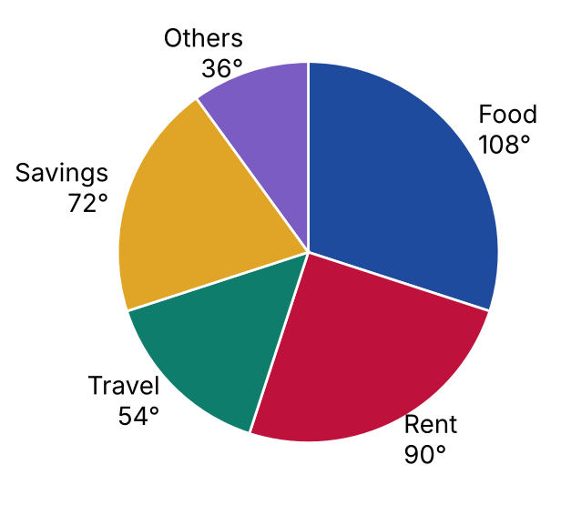
{OPTION 1} ₹4,800
{OPTION 2} ₹1,200
{OPTION 3} ₹3,600
{OPTION 4} ₹2,400
{OPTION 5}
{OPTION 6}
{OPTION 7}
{OPTION 8}
{OPTION 9}
{OPTION 10}
{RIGHT ANSWER} 4
{EXPLANATION} Savings is 72° out of 360°, so the salary = 9,600 × 360 / 72 = ₹48,000. Food = 108° → 48,000 × 108/360 = ₹14,400. Travel + Others = 54° + 36° = 90° → 48,000 × 90/360 = ₹12,000. Difference = 14,400 − 12,000 = ₹2,400.
{CORRECT MARKS} 1
{NEGATIVE MARKS} 0
{DIFFICULTY} Hard
{QUESTION ENDS}

{QUESTION BEGINS}
{QUESTION NUMBER} 2
{SUBJECT} Reasoning Ability
{TOPIC} Mathematical Operations
{TAGS} tcs nqt, reasoning ability, hard
{QUESTION TYPE} SINGLECORRECT
{QUESTION TEXT} If '+' and '×' are interchanged and '−' and '÷' are interchanged, what is the value of 5 + 3 × 12 − 4 ÷ 2 ?
{OPTION 1} 37
{OPTION 2} 41
{OPTION 3} 38
{OPTION 4} 16
{OPTION 5}
{OPTION 6}
{OPTION 7}
{OPTION 8}
{OPTION 9}
{OPTION 10}
{RIGHT ANSWER} 4
{EXPLANATION} After interchanging the signs the expression becomes 5 × 3 + 12 ÷ 4 − 2. Then 5 × 3 = 15, 12 ÷ 4 = 3, so 15 + 3 − 2 = 16.
{CORRECT MARKS} 1
{NEGATIVE MARKS} 0
{DIFFICULTY} Hard
{QUESTION ENDS}

{QUESTION BEGINS}
{QUESTION NUMBER} 3
{SUBJECT} Reasoning Ability
{TOPIC} Directions
{TAGS} tcs nqt, reasoning ability, hard
{QUESTION TYPE} SINGLECORRECT
{QUESTION TEXT} A wall clock is placed so that its 12 o'clock mark points towards the North and its 3 o'clock mark points towards the East. At 10:30, towards which directions do the hour hand and the minute hand point, respectively?
{OPTION 1} North and South
{OPTION 2} West and South
{OPTION 3} North-West and South
{OPTION 4} North-West and North
{OPTION 5}
{OPTION 6}
{OPTION 7}
{OPTION 8}
{OPTION 9}
{OPTION 10}
{RIGHT ANSWER} 3
{EXPLANATION} The 12 mark is North, the 3 mark East, the 6 mark South and the 9 mark West. At 10:30 the minute hand is on the 6 mark: South. The hour hand is halfway between 10 and 11, which is 315° from 12 in the clockwise direction: that is exactly North-West.
{CORRECT MARKS} 1
{NEGATIVE MARKS} 0
{DIFFICULTY} Hard
{QUESTION ENDS}

{QUESTION BEGINS}
{QUESTION NUMBER} 4
{SUBJECT} Reasoning Ability
{TOPIC} Puzzle
{TAGS} tcs nqt, reasoning ability, hard
{QUESTION TYPE} SINGLECORRECT
{QUESTION TEXT} Four teams A, B, C and D play a tournament in which every team plays every other team once and there are no draws. The number of matches won: A won 2, B won 2, C won 1 and D won 1. Also, B beat A and A beat C and A beat D and C beat B.
Who won the match between B and D?
{OPTION 1} D
{OPTION 2} Cannot be determined
{OPTION 3} B
{OPTION 4} The match was a draw
{OPTION 5}
{OPTION 6}
{OPTION 7}
{OPTION 8}
{OPTION 9}
{OPTION 10}
{RIGHT ANSWER} 3
{EXPLANATION} With the known results and each team's total number of wins, every other match is forced. A check of all 64 possible sets of results shows that exactly one set fits the information, in which B beat D.
{CORRECT MARKS} 1
{NEGATIVE MARKS} 0
{DIFFICULTY} Hard
{QUESTION ENDS}

{QUESTION BEGINS}
{QUESTION NUMBER} 5
{SUBJECT} Reasoning Ability
{TOPIC} Number Series
{TAGS} tcs nqt, reasoning ability, hard
{QUESTION TYPE} SINGLECORRECT
{QUESTION TEXT} Find the next term of the series: 4, 9, 25, 49, 121, ?
{OPTION 1} 144
{OPTION 2} 225
{OPTION 3} 169
{OPTION 4} 196
{OPTION 5}
{OPTION 6}
{OPTION 7}
{OPTION 8}
{OPTION 9}
{OPTION 10}
{RIGHT ANSWER} 3
{EXPLANATION} The terms are the squares of consecutive prime numbers: 2², 3², 5², 7², 11². The next prime is 13, so the next term is 13² = 169.
{CORRECT MARKS} 1
{NEGATIVE MARKS} 0
{DIFFICULTY} Hard
{QUESTION ENDS}

{QUESTION BEGINS}
{QUESTION NUMBER} 6
{SUBJECT} Reasoning Ability
{TOPIC} Alphanumeric Series
{TAGS} tcs nqt, reasoning ability, hard
{QUESTION TYPE} SINGLECORRECT
{QUESTION TEXT} Find the next term of the series: A1C, D4F, G9I, ?
{OPTION 1} J16M
{OPTION 2} J16L
{OPTION 3} K16L
{OPTION 4} J12L
{OPTION 5}
{OPTION 6}
{OPTION 7}
{OPTION 8}
{OPTION 9}
{OPTION 10}
{RIGHT ANSWER} 2
{EXPLANATION} The first letter moves 3 places forward each time (A, D, G, J), the number is the square of the term number (1, 4, 9, 16) and the last letter also moves 3 places (C, F, I, L). The next term is J16L.
{CORRECT MARKS} 1
{NEGATIVE MARKS} 0
{DIFFICULTY} Hard
{QUESTION ENDS}

{QUESTION BEGINS}
{QUESTION NUMBER} 7
{SUBJECT} Reasoning Ability
{TOPIC} Venn Diagram
{TAGS} tcs nqt, reasoning ability, figure based, hard
{QUESTION TYPE} SINGLECORRECT
{QUESTION TEXT} In the Venn diagram the rectangle represents a group of 110 people, and the expressions show the number of people in each region. How many people belong to exactly one of the two sets A and B?
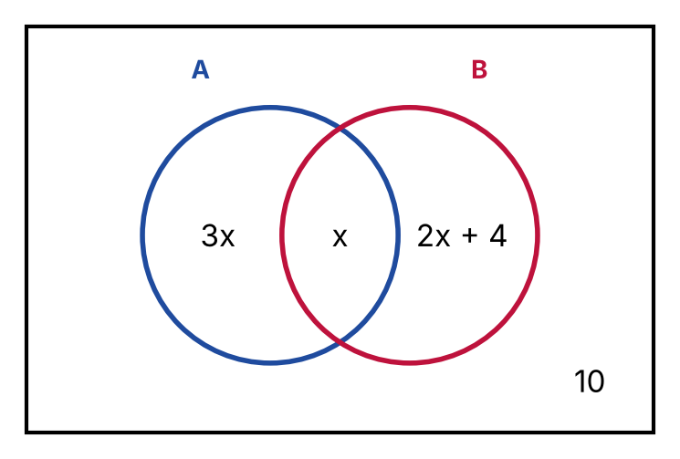
{OPTION 1} 92
{OPTION 2} 84
{OPTION 3} 88
{OPTION 4} 80
{OPTION 5}
{OPTION 6}
{OPTION 7}
{OPTION 8}
{OPTION 9}
{OPTION 10}
{RIGHT ANSWER} 2
{EXPLANATION} All regions add up to the total: 3x + x + (2x + 4) + 10 = 110, so 6x + 14 = 110 and x = 16. Exactly one set = only A + only B = 3x + (2x + 4) = 48 + 36 = 84.
{CORRECT MARKS} 1
{NEGATIVE MARKS} 0
{DIFFICULTY} Hard
{QUESTION ENDS}

{QUESTION BEGINS}
{QUESTION NUMBER} 8
{SUBJECT} Reasoning Ability
{TOPIC} Chess Reasoning
{TAGS} tcs nqt, reasoning ability, hard
{QUESTION TYPE} SINGLECORRECT
{QUESTION TEXT} A knight on a chessboard moves two squares in one direction (horizontally or vertically) and then one square at right angles to it. What is the minimum number of moves needed for a knight to go from the square a1 (a corner) to the opposite corner h8 on an empty 8 × 8 board?
{OPTION 1} 7
{OPTION 2} 5
{OPTION 3} 4
{OPTION 4} 6
{OPTION 5}
{OPTION 6}
{OPTION 7}
{OPTION 8}
{OPTION 9}
{OPTION 10}
{RIGHT ANSWER} 4
{EXPLANATION} A search over all squares reachable in 1, 2, 3, … moves shows that h8 is first reached after 6 moves, for example a1 → b3 → c5 → d7 → f8 → g6 → h8. No sequence with fewer moves reaches h8.
{CORRECT MARKS} 1
{NEGATIVE MARKS} 0
{DIFFICULTY} Hard
{QUESTION ENDS}

{QUESTION BEGINS}
{QUESTION NUMBER} 9
{SUBJECT} Reasoning Ability
{TOPIC} Route Reasoning
{TAGS} tcs nqt, reasoning ability, figure based, hard
{QUESTION TYPE} SINGLECORRECT
{QUESTION TEXT} The figure shows towns A to F and the roads between them with distances in km. What is the length of the shortest route from A to F?
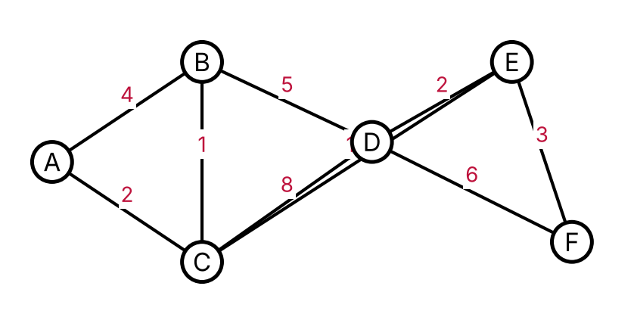
{OPTION 1} 17
{OPTION 2} 13
{OPTION 3} 15
{OPTION 4} 14
{OPTION 5}
{OPTION 6}
{OPTION 7}
{OPTION 8}
{OPTION 9}
{OPTION 10}
{RIGHT ANSWER} 2
{EXPLANATION} Examine the routes: A–C–B–D–E–F = 2 + 1 + 5 + 2 + 3 = 13; A–C–B–D–F = 2 + 1 + 5 + 6 = 14; A–B–D–E–F = 4 + 5 + 2 + 3 = 14. The shortest route is A–C–B–D–E–F with length 13 km.
{CORRECT MARKS} 1
{NEGATIVE MARKS} 0
{DIFFICULTY} Hard
{QUESTION ENDS}

{QUESTION BEGINS}
{QUESTION NUMBER} 10
{SUBJECT} Reasoning Ability
{TOPIC} Counting Figures
{TAGS} tcs nqt, reasoning ability, figure based, hard
{QUESTION TYPE} SINGLECORRECT
{QUESTION TEXT} A square has both its diagonals and both lines joining the midpoints of opposite sides drawn, as shown. How many triangles of all sizes are there in the figure?
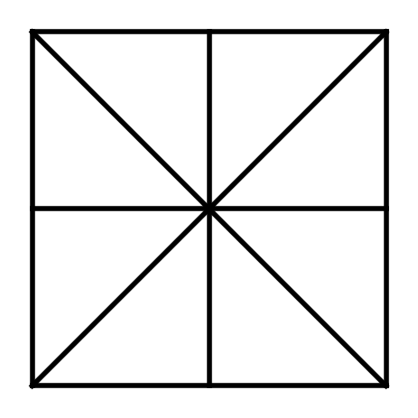
{OPTION 1} 12
{OPTION 2} 16
{OPTION 3} 20
{OPTION 4} 8
{OPTION 5}
{OPTION 6}
{OPTION 7}
{OPTION 8}
{OPTION 9}
{OPTION 10}
{RIGHT ANSWER} 2
{EXPLANATION} Taking the side of the square as 4, the triangles in the figure are of three sizes: 8 smallest triangles (area 2), 4 triangles of area 4 (each is made of two smallest triangles) and 4 big triangles of area 8 (half of the whole square, cut off by a diagonal). Total = 8 + 4 + 4 = 16. This was also confirmed by checking every set of three of the eight lines.
{CORRECT MARKS} 1
{NEGATIVE MARKS} 0
{DIFFICULTY} Hard
{QUESTION ENDS}

{QUESTION BEGINS}
{QUESTION NUMBER} 11
{SUBJECT} Reasoning Ability
{TOPIC} Table Reasoning
{TAGS} tcs nqt, reasoning ability, figure based, hard
{QUESTION TYPE} SINGLECORRECT
{QUESTION TEXT} The table shows the matches played, matches won and net run rate of five teams after five matches each. A win gives 2 points and a loss gives 0. Teams are ranked by points, and teams with equal points are ranked by net run rate (higher is better). Which team is ranked third?
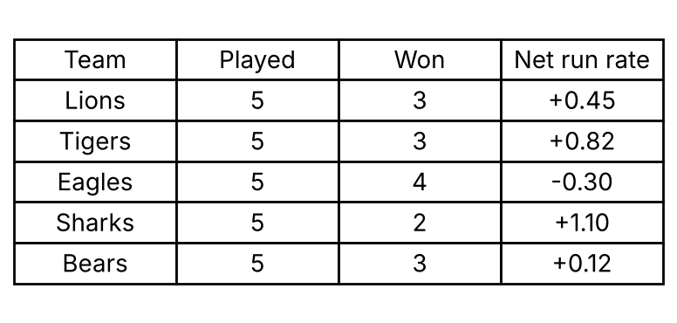
{OPTION 1} Bears
{OPTION 2} Sharks
{OPTION 3} Lions
{OPTION 4} Tigers
{OPTION 5}
{OPTION 6}
{OPTION 7}
{OPTION 8}
{OPTION 9}
{OPTION 10}
{RIGHT ANSWER} 3
{EXPLANATION} Points = 2 × wins: Lions 6, Tigers 6, Eagles 8, Sharks 4, Bears 6. Eagles (8) are first. Lions, Tigers and Bears have 6 points each; by net run rate Tigers (+0.82) are second, Lions (+0.45) third and Bears (+0.12) fourth. Sharks (4) are last. So the team ranked third is Lions.
{CORRECT MARKS} 1
{NEGATIVE MARKS} 0
{DIFFICULTY} Hard
{QUESTION ENDS}

{QUESTION BEGINS}
{QUESTION NUMBER} 12
{SUBJECT} Reasoning Ability
{TOPIC} Figure Series
{TAGS} tcs nqt, reasoning ability, figure based, hard
{QUESTION TYPE} SINGLECORRECT
{QUESTION TEXT} Select the figure that replaces the question mark (?) in the series.
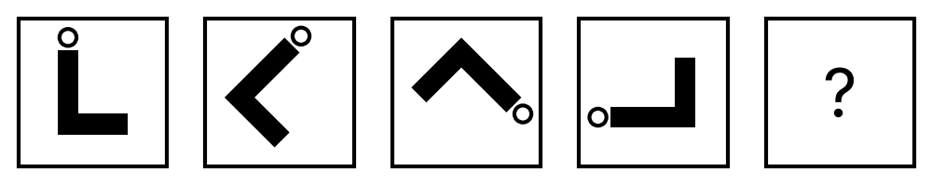
{OPTION 1} 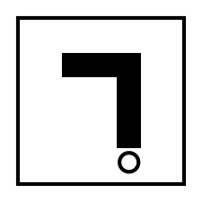
{OPTION 2} 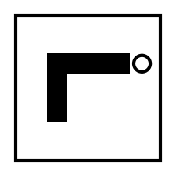
{OPTION 3} 
{OPTION 4} 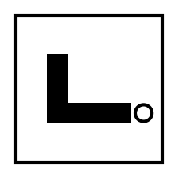
{OPTION 5}
{OPTION 6}
{OPTION 7}
{OPTION 8}
{OPTION 9}
{OPTION 10}
{RIGHT ANSWER} 2
{EXPLANATION} The figure turns clockwise by 45°, 90°, 135° in the successive steps (total turns 45°, 135°, 270°). The next turn is 180°, so the figure has turned 270° + 180° = 450° = 90° from its starting position. Option 2 has the same turn but is a mirror image, so it is wrong.
{CORRECT MARKS} 1
{NEGATIVE MARKS} 0
{DIFFICULTY} Hard
{QUESTION ENDS}

{QUESTION BEGINS}
{QUESTION NUMBER} 13
{SUBJECT} Reasoning Ability
{TOPIC} Data Sufficiency
{TAGS} tcs nqt, reasoning ability, hard
{QUESTION TYPE} SINGLECORRECT
{QUESTION TEXT} Five friends P, Q, R, S and T stand in a line facing north. Who stands at the extreme left?
Statement I: Q stands two places to the right of P, and S stands to the left of R.
Statement II: T is an immediate neighbour of R and stands to the right of P.
Which of the following is correct?
{OPTION 1} Statement I alone is sufficient
{OPTION 2} Neither statement alone is sufficient, but both together are sufficient
{OPTION 3} Even both together are not sufficient
{OPTION 4} Statement II alone is sufficient
{OPTION 5}
{OPTION 6}
{OPTION 7}
{OPTION 8}
{OPTION 9}
{OPTION 10}
{RIGHT ANSWER} 2
{EXPLANATION} With statement I alone, several arrangements are possible with different people at the left end; the same is true for statement II alone. Using both statements together, only one person can stand at the extreme left: P.
{CORRECT MARKS} 1
{NEGATIVE MARKS} 0
{DIFFICULTY} Hard
{QUESTION ENDS}

{QUESTION BEGINS}
{QUESTION NUMBER} 14
{SUBJECT} Reasoning Ability
{TOPIC} Alphabet Test
{TAGS} tcs nqt, reasoning ability, hard
{QUESTION TYPE} SINGLECORRECT
{QUESTION TEXT} In the word PROBLEMS, how many pairs of letters are there such that the number of letters between them in the word is equal to the number of letters between them in the English alphabet?
{OPTION 1} 3
{OPTION 2} 2
{OPTION 3} 1
{OPTION 4} 4
{OPTION 5}
{OPTION 6}
{OPTION 7}
{OPTION 8}
{OPTION 9}
{OPTION 10}
{RIGHT ANSWER} 2
{EXPLANATION} Check every pair of letters (positions in the word and in the alphabet): the pairs that match are PL, RM. So there are 2 such pairs.
{CORRECT MARKS} 1
{NEGATIVE MARKS} 0
{DIFFICULTY} Hard
{QUESTION ENDS}

{QUESTION BEGINS}
{QUESTION NUMBER} 15
{SUBJECT} Reasoning Ability
{TOPIC} Syllogism
{TAGS} tcs nqt, reasoning ability, hard
{QUESTION TYPE} SINGLECORRECT
{QUESTION TEXT} Statements: All files are folders. Some folders are drives. No drive is a disk.
Conclusions:
I. Some files are drives.
II. It is possible that some files are drives.
III. Some disks are not folders.
IV. No file is a disk.
Which of the conclusions is/are correct?
{OPTION 1} Only I and II follow
{OPTION 2} Only II follows
{OPTION 3} Only II and IV follow
{OPTION 4} Only III follows
{OPTION 5}
{OPTION 6}
{OPTION 7}
{OPTION 8}
{OPTION 9}
{OPTION 10}
{RIGHT ANSWER} 2
{EXPLANATION} The statements do not force any file to be a drive (the drives that are folders may be different from the files), so I does not follow definitely; but such a case can exist, so II (a possibility) is true. Disks may all be folders, so III is not definite, and files may be disks (a file is a folder and a folder may be a disk), so IV is not definite. Only II follows.
{CORRECT MARKS} 1
{NEGATIVE MARKS} 0
{DIFFICULTY} Hard
{QUESTION ENDS}

{QUESTION BEGINS}
{QUESTION NUMBER} 16
{SUBJECT} Reasoning Ability
{TOPIC} Counting
{TAGS} tcs nqt, reasoning ability, hard
{QUESTION TYPE} SINGLECORRECT
{QUESTION TEXT} How many three-digit numbers have a digit sum of 9 and are divisible by 5?
{OPTION 1} 12
{OPTION 2} 9
{OPTION 3} 13
{OPTION 4} 10
{OPTION 5}
{OPTION 6}
{OPTION 7}
{OPTION 8}
{OPTION 9}
{OPTION 10}
{RIGHT ANSWER} 3
{EXPLANATION} The last digit is 0 or 5. If it is 0, the first two digits add up to 9: the first digit can be 1 to 9, so there are 9 numbers (180, 270, 360, 450, 540, 630, 720, 810, 900). If it is 5, the first two digits add up to 4 with the first digit at least 1: 1+3, 2+2, 3+1, 4+0, giving 4 numbers (135, 225, 315, 405). Total = 9 + 4 = 13.
{CORRECT MARKS} 1
{NEGATIVE MARKS} 0
{DIFFICULTY} Hard
{QUESTION ENDS}

{QUESTION BEGINS}
{QUESTION NUMBER} 17
{SUBJECT} Reasoning Ability
{TOPIC} Blood Relations
{TAGS} tcs nqt, reasoning ability, hard
{QUESTION TYPE} SINGLECORRECT
{QUESTION TEXT} Pointing to a girl in a photograph, Meera said, "She is the daughter of the wife of the only son of my mother's father." How is the girl related to Meera?
{OPTION 1} Cousin
{OPTION 2} Aunt
{OPTION 3} Sister
{OPTION 4} Niece
{OPTION 5}
{OPTION 6}
{OPTION 7}
{OPTION 8}
{OPTION 9}
{OPTION 10}
{RIGHT ANSWER} 1
{EXPLANATION} My mother's father's only son is Meera's maternal uncle. His wife is Meera's maternal aunt (uncle's wife), and her daughter is the daughter of Meera's maternal uncle, who is Meera's cousin.
{CORRECT MARKS} 1
{NEGATIVE MARKS} 0
{DIFFICULTY} Hard
{QUESTION ENDS}

{QUESTION BEGINS}
{QUESTION NUMBER} 18
{SUBJECT} Reasoning Ability
{TOPIC} Odd One Out
{TAGS} tcs nqt, reasoning ability, figure based, hard
{QUESTION TYPE} SINGLECORRECT
{QUESTION TEXT} Select the odd figure out from the four letters shown.
{OPTION 1} 
{OPTION 2} 
{OPTION 3} 
{OPTION 4} 
{OPTION 5}
{OPTION 6}
{OPTION 7}
{OPTION 8}
{OPTION 9}
{OPTION 10}
{RIGHT ANSWER} 2
{EXPLANATION} Three of the figures are the letter R turned through different angles (90°, 180° and 270°). The fourth is a mirror image of the letter (it is reversed), and no turn can make a mirror image look like the original, so it is the odd one out.
{CORRECT MARKS} 1
{NEGATIVE MARKS} 0
{DIFFICULTY} Hard
{QUESTION ENDS}

{QUESTION BEGINS}
{QUESTION NUMBER} 19
{SUBJECT} Reasoning Ability
{TOPIC} Directions
{TAGS} tcs nqt, reasoning ability, figure based, hard
{QUESTION TYPE} SINGLECORRECT
{QUESTION TEXT} A robot stands on the shaded square of the grid, facing North (towards the top of the page; the arrow shows its direction). It obeys the commands: 'F n' = move forward n squares, 'R' = turn 90° to the right on the spot, 'L' = turn 90° to the left on the spot. The commands are: F3, R, F2, R, F1, L, F2, L, F1. On which square does the robot finish?
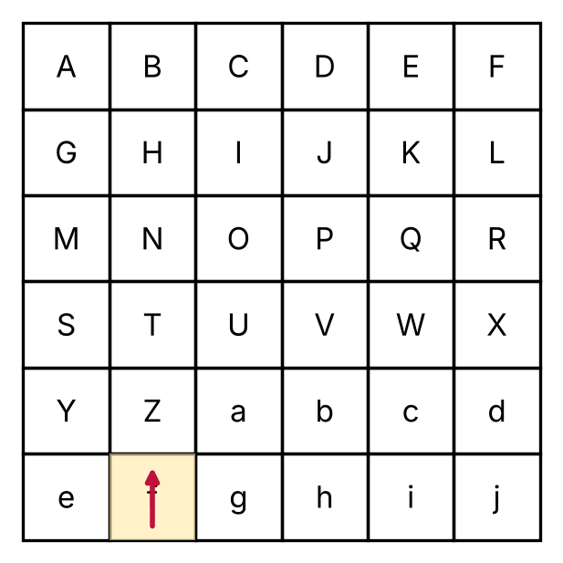
{OPTION 1} R
{OPTION 2} X
{OPTION 3} P
{OPTION 4} W
{OPTION 5}
{OPTION 6}
{OPTION 7}
{OPTION 8}
{OPTION 9}
{OPTION 10}
{RIGHT ANSWER} 1
{EXPLANATION} Start at column 2, row 1 (square f) facing North. F3 → 3 squares up; R → face East; F2 → 2 squares right; R → face South; F1 → 1 square down; L → face East; F2 → 2 squares right; L → face North; F1 → 1 square up. The final square is R (the robot faces North).
{CORRECT MARKS} 1
{NEGATIVE MARKS} 0
{DIFFICULTY} Hard
{QUESTION ENDS}

{QUESTION BEGINS}
{QUESTION NUMBER} 20
{SUBJECT} Reasoning Ability
{TOPIC} Cubes & Nets
{TAGS} tcs nqt, reasoning ability, figure based, hard
{QUESTION TYPE} SINGLECORRECT
{QUESTION TEXT} The figure shows a net of a cube whose faces carry the numbers 1 to 6. When the net is folded into a cube, what is the sum of the numbers on the four faces that are adjacent to (share an edge with) the face marked 4?
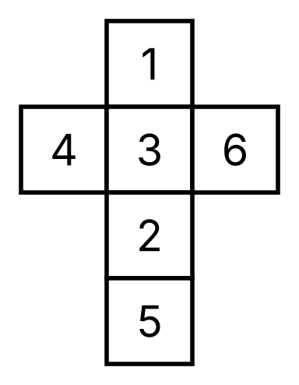
{OPTION 1} 17
{OPTION 2} 15
{OPTION 3} 13
{OPTION 4} 11
{OPTION 5}
{OPTION 6}
{OPTION 7}
{OPTION 8}
{OPTION 9}
{OPTION 10}
{RIGHT ANSWER} 4
{EXPLANATION} Opposite pairs after folding: 1–2, 3–5, 4–6. The faces adjacent to 4 are all faces except 4 itself and the face opposite it (which is 6). Sum of all six numbers = 21, so the required sum = 21 − 4 − 6 = 11.
{CORRECT MARKS} 1
{NEGATIVE MARKS} 0
{DIFFICULTY} Hard
{QUESTION ENDS}

