{QUESTION BEGINS}
{QUESTION NUMBER} 1
{SUBJECT} Reasoning Ability
{TOPIC} Syllogism
{TAGS} tcs nqt, reasoning ability, hard
{QUESTION TYPE} SINGLECORRECT
{QUESTION TEXT} Statements: Some doctors are teachers. All teachers are singers. No singer is a poet.
Conclusions:
I. Some singers are doctors.
II. No teacher is a poet.
III. Some doctors are not poets.
IV. Some poets are teachers.
{OPTION 1} Only I and II follow
{OPTION 2} Only I, II and III follow
{OPTION 3} All I, II, III and IV follow
{OPTION 4} Only II, III and IV follow
{OPTION 5}
{OPTION 6}
{OPTION 7}
{OPTION 8}
{OPTION 9}
{OPTION 10}
{RIGHT ANSWER} 2
{EXPLANATION} The doctors who are teachers are also singers (I follows), so they are not poets: no teacher is a poet (II) and these doctors are not poets (III). IV contradicts II, so it does not follow. Only I, II and III follow.
{CORRECT MARKS} 1
{NEGATIVE MARKS} 0
{DIFFICULTY} Hard
{QUESTION ENDS}

{QUESTION BEGINS}
{QUESTION NUMBER} 2
{SUBJECT} Reasoning Ability
{TOPIC} Odd One Out
{TAGS} tcs nqt, reasoning ability, figure based, hard
{QUESTION TYPE} SINGLECORRECT
{QUESTION TEXT} Select the odd figure out from the given options.
{OPTION 1} 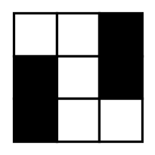
{OPTION 2} 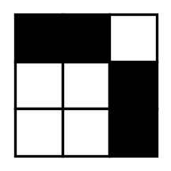
{OPTION 3} 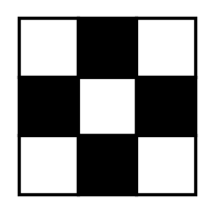
{OPTION 4} 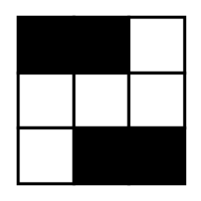
{OPTION 5}
{OPTION 6}
{OPTION 7}
{OPTION 8}
{OPTION 9}
{OPTION 10}
{RIGHT ANSWER} 2
{EXPLANATION} Each of the other three figures looks exactly the same after being turned upside down (rotated by 180°). The fourth figure does not, so it is the odd one out.
{CORRECT MARKS} 1
{NEGATIVE MARKS} 0
{DIFFICULTY} Hard
{QUESTION ENDS}

{QUESTION BEGINS}
{QUESTION NUMBER} 3
{SUBJECT} Reasoning Ability
{TOPIC} Inequalities
{TAGS} tcs nqt, reasoning ability, hard
{QUESTION TYPE} SINGLECORRECT
{QUESTION TEXT} In the following question the symbols @, $, #, % and & have these meanings: 'A @ B' means A is greater than or equal to B; 'A $ B' means A is less than B; 'A # B' means A is greater than B; 'A % B' means A is less than or equal to B; 'A & B' means A is equal to B.
Statement: P @ Q & R $ S % T
Conclusions:
I. S # Q
II. T # R
III. P # S
IV. P @ R
Which conclusions are definitely true?
{OPTION 1} Only I and II
{OPTION 2} I, II, III and IV
{OPTION 3} Only II, III and IV
{OPTION 4} Only I, II and IV
{OPTION 5}
{OPTION 6}
{OPTION 7}
{OPTION 8}
{OPTION 9}
{OPTION 10}
{RIGHT ANSWER} 4
{EXPLANATION} The statement reads P ≥ Q = R < S ≤ T. Since Q = R < S, S > Q (I true). R < S ≤ T gives T > R (II true). P and S are not directly comparable (P ≥ R and S > R), so III is not definite. P ≥ Q = R gives P ≥ R (IV true). So I, II and IV are true.
{CORRECT MARKS} 1
{NEGATIVE MARKS} 0
{DIFFICULTY} Hard
{QUESTION ENDS}

{QUESTION BEGINS}
{QUESTION NUMBER} 4
{SUBJECT} Reasoning Ability
{TOPIC} Blood Relations
{TAGS} tcs nqt, reasoning ability, hard
{QUESTION TYPE} SINGLECORRECT
{QUESTION TEXT} Pointing to a man in a photograph, Rekha said, "His mother is the only daughter of my father's father." How is the man related to Rekha?
{OPTION 1} Maternal uncle
{OPTION 2} Cousin
{OPTION 3} Brother
{OPTION 4} Nephew
{OPTION 5}
{OPTION 6}
{OPTION 7}
{OPTION 8}
{OPTION 9}
{OPTION 10}
{RIGHT ANSWER} 2
{EXPLANATION} My father's father is Rekha's paternal grandfather. His only daughter is Rekha's father's sister, that is Rekha's paternal aunt. The man is the son of this aunt, so he is Rekha's cousin.
{CORRECT MARKS} 1
{NEGATIVE MARKS} 0
{DIFFICULTY} Hard
{QUESTION ENDS}

{QUESTION BEGINS}
{QUESTION NUMBER} 5
{SUBJECT} Reasoning Ability
{TOPIC} Calendar
{TAGS} tcs nqt, reasoning ability, hard
{QUESTION TYPE} SINGLECORRECT
{QUESTION TEXT} 1 January 2024 was a Monday. On which day of the week will 1 January 2031 fall?
{OPTION 1} Wednesday
{OPTION 2} Thursday
{OPTION 3} Sunday
{OPTION 4} Friday
{OPTION 5}
{OPTION 6}
{OPTION 7}
{OPTION 8}
{OPTION 9}
{OPTION 10}
{RIGHT ANSWER} 1
{EXPLANATION} From 1 Jan 2024 to 1 Jan 2031 there are 7 years including the leap years 2024 and 2028, so the number of days is 7 × 365 + 2 = 2557. 2557 = 365 weeks + 2 days, so the day moves ahead by 2: Monday + 2 = Wednesday.
{CORRECT MARKS} 1
{NEGATIVE MARKS} 0
{DIFFICULTY} Hard
{QUESTION ENDS}

{QUESTION BEGINS}
{QUESTION NUMBER} 6
{SUBJECT} Reasoning Ability
{TOPIC} Venn Diagram
{TAGS} tcs nqt, reasoning ability, figure based, hard
{QUESTION TYPE} SINGLECORRECT
{QUESTION TEXT} Which diagram best represents the relationship among Humans (circle 1, the big circle), Students (circle 2) and Teachers (circle 3)?
{OPTION 1} 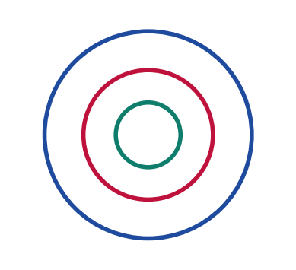
{OPTION 2} 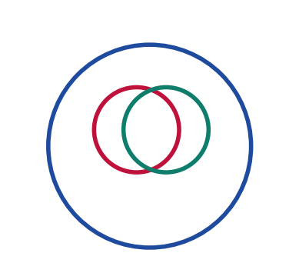
{OPTION 3} 
{OPTION 4} 
{OPTION 5}
{OPTION 6}
{OPTION 7}
{OPTION 8}
{OPTION 9}
{OPTION 10}
{RIGHT ANSWER} 2
{EXPLANATION} All students and all teachers are humans, so both circles lie inside the circle of humans. A person can be both a student and a teacher (a teacher who is studying), so the circles of students and teachers overlap each other.
{CORRECT MARKS} 1
{NEGATIVE MARKS} 0
{DIFFICULTY} Hard
{QUESTION ENDS}

{QUESTION BEGINS}
{QUESTION NUMBER} 7
{SUBJECT} Reasoning Ability
{TOPIC} Puzzle
{TAGS} tcs nqt, reasoning ability, hard
{QUESTION TYPE} SINGLECORRECT
{QUESTION TEXT} Five people A, B, C, D and E live on five different floors of a building, numbered 1 (lowest) to 5 (top). A does not live on a floor next to B's floor. C lives two floors above E. D lives below A but above E. B lives neither on the top floor nor on the bottom floor. Who lives on the 4th floor?
{OPTION 1} B
{OPTION 2} D
{OPTION 3} A
{OPTION 4} C
{OPTION 5}
{OPTION 6}
{OPTION 7}
{OPTION 8}
{OPTION 9}
{OPTION 10}
{RIGHT ANSWER} 2
{EXPLANATION} C is two above E, D is above E and A is above D. E cannot be 2 (then D = 3 and A = 5, leaving B = 1, which is not allowed). E cannot be 3 (then C = 5 and A cannot be above D). So E = 1 and C = 3. D = 2 would need A = 4 or 5, and B (not on floor 1 or 5) would then be floor 4 next to A in both cases or on floor 5: not allowed. So D = 4 and A = 5, which leaves B = 2, not next to A. So the floors are E 1, B 2, C 3, D 4, A 5, and D lives on the 4th floor.
{CORRECT MARKS} 1
{NEGATIVE MARKS} 0
{DIFFICULTY} Hard
{QUESTION ENDS}

{QUESTION BEGINS}
{QUESTION NUMBER} 8
{SUBJECT} Reasoning Ability
{TOPIC} Directions
{TAGS} tcs nqt, reasoning ability, hard
{QUESTION TYPE} SINGLECORRECT
{QUESTION TEXT} Ravi is facing East. He turns 135° clockwise, then 180° anticlockwise and then 90° clockwise. In which direction is he facing now?
{OPTION 1} South
{OPTION 2} South-West
{OPTION 3} North-East
{OPTION 4} South-East
{OPTION 5}
{OPTION 6}
{OPTION 7}
{OPTION 8}
{OPTION 9}
{OPTION 10}
{RIGHT ANSWER} 4
{EXPLANATION} East is 90°. After 135° clockwise: 225° (South-West). After 180° anticlockwise: 45° (North-East). After 90° clockwise: 135°, which is South-East.
{CORRECT MARKS} 1
{NEGATIVE MARKS} 0
{DIFFICULTY} Hard
{QUESTION ENDS}

{QUESTION BEGINS}
{QUESTION NUMBER} 9
{SUBJECT} Reasoning Ability
{TOPIC} Counting Figures
{TAGS} tcs nqt, reasoning ability, figure based, hard
{QUESTION TYPE} SINGLECORRECT
{QUESTION TEXT} How many rectangles of all sizes (squares included) are there in the given figure, which is a grid of 4 columns and 3 rows?
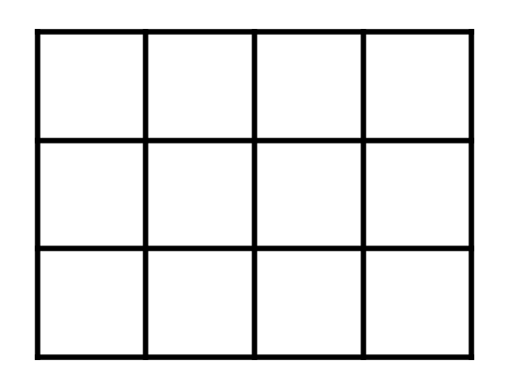
{OPTION 1} 30
{OPTION 2} 60
{OPTION 3} 48
{OPTION 4} 72
{OPTION 5}
{OPTION 6}
{OPTION 7}
{OPTION 8}
{OPTION 9}
{OPTION 10}
{RIGHT ANSWER} 2
{EXPLANATION} A rectangle is fixed by choosing 2 of the 5 vertical lines and 2 of the 4 horizontal lines: C(5, 2) × C(4, 2) = 10 × 6 = 60.
{CORRECT MARKS} 1
{NEGATIVE MARKS} 0
{DIFFICULTY} Hard
{QUESTION ENDS}

{QUESTION BEGINS}
{QUESTION NUMBER} 10
{SUBJECT} Reasoning Ability
{TOPIC} Data Sufficiency
{TAGS} tcs nqt, reasoning ability, hard
{QUESTION TYPE} SINGLECORRECT
{QUESTION TEXT} Question: Is Priya older than Sneha?
Statement I: Tara is older than Sneha.
Statement II: Priya is older than Tara.
Which of the following is correct?
{OPTION 1} Even both statements together are not sufficient
{OPTION 2} Both statements together are needed
{OPTION 3} Statement I alone is sufficient
{OPTION 4} Statement II alone is sufficient
{OPTION 5}
{OPTION 6}
{OPTION 7}
{OPTION 8}
{OPTION 9}
{OPTION 10}
{RIGHT ANSWER} 2
{EXPLANATION} From I alone Priya's position is unknown. From II alone (Priya > Tara) we still do not know where Sneha stands. Together: Priya > Tara > Sneha, so Priya is older than Sneha. Both are needed.
{CORRECT MARKS} 1
{NEGATIVE MARKS} 0
{DIFFICULTY} Hard
{QUESTION ENDS}

{QUESTION BEGINS}
{QUESTION NUMBER} 11
{SUBJECT} Reasoning Ability
{TOPIC} Clock
{TAGS} tcs nqt, reasoning ability, hard
{QUESTION TYPE} SINGLECORRECT
{QUESTION TEXT} The image of a clock in a mirror shows the time as 4:25. What is the actual time?
{OPTION 1} 7:25
{OPTION 2} 6:35
{OPTION 3} 7:35
{OPTION 4} 8:35
{OPTION 5}
{OPTION 6}
{OPTION 7}
{OPTION 8}
{OPTION 9}
{OPTION 10}
{RIGHT ANSWER} 3
{EXPLANATION} Actual time = 11:60 − mirror time = 11:60 − 4:25 = 7:35.
{CORRECT MARKS} 1
{NEGATIVE MARKS} 0
{DIFFICULTY} Hard
{QUESTION ENDS}

{QUESTION BEGINS}
{QUESTION NUMBER} 12
{SUBJECT} Reasoning Ability
{TOPIC} Coding-Decoding
{TAGS} tcs nqt, reasoning ability, hard
{QUESTION TYPE} SINGLECORRECT
{QUESTION TEXT} In a certain code language, DRIVE is written as FOLRH. How will TASK be written in that code?
{OPTION 1} VXTG
{OPTION 2} UXVG
{OPTION 3} VYVG
{OPTION 4} VXVG
{OPTION 5}
{OPTION 6}
{OPTION 7}
{OPTION 8}
{OPTION 9}
{OPTION 10}
{RIGHT ANSWER} 4
{EXPLANATION} Letters are shifted by +2, −3, +3, −4, +3 in turn: D→F, R→O, I→L, V→R, E→H. Applying the same shifts to TASK: T +2 = V, A −3 = X (wrapping round the alphabet), S +3 = V, K −4 = G. So TASK is VXVG.
{CORRECT MARKS} 1
{NEGATIVE MARKS} 0
{DIFFICULTY} Hard
{QUESTION ENDS}

{QUESTION BEGINS}
{QUESTION NUMBER} 13
{SUBJECT} Reasoning Ability
{TOPIC} Mathematical Operations
{TAGS} tcs nqt, reasoning ability, hard
{QUESTION TYPE} SINGLECORRECT
{QUESTION TEXT} If '+' means '×', '−' means '÷', '×' means '−' and '÷' means '+', then what is the value of 36 − 9 + 5 × 12 ÷ 4?
{OPTION 1} 20
{OPTION 2} 12
{OPTION 3} 8
{OPTION 4} 16
{OPTION 5}
{OPTION 6}
{OPTION 7}
{OPTION 8}
{OPTION 9}
{OPTION 10}
{RIGHT ANSWER} 2
{EXPLANATION} Replace the symbols: 36 ÷ 9 × 5 − 12 + 4. By BODMAS: 36 ÷ 9 = 4, 4 × 5 = 20, then 20 − 12 + 4 = 12.
{CORRECT MARKS} 1
{NEGATIVE MARKS} 0
{DIFFICULTY} Hard
{QUESTION ENDS}

{QUESTION BEGINS}
{QUESTION NUMBER} 14
{SUBJECT} Reasoning Ability
{TOPIC} Cubes
{TAGS} tcs nqt, reasoning ability, hard
{QUESTION TYPE} SINGLECORRECT
{QUESTION TEXT} A solid cube of side 6 cm has its two opposite faces painted blue and the other four faces painted green. It is then cut into 216 small cubes of side 1 cm. How many small cubes have exactly one blue face and exactly one green face?
{OPTION 1} 24
{OPTION 2} 48
{OPTION 3} 40
{OPTION 4} 32
{OPTION 5}
{OPTION 6}
{OPTION 7}
{OPTION 8}
{OPTION 9}
{OPTION 10}
{RIGHT ANSWER} 4
{EXPLANATION} A small cube has a blue face only if it lies in one of the two blue layers (2 choices of layer). It has exactly one green face if it lies on exactly one of the four green faces but not on an edge between two of them. In each blue layer these cubes lie along the 4 sides of the 6 × 6 square, excluding the 4 corners: 4 × 4 = 16. For the 2 layers: 2 × 16 = 32.
{CORRECT MARKS} 1
{NEGATIVE MARKS} 0
{DIFFICULTY} Hard
{QUESTION ENDS}

{QUESTION BEGINS}
{QUESTION NUMBER} 15
{SUBJECT} Reasoning Ability
{TOPIC} Seating Arrangement
{TAGS} tcs nqt, reasoning ability, hard
{QUESTION TYPE} SINGLECORRECT
{QUESTION TEXT} Seven friends P, Q, R, S, T, U and V sit in a row facing North. T sits third from the left end. P sits three places to the right of T. S sits immediately to the right of R. Q sits at one of the two ends. U and V are not neighbours. V sits to the left of T.
Which two friends sit at the two ends of the row?
{OPTION 1} T and U
{OPTION 2} V and U
{OPTION 3} Q and U
{OPTION 4} Q and P
{OPTION 5}
{OPTION 6}
{OPTION 7}
{OPTION 8}
{OPTION 9}
{OPTION 10}
{RIGHT ANSWER} 3
{EXPLANATION} T is in seat 3 and P in seat 6 (counting from the left). V is to the left of T, so V is in seat 1 or 2. Suppose Q is at the right end (seat 7). The free seats are then 1, 2, 4 and 5, and R and S (side by side) can only take seats 4 and 5, so U and V would have to take seats 1 and 2, which makes them neighbours: not allowed. So Q is at the left end (seat 1), V is in seat 2, R and S are in seats 4 and 5 and U is in seat 7. The row is Q V T R S P U, and the ends are Q and U.
{CORRECT MARKS} 1
{NEGATIVE MARKS} 0
{DIFFICULTY} Hard
{QUESTION ENDS}

{QUESTION BEGINS}
{QUESTION NUMBER} 16
{SUBJECT} Reasoning Ability
{TOPIC} Number Series
{TAGS} tcs nqt, reasoning ability, hard
{QUESTION TYPE} SINGLECORRECT
{QUESTION TEXT} Find the next term of the series: 3, 8, 6, 13, 12, 19, 21, ?
{OPTION 1} 26
{OPTION 2} 27
{OPTION 3} 25
{OPTION 4} 28
{OPTION 5}
{OPTION 6}
{OPTION 7}
{OPTION 8}
{OPTION 9}
{OPTION 10}
{RIGHT ANSWER} 1
{EXPLANATION} Alternate terms form two series. Terms 1, 3, 5, 7: 3, 6, 12, 21 (differences 3, 6, 9). Terms 2, 4, 6, 8: 8, 13, 19, ? (differences 5, 6, 7), so the next term is 19 + 7 = 26.
{CORRECT MARKS} 1
{NEGATIVE MARKS} 0
{DIFFICULTY} Hard
{QUESTION ENDS}

{QUESTION BEGINS}
{QUESTION NUMBER} 17
{SUBJECT} Reasoning Ability
{TOPIC} Directions
{TAGS} tcs nqt, reasoning ability, figure based, hard
{QUESTION TYPE} SINGLECORRECT
{QUESTION TEXT} The figure shows the route taken by a man from the Start point to the End point (N = up, E = right). How far is the End point from the Start point, and in which direction?
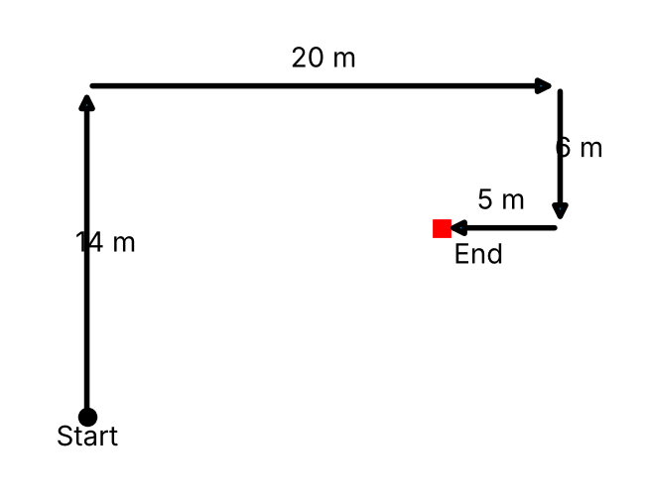
{OPTION 1} 15 m, North-East
{OPTION 2} 17 m, East
{OPTION 3} 17 m, North-East
{OPTION 4} 19 m, North-East
{OPTION 5}
{OPTION 6}
{OPTION 7}
{OPTION 8}
{OPTION 9}
{OPTION 10}
{RIGHT ANSWER} 3
{EXPLANATION} North 14 and south 6 leave 8 m north. East 20 and west 5 leave 15 m east. Distance = √(8² + 15²) = 17 m, and the End is to the north and east of Start, so it is North-East.
{CORRECT MARKS} 1
{NEGATIVE MARKS} 0
{DIFFICULTY} Hard
{QUESTION ENDS}

{QUESTION BEGINS}
{QUESTION NUMBER} 18
{SUBJECT} Reasoning Ability
{TOPIC} Figure Analogy
{TAGS} tcs nqt, reasoning ability, figure based, hard
{QUESTION TYPE} SINGLECORRECT
{QUESTION TEXT} Select the figure that is related to the third figure in the same way as the second figure is related to the first (A : B :: C : ?).
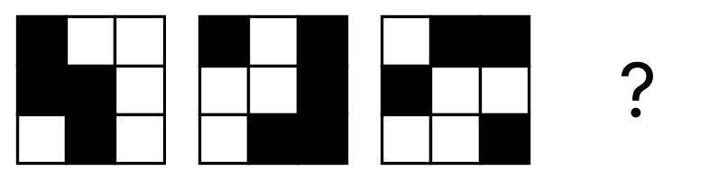
{OPTION 1} 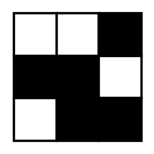
{OPTION 2} 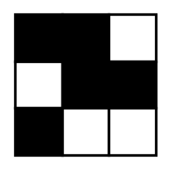
{OPTION 3} 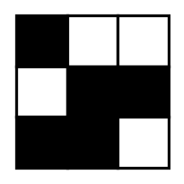
{OPTION 4} 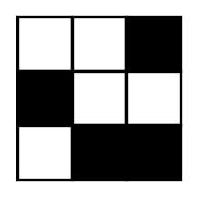
{OPTION 5}
{OPTION 6}
{OPTION 7}
{OPTION 8}
{OPTION 9}
{OPTION 10}
{RIGHT ANSWER} 2
{EXPLANATION} The second figure is the first one turned upside down (flipped top to bottom) with black and white swapped. Doing the same to the third figure gives the answer.
{CORRECT MARKS} 1
{NEGATIVE MARKS} 0
{DIFFICULTY} Hard
{QUESTION ENDS}

{QUESTION BEGINS}
{QUESTION NUMBER} 19
{SUBJECT} Reasoning Ability
{TOPIC} Figure Matrix
{TAGS} tcs nqt, reasoning ability, figure based, hard
{QUESTION TYPE} SINGLECORRECT
{QUESTION TEXT} In each row of the matrix, the third figure is formed from the first two figures by a fixed rule. Select the figure that replaces the question mark (?).
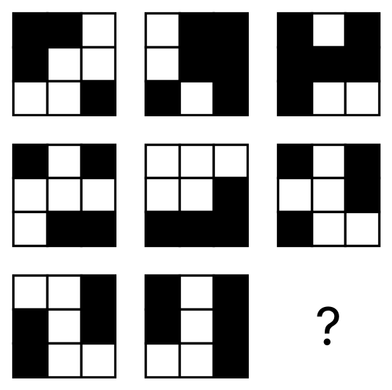
{OPTION 1} 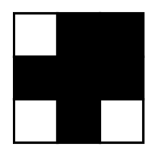
{OPTION 2} 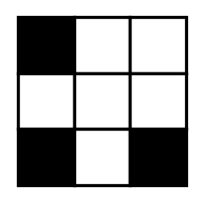
{OPTION 3} 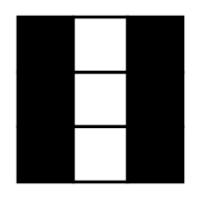
{OPTION 4} 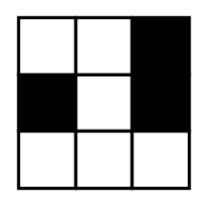
{OPTION 5}
{OPTION 6}
{OPTION 7}
{OPTION 8}
{OPTION 9}
{OPTION 10}
{RIGHT ANSWER} 2
{EXPLANATION} In the first two rows a cell of the third figure is black exactly when it is black in only one of the first two figures (if it is black in both, or in neither, it is white). Applying this to the last row gives the answer.
{CORRECT MARKS} 1
{NEGATIVE MARKS} 0
{DIFFICULTY} Hard
{QUESTION ENDS}

{QUESTION BEGINS}
{QUESTION NUMBER} 20
{SUBJECT} Reasoning Ability
{TOPIC} Figure Series
{TAGS} tcs nqt, reasoning ability, figure based, hard
{QUESTION TYPE} SINGLECORRECT
{QUESTION TEXT} Select the figure that replaces the question mark (?) in the series.
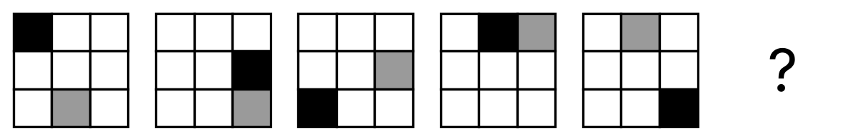
{OPTION 1} 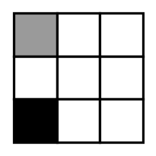
{OPTION 2} 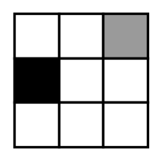
{OPTION 3} 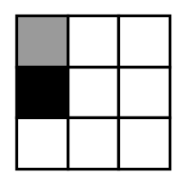
{OPTION 4} 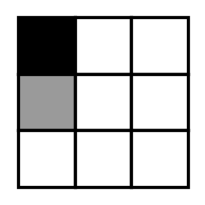
{OPTION 5}
{OPTION 6}
{OPTION 7}
{OPTION 8}
{OPTION 9}
{OPTION 10}
{RIGHT ANSWER} 3
{EXPLANATION} The black square moves 3 places clockwise along the border cells in every step, while the grey square moves 1 place anticlockwise in every step. Applying both moves to the fifth figure gives the missing figure.
{CORRECT MARKS} 1
{NEGATIVE MARKS} 0
{DIFFICULTY} Hard
{QUESTION ENDS}

