{QUESTION BEGINS}
{QUESTION NUMBER} 1
{SUBJECT} Reasoning Ability
{TOPIC} Mathematical Operations
{TAGS} tcs nqt, reasoning ability, hard
{QUESTION TYPE} SINGLECORRECT
{QUESTION TEXT} If '+' means '−', '−' means '×', '×' means '÷' and '÷' means '+', then what is the value of 36 ÷ 4 + 6 × 2 − 5?
{OPTION 1} 25
{OPTION 2} 50
{OPTION 3} 28
{OPTION 4} 21
{OPTION 5}
{OPTION 6}
{OPTION 7}
{OPTION 8}
{OPTION 9}
{OPTION 10}
{RIGHT ANSWER} 1
{EXPLANATION} Replace the signs as given: 36 + 4 − 6 ÷ 2 × 5. Working it out by BODMAS gives 25.
{CORRECT MARKS} 1
{NEGATIVE MARKS} 0
{DIFFICULTY} Hard
{QUESTION ENDS}

{QUESTION BEGINS}
{QUESTION NUMBER} 2
{SUBJECT} Reasoning Ability
{TOPIC} Dice
{TAGS} tcs nqt, reasoning ability, figure based, hard
{QUESTION TYPE} SINGLECORRECT
{QUESTION TEXT} Three different positions of the same dice are shown. Which number is on the face opposite to the face carrying 4?
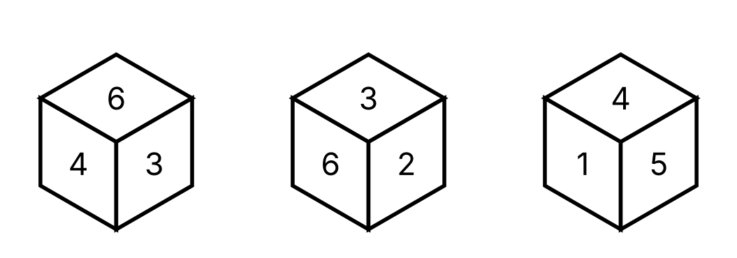
{OPTION 1} 1
{OPTION 2} 5
{OPTION 3} 3
{OPTION 4} 2
{OPTION 5}
{OPTION 6}
{OPTION 7}
{OPTION 8}
{OPTION 9}
{OPTION 10}
{RIGHT ANSWER} 4
{EXPLANATION} In every position the three visible faces meet at a corner, so no two of them are opposite. Using the three positions, 4 cannot be opposite any number it appears next to, which leaves only 2.
{CORRECT MARKS} 1
{NEGATIVE MARKS} 0
{DIFFICULTY} Hard
{QUESTION ENDS}

{QUESTION BEGINS}
{QUESTION NUMBER} 3
{SUBJECT} Reasoning Ability
{TOPIC} Coding-Decoding
{TAGS} tcs nqt, reasoning ability, hard
{QUESTION TYPE} SINGLECORRECT
{QUESTION TEXT} In a certain code language, PLANT is written as VPCNR. How is STONE written in that language?
{OPTION 1} UVQPG
{OPTION 2} CLMRQ
{OPTION 3} GPQVU
{OPTION 4} HQRWV
{OPTION 5}
{OPTION 6}
{OPTION 7}
{OPTION 8}
{OPTION 9}
{OPTION 10}
{RIGHT ANSWER} 3
{EXPLANATION} The word is written backwards and then every letter is moved 2 places forward in the alphabet: PLANT → TNALP → VPCNR. Doing this to STONE: ENOTS → GPQVU.
{CORRECT MARKS} 1
{NEGATIVE MARKS} 0
{DIFFICULTY} Hard
{QUESTION ENDS}

{QUESTION BEGINS}
{QUESTION NUMBER} 4
{SUBJECT} Reasoning Ability
{TOPIC} Seating Arrangement
{TAGS} tcs nqt, reasoning ability, hard
{QUESTION TYPE} SINGLECORRECT
{QUESTION TEXT} 6 friends Sana, Tara, Uday, Veer, Wasim and Yash sit around a circular table. Sana, Uday, Wasim face the centre while Tara, Veer, Yash face outside (away from the centre). Uday sits immediately to the left of Yash. Veer sits immediately to the right of Yash. Yash sits third to the right of Wasim. Wasim sits immediately to the left of Sana.
Who sits third to the right of Uday?
{OPTION 1} Veer
{OPTION 2} Wasim
{OPTION 3} Sana
{OPTION 4} Tara
{OPTION 5}
{OPTION 6}
{OPTION 7}
{OPTION 8}
{OPTION 9}
{OPTION 10}
{RIGHT ANSWER} 3
{EXPLANATION} (For a person facing the centre, left means clockwise; for a person facing outwards it means anticlockwise.) Using all the conditions, the only possible seating clockwise from Sana is Sana, Wasim, Tara, Uday, Yash, Veer. Counting 3 place(s) to the right of Uday gives Sana.
{CORRECT MARKS} 1
{NEGATIVE MARKS} 0
{DIFFICULTY} Hard
{QUESTION ENDS}

{QUESTION BEGINS}
{QUESTION NUMBER} 5
{SUBJECT} Reasoning Ability
{TOPIC} Syllogism
{TAGS} tcs nqt, reasoning ability, hard
{QUESTION TYPE} SINGLECORRECT
{QUESTION TEXT} Statements: No wire is a lamp. Some lamps are bulbs.
Conclusions:
I. Some lamps are wires.
II. All lamps are bulbs.
III. Some bulbs are lamps.
IV. Some wires are not lamps.
Which of the following is correct?
{OPTION 1} Only I and IV follow
{OPTION 2} Only I follows
{OPTION 3} Only I, II and IV follow
{OPTION 4} Only III follows
{OPTION 5}
{OPTION 6}
{OPTION 7}
{OPTION 8}
{OPTION 9}
{OPTION 10}
{RIGHT ANSWER} 4
{EXPLANATION} Draw the Venn diagram for the statements and test each conclusion in every possible diagram. I does not follow. II does not follow. III follows. IV does not follow. Only III follows.
{CORRECT MARKS} 1
{NEGATIVE MARKS} 0
{DIFFICULTY} Hard
{QUESTION ENDS}

{QUESTION BEGINS}
{QUESTION NUMBER} 6
{SUBJECT} Reasoning Ability
{TOPIC} Letter Series
{TAGS} tcs nqt, reasoning ability, hard
{QUESTION TYPE} SINGLECORRECT
{QUESTION TEXT} Find the next letter: C, D, F, I, M, ?
{OPTION 1} S
{OPTION 2} R
{OPTION 3} Q
{OPTION 4} T
{OPTION 5}
{OPTION 6}
{OPTION 7}
{OPTION 8}
{OPTION 9}
{OPTION 10}
{RIGHT ANSWER} 2
{EXPLANATION} The gaps between the letters grow by 1 each time: 1, 2, 3, 4, 5. So the next letter is R.
{CORRECT MARKS} 1
{NEGATIVE MARKS} 0
{DIFFICULTY} Hard
{QUESTION ENDS}

{QUESTION BEGINS}
{QUESTION NUMBER} 7
{SUBJECT} Reasoning Ability
{TOPIC} Counting Figures
{TAGS} tcs nqt, reasoning ability, figure based, hard
{QUESTION TYPE} SINGLECORRECT
{QUESTION TEXT} How many rectangles of all sizes (squares included) are there in the given grid of 5 columns and 3 rows?
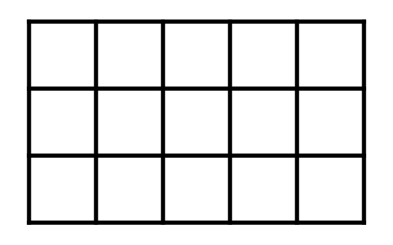
{OPTION 1} 95
{OPTION 2} 84
{OPTION 3} 90
{OPTION 4} 78
{OPTION 5}
{OPTION 6}
{OPTION 7}
{OPTION 8}
{OPTION 9}
{OPTION 10}
{RIGHT ANSWER} 3
{EXPLANATION} Choose 2 of the 6 vertical lines and 2 of the 4 horizontal lines: C(6, 2) × C(4, 2) = 15 × 6 = 90.
{CORRECT MARKS} 1
{NEGATIVE MARKS} 0
{DIFFICULTY} Hard
{QUESTION ENDS}

{QUESTION BEGINS}
{QUESTION NUMBER} 8
{SUBJECT} Reasoning Ability
{TOPIC} Clock
{TAGS} tcs nqt, reasoning ability, figure based, hard
{QUESTION TYPE} SINGLECORRECT
{QUESTION TEXT} The two clocks show the starting time and the finishing time of a journey (the journey lasted less than 12 hours). If the vehicle covered 217 km in this time, what was its average speed?
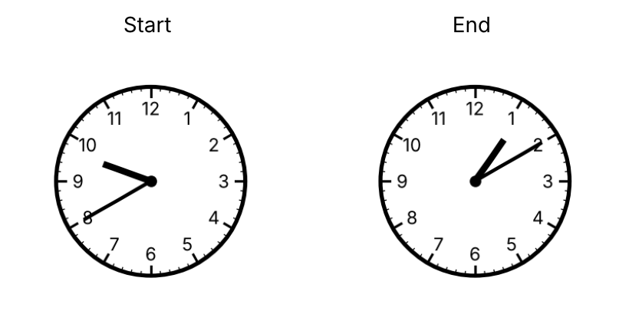
{OPTION 1} 66 km/h
{OPTION 2} 59 km/h
{OPTION 3} 62 km/h
{OPTION 4} 69 km/h
{OPTION 5}
{OPTION 6}
{OPTION 7}
{OPTION 8}
{OPTION 9}
{OPTION 10}
{RIGHT ANSWER} 3
{EXPLANATION} The clocks show 9:40 and 1:10, so the time taken = 3 h 30 min = 210 minutes. Speed = 217 ÷ (210/60) = 62 km/h.
{CORRECT MARKS} 1
{NEGATIVE MARKS} 0
{DIFFICULTY} Hard
{QUESTION ENDS}

{QUESTION BEGINS}
{QUESTION NUMBER} 9
{SUBJECT} Reasoning Ability
{TOPIC} Syllogism
{TAGS} tcs nqt, reasoning ability, hard
{QUESTION TYPE} SINGLECORRECT
{QUESTION TEXT} Statements: All mangoes are juices. No juice is a fruit.
Conclusions:
I. All juices are fruits.
II. No mango is a fruit.
III. No mango is a juice.
IV. Some fruits are not juices.
Which of the following is correct?
{OPTION 1} Only I follows
{OPTION 2} Only I and IV follow
{OPTION 3} Only II follows
{OPTION 4} Only I, II and IV follow
{OPTION 5}
{OPTION 6}
{OPTION 7}
{OPTION 8}
{OPTION 9}
{OPTION 10}
{RIGHT ANSWER} 3
{EXPLANATION} Draw the Venn diagram for the statements and test each conclusion in every possible diagram. I does not follow. II follows. III does not follow. IV does not follow. Only II follows.
{CORRECT MARKS} 1
{NEGATIVE MARKS} 0
{DIFFICULTY} Hard
{QUESTION ENDS}

{QUESTION BEGINS}
{QUESTION NUMBER} 10
{SUBJECT} Reasoning Ability
{TOPIC} Number Series
{TAGS} tcs nqt, reasoning ability, hard
{QUESTION TYPE} SINGLECORRECT
{QUESTION TEXT} Find the next term of the series: 2, 4, 9, 17, 31, 54, ?
{OPTION 1} 99
{OPTION 2} 87
{OPTION 3} 105
{OPTION 4} 92
{OPTION 5}
{OPTION 6}
{OPTION 7}
{OPTION 8}
{OPTION 9}
{OPTION 10}
{RIGHT ANSWER} 4
{EXPLANATION} Each term is the sum of the previous two terms plus the position number of the term: 9+17+5=31, 17+31+6=54, 31+54+7=92 … so the next term is 31+54+7 = 92.
{CORRECT MARKS} 1
{NEGATIVE MARKS} 0
{DIFFICULTY} Hard
{QUESTION ENDS}

{QUESTION BEGINS}
{QUESTION NUMBER} 11
{SUBJECT} Reasoning Ability
{TOPIC} Alphabet Test
{TAGS} tcs nqt, reasoning ability, hard
{QUESTION TYPE} SINGLECORRECT
{QUESTION TEXT} In the word STRAIGHT, how many pairs of letters are there, each pair having as many letters between them in the word as in the English alphabet?
{OPTION 1} 4
{OPTION 2} 3
{OPTION 3} 5
{OPTION 4} 2
{OPTION 5}
{OPTION 6}
{OPTION 7}
{OPTION 8}
{OPTION 9}
{OPTION 10}
{RIGHT ANSWER} 4
{EXPLANATION} Check every pair of letters: the pairs that match are ST, GH. So the answer is 2.
{CORRECT MARKS} 1
{NEGATIVE MARKS} 0
{DIFFICULTY} Hard
{QUESTION ENDS}

{QUESTION BEGINS}
{QUESTION NUMBER} 12
{SUBJECT} Reasoning Ability
{TOPIC} Blood Relations
{TAGS} tcs nqt, reasoning ability, hard
{QUESTION TYPE} SINGLECORRECT
{QUESTION TEXT} Read the statements: A is the father of H. A is the father of K. H is the mother of D. I is the husband of H. B is the mother of H.
How is I (a man) related to K?
{OPTION 1} Maternal grandfather
{OPTION 2} Brother
{OPTION 3} Paternal uncle
{OPTION 4} Brother-in-law
{OPTION 5}
{OPTION 6}
{OPTION 7}
{OPTION 8}
{OPTION 9}
{OPTION 10}
{RIGHT ANSWER} 4
{EXPLANATION} Draw the family tree from the statements: A is the father of H; A is the father of K; H is the mother of D; I is the husband of H; B is the mother of H. In this tree I is the brother of K's spouse or the husband of K's sister, so I is the brother-in-law of K.
{CORRECT MARKS} 1
{NEGATIVE MARKS} 0
{DIFFICULTY} Hard
{QUESTION ENDS}

{QUESTION BEGINS}
{QUESTION NUMBER} 13
{SUBJECT} Reasoning Ability
{TOPIC} Directions
{TAGS} tcs nqt, reasoning ability, hard
{QUESTION TYPE} SINGLECORRECT
{QUESTION TEXT} A man starts from his house and walks 39 m towards the North, turns right and walks 20 m, turns right and walks 4 m, turns right and walks 8 m. How far is he from his house now, and in which direction (with respect to the house)?
{OPTION 1} 37 m, East
{OPTION 2} 37 m, South-East
{OPTION 3} 38 m, North-East
{OPTION 4} 37 m, North-East
{OPTION 5}
{OPTION 6}
{OPTION 7}
{OPTION 8}
{OPTION 9}
{OPTION 10}
{RIGHT ANSWER} 4
{EXPLANATION} Take East as +x and North as +y. The four moves give a net displacement of 12 m towards the East and 35 m towards the North. Distance = √(12² + 35²) = 37 m, in the North-East direction.
{CORRECT MARKS} 1
{NEGATIVE MARKS} 0
{DIFFICULTY} Hard
{QUESTION ENDS}

{QUESTION BEGINS}
{QUESTION NUMBER} 14
{SUBJECT} Reasoning Ability
{TOPIC} Figure Overlay
{TAGS} tcs nqt, reasoning ability, figure based, hard
{QUESTION TYPE} SINGLECORRECT
{QUESTION TEXT} Two transparent sheets with black squares are placed exactly one over the other. A square appears black if it is black on exactly one sheet, and grey if it is black on both sheets. Which figure do you see?
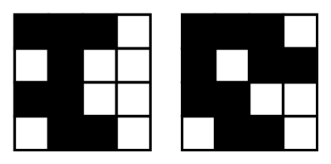
{OPTION 1} 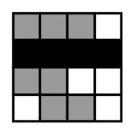
{OPTION 2} 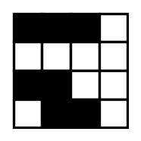
{OPTION 3} 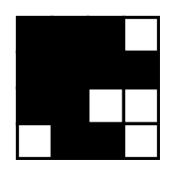
{OPTION 4} 
{OPTION 5}
{OPTION 6}
{OPTION 7}
{OPTION 8}
{OPTION 9}
{OPTION 10}
{RIGHT ANSWER} 1
{EXPLANATION} Compare square by square: black on one sheet only → black; black on both → grey; white on both → white. Option 1 follows this rule for every square.
{CORRECT MARKS} 1
{NEGATIVE MARKS} 0
{DIFFICULTY} Hard
{QUESTION ENDS}

{QUESTION BEGINS}
{QUESTION NUMBER} 15
{SUBJECT} Reasoning Ability
{TOPIC} Data Sufficiency
{TAGS} tcs nqt, reasoning ability, hard
{QUESTION TYPE} SINGLECORRECT
{QUESTION TEXT} Question: Is point P to the North-West of point Q?
Statement I: P is 8 m to the West of R, and R is 8 m to the North of Q.
Statement II: Q is 8 m to the South of R.
Which of the following is correct?
{OPTION 1} Both statements together are needed
{OPTION 2} Statement I alone is sufficient
{OPTION 3} Statement II alone is sufficient
{OPTION 4} Even both statements together are not sufficient
{OPTION 5}
{OPTION 6}
{OPTION 7}
{OPTION 8}
{OPTION 9}
{OPTION 10}
{RIGHT ANSWER} 2
{EXPLANATION} From statement I: R is 8 m north of Q and P is 8 m west of R, so P is 8 m west and 8 m north of Q, which is exactly North-West of Q. Statement II only repeats that R is north of Q and says nothing about P. So I alone is sufficient.
{CORRECT MARKS} 1
{NEGATIVE MARKS} 0
{DIFFICULTY} Hard
{QUESTION ENDS}

{QUESTION BEGINS}
{QUESTION NUMBER} 16
{SUBJECT} Reasoning Ability
{TOPIC} Mirror Image
{TAGS} tcs nqt, reasoning ability, figure based, hard
{QUESTION TYPE} SINGLECORRECT
{QUESTION TEXT} Which of the following is the mirror image of the given string, if a mirror is held vertically along its right edge?
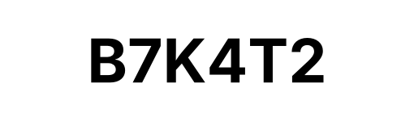
{OPTION 1} 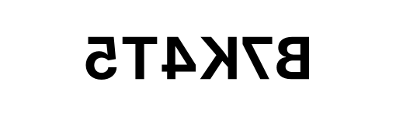
{OPTION 2} 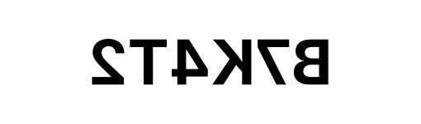
{OPTION 3} 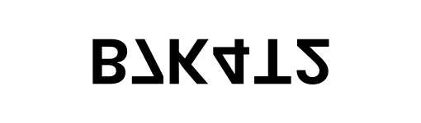
{OPTION 4} 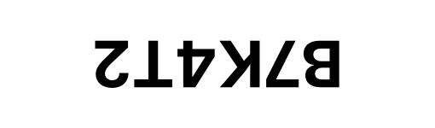
{OPTION 5}
{OPTION 6}
{OPTION 7}
{OPTION 8}
{OPTION 9}
{OPTION 10}
{RIGHT ANSWER} 2
{EXPLANATION} A vertical mirror on its right side reverses the order of the characters and flips each one left to right. The other options show a different kind of reflection, a half turn, or a different string.
{CORRECT MARKS} 1
{NEGATIVE MARKS} 0
{DIFFICULTY} Hard
{QUESTION ENDS}

{QUESTION BEGINS}
{QUESTION NUMBER} 17
{SUBJECT} Reasoning Ability
{TOPIC} Directions
{TAGS} tcs nqt, reasoning ability, hard
{QUESTION TYPE} SINGLECORRECT
{QUESTION TEXT} A man starts from his house and walks 27 m towards the South, turns left and walks 29 m, turns left and walks 6 m, turns left and walks 9 m. How far is he from his house now, and in which direction (with respect to the house)?
{OPTION 1} 30 m, South-East
{OPTION 2} 29 m, South-East
{OPTION 3} 29 m, East
{OPTION 4} 29 m, North-East
{OPTION 5}
{OPTION 6}
{OPTION 7}
{OPTION 8}
{OPTION 9}
{OPTION 10}
{RIGHT ANSWER} 2
{EXPLANATION} Take East as +x and North as +y. The four moves give a net displacement of 20 m towards the East and 21 m towards the South. Distance = √(20² + 21²) = 29 m, in the South-East direction.
{CORRECT MARKS} 1
{NEGATIVE MARKS} 0
{DIFFICULTY} Hard
{QUESTION ENDS}

{QUESTION BEGINS}
{QUESTION NUMBER} 18
{SUBJECT} Reasoning Ability
{TOPIC} Figure Series
{TAGS} tcs nqt, reasoning ability, figure based, hard
{QUESTION TYPE} SINGLECORRECT
{QUESTION TEXT} Select the figure that can replace the question mark (?) in the series. (Each figure has seven symbols placed at the top-centre, in the middle row and in the bottom row.)
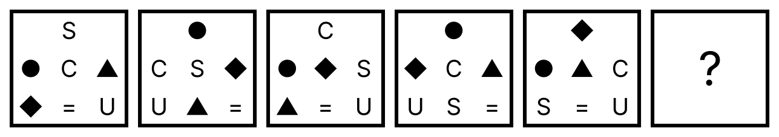
{OPTION 1} 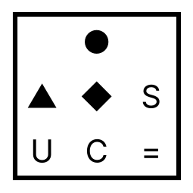
{OPTION 2} 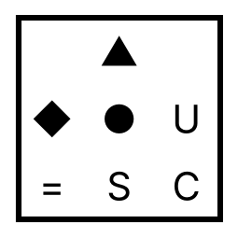
{OPTION 3} 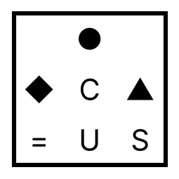
{OPTION 4} 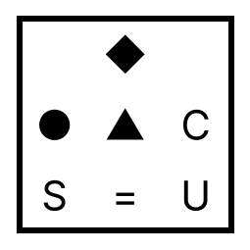
{OPTION 5}
{OPTION 6}
{OPTION 7}
{OPTION 8}
{OPTION 9}
{OPTION 10}
{RIGHT ANSWER} 1
{EXPLANATION} Number the positions 1 (top), 2, 3, 4 (middle row, left to right) and 5, 6, 7 (bottom row). Steps alternate between two fixed shuffles. Shuffle A sends the symbol at 1→3, 2→1, 3→2, 4→6, 5→4, 6→7, 7→5. Shuffle B sends 1→2, 2→1, 3→4, 4→3, 5→7, 6→5, 7→6. Figures 1→2, 3→4 and 5→6 use A, and figures 2→3 and 4→5 use B. Applying A to figure 5 gives the answer.
{CORRECT MARKS} 1
{NEGATIVE MARKS} 0
{DIFFICULTY} Hard
{QUESTION ENDS}

{QUESTION BEGINS}
{QUESTION NUMBER} 19
{SUBJECT} Reasoning Ability
{TOPIC} Venn Diagram
{TAGS} tcs nqt, reasoning ability, figure based, hard
{QUESTION TYPE} SINGLECORRECT
{QUESTION TEXT} In the figure the circles show Doctors, Poets and Players (letters mark the regions). Which regions together represent the people who belong to poets or players but not to doctors?
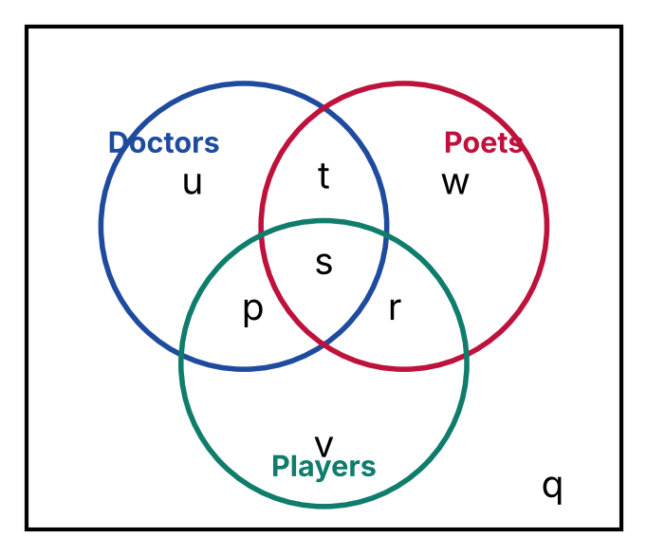
{OPTION 1} p, r, t
{OPTION 2} p
{OPTION 3} t, u, w
{OPTION 4} r, v, w
{OPTION 5}
{OPTION 6}
{OPTION 7}
{OPTION 8}
{OPTION 9}
{OPTION 10}
{RIGHT ANSWER} 4
{EXPLANATION} Regions: only Doctors = u, only Poets = w, only Players = v, Doctors∩Poets only = t, Doctors∩Players only = p, Poets∩Players only = r, all three = s. The required regions are r, v, w.
{CORRECT MARKS} 1
{NEGATIVE MARKS} 0
{DIFFICULTY} Hard
{QUESTION ENDS}

{QUESTION BEGINS}
{QUESTION NUMBER} 20
{SUBJECT} Reasoning Ability
{TOPIC} Ranking
{TAGS} tcs nqt, reasoning ability, hard
{QUESTION TYPE} SINGLECORRECT
{QUESTION TEXT} Six friends A, B, C, D, E and F have different heights. E is taller than B. E is taller than F. E is taller than A. B is taller than D. D is taller than C. F is taller than B. A is taller than F.
Who is the fourth tallest?
{OPTION 1} D
{OPTION 2} C
{OPTION 3} A
{OPTION 4} B
{OPTION 5}
{OPTION 6}
{OPTION 7}
{OPTION 8}
{OPTION 9}
{OPTION 10}
{RIGHT ANSWER} 4
{EXPLANATION} Arranging the friends from the tallest using all the comparisons gives the order: E > A > F > B > D > C. The fourth tallest is B.
{CORRECT MARKS} 1
{NEGATIVE MARKS} 0
{DIFFICULTY} Hard
{QUESTION ENDS}

{QUESTION BEGINS}
{QUESTION NUMBER} 21
{SUBJECT} Reasoning Ability
{TOPIC} Syllogism
{TAGS} tcs nqt, reasoning ability, hard
{QUESTION TYPE} SINGLECORRECT
{QUESTION TEXT} Statements: No bus is a bridge. All bridges are trains. Some trains are roads.
Conclusions:
I. Some trains are buses.
II. Some roads are trains.
III. Some trains are not roads.
IV. No bridge is a train.
Which of the following is correct?
{OPTION 1} Only I follows
{OPTION 2} Only I and IV follow
{OPTION 3} Only I, II and IV follow
{OPTION 4} Only II follows
{OPTION 5}
{OPTION 6}
{OPTION 7}
{OPTION 8}
{OPTION 9}
{OPTION 10}
{RIGHT ANSWER} 4
{EXPLANATION} Draw the Venn diagram for the statements and test each conclusion in every possible diagram. I does not follow. II follows. III does not follow. IV does not follow. Only II follows.
{CORRECT MARKS} 1
{NEGATIVE MARKS} 0
{DIFFICULTY} Hard
{QUESTION ENDS}

{QUESTION BEGINS}
{QUESTION NUMBER} 22
{SUBJECT} Reasoning Ability
{TOPIC} Cubes & Nets
{TAGS} tcs nqt, reasoning ability, figure based, hard
{QUESTION TYPE} SINGLECORRECT
{QUESTION TEXT} Which one of the boxes below is NOT possible when the net shown is folded?
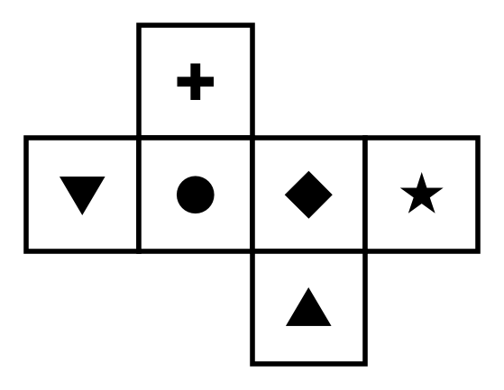
{OPTION 1} 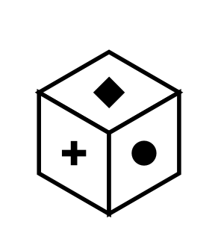
{OPTION 2} 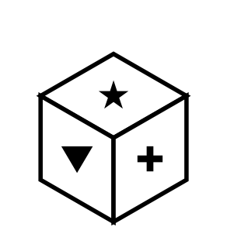
{OPTION 3} 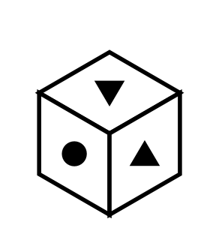
{OPTION 4} 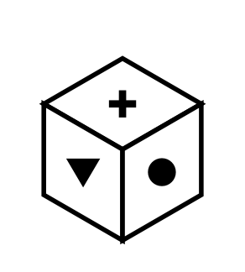
{OPTION 5}
{OPTION 6}
{OPTION 7}
{OPTION 8}
{OPTION 9}
{OPTION 10}
{RIGHT ANSWER} 3
{EXPLANATION} Three boxes show faces that meet at a corner in the correct order. The fourth shows the same three faces with the left and right faces interchanged (a mirror image), which cannot be obtained by folding.
{CORRECT MARKS} 1
{NEGATIVE MARKS} 0
{DIFFICULTY} Hard
{QUESTION ENDS}

{QUESTION BEGINS}
{QUESTION NUMBER} 23
{SUBJECT} Reasoning Ability
{TOPIC} Directions
{TAGS} tcs nqt, reasoning ability, hard
{QUESTION TYPE} SINGLECORRECT
{QUESTION TEXT} Raju starts from point O and walks 17 m North and then 6 m East. Sanju starts from the same point O, walks 18 m West and then 10 m North. What is the distance between them now?
{OPTION 1} 23 m
{OPTION 2} 25 m
{OPTION 3} 32 m
{OPTION 4} 28 m
{OPTION 5}
{OPTION 6}
{OPTION 7}
{OPTION 8}
{OPTION 9}
{OPTION 10}
{RIGHT ANSWER} 2
{EXPLANATION} With O as the origin, Raju is at (6, 17) and Sanju is at (-18, 10). The difference is 24 m in the east–west direction and 7 m in the north–south direction, so the distance is √(24² + 7²) = 25 m.
{CORRECT MARKS} 1
{NEGATIVE MARKS} 0
{DIFFICULTY} Hard
{QUESTION ENDS}

{QUESTION BEGINS}
{QUESTION NUMBER} 24
{SUBJECT} Reasoning Ability
{TOPIC} Calendar
{TAGS} tcs nqt, reasoning ability, hard
{QUESTION TYPE} SINGLECORRECT
{QUESTION TEXT} What is the day of the week on 31 December 2049? (You know that 1 January 2000 was a Saturday.)
{OPTION 1} Tuesday
{OPTION 2} Monday
{OPTION 3} Wednesday
{OPTION 4} Friday
{OPTION 5}
{OPTION 6}
{OPTION 7}
{OPTION 8}
{OPTION 9}
{OPTION 10}
{RIGHT ANSWER} 4
{EXPLANATION} From 1 Jan 2000 to 31 Dec 2049 there are 18262 days = 2608 weeks + 6 odd day(s) (leap years included), so the day is Friday.
{CORRECT MARKS} 1
{NEGATIVE MARKS} 0
{DIFFICULTY} Hard
{QUESTION ENDS}

{QUESTION BEGINS}
{QUESTION NUMBER} 25
{SUBJECT} Reasoning Ability
{TOPIC} Puzzle
{TAGS} tcs nqt, reasoning ability, hard
{QUESTION TYPE} SINGLECORRECT
{QUESTION TEXT} Five friends A, B, C, D and E live on five different floors of a building numbered 1 (lowest) to 5 (top), one on each floor. B lives on either floor 1 or floor 4. C lives on either floor 1 or floor 2. C and B live on neighbouring floors. D and E live on neighbouring floors. D and A live on neighbouring floors. E lives on either floor 4 or floor 5.
On which floor does D live?
{OPTION 1} floor 2
{OPTION 2} floor 1
{OPTION 3} floor 3
{OPTION 4} floor 4
{OPTION 5}
{OPTION 6}
{OPTION 7}
{OPTION 8}
{OPTION 9}
{OPTION 10}
{RIGHT ANSWER} 4
{EXPLANATION} Combining all the statements (all possible assignments were checked), exactly one arrangement is possible: A: floor 3, B: floor 1, C: floor 2, D: floor 4, E: floor 5. So the answer is floor 4.
{CORRECT MARKS} 1
{NEGATIVE MARKS} 0
{DIFFICULTY} Hard
{QUESTION ENDS}

{QUESTION BEGINS}
{QUESTION NUMBER} 26
{SUBJECT} Reasoning Ability
{TOPIC} Cubes & Nets
{TAGS} tcs nqt, reasoning ability, figure based, hard
{QUESTION TYPE} SINGLECORRECT
{QUESTION TEXT} Which of the following boxes can be made by folding the net shown?
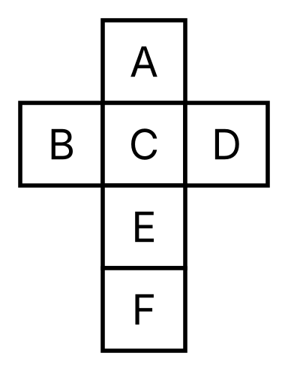
{OPTION 1} 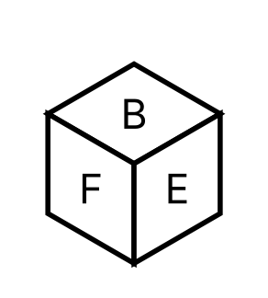
{OPTION 2} 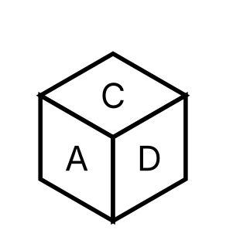
{OPTION 3} 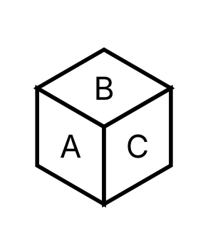
{OPTION 4} 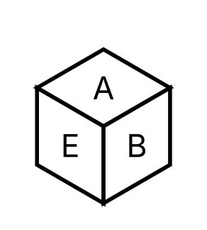
{OPTION 5}
{OPTION 6}
{OPTION 7}
{OPTION 8}
{OPTION 9}
{OPTION 10}
{RIGHT ANSWER} 1
{EXPLANATION} Opposite faces after folding: A–E, B–D, C–F. A box that shows two opposite faces together is impossible, and a box that shows the right faces in the wrong left–right order is a mirror image and cannot be made by folding. Only option 1 is possible.
{CORRECT MARKS} 1
{NEGATIVE MARKS} 0
{DIFFICULTY} Hard
{QUESTION ENDS}

{QUESTION BEGINS}
{QUESTION NUMBER} 27
{SUBJECT} Reasoning Ability
{TOPIC} Odd One Out
{TAGS} tcs nqt, reasoning ability, figure based, hard
{QUESTION TYPE} SINGLECORRECT
{QUESTION TEXT} Select the odd figure out. (All figures have the same number of black squares; black squares that touch along an edge belong to the same group.)
{OPTION 1} 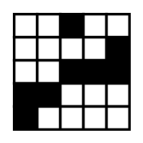
{OPTION 2} 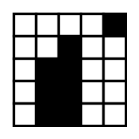
{OPTION 3} 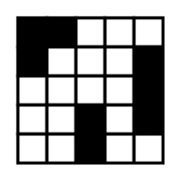
{OPTION 4} 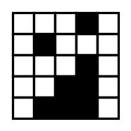
{OPTION 5}
{OPTION 6}
{OPTION 7}
{OPTION 8}
{OPTION 9}
{OPTION 10}
{RIGHT ANSWER} 2
{EXPLANATION} Three figures have 3 separate black groups but the fourth has only 2, so it is the odd one out.
{CORRECT MARKS} 1
{NEGATIVE MARKS} 0
{DIFFICULTY} Hard
{QUESTION ENDS}

{QUESTION BEGINS}
{QUESTION NUMBER} 28
{SUBJECT} Reasoning Ability
{TOPIC} Ranking
{TAGS} tcs nqt, reasoning ability, hard
{QUESTION TYPE} SINGLECORRECT
{QUESTION TEXT} In a class, Neha ranks 9th from the top and 28th from the bottom. Meena ranks 13th from the bottom. How many students are there between Neha and Meena?
{OPTION 1} 13
{OPTION 2} 15
{OPTION 3} 16
{OPTION 4} 14
{OPTION 5}
{OPTION 6}
{OPTION 7}
{OPTION 8}
{OPTION 9}
{OPTION 10}
{RIGHT ANSWER} 4
{EXPLANATION} Total students = 9 + 28 − 1 = 36. Meena is 36 − 13 + 1 = 24th from the top. Students between = |24 − 9| − 1 = 14.
{CORRECT MARKS} 1
{NEGATIVE MARKS} 0
{DIFFICULTY} Hard
{QUESTION ENDS}

{QUESTION BEGINS}
{QUESTION NUMBER} 29
{SUBJECT} Reasoning Ability
{TOPIC} Venn Diagram
{TAGS} tcs nqt, reasoning ability, figure based, hard
{QUESTION TYPE} SINGLECORRECT
{QUESTION TEXT} In the figure the circles show Teachers, Writers and Singers (letters mark the regions). Which regions together represent the people who belong to at least one group and are not singers?
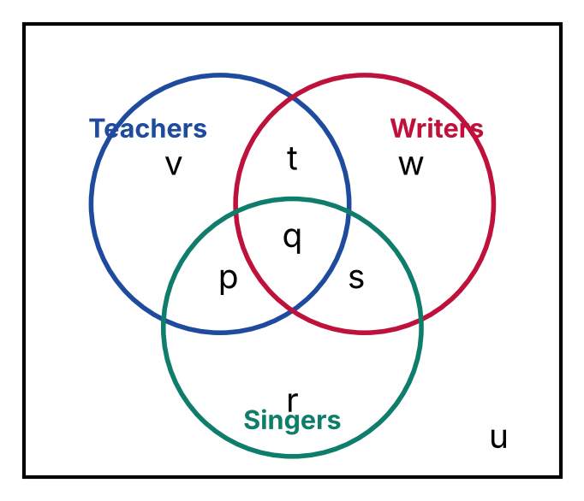
{OPTION 1} r, s, w
{OPTION 2} p
{OPTION 3} t, v, w
{OPTION 4} p, s, t
{OPTION 5}
{OPTION 6}
{OPTION 7}
{OPTION 8}
{OPTION 9}
{OPTION 10}
{RIGHT ANSWER} 3
{EXPLANATION} Regions: only Teachers = v, only Writers = w, only Singers = r, Teachers∩Writers only = t, Teachers∩Singers only = p, Writers∩Singers only = s, all three = q. The required regions are t, v, w.
{CORRECT MARKS} 1
{NEGATIVE MARKS} 0
{DIFFICULTY} Hard
{QUESTION ENDS}

{QUESTION BEGINS}
{QUESTION NUMBER} 30
{SUBJECT} Reasoning Ability
{TOPIC} Venn Diagram
{TAGS} tcs nqt, reasoning ability, figure based, hard
{QUESTION TYPE} SINGLECORRECT
{QUESTION TEXT} Refer to the Venn diagram (the rectangle is the universal set).
Which of the following are correct?
a. n(A′) + n(B ∩ C) = 154
b. n(A′ ∩ B′ ∩ C′) < n(A ∩ B ∩ C) − n(A ∩ C ∩ B′)
c. n(A ∪ B ∪ C) − n(A ∩ B) = 129
d. n(A ∩ B′) + n(B ∩ C′) = 108
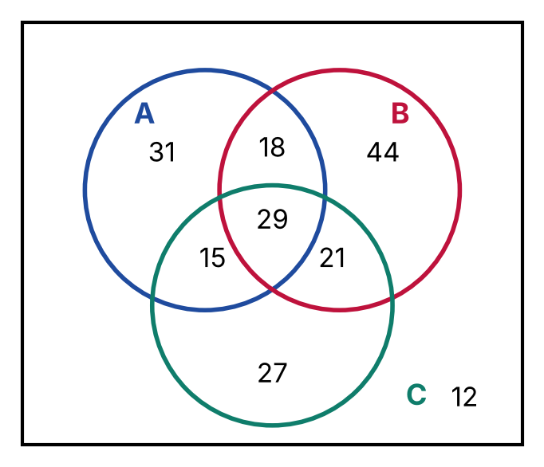
{OPTION 1} a, c, d only
{OPTION 2} c, d only
{OPTION 3} a, b, c only
{OPTION 4} a, b, d only
{OPTION 5}
{OPTION 6}
{OPTION 7}
{OPTION 8}
{OPTION 9}
{OPTION 10}
{RIGHT ANSWER} 4
{EXPLANATION} Region values: a = 31, b = 44, c = 27, ab = 18, ac = 15, bc = 21, abc = 29, outside = 12. Evaluate each statement: a is correct; b is correct; c is wrong; d is correct.
{CORRECT MARKS} 1
{NEGATIVE MARKS} 0
{DIFFICULTY} Hard
{QUESTION ENDS}

{QUESTION BEGINS}
{QUESTION NUMBER} 31
{SUBJECT} Reasoning Ability
{TOPIC} Figure Series
{TAGS} tcs nqt, reasoning ability, figure based, hard
{QUESTION TYPE} SINGLECORRECT
{QUESTION TEXT} Choose the figure that should come in place of the question mark (?).
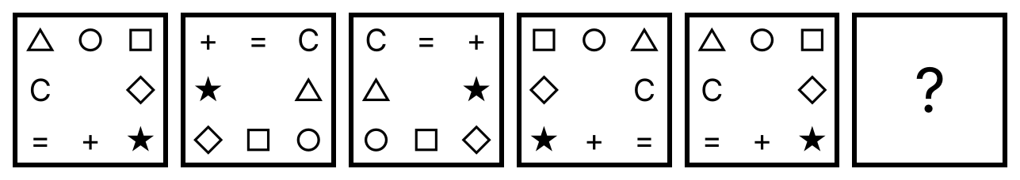
{OPTION 1} 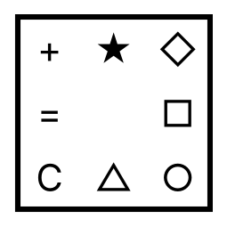
{OPTION 2} 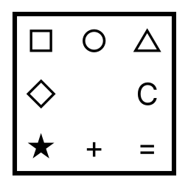
{OPTION 3} 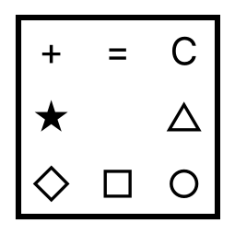
{OPTION 4} 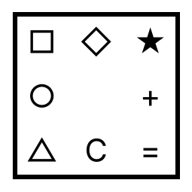
{OPTION 5}
{OPTION 6}
{OPTION 7}
{OPTION 8}
{OPTION 9}
{OPTION 10}
{RIGHT ANSWER} 3
{EXPLANATION} The symbols change in two alternating steps: step A: every symbol moves 3 places clockwise along the border; step B: the figure is reflected left to right. The step from figure 5 to figure 6 is A, and applying it gives the missing figure.
{CORRECT MARKS} 1
{NEGATIVE MARKS} 0
{DIFFICULTY} Hard
{QUESTION ENDS}

{QUESTION BEGINS}
{QUESTION NUMBER} 32
{SUBJECT} Reasoning Ability
{TOPIC} Logical Deduction
{TAGS} tcs nqt, reasoning ability, hard
{QUESTION TYPE} SINGLECORRECT
{QUESTION TEXT} Statements: All members who attended the meeting received a gift. Some members who received a gift are women. Rekha attended the meeting.
Which of the following is definitely true?
{OPTION 1} Rekha received a gift
{OPTION 2} Rekha is a woman
{OPTION 3} Rekha is not a woman
{OPTION 4} All women received a gift
{OPTION 5}
{OPTION 6}
{OPTION 7}
{OPTION 8}
{OPTION 9}
{OPTION 10}
{RIGHT ANSWER} 1
{EXPLANATION} Rekha attended the meeting, and all members who attended received a gift, so Rekha received a gift. Nothing is said about whether she is a woman, and 'some members who received a gift are women' does not mean all women received a gift.
{CORRECT MARKS} 1
{NEGATIVE MARKS} 0
{DIFFICULTY} Hard
{QUESTION ENDS}

{QUESTION BEGINS}
{QUESTION NUMBER} 33
{SUBJECT} Reasoning Ability
{TOPIC} Number Series
{TAGS} tcs nqt, reasoning ability, hard
{QUESTION TYPE} SINGLECORRECT
{QUESTION TEXT} Find the next term of the series: 1, 2, 8, 33, 148, ?
{OPTION 1} 778
{OPTION 2} 760
{OPTION 3} 765
{OPTION 4} 772
{OPTION 5}
{OPTION 6}
{OPTION 7}
{OPTION 8}
{OPTION 9}
{OPTION 10}
{RIGHT ANSWER} 3
{EXPLANATION} Each term = previous term × k + k², where k = 1, 2, 3, …: 1×1+1=2, 2×2+4=8, 8×3+9=33, 33×4+16=148, 148×5+25=765.
{CORRECT MARKS} 1
{NEGATIVE MARKS} 0
{DIFFICULTY} Hard
{QUESTION ENDS}

{QUESTION BEGINS}
{QUESTION NUMBER} 34
{SUBJECT} Reasoning Ability
{TOPIC} Alphabet Test
{TAGS} tcs nqt, reasoning ability, hard
{QUESTION TYPE} SINGLECORRECT
{QUESTION TEXT} If the English alphabet is written in reverse order (Z to A), which letter is the 9th letter to the right of the 11th letter from the left end?
{OPTION 1} T
{OPTION 2} H
{OPTION 3} G
{OPTION 4} F
{OPTION 5}
{OPTION 6}
{OPTION 7}
{OPTION 8}
{OPTION 9}
{OPTION 10}
{RIGHT ANSWER} 3
{EXPLANATION} In the reversed alphabet the 11th letter from the left is P. The 9th letter to its right is the 20th letter from the left, which is G.
{CORRECT MARKS} 1
{NEGATIVE MARKS} 0
{DIFFICULTY} Hard
{QUESTION ENDS}

{QUESTION BEGINS}
{QUESTION NUMBER} 35
{SUBJECT} Reasoning Ability
{TOPIC} Mathematical Operations
{TAGS} tcs nqt, reasoning ability, hard
{QUESTION TYPE} SINGLECORRECT
{QUESTION TEXT} If 'A ◊ B' means A² − 2B and 'A ∆ B' means A + B², then what is the value of (9 ◊ 4) ∆ (4 ◊ 5)?
{OPTION 1} 101
{OPTION 2} 109
{OPTION 3} 123
{OPTION 4} 114
{OPTION 5}
{OPTION 6}
{OPTION 7}
{OPTION 8}
{OPTION 9}
{OPTION 10}
{RIGHT ANSWER} 2
{EXPLANATION} 9 ◊ 4 = 9² − 2 × 4 = 73, 4 ◊ 5 = 4² − 2 × 5 = 6. Then 73 ∆ 6 = 73 + 6² = 109.
{CORRECT MARKS} 1
{NEGATIVE MARKS} 0
{DIFFICULTY} Hard
{QUESTION ENDS}

{QUESTION BEGINS}
{QUESTION NUMBER} 36
{SUBJECT} Reasoning Ability
{TOPIC} Counting Figures
{TAGS} tcs nqt, reasoning ability, figure based, hard
{QUESTION TYPE} SINGLECORRECT
{QUESTION TEXT} 16 dots are arranged in a 4 × 4 square grid as shown. How many different triangles can be formed by joining any three dots (the three dots must not lie on one straight line)?
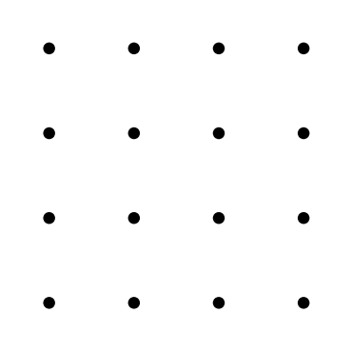
{OPTION 1} 524
{OPTION 2} 528
{OPTION 3} 516
{OPTION 4} 508
{OPTION 5}
{OPTION 6}
{OPTION 7}
{OPTION 8}
{OPTION 9}
{OPTION 10}
{RIGHT ANSWER} 3
{EXPLANATION} Three dots can be chosen in C(16, 3) = 560 ways. Subtract the sets of three collinear dots (44 sets). So the number of triangles = 516.
{CORRECT MARKS} 1
{NEGATIVE MARKS} 0
{DIFFICULTY} Hard
{QUESTION ENDS}

{QUESTION BEGINS}
{QUESTION NUMBER} 37
{SUBJECT} Reasoning Ability
{TOPIC} Inequalities
{TAGS} tcs nqt, reasoning ability, hard
{QUESTION TYPE} SINGLECORRECT
{QUESTION TEXT} In the following question the symbols have these meanings: 'A % B' means A is greater than B; 'A $ B' means A is greater than or equal to B; 'A & B' means A is less than B; 'A © B' means A is less than or equal to B; 'A ★ B' means A is equal to B.
Statement: Q © P & S & T % R
Conclusions:
I. Q & T
II. R © Q
III. Q & P
IV. Q ★ S
Which of the following is/are definitely true?
{OPTION 1} Only I and IV follow
{OPTION 2} Only II follows
{OPTION 3} Only I follows
{OPTION 4} Only I, II and IV follow
{OPTION 5}
{OPTION 6}
{OPTION 7}
{OPTION 8}
{OPTION 9}
{OPTION 10}
{RIGHT ANSWER} 3
{EXPLANATION} Decoding the statement gives Q ≤ P < S < T > R. Check each conclusion for every value that satisfies the chain (all combinations were tested): I is definitely true. II is not definitely true. III is not definitely true. IV is not definitely true.
{CORRECT MARKS} 1
{NEGATIVE MARKS} 0
{DIFFICULTY} Hard
{QUESTION ENDS}

{QUESTION BEGINS}
{QUESTION NUMBER} 38
{SUBJECT} Reasoning Ability
{TOPIC} Number Analogy
{TAGS} tcs nqt, reasoning ability, hard
{QUESTION TYPE} SINGLECORRECT
{QUESTION TEXT} Find the number that replaces the question mark: 12 : 9 :: 23 : ?
{OPTION 1} 35
{OPTION 2} 31
{OPTION 3} 41
{OPTION 4} 46
{OPTION 5}
{OPTION 6}
{OPTION 7}
{OPTION 8}
{OPTION 9}
{OPTION 10}
{RIGHT ANSWER} 1
{EXPLANATION} The rule is: the sum of the cubes of the digits. For 12: 9; so for 23: 35.
{CORRECT MARKS} 1
{NEGATIVE MARKS} 0
{DIFFICULTY} Hard
{QUESTION ENDS}

{QUESTION BEGINS}
{QUESTION NUMBER} 39
{SUBJECT} Reasoning Ability
{TOPIC} Figure Series
{TAGS} tcs nqt, reasoning ability, figure based, hard
{QUESTION TYPE} SINGLECORRECT
{QUESTION TEXT} The shaded sector moves round the circle (anticlockwise) and its shade alternates. Select the figure that replaces the question mark (?).
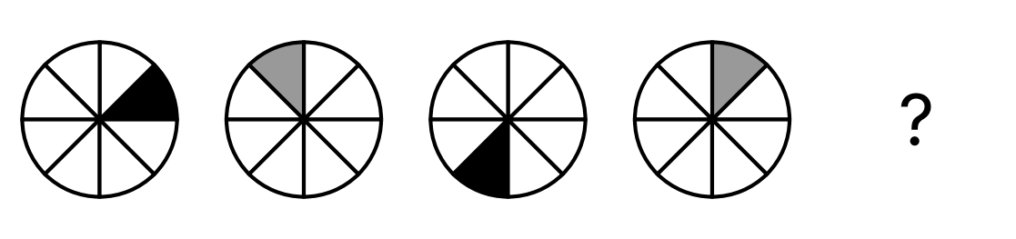
{OPTION 1} 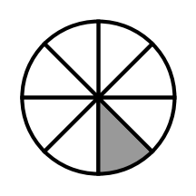
{OPTION 2} 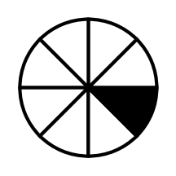
{OPTION 3} 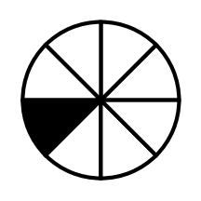
{OPTION 4} 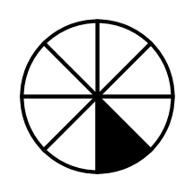
{OPTION 5}
{OPTION 6}
{OPTION 7}
{OPTION 8}
{OPTION 9}
{OPTION 10}
{RIGHT ANSWER} 4
{EXPLANATION} The shaded sector moves 2, 3, 4 places in successive steps (the step increases by 1 each time), so the next step is 5 places: position 6. The shade alternates black and grey, so the next shade is black.
{CORRECT MARKS} 1
{NEGATIVE MARKS} 0
{DIFFICULTY} Hard
{QUESTION ENDS}

{QUESTION BEGINS}
{QUESTION NUMBER} 40
{SUBJECT} Reasoning Ability
{TOPIC} Number Series
{TAGS} tcs nqt, reasoning ability, hard
{QUESTION TYPE} SINGLECORRECT
{QUESTION TEXT} Find the next term of the series: 17, 28, 41, 58, 77, ?
{OPTION 1} 95
{OPTION 2} 100
{OPTION 3} 107
{OPTION 4} 113
{OPTION 5}
{OPTION 6}
{OPTION 7}
{OPTION 8}
{OPTION 9}
{OPTION 10}
{RIGHT ANSWER} 2
{EXPLANATION} The terms are the sums of consecutive primes (2, 2+3, 2+3+5, …): the differences are the primes themselves. The next term is 100.
{CORRECT MARKS} 1
{NEGATIVE MARKS} 0
{DIFFICULTY} Hard
{QUESTION ENDS}

{QUESTION BEGINS}
{QUESTION NUMBER} 41
{SUBJECT} Reasoning Ability
{TOPIC} Calendar
{TAGS} tcs nqt, reasoning ability, hard
{QUESTION TYPE} SINGLECORRECT
{QUESTION TEXT} How many Fridays are there in October 2031?
{OPTION 1} 4
{OPTION 2} 5
{OPTION 3} 7
{OPTION 4} 6
{OPTION 5}
{OPTION 6}
{OPTION 7}
{OPTION 8}
{OPTION 9}
{OPTION 10}
{RIGHT ANSWER} 2
{EXPLANATION} October 2031 has 31 days and begins on a Wednesday. Listing the dates gives 5 Fridays.
{CORRECT MARKS} 1
{NEGATIVE MARKS} 0
{DIFFICULTY} Hard
{QUESTION ENDS}

{QUESTION BEGINS}
{QUESTION NUMBER} 42
{SUBJECT} Reasoning Ability
{TOPIC} Calendar
{TAGS} tcs nqt, reasoning ability, figure based, hard
{QUESTION TYPE} SINGLECORRECT
{QUESTION TEXT} The calendar of May 2027 is shown. On which day of the week will it be exactly 150 days after 19 May 2027?
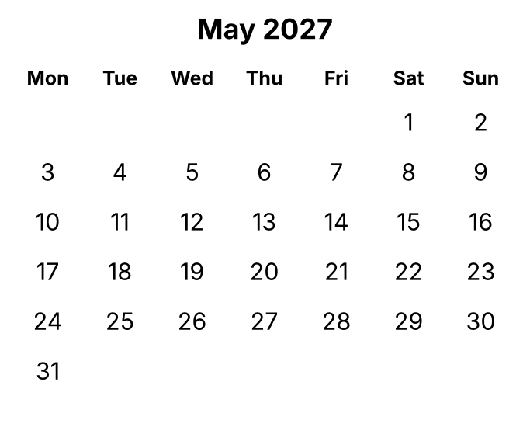
{OPTION 1} Tuesday
{OPTION 2} Wednesday
{OPTION 3} Monday
{OPTION 4} Saturday
{OPTION 5}
{OPTION 6}
{OPTION 7}
{OPTION 8}
{OPTION 9}
{OPTION 10}
{RIGHT ANSWER} 4
{EXPLANATION} In the calendar 19 May is a Wednesday. 150 days = 21 weeks + 3 day(s), so the day is 3 day(s) after Wednesday: Saturday.
{CORRECT MARKS} 1
{NEGATIVE MARKS} 0
{DIFFICULTY} Hard
{QUESTION ENDS}

{QUESTION BEGINS}
{QUESTION NUMBER} 43
{SUBJECT} Reasoning Ability
{TOPIC} Counting
{TAGS} tcs nqt, reasoning ability, hard
{QUESTION TYPE} SINGLECORRECT
{QUESTION TEXT} How many three-digit numbers are divisible by 7 and have a digit sum of 10?
{OPTION 1} 13
{OPTION 2} 5
{OPTION 3} 8
{OPTION 4} 10
{OPTION 5}
{OPTION 6}
{OPTION 7}
{OPTION 8}
{OPTION 9}
{OPTION 10}
{RIGHT ANSWER} 3
{EXPLANATION} Check the multiples of 7 from 105 to 994 whose digits add up to 10. Counting systematically gives 8.
{CORRECT MARKS} 1
{NEGATIVE MARKS} 0
{DIFFICULTY} Hard
{QUESTION ENDS}

{QUESTION BEGINS}
{QUESTION NUMBER} 44
{SUBJECT} Reasoning Ability
{TOPIC} Blood Relations
{TAGS} tcs nqt, reasoning ability, hard
{QUESTION TYPE} SINGLECORRECT
{QUESTION TEXT} Read the statements: K is the father of H. H is the father of D. E is the mother of B. K is the father of E.
How is B (a woman) related to D?
{OPTION 1} Cousin
{OPTION 2} Sister-in-law
{OPTION 3} Maternal grandmother
{OPTION 4} Mother-in-law
{OPTION 5}
{OPTION 6}
{OPTION 7}
{OPTION 8}
{OPTION 9}
{OPTION 10}
{RIGHT ANSWER} 1
{EXPLANATION} Draw the family tree from the statements: K is the father of H; H is the father of D; E is the mother of B; K is the father of E. In this tree B is a child of the brother or sister of D's parent, so B is the cousin of D.
{CORRECT MARKS} 1
{NEGATIVE MARKS} 0
{DIFFICULTY} Hard
{QUESTION ENDS}

{QUESTION BEGINS}
{QUESTION NUMBER} 45
{SUBJECT} Reasoning Ability
{TOPIC} Cubes & Nets
{TAGS} tcs nqt, reasoning ability, figure based, hard
{QUESTION TYPE} SINGLECORRECT
{QUESTION TEXT} The figure shows a net of a cube with numbered faces. What is the sum of the numbers on the four faces adjacent to the face marked 2?
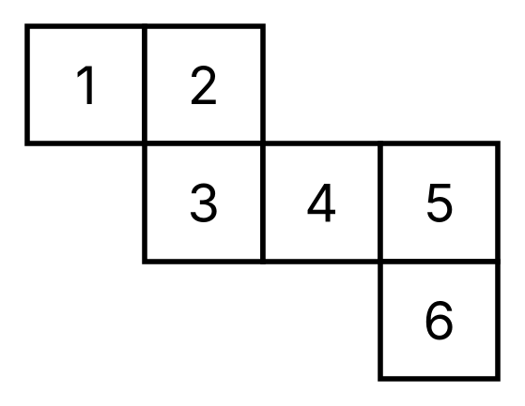
{OPTION 1} 19
{OPTION 2} 16
{OPTION 3} 10
{OPTION 4} 13
{OPTION 5}
{OPTION 6}
{OPTION 7}
{OPTION 8}
{OPTION 9}
{OPTION 10}
{RIGHT ANSWER} 4
{EXPLANATION} The face opposite 2 is 6; the four adjacent faces are all the others. Sum = 21 − 2 − 6 = 13.
{CORRECT MARKS} 1
{NEGATIVE MARKS} 0
{DIFFICULTY} Hard
{QUESTION ENDS}

{QUESTION BEGINS}
{QUESTION NUMBER} 46
{SUBJECT} Reasoning Ability
{TOPIC} Paper Folding
{TAGS} tcs nqt, reasoning ability, figure based, hard
{QUESTION TYPE} SINGLECORRECT
{QUESTION TEXT} A square sheet is folded twice as shown: first the left half over the right half, then the top half over the bottom half. A hole is punched through all layers at the marked place of the folded paper. How will the sheet look when it is unfolded?
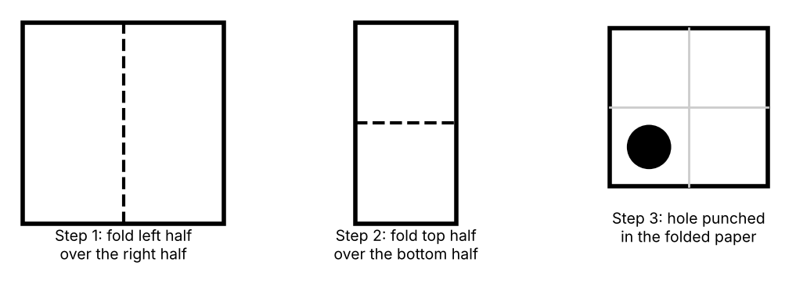
{OPTION 1} 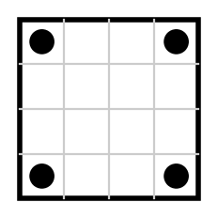
{OPTION 2} 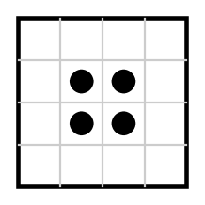
{OPTION 3} 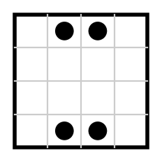
{OPTION 4} 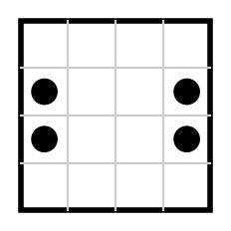
{OPTION 5}
{OPTION 6}
{OPTION 7}
{OPTION 8}
{OPTION 9}
{OPTION 10}
{RIGHT ANSWER} 3
{EXPLANATION} The folded paper has four layers, so one punch makes four holes. Unfolding the second fold mirrors the hole in the horizontal middle line and unfolding the first mirrors every hole in the vertical middle line, so the holes lie symmetrically in the four quarters of the sheet. Only option 1 shows this.
{CORRECT MARKS} 1
{NEGATIVE MARKS} 0
{DIFFICULTY} Hard
{QUESTION ENDS}

{QUESTION BEGINS}
{QUESTION NUMBER} 47
{SUBJECT} Reasoning Ability
{TOPIC} Directions
{TAGS} tcs nqt, reasoning ability, hard
{QUESTION TYPE} SINGLECORRECT
{QUESTION TEXT} Just before sunset, Mohan stands in an open ground and his shadow falls exactly to his left. He then turns 90° clockwise. Where does his shadow fall now with respect to him?
{OPTION 1} to his right
{OPTION 2} to his left
{OPTION 3} behind him
{OPTION 4} in front of him
{OPTION 5}
{OPTION 6}
{OPTION 7}
{OPTION 8}
{OPTION 9}
{OPTION 10}
{RIGHT ANSWER} 3
{EXPLANATION} At sunset the sun is in the West, so the shadow points East. East is on Mohan's left, so he is facing South. After turning 90° clockwise he faces 270° from North, while the shadow still points East (90°). The shadow is 180° clockwise from his front: behind him.
{CORRECT MARKS} 1
{NEGATIVE MARKS} 0
{DIFFICULTY} Hard
{QUESTION ENDS}

{QUESTION BEGINS}
{QUESTION NUMBER} 48
{SUBJECT} Reasoning Ability
{TOPIC} Figure Series
{TAGS} tcs nqt, reasoning ability, figure based, hard
{QUESTION TYPE} SINGLECORRECT
{QUESTION TEXT} Which figure will come next in the series?
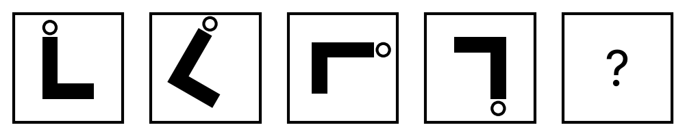
{OPTION 1} 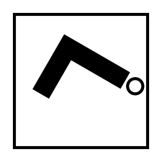
{OPTION 2} 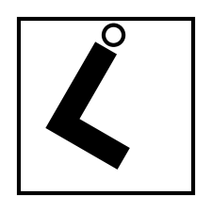
{OPTION 3} 
{OPTION 4} 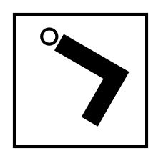
{OPTION 5}
{OPTION 6}
{OPTION 7}
{OPTION 8}
{OPTION 9}
{OPTION 10}
{RIGHT ANSWER} 3
{EXPLANATION} The figure turns clockwise by 30°, 60°, 90° in the successive steps, so the turns themselves increase by 30° each time. The next turn is 120°, giving a total turn of 300 ° = 300° from the start. Option 2 has the same turn but is a mirror image.
{CORRECT MARKS} 1
{NEGATIVE MARKS} 0
{DIFFICULTY} Hard
{QUESTION ENDS}

{QUESTION BEGINS}
{QUESTION NUMBER} 49
{SUBJECT} Reasoning Ability
{TOPIC} Classification
{TAGS} tcs nqt, reasoning ability, hard
{QUESTION TYPE} SINGLECORRECT
{QUESTION TEXT} Four of the following five letter-groups follow the same pattern. Which one does NOT belong? CFI, DGJ, EHK, FJM, GJM
{OPTION 1} GJM
{OPTION 2} FJM
{OPTION 3} EHK
{OPTION 4} CFI
{OPTION 5}
{OPTION 6}
{OPTION 7}
{OPTION 8}
{OPTION 9}
{OPTION 10}
{RIGHT ANSWER} 2
{EXPLANATION} In CFI, DGJ, EHK and GJM, the letters are 3 places apart (C→F→I, D→G→J, E→H→K, G→J→M). In FJM the gaps are 4 and 3 (F→J→M), so FJM does not belong.
{CORRECT MARKS} 1
{NEGATIVE MARKS} 0
{DIFFICULTY} Hard
{QUESTION ENDS}

{QUESTION BEGINS}
{QUESTION NUMBER} 50
{SUBJECT} Reasoning Ability
{TOPIC} Number Series
{TAGS} tcs nqt, reasoning ability, hard
{QUESTION TYPE} SINGLECORRECT
{QUESTION TEXT} Find the next term of the series: 3, 12, 33, 72, 135, ?
{OPTION 1} 223
{OPTION 2} 235
{OPTION 3} 241
{OPTION 4} 228
{OPTION 5}
{OPTION 6}
{OPTION 7}
{OPTION 8}
{OPTION 9}
{OPTION 10}
{RIGHT ANSWER} 4
{EXPLANATION} The terms follow n³-type pattern: term n = 1n³ + 0n² + 2n. The differences of the differences are constant after three levels, and the next term is 228.
{CORRECT MARKS} 1
{NEGATIVE MARKS} 0
{DIFFICULTY} Hard
{QUESTION ENDS}

{QUESTION BEGINS}
{QUESTION NUMBER} 51
{SUBJECT} Reasoning Ability
{TOPIC} Cubes
{TAGS} tcs nqt, reasoning ability, figure based, hard
{QUESTION TYPE} SINGLECORRECT
{QUESTION TEXT} The figure shows a solid made by stacking identical unit cubes on a square base (the columns get taller towards the back). Assuming there are no gaps below any visible cube, how many unit cubes make up the solid?
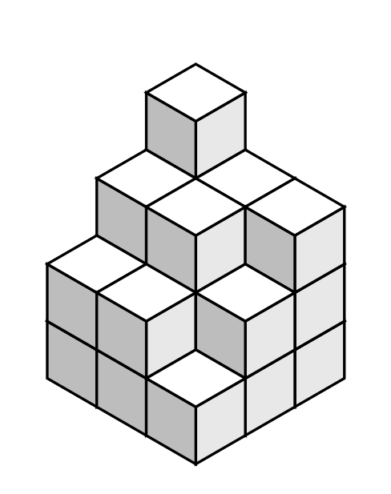
{OPTION 1} 28
{OPTION 2} 26
{OPTION 3} 20
{OPTION 4} 23
{OPTION 5}
{OPTION 6}
{OPTION 7}
{OPTION 8}
{OPTION 9}
{OPTION 10}
{RIGHT ANSWER} 4
{EXPLANATION} The nine (or more) columns have heights 1, 2, 2, 2, 3, 3, 3, 3, 4. Total = 23.
{CORRECT MARKS} 1
{NEGATIVE MARKS} 0
{DIFFICULTY} Hard
{QUESTION ENDS}

{QUESTION BEGINS}
{QUESTION NUMBER} 52
{SUBJECT} Reasoning Ability
{TOPIC} Water Image
{TAGS} tcs nqt, reasoning ability, figure based, hard
{QUESTION TYPE} SINGLECORRECT
{QUESTION TEXT} Select the water image (reflection in a mirror placed horizontally below) of the given string.
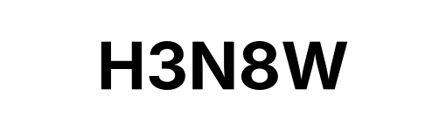
{OPTION 1} 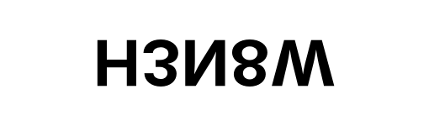
{OPTION 2} 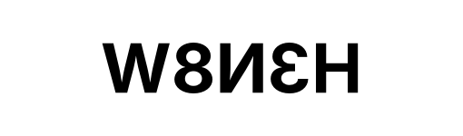
{OPTION 3} 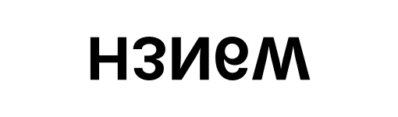
{OPTION 4} 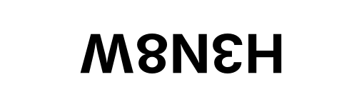
{OPTION 5}
{OPTION 6}
{OPTION 7}
{OPTION 8}
{OPTION 9}
{OPTION 10}
{RIGHT ANSWER} 1
{EXPLANATION} A mirror placed below the string turns it upside down but keeps the order of the characters from left to right (water image). The other options show a different kind of reflection, a half turn, or a different string.
{CORRECT MARKS} 1
{NEGATIVE MARKS} 0
{DIFFICULTY} Hard
{QUESTION ENDS}

{QUESTION BEGINS}
{QUESTION NUMBER} 53
{SUBJECT} Reasoning Ability
{TOPIC} Blood Relations
{TAGS} tcs nqt, reasoning ability, hard
{QUESTION TYPE} SINGLECORRECT
{QUESTION TEXT} Read the statements: D is the mother of C. H is the father of G. E is the mother of G. E is the mother of I. D is the mother of E.
How is G (a woman) related to C?
{OPTION 1} Daughter-in-law
{OPTION 2} Niece
{OPTION 3} Paternal grandmother
{OPTION 4} Maternal grandmother
{OPTION 5}
{OPTION 6}
{OPTION 7}
{OPTION 8}
{OPTION 9}
{OPTION 10}
{RIGHT ANSWER} 2
{EXPLANATION} Draw the family tree from the statements: D is the mother of C; H is the father of G; E is the mother of G; E is the mother of I; D is the mother of E. In this tree G is the daughter of C's brother or sister, so G is the niece of C.
{CORRECT MARKS} 1
{NEGATIVE MARKS} 0
{DIFFICULTY} Hard
{QUESTION ENDS}

{QUESTION BEGINS}
{QUESTION NUMBER} 54
{SUBJECT} Reasoning Ability
{TOPIC} Chart Reasoning
{TAGS} tcs nqt, reasoning ability, figure based, hard
{QUESTION TYPE} SINGLECORRECT
{QUESTION TEXT} The pie chart shows how a family's monthly income is divided. The angles of the sectors are marked. If the family spends ₹15,000 on Savings, how much more is spent on Food than on Travel and Others?
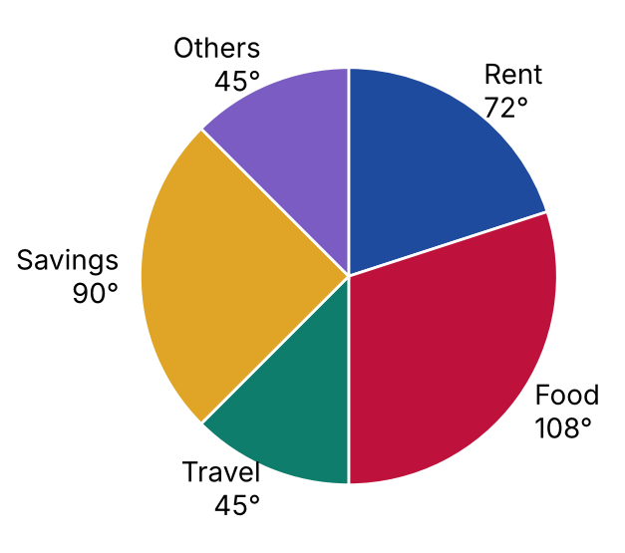
{OPTION 1} ₹4,200
{OPTION 2} ₹6,000
{OPTION 3} ₹3,000
{OPTION 4} ₹2,400
{OPTION 5}
{OPTION 6}
{OPTION 7}
{OPTION 8}
{OPTION 9}
{OPTION 10}
{RIGHT ANSWER} 3
{EXPLANATION} Savings is 90° of 360°, so the total income = 15,000 × 360 / 90 = ₹60,000. Food = 18,000. The difference works out to ₹3,000.
{CORRECT MARKS} 1
{NEGATIVE MARKS} 0
{DIFFICULTY} Hard
{QUESTION ENDS}

{QUESTION BEGINS}
{QUESTION NUMBER} 55
{SUBJECT} Reasoning Ability
{TOPIC} Seating Arrangement
{TAGS} tcs nqt, reasoning ability, hard
{QUESTION TYPE} SINGLECORRECT
{QUESTION TEXT} Eight friends Aarav, Bhumi, Chetan, Divya, Eshan, Farah, Gopal and Hema sit in two rows of four seats each. The friends in the first row face south and the friends in the second row face north, so every person faces exactly one person of the other row. Farah sits at one of the ends of a row. Farah sits in the first row. Aarav is an immediate neighbour of Farah. Gopal sits in the first row. Eshan sits in the second row. Divya sits opposite Hema. Gopal sits at one of the ends of a row. Bhumi does not sit at an end of a row.
Who sits opposite Aarav?
{OPTION 1} Eshan
{OPTION 2} Divya
{OPTION 3} Bhumi
{OPTION 4} Chetan
{OPTION 5}
{OPTION 6}
{OPTION 7}
{OPTION 8}
{OPTION 9}
{OPTION 10}
{RIGHT ANSWER} 3
{EXPLANATION} All 8 seatings that satisfy every statement were examined; in every one of them Bhumi sits opposite Aarav. One valid seating is: first row Farah Aarav Divya Gopal, second row Chetan Bhumi Hema Eshan.
{CORRECT MARKS} 1
{NEGATIVE MARKS} 0
{DIFFICULTY} Hard
{QUESTION ENDS}

{QUESTION BEGINS}
{QUESTION NUMBER} 56
{SUBJECT} Reasoning Ability
{TOPIC} Figure Analogy
{TAGS} tcs nqt, reasoning ability, figure based, hard
{QUESTION TYPE} SINGLECORRECT
{QUESTION TEXT} Find the figure that bears the same relation to figure C as figure B bears to figure A.
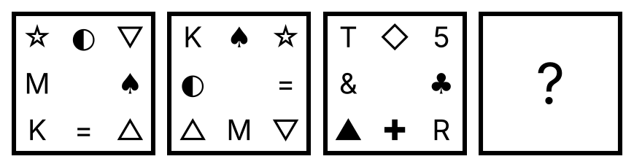
{OPTION 1} 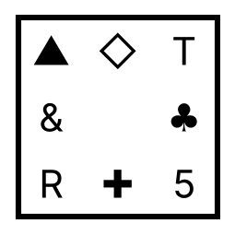
{OPTION 2} 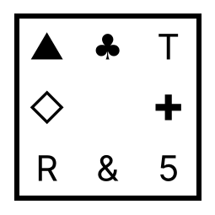
{OPTION 3} 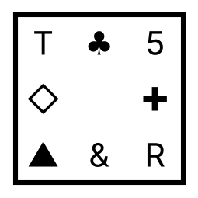
{OPTION 4} 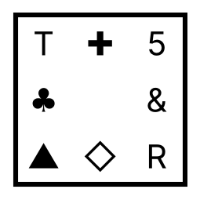
{OPTION 5}
{OPTION 6}
{OPTION 7}
{OPTION 8}
{OPTION 9}
{OPTION 10}
{RIGHT ANSWER} 2
{EXPLANATION} From the first figure to the second, the four corner symbols each move one corner clockwise while the four symbols in the middle of the sides each move one side anticlockwise. Doing the same to the third figure gives the answer.
{CORRECT MARKS} 1
{NEGATIVE MARKS} 0
{DIFFICULTY} Hard
{QUESTION ENDS}

{QUESTION BEGINS}
{QUESTION NUMBER} 57
{SUBJECT} Reasoning Ability
{TOPIC} Alphanumeric Series
{TAGS} tcs nqt, reasoning ability, hard
{QUESTION TYPE} SINGLECORRECT
{QUESTION TEXT} Find the next term of the series: B2D, E5H, H11L, K23P, ?
{OPTION 1} N47P
{OPTION 2} N48T
{OPTION 3} O47T
{OPTION 4} N47T
{OPTION 5}
{OPTION 6}
{OPTION 7}
{OPTION 8}
{OPTION 9}
{OPTION 10}
{RIGHT ANSWER} 4
{EXPLANATION} The first letters move 3 places each time (B, E, H, K, …), the numbers follow 'double and add 1' (2, 5, 11, 23, 47) and the last letters move 4 places each time (D, H, L, P, …). The next term is N47T.
{CORRECT MARKS} 1
{NEGATIVE MARKS} 0
{DIFFICULTY} Hard
{QUESTION ENDS}

{QUESTION BEGINS}
{QUESTION NUMBER} 58
{SUBJECT} Reasoning Ability
{TOPIC} Data Sufficiency
{TAGS} tcs nqt, reasoning ability, hard
{QUESTION TYPE} SINGLECORRECT
{QUESTION TEXT} Question: What is the code for 'blue' in a certain code language?
Statement I: In that code language, 'blue sky' is written as 'ni po' and 'sky day' is written as 'po ru'.
Statement II: In that code language, 'day night' is written as 'ru ta' and 'sun moon' is written as 'zu ke'.
Which of the following is correct?
{OPTION 1} Even both statements together are not sufficient
{OPTION 2} Statement II alone is sufficient
{OPTION 3} Statement I alone is sufficient
{OPTION 4} Both statements together are needed
{OPTION 5}
{OPTION 6}
{OPTION 7}
{OPTION 8}
{OPTION 9}
{OPTION 10}
{RIGHT ANSWER} 3
{EXPLANATION} From statement I: 'sky' is common to both groups, and the common code is 'po', so 'sky' = po and therefore 'blue' = ni. So statement I alone is sufficient. Statement II does not mention 'blue' and cannot give its code.
{CORRECT MARKS} 1
{NEGATIVE MARKS} 0
{DIFFICULTY} Hard
{QUESTION ENDS}

{QUESTION BEGINS}
{QUESTION NUMBER} 59
{SUBJECT} Reasoning Ability
{TOPIC} Clock
{TAGS} tcs nqt, reasoning ability, hard
{QUESTION TYPE} SINGLECORRECT
{QUESTION TEXT} A watch gains 2 minutes every hour. It was set right at 7:00 a.m. When the watch shows 7:24 p.m. on the same day, what is the correct time?
{OPTION 1} 6:48 p.m.
{OPTION 2} 7:12 p.m.
{OPTION 3} 6:36 p.m.
{OPTION 4} 7:00 p.m.
{OPTION 5}
{OPTION 6}
{OPTION 7}
{OPTION 8}
{OPTION 9}
{OPTION 10}
{RIGHT ANSWER} 4
{EXPLANATION} The watch shows 12 h 24 min = 744 minutes. In every real 60 minutes the watch shows 62 minutes, so the real time elapsed = 744 × 60/62 = 720 minutes = 12 hours. The correct time is 7:00 a.m. + 12 h = 7:00 p.m.
{CORRECT MARKS} 1
{NEGATIVE MARKS} 0
{DIFFICULTY} Hard
{QUESTION ENDS}

{QUESTION BEGINS}
{QUESTION NUMBER} 60
{SUBJECT} Reasoning Ability
{TOPIC} Seating Arrangement
{TAGS} tcs nqt, reasoning ability, hard
{QUESTION TYPE} SINGLECORRECT
{QUESTION TEXT} Seven friends Dev, Esha, Farid, Gita, Hari, Isha and Jay sit in a row facing North. Dev sits second from the left end. Esha sits at the left end. Jay sits third from the right end. Isha sits second to the right of Esha. Gita sits third to the right of Esha. Farid sits at one of the ends.
Who sits immediately to the right of Gita?
{OPTION 1} Dev
{OPTION 2} Jay
{OPTION 3} Esha
{OPTION 4} Farid
{OPTION 5}
{OPTION 6}
{OPTION 7}
{OPTION 8}
{OPTION 9}
{OPTION 10}
{RIGHT ANSWER} 2
{EXPLANATION} Placing the friends one condition at a time leaves only one possible row (from the left): Esha Dev Isha Gita Jay Hari Farid. In this row Jay sits immediately to the right of Gita.
{CORRECT MARKS} 1
{NEGATIVE MARKS} 0
{DIFFICULTY} Hard
{QUESTION ENDS}

{QUESTION BEGINS}
{QUESTION NUMBER} 61
{SUBJECT} Reasoning Ability
{TOPIC} Coding-Decoding
{TAGS} tcs nqt, reasoning ability, hard
{QUESTION TYPE} SINGLECORRECT
{QUESTION TEXT} In a certain code language, DOG is coded as 32; BIRD is coded as 41. How is FISH coded in the same language?
{OPTION 1} 54
{OPTION 2} 47
{OPTION 3} 50
{OPTION 4} 42
{OPTION 5}
{OPTION 6}
{OPTION 7}
{OPTION 8}
{OPTION 9}
{OPTION 10}
{RIGHT ANSWER} 3
{EXPLANATION} The code of a word = (sum of the alphabet positions of its letters) + 2 × (number of letters). DOG: 26 → 32; BIRD: 33 → 41. For FISH: sum of positions = 42, so the code is 50.
{CORRECT MARKS} 1
{NEGATIVE MARKS} 0
{DIFFICULTY} Hard
{QUESTION ENDS}

{QUESTION BEGINS}
{QUESTION NUMBER} 62
{SUBJECT} Reasoning Ability
{TOPIC} Letter Analogy
{TAGS} tcs nqt, reasoning ability, hard
{QUESTION TYPE} SINGLECORRECT
{QUESTION TEXT} Find the missing term: TABLE : GZYOV :: CHAIR : ?
{OPTION 1} IRZSX
{OPTION 2} XSZRI
{OPTION 3} YTASJ
{OPTION 4} RIAHC
{OPTION 5}
{OPTION 6}
{OPTION 7}
{OPTION 8}
{OPTION 9}
{OPTION 10}
{RIGHT ANSWER} 2
{EXPLANATION} In the first pair every letter is replaced by its opposite letter in the alphabet (A ↔ Z, B ↔ Y, C ↔ X, …): TABLE → GZYOV. Doing the same to CHAIR: XSZRI.
{CORRECT MARKS} 1
{NEGATIVE MARKS} 0
{DIFFICULTY} Hard
{QUESTION ENDS}

{QUESTION BEGINS}
{QUESTION NUMBER} 63
{SUBJECT} Reasoning Ability
{TOPIC} Blood Relations
{TAGS} tcs nqt, reasoning ability, hard
{QUESTION TYPE} SINGLECORRECT
{QUESTION TEXT} Read the statements: C is the mother of D. F is the father of I. F is the father of H. C is the mother of H. I is the father of K.
How is H (a woman) related to K?
{OPTION 1} Paternal aunt
{OPTION 2} Daughter-in-law
{OPTION 3} Maternal aunt
{OPTION 4} Sister-in-law
{OPTION 5}
{OPTION 6}
{OPTION 7}
{OPTION 8}
{OPTION 9}
{OPTION 10}
{RIGHT ANSWER} 1
{EXPLANATION} Draw the family tree from the statements: C is the mother of D; F is the father of I; F is the father of H; C is the mother of H; I is the father of K. In this tree H is the sister of K's father, so H is the paternal aunt of K.
{CORRECT MARKS} 1
{NEGATIVE MARKS} 0
{DIFFICULTY} Hard
{QUESTION ENDS}

{QUESTION BEGINS}
{QUESTION NUMBER} 64
{SUBJECT} Reasoning Ability
{TOPIC} Inequalities
{TAGS} tcs nqt, reasoning ability, hard
{QUESTION TYPE} SINGLECORRECT
{QUESTION TEXT} In the following question the symbols have these meanings: 'A % B' means A is greater than B; 'A ★ B' means A is greater than or equal to B; 'A # B' means A is less than B; 'A & B' means A is less than or equal to B; 'A $ B' means A is equal to B.
Statement: O % L % N $ M ★ K
Conclusions:
I. M $ K
II. K & N
III. K & O
IV. M ★ O
Which of the following is/are definitely true?
{OPTION 1} All the conclusions follow
{OPTION 2} Only I follows
{OPTION 3} Only I and II follow
{OPTION 4} Only II and III follow
{OPTION 5}
{OPTION 6}
{OPTION 7}
{OPTION 8}
{OPTION 9}
{OPTION 10}
{RIGHT ANSWER} 4
{EXPLANATION} Decoding the statement gives O > L > N = M ≥ K. Check each conclusion for every value that satisfies the chain (all combinations were tested): I is not definitely true. II is definitely true. III is definitely true. IV is not definitely true.
{CORRECT MARKS} 1
{NEGATIVE MARKS} 0
{DIFFICULTY} Hard
{QUESTION ENDS}

{QUESTION BEGINS}
{QUESTION NUMBER} 65
{SUBJECT} Reasoning Ability
{TOPIC} Odd One Out
{TAGS} tcs nqt, reasoning ability, figure based, hard
{QUESTION TYPE} SINGLECORRECT
{QUESTION TEXT} Which one of the four figures is different from the other three?
{OPTION 1} 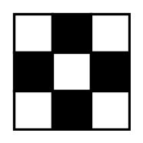
{OPTION 2} 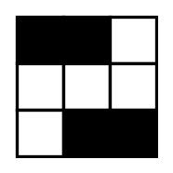
{OPTION 3} 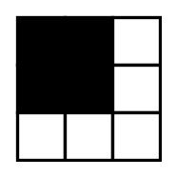
{OPTION 4} 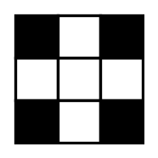
{OPTION 5}
{OPTION 6}
{OPTION 7}
{OPTION 8}
{OPTION 9}
{OPTION 10}
{RIGHT ANSWER} 3
{EXPLANATION} Three of the figures look exactly the same after being turned through 180°; the fourth does not, so it is the odd one out.
{CORRECT MARKS} 1
{NEGATIVE MARKS} 0
{DIFFICULTY} Hard
{QUESTION ENDS}

{QUESTION BEGINS}
{QUESTION NUMBER} 66
{SUBJECT} Reasoning Ability
{TOPIC} Syllogism
{TAGS} tcs nqt, reasoning ability, hard
{QUESTION TYPE} SINGLECORRECT
{QUESTION TEXT} Statements: No lake is an ocean. All oceans are ponds. Some ponds are rivers.
Conclusions:
I. All rivers are lakes.
II. No pond is a lake.
III. All ponds are rivers.
IV. Some rivers are ponds.
Which of the following is correct?
{OPTION 1} Only I follows
{OPTION 2} Only IV follows
{OPTION 3} Only I and IV follow
{OPTION 4} Only I, II and IV follow
{OPTION 5}
{OPTION 6}
{OPTION 7}
{OPTION 8}
{OPTION 9}
{OPTION 10}
{RIGHT ANSWER} 2
{EXPLANATION} Draw the Venn diagram for the statements and test each conclusion in every possible diagram. I does not follow. II does not follow. III does not follow. IV follows. Only IV follows.
{CORRECT MARKS} 1
{NEGATIVE MARKS} 0
{DIFFICULTY} Hard
{QUESTION ENDS}

{QUESTION BEGINS}
{QUESTION NUMBER} 67
{SUBJECT} Reasoning Ability
{TOPIC} Clock
{TAGS} tcs nqt, reasoning ability, hard
{QUESTION TYPE} SINGLECORRECT
{QUESTION TEXT} At what time between 2 and 3 o'clock will the hands of a clock be at right angles to each other for the first time after 2 o'clock?
{OPTION 1} 28 minutes past 2
{OPTION 2} 25 minutes past 2
{OPTION 3} 27 3/11 minutes past 2
{OPTION 4} 27 1/11 minutes past 2
{OPTION 5}
{OPTION 6}
{OPTION 7}
{OPTION 8}
{OPTION 9}
{OPTION 10}
{RIGHT ANSWER} 3
{EXPLANATION} At m minutes past 2 the minute hand is at 6m° and the hour hand at 60 + m/2 degrees. The hands are at right angles when 6m − (60 + m/2) = +90 or −90, that is 5.5m = 150 or 5.5m = -30. This gives m = 300/11 or m = -60/11; the values between 0 and 60 are 300/11, so the first time after 2 o'clock is 27 3/11 minutes past 2.
{CORRECT MARKS} 1
{NEGATIVE MARKS} 0
{DIFFICULTY} Hard
{QUESTION ENDS}

{QUESTION BEGINS}
{QUESTION NUMBER} 68
{SUBJECT} Reasoning Ability
{TOPIC} Letter Series
{TAGS} tcs nqt, reasoning ability, hard
{QUESTION TYPE} SINGLECORRECT
{QUESTION TEXT} Find the next two letters of the series: Z, A, Y, B, X, C, W, D, ?, ?
{OPTION 1} V, V
{OPTION 2} V, E
{OPTION 3} W, D
{OPTION 4} E, V
{OPTION 5}
{OPTION 6}
{OPTION 7}
{OPTION 8}
{OPTION 9}
{OPTION 10}
{RIGHT ANSWER} 2
{EXPLANATION} Letters in the odd places go backwards from Z (Z, Y, X, W, …) and letters in the even places go forwards from A (A, B, C, D, …). The next two letters are V and E.
{CORRECT MARKS} 1
{NEGATIVE MARKS} 0
{DIFFICULTY} Hard
{QUESTION ENDS}

{QUESTION BEGINS}
{QUESTION NUMBER} 69
{SUBJECT} Reasoning Ability
{TOPIC} Logical Deduction
{TAGS} tcs nqt, reasoning ability, hard
{QUESTION TYPE} SINGLECORRECT
{QUESTION TEXT} Statements: If the signal is red, the train stops. If the train stops, the passengers get off. The passengers did not get off.
Which of the following conclusions is definitely true?
{OPTION 1} The train stopped but the signal was not red
{OPTION 2} The train did not stop and the signal was not red
{OPTION 3} The signal was red
{OPTION 4} The signal was not red but the train stopped
{OPTION 5}
{OPTION 6}
{OPTION 7}
{OPTION 8}
{OPTION 9}
{OPTION 10}
{RIGHT ANSWER} 2
{EXPLANATION} 'Not R' means the passengers did not get off. Since stopping leads to getting off, the train cannot have stopped. And since a red signal leads to stopping, the signal cannot have been red either.
{CORRECT MARKS} 1
{NEGATIVE MARKS} 0
{DIFFICULTY} Hard
{QUESTION ENDS}

{QUESTION BEGINS}
{QUESTION NUMBER} 70
{SUBJECT} Reasoning Ability
{TOPIC} Ages
{TAGS} tcs nqt, reasoning ability, hard
{QUESTION TYPE} SINGLECORRECT
{QUESTION TEXT} The present ages of a father and his son are in the ratio 5 : 3 and the sum of their ages is 72 years. What will be the sum of the digits of the father's age after 15 years?
{OPTION 1} 5
{OPTION 2} 10
{OPTION 3} 8
{OPTION 4} 6
{OPTION 5}
{OPTION 6}
{OPTION 7}
{OPTION 8}
{OPTION 9}
{OPTION 10}
{RIGHT ANSWER} 4
{EXPLANATION} The father's age = 72 × 5/8 = 45 years and the son's age = 27. After 15 years the father is 60, and the sum of its digits is 6.
{CORRECT MARKS} 1
{NEGATIVE MARKS} 0
{DIFFICULTY} Hard
{QUESTION ENDS}

{QUESTION BEGINS}
{QUESTION NUMBER} 71
{SUBJECT} Reasoning Ability
{TOPIC} Dice
{TAGS} tcs nqt, reasoning ability, figure based, hard
{QUESTION TYPE} SINGLECORRECT
{QUESTION TEXT} A die has numbers 1 to 6 on its faces, with the numbers on opposite faces adding up to 7. It is placed at the Start cell with 2 on top, 3 in front and 1 on the right (see the figure). It is rolled over its edges, one cell at a time, in the order North, East, East, North, West, South. Which number is on the top face in the End cell?
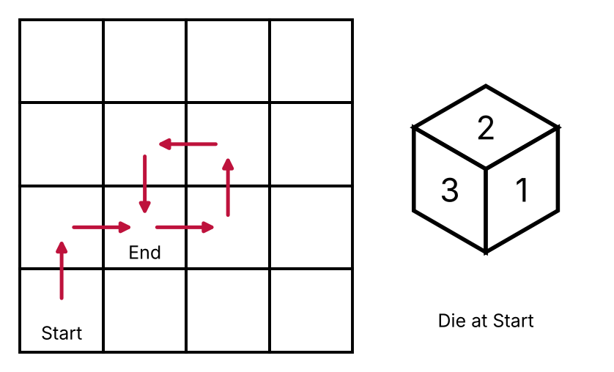
{OPTION 1} 2
{OPTION 2} 4
{OPTION 3} 1
{OPTION 4} 3
{OPTION 5}
{OPTION 6}
{OPTION 7}
{OPTION 8}
{OPTION 9}
{OPTION 10}
{RIGHT ANSWER} 2
{EXPLANATION} Track (top, front, right) while rolling: start (2, 3, 1); North: (3, 5, 5); East: (2, 5, 3); East: (4, 5, 2); North: (5, 3, 2); West: (2, 3, 2); South: (4, 2, 2). The top face at the End cell is 4.
{CORRECT MARKS} 1
{NEGATIVE MARKS} 0
{DIFFICULTY} Hard
{QUESTION ENDS}

{QUESTION BEGINS}
{QUESTION NUMBER} 72
{SUBJECT} Reasoning Ability
{TOPIC} Data Sufficiency
{TAGS} tcs nqt, reasoning ability, hard
{QUESTION TYPE} SINGLECORRECT
{QUESTION TEXT} Question: Among A, B, C, D and E, who is the tallest?
Statement I: A is taller than C. B is taller than D.
Statement II: C is taller than E. E is taller than B.
Which of the following is correct?
{OPTION 1} Statement II alone is sufficient
{OPTION 2} Both statements together are needed
{OPTION 3} Even both statements together are not sufficient
{OPTION 4} Statement I alone is sufficient
{OPTION 5}
{OPTION 6}
{OPTION 7}
{OPTION 8}
{OPTION 9}
{OPTION 10}
{RIGHT ANSWER} 2
{EXPLANATION} Statement I alone leaves more than one possible tallest person (A, B, E); statement II alone also leaves more than one (A, C, D). Together only A can be the tallest, so both are needed.
{CORRECT MARKS} 1
{NEGATIVE MARKS} 0
{DIFFICULTY} Hard
{QUESTION ENDS}

{QUESTION BEGINS}
{QUESTION NUMBER} 73
{SUBJECT} Reasoning Ability
{TOPIC} Clock
{TAGS} tcs nqt, reasoning ability, hard
{QUESTION TYPE} SINGLECORRECT
{QUESTION TEXT} What is the smaller angle between the hour hand and the minute hand of a clock at 5:48?
{OPTION 1} 114°
{OPTION 2} 99°
{OPTION 3} 246°
{OPTION 4} 121.5°
{OPTION 5}
{OPTION 6}
{OPTION 7}
{OPTION 8}
{OPTION 9}
{OPTION 10}
{RIGHT ANSWER} 1
{EXPLANATION} Angle = |30 × 5 − 5.5 × 48| = |150 − 264.0| = 114.0°, and the smaller angle is 114°.
{CORRECT MARKS} 1
{NEGATIVE MARKS} 0
{DIFFICULTY} Hard
{QUESTION ENDS}

{QUESTION BEGINS}
{QUESTION NUMBER} 74
{SUBJECT} Reasoning Ability
{TOPIC} Table Reasoning
{TAGS} tcs nqt, reasoning ability, figure based, hard
{QUESTION TYPE} SINGLECORRECT
{QUESTION TEXT} The table shows the matches played, matches won and net run rate of five teams. A win gives 2 points; teams on equal points are ranked by net run rate (higher is better). Which team is ranked third?
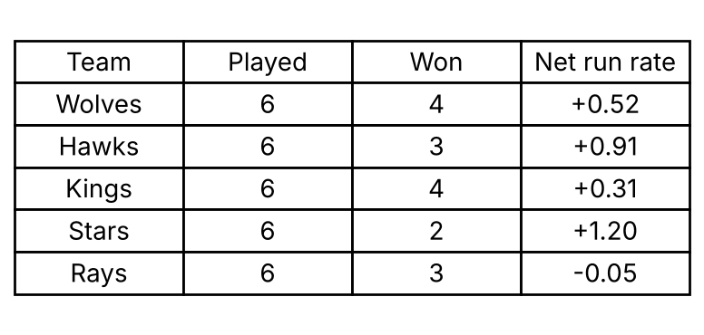
{OPTION 1} Hawks
{OPTION 2} Kings
{OPTION 3} Stars
{OPTION 4} Wolves
{OPTION 5}
{OPTION 6}
{OPTION 7}
{OPTION 8}
{OPTION 9}
{OPTION 10}
{RIGHT ANSWER} 1
{EXPLANATION} Ranking order after applying the rule: Wolves, Kings, Hawks, Rays, Stars. So the team ranked third is Hawks.
{CORRECT MARKS} 1
{NEGATIVE MARKS} 0
{DIFFICULTY} Hard
{QUESTION ENDS}

{QUESTION BEGINS}
{QUESTION NUMBER} 75
{SUBJECT} Reasoning Ability
{TOPIC} Coding-Decoding
{TAGS} tcs nqt, reasoning ability, hard
{QUESTION TYPE} SINGLECORRECT
{QUESTION TEXT} In a certain code language, STUDENT is written as TWWHHSX. How is TEACHER written in that code language?
{OPTION 1} UHCGKJV
{OPTION 2} VIDHLKW
{OPTION 3} WGEFMIS
{OPTION 4} SBYYEZN
{OPTION 5}
{OPTION 6}
{OPTION 7}
{OPTION 8}
{OPTION 9}
{OPTION 10}
{RIGHT ANSWER} 1
{EXPLANATION} Compare the letters of STUDENT and TWWHHSX: the shifts are +1, +3, +2, +4, +3, +5, +4 in order. Applying the same shifts to TEACHER gives UHCGKJV.
{CORRECT MARKS} 1
{NEGATIVE MARKS} 0
{DIFFICULTY} Hard
{QUESTION ENDS}

{QUESTION BEGINS}
{QUESTION NUMBER} 76
{SUBJECT} Reasoning Ability
{TOPIC} Coding-Decoding
{TAGS} tcs nqt, reasoning ability, figure based, hard
{QUESTION TYPE} SINGLECORRECT
{QUESTION TEXT} In the figure a letter is coded by the row number followed by the column number of its position (the columns of Matrix I are 0 to 3 and the columns of Matrix II are 4 to 7). For example, the first letter of the first row of Matrix I is coded 00. How is the word MATE coded?
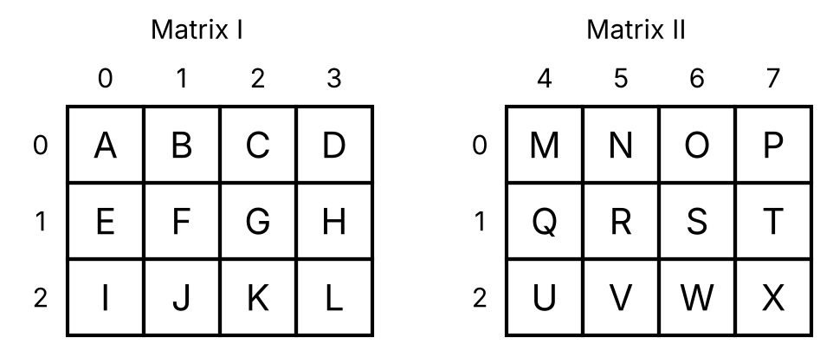
{OPTION 1} 05, 01, 10, 11
{OPTION 2} 40, 00, 71, 01
{OPTION 3} 10, 17, 00, 04
{OPTION 4} 04, 00, 17, 10
{OPTION 5}
{OPTION 6}
{OPTION 7}
{OPTION 8}
{OPTION 9}
{OPTION 10}
{RIGHT ANSWER} 4
{EXPLANATION} Find each letter in the matrices and write its row number followed by its column number: M = 04; A = 00; T = 17; E = 10. So MATE is coded as 04, 00, 17, 10.
{CORRECT MARKS} 1
{NEGATIVE MARKS} 0
{DIFFICULTY} Hard
{QUESTION ENDS}

{QUESTION BEGINS}
{QUESTION NUMBER} 77
{SUBJECT} Reasoning Ability
{TOPIC} Cubes
{TAGS} tcs nqt, reasoning ability, figure based, hard
{QUESTION TYPE} SINGLECORRECT
{QUESTION TEXT} The figure shows a solid made of unit cubes (a 3 × 3 × 3 cube from which some unit cubes have been removed). How many unit squares make up the whole outer surface of the solid, including the bottom?
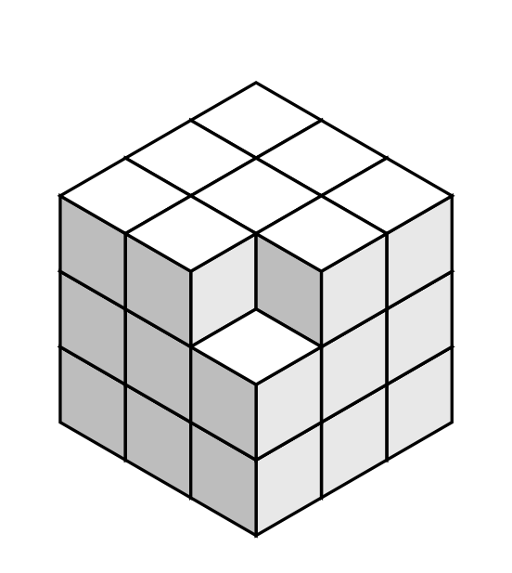
{OPTION 1} 58
{OPTION 2} 54
{OPTION 3} 52
{OPTION 4} 56
{OPTION 5}
{OPTION 6}
{OPTION 7}
{OPTION 8}
{OPTION 9}
{OPTION 10}
{RIGHT ANSWER} 2
{EXPLANATION} Count the exposed faces of all 26 unit cubes: 54.
{CORRECT MARKS} 1
{NEGATIVE MARKS} 0
{DIFFICULTY} Hard
{QUESTION ENDS}

{QUESTION BEGINS}
{QUESTION NUMBER} 78
{SUBJECT} Reasoning Ability
{TOPIC} Embedded Figure
{TAGS} tcs nqt, reasoning ability, figure based, hard
{QUESTION TYPE} SINGLECORRECT
{QUESTION TEXT} Select the figure in which the given figure is embedded (same size and orientation).
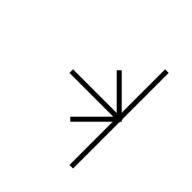
{OPTION 1} 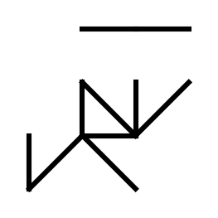
{OPTION 2} 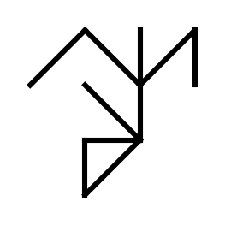
{OPTION 3} 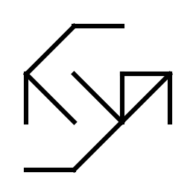
{OPTION 4} 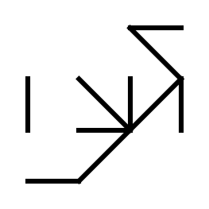
{OPTION 5}
{OPTION 6}
{OPTION 7}
{OPTION 8}
{OPTION 9}
{OPTION 10}
{RIGHT ANSWER} 4
{EXPLANATION} The given figure has five line segments. Each wrong option misses exactly one of them, so the figure cannot be found complete in it; only option 1 contains all five segments.
{CORRECT MARKS} 1
{NEGATIVE MARKS} 0
{DIFFICULTY} Hard
{QUESTION ENDS}

{QUESTION BEGINS}
{QUESTION NUMBER} 79
{SUBJECT} Reasoning Ability
{TOPIC} Classification
{TAGS} tcs nqt, reasoning ability, hard
{QUESTION TYPE} SINGLECORRECT
{QUESTION TEXT} Four of the following five numbers belong to the same group. Find the one that does NOT belong: 196, 225, 289, 361, 250
{OPTION 1} 289
{OPTION 2} 196
{OPTION 3} 225
{OPTION 4} 250
{OPTION 5}
{OPTION 6}
{OPTION 7}
{OPTION 8}
{OPTION 9}
{OPTION 10}
{RIGHT ANSWER} 4
{EXPLANATION} 196, 225, 289 and 361 are 14², 15², 17² and 19². 250 is not a perfect square.
{CORRECT MARKS} 1
{NEGATIVE MARKS} 0
{DIFFICULTY} Hard
{QUESTION ENDS}

{QUESTION BEGINS}
{QUESTION NUMBER} 80
{SUBJECT} Reasoning Ability
{TOPIC} Number Series
{TAGS} tcs nqt, reasoning ability, hard
{QUESTION TYPE} SINGLECORRECT
{QUESTION TEXT} Find the next term of the series: 5, 2, 9, 6, 13, 18, 17, ?
{OPTION 1} 49
{OPTION 2} 61
{OPTION 3} 67
{OPTION 4} 54
{OPTION 5}
{OPTION 6}
{OPTION 7}
{OPTION 8}
{OPTION 9}
{OPTION 10}
{RIGHT ANSWER} 4
{EXPLANATION} Alternate terms form two series. Terms 1, 3, 5, 7 increase by 4 each time, and terms 2, 4, 6, 8 are multiplied by 3 each time: 2, 6, 18, 54. The next term is 54.
{CORRECT MARKS} 1
{NEGATIVE MARKS} 0
{DIFFICULTY} Hard
{QUESTION ENDS}

{QUESTION BEGINS}
{QUESTION NUMBER} 81
{SUBJECT} Reasoning Ability
{TOPIC} Ranking
{TAGS} tcs nqt, reasoning ability, hard
{QUESTION TYPE} SINGLECORRECT
{QUESTION TEXT} In a row of 45 students, Mohan is 18th from the left end. When Mohan exchanges position with Sohan, Mohan becomes 14th from the right end. How many students are between Mohan and Sohan in the original row?
{OPTION 1} 14
{OPTION 2} 15
{OPTION 3} 13
{OPTION 4} 12
{OPTION 5}
{OPTION 6}
{OPTION 7}
{OPTION 8}
{OPTION 9}
{OPTION 10}
{RIGHT ANSWER} 3
{EXPLANATION} After the exchange Mohan stands where Sohan stood, which is 14th from the right: 45 − 14 + 1 = 32nd from the left. Originally Mohan was 18th from the left, so the students between them = 32 − 18 − 1 = 13.
{CORRECT MARKS} 1
{NEGATIVE MARKS} 0
{DIFFICULTY} Hard
{QUESTION ENDS}

{QUESTION BEGINS}
{QUESTION NUMBER} 82
{SUBJECT} Reasoning Ability
{TOPIC} Coding-Decoding
{TAGS} tcs nqt, reasoning ability, hard
{QUESTION TYPE} SINGLECORRECT
{QUESTION TEXT} In a certain code language, 'qo ve su' means 'green grape red'; 'jy ni pa' means 'apple lemon blue'; 'jy su ve' means 'apple red grape'. What is the code for 'green' in that language?
{OPTION 1} ni
{OPTION 2} pa
{OPTION 3} qo
{OPTION 4} su
{OPTION 5}
{OPTION 6}
{OPTION 7}
{OPTION 8}
{OPTION 9}
{OPTION 10}
{RIGHT ANSWER} 3
{EXPLANATION} Find the words common to two statements and match their common codes; this fixes the codes one by one. Checking every possible assignment of codes to words shows that the code of 'green' is qo.
{CORRECT MARKS} 1
{NEGATIVE MARKS} 0
{DIFFICULTY} Hard
{QUESTION ENDS}

{QUESTION BEGINS}
{QUESTION NUMBER} 83
{SUBJECT} Reasoning Ability
{TOPIC} Counting Figures
{TAGS} tcs nqt, reasoning ability, figure based, hard
{QUESTION TYPE} SINGLECORRECT
{QUESTION TEXT} The figure is an equilateral triangle divided into small equilateral triangles by lines parallel to its sides, with 6 divisions along each side. How many triangles of all sizes are there in the figure?
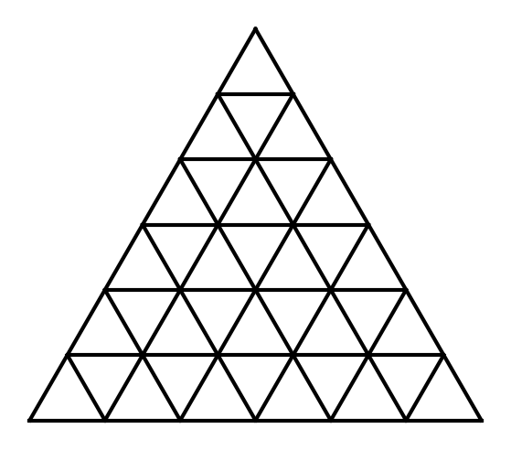
{OPTION 1} 90
{OPTION 2} 71
{OPTION 3} 78
{OPTION 4} 85
{OPTION 5}
{OPTION 6}
{OPTION 7}
{OPTION 8}
{OPTION 9}
{OPTION 10}
{RIGHT ANSWER} 3
{EXPLANATION} Triangles pointing up: 56; triangles pointing down: 22. Total = 56 + 22 = 78.
{CORRECT MARKS} 1
{NEGATIVE MARKS} 0
{DIFFICULTY} Hard
{QUESTION ENDS}

{QUESTION BEGINS}
{QUESTION NUMBER} 84
{SUBJECT} Reasoning Ability
{TOPIC} Directions
{TAGS} tcs nqt, reasoning ability, hard
{QUESTION TYPE} SINGLECORRECT
{QUESTION TEXT} A girl is facing South. She turns 45° clockwise, then 225° anticlockwise, then 180° anticlockwise, then 225° anticlockwise. In which direction is she facing now?
{OPTION 1} North-East
{OPTION 2} North-West
{OPTION 3} South-East
{OPTION 4} North
{OPTION 5}
{OPTION 6}
{OPTION 7}
{OPTION 8}
{OPTION 9}
{OPTION 10}
{RIGHT ANSWER} 2
{EXPLANATION} Start at 180° (measuring clockwise from North). After turning 45° clockwise: 225°. After turning 225° anticlockwise: 0°. After turning 180° anticlockwise: 180°. After turning 225° anticlockwise: 315°. The final direction is 315°, which is North-West.
{CORRECT MARKS} 1
{NEGATIVE MARKS} 0
{DIFFICULTY} Hard
{QUESTION ENDS}

{QUESTION BEGINS}
{QUESTION NUMBER} 85
{SUBJECT} Reasoning Ability
{TOPIC} Number Series
{TAGS} tcs nqt, reasoning ability, hard
{QUESTION TYPE} SINGLECORRECT
{QUESTION TEXT} Find the next term of the series: 7, 8, 16, 43, 107, ?
{OPTION 1} 227
{OPTION 2} 245
{OPTION 3} 239
{OPTION 4} 232
{OPTION 5}
{OPTION 6}
{OPTION 7}
{OPTION 8}
{OPTION 9}
{OPTION 10}
{RIGHT ANSWER} 4
{EXPLANATION} The differences between consecutive terms are the cubes 1, 8, 27, 64, so the next difference is 125 and the next term is 232.
{CORRECT MARKS} 1
{NEGATIVE MARKS} 0
{DIFFICULTY} Hard
{QUESTION ENDS}

{QUESTION BEGINS}
{QUESTION NUMBER} 86
{SUBJECT} Reasoning Ability
{TOPIC} Number Puzzle
{TAGS} tcs nqt, reasoning ability, figure based, hard
{QUESTION TYPE} SINGLECORRECT
{QUESTION TEXT} What number should replace the question mark in the third triangle, if all three triangles follow the same rule?
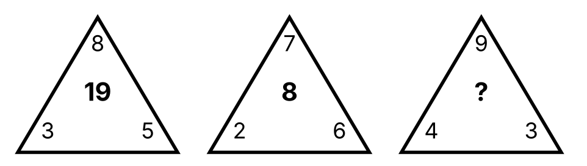
{OPTION 1} 33
{OPTION 2} 35
{OPTION 3} 37
{OPTION 4} 31
{OPTION 5}
{OPTION 6}
{OPTION 7}
{OPTION 8}
{OPTION 9}
{OPTION 10}
{RIGHT ANSWER} 1
{EXPLANATION} In each triangle the number in the middle = (top × left) − right. First triangle: 19; second: 8; third: 33.
{CORRECT MARKS} 1
{NEGATIVE MARKS} 0
{DIFFICULTY} Hard
{QUESTION ENDS}

{QUESTION BEGINS}
{QUESTION NUMBER} 87
{SUBJECT} Reasoning Ability
{TOPIC} Seating Arrangement
{TAGS} tcs nqt, reasoning ability, hard
{QUESTION TYPE} SINGLECORRECT
{QUESTION TEXT} 8 friends Kiran, Lata, Mohan, Neel, Opal, Pooja, Qadir and Rahul sit around a circular table. All of them face the centre of the table. Opal sits second to the left of Rahul. Neel sits immediately to the right of Opal. Mohan sits opposite Rahul. Opal sits immediately to the right of Qadir. Rahul sits third to the left of Pooja. Kiran sits third to the left of Qadir.
Who sits second to the right of Neel?
{OPTION 1} Lata
{OPTION 2} Kiran
{OPTION 3} Opal
{OPTION 4} Mohan
{OPTION 5}
{OPTION 6}
{OPTION 7}
{OPTION 8}
{OPTION 9}
{OPTION 10}
{RIGHT ANSWER} 1
{EXPLANATION} (For a person facing the centre, left means clockwise; for a person facing outwards it means anticlockwise.) Using all the conditions, the only possible seating clockwise from Kiran is Kiran, Lata, Rahul, Neel, Opal, Qadir, Mohan, Pooja. Counting 2 place(s) to the right of Neel gives Lata.
{CORRECT MARKS} 1
{NEGATIVE MARKS} 0
{DIFFICULTY} Hard
{QUESTION ENDS}

{QUESTION BEGINS}
{QUESTION NUMBER} 88
{SUBJECT} Reasoning Ability
{TOPIC} Puzzle
{TAGS} tcs nqt, reasoning ability, hard
{QUESTION TYPE} SINGLECORRECT
{QUESTION TEXT} Six persons U, V, W, X, Y and Z have six different professions: architect, banker, cricketer, dancer, editor and farmer (one each). Y is not the farmer. X is either the editor or the farmer. W is either the dancer or the editor. U is either the architect or the editor. Z is either the dancer or the editor. W is not the editor. V is either the architect or the cricketer.
What is V's profession?
{OPTION 1} dancer
{OPTION 2} cricketer
{OPTION 3} architect
{OPTION 4} banker
{OPTION 5}
{OPTION 6}
{OPTION 7}
{OPTION 8}
{OPTION 9}
{OPTION 10}
{RIGHT ANSWER} 2
{EXPLANATION} Combining all the statements (all possible assignments were checked), exactly one arrangement is possible: U: architect, V: cricketer, W: dancer, X: farmer, Y: banker, Z: editor. So the answer is cricketer.
{CORRECT MARKS} 1
{NEGATIVE MARKS} 0
{DIFFICULTY} Hard
{QUESTION ENDS}

{QUESTION BEGINS}
{QUESTION NUMBER} 89
{SUBJECT} Reasoning Ability
{TOPIC} Cubes & Nets
{TAGS} tcs nqt, reasoning ability, figure based, hard
{QUESTION TYPE} SINGLECORRECT
{QUESTION TEXT} The figure shows a net followed by four boxes (1) to (4). How many of the four boxes can be formed by folding the net?
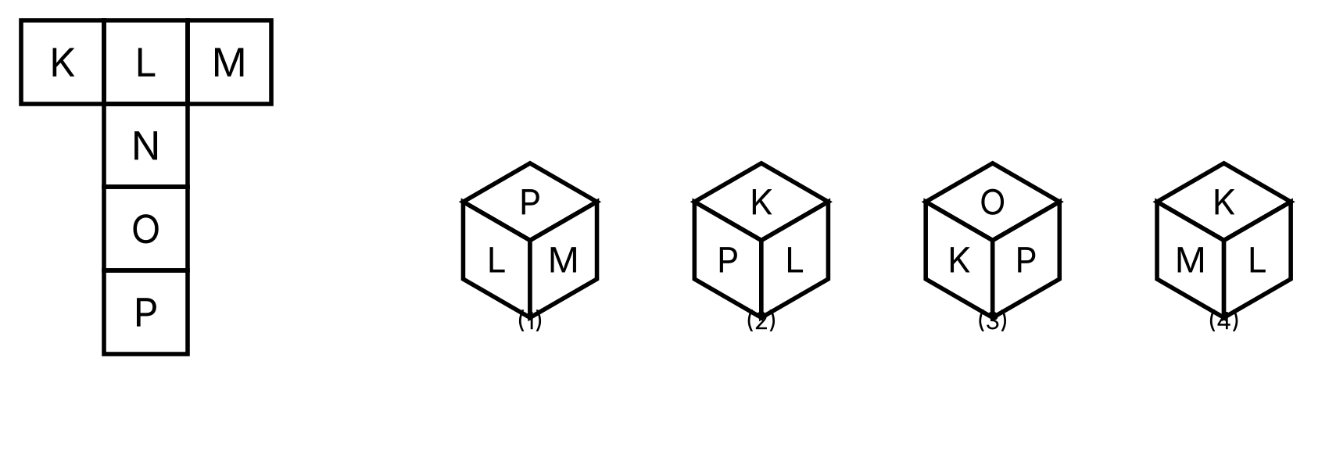
{OPTION 1} Three
{OPTION 2} Two
{OPTION 3} One
{OPTION 4} Zero
{OPTION 5}
{OPTION 6}
{OPTION 7}
{OPTION 8}
{OPTION 9}
{OPTION 10}
{RIGHT ANSWER} 2
{EXPLANATION} Box (4) shows two opposite faces together and is impossible; any box with the right faces in the wrong left–right order is a mirror image and impossible. Checking each box this way, two of the boxes can be formed.
{CORRECT MARKS} 1
{NEGATIVE MARKS} 0
{DIFFICULTY} Hard
{QUESTION ENDS}

{QUESTION BEGINS}
{QUESTION NUMBER} 90
{SUBJECT} Reasoning Ability
{TOPIC} Puzzle
{TAGS} tcs nqt, reasoning ability, hard
{QUESTION TYPE} SINGLECORRECT
{QUESTION TEXT} Five colleagues P, Q, R, S and T are on duty on five different days from Monday to Friday, one on each day. P is on duty earlier in the week than S. S does not work on Thursday. Q is on duty earlier in the week than P. Q is on duty earlier in the week than R. R does not work on Friday. R and Q work on consecutive days. Q works 2 days before P. Q and T work on consecutive days.
On which day is P on duty?
{OPTION 1} Thursday
{OPTION 2} Wednesday
{OPTION 3} Monday
{OPTION 4} Tuesday
{OPTION 5}
{OPTION 6}
{OPTION 7}
{OPTION 8}
{OPTION 9}
{OPTION 10}
{RIGHT ANSWER} 1
{EXPLANATION} Combining all the statements (all possible assignments were checked), exactly one arrangement is possible: P: Thursday, Q: Tuesday, R: Wednesday, S: Friday, T: Monday. So the answer is Thursday.
{CORRECT MARKS} 1
{NEGATIVE MARKS} 0
{DIFFICULTY} Hard
{QUESTION ENDS}

{QUESTION BEGINS}
{QUESTION NUMBER} 91
{SUBJECT} Reasoning Ability
{TOPIC} Alphabet Test
{TAGS} tcs nqt, reasoning ability, hard
{QUESTION TYPE} SINGLECORRECT
{QUESTION TEXT} How many letters of the word BOUNDARIES remain at the same position when the letters are arranged in alphabetical order from left to right?
{OPTION 1} 2
{OPTION 2} 1
{OPTION 3} 0
{OPTION 4} 3
{OPTION 5}
{OPTION 6}
{OPTION 7}
{OPTION 8}
{OPTION 9}
{OPTION 10}
{RIGHT ANSWER} 3
{EXPLANATION} In alphabetical order the word becomes ABDEINORSU. Comparing position by position with BOUNDARIES, 0 letter(s) stay in the same place.
{CORRECT MARKS} 1
{NEGATIVE MARKS} 0
{DIFFICULTY} Hard
{QUESTION ENDS}

{QUESTION BEGINS}
{QUESTION NUMBER} 92
{SUBJECT} Reasoning Ability
{TOPIC} Mathematical Operations
{TAGS} tcs nqt, reasoning ability, hard
{QUESTION TYPE} SINGLECORRECT
{QUESTION TEXT} If '+' means '×', '−' means '÷', '×' means '−' and '÷' means '+', then what is the value of 12 − 4 + 6 × 3 ÷ 2?
{OPTION 1} 20
{OPTION 2} 34
{OPTION 3} 13
{OPTION 4} 17
{OPTION 5}
{OPTION 6}
{OPTION 7}
{OPTION 8}
{OPTION 9}
{OPTION 10}
{RIGHT ANSWER} 4
{EXPLANATION} Replace the signs as given: 12 ÷ 4 × 6 − 3 + 2. Working it out by BODMAS gives 17.
{CORRECT MARKS} 1
{NEGATIVE MARKS} 0
{DIFFICULTY} Hard
{QUESTION ENDS}

{QUESTION BEGINS}
{QUESTION NUMBER} 93
{SUBJECT} Reasoning Ability
{TOPIC} Calendar
{TAGS} tcs nqt, reasoning ability, hard
{QUESTION TYPE} SINGLECORRECT
{QUESTION TEXT} If 12 June 2023 was a Monday, on which day of the week did 29 February 2036 fall?
{OPTION 1} Wednesday
{OPTION 2} Tuesday
{OPTION 3} Friday
{OPTION 4} Monday
{OPTION 5}
{OPTION 6}
{OPTION 7}
{OPTION 8}
{OPTION 9}
{OPTION 10}
{RIGHT ANSWER} 3
{EXPLANATION} The number of days between the two dates is 4645. 4645 = 663 weeks + 4 day(s), so the day of the week moves forward by 4: Friday.
{CORRECT MARKS} 1
{NEGATIVE MARKS} 0
{DIFFICULTY} Hard
{QUESTION ENDS}

{QUESTION BEGINS}
{QUESTION NUMBER} 94
{SUBJECT} Reasoning Ability
{TOPIC} Chart Reasoning
{TAGS} tcs nqt, reasoning ability, figure based, hard
{QUESTION TYPE} SINGLECORRECT
{QUESTION TEXT} The line graph shows the monthly sales (in lakh ₹) of two companies. In how many months were the sales of Company A higher than those of Company B, and in which month was the difference the greatest?
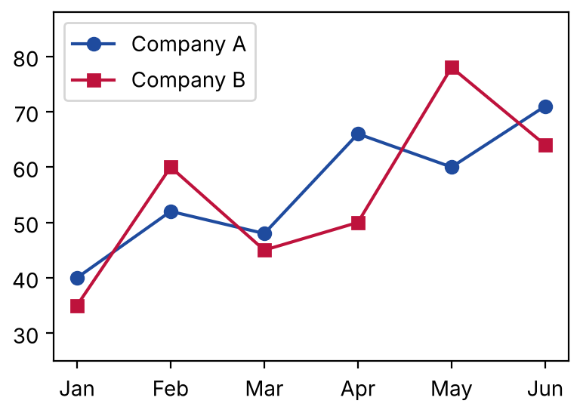
{OPTION 1} 5 months; May
{OPTION 2} 4 months; Jun
{OPTION 3} 3 months; Jan
{OPTION 4} 4 months; May
{OPTION 5}
{OPTION 6}
{OPTION 7}
{OPTION 8}
{OPTION 9}
{OPTION 10}
{RIGHT ANSWER} 4
{EXPLANATION} Differences (Company A − Company B): Jan +5, Feb -8, Mar +3, Apr +16, May -18, Jun +7. Company A leads in 4 months and the greatest difference is in May.
{CORRECT MARKS} 1
{NEGATIVE MARKS} 0
{DIFFICULTY} Hard
{QUESTION ENDS}

{QUESTION BEGINS}
{QUESTION NUMBER} 95
{SUBJECT} Reasoning Ability
{TOPIC} Ages
{TAGS} tcs nqt, reasoning ability, hard
{QUESTION TYPE} SINGLECORRECT
{QUESTION TEXT} 6 years ago, Rohan's age was 4 times Sunil's age. 12 years from now, Rohan's age will be 2 times Sunil's age. What is Rohan's present age?
{OPTION 1} 47
{OPTION 2} 37
{OPTION 3} 42
{OPTION 4} 52
{OPTION 5}
{OPTION 6}
{OPTION 7}
{OPTION 8}
{OPTION 9}
{OPTION 10}
{RIGHT ANSWER} 3
{EXPLANATION} Let the present ages be a and b. a − 6 = 4(b − 6) and a + 12 = 2(b + 12). Solving gives b = 15 and a = 42.
{CORRECT MARKS} 1
{NEGATIVE MARKS} 0
{DIFFICULTY} Hard
{QUESTION ENDS}

{QUESTION BEGINS}
{QUESTION NUMBER} 96
{SUBJECT} Reasoning Ability
{TOPIC} Chart Reasoning
{TAGS} tcs nqt, reasoning ability, figure based, hard
{QUESTION TYPE} SINGLECORRECT
{QUESTION TEXT} The bar chart shows the number of laptops sold (in hundreds) by a store. In which year was the absolute percentage change compared with the previous year the highest?
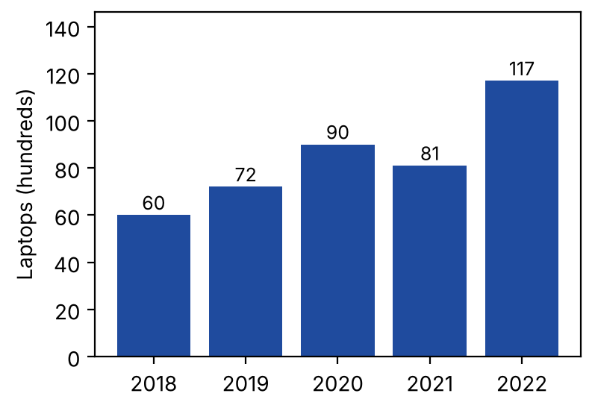
{OPTION 1} 2019 (20% rise)
{OPTION 2} 2022 (44.4% rise)
{OPTION 3} 2020 (25% rise)
{OPTION 4} 2021 (10% fall)
{OPTION 5}
{OPTION 6}
{OPTION 7}
{OPTION 8}
{OPTION 9}
{OPTION 10}
{RIGHT ANSWER} 2
{EXPLANATION} Year-on-year changes: 2019: (72 − 60)/60 = 20%; 2020: (90 − 72)/72 = 25%; 2021: (81 − 90)/90 = -10%; 2022: (117 − 81)/81 = 44.4%. The largest absolute change is in 2022.
{CORRECT MARKS} 1
{NEGATIVE MARKS} 0
{DIFFICULTY} Hard
{QUESTION ENDS}

{QUESTION BEGINS}
{QUESTION NUMBER} 97
{SUBJECT} Reasoning Ability
{TOPIC} Inequalities
{TAGS} tcs nqt, reasoning ability, hard
{QUESTION TYPE} SINGLECORRECT
{QUESTION TEXT} In the following question the symbols have these meanings: 'A & B' means A is greater than B; 'A $ B' means A is greater than or equal to B; 'A @ B' means A is less than B; 'A © B' means A is less than or equal to B; 'A % B' means A is equal to B.
Statement: E $ D % B @ C $ A
Conclusions:
I. C © A
II. E % A
III. D © C
IV. C @ E
Which of the following is/are definitely true?
{OPTION 1} Only III follows
{OPTION 2} Only I follows
{OPTION 3} Only I, II and IV follow
{OPTION 4} Only I and IV follow
{OPTION 5}
{OPTION 6}
{OPTION 7}
{OPTION 8}
{OPTION 9}
{OPTION 10}
{RIGHT ANSWER} 1
{EXPLANATION} Decoding the statement gives E ≥ D = B < C ≥ A. Check each conclusion for every value that satisfies the chain (all combinations were tested): I is not definitely true. II is not definitely true. III is definitely true. IV is not definitely true.
{CORRECT MARKS} 1
{NEGATIVE MARKS} 0
{DIFFICULTY} Hard
{QUESTION ENDS}

{QUESTION BEGINS}
{QUESTION NUMBER} 98
{SUBJECT} Reasoning Ability
{TOPIC} Number Puzzle
{TAGS} tcs nqt, reasoning ability, figure based, hard
{QUESTION TYPE} SINGLECORRECT
{QUESTION TEXT} What number should come in place of the question mark in the table of numbers?
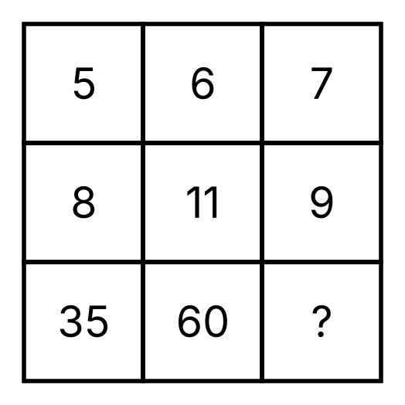
{OPTION 1} 58
{OPTION 2} 56
{OPTION 3} 60
{OPTION 4} 54
{OPTION 5}
{OPTION 6}
{OPTION 7}
{OPTION 8}
{OPTION 9}
{OPTION 10}
{RIGHT ANSWER} 2
{EXPLANATION} In each column the bottom number = (top × middle) − top. For the last column: 56.
{CORRECT MARKS} 1
{NEGATIVE MARKS} 0
{DIFFICULTY} Hard
{QUESTION ENDS}

{QUESTION BEGINS}
{QUESTION NUMBER} 99
{SUBJECT} Reasoning Ability
{TOPIC} Puzzle
{TAGS} tcs nqt, reasoning ability, hard
{QUESTION TYPE} SINGLECORRECT
{QUESTION TEXT} On an island knights always tell the truth and knaves always lie. Four islanders A, B, C and D say: A: "B is a knight and C is a knave." B: "A and D are of the same type." C: "D is a knave." D: "At least one of A and C is a knight."
How many of the four are knights?
{OPTION 1} 1
{OPTION 2} 3
{OPTION 3} 0
{OPTION 4} 2
{OPTION 5}
{OPTION 6}
{OPTION 7}
{OPTION 8}
{OPTION 9}
{OPTION 10}
{RIGHT ANSWER} 2
{EXPLANATION} Checking all 16 possible combinations of knights and knaves against the four statements, only one combination is consistent. Knights are: A, B, D. So there are 3 knights.
{CORRECT MARKS} 1
{NEGATIVE MARKS} 0
{DIFFICULTY} Hard
{QUESTION ENDS}

{QUESTION BEGINS}
{QUESTION NUMBER} 100
{SUBJECT} Reasoning Ability
{TOPIC} Syllogism
{TAGS} tcs nqt, reasoning ability, hard
{QUESTION TYPE} SINGLECORRECT
{QUESTION TEXT} Statements: Some writers are poets. No poet is a judge. All judges are artists.
Conclusions:
I. Some poets are not judges.
II. Some writers are judges.
III. No poet is an artist.
IV. All writers are artists.
Which of the following is correct?
{OPTION 1} Only II follows
{OPTION 2} Only I follows
{OPTION 3} Only I, II and IV follow
{OPTION 4} Only I and IV follow
{OPTION 5}
{OPTION 6}
{OPTION 7}
{OPTION 8}
{OPTION 9}
{OPTION 10}
{RIGHT ANSWER} 2
{EXPLANATION} Draw the Venn diagram for the statements and test each conclusion in every possible diagram. I follows. II does not follow. III does not follow. IV does not follow. Only I follows.
{CORRECT MARKS} 1
{NEGATIVE MARKS} 0
{DIFFICULTY} Hard
{QUESTION ENDS}

