{QUESTION BEGINS}
{QUESTION NUMBER} 1
{SUBJECT} Technical Assessment
{TOPIC} Pseudocode - OOPs
{TAGS} accenture, technical assessment, pseudocode, oops, inheritance, oops mock test 1, hard
{QUESTION TYPE} SINGLECORRECT
{QUESTION TEXT} What will be the output of the following pseudocode?
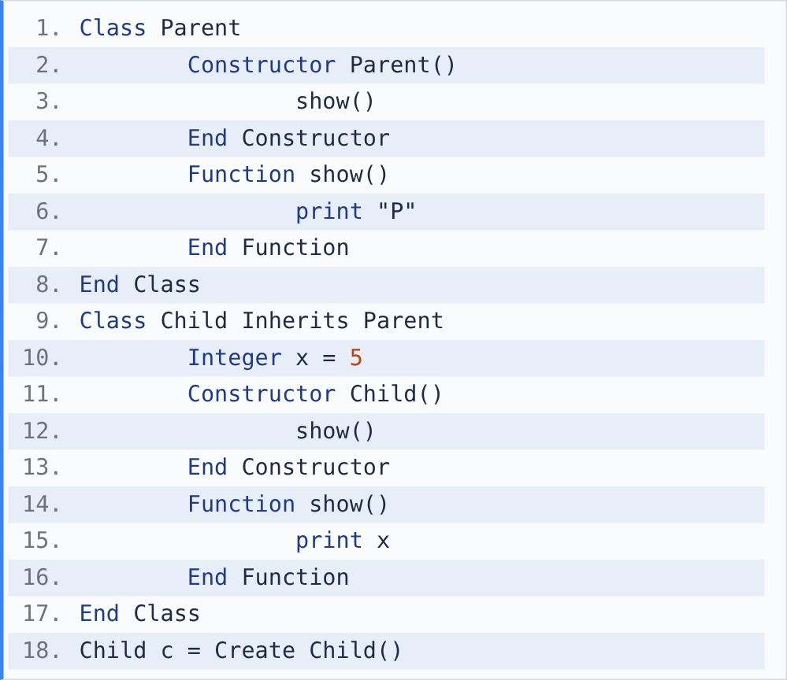
[Note - Objects are created as in Java: the parent constructor runs first, and the child's fields get their initial values only after the parent constructor finishes.]

{OPTION 1} 0 5
{OPTION 2} P 5
{OPTION 3} 5 5
{OPTION 4} P 0
{OPTION 5}
{OPTION 6}
{OPTION 7}
{OPTION 8}
{OPTION 9}
{OPTION 10}
{RIGHT ANSWER} 1
{EXPLANATION} Create Child() first runs Parent(). Parent() calls show(), and because the object is a Child, the overridden Child.show() runs. At that moment x is not yet initialised, so it prints 0. Then x is set to 5 and Child() calls show() again, printing 5. Output: 0 5.
{CORRECT MARKS} 1
{NEGATIVE MARKS} 0
{DIFFICULTY} Hard
{QUESTION ENDS}

{QUESTION BEGINS}
{QUESTION NUMBER} 2
{SUBJECT} Technical Assessment
{TOPIC} Pseudocode - OOPs
{TAGS} accenture, technical assessment, pseudocode, oops, polymorphism, oops mock test 1, medium
{QUESTION TYPE} SINGLECORRECT
{QUESTION TEXT} What will be the output of the following pseudocode?
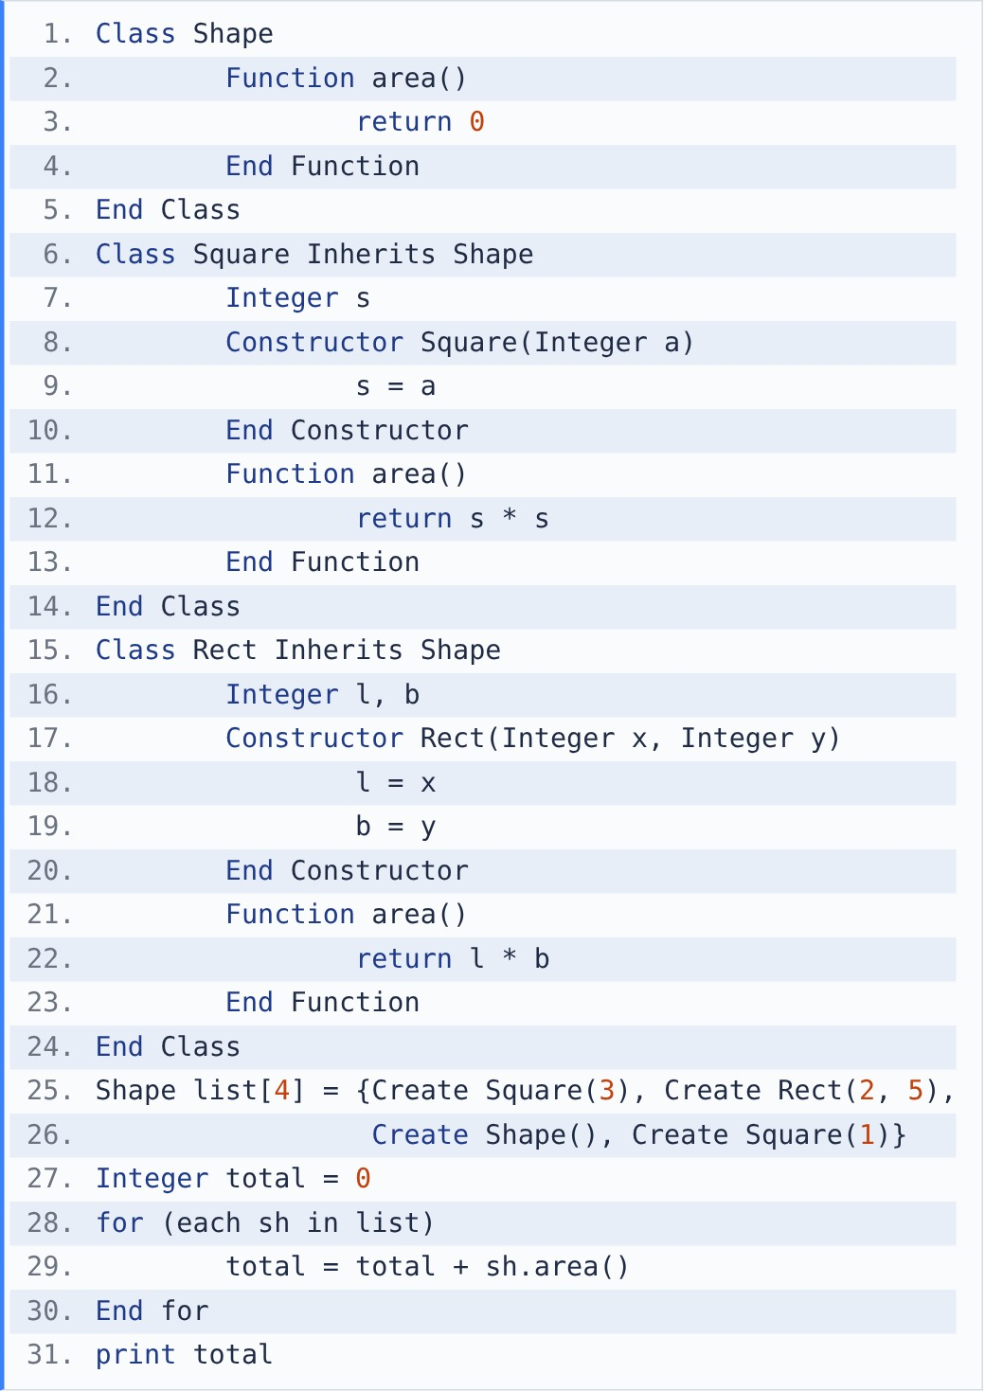

{OPTION 1} 20
{OPTION 2} 0
{OPTION 3} 9
{OPTION 4} 21
{OPTION 5}
{OPTION 6}
{OPTION 7}
{OPTION 8}
{OPTION 9}
{OPTION 10}
{RIGHT ANSWER} 1
{EXPLANATION} The array holds Shape references, but each call sh.area() runs the version of the actual object (runtime polymorphism): Square(3) → 9, Rect(2,5) → 10, Shape → 0, Square(1) → 1. Total = 20.
{CORRECT MARKS} 1
{NEGATIVE MARKS} 0
{DIFFICULTY} Medium
{QUESTION ENDS}

{QUESTION BEGINS}
{QUESTION NUMBER} 3
{SUBJECT} Technical Assessment
{TOPIC} Pseudocode - OOPs
{TAGS} accenture, technical assessment, pseudocode, oops, encapsulation, oops mock test 1, medium
{QUESTION TYPE} SINGLECORRECT
{QUESTION TEXT} What will be the output of the following pseudocode?
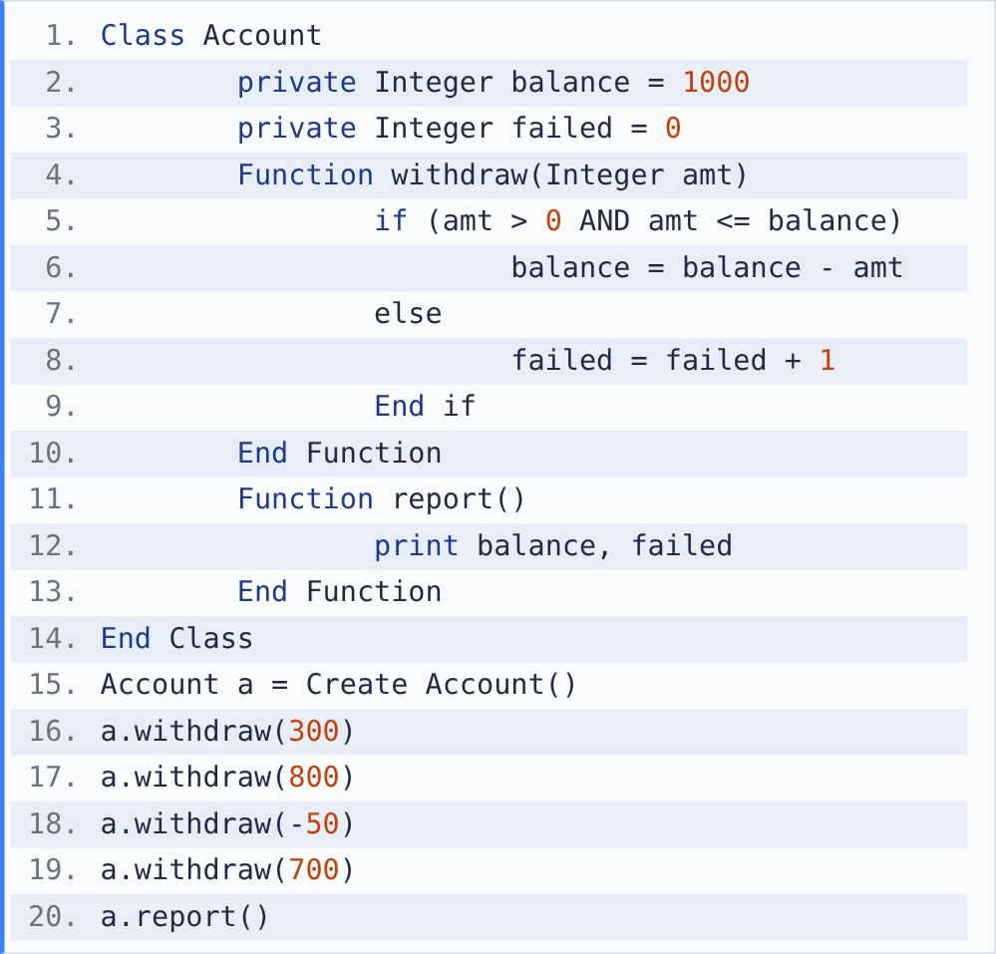

{OPTION 1} 700 2
{OPTION 2} -100 1
{OPTION 3} 0 1
{OPTION 4} 0 2
{OPTION 5}
{OPTION 6}
{OPTION 7}
{OPTION 8}
{OPTION 9}
{OPTION 10}
{RIGHT ANSWER} 4
{EXPLANATION} balance is private and changes only through withdraw(), which validates every request. 300 → balance 700. 800 > 700 → rejected (failed 1). -50 is not > 0 → rejected (failed 2). 700 ≤ 700 → balance 0. Output: 0 2.
{CORRECT MARKS} 1
{NEGATIVE MARKS} 0
{DIFFICULTY} Medium
{QUESTION ENDS}

{QUESTION BEGINS}
{QUESTION NUMBER} 4
{SUBJECT} Technical Assessment
{TOPIC} Pseudocode - OOPs
{TAGS} accenture, technical assessment, pseudocode, oops, static vs instance, oops mock test 1, hard
{QUESTION TYPE} SINGLECORRECT
{QUESTION TEXT} What will be the output of the following pseudocode?
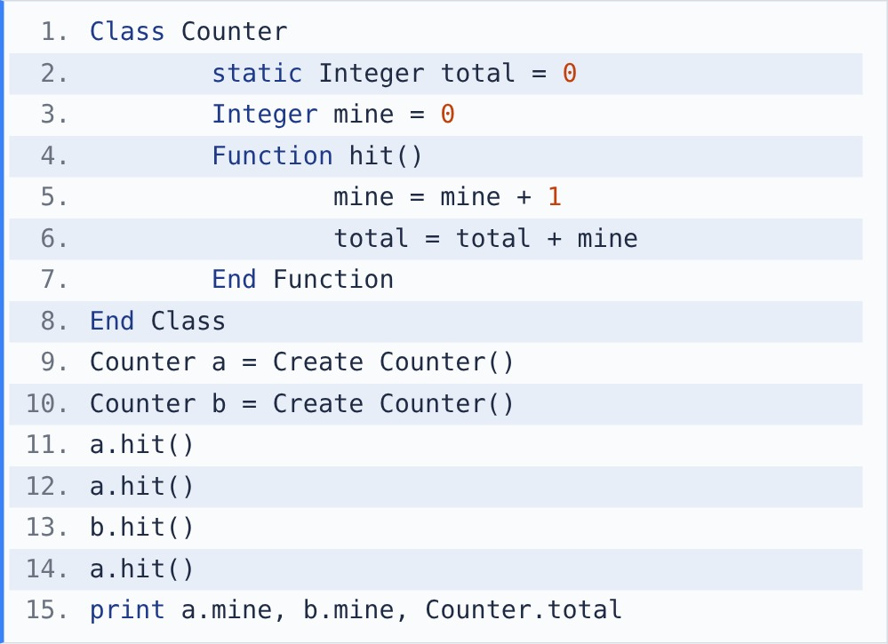
[Note - A static variable has one copy shared by all objects; an instance variable has a separate copy in each object.]

{OPTION 1} 3 1 4
{OPTION 2} 3 1 3
{OPTION 3} 3 1 7
{OPTION 4} 1 1 7
{OPTION 5}
{OPTION 6}
{OPTION 7}
{OPTION 8}
{OPTION 9}
{OPTION 10}
{RIGHT ANSWER} 3
{EXPLANATION} mine is separate per object, total is shared. a.hit(): a.mine 1, total 1. a.hit(): a.mine 2, total 3. b.hit(): b.mine 1, total 4. a.hit(): a.mine 3, total 7. Output: 3 1 7.
{CORRECT MARKS} 1
{NEGATIVE MARKS} 0
{DIFFICULTY} Hard
{QUESTION ENDS}

{QUESTION BEGINS}
{QUESTION NUMBER} 5
{SUBJECT} Technical Assessment
{TOPIC} Pseudocode - OOPs
{TAGS} accenture, technical assessment, pseudocode, oops, polymorphism (overloading), oops mock test 1, hard
{QUESTION TYPE} SINGLECORRECT
{QUESTION TEXT} What will be the output of the following pseudocode?
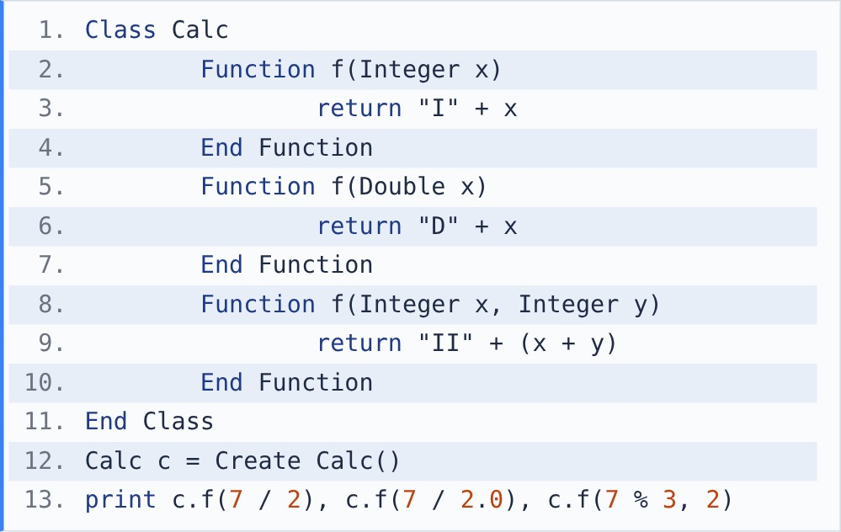
[Note - / between two integers is integer division; % gives the remainder. The method that runs is chosen by the number and type of the arguments.]

{OPTION 1} D3.5 D3.5 II3
{OPTION 2} I3 D3.5 II3
{OPTION 3} I3 I3 II12
{OPTION 4} I3.5 D3.5 II3
{OPTION 5}
{OPTION 6}
{OPTION 7}
{OPTION 8}
{OPTION 9}
{OPTION 10}
{RIGHT ANSWER} 2
{EXPLANATION} Overloading is resolved at compile time from the argument types. 7 / 2 = 3 (integer) → f(Integer) → I3. 7 / 2.0 = 3.5 (decimal) → f(Double) → D3.5. 7 % 3 = 1 and 2 → f(Integer, Integer) → II + (1 + 2) = II3.
{CORRECT MARKS} 1
{NEGATIVE MARKS} 0
{DIFFICULTY} Hard
{QUESTION ENDS}

{QUESTION BEGINS}
{QUESTION NUMBER} 6
{SUBJECT} Technical Assessment
{TOPIC} Pseudocode - OOPs
{TAGS} accenture, technical assessment, pseudocode, oops, inheritance (multilevel + super), oops mock test 1, medium
{QUESTION TYPE} SINGLECORRECT
{QUESTION TEXT} What will be the output of the following pseudocode?
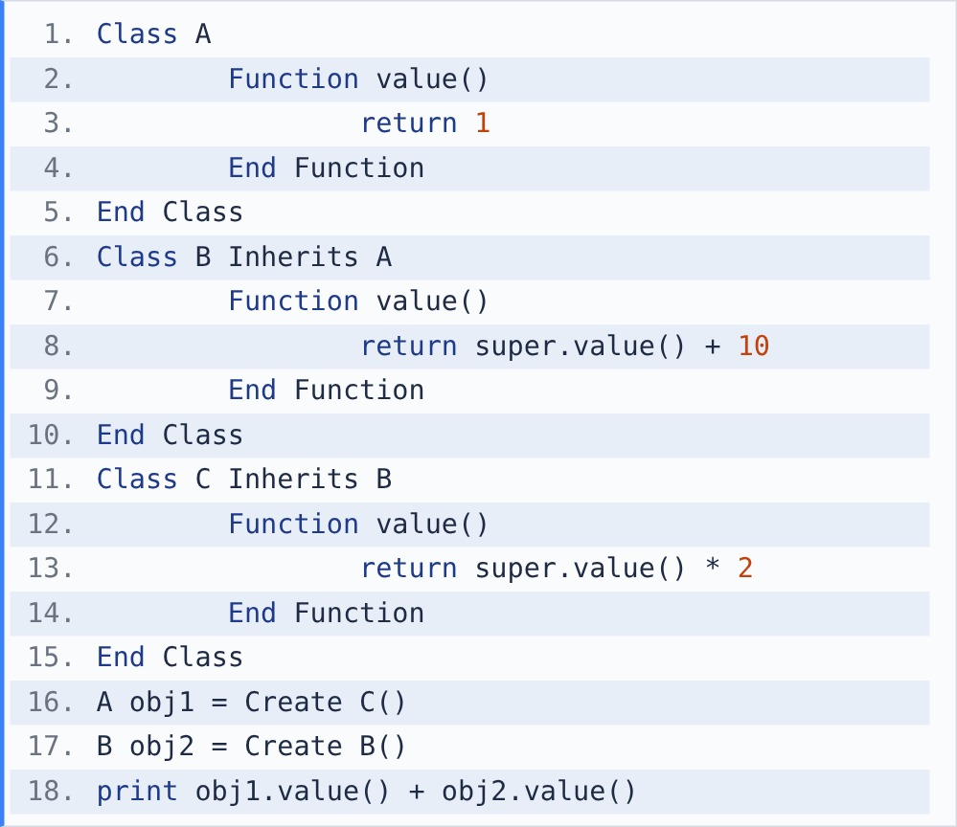
[Note - super.value() calls the parent class's version of the method.]

{OPTION 1} 3
{OPTION 2} 24
{OPTION 3} 33
{OPTION 4} 22
{OPTION 5}
{OPTION 6}
{OPTION 7}
{OPTION 8}
{OPTION 9}
{OPTION 10}
{RIGHT ANSWER} 3
{EXPLANATION} obj1 is a C object: C.value() = B.value() × 2 = (A.value() + 10) × 2 = (1 + 10) × 2 = 22. obj2 is a B object: 1 + 10 = 11. 22 + 11 = 33. The reference type (A) does not matter for overridden methods.
{CORRECT MARKS} 1
{NEGATIVE MARKS} 0
{DIFFICULTY} Medium
{QUESTION ENDS}

{QUESTION BEGINS}
{QUESTION NUMBER} 7
{SUBJECT} Technical Assessment
{TOPIC} Pseudocode - OOPs
{TAGS} accenture, technical assessment, pseudocode, oops, abstraction, oops mock test 1, medium
{QUESTION TYPE} SINGLECORRECT
{QUESTION TEXT} What will be the output of the following pseudocode?
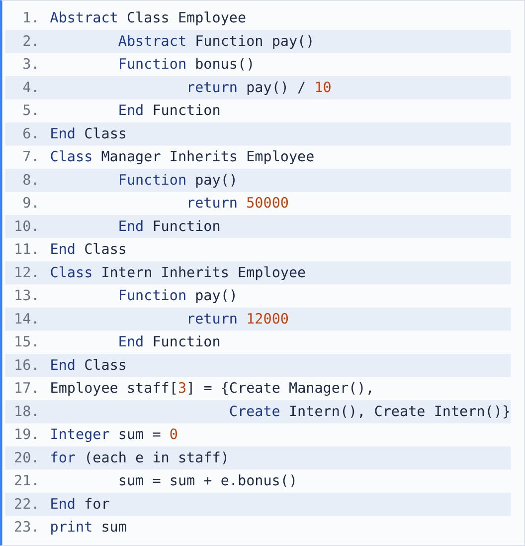

{OPTION 1} 6200
{OPTION 2} 74000
{OPTION 3} Error: pay() has no body in Employee
{OPTION 4} 7400
{OPTION 5}
{OPTION 6}
{OPTION 7}
{OPTION 8}
{OPTION 9}
{OPTION 10}
{RIGHT ANSWER} 4
{EXPLANATION} The abstract class can still have a normal method (bonus) that calls the abstract one (pay). At run time pay() uses each object's own version: Manager 50000 / 10 = 5000, Intern 12000 / 10 = 1200 twice. 5000 + 1200 + 1200 = 7400. Only objects of concrete classes are created, so there is no error.
{CORRECT MARKS} 1
{NEGATIVE MARKS} 0
{DIFFICULTY} Medium
{QUESTION ENDS}

{QUESTION BEGINS}
{QUESTION NUMBER} 8
{SUBJECT} Technical Assessment
{TOPIC} Pseudocode - OOPs
{TAGS} accenture, technical assessment, pseudocode, oops, abstraction (interface), oops mock test 1, medium
{QUESTION TYPE} SINGLECORRECT
{QUESTION TEXT} What will be the output of the following pseudocode?
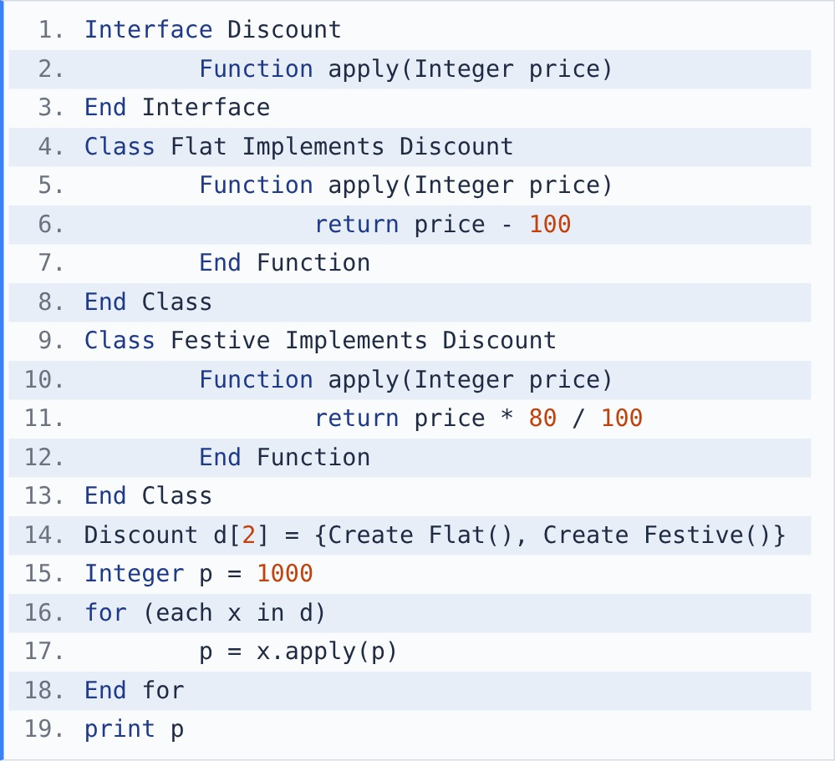
[Note - / between two integers is integer division.]

{OPTION 1} 720
{OPTION 2} 700
{OPTION 3} 800
{OPTION 4} 900
{OPTION 5}
{OPTION 6}
{OPTION 7}
{OPTION 8}
{OPTION 9}
{OPTION 10}
{RIGHT ANSWER} 1
{EXPLANATION} Each class implements the same interface method differently. The discounts are applied in array order: Flat: 1000 - 100 = 900, then Festive: 900 × 80 / 100 = 720. (In the other order the result would be 700.)
{CORRECT MARKS} 1
{NEGATIVE MARKS} 0
{DIFFICULTY} Medium
{QUESTION ENDS}

{QUESTION BEGINS}
{QUESTION NUMBER} 9
{SUBJECT} Technical Assessment
{TOPIC} Pseudocode - OOPs
{TAGS} accenture, technical assessment, pseudocode, oops, polymorphism (static hiding), oops mock test 1, hard
{QUESTION TYPE} SINGLECORRECT
{QUESTION TEXT} What will be the output of the following pseudocode?
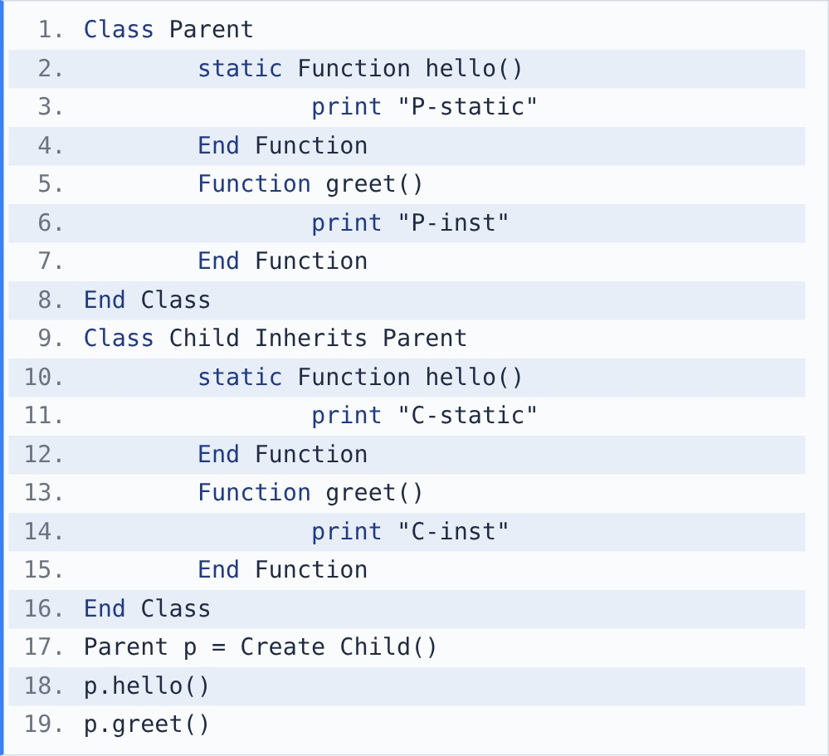
[Note - static methods belong to the class, instance methods belong to the object.]

{OPTION 1} C-static C-inst
{OPTION 2} P-static C-inst
{OPTION 3} P-static P-inst
{OPTION 4} C-static P-inst
{OPTION 5}
{OPTION 6}
{OPTION 7}
{OPTION 8}
{OPTION 9}
{OPTION 10}
{RIGHT ANSWER} 2
{EXPLANATION} Instance methods are overridden: greet() runs the object's version (Child) → C-inst. Static methods are not overridden but hidden: they are chosen by the reference type (Parent), so hello() → P-static. Output: P-static C-inst.
{CORRECT MARKS} 1
{NEGATIVE MARKS} 0
{DIFFICULTY} Hard
{QUESTION ENDS}

{QUESTION BEGINS}
{QUESTION NUMBER} 10
{SUBJECT} Technical Assessment
{TOPIC} Pseudocode - OOPs
{TAGS} accenture, technical assessment, pseudocode, oops, encapsulation (object identity), oops mock test 1, medium
{QUESTION TYPE} SINGLECORRECT
{QUESTION TEXT} What will be the output of the following pseudocode?
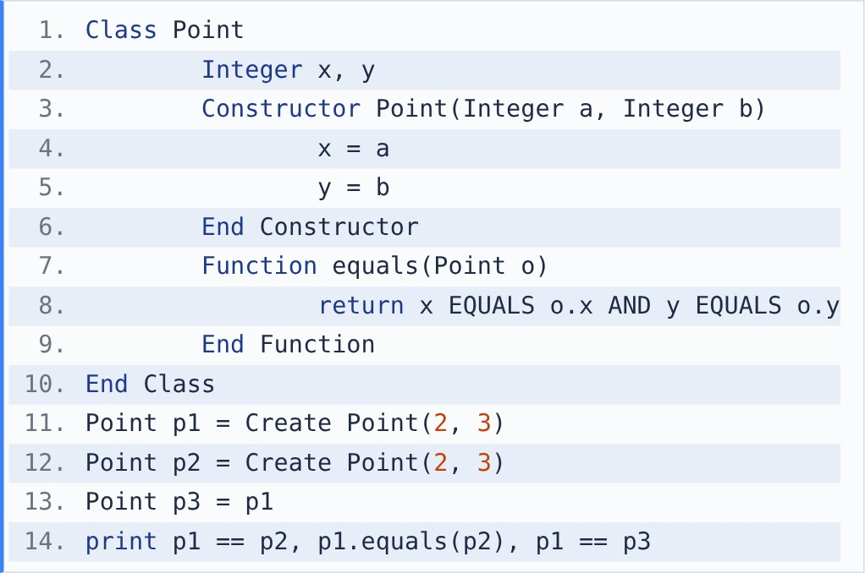
[Note - == compares whether two references point to the same object.]

{OPTION 1} true true true
{OPTION 2} false true true
{OPTION 3} false false true
{OPTION 4} true true false
{OPTION 5}
{OPTION 6}
{OPTION 7}
{OPTION 8}
{OPTION 9}
{OPTION 10}
{RIGHT ANSWER} 2
{EXPLANATION} p1 and p2 are two different objects with the same values: p1 == p2 is false (different references), but equals() compares the fields, so it is true. p3 = p1 copies the reference, so p1 == p3 is true.
{CORRECT MARKS} 1
{NEGATIVE MARKS} 0
{DIFFICULTY} Medium
{QUESTION ENDS}

