{QUESTION BEGINS}
{QUESTION NUMBER} 1
{SUBJECT} Reasoning Ability
{TOPIC} Syllogism
{TAGS} tcs nqt, reasoning ability, hard
{QUESTION TYPE} SINGLECORRECT
{QUESTION TEXT} Statements: Some animals are birds. All birds are flyers. No flyer is a stone. Some stones are not animals.
Conclusions:
I. Some animals are not stones.
II. Some stones are not flyers.
III. Some flyers are animals.
IV. No animal is a stone.
{OPTION 1} Only I, II and III follow
{OPTION 2} All I, II, III and IV follow
{OPTION 3} Only I and III follow
{OPTION 4} Only II and IV follow
{OPTION 5}
{OPTION 6}
{OPTION 7}
{OPTION 8}
{OPTION 9}
{OPTION 10}
{RIGHT ANSWER} 1
{EXPLANATION} Let the sets be A (animals), B (birds), C (flyers) and D (stones). The animals that are birds are flyers (so some flyers are animals: III) and are not stones, so some animals are not stones (I). 'Some stones are not animals' and no flyer is a stone together mean those stones are not flyers, so some stones are not flyers (II). IV says no animal is a stone, but some animals may be stones, so IV does not follow.
{CORRECT MARKS} 1
{NEGATIVE MARKS} 0
{DIFFICULTY} Hard
{QUESTION ENDS}

{QUESTION BEGINS}
{QUESTION NUMBER} 2
{SUBJECT} Reasoning Ability
{TOPIC} Mirror Image
{TAGS} tcs nqt, reasoning ability, figure based, hard
{QUESTION TYPE} SINGLECORRECT
{QUESTION TEXT} Select the figure that is the mirror image of the given string when a mirror is placed vertically on its right side.
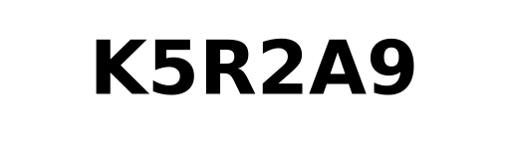
{OPTION 1} 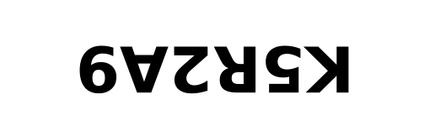
{OPTION 2} 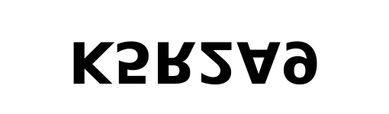
{OPTION 3} 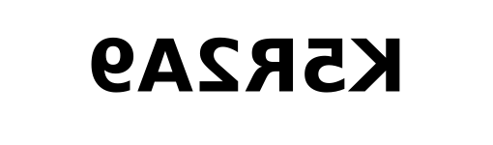
{OPTION 4} 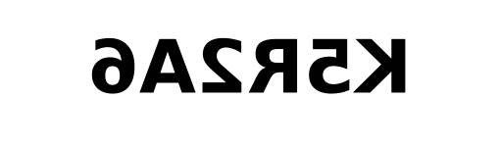
{OPTION 5}
{OPTION 6}
{OPTION 7}
{OPTION 8}
{OPTION 9}
{OPTION 10}
{RIGHT ANSWER} 3
{EXPLANATION} A vertical mirror on the right reverses the order of the characters and flips each one left to right, so the string appears as if read from the back with every character reversed. Option 2 is the figure flipped upside down (water image), option 3 is turned through 180°, and option 4 is a mirror image of a different string (the last character differs).
{CORRECT MARKS} 1
{NEGATIVE MARKS} 0
{DIFFICULTY} Hard
{QUESTION ENDS}

{QUESTION BEGINS}
{QUESTION NUMBER} 3
{SUBJECT} Reasoning Ability
{TOPIC} Paper Folding
{TAGS} tcs nqt, reasoning ability, figure based, hard
{QUESTION TYPE} SINGLECORRECT
{QUESTION TEXT} A square sheet is folded twice as shown: first the left half is folded over the right half, then the top half is folded over the bottom half. A hole is punched through all the layers at the marked position of the folded paper. How will the sheet look when it is completely unfolded?
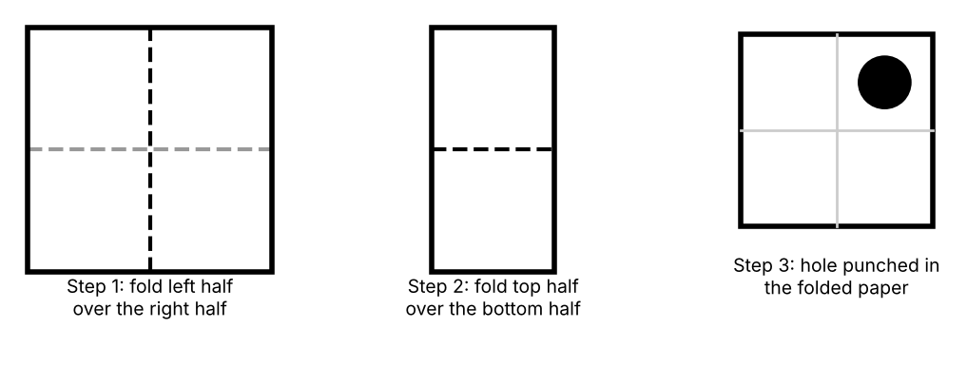
{OPTION 1} 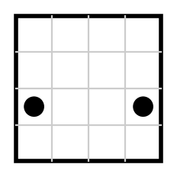
{OPTION 2} 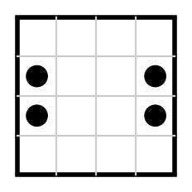
{OPTION 3} 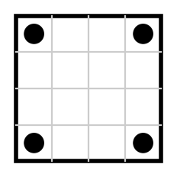
{OPTION 4} 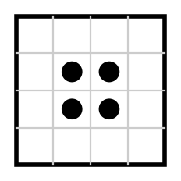
{OPTION 5}
{OPTION 6}
{OPTION 7}
{OPTION 8}
{OPTION 9}
{OPTION 10}
{RIGHT ANSWER} 2
{EXPLANATION} The folded paper has 4 layers, so the punch makes 4 holes. Unfolding the second fold (top over bottom) mirrors the hole in the horizontal middle line; unfolding the first fold (left over right) mirrors every hole in the vertical middle line. The one hole therefore becomes four holes, one in every quarter of the sheet, placed symmetrically about both middle lines. Only option 1 shows this.
{CORRECT MARKS} 1
{NEGATIVE MARKS} 0
{DIFFICULTY} Hard
{QUESTION ENDS}

{QUESTION BEGINS}
{QUESTION NUMBER} 4
{SUBJECT} Reasoning Ability
{TOPIC} Number Puzzle
{TAGS} tcs nqt, reasoning ability, figure based, hard
{QUESTION TYPE} SINGLECORRECT
{QUESTION TEXT} Find the missing number (?) if the numbers in all the circles follow the same rule.
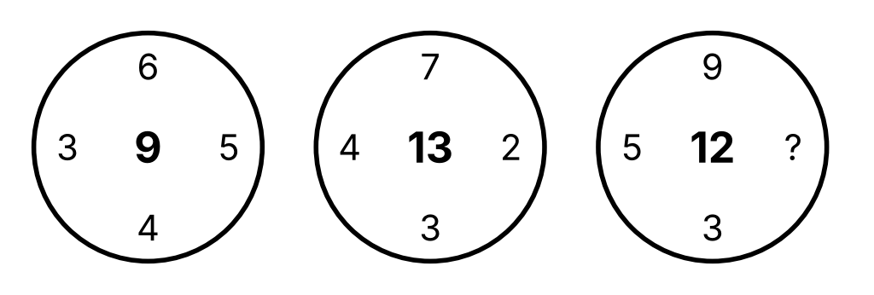
{OPTION 1} 4
{OPTION 2} 2
{OPTION 3} 5
{OPTION 4} 3
{OPTION 5}
{OPTION 6}
{OPTION 7}
{OPTION 8}
{OPTION 9}
{OPTION 10}
{RIGHT ANSWER} 4
{EXPLANATION} In the first circle: top × bottom − left × right = 6 × 4 − 3 × 5 = 24 − 15 = 9, which is the centre number. Second circle: 7 × 3 − 4 × 2 = 21 − 8 = 13. For the third circle: 9 × 3 − 5 × ? = 12, so 27 − 5 × ? = 12 and ? = 3.
{CORRECT MARKS} 1
{NEGATIVE MARKS} 0
{DIFFICULTY} Hard
{QUESTION ENDS}

{QUESTION BEGINS}
{QUESTION NUMBER} 5
{SUBJECT} Reasoning Ability
{TOPIC} Cubes
{TAGS} tcs nqt, reasoning ability, figure based, hard
{QUESTION TYPE} SINGLECORRECT
{QUESTION TEXT} Unit cubes are stacked on a 4 × 3 board. The number in each square of the top view shows how many cubes are stacked in that square (0 means empty). Cubes are glued face to face, and the whole solid is dipped in paint (including the bottom face). How many unit faces get painted?
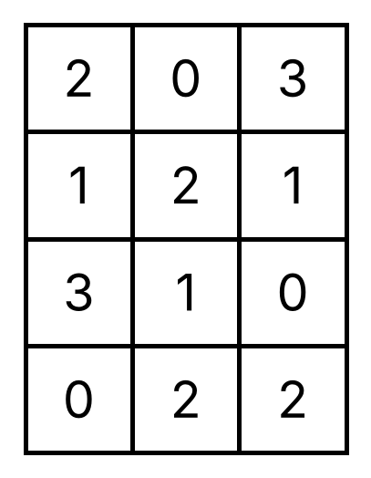
{OPTION 1} 70
{OPTION 2} 74
{OPTION 3} 66
{OPTION 4} 62
{OPTION 5}
{OPTION 6}
{OPTION 7}
{OPTION 8}
{OPTION 9}
{OPTION 10}
{RIGHT ANSWER} 3
{EXPLANATION} There are 17 cubes. Top and bottom faces: 9 squares are non-empty, so 9 + 9 = 18 faces. Side faces: for every square, and each of its four sides, count max(0, own height − height of the neighbouring square) (a neighbour beyond the board has height 0). Adding these over all squares gives 48 side faces. Total painted faces = 18 + 48 = 66.
{CORRECT MARKS} 1
{NEGATIVE MARKS} 0
{DIFFICULTY} Hard
{QUESTION ENDS}

{QUESTION BEGINS}
{QUESTION NUMBER} 6
{SUBJECT} Reasoning Ability
{TOPIC} Embedded Figure
{TAGS} tcs nqt, reasoning ability, figure based, hard
{QUESTION TYPE} SINGLECORRECT
{QUESTION TEXT} Select the figure in which the given figure is embedded (the given figure must appear in the same orientation and size as part of the option).
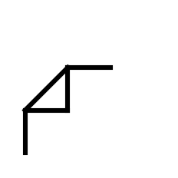
{OPTION 1} 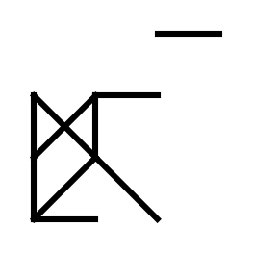
{OPTION 2} 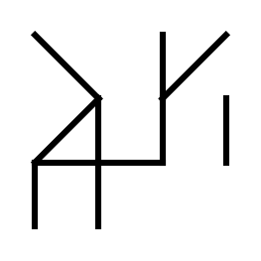
{OPTION 3} 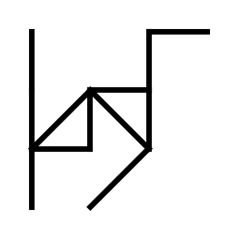
{OPTION 4} 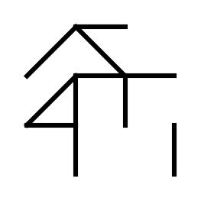
{OPTION 5}
{OPTION 6}
{OPTION 7}
{OPTION 8}
{OPTION 9}
{OPTION 10}
{RIGHT ANSWER} 3
{EXPLANATION} The given figure consists of five line segments: a vertical piece, a horizontal piece, another vertical piece, another horizontal piece and one diagonal. Each wrong option is missing exactly one of these five segments, so the figure cannot be found complete in it. Only option 1 contains all five segments.
{CORRECT MARKS} 1
{NEGATIVE MARKS} 0
{DIFFICULTY} Hard
{QUESTION ENDS}

{QUESTION BEGINS}
{QUESTION NUMBER} 7
{SUBJECT} Reasoning Ability
{TOPIC} Alphabet Test
{TAGS} tcs nqt, reasoning ability, hard
{QUESTION TYPE} SINGLECORRECT
{QUESTION TEXT} If the letters of the word PRODUCTION are rearranged so that the first and the last letters are interchanged, the second and the second-last are interchanged, and so on (that is, the word is reversed), how many letters will remain at the same position?
{OPTION 1} 0
{OPTION 2} 5
{OPTION 3} 4
{OPTION 4} 1
{OPTION 5}
{OPTION 6}
{OPTION 7}
{OPTION 8}
{OPTION 9}
{OPTION 10}
{RIGHT ANSWER} 1
{EXPLANATION} Reversed, the word is NOITCUDORP. Comparing position by position with PRODUCTION: P/N, R/O, O/I, D/T, U/C, C/U, T/D, I/O, O/R, N/P. No position has the same letter, so the answer is 0.
{CORRECT MARKS} 1
{NEGATIVE MARKS} 0
{DIFFICULTY} Hard
{QUESTION ENDS}

{QUESTION BEGINS}
{QUESTION NUMBER} 8
{SUBJECT} Reasoning Ability
{TOPIC} Number Arrangement
{TAGS} tcs nqt, reasoning ability, hard
{QUESTION TYPE} SINGLECORRECT
{QUESTION TEXT} The following steps are applied to the number 83415726: (i) every two adjacent digits starting from the left are interchanged (the 1st with the 2nd, the 3rd with the 4th and so on); (ii) every digit that is greater than 5 is then replaced by the digit that is 3 less than it. What is the sum of the digits at the even places (2nd, 4th, 6th and 8th from the left) of the final number?
{OPTION 1} 17
{OPTION 2} 14
{OPTION 3} 16
{OPTION 4} 18
{OPTION 5}
{OPTION 6}
{OPTION 7}
{OPTION 8}
{OPTION 9}
{OPTION 10}
{RIGHT ANSWER} 3
{EXPLANATION} After step (i): 38147562. After step (ii): 8 becomes 5, 7 becomes 4 and 6 becomes 3: 35144532. The digits at the 2nd, 4th, 6th and 8th places are 5, 4, 5 and 2, and their sum is 16.
{CORRECT MARKS} 1
{NEGATIVE MARKS} 0
{DIFFICULTY} Hard
{QUESTION ENDS}

{QUESTION BEGINS}
{QUESTION NUMBER} 9
{SUBJECT} Reasoning Ability
{TOPIC} Inequalities
{TAGS} tcs nqt, reasoning ability, hard
{QUESTION TYPE} SINGLECORRECT
{QUESTION TEXT} In the following question the symbols have these meanings: 'A $ B' means A ≥ B, 'A @ B' means A < B, 'A # B' means A = B, 'A % B' means A > B.
Statement: P $ Q @ R # S % T
Conclusions:
I. S @ Q
II. R % T
III. P @ R
IV. S % Q
Which of the following is definitely true?
{OPTION 1} Only II and IV
{OPTION 2} Only I and II
{OPTION 3} Only IV
{OPTION 4} Only III and IV
{OPTION 5}
{OPTION 6}
{OPTION 7}
{OPTION 8}
{OPTION 9}
{OPTION 10}
{RIGHT ANSWER} 1
{EXPLANATION} The statement reads P ≥ Q < R = S > T. Q < R and R = S give S > Q, so IV is true and I (S < Q) is false. R = S > T gives R > T, so II is true. P and R are not directly comparable (P ≥ Q and Q < R), so III is not definite. Only II and IV are true.
{CORRECT MARKS} 1
{NEGATIVE MARKS} 0
{DIFFICULTY} Hard
{QUESTION ENDS}

{QUESTION BEGINS}
{QUESTION NUMBER} 10
{SUBJECT} Reasoning Ability
{TOPIC} Blood Relations
{TAGS} tcs nqt, reasoning ability, hard
{QUESTION TYPE} SINGLECORRECT
{QUESTION TEXT} In a certain code language, 'A ★ B' means 'A is the mother of B', 'A ◆ B' means 'A is the brother of B', 'A ▲ B' means 'A is the husband of B' and 'A ● B' means 'A is the daughter of B'.
If P ◆ Q ★ R ▲ S ● T, how is P related to S?
{OPTION 1} Husband's paternal uncle
{OPTION 2} Father-in-law
{OPTION 3} Husband's maternal uncle
{OPTION 4} Brother-in-law
{OPTION 5}
{OPTION 6}
{OPTION 7}
{OPTION 8}
{OPTION 9}
{OPTION 10}
{RIGHT ANSWER} 3
{EXPLANATION} P ◆ Q: P is the brother of Q. Q ★ R: Q is the mother of R, so P is R's maternal uncle. R ▲ S: R is the husband of S. So P is the maternal uncle of S's husband.
{CORRECT MARKS} 1
{NEGATIVE MARKS} 0
{DIFFICULTY} Hard
{QUESTION ENDS}

{QUESTION BEGINS}
{QUESTION NUMBER} 11
{SUBJECT} Reasoning Ability
{TOPIC} Input-Output
{TAGS} tcs nqt, reasoning ability, hard
{QUESTION TYPE} SINGLECORRECT
{QUESTION TEXT} A machine rearranges an input line of words and numbers step by step following a fixed rule. Input: tap 56 jar 23 oak 71 fig 38
Step I: 23 tap 56 jar oak 71 fig 38
Step II: 23 tap 56 jar oak 71 38 fig
Step III: 23 38 tap 56 jar oak 71 fig
Which element is at the 5th position from the left in Step IV?
{OPTION 1} 56
{OPTION 2} 71
{OPTION 3} tap
{OPTION 4} oak
{OPTION 5}
{OPTION 6}
{OPTION 7}
{OPTION 8}
{OPTION 9}
{OPTION 10}
{RIGHT ANSWER} 4
{EXPLANATION} Rule: in odd steps the smallest number not yet placed moves to the left end (after the numbers already placed); in even steps the alphabetically first word not yet placed moves to the right end (before the words already placed). Step IV: the next word in alphabetical order is 'jar', which goes to the right end before 'fig': 23 38 tap 56 oak 71 jar fig. The 5th element from the left is oak.
{CORRECT MARKS} 1
{NEGATIVE MARKS} 0
{DIFFICULTY} Hard
{QUESTION ENDS}

{QUESTION BEGINS}
{QUESTION NUMBER} 12
{SUBJECT} Reasoning Ability
{TOPIC} Counting Figures
{TAGS} tcs nqt, reasoning ability, figure based, hard
{QUESTION TYPE} SINGLECORRECT
{QUESTION TEXT} The given figure is an equilateral triangle divided into smaller equilateral triangles by lines parallel to its sides, 5 lines in each direction (side of the big triangle = 5 small sides). How many triangles of all sizes are there in the figure?
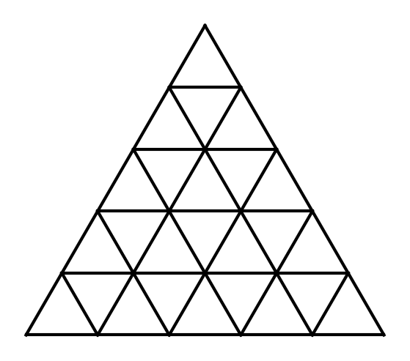
{OPTION 1} 35
{OPTION 2} 42
{OPTION 3} 52
{OPTION 4} 48
{OPTION 5}
{OPTION 6}
{OPTION 7}
{OPTION 8}
{OPTION 9}
{OPTION 10}
{RIGHT ANSWER} 4
{EXPLANATION} Triangles pointing up: side 1: 15, side 2: 10, side 3: 6, side 4: 3, side 5: 1, total 35. Triangles pointing down: side 1: 10 and side 2: 3, total 13. Altogether 35 + 13 = 48.
{CORRECT MARKS} 1
{NEGATIVE MARKS} 0
{DIFFICULTY} Hard
{QUESTION ENDS}

{QUESTION BEGINS}
{QUESTION NUMBER} 13
{SUBJECT} Reasoning Ability
{TOPIC} Number Series
{TAGS} tcs nqt, reasoning ability, hard
{QUESTION TYPE} SINGLECORRECT
{QUESTION TEXT} Find the next term of the series: 3, 7, 16, 35, 74, ?
{OPTION 1} 148
{OPTION 2} 156
{OPTION 3} 152
{OPTION 4} 153
{OPTION 5}
{OPTION 6}
{OPTION 7}
{OPTION 8}
{OPTION 9}
{OPTION 10}
{RIGHT ANSWER} 4
{EXPLANATION} Each term is twice the previous term plus an increasing number: 3×2+1 = 7, 7×2+2 = 16, 16×2+3 = 35, 35×2+4 = 74, so the next term is 74×2+5 = 153.
{CORRECT MARKS} 1
{NEGATIVE MARKS} 0
{DIFFICULTY} Hard
{QUESTION ENDS}

{QUESTION BEGINS}
{QUESTION NUMBER} 14
{SUBJECT} Reasoning Ability
{TOPIC} Directions
{TAGS} tcs nqt, reasoning ability, hard
{QUESTION TYPE} SINGLECORRECT
{QUESTION TEXT} Early in the morning, just after sunrise, Ravi stood in an open field. His shadow fell exactly to his right. He then turned 135° anticlockwise. In which position relative to him does his shadow now fall?
{OPTION 1} in front and to his left
{OPTION 2} to his left
{OPTION 3} behind and to his right
{OPTION 4} behind and to his left
{OPTION 5}
{OPTION 6}
{OPTION 7}
{OPTION 8}
{OPTION 9}
{OPTION 10}
{RIGHT ANSWER} 4
{EXPLANATION} After sunrise the sun is in the East, so the shadow falls towards the West. West is on Ravi's right, so he was facing South. Turning 135° anticlockwise, he faces North-East. The shadow still points West, which is 225° clockwise from North-East: that is behind him and to his left.
{CORRECT MARKS} 1
{NEGATIVE MARKS} 0
{DIFFICULTY} Hard
{QUESTION ENDS}

{QUESTION BEGINS}
{QUESTION NUMBER} 15
{SUBJECT} Reasoning Ability
{TOPIC} Puzzle
{TAGS} tcs nqt, reasoning ability, hard
{QUESTION TYPE} SINGLECORRECT
{QUESTION TEXT} Seven friends A, B, C, D, E, F and G each visit a museum on a different day of one week, from Monday to Sunday (one friend per day). C visits the day immediately after F. D visits after E but before A. B visits neither on Monday nor on Sunday, and visits before E. G visits two days after D. A and B do not visit on consecutive days. F visits before E.
Who visits the museum on Thursday?
{OPTION 1} A
{OPTION 2} G
{OPTION 3} E
{OPTION 4} D
{OPTION 5}
{OPTION 6}
{OPTION 7}
{OPTION 8}
{OPTION 9}
{OPTION 10}
{RIGHT ANSWER} 3
{EXPLANATION} F and C are consecutive (F first). E, D, A are in that order, with G two days after D, so D, ?, G; the only way to fit all seven days is F, C, B, E, D, A, G: B must come before E and not on Monday or Sunday, so B is on Wednesday (after F and C). That gives Monday F, Tuesday C, Wednesday B, Thursday E, Friday D, Saturday A, Sunday G. A and B are not consecutive, as required. So E visits on Thursday.
{CORRECT MARKS} 1
{NEGATIVE MARKS} 0
{DIFFICULTY} Hard
{QUESTION ENDS}

{QUESTION BEGINS}
{QUESTION NUMBER} 16
{SUBJECT} Reasoning Ability
{TOPIC} Data Sufficiency
{TAGS} tcs nqt, reasoning ability, hard
{QUESTION TYPE} SINGLECORRECT
{QUESTION TEXT} Question: What is the code for 'light' in a certain code language?
Statement I: In the code language, 'bright light day' is written as 'ka mi ro' and 'day sun' is written as 'ro tu'.
Statement II: In the same code language, 'bright moon' is written as 'ka ze' and 'moon day' is written as 'ze ro'.
Which of the following is correct?
{OPTION 1} Both statements together are sufficient, but neither alone
{OPTION 2} Statement II alone is sufficient
{OPTION 3} Statement I alone is sufficient
{OPTION 4} Even both statements together are not sufficient
{OPTION 5}
{OPTION 6}
{OPTION 7}
{OPTION 8}
{OPTION 9}
{OPTION 10}
{RIGHT ANSWER} 1
{EXPLANATION} From I: 'day' = ro (common to both groups), so 'bright light' = 'ka mi' but we cannot tell which is which. From II alone: 'moon' = ze, 'bright' = ka, 'day' = ro, but 'light' is not mentioned. Together: from II, 'bright' = ka; so in I the other code of 'bright light' is 'mi', which is 'light'. So both together are needed.
{CORRECT MARKS} 1
{NEGATIVE MARKS} 0
{DIFFICULTY} Hard
{QUESTION ENDS}

{QUESTION BEGINS}
{QUESTION NUMBER} 17
{SUBJECT} Reasoning Ability
{TOPIC} Venn Diagram
{TAGS} tcs nqt, reasoning ability, figure based, hard
{QUESTION TYPE} SINGLECORRECT
{QUESTION TEXT} In the figure, the big rectangle represents the players who play Cricket, the circle represents the players who play Chess, the triangle represents the players who play Football and the small rectangle represents the players who play Hockey. Which numbers represent the players who play Chess and Football but NOT Hockey?
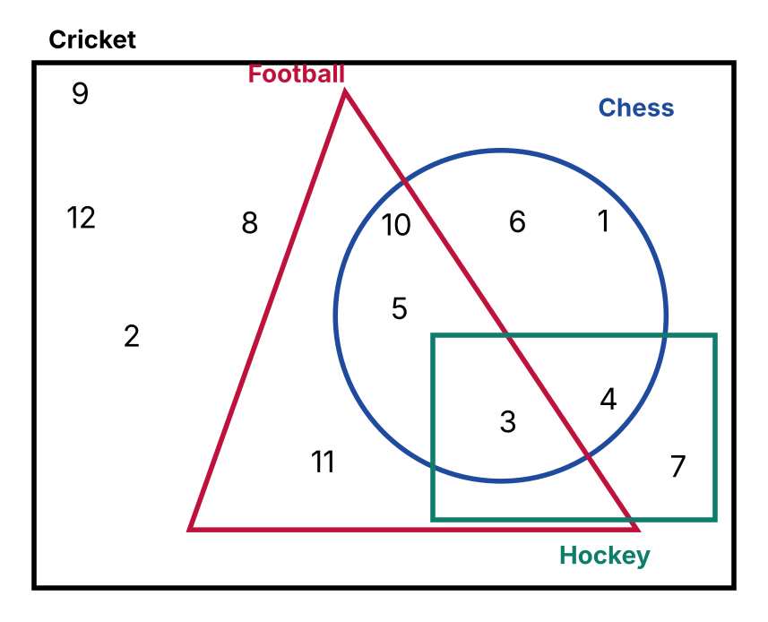
{OPTION 1} 5, 10
{OPTION 2} 3, 5, 10
{OPTION 3} 5
{OPTION 4} 4, 5, 10
{OPTION 5}
{OPTION 6}
{OPTION 7}
{OPTION 8}
{OPTION 9}
{OPTION 10}
{RIGHT ANSWER} 1
{EXPLANATION} Look for the numbers that lie inside both the Chess shape and the Football shape but outside the Hockey shape. The numbers that satisfy this are 5, 10. The other options include numbers that are also in Hockey or lie in only one of the two required shapes.
{CORRECT MARKS} 1
{NEGATIVE MARKS} 0
{DIFFICULTY} Hard
{QUESTION ENDS}

{QUESTION BEGINS}
{QUESTION NUMBER} 18
{SUBJECT} Reasoning Ability
{TOPIC} Clock
{TAGS} tcs nqt, reasoning ability, figure based, hard
{QUESTION TYPE} SINGLECORRECT
{QUESTION TEXT} The clock in the figure shows the present time. What will be the angle between the hour hand and the minute hand after 2 hours 50 minutes?
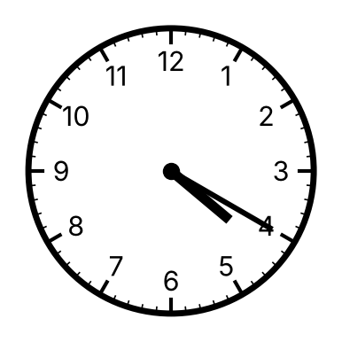
{OPTION 1} 160°
{OPTION 2} 155°
{OPTION 3} 120°
{OPTION 4} 132.5°
{OPTION 5}
{OPTION 6}
{OPTION 7}
{OPTION 8}
{OPTION 9}
{OPTION 10}
{RIGHT ANSWER} 2
{EXPLANATION} The clock shows 4:20. After 2 hours 50 minutes the time is 7:10. Angle = |30 × 7 + 0.5 × 10 − 6 × 10| = |210 + 5 − 60| = 155°. (The smaller angle is 155° as it is less than 180°.)
{CORRECT MARKS} 1
{NEGATIVE MARKS} 0
{DIFFICULTY} Hard
{QUESTION ENDS}

{QUESTION BEGINS}
{QUESTION NUMBER} 19
{SUBJECT} Reasoning Ability
{TOPIC} Figure Analogy
{TAGS} tcs nqt, reasoning ability, figure based, hard
{QUESTION TYPE} SINGLECORRECT
{QUESTION TEXT} Select the figure that is related to the third figure in the same way as the second figure is related to the first figure (A : B :: C : ?).
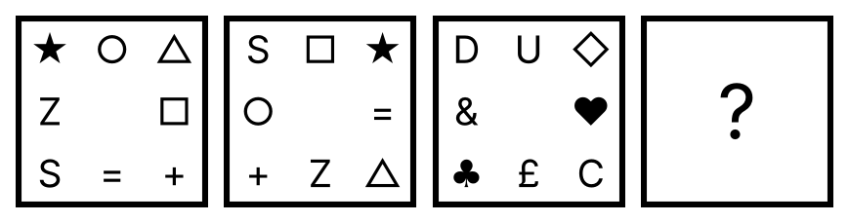
{OPTION 1} 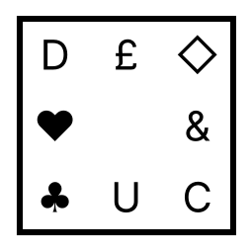
{OPTION 2} 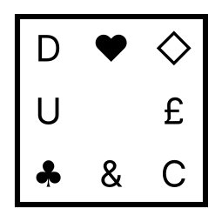
{OPTION 3} 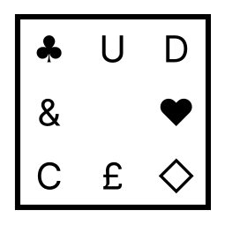
{OPTION 4} 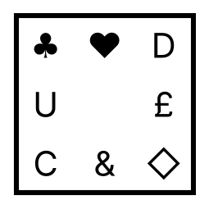
{OPTION 5}
{OPTION 6}
{OPTION 7}
{OPTION 8}
{OPTION 9}
{OPTION 10}
{RIGHT ANSWER} 4
{EXPLANATION} From the first figure to the second, the four corner symbols each move one corner clockwise, while the four symbols in the middle of the sides each move one side anticlockwise. Applying the same to the third figure gives the answer.
{CORRECT MARKS} 1
{NEGATIVE MARKS} 0
{DIFFICULTY} Hard
{QUESTION ENDS}

{QUESTION BEGINS}
{QUESTION NUMBER} 20
{SUBJECT} Reasoning Ability
{TOPIC} Ages
{TAGS} tcs nqt, reasoning ability, hard
{QUESTION TYPE} SINGLECORRECT
{QUESTION TEXT} Five years ago, A's age was three times B's age. Ten years from now, A's age will be twice B's age. C's present age is 3/5 of A's present age. What is the sum of the present ages of B and C?
{OPTION 1} 52
{OPTION 2} 50
{OPTION 3} 48
{OPTION 4} 56
{OPTION 5}
{OPTION 6}
{OPTION 7}
{OPTION 8}
{OPTION 9}
{OPTION 10}
{RIGHT ANSWER} 2
{EXPLANATION} Let A and B be the present ages. A − 5 = 3(B − 5) gives A = 3B − 10. A + 10 = 2(B + 10) gives A = 2B + 10. So 3B − 10 = 2B + 10, B = 20 and A = 50. C = 3/5 × 50 = 30. Sum of B and C = 20 + 30 = 50.
{CORRECT MARKS} 1
{NEGATIVE MARKS} 0
{DIFFICULTY} Hard
{QUESTION ENDS}

