{QUESTION BEGINS}
{QUESTION NUMBER} 1
{SUBJECT} Advanced Quantitative Ability
{TOPIC} Coding-Decoding
{TAGS} tcs nqt, advanced quantitative, TITA, hard
{QUESTION TYPE} NUMERICAL
{QUESTION TEXT} 
{OPTION 1}
{OPTION 2}
{OPTION 3}
{OPTION 4}
{OPTION 5}
{OPTION 6}
{OPTION 7}
{OPTION 8}
{OPTION 9}
{OPTION 10}
{RIGHT ANSWER} 6453
{EXPLANATION} From DEAF = 3587: D = 3, E = 5, A = 8, F = 7. From FILE = 7465: F = 7, I = 4, L = 6, E = 5 (E = 5 agrees with the first word). So LIED = L I E D = 6 4 5 3 = 6453.
{CORRECT MARKS} 1
{NEGATIVE MARKS} 0
{DIFFICULTY} Hard
{QUESTION ENDS}

{QUESTION BEGINS}
{QUESTION NUMBER} 2
{SUBJECT} Advanced Quantitative Ability
{TOPIC} Percentages
{TAGS} tcs nqt, advanced quantitative, TITA, hard
{QUESTION TYPE} NUMERICAL
{QUESTION TEXT}
{OPTION 1}
{OPTION 2}
{OPTION 3}
{OPTION 4}
{OPTION 5}
{OPTION 6}
{OPTION 7}
{OPTION 8}
{OPTION 9}
{OPTION 10}
{RIGHT ANSWER} 550
{EXPLANATION} The difference of the two parts = (0.125 − 0.1) × N = 0.025N = 13.75, so N = 13.75/0.025 = 550.
{CORRECT MARKS} 1
{NEGATIVE MARKS} 0
{DIFFICULTY} Hard
{QUESTION ENDS}

{QUESTION BEGINS}
{QUESTION NUMBER} 3
{SUBJECT} Advanced Quantitative Ability
{TOPIC} Inequalities
{TAGS} tcs nqt, advanced quantitative, TITA, hard
{QUESTION TYPE} NUMERICAL
{QUESTION TEXT} 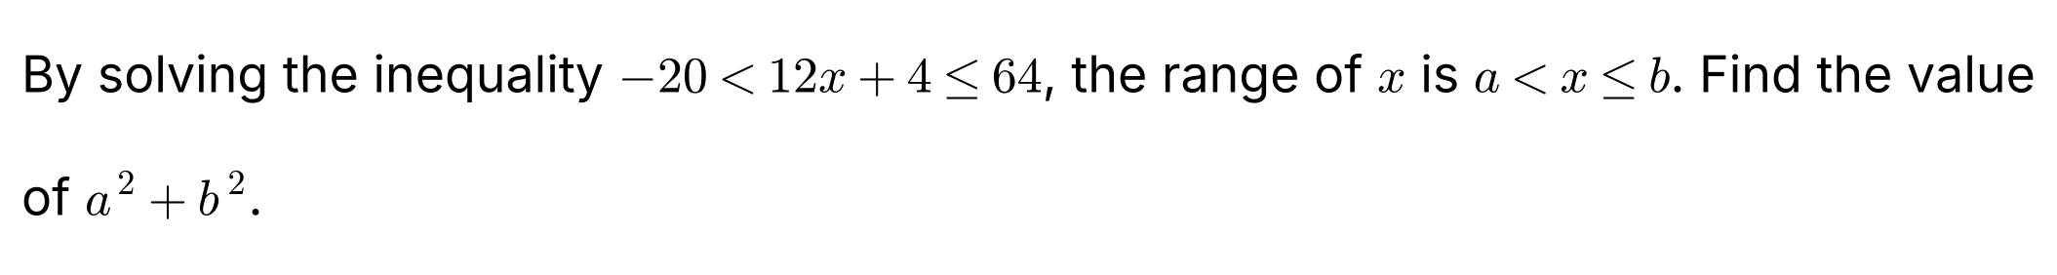
{OPTION 1}
{OPTION 2}
{OPTION 3}
{OPTION 4}
{OPTION 5}
{OPTION 6}
{OPTION 7}
{OPTION 8}
{OPTION 9}
{OPTION 10}
{RIGHT ANSWER} 29
{EXPLANATION} −20 < 12x + 4 ≤ 64 gives −24 < 12x ≤ 60, so −2 < x ≤ 5. Hence a = −2 and b = 5, and a² + b² = 4 + 25 = 29.
{CORRECT MARKS} 1
{NEGATIVE MARKS} 0
{DIFFICULTY} Hard
{QUESTION ENDS}

{QUESTION BEGINS}
{QUESTION NUMBER} 4
{SUBJECT} Advanced Quantitative Ability
{TOPIC} Inequalities
{TAGS} tcs nqt, advanced quantitative, TITA, hard
{QUESTION TYPE} NUMERICAL
{QUESTION TEXT} 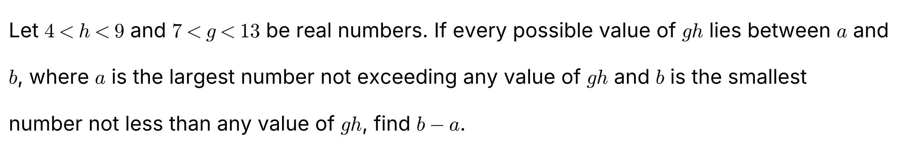
{OPTION 1}
{OPTION 2}
{OPTION 3}
{OPTION 4}
{OPTION 5}
{OPTION 6}
{OPTION 7}
{OPTION 8}
{OPTION 9}
{OPTION 10}
{RIGHT ANSWER} 89
{EXPLANATION} Both h and g are positive, so gh lies between the product of the smallest values and the product of the largest values: a = 4 × 7 = 28 and b = 9 × 13 = 117. So b − a = 117 − 28 = 89.
{CORRECT MARKS} 1
{NEGATIVE MARKS} 0
{DIFFICULTY} Hard
{QUESTION ENDS}

{QUESTION BEGINS}
{QUESTION NUMBER} 5
{SUBJECT} Advanced Quantitative Ability
{TOPIC} Polynomials
{TAGS} tcs nqt, advanced quantitative, TITA, hard
{QUESTION TYPE} NUMERICAL
{QUESTION TEXT} 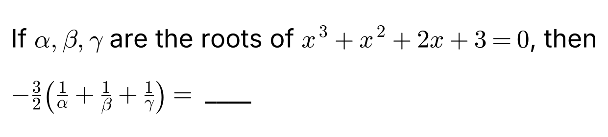
{OPTION 1}
{OPTION 2}
{OPTION 3}
{OPTION 4}
{OPTION 5}
{OPTION 6}
{OPTION 7}
{OPTION 8}
{OPTION 9}
{OPTION 10}
{RIGHT ANSWER} 1
{EXPLANATION} For x³ + x² + 2x + 3 = 0: αβ + βγ + γα = 2 and αβγ = −3. Then 1/α + 1/β + 1/γ = (αβ + βγ + γα)/(αβγ) = 2/(−3) = −2/3. So −(3/2) × (−2/3) = 1.
{CORRECT MARKS} 1
{NEGATIVE MARKS} 0
{DIFFICULTY} Hard
{QUESTION ENDS}

{QUESTION BEGINS}
{QUESTION NUMBER} 6
{SUBJECT} Advanced Quantitative Ability
{TOPIC} Mensuration
{TAGS} tcs nqt, advanced quantitative, TITA, hard
{QUESTION TYPE} NUMERICAL
{QUESTION TEXT} 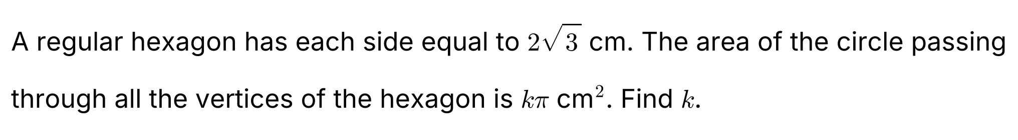
{OPTION 1}
{OPTION 2}
{OPTION 3}
{OPTION 4}
{OPTION 5}
{OPTION 6}
{OPTION 7}
{OPTION 8}
{OPTION 9}
{OPTION 10}
{RIGHT ANSWER} 12
{EXPLANATION} In a regular hexagon the distance from the centre to each vertex equals the side, so the radius of the circle through the vertices = 2√3 cm. Area = π(2√3)² = 12π cm². So k = 12.
{CORRECT MARKS} 1
{NEGATIVE MARKS} 0
{DIFFICULTY} Hard
{QUESTION ENDS}

{QUESTION BEGINS}
{QUESTION NUMBER} 7
{SUBJECT} Advanced Quantitative Ability
{TOPIC} Quadratic Equations
{TAGS} tcs nqt, advanced quantitative, TITA, hard
{QUESTION TYPE} NUMERICAL
{QUESTION TEXT}
{OPTION 1}
{OPTION 2}
{OPTION 3}
{OPTION 4}
{OPTION 5}
{OPTION 6}
{OPTION 7}
{OPTION 8}
{OPTION 9}
{OPTION 10}
{RIGHT ANSWER} 386
{EXPLANATION} α + β = 6 and αβ = 7. α² + β² = 36 − 14 = 22. α⁴ + β⁴ = (α² + β²)² − 2(αβ)² = 484 − 98 = 386.
{CORRECT MARKS} 1
{NEGATIVE MARKS} 0
{DIFFICULTY} Hard
{QUESTION ENDS}

{QUESTION BEGINS}
{QUESTION NUMBER} 8
{SUBJECT} Advanced Quantitative Ability
{TOPIC} Probability
{TAGS} tcs nqt, advanced quantitative, TITA, hard
{QUESTION TYPE} NUMERICAL
{QUESTION TEXT} 
{OPTION 1}
{OPTION 2}
{OPTION 3}
{OPTION 4}
{OPTION 5}
{OPTION 6}
{OPTION 7}
{OPTION 8}
{OPTION 9}
{OPTION 10}
{RIGHT ANSWER} 9
{EXPLANATION} Number of ways to get a sum of 10 with three dice = 27 (ordered triples such as 1-3-6 (6 ways), 1-4-5 (6), 2-2-6 (3), 2-3-5 (6), 2-4-4 (3), 3-3-4 (3)). Total outcomes = 216. Probability = 27/216 = 1/8, so p + q = 1 + 8 = 9.
{CORRECT MARKS} 1
{NEGATIVE MARKS} 0
{DIFFICULTY} Hard
{QUESTION ENDS}

{QUESTION BEGINS}
{QUESTION NUMBER} 9
{SUBJECT} Advanced Quantitative Ability
{TOPIC} Logarithms
{TAGS} tcs nqt, advanced quantitative, TITA, hard
{QUESTION TYPE} NUMERICAL
{QUESTION TEXT} 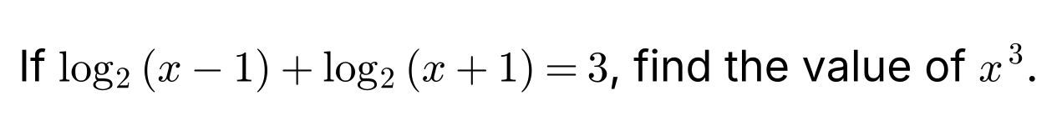
{OPTION 1}
{OPTION 2}
{OPTION 3}
{OPTION 4}
{OPTION 5}
{OPTION 6}
{OPTION 7}
{OPTION 8}
{OPTION 9}
{OPTION 10}
{RIGHT ANSWER} 27
{EXPLANATION} log₂[(x − 1)(x + 1)] = 3, so x² − 1 = 8 and x² = 9. Since the logarithms need x − 1 > 0, x = 3 (x = −3 is rejected). So x³ = 27.
{CORRECT MARKS} 1
{NEGATIVE MARKS} 0
{DIFFICULTY} Hard
{QUESTION ENDS}

{QUESTION BEGINS}
{QUESTION NUMBER} 10
{SUBJECT} Advanced Quantitative Ability
{TOPIC} Trigonometry
{TAGS} tcs nqt, advanced quantitative, TITA, hard
{QUESTION TYPE} NUMERICAL
{QUESTION TEXT} 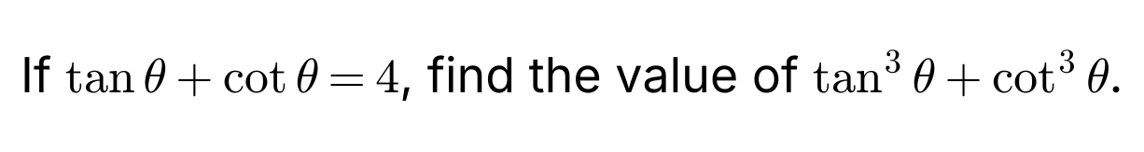
{OPTION 1}
{OPTION 2}
{OPTION 3}
{OPTION 4}
{OPTION 5}
{OPTION 6}
{OPTION 7}
{OPTION 8}
{OPTION 9}
{OPTION 10}
{RIGHT ANSWER} 52
{EXPLANATION} Let s = tan θ + cot θ = 4 and tan θ · cot θ = 1. Then tan³θ + cot³θ = s³ − 3s = 64 − 12 = 52.
{CORRECT MARKS} 1
{NEGATIVE MARKS} 0
{DIFFICULTY} Hard
{QUESTION ENDS}

{QUESTION BEGINS}
{QUESTION NUMBER} 11
{SUBJECT} Advanced Quantitative Ability
{TOPIC} Mensuration
{TAGS} tcs nqt, advanced quantitative, TITA, hard
{QUESTION TYPE} NUMERICAL
{QUESTION TEXT} 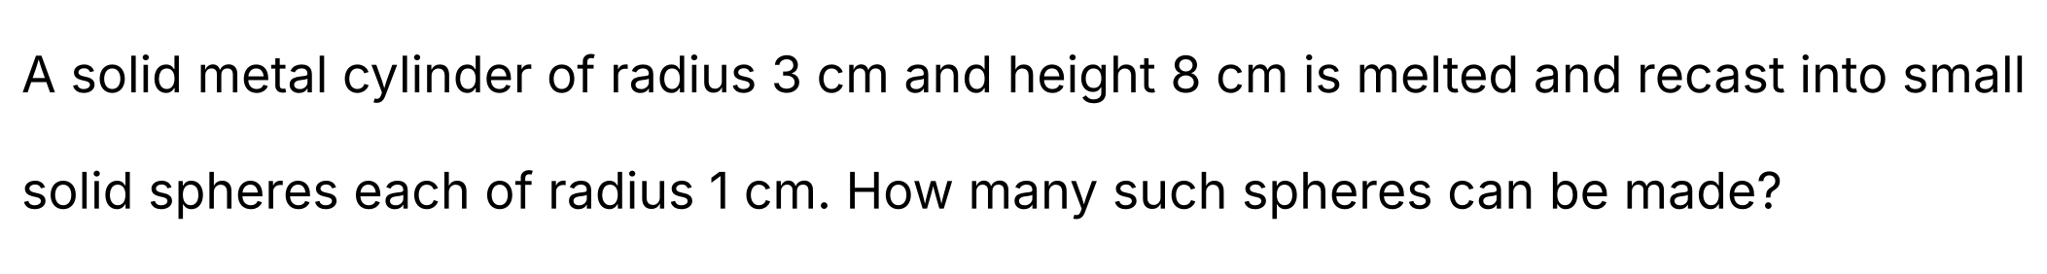
{OPTION 1}
{OPTION 2}
{OPTION 3}
{OPTION 4}
{OPTION 5}
{OPTION 6}
{OPTION 7}
{OPTION 8}
{OPTION 9}
{OPTION 10}
{RIGHT ANSWER} 54
{EXPLANATION} Volume of the cylinder = π × 3² × 8 = 72π cm³. Volume of one sphere = (4/3)π × 1³ = 4π/3 cm³. Number of spheres = 72π ÷ (4π/3) = 54.
{CORRECT MARKS} 1
{NEGATIVE MARKS} 0
{DIFFICULTY} Hard
{QUESTION ENDS}

{QUESTION BEGINS}
{QUESTION NUMBER} 12
{SUBJECT} Advanced Quantitative Ability
{TOPIC} Number Theory
{TAGS} tcs nqt, advanced quantitative, TITA, hard
{QUESTION TYPE} NUMERICAL
{QUESTION TEXT} 
{OPTION 1}
{OPTION 2}
{OPTION 3}
{OPTION 4}
{OPTION 5}
{OPTION 6}
{OPTION 7}
{OPTION 8}
{OPTION 9}
{OPTION 10}
{RIGHT ANSWER} 40
{EXPLANATION} 2160 = 2⁴ × 3³ × 5¹. The number of divisors = (4 + 1)(3 + 1)(1 + 1) = 5 × 4 × 2 = 40.
{CORRECT MARKS} 1
{NEGATIVE MARKS} 0
{DIFFICULTY} Hard
{QUESTION ENDS}

{QUESTION BEGINS}
{QUESTION NUMBER} 13
{SUBJECT} Advanced Quantitative Ability
{TOPIC} Permutations
{TAGS} tcs nqt, advanced quantitative, TITA, hard
{QUESTION TYPE} NUMERICAL
{QUESTION TEXT}
{OPTION 1}
{OPTION 2}
{OPTION 3}
{OPTION 4}
{OPTION 5}
{OPTION 6}
{OPTION 7}
{OPTION 8}
{OPTION 9}
{OPTION 10}
{RIGHT ANSWER} 60
{EXPLANATION} BANANA has 6 letters with A repeated 3 times and N repeated 2 times. Number of arrangements = 6!/(3! × 2!) = 720/12 = 60.
{CORRECT MARKS} 1
{NEGATIVE MARKS} 0
{DIFFICULTY} Hard
{QUESTION ENDS}

{QUESTION BEGINS}
{QUESTION NUMBER} 14
{SUBJECT} Advanced Quantitative Ability
{TOPIC} Progressions
{TAGS} tcs nqt, advanced quantitative, TITA, hard
{QUESTION TYPE} NUMERICAL
{QUESTION TEXT} 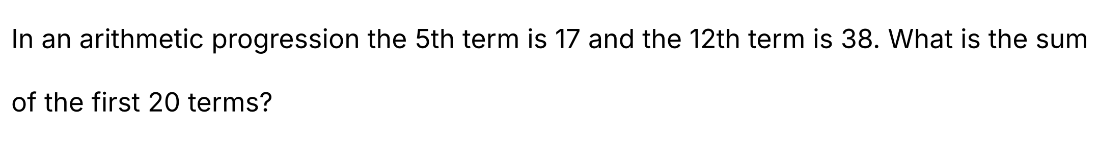
{OPTION 1}
{OPTION 2}
{OPTION 3}
{OPTION 4}
{OPTION 5}
{OPTION 6}
{OPTION 7}
{OPTION 8}
{OPTION 9}
{OPTION 10}
{RIGHT ANSWER} 670
{EXPLANATION} Let the first term be a and the common difference d. a + 4d = 17 and a + 11d = 38, so 7d = 21, d = 3 and a = 5. Sum of the first 20 terms = (20/2)[2 × 5 + 19 × 3] = 10 × 67 = 670.
{CORRECT MARKS} 1
{NEGATIVE MARKS} 0
{DIFFICULTY} Hard
{QUESTION ENDS}

