{QUESTION BEGINS}
{QUESTION NUMBER} 1
{SUBJECT} Reasoning Ability
{TOPIC} Cubes
{TAGS} tcs nqt, reasoning ability, figure based, hard
{QUESTION TYPE} SINGLECORRECT
{QUESTION TEXT} The figure shows a solid made by stacking identical unit cubes in columns on a 3 × 3 base; the columns get taller towards the back. Assuming that there are no gaps below any visible cube, how many unit cubes make up the solid?
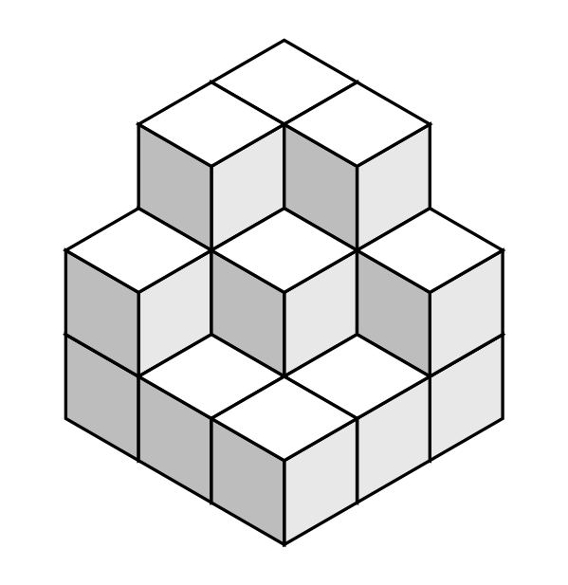
{OPTION 1} 18
{OPTION 2} 15
{OPTION 3} 20
{OPTION 4} 21
{OPTION 5}
{OPTION 6}
{OPTION 7}
{OPTION 8}
{OPTION 9}
{OPTION 10}
{RIGHT ANSWER} 1
{EXPLANATION} Count the cubes in each of the nine columns, using the height of its top face above the neighbouring columns: the heights are 1, 1, 2 / 1, 2, 3 / 2, 3, 3 (growing towards the back). Total number of cubes = 1 + 1 + 2 + 1 + 2 + 3 + 2 + 3 + 3 = 18.
{CORRECT MARKS} 1
{NEGATIVE MARKS} 0
{DIFFICULTY} Hard
{QUESTION ENDS}

{QUESTION BEGINS}
{QUESTION NUMBER} 2
{SUBJECT} Reasoning Ability
{TOPIC} Matrix Reasoning
{TAGS} tcs nqt, reasoning ability, figure based, hard
{QUESTION TYPE} SINGLECORRECT
{QUESTION TEXT} In the 4 × 4 square each of the four symbols ★, ●, ▲ and ■ appears exactly once in every row and exactly once in every column. Which symbols replace '?' and '#', respectively?
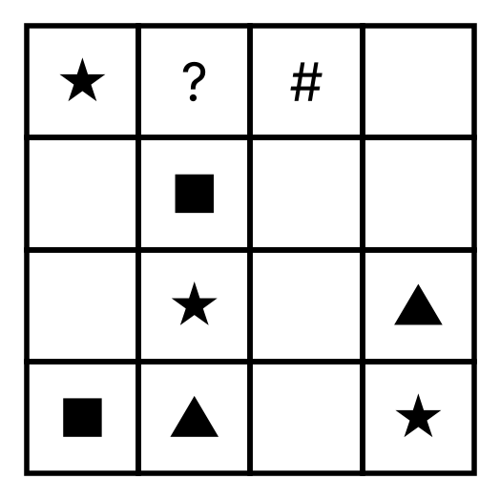
{OPTION 1} ▲ and ●
{OPTION 2} ★ and ▲
{OPTION 3} ★ and ●
{OPTION 4} ● and ▲
{OPTION 5}
{OPTION 6}
{OPTION 7}
{OPTION 8}
{OPTION 9}
{OPTION 10}
{RIGHT ANSWER} 4
{EXPLANATION} Fill the grid so that every row and column contains all four symbols. Starting with the rows or columns that have only one empty square and working step by step gives the only possible completion, in which '?' is ● and '#' is ▲.
{CORRECT MARKS} 1
{NEGATIVE MARKS} 0
{DIFFICULTY} Hard
{QUESTION ENDS}

{QUESTION BEGINS}
{QUESTION NUMBER} 3
{SUBJECT} Reasoning Ability
{TOPIC} Odd One Out
{TAGS} tcs nqt, reasoning ability, figure based, hard
{QUESTION TYPE} SINGLECORRECT
{QUESTION TEXT} In each of the figures, the number in the middle is obtained from the other three numbers by a rule. Which figure does not follow the rule followed by the other three?
{OPTION 1} 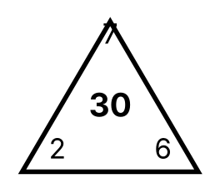
{OPTION 2} 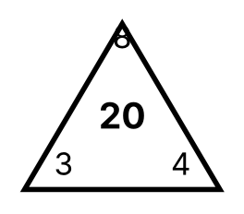
{OPTION 3} 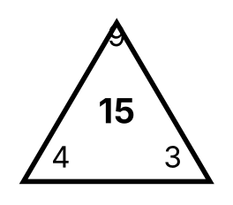
{OPTION 4} 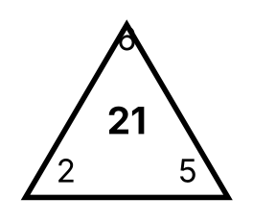
{OPTION 5}
{OPTION 6}
{OPTION 7}
{OPTION 8}
{OPTION 9}
{OPTION 10}
{RIGHT ANSWER} 4
{EXPLANATION} In the first figure (9 − 4) × 3 = 15, in the second (8 − 3) × 4 = 20 and in the third (7 − 2) × 6 = 30, so the middle number = (top − left) × right. In the fourth figure (6 − 2) × 5 = 20 but the middle number is 21, so it does not follow the rule.
{CORRECT MARKS} 1
{NEGATIVE MARKS} 0
{DIFFICULTY} Hard
{QUESTION ENDS}

{QUESTION BEGINS}
{QUESTION NUMBER} 4
{SUBJECT} Reasoning Ability
{TOPIC} Seating Arrangement
{TAGS} tcs nqt, reasoning ability, hard
{QUESTION TYPE} SINGLECORRECT
{QUESTION TEXT} Six friends A, B, C, D, E and F sit around a circular table. A, C and E face the centre of the table, while B, D and F face away from the centre (outside). F sits second to the left of D. A sits immediate to the right of F. C sits second to the left of E.
Who sits second to the left of D?
{OPTION 1} A
{OPTION 2} B
{OPTION 3} C
{OPTION 4} F
{OPTION 5}
{OPTION 6}
{OPTION 7}
{OPTION 8}
{OPTION 9}
{OPTION 10}
{RIGHT ANSWER} 4
{EXPLANATION} Remember that for a person facing the centre 'left' is clockwise, while for a person facing outwards 'left' is anticlockwise. Using all the statements, the only possible seating (clockwise from A) is A, D, E, B, C, F. D faces outside, so counting two places to D's left (anticlockwise) gives F.
{CORRECT MARKS} 1
{NEGATIVE MARKS} 0
{DIFFICULTY} Hard
{QUESTION ENDS}

{QUESTION BEGINS}
{QUESTION NUMBER} 5
{SUBJECT} Reasoning Ability
{TOPIC} Pattern Reasoning
{TAGS} tcs nqt, reasoning ability, figure based, hard
{QUESTION TYPE} SINGLECORRECT
{QUESTION TEXT} The figures show a pattern made with matchsticks: Figure 1 has a 2 × 1 block of squares, Figure 2 a 2 × 2 block and Figure 3 a 2 × 3 block. How many matchsticks are needed for Figure 9 following the same pattern?
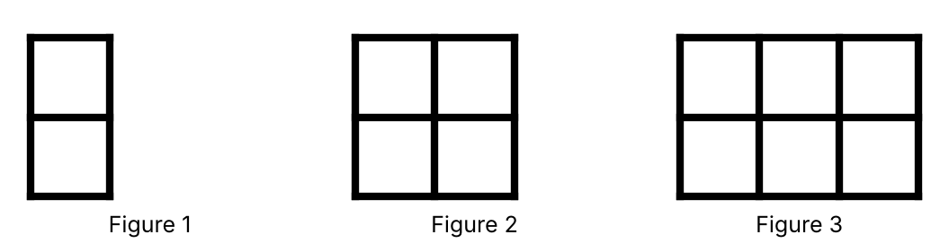
{OPTION 1} 45
{OPTION 2} 47
{OPTION 3} 50
{OPTION 4} 52
{OPTION 5}
{OPTION 6}
{OPTION 7}
{OPTION 8}
{OPTION 9}
{OPTION 10}
{RIGHT ANSWER} 2
{EXPLANATION} Figure 1 uses 7 sticks, Figure 2 uses 12 and Figure 3 uses 17, so each new column adds 5 sticks: the number of sticks = 5n + 2. For Figure 9: 5 × 9 + 2 = 47.
{CORRECT MARKS} 1
{NEGATIVE MARKS} 0
{DIFFICULTY} Hard
{QUESTION ENDS}

{QUESTION BEGINS}
{QUESTION NUMBER} 6
{SUBJECT} Reasoning Ability
{TOPIC} Puzzle
{TAGS} tcs nqt, reasoning ability, hard
{QUESTION TYPE} SINGLECORRECT
{QUESTION TEXT} Six persons A, B, C, D, E and F are a doctor, an engineer, a pilot, a teacher, a lawyer and a chef (not necessarily in this order), one profession each. A is either the chef or the engineer. F is either the pilot or the chef. D is either the doctor or the engineer. F is either the pilot or the doctor. B is either the engineer or the teacher. B is either the engineer or the chef. E is either the lawyer or the engineer.
What is the profession of C?
{OPTION 1} teacher
{OPTION 2} doctor
{OPTION 3} pilot
{OPTION 4} engineer
{OPTION 5}
{OPTION 6}
{OPTION 7}
{OPTION 8}
{OPTION 9}
{OPTION 10}
{RIGHT ANSWER} 1
{EXPLANATION} Combining all the statements, only one assignment of the six professions to the six persons is possible, and in it C is the teacher. (All 720 possible assignments were checked.)
{CORRECT MARKS} 1
{NEGATIVE MARKS} 0
{DIFFICULTY} Hard
{QUESTION ENDS}

{QUESTION BEGINS}
{QUESTION NUMBER} 7
{SUBJECT} Reasoning Ability
{TOPIC} Puzzle
{TAGS} tcs nqt, reasoning ability, hard
{QUESTION TYPE} SINGLECORRECT
{QUESTION TEXT} On an island every person is either a knight (always tells the truth) or a knave (always lies). Four islanders A, B, C and D say the following. A: "B and C are both knaves." B: "A is a knave." C: "A and D are of different types." D: "C is a knave."
How many of them are knights?
{OPTION 1} 0
{OPTION 2} 1
{OPTION 3} 2
{OPTION 4} 3
{OPTION 5}
{OPTION 6}
{OPTION 7}
{OPTION 8}
{OPTION 9}
{OPTION 10}
{RIGHT ANSWER} 3
{EXPLANATION} Suppose A is a knave. Then B's statement 'A is a knave' is true, so B is a knight. Now if C is a knight, then A and D differ, so D is a knight; but D says 'C is a knave', which would then be false: a contradiction. If C is a knave, then 'A and D differ' is false, so D is a knave like A; but D says 'C is a knave', which is true: another contradiction. So A is a knight. Then B and C are knaves (A tells the truth), B's false statement fits, C's statement 'A and D differ' is false, so D is a knight like A, and D's statement 'C is a knave' is true. The knights are A and D: 2.
{CORRECT MARKS} 1
{NEGATIVE MARKS} 0
{DIFFICULTY} Hard
{QUESTION ENDS}

{QUESTION BEGINS}
{QUESTION NUMBER} 8
{SUBJECT} Reasoning Ability
{TOPIC} Syllogism
{TAGS} tcs nqt, reasoning ability, hard
{QUESTION TYPE} SINGLECORRECT
{QUESTION TEXT} Statements: Only a few cats are dogs. All dogs are pets. No pet is a rock.
Conclusions:
I. Some cats are pets.
II. Some cats are not rocks.
III. Some cats are not pets.
IV. All cats are pets.
Which of the following follows?
{OPTION 1} Only II and IV follow
{OPTION 2} Only I, II and III follow
{OPTION 3} Only I and IV follow
{OPTION 4} Only I and II follow
{OPTION 5}
{OPTION 6}
{OPTION 7}
{OPTION 8}
{OPTION 9}
{OPTION 10}
{RIGHT ANSWER} 4
{EXPLANATION} 'Only a few cats are dogs' means some cats are dogs and some cats are not dogs. The cats that are dogs are pets (I follows) and, because no pet is a rock, they are not rocks (II follows). The cats that are not dogs may or may not be pets, so III and IV are not certain. Only I and II follow.
{CORRECT MARKS} 1
{NEGATIVE MARKS} 0
{DIFFICULTY} Hard
{QUESTION ENDS}

{QUESTION BEGINS}
{QUESTION NUMBER} 9
{SUBJECT} Reasoning Ability
{TOPIC} Cryptarithm
{TAGS} tcs nqt, reasoning ability, hard
{QUESTION TYPE} SINGLECORRECT
{QUESTION TEXT} In the addition SEND + MORE = MONEY every letter stands for a different digit and no number starts with zero. What is the value of D + E + Y?
{OPTION 1} 18
{OPTION 2} 14
{OPTION 3} 12
{OPTION 4} 16
{OPTION 5}
{OPTION 6}
{OPTION 7}
{OPTION 8}
{OPTION 9}
{OPTION 10}
{RIGHT ANSWER} 2
{EXPLANATION} The sum of two 4-digit numbers is a 5-digit number, so M = 1. Then S + M + carry must give O with a carry, which forces S = 9 and O = 0. Solving the remaining columns gives E = 5, N = 6, D = 7, R = 8 and Y = 2 (9567 + 1085 = 10652). So D + E + Y = 7 + 5 + 2 = 14.
{CORRECT MARKS} 1
{NEGATIVE MARKS} 0
{DIFFICULTY} Hard
{QUESTION ENDS}

{QUESTION BEGINS}
{QUESTION NUMBER} 10
{SUBJECT} Reasoning Ability
{TOPIC} Calendar
{TAGS} tcs nqt, reasoning ability, hard
{QUESTION TYPE} SINGLECORRECT
{QUESTION TEXT} The calendar of the year 2024 will be exactly the same (every date falling on the same day of the week) as the calendar of which later year?
{OPTION 1} 2050
{OPTION 2} 2048
{OPTION 3} 2052
{OPTION 4} 2056
{OPTION 5}
{OPTION 6}
{OPTION 7}
{OPTION 8}
{OPTION 9}
{OPTION 10}
{RIGHT ANSWER} 3
{EXPLANATION} 2024 is a leap year starting on a Monday. A later leap year must also start on a Monday. Leap years after 2024 are 2028 (Saturday), 2032 (Thursday), 2036 (Tuesday), 2040 (Sunday), 2044 (Friday), 2048 (Wednesday) and 2052 (Monday). So the first year with the same calendar is 2052.
{CORRECT MARKS} 1
{NEGATIVE MARKS} 0
{DIFFICULTY} Hard
{QUESTION ENDS}

{QUESTION BEGINS}
{QUESTION NUMBER} 11
{SUBJECT} Reasoning Ability
{TOPIC} Paper Cutting
{TAGS} tcs nqt, reasoning ability, figure based, hard
{QUESTION TYPE} SINGLECORRECT
{QUESTION TEXT} A square sheet of paper is folded along the two dotted lines (first vertically, then horizontally) to make four layers, and a triangular piece is cut out along the bottom edge as shown. How will the sheet look when it is unfolded?
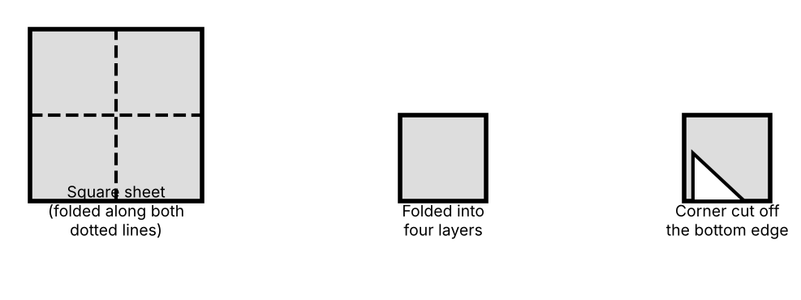
{OPTION 1} 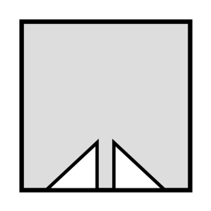
{OPTION 2} 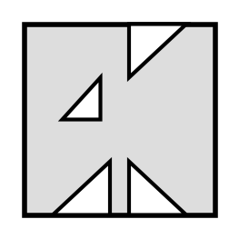
{OPTION 3} 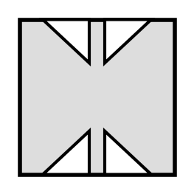
{OPTION 4} 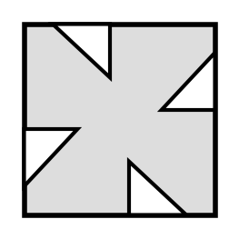
{OPTION 5}
{OPTION 6}
{OPTION 7}
{OPTION 8}
{OPTION 9}
{OPTION 10}
{RIGHT ANSWER} 3
{EXPLANATION} Cutting through four layers makes four cut-outs. On unfolding, each cut-out is the mirror image of its neighbour across the fold lines (not a rotated copy): one cut-out on the bottom edge on each side of the vertical middle line and the mirror images of both on the top edge. Only option 1 shows four cuts that are mirror images across both middle lines.
{CORRECT MARKS} 1
{NEGATIVE MARKS} 0
{DIFFICULTY} Hard
{QUESTION ENDS}

{QUESTION BEGINS}
{QUESTION NUMBER} 12
{SUBJECT} Reasoning Ability
{TOPIC} Figure Overlay
{TAGS} tcs nqt, reasoning ability, figure based, hard
{QUESTION TYPE} SINGLECORRECT
{QUESTION TEXT} Two transparent sheets with black squares are placed exactly one over the other (without turning). A square appears black if it is black on exactly one sheet, and it appears grey if it is black on both sheets. Which figure do you see?
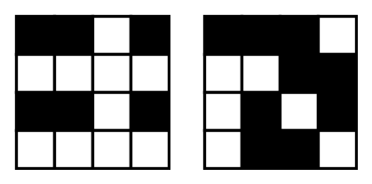
{OPTION 1} 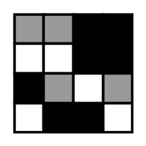
{OPTION 2} 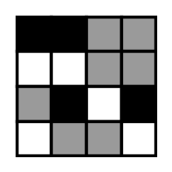
{OPTION 3} 
{OPTION 4} 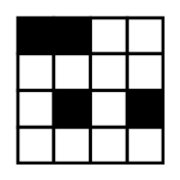
{OPTION 5}
{OPTION 6}
{OPTION 7}
{OPTION 8}
{OPTION 9}
{OPTION 10}
{RIGHT ANSWER} 1
{EXPLANATION} Compare the sheets square by square: a square that is black on only one sheet is black, a square that is black on both is grey, and a square that is white on both stays white. Option 1 follows this rule for every square.
{CORRECT MARKS} 1
{NEGATIVE MARKS} 0
{DIFFICULTY} Hard
{QUESTION ENDS}

{QUESTION BEGINS}
{QUESTION NUMBER} 13
{SUBJECT} Reasoning Ability
{TOPIC} Number Analogy
{TAGS} tcs nqt, reasoning ability, hard
{QUESTION TYPE} SINGLECORRECT
{QUESTION TEXT} Find the number that will replace the question mark: 24 : 5 :: 63 : ?
{OPTION 1} 6
{OPTION 2} 7
{OPTION 3} 9
{OPTION 4} 8
{OPTION 5}
{OPTION 6}
{OPTION 7}
{OPTION 8}
{OPTION 9}
{OPTION 10}
{RIGHT ANSWER} 4
{EXPLANATION} 24 = 5² − 1, so 24 is paired with 5. Similarly 63 = 8² − 1, so 63 is paired with 8.
{CORRECT MARKS} 1
{NEGATIVE MARKS} 0
{DIFFICULTY} Hard
{QUESTION ENDS}

{QUESTION BEGINS}
{QUESTION NUMBER} 14
{SUBJECT} Reasoning Ability
{TOPIC} Mathematical Operations
{TAGS} tcs nqt, reasoning ability, hard
{QUESTION TYPE} SINGLECORRECT
{QUESTION TEXT} If 'A @ B' means A² − B and 'A # B' means A + B², what is the value of (5 @ 4) # (3 @ 2)?
{OPTION 1} 66
{OPTION 2} 57
{OPTION 3} 64
{OPTION 4} 70
{OPTION 5}
{OPTION 6}
{OPTION 7}
{OPTION 8}
{OPTION 9}
{OPTION 10}
{RIGHT ANSWER} 4
{EXPLANATION} 5 @ 4 = 5² − 4 = 21 and 3 @ 2 = 3² − 2 = 7. Then 21 # 7 = 21 + 7² = 21 + 49 = 70.
{CORRECT MARKS} 1
{NEGATIVE MARKS} 0
{DIFFICULTY} Hard
{QUESTION ENDS}

{QUESTION BEGINS}
{QUESTION NUMBER} 15
{SUBJECT} Reasoning Ability
{TOPIC} Directions
{TAGS} tcs nqt, reasoning ability, figure based, hard
{QUESTION TYPE} SINGLECORRECT
{QUESTION TEXT} The figure shows the positions of five places on a map (the distance between two neighbouring grid lines is 1 km, and North is towards the top). What is the shortest distance between P and Q, and in which direction is Q with respect to P?
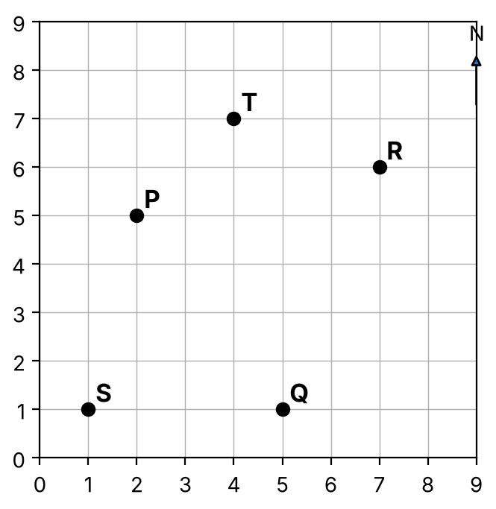
{OPTION 1} 5 km, South-East
{OPTION 2} 4 km, South
{OPTION 3} 5 km, North-East
{OPTION 4} 7 km, South-East
{OPTION 5}
{OPTION 6}
{OPTION 7}
{OPTION 8}
{OPTION 9}
{OPTION 10}
{RIGHT ANSWER} 1
{EXPLANATION} P is at (2, 5) and Q is at (5, 1). Q is 3 km east and 4 km south of P. The distance = √(3² + 4²) = 5 km, and since Q is to the east and to the south of P, it lies in the South-East direction.
{CORRECT MARKS} 1
{NEGATIVE MARKS} 0
{DIFFICULTY} Hard
{QUESTION ENDS}

{QUESTION BEGINS}
{QUESTION NUMBER} 16
{SUBJECT} Reasoning Ability
{TOPIC} Number Series
{TAGS} tcs nqt, reasoning ability, hard
{QUESTION TYPE} SINGLECORRECT
{QUESTION TEXT} Find the next term of the series: 1, 2, 6, 15, 31, ?
{OPTION 1} 52
{OPTION 2} 56
{OPTION 3} 58
{OPTION 4} 54
{OPTION 5}
{OPTION 6}
{OPTION 7}
{OPTION 8}
{OPTION 9}
{OPTION 10}
{RIGHT ANSWER} 2
{EXPLANATION} The differences between consecutive terms are 1, 4, 9, 16, which are the squares of 1, 2, 3, 4. The next difference is 5² = 25, so the next term is 31 + 25 = 56.
{CORRECT MARKS} 1
{NEGATIVE MARKS} 0
{DIFFICULTY} Hard
{QUESTION ENDS}

{QUESTION BEGINS}
{QUESTION NUMBER} 17
{SUBJECT} Reasoning Ability
{TOPIC} Figure Series
{TAGS} tcs nqt, reasoning ability, figure based, hard
{QUESTION TYPE} SINGLECORRECT
{QUESTION TEXT} Select the figure that replaces the question mark (?) in the series.
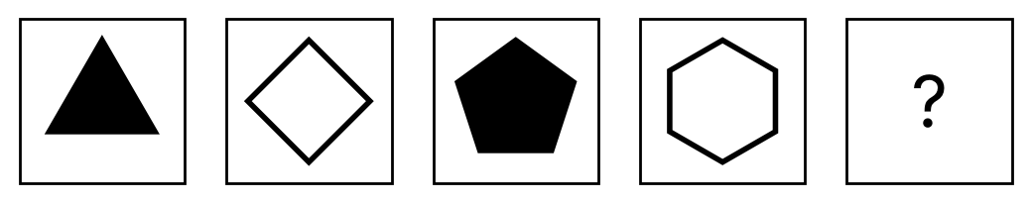
{OPTION 1} 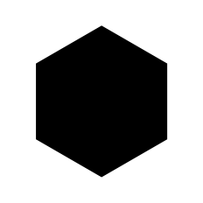
{OPTION 2} 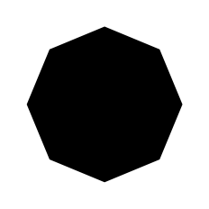
{OPTION 3} 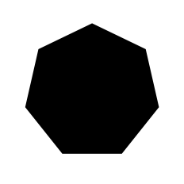
{OPTION 4} 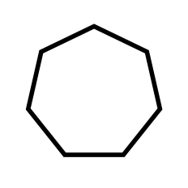
{OPTION 5}
{OPTION 6}
{OPTION 7}
{OPTION 8}
{OPTION 9}
{OPTION 10}
{RIGHT ANSWER} 3
{EXPLANATION} The number of sides increases by one in every figure (3, 4, 5, 6, …) and the shading alternates between black and white (black, white, black, white, …). So the next figure is a black seven-sided figure.
{CORRECT MARKS} 1
{NEGATIVE MARKS} 0
{DIFFICULTY} Hard
{QUESTION ENDS}

{QUESTION BEGINS}
{QUESTION NUMBER} 18
{SUBJECT} Reasoning Ability
{TOPIC} Alphabet Test
{TAGS} tcs nqt, reasoning ability, hard
{QUESTION TYPE} SINGLECORRECT
{QUESTION TEXT} If all the possible arrangements of the letters of the word TRAIN are written in alphabetical (dictionary) order, what is the position of the word TRAIN?
{OPTION 1} 112
{OPTION 2} 96
{OPTION 3} 115
{OPTION 4} 108
{OPTION 5}
{OPTION 6}
{OPTION 7}
{OPTION 8}
{OPTION 9}
{OPTION 10}
{RIGHT ANSWER} 3
{EXPLANATION} Letters in order: A, I, N, R, T. Words starting with A, I, N, R each have 4! = 24 arrangements: 4 × 24 = 96 words before the words starting with T. For T, the next letter R: letters left A, I, N, R; words beginning TA, TI, TN need 3 × 6 = 18 more. Then TRA: the letters left are I, N: TRAIN is the first of TRAIN, TRANI, so it comes right after those 18. Position = 96 + 18 + 1 = 115.
{CORRECT MARKS} 1
{NEGATIVE MARKS} 0
{DIFFICULTY} Hard
{QUESTION ENDS}

{QUESTION BEGINS}
{QUESTION NUMBER} 19
{SUBJECT} Reasoning Ability
{TOPIC} Inequalities
{TAGS} tcs nqt, reasoning ability, hard
{QUESTION TYPE} SINGLECORRECT
{QUESTION TEXT} In the following question the symbols have these meanings: 'A $ B' means A ≥ B, 'A # B' means A > B, 'A @ B' means A = B, 'A % B' means A < B.
Statement: M # N $ O @ P % Q
Conclusions:
I. N # P
II. N @ P
III. M # P
IV. Q # O
Which of the following is correct?
{OPTION 1} Either I or II follows, and III and IV also follow
{OPTION 2} Both I and II follow, and III follows
{OPTION 3} Only III and IV follow
{OPTION 4} Either I or II follows, but III and IV do not follow
{OPTION 5}
{OPTION 6}
{OPTION 7}
{OPTION 8}
{OPTION 9}
{OPTION 10}
{RIGHT ANSWER} 1
{EXPLANATION} The statement reads M > N ≥ O = P < Q. N ≥ P, so N is either greater than P (I) or equal to P (II): neither is definite alone, but one of them must be true, so 'either I or II' follows. M > N ≥ P gives M > P (III true). Q > P = O gives Q > O (IV true).
{CORRECT MARKS} 1
{NEGATIVE MARKS} 0
{DIFFICULTY} Hard
{QUESTION ENDS}

{QUESTION BEGINS}
{QUESTION NUMBER} 20
{SUBJECT} Reasoning Ability
{TOPIC} Chart Reasoning
{TAGS} tcs nqt, reasoning ability, figure based, hard
{QUESTION TYPE} SINGLECORRECT
{QUESTION TEXT} The line graph shows the monthly sales (in lakh ₹) of two companies A and B. In how many months were the sales of A more than those of B, and in which month was the difference between their sales the greatest?
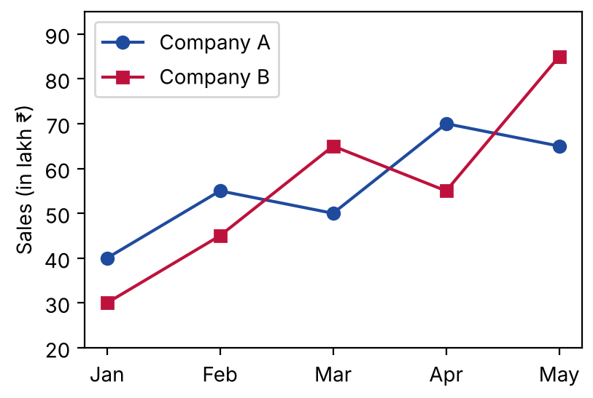
{OPTION 1} 3 months; April
{OPTION 2} 2 months; May
{OPTION 3} 3 months; May
{OPTION 4} 2 months; March
{OPTION 5}
{OPTION 6}
{OPTION 7}
{OPTION 8}
{OPTION 9}
{OPTION 10}
{RIGHT ANSWER} 3
{EXPLANATION} Sales (A, B): Jan (40, 30), Feb (55, 45), Mar (50, 65), Apr (70, 55), May (65, 85). A − B = +10, +10, −15, +15, −20. A is ahead in January, February and April: 3 months. The greatest difference in size is 20, in May.
{CORRECT MARKS} 1
{NEGATIVE MARKS} 0
{DIFFICULTY} Hard
{QUESTION ENDS}

