{QUESTION BEGINS}
{QUESTION NUMBER} 1
{SUBJECT} Technical Assessment
{TOPIC} Pseudocode
{TAGS} accenture, technical assessment, pseudocode, mock test 4, hard
{QUESTION TYPE} SINGLECORRECT
{QUESTION TEXT} What will be the output of the following pseudocode?
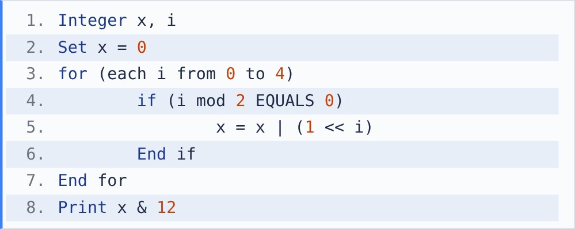
[Note - |: bitwise OR sets a result bit to 1 if either bit is 1. &: bitwise AND sets it to 1 only if both bits are 1. <<: left shift, 1 << i equals 2 to the power i.]

{OPTION 1} 21
{OPTION 2} 12
{OPTION 3} 4
{OPTION 4} 5
{OPTION 5}
{OPTION 6}
{OPTION 7}
{OPTION 8}
{OPTION 9}
{OPTION 10}
{RIGHT ANSWER} 3
{EXPLANATION} i = 0, 2, 4 are even, so x = 1 | 4 | 16 = 21 (binary 10101). 12 is 01100. 10101 & 01100 = 00100 = 4.
{CORRECT MARKS} 1
{NEGATIVE MARKS} 0
{DIFFICULTY} Hard
{QUESTION ENDS}

{QUESTION BEGINS}
{QUESTION NUMBER} 2
{SUBJECT} Technical Assessment
{TOPIC} Pseudocode
{TAGS} accenture, technical assessment, pseudocode, mock test 4, medium
{QUESTION TYPE} SINGLECORRECT
{QUESTION TEXT} What will be the output of the following pseudocode for fun(13)?
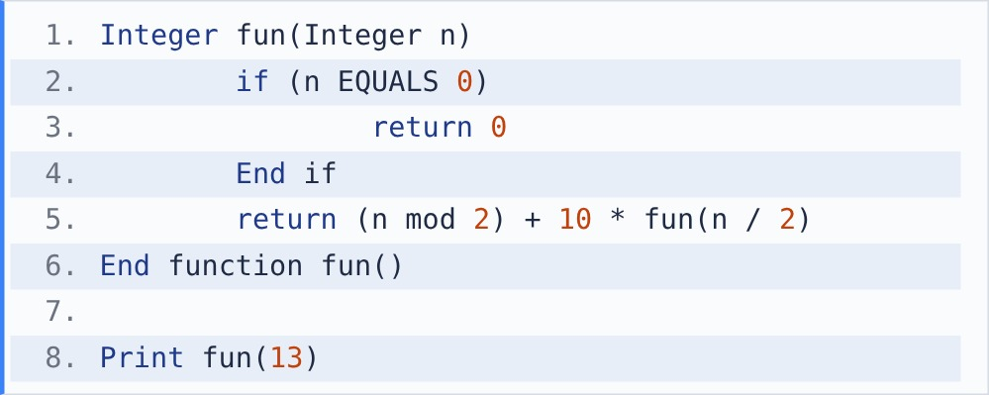
[Note - mod finds the remainder after division. For example, 17 mod 5 = 2.] [Note - / between two integers gives integer division, which drops the remainder: 123 / 10 = 12.]

{OPTION 1} 1011
{OPTION 2} 1101
{OPTION 3} 13
{OPTION 4} 111
{OPTION 5}
{OPTION 6}
{OPTION 7}
{OPTION 8}
{OPTION 9}
{OPTION 10}
{RIGHT ANSWER} 2
{EXPLANATION} fun(13) = 1 + 10*fun(6); fun(6) = 0 + 10*fun(3); fun(3) = 1 + 10*fun(1); fun(1) = 1 + 10*fun(0) = 1. So fun(3) = 11, fun(6) = 110, fun(13) = 1101. The function builds the binary form of n.
{CORRECT MARKS} 1
{NEGATIVE MARKS} 0
{DIFFICULTY} Medium
{QUESTION ENDS}

{QUESTION BEGINS}
{QUESTION NUMBER} 3
{SUBJECT} Technical Assessment
{TOPIC} Pseudocode
{TAGS} accenture, technical assessment, pseudocode, mock test 4, easy
{QUESTION TYPE} SINGLECORRECT
{QUESTION TEXT} What will be the output of the following pseudocode?
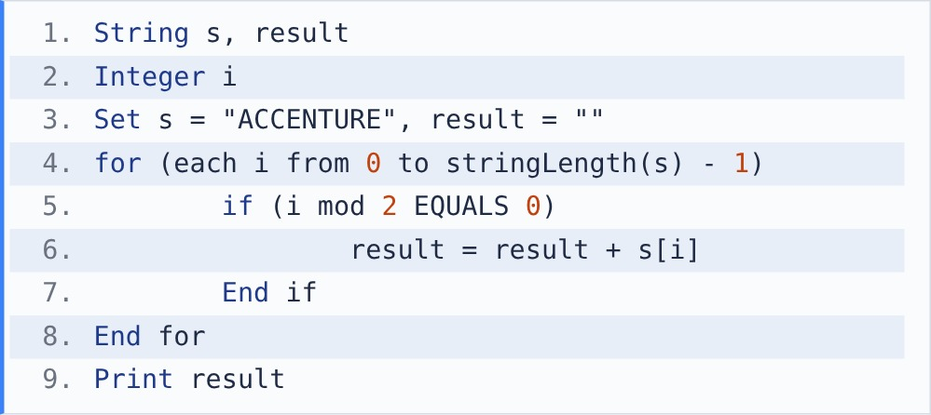
[Note - stringLength() returns the number of characters in a string. s[i] is the character at index i; indexing starts at 0. + joins two strings.]

{OPTION 1} ACNUE
{OPTION 2} CENTR
{OPTION 3} ACEUE
{OPTION 4} CCTR
{OPTION 5}
{OPTION 6}
{OPTION 7}
{OPTION 8}
{OPTION 9}
{OPTION 10}
{RIGHT ANSWER} 1
{EXPLANATION} "ACCENTURE" has indexes 0-8. Even indexes are 0:A, 2:C, 4:N, 6:U, 8:E, so result = ACNUE.
{CORRECT MARKS} 1
{NEGATIVE MARKS} 0
{DIFFICULTY} Easy
{QUESTION ENDS}

{QUESTION BEGINS}
{QUESTION NUMBER} 4
{SUBJECT} Technical Assessment
{TOPIC} Pseudocode
{TAGS} accenture, technical assessment, pseudocode, mock test 4, medium
{QUESTION TYPE} SINGLECORRECT
{QUESTION TEXT} What happens when the following pseudocode is executed?
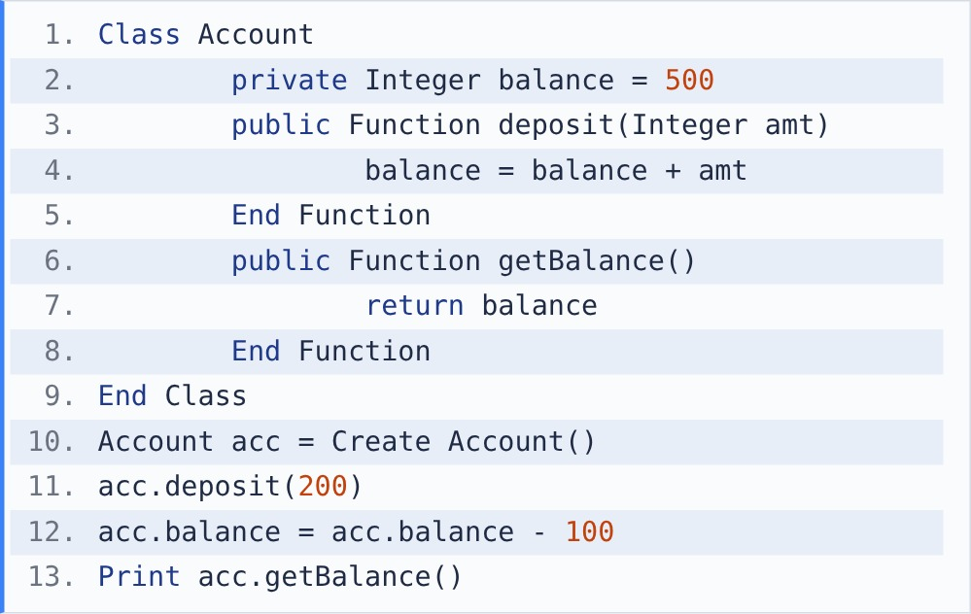

{OPTION 1} It prints 600
{OPTION 2} It prints 700
{OPTION 3} Compilation error at line 12, because balance is private
{OPTION 4} Runtime error at line 11, because deposit() changes balance
{OPTION 5}
{OPTION 6}
{OPTION 7}
{OPTION 8}
{OPTION 9}
{OPTION 10}
{RIGHT ANSWER} 3
{EXPLANATION} balance is private (encapsulation), so it can be used only inside the class. Line 11 is fine because deposit() is a public method. Line 12 accesses acc.balance from outside the class, which the compiler rejects. The correct way is to change balance only through public methods.
{CORRECT MARKS} 1
{NEGATIVE MARKS} 0
{DIFFICULTY} Medium
{QUESTION ENDS}

{QUESTION BEGINS}
{QUESTION NUMBER} 5
{SUBJECT} Technical Assessment
{TOPIC} Pseudocode
{TAGS} accenture, technical assessment, pseudocode, mock test 4, easy
{QUESTION TYPE} SINGLECORRECT
{QUESTION TEXT} What will be the output of the following pseudocode?
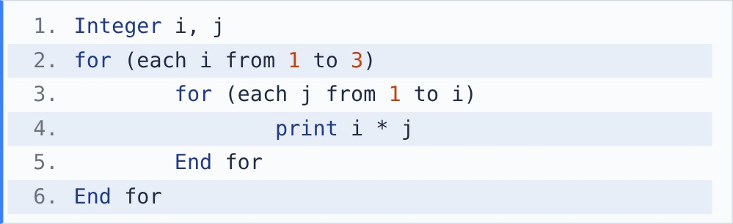

{OPTION 1} 1 2 3 4 6 9
{OPTION 2} 1 2 4 3 6 9
{OPTION 3} 1 2 3 2 4 6 3 6 9
{OPTION 4} 1 4 9
{OPTION 5}
{OPTION 6}
{OPTION 7}
{OPTION 8}
{OPTION 9}
{OPTION 10}
{RIGHT ANSWER} 2
{EXPLANATION} The inner loop runs j = 1 to i. i=1: 1. i=2: 2, 4. i=3: 3, 6, 9. Output in order: 1 2 4 3 6 9.
{CORRECT MARKS} 1
{NEGATIVE MARKS} 0
{DIFFICULTY} Easy
{QUESTION ENDS}

{QUESTION BEGINS}
{QUESTION NUMBER} 6
{SUBJECT} Technical Assessment
{TOPIC} Pseudocode
{TAGS} accenture, technical assessment, pseudocode, mock test 4, medium
{QUESTION TYPE} SINGLECORRECT
{QUESTION TEXT} What will be the output of the following pseudocode?
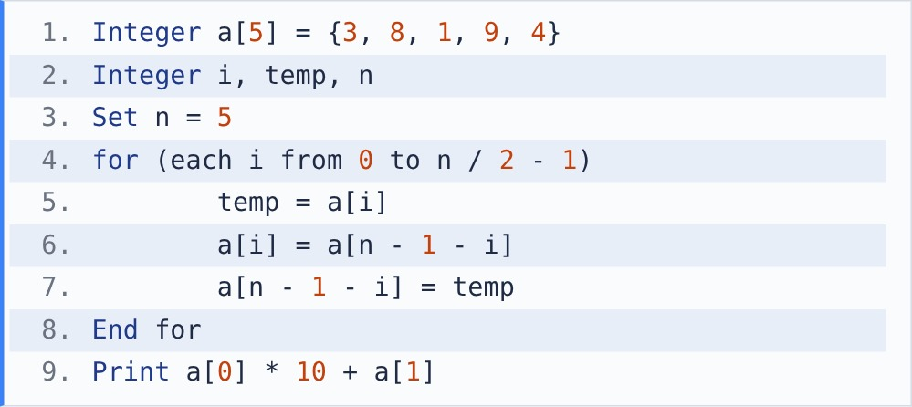
[Note - / between two integers gives integer division, which drops the remainder: 123 / 10 = 12.]

{OPTION 1} 38
{OPTION 2} 49
{OPTION 3} 94
{OPTION 4} 83
{OPTION 5}
{OPTION 6}
{OPTION 7}
{OPTION 8}
{OPTION 9}
{OPTION 10}
{RIGHT ANSWER} 2
{EXPLANATION} n / 2 - 1 = 1, so i = 0 and 1. i=0 swaps a[0] and a[4]: {4, 8, 1, 9, 3}. i=1 swaps a[1] and a[3]: {4, 9, 1, 8, 3}. The array is reversed. Print 4 * 10 + 9 = 49.
{CORRECT MARKS} 1
{NEGATIVE MARKS} 0
{DIFFICULTY} Medium
{QUESTION ENDS}

{QUESTION BEGINS}
{QUESTION NUMBER} 7
{SUBJECT} Technical Assessment
{TOPIC} Pseudocode
{TAGS} accenture, technical assessment, pseudocode, mock test 4, medium
{QUESTION TYPE} SINGLECORRECT
{QUESTION TEXT} What will be the output of the following pseudocode?
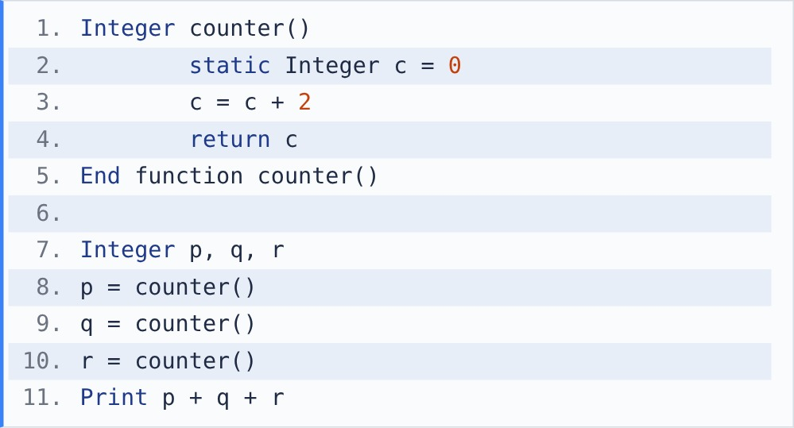
[Note - a static variable is initialised only once and keeps its value between function calls.]

{OPTION 1} 6
{OPTION 2} 2
{OPTION 3} 12
{OPTION 4} 18
{OPTION 5}
{OPTION 6}
{OPTION 7}
{OPTION 8}
{OPTION 9}
{OPTION 10}
{RIGHT ANSWER} 3
{EXPLANATION} c is static, so it is set to 0 only once and keeps its value. 1st call: c = 2. 2nd: c = 4. 3rd: c = 6. p + q + r = 2 + 4 + 6 = 12. (With a normal local variable each call would return 2, giving 6.)
{CORRECT MARKS} 1
{NEGATIVE MARKS} 0
{DIFFICULTY} Medium
{QUESTION ENDS}

{QUESTION BEGINS}
{QUESTION NUMBER} 8
{SUBJECT} Technical Assessment
{TOPIC} Pseudocode
{TAGS} accenture, technical assessment, pseudocode, mock test 4, easy
{QUESTION TYPE} SINGLECORRECT
{QUESTION TEXT} What will be the output of the following pseudocode?
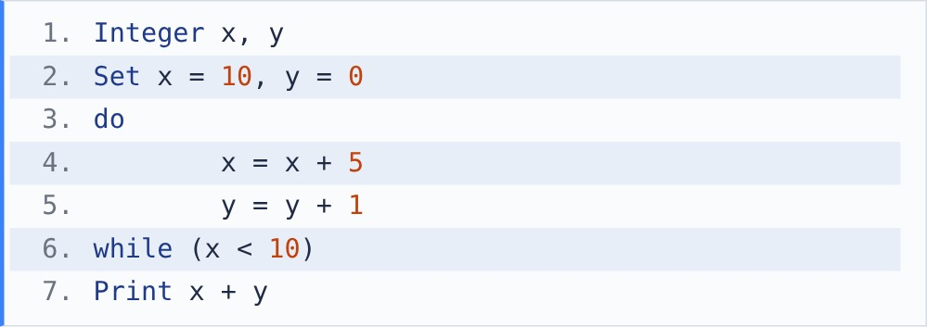
[Note - in a do-while loop the body runs first and the condition is checked afterwards.]

{OPTION 1} 10
{OPTION 2} 15
{OPTION 3} 16
{OPTION 4} 11
{OPTION 5}
{OPTION 6}
{OPTION 7}
{OPTION 8}
{OPTION 9}
{OPTION 10}
{RIGHT ANSWER} 3
{EXPLANATION} The body runs once before the check: x = 15, y = 1. Then 15 < 10 is false, so the loop stops. Print 15 + 1 = 16.
{CORRECT MARKS} 1
{NEGATIVE MARKS} 0
{DIFFICULTY} Easy
{QUESTION ENDS}

{QUESTION BEGINS}
{QUESTION NUMBER} 9
{SUBJECT} Technical Assessment
{TOPIC} Pseudocode
{TAGS} accenture, technical assessment, pseudocode, mock test 4, medium
{QUESTION TYPE} SINGLECORRECT
{QUESTION TEXT} What will be the output of the following pseudocode?
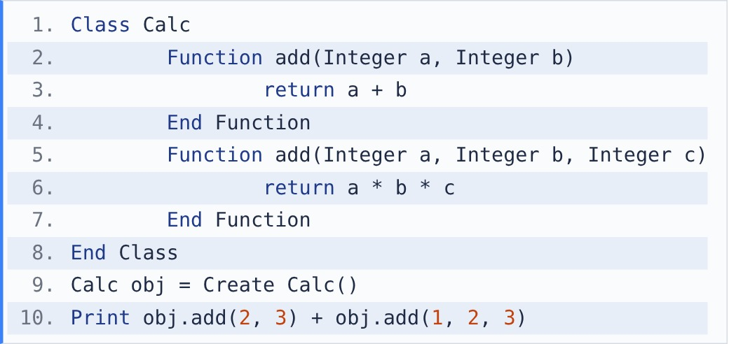

{OPTION 1} 11
{OPTION 2} 5
{OPTION 3} 6
{OPTION 4} Compilation error: add is defined twice
{OPTION 5}
{OPTION 6}
{OPTION 7}
{OPTION 8}
{OPTION 9}
{OPTION 10}
{RIGHT ANSWER} 1
{EXPLANATION} add is overloaded (compile-time polymorphism): the version is chosen by the number of arguments. add(2, 3) uses the 2-parameter version: 2 + 3 = 5. add(1, 2, 3) uses the 3-parameter version: 1 * 2 * 3 = 6. 5 + 6 = 11.
{CORRECT MARKS} 1
{NEGATIVE MARKS} 0
{DIFFICULTY} Medium
{QUESTION ENDS}

{QUESTION BEGINS}
{QUESTION NUMBER} 10
{SUBJECT} Technical Assessment
{TOPIC} Pseudocode
{TAGS} accenture, technical assessment, pseudocode, mock test 4, hard
{QUESTION TYPE} SINGLECORRECT
{QUESTION TEXT} What will be the output of the following pseudocode?
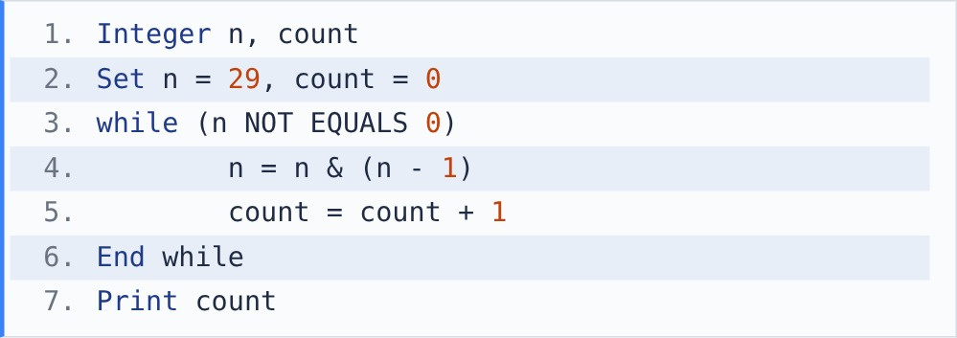
[Note - &: bitwise AND.]

{OPTION 1} 5
{OPTION 2} 3
{OPTION 3} 4
{OPTION 4} 29
{OPTION 5}
{OPTION 6}
{OPTION 7}
{OPTION 8}
{OPTION 9}
{OPTION 10}
{RIGHT ANSWER} 3
{EXPLANATION} n & (n - 1) removes the lowest 1-bit each time, so the loop counts the 1-bits. 29 = 11101 -> 11100 (28) -> 11000 (24) -> 10000 (16) -> 0. That is 4 passes, so it prints 4.
{CORRECT MARKS} 1
{NEGATIVE MARKS} 0
{DIFFICULTY} Hard
{QUESTION ENDS}

