{QUESTION BEGINS}
{QUESTION NUMBER} 1
{SUBJECT} Technical Assessment
{TOPIC} Pseudocode
{TAGS} accenture, technical assessment, pseudocode, mock test 5, medium
{QUESTION TYPE} SINGLECORRECT
{QUESTION TEXT} What will be the output of the following pseudocode?
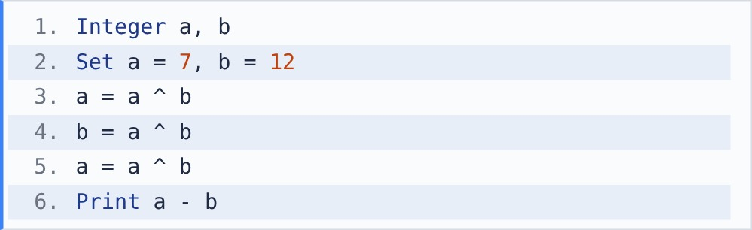
[Note - ^ is bitwise XOR: a result bit is 1 only when the two bits are different.]

{OPTION 1} -5
{OPTION 2} 0
{OPTION 3} 19
{OPTION 4} 5
{OPTION 5}
{OPTION 6}
{OPTION 7}
{OPTION 8}
{OPTION 9}
{OPTION 10}
{RIGHT ANSWER} 4
{EXPLANATION} Three XORs swap the two values without a temp variable: after them a = 12 and b = 7. Print 12 - 7 = 5.
{CORRECT MARKS} 1
{NEGATIVE MARKS} 0
{DIFFICULTY} Medium
{QUESTION ENDS}

{QUESTION BEGINS}
{QUESTION NUMBER} 2
{SUBJECT} Technical Assessment
{TOPIC} Pseudocode
{TAGS} accenture, technical assessment, pseudocode, mock test 5, hard
{QUESTION TYPE} SINGLECORRECT
{QUESTION TEXT} What will be printed when show(3) is called?
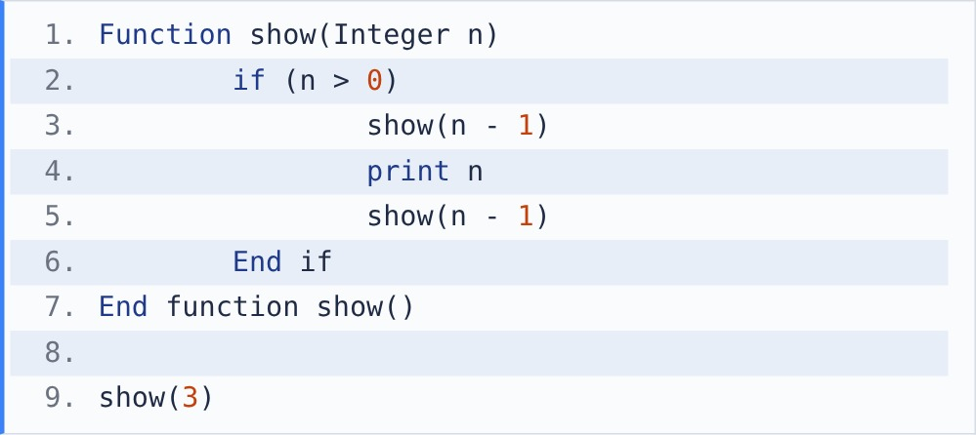

{OPTION 1} 3 2 1
{OPTION 2} 1 2 3
{OPTION 3} 1 2 1 3 1 2 1
{OPTION 4} 3 2 1 1 2 1
{OPTION 5}
{OPTION 6}
{OPTION 7}
{OPTION 8}
{OPTION 9}
{OPTION 10}
{RIGHT ANSWER} 3
{EXPLANATION} show(n) prints show(n-1), then n, then show(n-1) again. show(1) prints 1. show(2) prints 1 2 1. show(3) prints (1 2 1) 3 (1 2 1) = 1 2 1 3 1 2 1.
{CORRECT MARKS} 1
{NEGATIVE MARKS} 0
{DIFFICULTY} Hard
{QUESTION ENDS}

{QUESTION BEGINS}
{QUESTION NUMBER} 3
{SUBJECT} Technical Assessment
{TOPIC} Pseudocode
{TAGS} accenture, technical assessment, pseudocode, mock test 5, medium
{QUESTION TYPE} SINGLECORRECT
{QUESTION TEXT} What will be the output of the following pseudocode?
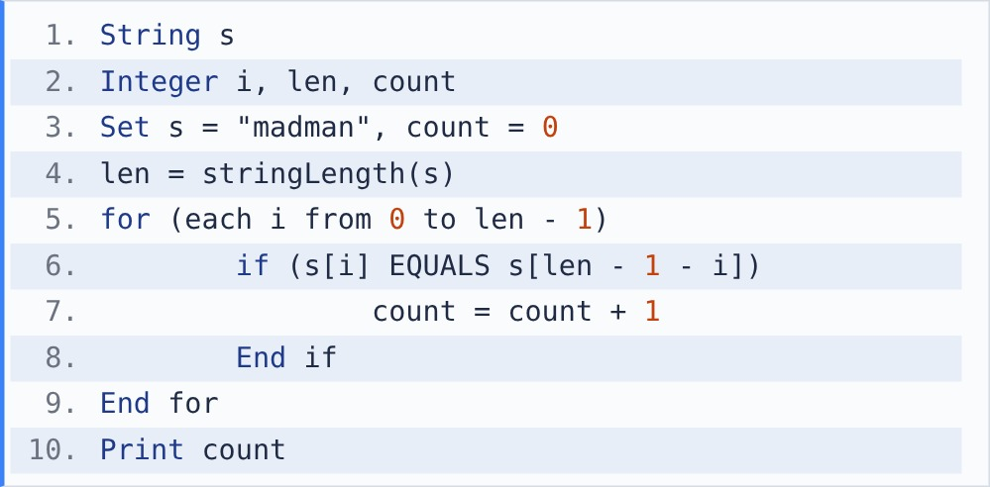
[Note - stringLength() returns the number of characters in a string. s[i] is the character at index i; indexing starts at 0. + joins two strings.]

{OPTION 1} 6
{OPTION 2} 2
{OPTION 3} 3
{OPTION 4} 0
{OPTION 5}
{OPTION 6}
{OPTION 7}
{OPTION 8}
{OPTION 9}
{OPTION 10}
{RIGHT ANSWER} 2
{EXPLANATION} Compare s[i] with s[5 - i] for "madman": m/n no, a/a yes, d/m no, m/d no, a/a yes, n/m no. count = 2 (the word is not a palindrome).
{CORRECT MARKS} 1
{NEGATIVE MARKS} 0
{DIFFICULTY} Medium
{QUESTION ENDS}

{QUESTION BEGINS}
{QUESTION NUMBER} 4
{SUBJECT} Technical Assessment
{TOPIC} Pseudocode
{TAGS} accenture, technical assessment, pseudocode, mock test 5, medium
{QUESTION TYPE} SINGLECORRECT
{QUESTION TEXT} Which statement about the following pseudocode is correct?
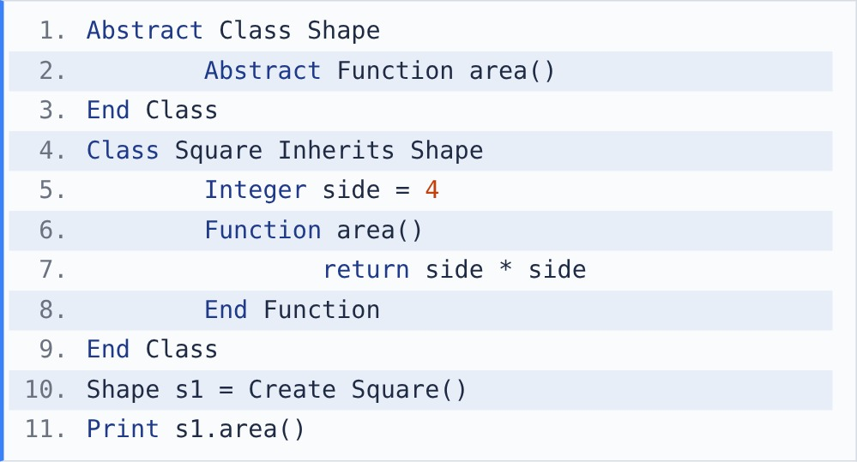

{OPTION 1} It prints 16. Shape cannot be created directly, but a Shape variable can refer to a Square object
{OPTION 2} Compilation error, because area() has no body in Shape
{OPTION 3} It prints 0, because Shape's area() is called
{OPTION 4} Runtime error, because s1 is declared as Shape
{OPTION 5}
{OPTION 6}
{OPTION 7}
{OPTION 8}
{OPTION 9}
{OPTION 10}
{RIGHT ANSWER} 1
{EXPLANATION} Shape is abstract (abstraction): it declares area() without a body and cannot be instantiated. Square gives area() a body. s1 is a Shape reference to a Square object, so s1.area() runs Square's version: 4 * 4 = 16.
{CORRECT MARKS} 1
{NEGATIVE MARKS} 0
{DIFFICULTY} Medium
{QUESTION ENDS}

{QUESTION BEGINS}
{QUESTION NUMBER} 5
{SUBJECT} Technical Assessment
{TOPIC} Pseudocode
{TAGS} accenture, technical assessment, pseudocode, mock test 5, medium
{QUESTION TYPE} SINGLECORRECT
{QUESTION TEXT} What will be the output of the following pseudocode?
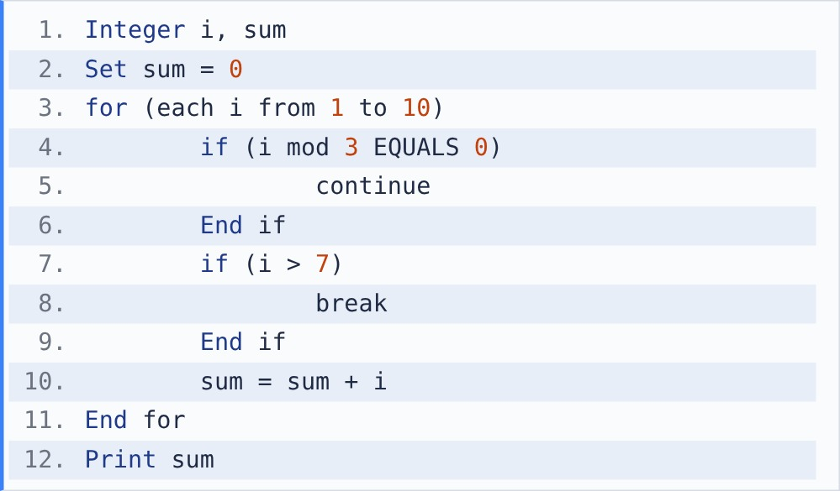
[Note - continue skips the rest of the current iteration; break exits the loop completely.]

{OPTION 1} 19
{OPTION 2} 27
{OPTION 3} 22
{OPTION 4} 40
{OPTION 5}
{OPTION 6}
{OPTION 7}
{OPTION 8}
{OPTION 9}
{OPTION 10}
{RIGHT ANSWER} 1
{EXPLANATION} i = 3 and 6 are skipped by continue. At i = 8 (not a multiple of 3, and > 7) break ends the loop. sum = 1 + 2 + 4 + 5 + 7 = 19.
{CORRECT MARKS} 1
{NEGATIVE MARKS} 0
{DIFFICULTY} Medium
{QUESTION ENDS}

{QUESTION BEGINS}
{QUESTION NUMBER} 6
{SUBJECT} Technical Assessment
{TOPIC} Pseudocode
{TAGS} accenture, technical assessment, pseudocode, mock test 5, medium
{QUESTION TYPE} SINGLECORRECT
{QUESTION TEXT} What will be the output of the following pseudocode?
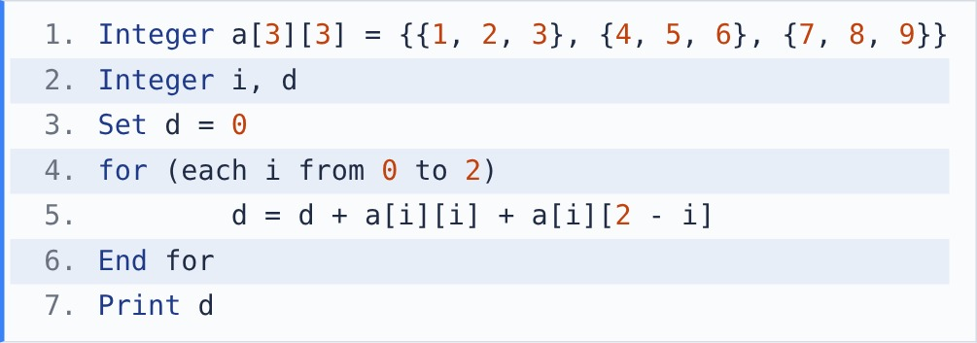

{OPTION 1} 25
{OPTION 2} 15
{OPTION 3} 30
{OPTION 4} 45
{OPTION 5}
{OPTION 6}
{OPTION 7}
{OPTION 8}
{OPTION 9}
{OPTION 10}
{RIGHT ANSWER} 3
{EXPLANATION} Each row adds its main-diagonal and anti-diagonal element: row 0: 1 + 3, row 1: 5 + 5, row 2: 9 + 7. The centre 5 is counted twice. d = 4 + 10 + 16 = 30.
{CORRECT MARKS} 1
{NEGATIVE MARKS} 0
{DIFFICULTY} Medium
{QUESTION ENDS}

{QUESTION BEGINS}
{QUESTION NUMBER} 7
{SUBJECT} Technical Assessment
{TOPIC} Pseudocode
{TAGS} accenture, technical assessment, pseudocode, mock test 5, easy
{QUESTION TYPE} SINGLECORRECT
{QUESTION TEXT} What will be the output when the object of class C is created?
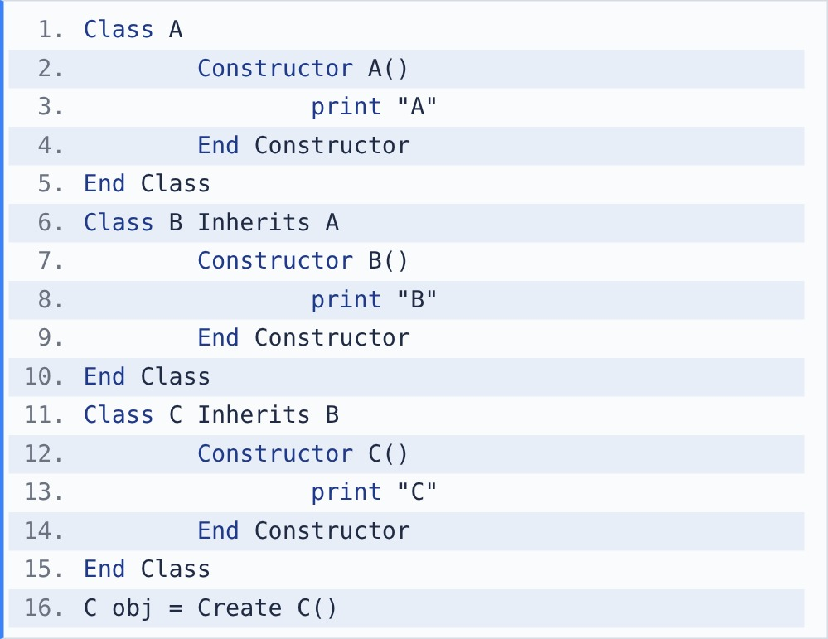

{OPTION 1} CBA
{OPTION 2} C
{OPTION 3} ABC
{OPTION 4} AC
{OPTION 5}
{OPTION 6}
{OPTION 7}
{OPTION 8}
{OPTION 9}
{OPTION 10}
{RIGHT ANSWER} 3
{EXPLANATION} Creating a child object first runs the parent constructors, from the top of the inheritance chain down: A(), then B(), then C(). Output: ABC.
{CORRECT MARKS} 1
{NEGATIVE MARKS} 0
{DIFFICULTY} Easy
{QUESTION ENDS}

{QUESTION BEGINS}
{QUESTION NUMBER} 8
{SUBJECT} Technical Assessment
{TOPIC} Pseudocode
{TAGS} accenture, technical assessment, pseudocode, mock test 5, medium
{QUESTION TYPE} SINGLECORRECT
{QUESTION TEXT} What will be the output of the following pseudocode?
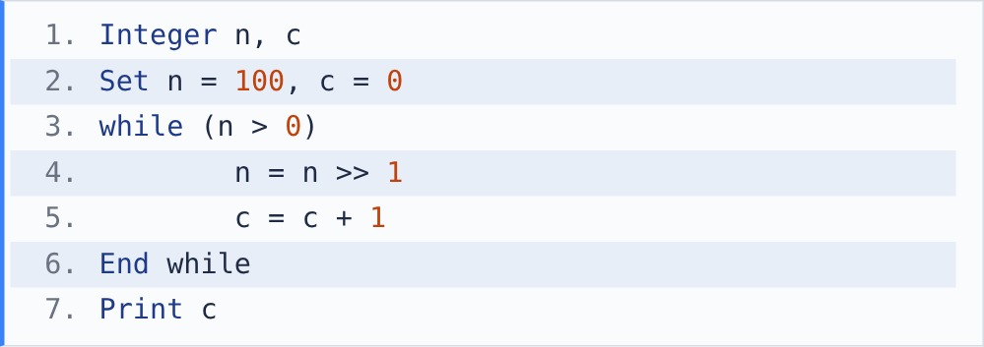
[Note - >> is right shift: n >> 1 moves the bits one place right, i.e. integer division by 2.]

{OPTION 1} 6
{OPTION 2} 7
{OPTION 3} 50
{OPTION 4} 100
{OPTION 5}
{OPTION 6}
{OPTION 7}
{OPTION 8}
{OPTION 9}
{OPTION 10}
{RIGHT ANSWER} 2
{EXPLANATION} 100 -> 50 -> 25 -> 12 -> 6 -> 3 -> 1 -> 0: seven shifts. c = 7, which is the number of bits needed to write 100 in binary (1100100).
{CORRECT MARKS} 1
{NEGATIVE MARKS} 0
{DIFFICULTY} Medium
{QUESTION ENDS}

{QUESTION BEGINS}
{QUESTION NUMBER} 9
{SUBJECT} Technical Assessment
{TOPIC} Pseudocode
{TAGS} accenture, technical assessment, pseudocode, mock test 5, easy
{QUESTION TYPE} SINGLECORRECT
{QUESTION TEXT} What will be the output of the following pseudocode?
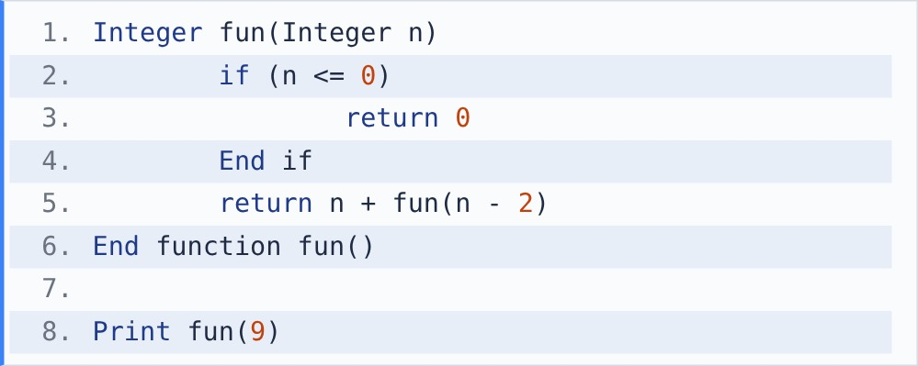

{OPTION 1} 45
{OPTION 2} 25
{OPTION 3} 24
{OPTION 4} 16
{OPTION 5}
{OPTION 6}
{OPTION 7}
{OPTION 8}
{OPTION 9}
{OPTION 10}
{RIGHT ANSWER} 2
{EXPLANATION} fun(9) = 9 + fun(7) = 9 + 7 + fun(5) = ... = 9 + 7 + 5 + 3 + 1 + fun(-1). fun(-1) returns 0. Sum = 25.
{CORRECT MARKS} 1
{NEGATIVE MARKS} 0
{DIFFICULTY} Easy
{QUESTION ENDS}

{QUESTION BEGINS}
{QUESTION NUMBER} 10
{SUBJECT} Technical Assessment
{TOPIC} Pseudocode
{TAGS} accenture, technical assessment, pseudocode, mock test 5, hard
{QUESTION TYPE} SINGLECORRECT
{QUESTION TEXT} What will be the output of the following pseudocode?
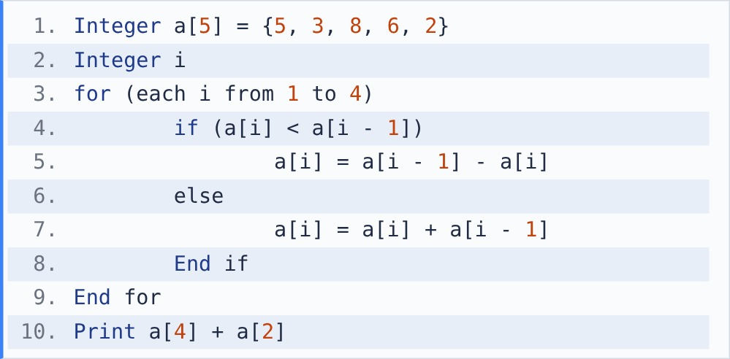

{OPTION 1} 10
{OPTION 2} 4
{OPTION 3} 16
{OPTION 4} 12
{OPTION 5}
{OPTION 6}
{OPTION 7}
{OPTION 8}
{OPTION 9}
{OPTION 10}
{RIGHT ANSWER} 4
{EXPLANATION} i=1: 3 < 5, a[1] = 5 - 3 = 2. i=2: 8 > 2, a[2] = 8 + 2 = 10. i=3: 6 < 10, a[3] = 10 - 6 = 4. i=4: 2 < 4, a[4] = 4 - 2 = 2. Print a[4] + a[2] = 2 + 10 = 12.
{CORRECT MARKS} 1
{NEGATIVE MARKS} 0
{DIFFICULTY} Hard
{QUESTION ENDS}

