{QUESTION BEGINS}
{QUESTION NUMBER} 1
{SUBJECT} Technical Assessment
{TOPIC} Pseudocode
{TAGS} accenture, technical assessment, pseudocode, mock test 1, medium
{QUESTION TYPE} SINGLECORRECT
{QUESTION TEXT} What will be the output of the following pseudocode?
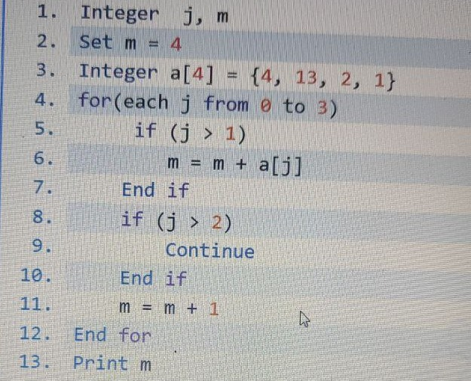
[Note - Continue: when a continue statement is encountered inside a loop, control jumps to the beginning of the loop for the next iteration, skipping the remaining statements of the current iteration.]

{OPTION 1} 10
{OPTION 2} 1
{OPTION 3} 8
{OPTION 4} 5
{OPTION 5}
{OPTION 6}
{OPTION 7}
{OPTION 8}
{OPTION 9}
{OPTION 10}
{RIGHT ANSWER} 1
{EXPLANATION} m starts at 4. j=0: j>1 false, m=m+1=5. j=1: m=6. j=2: m=6+a[2]=8, then m=9. j=3: m=9+a[3]=10, then j>2 so Continue skips m=m+1. Output: 10.
{CORRECT MARKS} 1
{NEGATIVE MARKS} 0
{DIFFICULTY} Medium
{QUESTION ENDS}

{QUESTION BEGINS}
{QUESTION NUMBER} 2
{SUBJECT} Technical Assessment
{TOPIC} Pseudocode
{TAGS} accenture, technical assessment, pseudocode, mock test 1, easy
{QUESTION TYPE} SINGLECORRECT
{QUESTION TEXT} Which of the following options is correct for the given pseudocode?
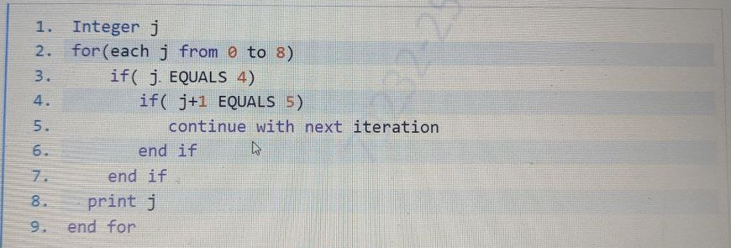
[Note - Continue: when a continue statement is encountered inside a loop, control jumps to the beginning of the loop for the next iteration, skipping the remaining statements of the current iteration.]

{OPTION 1} It will print all the numbers from 0 to 8 except the number 4
{OPTION 2} It will print all the numbers from 0 to 8 except the number 5
{OPTION 3} It will print the numbers from 0 to 8
{OPTION 4} It will print the numbers from 0 to 4
{OPTION 5}
{OPTION 6}
{OPTION 7}
{OPTION 8}
{OPTION 9}
{OPTION 10}
{RIGHT ANSWER} 1
{EXPLANATION} Only when j = 4 are both conditions true (j EQUALS 4 and j+1 EQUALS 5), so continue skips print j for 4 only. The loop goes on to 8. Output: 0 1 2 3 5 6 7 8.
{CORRECT MARKS} 1
{NEGATIVE MARKS} 0
{DIFFICULTY} Easy
{QUESTION ENDS}

{QUESTION BEGINS}
{QUESTION NUMBER} 3
{SUBJECT} Technical Assessment
{TOPIC} Pseudocode
{TAGS} accenture, technical assessment, pseudocode, mock test 1, medium
{QUESTION TYPE} SINGLECORRECT
{QUESTION TEXT} What will be the output of the following pseudocode?
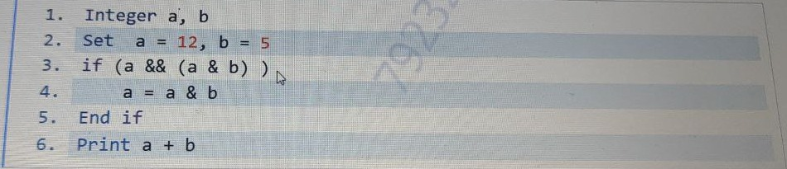
[Note - &&: Logical AND returns true (1) if both operands are true (non-zero), otherwise false (0). &: Bitwise AND compares each bit of both operands; a result bit is 1 only if both bits are 1.]

{OPTION 1} 5
{OPTION 2} 7
{OPTION 3} 9
{OPTION 4} 4
{OPTION 5}
{OPTION 6}
{OPTION 7}
{OPTION 8}
{OPTION 9}
{OPTION 10}
{RIGHT ANSWER} 3
{EXPLANATION} 12 = 1100 and 5 = 0101 in binary, so 12 & 5 = 0100 = 4 (non-zero = true). a && 4 is true, so the if runs: a = 12 & 5 = 4. Print a + b = 4 + 5 = 9.
{CORRECT MARKS} 1
{NEGATIVE MARKS} 0
{DIFFICULTY} Medium
{QUESTION ENDS}

{QUESTION BEGINS}
{QUESTION NUMBER} 4
{SUBJECT} Technical Assessment
{TOPIC} Pseudocode
{TAGS} accenture, technical assessment, pseudocode, mock test 1, medium
{QUESTION TYPE} SINGLECORRECT
{QUESTION TEXT} What will be the output of the following pseudocode?
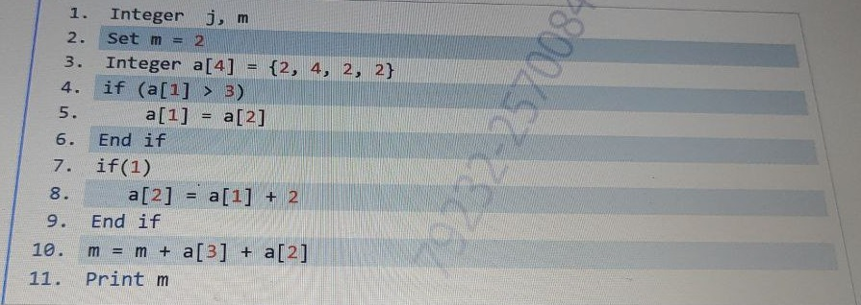
[Note - if(x) gets executed if the value inside if(), i.e. x, is not zero.]

{OPTION 1} 2
{OPTION 2} 8
{OPTION 3} 1
{OPTION 4} 7
{OPTION 5}
{OPTION 6}
{OPTION 7}
{OPTION 8}
{OPTION 9}
{OPTION 10}
{RIGHT ANSWER} 2
{EXPLANATION} a = {2, 4, 2, 2}. a[1] = 4 > 3, so a[1] = a[2] = 2. if(1) is always true, so a[2] = a[1] + 2 = 4. m = 2 + a[3] + a[2] = 2 + 2 + 4 = 8.
{CORRECT MARKS} 1
{NEGATIVE MARKS} 0
{DIFFICULTY} Medium
{QUESTION ENDS}

{QUESTION BEGINS}
{QUESTION NUMBER} 5
{SUBJECT} Technical Assessment
{TOPIC} Pseudocode
{TAGS} accenture, technical assessment, pseudocode, mock test 1, hard
{QUESTION TYPE} SINGLECORRECT
{QUESTION TEXT} What will be the output of the following pseudocode for a = 2, b = 3?
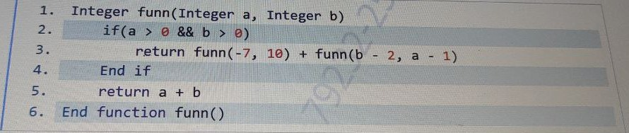
[Note - &&: Logical AND returns true (1) if both operands are true (non-zero), otherwise false (0). &: Bitwise AND compares each bit of both operands; a result bit is 1 only if both bits are 1.] [Note - if(x) gets executed if the value inside if(), i.e. x, is not zero.]

{OPTION 1} 4
{OPTION 2} 5
{OPTION 3} 7
{OPTION 4} 1
{OPTION 5}
{OPTION 6}
{OPTION 7}
{OPTION 8}
{OPTION 9}
{OPTION 10}
{RIGHT ANSWER} 2
{EXPLANATION} funn(2,3): both > 0, so return funn(-7,10) + funn(1,1). funn(-7,10): a is not > 0, return -7+10 = 3. funn(1,1) = funn(-7,10) + funn(-1,0) = 3 + (-1) = 2. Total = 3 + 2 = 5.
{CORRECT MARKS} 1
{NEGATIVE MARKS} 0
{DIFFICULTY} Hard
{QUESTION ENDS}

{QUESTION BEGINS}
{QUESTION NUMBER} 6
{SUBJECT} Technical Assessment
{TOPIC} Pseudocode
{TAGS} accenture, technical assessment, pseudocode, mock test 1, easy
{QUESTION TYPE} SINGLECORRECT
{QUESTION TEXT} What will be the output of the following pseudocode?
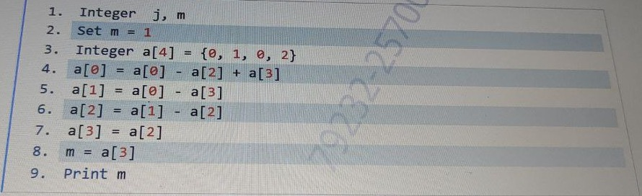

{OPTION 1} 0
{OPTION 2} 2
{OPTION 3} 6
{OPTION 4} 1
{OPTION 5}
{OPTION 6}
{OPTION 7}
{OPTION 8}
{OPTION 9}
{OPTION 10}
{RIGHT ANSWER} 1
{EXPLANATION} a = {0, 1, 0, 2}. a[0] = 0 - 0 + 2 = 2. a[1] = a[0] - a[3] = 2 - 2 = 0. a[2] = a[1] - a[2] = 0 - 0 = 0. a[3] = a[2] = 0. m = a[3] = 0.
{CORRECT MARKS} 1
{NEGATIVE MARKS} 0
{DIFFICULTY} Easy
{QUESTION ENDS}

{QUESTION BEGINS}
{QUESTION NUMBER} 7
{SUBJECT} Technical Assessment
{TOPIC} Pseudocode
{TAGS} accenture, technical assessment, pseudocode, mock test 1, hard
{QUESTION TYPE} SINGLECORRECT
{QUESTION TEXT} What will be the output of the following pseudocode?
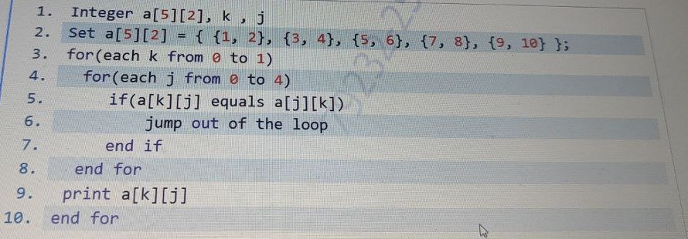

{OPTION 1} 1 4
{OPTION 2} It will print nothing
{OPTION 3} 1 3
{OPTION 4} 1 2
{OPTION 5}
{OPTION 6}
{OPTION 7}
{OPTION 8}
{OPTION 9}
{OPTION 10}
{RIGHT ANSWER} 1
{EXPLANATION} k=0, j=0: a[0][0] equals a[0][0], so jump out of the inner loop with j=0 and print a[0][0] = 1. k=1, j=0: a[1][0]=3 vs a[0][1]=2, not equal; j=1: a[1][1] equals a[1][1], jump out and print a[1][1] = 4. Output: 1 4.
{CORRECT MARKS} 1
{NEGATIVE MARKS} 0
{DIFFICULTY} Hard
{QUESTION ENDS}

{QUESTION BEGINS}
{QUESTION NUMBER} 8
{SUBJECT} Technical Assessment
{TOPIC} Pseudocode
{TAGS} accenture, technical assessment, pseudocode, mock test 1, easy
{QUESTION TYPE} SINGLECORRECT
{QUESTION TEXT} What will be the output of the following pseudocode?
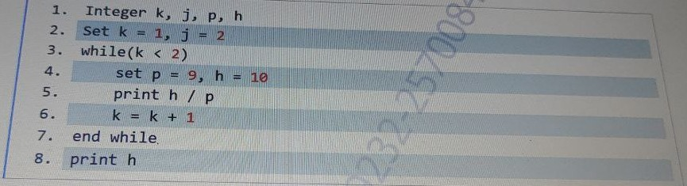

{OPTION 1} 1 0
{OPTION 2} 1 10
{OPTION 3} 0 1
{OPTION 4} 10 10
{OPTION 5}
{OPTION 6}
{OPTION 7}
{OPTION 8}
{OPTION 9}
{OPTION 10}
{RIGHT ANSWER} 2
{EXPLANATION} The loop runs once (k = 1 < 2). h / p = 10 / 9 = 1 with integer division, so it prints 1. k becomes 2 and the loop stops. Then print h prints 10. Output: 1 10.
{CORRECT MARKS} 1
{NEGATIVE MARKS} 0
{DIFFICULTY} Easy
{QUESTION ENDS}

{QUESTION BEGINS}
{QUESTION NUMBER} 9
{SUBJECT} Technical Assessment
{TOPIC} Pseudocode
{TAGS} accenture, technical assessment, pseudocode, mock test 1, medium
{QUESTION TYPE} SINGLECORRECT
{QUESTION TEXT} What will be the output of the following pseudocode for a = 8, b = 7?
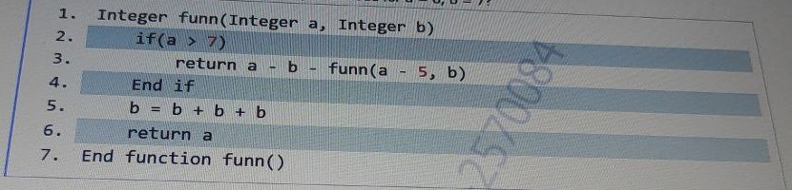

{OPTION 1} -1
{OPTION 2} -2
{OPTION 3} 1
{OPTION 4} 0
{OPTION 5}
{OPTION 6}
{OPTION 7}
{OPTION 8}
{OPTION 9}
{OPTION 10}
{RIGHT ANSWER} 2
{EXPLANATION} funn(8,7): 8 > 7, so return 8 - 7 - funn(3,7). funn(3,7): 3 is not > 7, b = 21 (local only), return a = 3. Result = 1 - 3 = -2.
{CORRECT MARKS} 1
{NEGATIVE MARKS} 0
{DIFFICULTY} Medium
{QUESTION ENDS}

{QUESTION BEGINS}
{QUESTION NUMBER} 10
{SUBJECT} Technical Assessment
{TOPIC} Pseudocode
{TAGS} accenture, technical assessment, pseudocode, mock test 1, medium
{QUESTION TYPE} SINGLECORRECT
{QUESTION TEXT} What will be the output of the following pseudocode?
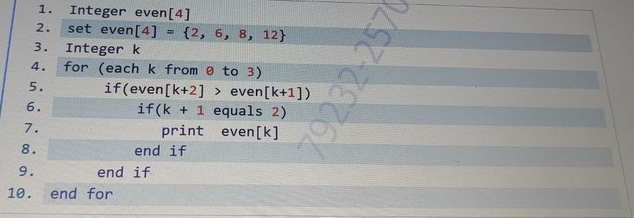

{OPTION 1} 5
{OPTION 2} 3
{OPTION 3} 6
{OPTION 4} 4
{OPTION 5}
{OPTION 6}
{OPTION 7}
{OPTION 8}
{OPTION 9}
{OPTION 10}
{RIGHT ANSWER} 3
{EXPLANATION} even = {2, 6, 8, 12}. k=0: 8 > 6 true but k+1 = 1, not 2. k=1: even[3]=12 > even[2]=8 true and k+1 = 2, so print even[1] = 6. For k = 2 and 3, k+1 is never 2, so nothing else prints. Output: 6.
{CORRECT MARKS} 1
{NEGATIVE MARKS} 0
{DIFFICULTY} Medium
{QUESTION ENDS}

