{QUESTION BEGINS}
{QUESTION NUMBER} 1
{SUBJECT} Technical Assessment
{TOPIC} Pseudocode
{TAGS} accenture, technical assessment, pseudocode, mock test 2, easy
{QUESTION TYPE} SINGLECORRECT
{QUESTION TEXT} What would be the output of the given pseudocode?
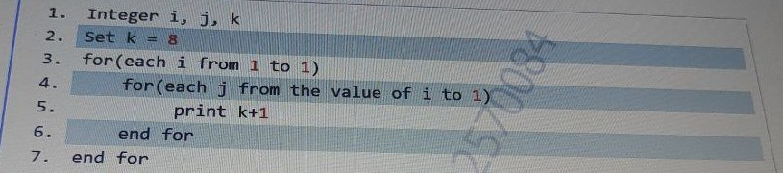

{OPTION 1} 8
{OPTION 2} 7
{OPTION 3} 2
{OPTION 4} 9
{OPTION 5}
{OPTION 6}
{OPTION 7}
{OPTION 8}
{OPTION 9}
{OPTION 10}
{RIGHT ANSWER} 4
{EXPLANATION} Both loops run from 1 to 1, so the inner body runs exactly once. It prints k + 1 = 8 + 1 = 9. (k itself is not changed.)
{CORRECT MARKS} 1
{NEGATIVE MARKS} 0
{DIFFICULTY} Easy
{QUESTION ENDS}

{QUESTION BEGINS}
{QUESTION NUMBER} 2
{SUBJECT} Technical Assessment
{TOPIC} Pseudocode
{TAGS} accenture, technical assessment, pseudocode, mock test 2, medium
{QUESTION TYPE} SINGLECORRECT
{QUESTION TEXT} What will be the output of the following pseudocode?
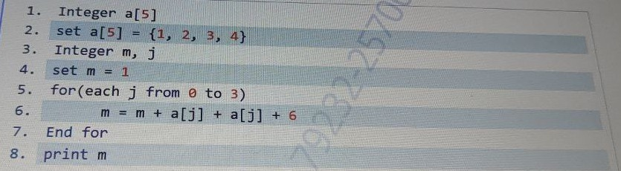

{OPTION 1} 46
{OPTION 2} 23
{OPTION 3} 43
{OPTION 4} 45
{OPTION 5}
{OPTION 6}
{OPTION 7}
{OPTION 8}
{OPTION 9}
{OPTION 10}
{RIGHT ANSWER} 4
{EXPLANATION} Each pass adds 2*a[j] + 6. j=0: 1+2+6 = 9. j=1: 9+4+6 = 19. j=2: 19+6+6 = 31. j=3: 31+8+6 = 45. Output: 45.
{CORRECT MARKS} 1
{NEGATIVE MARKS} 0
{DIFFICULTY} Medium
{QUESTION ENDS}

{QUESTION BEGINS}
{QUESTION NUMBER} 3
{SUBJECT} Technical Assessment
{TOPIC} Pseudocode
{TAGS} accenture, technical assessment, pseudocode, mock test 2, easy
{QUESTION TYPE} SINGLECORRECT
{QUESTION TEXT} What will be the output of the following pseudocode?
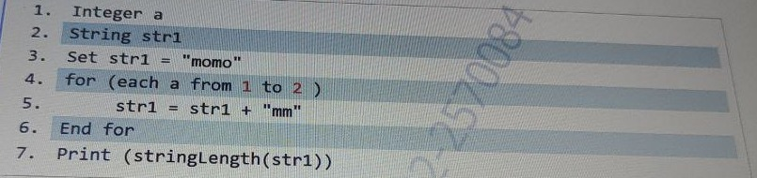
[Note - stringLength(): the stringLength() function counts the number of characters in a given string and returns the integer value.]

{OPTION 1} 8
{OPTION 2} 6
{OPTION 3} 7
{OPTION 4} 4
{OPTION 5}
{OPTION 6}
{OPTION 7}
{OPTION 8}
{OPTION 9}
{OPTION 10}
{RIGHT ANSWER} 1
{EXPLANATION} The loop runs twice (a = 1, 2), adding "mm" each time: "momo" -> "momomm" -> "momommmm". Its length is 4 + 2 + 2 = 8.
{CORRECT MARKS} 1
{NEGATIVE MARKS} 0
{DIFFICULTY} Easy
{QUESTION ENDS}

{QUESTION BEGINS}
{QUESTION NUMBER} 4
{SUBJECT} Technical Assessment
{TOPIC} Pseudocode
{TAGS} accenture, technical assessment, pseudocode, mock test 2, medium
{QUESTION TYPE} SINGLECORRECT
{QUESTION TEXT} Choose the correct output for the given pseudocode. What does the given code output when N is 4?
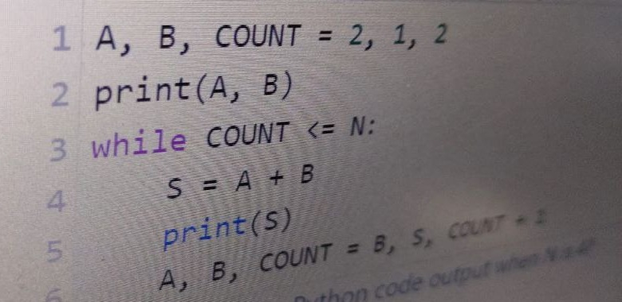

{OPTION 1} 2, 1, 3, 4
{OPTION 2} 2, 1, 3, 4, 7
{OPTION 3} 2, 1, 3, 4, 7, 11
{OPTION 4} 2, 1, 3, 4, 7, 11, 18
{OPTION 5}
{OPTION 6}
{OPTION 7}
{OPTION 8}
{OPTION 9}
{OPTION 10}
{RIGHT ANSWER} 2
{EXPLANATION} It prints A, B = 2, 1 first. COUNT=2: S=3, then A,B=1,3. COUNT=3: S=4, then A,B=3,4. COUNT=4: S=7. COUNT becomes 5 > N, so the loop stops. Output: 2, 1, 3, 4, 7 (the Lucas series).
{CORRECT MARKS} 1
{NEGATIVE MARKS} 0
{DIFFICULTY} Medium
{QUESTION ENDS}

{QUESTION BEGINS}
{QUESTION NUMBER} 5
{SUBJECT} Technical Assessment
{TOPIC} Pseudocode
{TAGS} accenture, technical assessment, pseudocode, mock test 2, easy
{QUESTION TYPE} SINGLECORRECT
{QUESTION TEXT} What will be the output printed by the given pseudocode? Analyze the pseudocode and select the correct option.
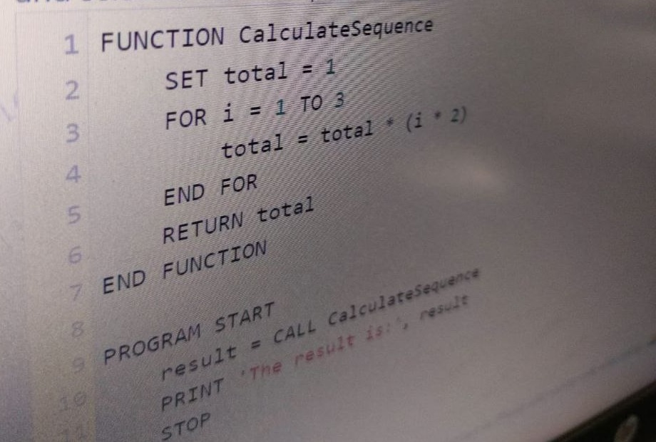

{OPTION 1} The result is: 6
{OPTION 2} The result is: 12
{OPTION 3} The result is: 48
{OPTION 4} The result is: 24
{OPTION 5}
{OPTION 6}
{OPTION 7}
{OPTION 8}
{OPTION 9}
{OPTION 10}
{RIGHT ANSWER} 3
{EXPLANATION} total starts at 1. i=1: total = 1 * 2 = 2. i=2: total = 2 * 4 = 8. i=3: total = 8 * 6 = 48. The function returns 48, so it prints The result is: 48.
{CORRECT MARKS} 1
{NEGATIVE MARKS} 0
{DIFFICULTY} Easy
{QUESTION ENDS}

{QUESTION BEGINS}
{QUESTION NUMBER} 6
{SUBJECT} Technical Assessment
{TOPIC} Pseudocode
{TAGS} accenture, technical assessment, pseudocode, mock test 2, easy
{QUESTION TYPE} SINGLECORRECT
{QUESTION TEXT} Consider the below code. What will be printed?
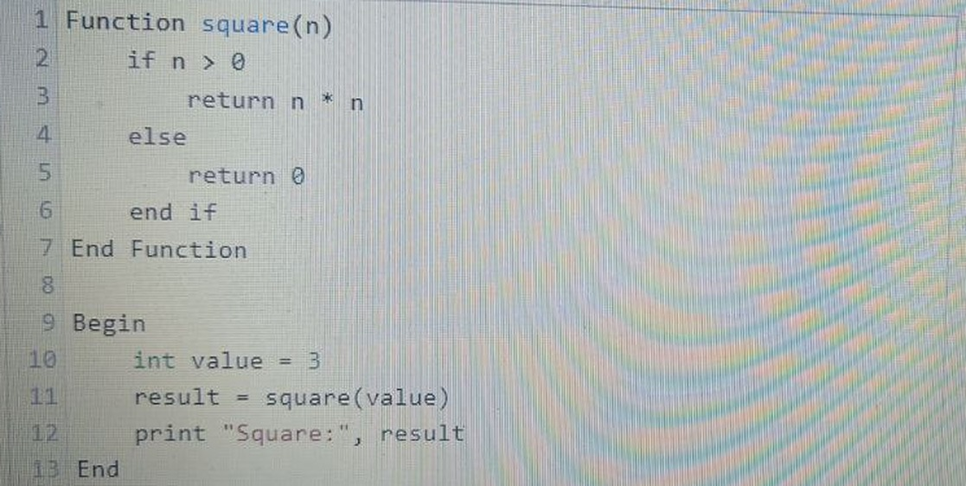

{OPTION 1} 3
{OPTION 2} 6
{OPTION 3} 9
{OPTION 4} 12
{OPTION 5}
{OPTION 6}
{OPTION 7}
{OPTION 8}
{OPTION 9}
{OPTION 10}
{RIGHT ANSWER} 3
{EXPLANATION} value = 3 is greater than 0, so square returns 3 * 3 = 9. It prints Square: 9.
{CORRECT MARKS} 1
{NEGATIVE MARKS} 0
{DIFFICULTY} Easy
{QUESTION ENDS}

{QUESTION BEGINS}
{QUESTION NUMBER} 7
{SUBJECT} Technical Assessment
{TOPIC} Pseudocode
{TAGS} accenture, technical assessment, pseudocode, mock test 2, hard
{QUESTION TYPE} SINGLECORRECT
{QUESTION TEXT} Determine the output of the following pseudocode?
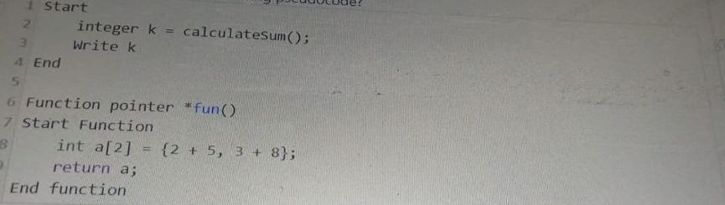

{OPTION 1} 2 3
{OPTION 2} 7 11
{OPTION 3} 5 8
{OPTION 4} Compilation Error
{OPTION 5}
{OPTION 6}
{OPTION 7}
{OPTION 8}
{OPTION 9}
{OPTION 10}
{RIGHT ANSWER} 4
{EXPLANATION} The program calls calculateSum(), but no function with that name is defined (only fun() is). It also stores an array (pointer) result in an integer k. So the code does not compile: Compilation Error.
{CORRECT MARKS} 1
{NEGATIVE MARKS} 0
{DIFFICULTY} Hard
{QUESTION ENDS}

{QUESTION BEGINS}
{QUESTION NUMBER} 8
{SUBJECT} Technical Assessment
{TOPIC} Pseudocode
{TAGS} accenture, technical assessment, pseudocode, mock test 2, medium
{QUESTION TYPE} SINGLECORRECT
{QUESTION TEXT} What is the purpose of the below pseudocode?
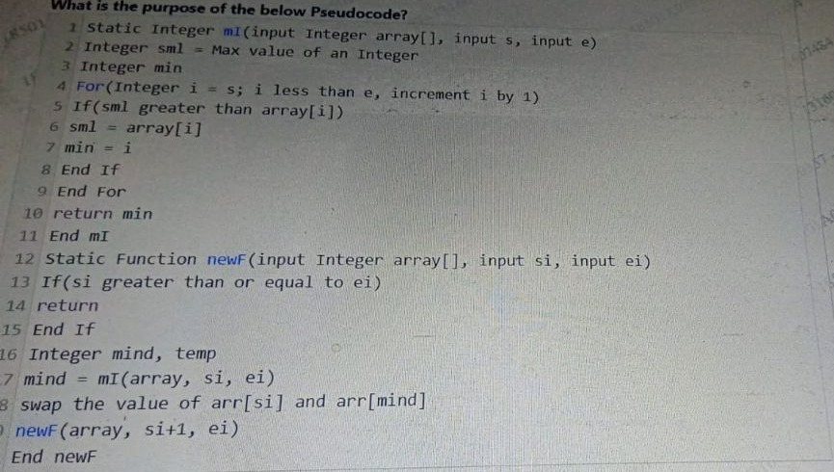

{OPTION 1} Recursive implementation of Binary Sort
{OPTION 2} Recursive implementation of Insertion Sort
{OPTION 3} Recursive implementation of Bubble Sort
{OPTION 4} Recursive implementation of Selection Sort
{OPTION 5}
{OPTION 6}
{OPTION 7}
{OPTION 8}
{OPTION 9}
{OPTION 10}
{RIGHT ANSWER} 4
{EXPLANATION} mI() finds the index of the smallest element between s and e. newF() swaps that minimum into position si, then calls itself for si+1. Picking the minimum and placing it at the front each round is selection sort, done recursively.
{CORRECT MARKS} 1
{NEGATIVE MARKS} 0
{DIFFICULTY} Medium
{QUESTION ENDS}

{QUESTION BEGINS}
{QUESTION NUMBER} 9
{SUBJECT} Technical Assessment
{TOPIC} Pseudocode
{TAGS} accenture, technical assessment, pseudocode, mock test 2, medium
{QUESTION TYPE} SINGLECORRECT
{QUESTION TEXT} Consider the following pseudocode. What will be printed when the above pseudocode is executed?
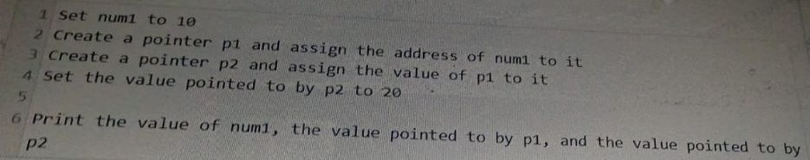

{OPTION 1} 10, 20, 10
{OPTION 2} 20, 10, 20
{OPTION 3} 20, 20, 20
{OPTION 4} 10, 10, 20
{OPTION 5}
{OPTION 6}
{OPTION 7}
{OPTION 8}
{OPTION 9}
{OPTION 10}
{RIGHT ANSWER} 3
{EXPLANATION} p1 holds the address of num1. p2 gets the value of p1, which is the same address, so p2 also points to num1. Setting the value pointed to by p2 to 20 changes num1 to 20. num1, *p1 and *p2 all read the same memory: 20, 20, 20.
{CORRECT MARKS} 1
{NEGATIVE MARKS} 0
{DIFFICULTY} Medium
{QUESTION ENDS}

{QUESTION BEGINS}
{QUESTION NUMBER} 10
{SUBJECT} Technical Assessment
{TOPIC} Pseudocode
{TAGS} accenture, technical assessment, pseudocode, mock test 2, medium
{QUESTION TYPE} SINGLECORRECT
{QUESTION TEXT} Consider the following code implementing the Union-Find data structure. What does the Union procedure do in the Union-Find data structure?
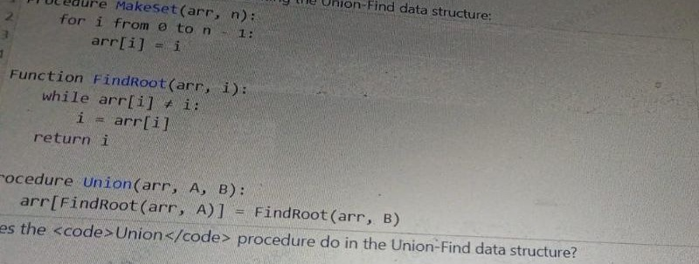

{OPTION 1} Initializes the array arr with values from 0 to n-1
{OPTION 2} Merges the two sets represented by elements A and B
{OPTION 3} Finds the root of a given element in the Union-Find structure
{OPTION 4} Checks if two elements A and B are connected
{OPTION 5}
{OPTION 6}
{OPTION 7}
{OPTION 8}
{OPTION 9}
{OPTION 10}
{RIGHT ANSWER} 2
{EXPLANATION} Union finds the root of A and makes it point to the root of B (arr[root(A)] = root(B)). That joins the two trees into one, so it merges the sets of A and B. MakeSet initializes, FindRoot finds roots, and checking connectivity would compare the two roots.
{CORRECT MARKS} 1
{NEGATIVE MARKS} 0
{DIFFICULTY} Medium
{QUESTION ENDS}

