{QUESTION BEGINS}
{QUESTION NUMBER} 1
{SUBJECT} Numerical Ability
{TOPIC} Algebra
{TAGS} tcs nqt, numerical ability, actual question, medium
{QUESTION TYPE} SINGLECORRECT
{QUESTION TEXT} 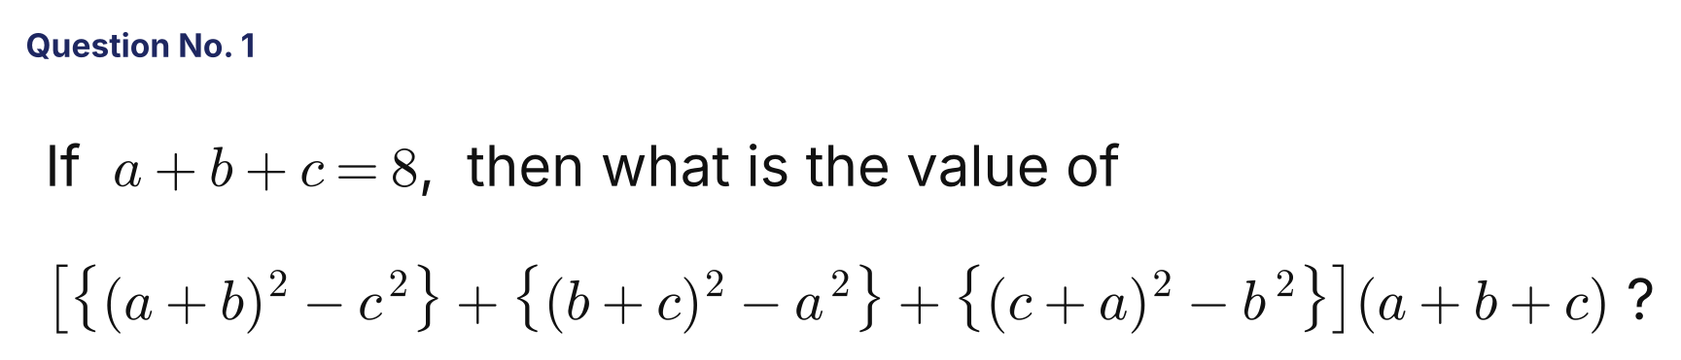
{OPTION 1} 216
{OPTION 2} 729
{OPTION 3} 343
{OPTION 4} 512
{OPTION 5}
{OPTION 6}
{OPTION 7}
{OPTION 8}
{OPTION 9}
{OPTION 10}
{RIGHT ANSWER} 4
{EXPLANATION} (a+b)² − c² = (a+b−c)(a+b+c). Adding the three terms: (a+b+c)[(a+b−c) + (b+c−a) + (c+a−b)] = (a+b+c)(a+b+c) = 8 × 8 = 64. Multiplying by (a+b+c) = 8 gives 512.
{CORRECT MARKS} 1
{NEGATIVE MARKS} 0
{DIFFICULTY} Medium
{QUESTION ENDS}

{QUESTION BEGINS}
{QUESTION NUMBER} 2
{SUBJECT} Numerical Ability
{TOPIC} Averages
{TAGS} tcs nqt, numerical ability, actual question, medium
{QUESTION TYPE} SINGLECORRECT
{QUESTION TEXT} The average temperature of Monday, Tuesday and Wednesday was 38 degrees and of Tuesday, Wednesday and Thursday was 35 degrees. If the temperature of Monday and Thursday was in a ratio 7 : 2, then find the temperature on Monday (in degrees).
{OPTION 1} 13.6
{OPTION 2} 10.6
{OPTION 3} 11.6
{OPTION 4} 12.6
{OPTION 5}
{OPTION 6}
{OPTION 7}
{OPTION 8}
{OPTION 9}
{OPTION 10}
{RIGHT ANSWER} 4
{EXPLANATION} Mon + Tue + Wed = 114 and Tue + Wed + Thu = 105, so Mon − Thu = 9. With Mon : Thu = 7 : 2, 5 parts = 9, so 1 part = 1.8 and Monday = 7 × 1.8 = 12.6.
{CORRECT MARKS} 1
{NEGATIVE MARKS} 0
{DIFFICULTY} Medium
{QUESTION ENDS}

{QUESTION BEGINS}
{QUESTION NUMBER} 3
{SUBJECT} Numerical Ability
{TOPIC} Compound Interest
{TAGS} tcs nqt, numerical ability, actual question, hard
{QUESTION TYPE} SINGLECORRECT
{QUESTION TEXT} A man wants to deposit a sum of ₹10,347 into the bank in the account of his son and daughter so that both will get equal money after 16 years and 18 years, respectively, at the rate of 7.5% compound annually. Find the amount deposited in the account of the daughter.
{OPTION 1} ₹5,500
{OPTION 2} ₹4,847
{OPTION 3} ₹6,547
{OPTION 4} ₹4,800
{OPTION 5}
{OPTION 6}
{OPTION 7}
{OPTION 8}
{OPTION 9}
{OPTION 10}
{RIGHT ANSWER} 4
{EXPLANATION} Son's amount x and daughter's amount y satisfy x(1.075)^16 = y(1.075)^18, so x = y(1.075)². Then y[(1.075)² + 1] = 10347, i.e. y × 2.155625 = 10347 and y = ₹4,800.
{CORRECT MARKS} 1
{NEGATIVE MARKS} 0
{DIFFICULTY} Hard
{QUESTION ENDS}

{QUESTION BEGINS}
{QUESTION NUMBER} 4
{SUBJECT} Numerical Ability
{TOPIC} Profit and Loss
{TAGS} tcs nqt, numerical ability, actual question, hard
{QUESTION TYPE} SINGLECORRECT
{QUESTION TEXT} A real estate agent sells two sites for ₹7,50,000 each. On one deal he gains 25% and on another deal he loses 25%. Again, he sells two sites of cost price ₹8,00,000 each. On one he makes 25% profit and on another a 20% loss. Finally, he had to sell his car for ₹6,60,000 to overall reach a state of no profit and no loss. What is the percentage profit that the dealer gained in selling the car?
{OPTION 1} 12%
{OPTION 2} 10%
{OPTION 3} 8%
{OPTION 4} 14%
{OPTION 5}
{OPTION 6}
{OPTION 7}
{OPTION 8}
{OPTION 9}
{OPTION 10}
{RIGHT ANSWER} 2
{EXPLANATION} First pair: CP = 7,50,000/1.25 + 7,50,000/0.75 = 6,00,000 + 10,00,000 = 16,00,000, SP = 15,00,000, so a loss of ₹1,00,000. Second pair: profit 25% of 8,00,000 = 2,00,000 and loss 20% of 8,00,000 = 1,60,000, so a gain of ₹40,000. Net so far = −₹60,000. For no overall profit or loss the car must give +₹60,000, so its CP = 6,60,000 − 60,000 = ₹6,00,000. Profit % = 60,000/6,00,000 = 10%.
{CORRECT MARKS} 1
{NEGATIVE MARKS} 0
{DIFFICULTY} Hard
{QUESTION ENDS}

{QUESTION BEGINS}
{QUESTION NUMBER} 5
{SUBJECT} Numerical Ability
{TOPIC} Simplification
{TAGS} tcs nqt, numerical ability, actual question, hard
{QUESTION TYPE} SINGLECORRECT
{QUESTION TEXT} 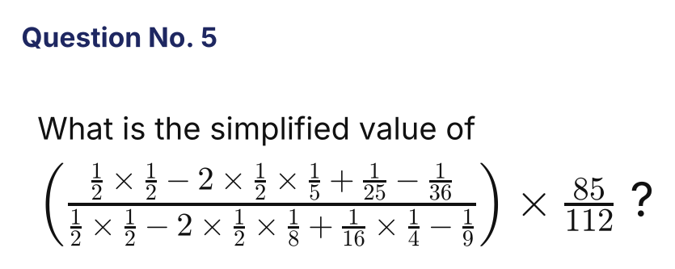
{OPTION 1} 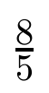
{OPTION 2} 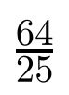
{OPTION 3} 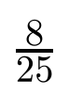
{OPTION 4} 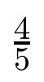
{OPTION 5}
{OPTION 6}
{OPTION 7}
{OPTION 8}
{OPTION 9}
{OPTION 10}
{RIGHT ANSWER} 1
{EXPLANATION} Numerator: (1/2 − 1/5)² − 1/36 = 9/100 − 1/36 = 56/900 = 14/225. Denominator: (1/2 − 1/8)² − 1/9 = 9/64 − 1/9 = 17/576. The ratio = (14/225) × (576/17) = 896/425. Multiplying by 85/112: (896/112) × (85/425) = 8 × 1/5 = 8/5.
{CORRECT MARKS} 1
{NEGATIVE MARKS} 0
{DIFFICULTY} Hard
{QUESTION ENDS}

{QUESTION BEGINS}
{QUESTION NUMBER} 6
{SUBJECT} Numerical Ability
{TOPIC} Averages
{TAGS} tcs nqt, numerical ability, actual question, medium
{QUESTION TYPE} SINGLECORRECT
{QUESTION TEXT} The average run scored by a batter in nine innings is 40. How much does she need to score unbeaten in the tenth innings so as just to be able to achieve the qualifying average of 42, which is required for a subsequent selection?
{OPTION 1} 48
{OPTION 2} 18
{OPTION 3} 60
{OPTION 4} 36
{OPTION 5}
{OPTION 6}
{OPTION 7}
{OPTION 8}
{OPTION 9}
{OPTION 10}
{RIGHT ANSWER} 3
{EXPLANATION} Total after 9 innings = 360. Total needed after 10 innings = 420. Runs needed in the tenth innings = 420 − 360 = 60.
{CORRECT MARKS} 1
{NEGATIVE MARKS} 0
{DIFFICULTY} Medium
{QUESTION ENDS}

{QUESTION BEGINS}
{QUESTION NUMBER} 7
{SUBJECT} Numerical Ability
{TOPIC} Simple Interest
{TAGS} tcs nqt, numerical ability, actual question, easy
{QUESTION TYPE} SINGLECORRECT
{QUESTION TEXT} At what rate per cent of simple interest does a sum of money double itself in 12 years?
{OPTION 1} 9 2/3 %
{OPTION 2} 9 1/3 %
{OPTION 3} 8 2/3 %
{OPTION 4} 8 1/3 %
{OPTION 5}
{OPTION 6}
{OPTION 7}
{OPTION 8}
{OPTION 9}
{OPTION 10}
{RIGHT ANSWER} 4
{EXPLANATION} For the sum to double, the interest equals the principal: P × R × 12/100 = P, so R = 100/12 = 8 1/3 %.
{CORRECT MARKS} 1
{NEGATIVE MARKS} 0
{DIFFICULTY} Easy
{QUESTION ENDS}

{QUESTION BEGINS}
{QUESTION NUMBER} 8
{SUBJECT} Numerical Ability
{TOPIC} Ratio and Proportion
{TAGS} tcs nqt, numerical ability, actual question, medium
{QUESTION TYPE} SINGLECORRECT
{QUESTION TEXT} Mangesh has coins of ₹1, 50 Paisa and 25 Paisa in the ratio of 13 : 17 : 23 and amounting to ₹218. Calculate the number of coins he has.
{OPTION 1} 404
{OPTION 2} 442
{OPTION 3} 424
{OPTION 4} 244
{OPTION 5}
{OPTION 6}
{OPTION 7}
{OPTION 8}
{OPTION 9}
{OPTION 10}
{RIGHT ANSWER} 3
{EXPLANATION} Let the numbers of coins be 13k, 17k and 23k. Value = 13k × 1 + 17k × 0.50 + 23k × 0.25 = 13k + 8.5k + 5.75k = 27.25k = 218, so k = 8. Total coins = 53 × 8 = 424.
{CORRECT MARKS} 1
{NEGATIVE MARKS} 0
{DIFFICULTY} Medium
{QUESTION ENDS}

{QUESTION BEGINS}
{QUESTION NUMBER} 9
{SUBJECT} Numerical Ability
{TOPIC} Probability
{TAGS} tcs nqt, numerical ability, actual question, hard
{QUESTION TYPE} SINGLECORRECT
{QUESTION TEXT} A basket contains 15 apples and 25 oranges out of which 4 apples and 6 oranges are defective. If we choose two fruits at random, what is the probability that either both are oranges or both are non-defective?
{OPTION 1} 47/65
{OPTION 2} 23/35
{OPTION 3} 31/45
{OPTION 4} 19/55
{OPTION 5}
{OPTION 6}
{OPTION 7}
{OPTION 8}
{OPTION 9}
{OPTION 10}
{RIGHT ANSWER} 1
{EXPLANATION} Total ways = C(40,2) = 780. Both oranges: C(25,2) = 300. Both non-defective (30 non-defective fruits): C(30,2) = 435. Both non-defective oranges (19): C(19,2) = 171. Favourable = 300 + 435 − 171 = 564. Probability = 564/780 = 47/65.
{CORRECT MARKS} 1
{NEGATIVE MARKS} 0
{DIFFICULTY} Hard
{QUESTION ENDS}

{QUESTION BEGINS}
{QUESTION NUMBER} 10
{SUBJECT} Numerical Ability
{TOPIC} Profit and Loss
{TAGS} tcs nqt, numerical ability, actual question, medium
{QUESTION TYPE} SINGLECORRECT
{QUESTION TEXT} 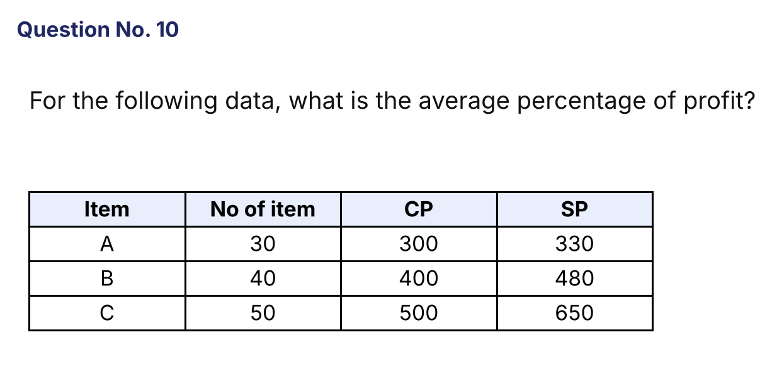
{OPTION 1} 21.7%
{OPTION 2} 20.7%
{OPTION 3} 23%
{OPTION 4} 20%
{OPTION 5}
{OPTION 6}
{OPTION 7}
{OPTION 8}
{OPTION 9}
{OPTION 10}
{RIGHT ANSWER} 1
{EXPLANATION} Profit % of A = 30/300 = 10%, of B = 80/400 = 20% and of C = 150/500 = 30%. Weighted by the number of items: (30 × 10 + 40 × 20 + 50 × 30)/120 = 2600/120 = 21.7%. (Using totals: CP = 1200, SP = 1460, profit = 260/1200 = 21.7%.)
{CORRECT MARKS} 1
{NEGATIVE MARKS} 0
{DIFFICULTY} Medium
{QUESTION ENDS}

{QUESTION BEGINS}
{QUESTION NUMBER} 11
{SUBJECT} Numerical Ability
{TOPIC} Time, Speed and Distance
{TAGS} tcs nqt, numerical ability, actual question, medium
{QUESTION TYPE} SINGLECORRECT
{QUESTION TEXT} A car is moving at a speed of 60 km/h. The driver applies the brake and stops it over a distance in 5 seconds. Determine the distance covered in metres by the car in stopping. Consider average speed.
{OPTION 1} 42.67
{OPTION 2} 44.67
{OPTION 3} 41.67
{OPTION 4} 43.67
{OPTION 5}
{OPTION 6}
{OPTION 7}
{OPTION 8}
{OPTION 9}
{OPTION 10}
{RIGHT ANSWER} 3
{EXPLANATION} The speed falls uniformly from 60 km/h to 0, so the average speed = 30 km/h = 30 × 5/18 = 8.33 m/s. Distance = 8.33 × 5 = 41.67 m.
{CORRECT MARKS} 1
{NEGATIVE MARKS} 0
{DIFFICULTY} Medium
{QUESTION ENDS}

{QUESTION BEGINS}
{QUESTION NUMBER} 12
{SUBJECT} Numerical Ability
{TOPIC} Time and Work
{TAGS} tcs nqt, numerical ability, actual question, hard
{QUESTION TYPE} SINGLECORRECT
{QUESTION TEXT} 4 men and 6 women can do a piece of work in 5 days while 6 men and 4 women can do the same work in 4 days. In how many days can 4 men and 2 women do the same work?
{OPTION 1} 6 1/4 days
{OPTION 2} 10 1/2 days
{OPTION 3} 12 1/2 days
{OPTION 4} 9 1/4 days
{OPTION 5}
{OPTION 6}
{OPTION 7}
{OPTION 8}
{OPTION 9}
{OPTION 10}
{RIGHT ANSWER} 1
{EXPLANATION} Let a man's and a woman's one-day work be m and w. 5(4m + 6w) = 1 and 4(6m + 4w) = 1, so 20m + 30w = 24m + 16w, which gives 14w = 4m, m = 3.5w. Then 100w = 1, so w = 1/100 and m = 3.5/100. 4 men and 2 women do 14/100 + 2/100 = 16/100 per day, so they need 100/16 = 6 1/4 days.
{CORRECT MARKS} 1
{NEGATIVE MARKS} 0
{DIFFICULTY} Hard
{QUESTION ENDS}

{QUESTION BEGINS}
{QUESTION NUMBER} 13
{SUBJECT} Numerical Ability
{TOPIC} Mensuration
{TAGS} tcs nqt, numerical ability, actual question, hard
{QUESTION TYPE} SINGLECORRECT
{QUESTION TEXT} 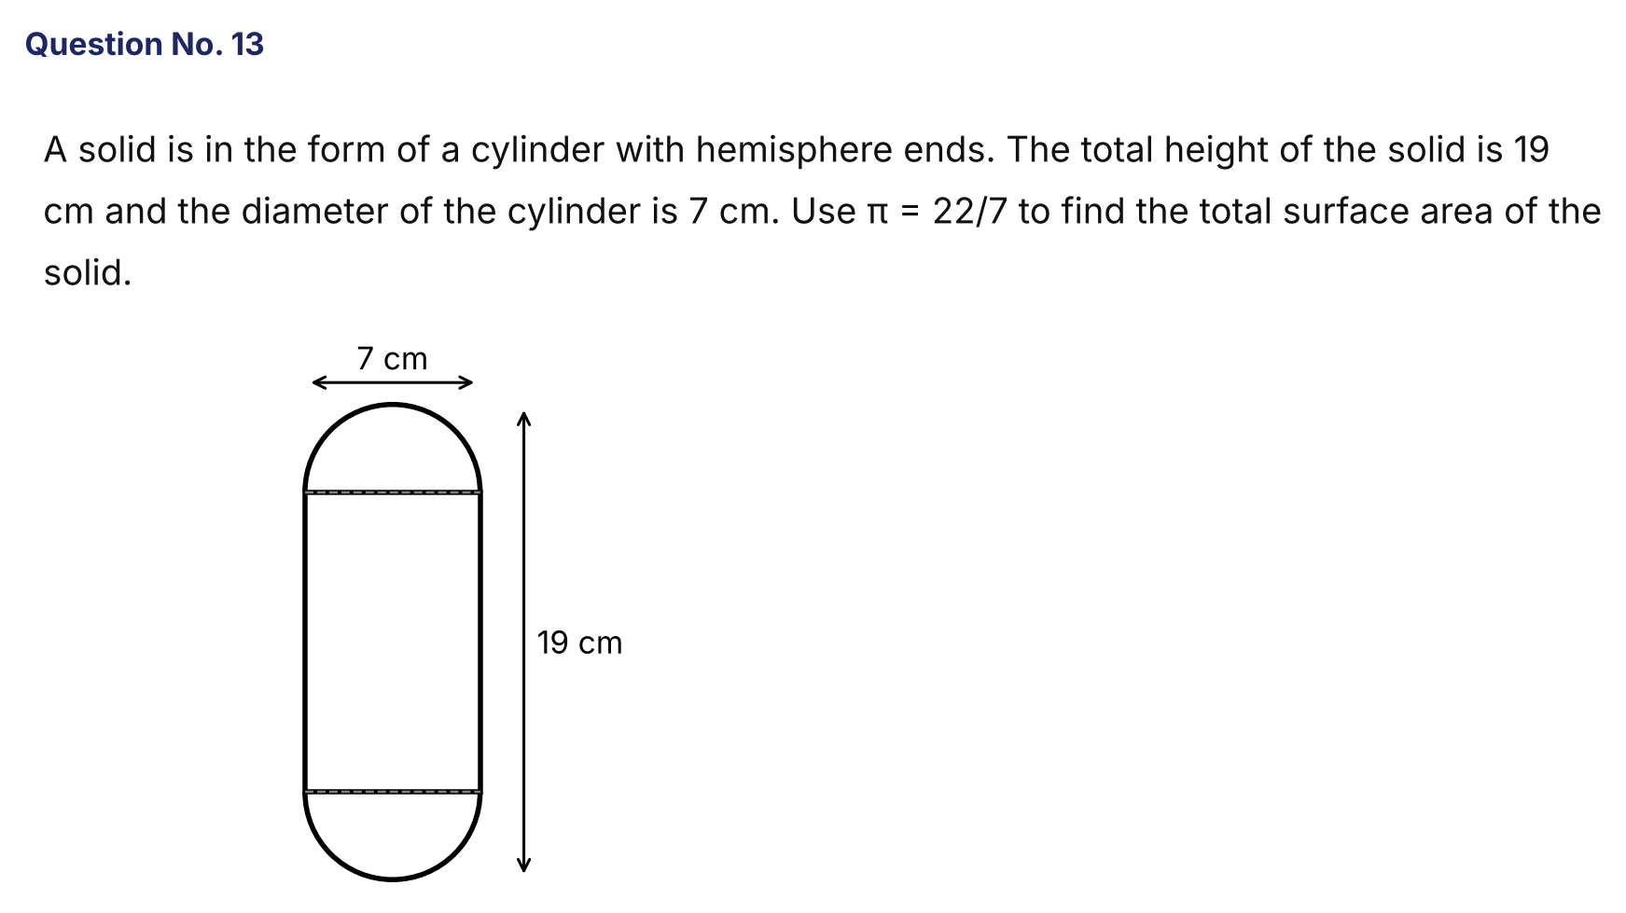
{OPTION 1} 482 cm²
{OPTION 2} 418 cm²
{OPTION 3} 486 cm²
{OPTION 4} 432 cm²
{OPTION 5}
{OPTION 6}
{OPTION 7}
{OPTION 8}
{OPTION 9}
{OPTION 10}
{RIGHT ANSWER} 2
{EXPLANATION} Radius = 3.5 cm. Height of the cylindrical part = 19 − 2 × 3.5 = 12 cm. TSA = curved surface of the cylinder + two hemispheres = 2πrh + 4πr² = 2 × (22/7) × 3.5 × 12 + 4 × (22/7) × 3.5² = 264 + 154 = 418 cm².
{CORRECT MARKS} 1
{NEGATIVE MARKS} 0
{DIFFICULTY} Hard
{QUESTION ENDS}

{QUESTION BEGINS}
{QUESTION NUMBER} 14
{SUBJECT} Numerical Ability
{TOPIC} Profit and Loss
{TAGS} tcs nqt, numerical ability, actual question, hard
{QUESTION TYPE} NUMERICAL
{QUESTION TEXT} In a shop, the cost price of a blue ink and a black ink is the same. Blue ink is sold at a profit of 14 2/7 % and the selling price of black ink is ₹80 less than the blue one. Find the sum of the cost price (in ₹) of both the inks if the net profit is 6 2/3 %. (Enter the answer as a whole number.)
{OPTION 1}
{OPTION 2}
{OPTION 3}
{OPTION 4}
{OPTION 5}
{OPTION 6}
{OPTION 7}
{OPTION 8}
{OPTION 9}
{OPTION 10}
{RIGHT ANSWER} 1050
{EXPLANATION} Let the cost of each ink be c. Blue SP = c × 8/7. Black SP = 8c/7 − 80. Total SP = 16c/7 − 80, which must equal 2c × 16/15 (net profit 6 2/3 % = 1/15). So 16c/7 − 32c/15 = 80, i.e. 16c/105 = 80 and c = 525. Sum of the cost prices = 2 × 525 = ₹1,050.
{CORRECT MARKS} 1
{NEGATIVE MARKS} 0
{DIFFICULTY} Hard
{QUESTION ENDS}

{QUESTION BEGINS}
{QUESTION NUMBER} 15
{SUBJECT} Numerical Ability
{TOPIC} Time and Work
{TAGS} tcs nqt, numerical ability, practice, hard
{QUESTION TYPE} SINGLECORRECT
{QUESTION TEXT} A and B together can complete a work in 12 days, B and C together in 15 days, and C and A together in 20 days. In how many days can A alone complete the work?
{OPTION 1} 40 days
{OPTION 2} 24 days
{OPTION 3} 30 days
{OPTION 4} 36 days
{OPTION 5}
{OPTION 6}
{OPTION 7}
{OPTION 8}
{OPTION 9}
{OPTION 10}
{RIGHT ANSWER} 3
{EXPLANATION} (A + B) + (C + A) − (B + C) = 2A = 1/12 + 1/20 − 1/15 = (5 + 3 − 4)/60 = 1/15. So A's one-day work = 1/30, and A alone takes 30 days.
{CORRECT MARKS} 1
{NEGATIVE MARKS} 0
{DIFFICULTY} Hard
{QUESTION ENDS}

{QUESTION BEGINS}
{QUESTION NUMBER} 16
{SUBJECT} Numerical Ability
{TOPIC} Mixtures
{TAGS} tcs nqt, numerical ability, practice, hard
{QUESTION TYPE} SINGLECORRECT
{QUESTION TEXT} A vessel contains 60 litres of a mixture of milk and water in the ratio 7 : 3. How many litres of water must be added to change the ratio of milk to water to 7 : 5?
{OPTION 1} 10 litres
{OPTION 2} 15 litres
{OPTION 3} 8 litres
{OPTION 4} 12 litres
{OPTION 5}
{OPTION 6}
{OPTION 7}
{OPTION 8}
{OPTION 9}
{OPTION 10}
{RIGHT ANSWER} 4
{EXPLANATION} Milk = 42 L and water = 18 L. For a ratio 7 : 5 with 42 L of milk, water = 42 × 5/7 = 30 L. Water to add = 30 − 18 = 12 litres.
{CORRECT MARKS} 1
{NEGATIVE MARKS} 0
{DIFFICULTY} Hard
{QUESTION ENDS}

{QUESTION BEGINS}
{QUESTION NUMBER} 17
{SUBJECT} Numerical Ability
{TOPIC} Time, Speed and Distance
{TAGS} tcs nqt, numerical ability, practice, hard
{QUESTION TYPE} SINGLECORRECT
{QUESTION TEXT} Two trains of lengths 120 m and 180 m run on parallel tracks. When they run in the same direction, the faster train passes the slower one in 60 seconds. When they run in opposite directions, they cross each other in 12 seconds. What is the speed of the faster train?
{OPTION 1} 36 km/h
{OPTION 2} 54 km/h
{OPTION 3} 60 km/h
{OPTION 4} 45 km/h
{OPTION 5}
{OPTION 6}
{OPTION 7}
{OPTION 8}
{OPTION 9}
{OPTION 10}
{RIGHT ANSWER} 2
{EXPLANATION} Total length = 300 m. Same direction: u − v = 300/60 = 5 m/s. Opposite direction: u + v = 300/12 = 25 m/s. So u = 15 m/s and v = 10 m/s. The faster train's speed = 15 × 18/5 = 54 km/h.
{CORRECT MARKS} 1
{NEGATIVE MARKS} 0
{DIFFICULTY} Hard
{QUESTION ENDS}

{QUESTION BEGINS}
{QUESTION NUMBER} 18
{SUBJECT} Numerical Ability
{TOPIC} Compound Interest
{TAGS} tcs nqt, numerical ability, practice, medium
{QUESTION TYPE} SINGLECORRECT
{QUESTION TEXT} What sum of money will earn a compound interest of ₹2,080 in 2 years at 8% per annum?
{OPTION 1} ₹10,400
{OPTION 2} ₹13,000
{OPTION 3} ₹12,500
{OPTION 4} ₹12,000
{OPTION 5}
{OPTION 6}
{OPTION 7}
{OPTION 8}
{OPTION 9}
{OPTION 10}
{RIGHT ANSWER} 3
{EXPLANATION} Compound interest = P[(1.08)² − 1] = P × 0.1664 = 2080. So P = 2080/0.1664 = ₹12,500.
{CORRECT MARKS} 1
{NEGATIVE MARKS} 0
{DIFFICULTY} Medium
{QUESTION ENDS}

{QUESTION BEGINS}
{QUESTION NUMBER} 19
{SUBJECT} Numerical Ability
{TOPIC} Percentages
{TAGS} tcs nqt, numerical ability, practice, hard
{QUESTION TYPE} SINGLECORRECT
{QUESTION TEXT} In a school, 40% of the students are girls. 70% of the boys and 50% of the girls passed an examination. What percentage of the total students failed?
{OPTION 1} 42%
{OPTION 2} 38%
{OPTION 3} 36%
{OPTION 4} 40%
{OPTION 5}
{OPTION 6}
{OPTION 7}
{OPTION 8}
{OPTION 9}
{OPTION 10}
{RIGHT ANSWER} 2
{EXPLANATION} Take 100 students: 60 boys and 40 girls. Boys who failed = 30% of 60 = 18. Girls who failed = 50% of 40 = 20. Total failed = 38, which is 38%.
{CORRECT MARKS} 1
{NEGATIVE MARKS} 0
{DIFFICULTY} Hard
{QUESTION ENDS}

{QUESTION BEGINS}
{QUESTION NUMBER} 20
{SUBJECT} Numerical Ability
{TOPIC} Permutation and Combination
{TAGS} tcs nqt, numerical ability, practice, hard
{QUESTION TYPE} SINGLECORRECT
{QUESTION TEXT} How many 3-digit numbers divisible by 5 can be formed using the digits 0, 1, 2, 3, 4, 5 if no digit is repeated?
{OPTION 1} 48
{OPTION 2} 30
{OPTION 3} 36
{OPTION 4} 40
{OPTION 5}
{OPTION 6}
{OPTION 7}
{OPTION 8}
{OPTION 9}
{OPTION 10}
{RIGHT ANSWER} 3
{EXPLANATION} Last digit 0: the other two places can be filled in 5 × 4 = 20 ways. Last digit 5: the first digit can be 1, 2, 3 or 4 (4 choices, not 0 or 5), and the middle digit can be any of the remaining 4 digits (including 0): 4 × 4 = 16. Total = 20 + 16 = 36.
{CORRECT MARKS} 1
{NEGATIVE MARKS} 0
{DIFFICULTY} Hard
{QUESTION ENDS}

