Modification Output

We have created web application where you can upload image and then web application can detect weather image is fake or real.

To run this code you need to install below extra package

pip install Django==2.1.7

In below screen you can see we can upload either PNG or JPG or TIFF images

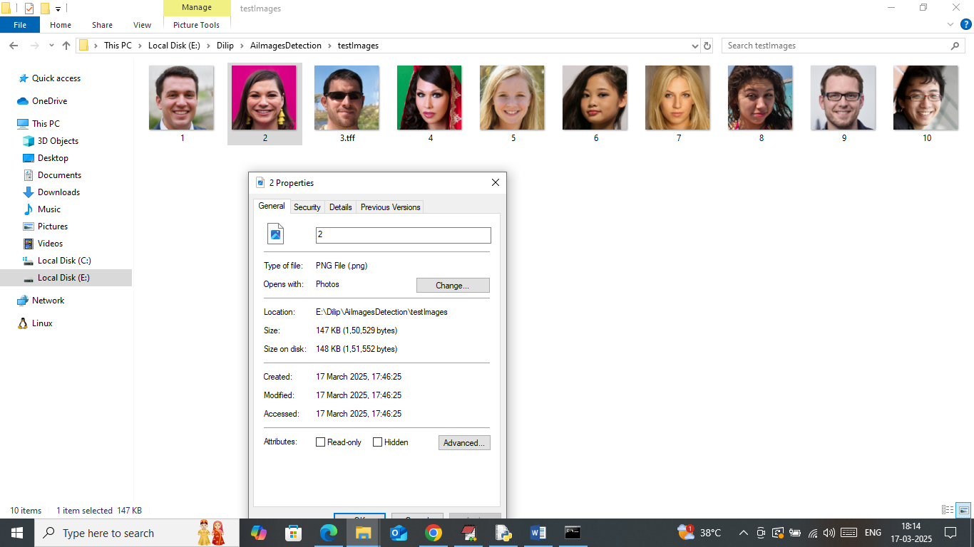

In above screen you can we have mixed of TIFF, PNG and JPG images

Now double click on ‘runWebServer.bat’ file to start python web server and then will get below page

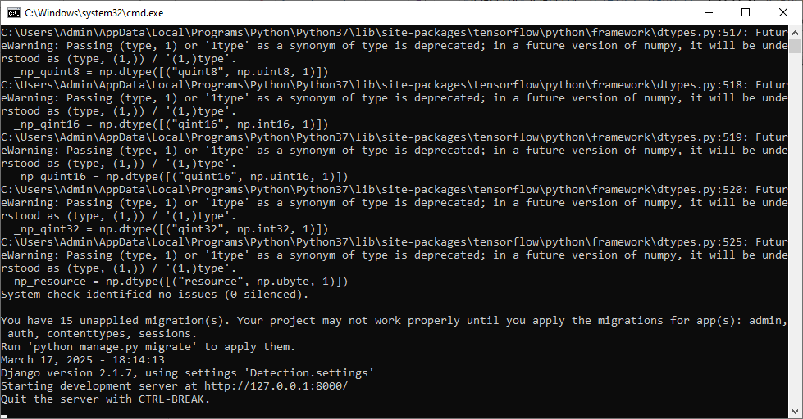

In above screen python web server started and now open browser and enter URL as <http://127.0.0.1:8000/index.html> and then press enter key to get below page



In above screen click on ‘User Login’ link to get below page



In above screen user can login by entering username and password as ‘admin and admin’ and then press button to get below page



In above screen click on ‘Fake Image Detection’ link to get below page

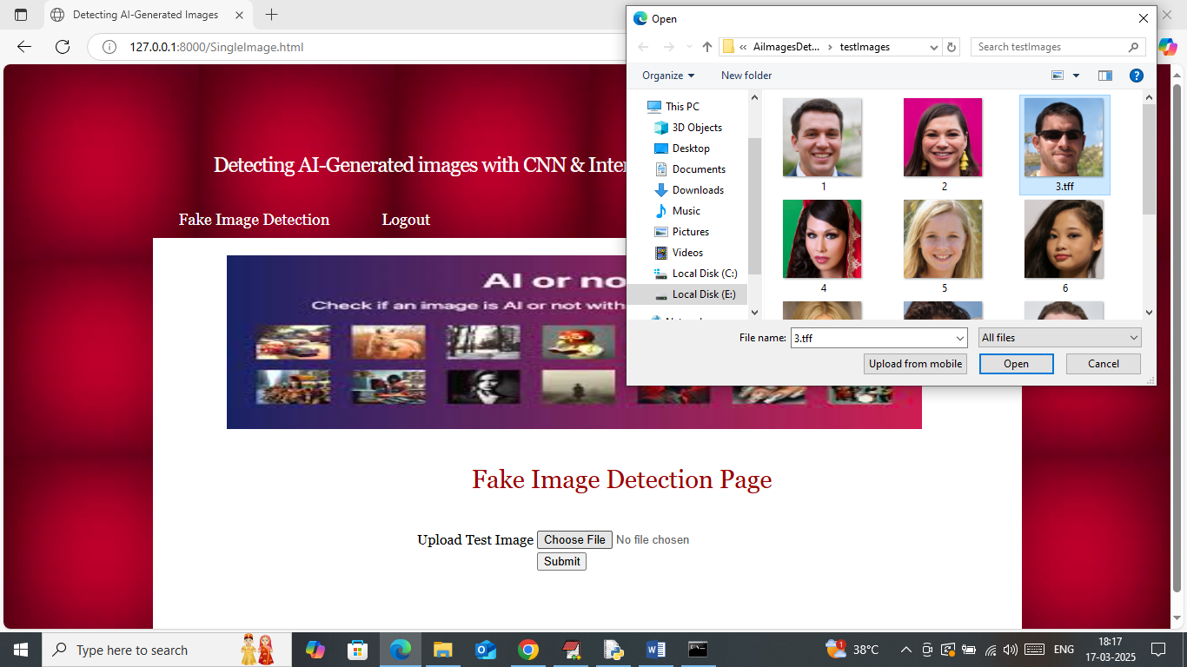

In above screen select and upload test image and then press buttons to get below page

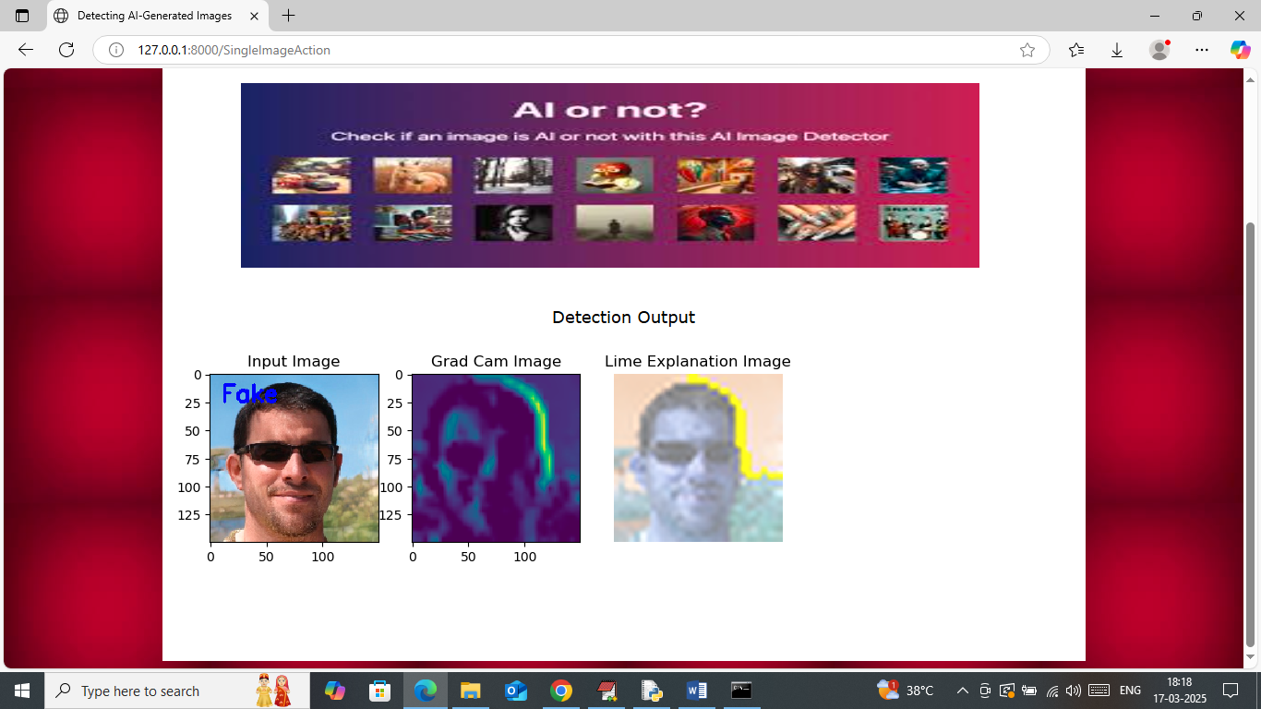

In above screen given image predicted as FAKE. Similarly you can upload and test other image

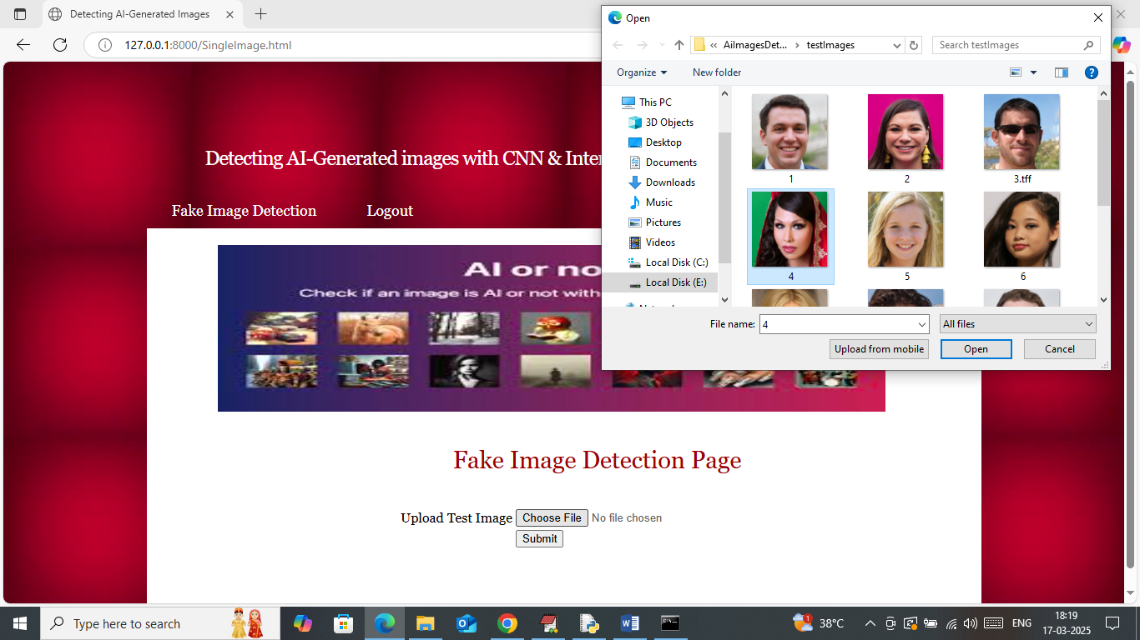

In above screen uploading another image and below is the output

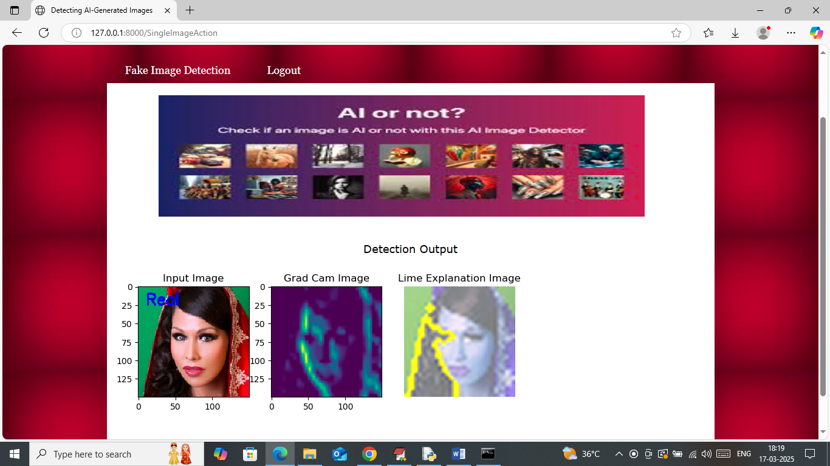

Above image detected as REAL.